- Compatibility Testing:-
In this, we have to test the compatibility that the website is opening in the browser or not. So have tested the compatibility in the 3 of the top browsers named Google Chrome, Mozilla Firefox and Microsoft Edge. Name of the video is Compatibility_Testing.mkv

Google Chrome:
Again after updation I’ve tested the compatibility of the website in this sprint in Google Chrome.
Expedted Result :- This Link should Get opened in the Google Chrome Browser.
Actual Result :- This Link is opening in Google Chrome Browser.
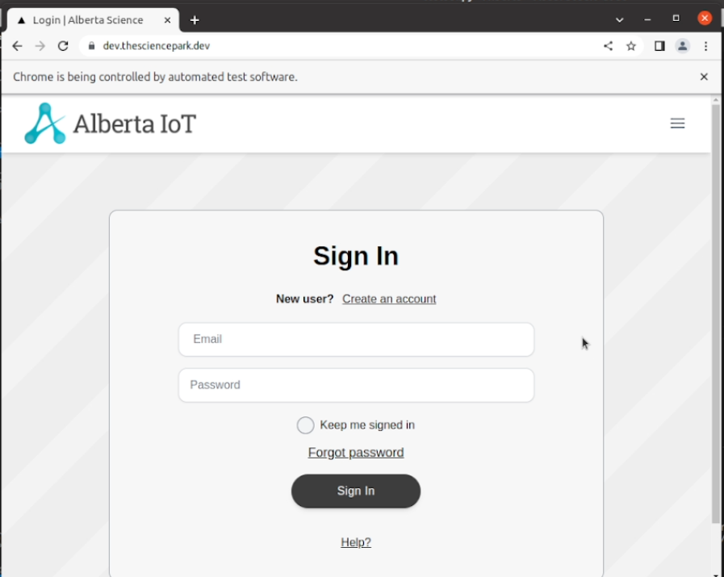

Mozilla Firefox:
Again after updation I’ve tested the compatibility of the website in this sprint in Mozilla Firefox
Expedted Result :- This Link should Get opened in the Mozilla Firefox Browser.
Actual Result :- This Link is opening in Mozilla Firefox Browser.
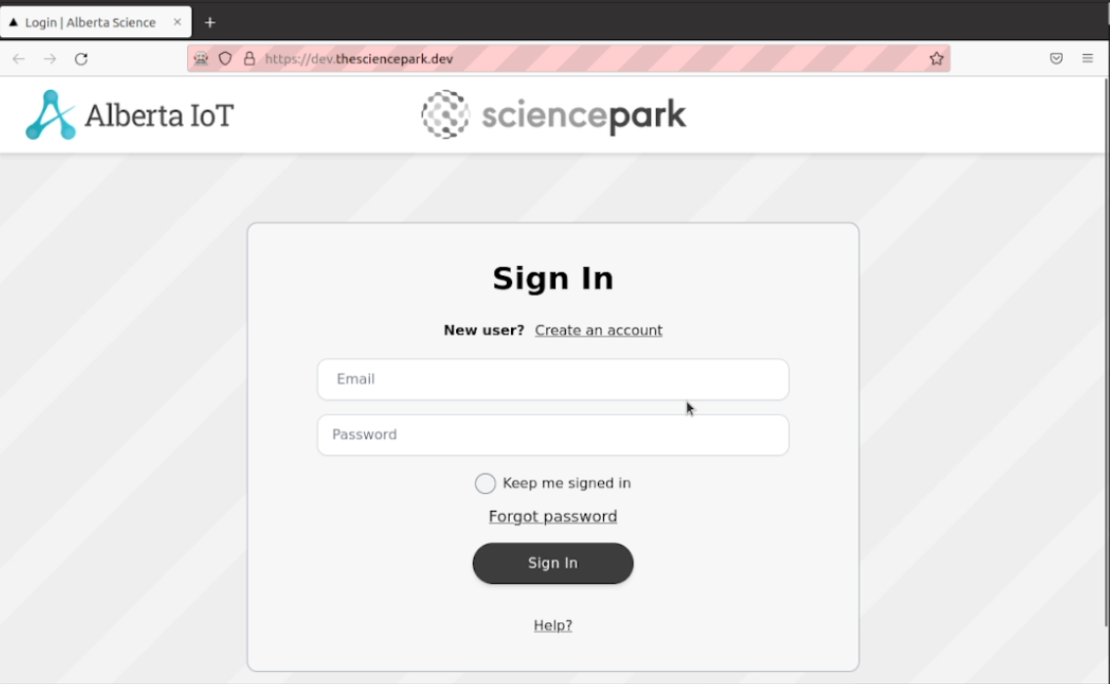

Microsoft Edge:
Again after updation I’ve tested the compatibility of the website in this sprint in Microsoft Edge.
Expedted Result :- This Link should Get opened in the Microsoft Edge Browser.
Actual Result :- This Link is opening in Microsoft Edge Browser.
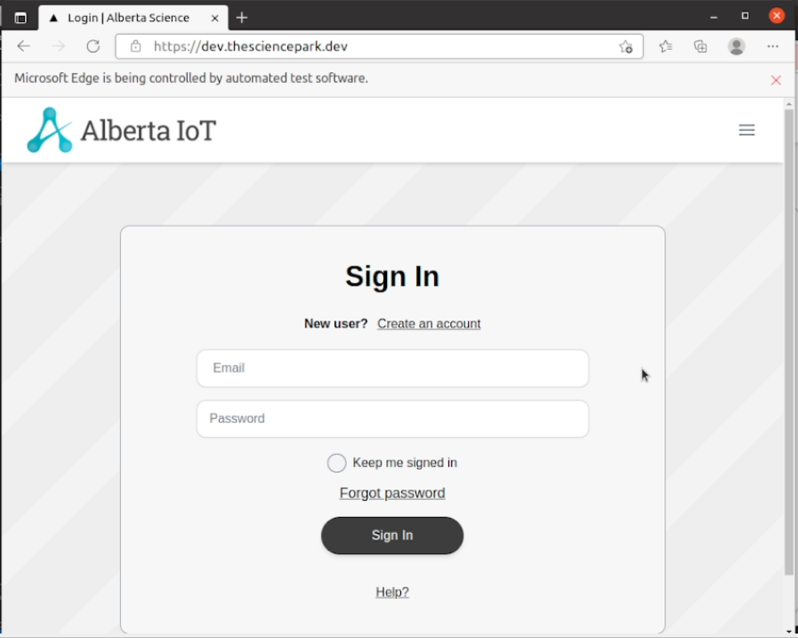
- Penetration Testing:-
In penetration testing, I have scanned the ports in the website from 1 to 50000. In this no any port is open. Name of the video is penetration_testing_port_scanner.mkv

Again after updation of the website, I’ve tested the ports but no open ports were detected.
Expected Result :- No Ports should be opened.
Actual Result :- No Ports are opened
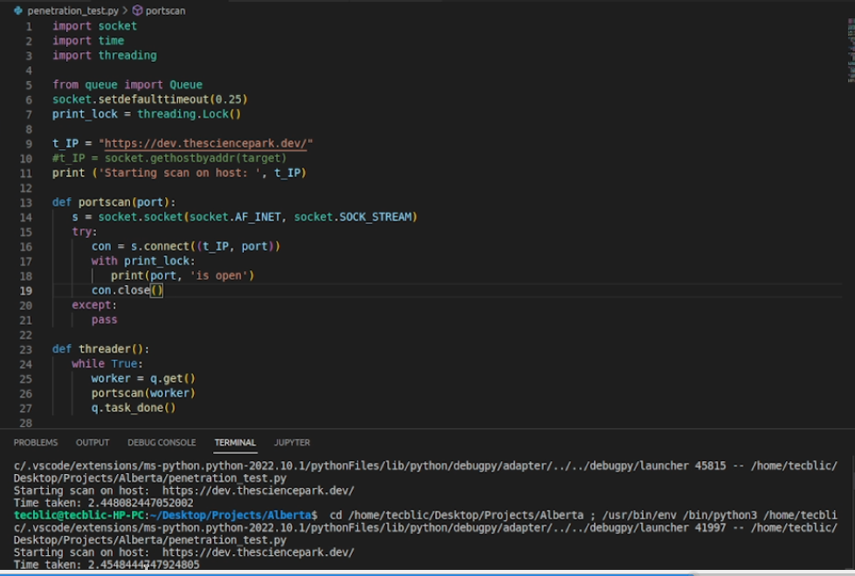

- GUI Testing:-
In this testing, we test the UI of the website. It generally evaluates the textboxes, buttons, links, icons, lists, etc. In this, I have tested Signup Page, Login Page, Create Profile Page, Edit Profile Page, Create Challenge and Business Profile Page. Names of the videos are signup_page.mkv, Login.mkv, Profile_Create.mkv, Edit_Profile.mkv, Business_Profile.mkv, Create_Challenge.mkv.

Signup Page
Again after updation I’ve tested the Signup Page of the website in this sprint.
Expected Result :- The textboxes should be clickable and user should be able to enter the values.
Actual Result :- The textboxes are clickable and user is able to enter the values.
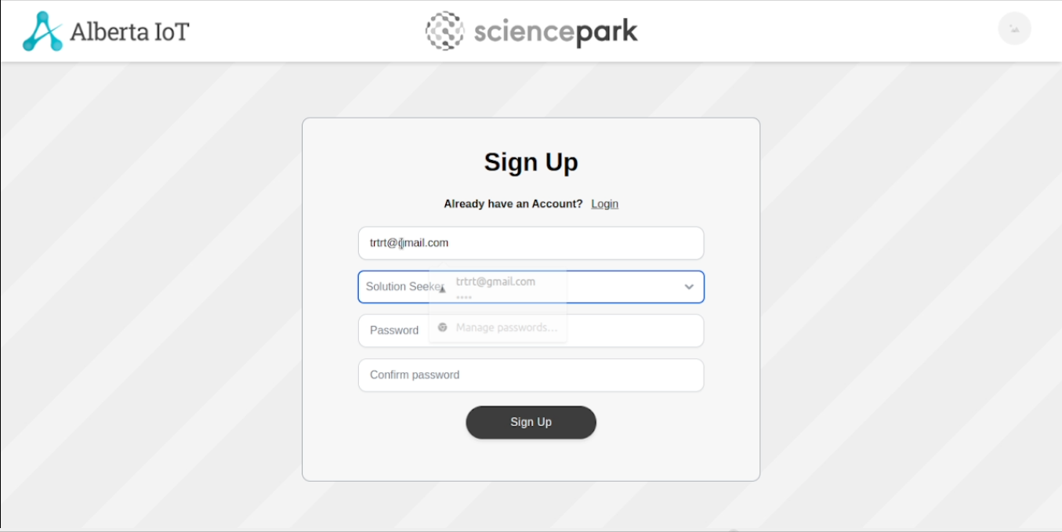
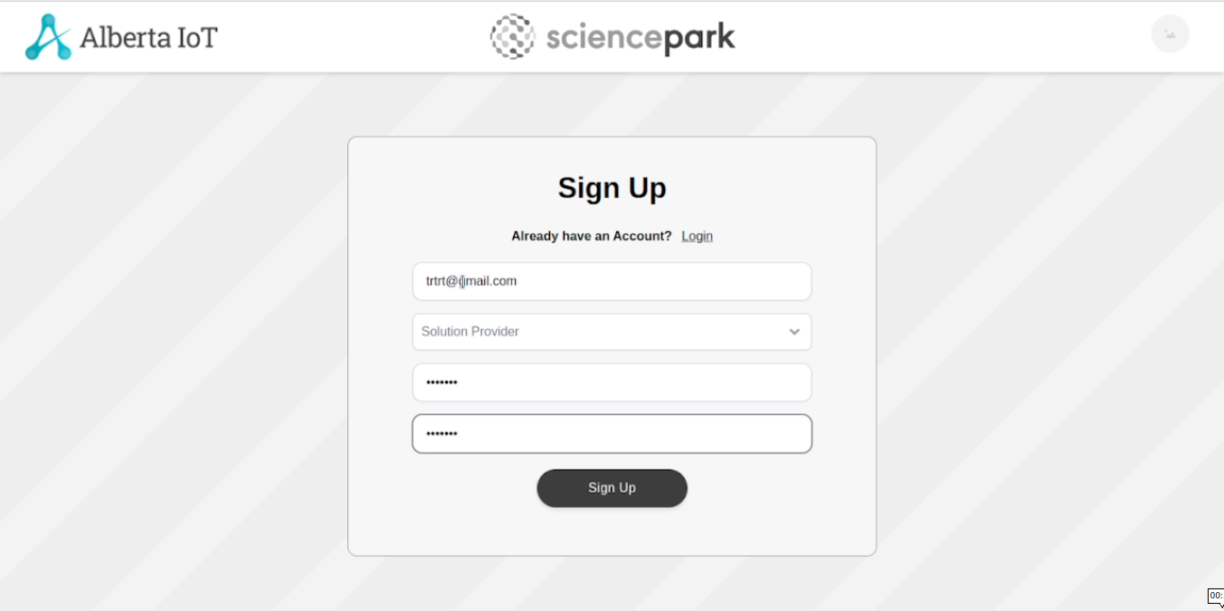
Login Page
Again after updation I’ve tested the Login Page of the website in this sprint.
Expected Result :- The textboxes should be clickable and user should be able to enter the values.
Actual Result :- The textboxes are clickable and user is able to enter the values.
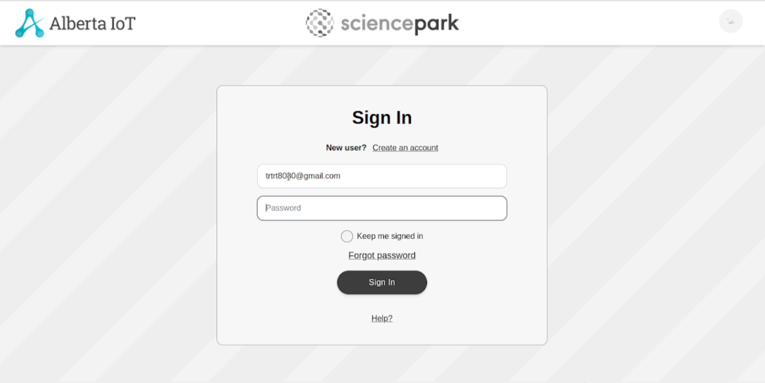
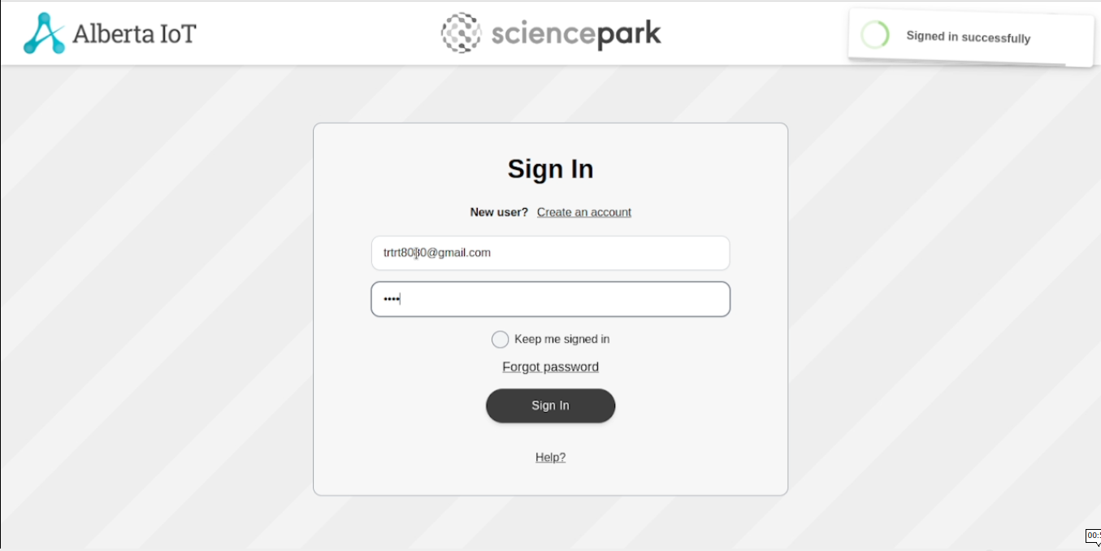
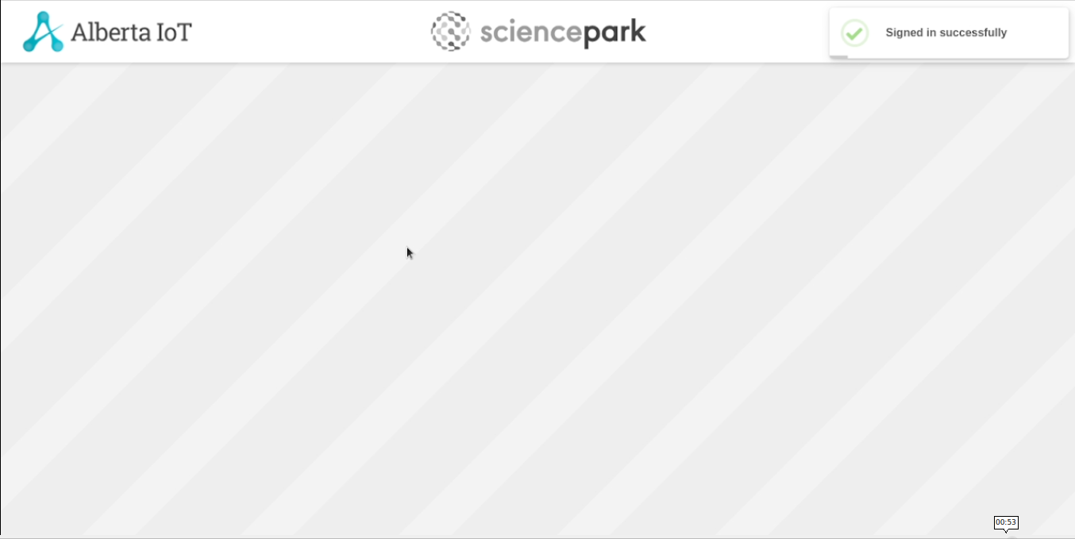
Profile Create Page:
Again after updation I’ve tested the Profile Create Page of the website in this sprint.
Expected Result :- The textboxes should be clickable and user should be able to enter the values.
Actual Result :- The textboxes are clickable and user is able to enter the values.
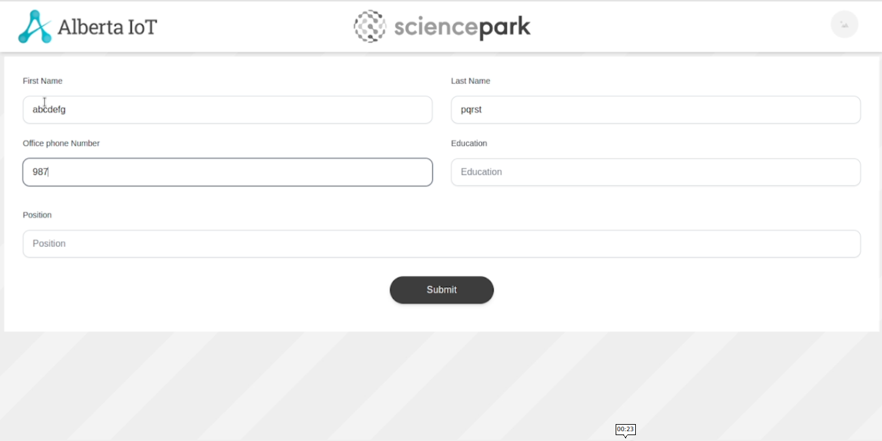
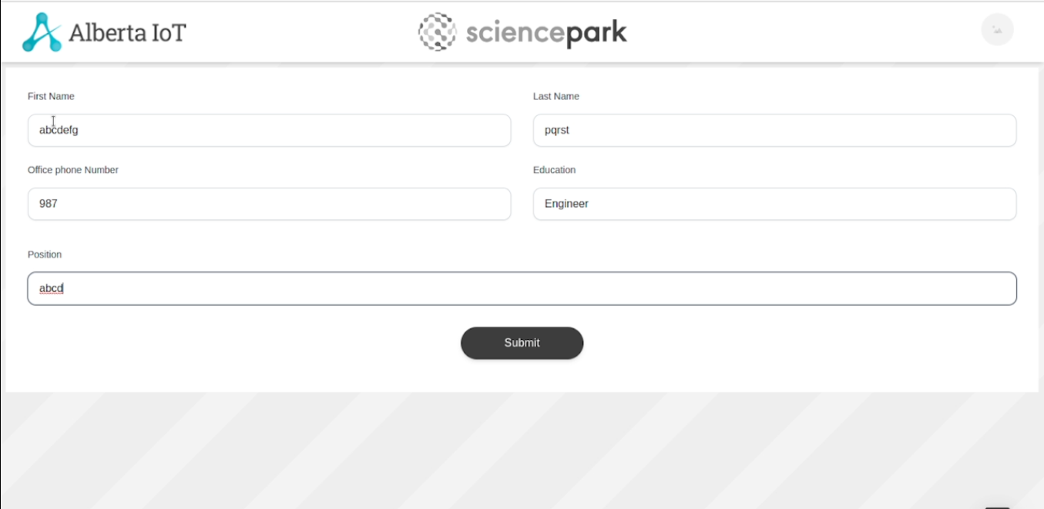

Edit Profile:
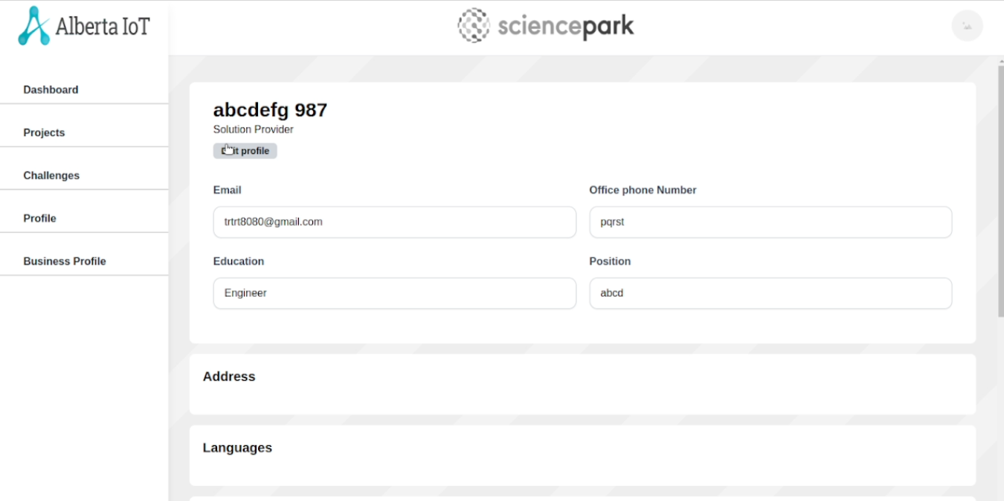
Have tested the Edit Profile page testboxes and by adding the values.
Expected Result :- The textboxes should be clickable and user should be able to enter the values.
Actual Result :- The textboxes are clickable and user is able to enter the values.

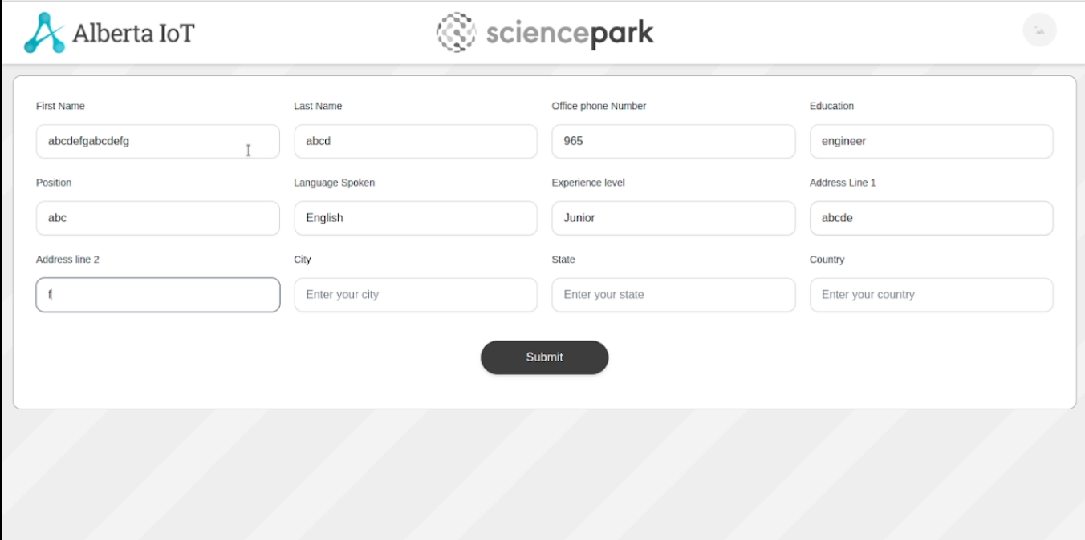

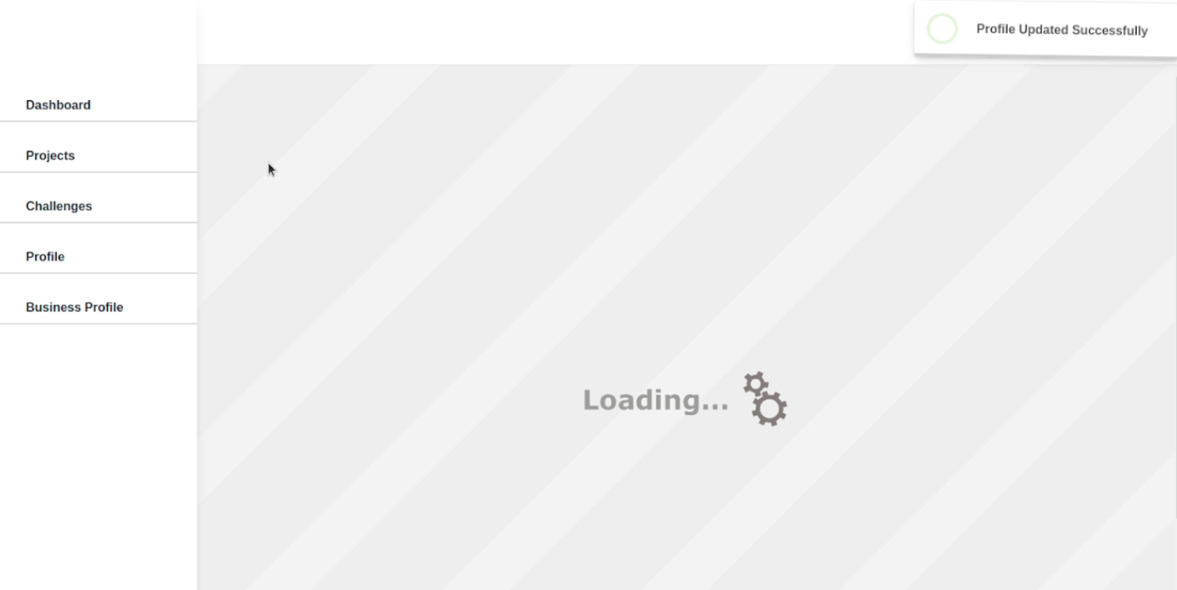

Business Profile Page
Have tested the Business Profile page testboxes, Dropdown and by adding the values.
Expected Result :- The textboxes and Dropdown should be clickable and user should be able to enter the values in the textboxes.
Actual Result :- The textboxes and Dropdown are clickable and user is able to enter the values in the textboxes.
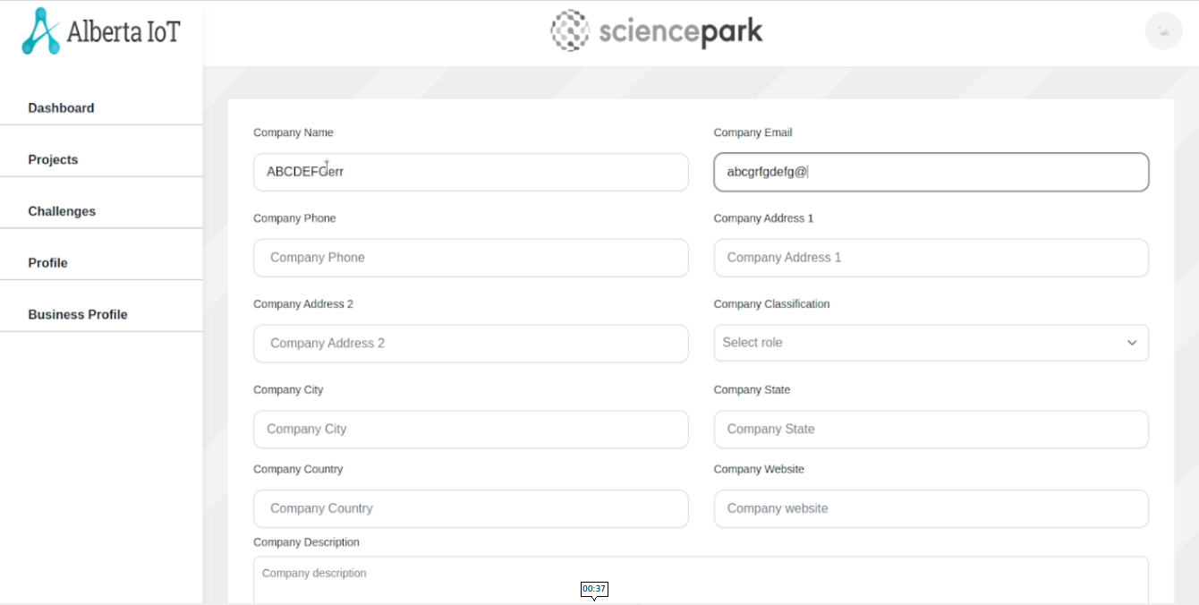
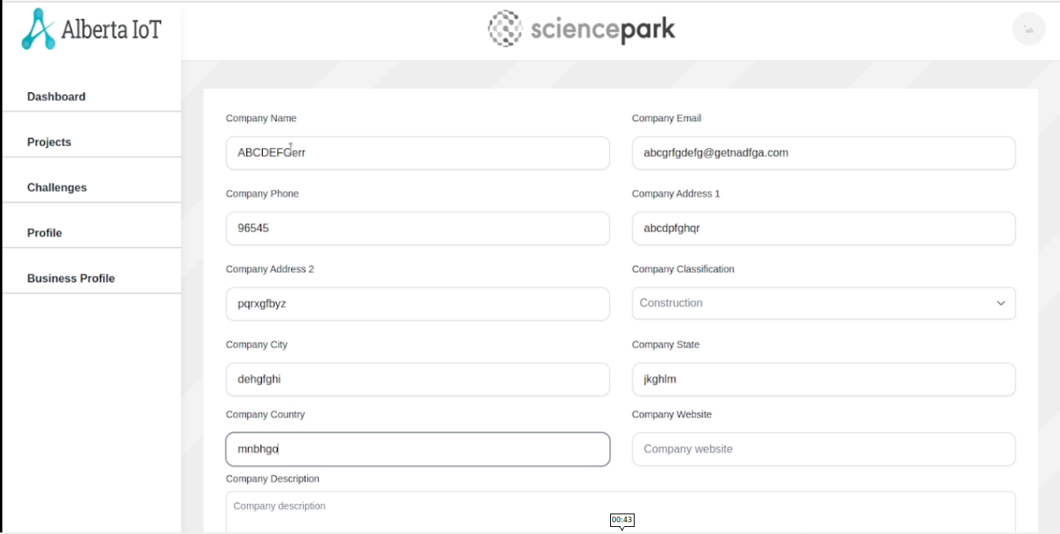
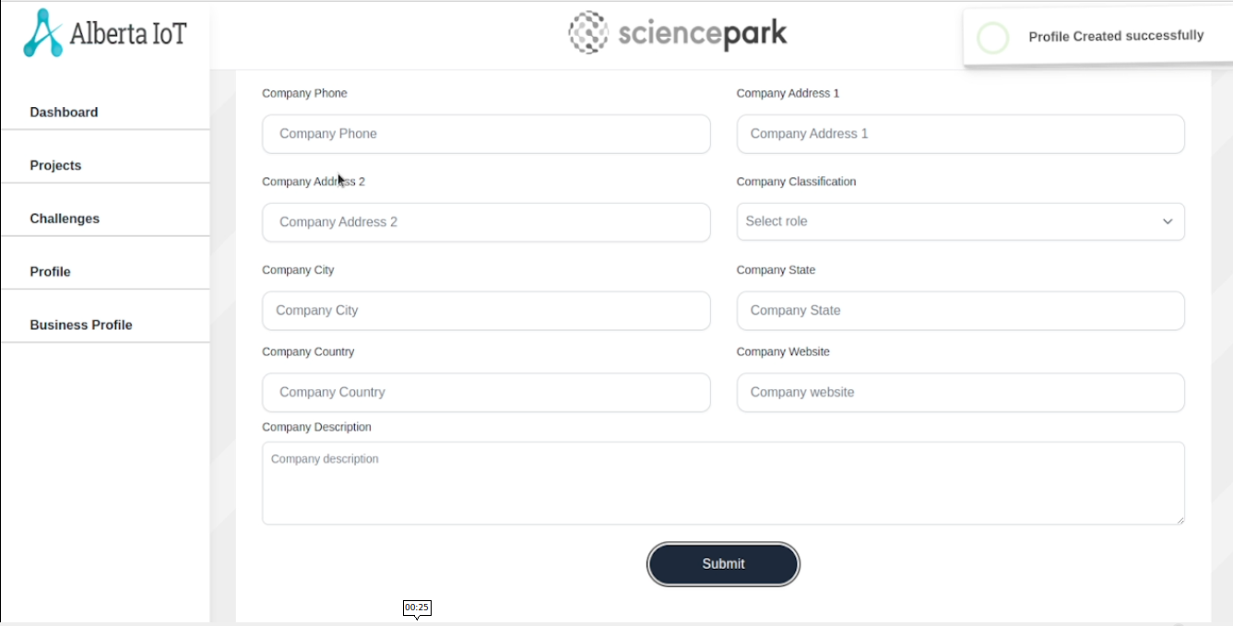

Create Challenge Page:
Have tested the Create Challenge page testboxes, Dropdown, Checkboxes and by adding the values.
Expected Result :- The textboxes, Dropdown and Checkboxes should be clickable and user should be able to enter the values in the textboxes.
Actual Result :- The textboxes, Dropdown and Checkboxes are clickable and user is able to enter the values in the textboxes.
