- Compatibility Testing:-
In this, we have to test the compatibility that the website is opening in the browser or not. So have tested the compatibility in the 3 of the top browsers named Google Chrome, Mozilla Firefox and Microsoft Edge. Name of the video is Compatibility_Testing.mkv

Google Chrome:

Again after updation I’ve tested the compatibility of the website in this sprint in Google Chrome.
Expedted Result :- This Link should Get opened in the Google Chrome Browser.
Actual Result :- This Link is opening in Google Chrome Browser.

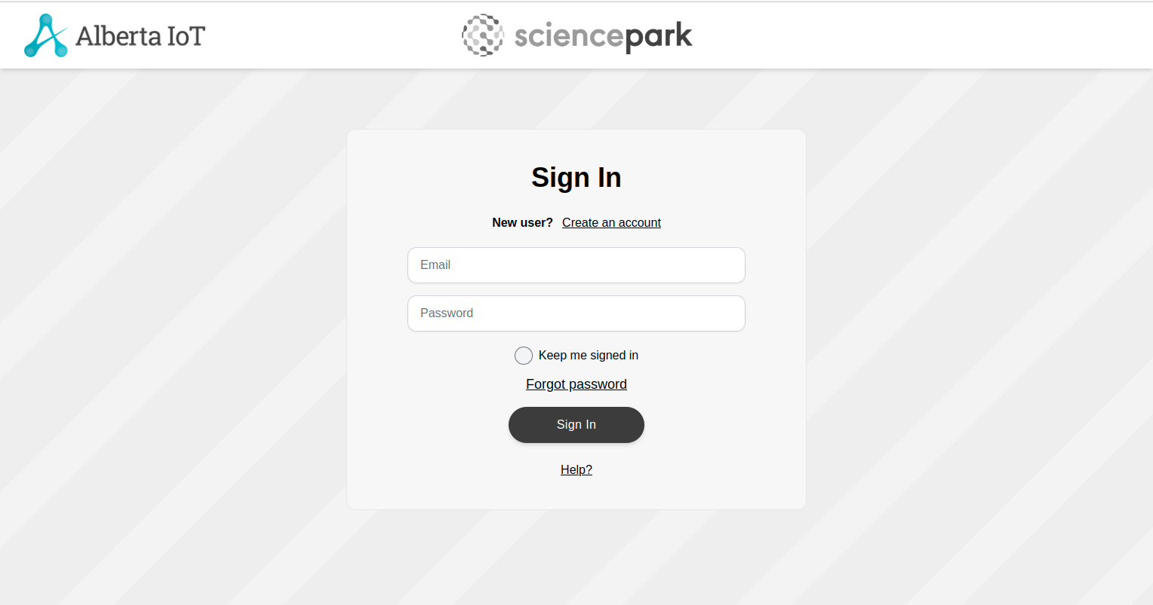

Mozilla Firefox:

Again after updation I’ve tested the compatibility of the website in this sprint in Mozilla Firefox
Expedted Result :- This Link should Get opened in the Mozilla Firefox Browser.
Actual Result :- This Link is opening in Mozilla Firefox Browser.

Microsoft Edge:

Again after updation I’ve tested the compatibility of the website in this sprint in Microsoft Edge.
Expedted Result :- This Link should Get opened in the Microsoft Edge Browser.
Actual Result :- This Link is opening in Microsoft Edge Browser.

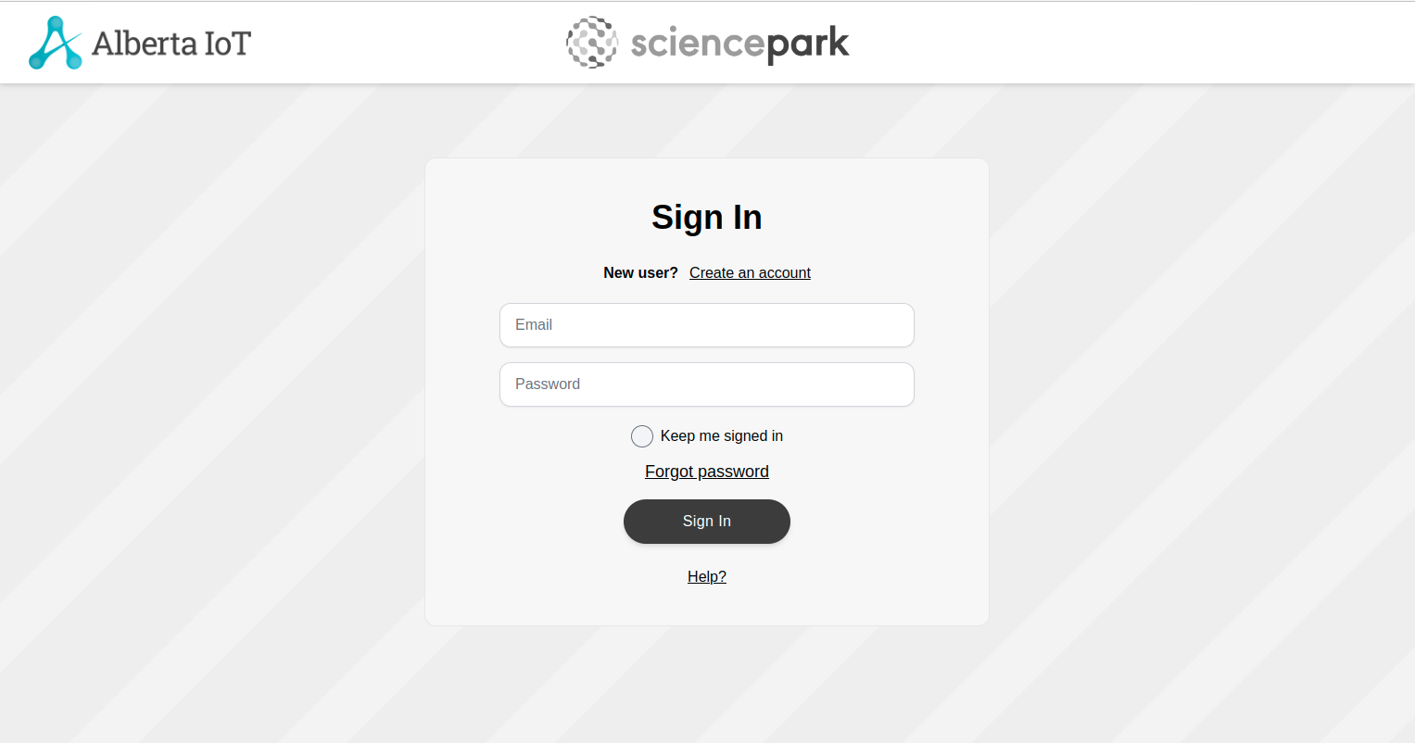

- Penetration Testing:-
In penetration testing, I have scanned the ports in the website from 1 to 50000. In this no any port is open. Name of the video is penetration_testing_port_scanner.mkv

Again after updation of the website, I’ve tested the ports but no open ports were detected.
Expected Result :- No Ports should be opened.
Actual Result :- No Ports are opened
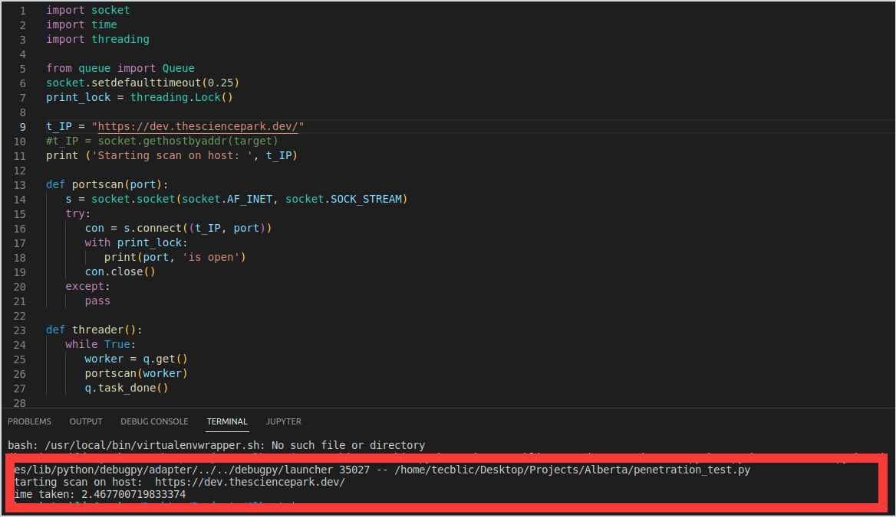

- GUI Testing:-
In this testing, we test the UI of the website. It generally evaluates the textboxes, buttons, links, icons, lists, etc. In this, I have tested Signup Page, Login Page, Create Profile Page, Edit Profile Page, Create Challenge and Business Profile Page. Names of the videos are signup_page.mkv, Login.mkv, Profile_Create.mkv, Edit_Profile.mkv, Business_Profile.mkv, Create_Challenge.mkv.

Signup Page
Again after updation I’ve tested the Signup Page of the website in this sprint.
Expected Result :- The textboxes should be clickable and user should be able to enter the values.
Actual Result :- The textboxes are clickable and user is able to enter the values.

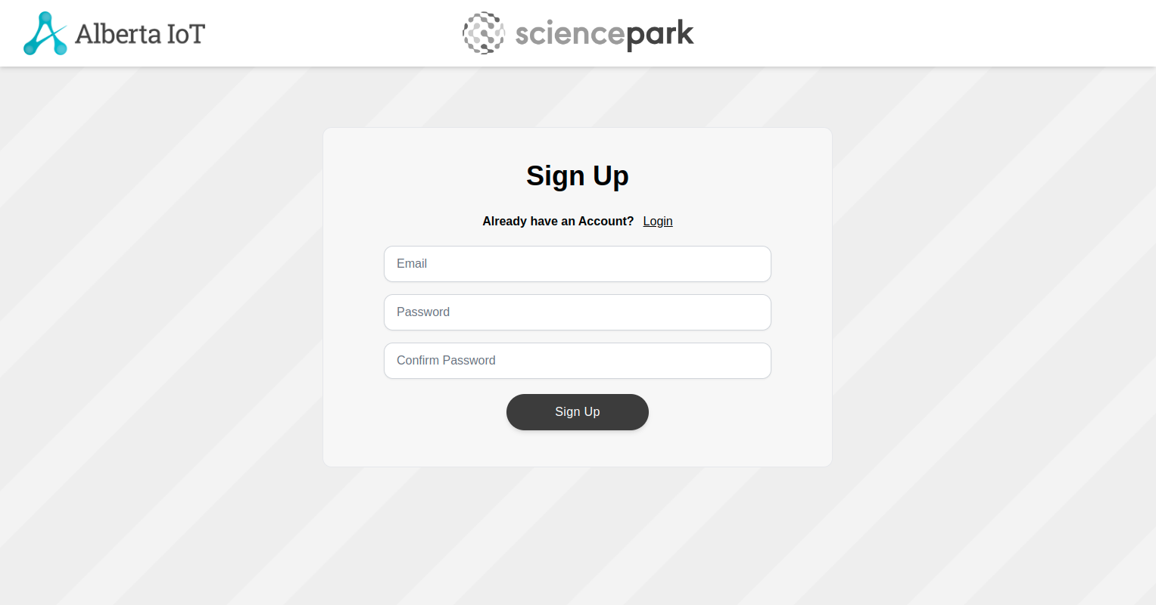

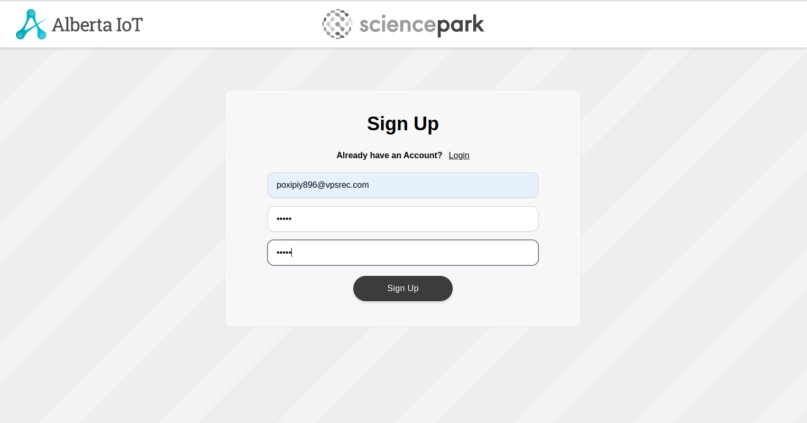

Login Page
Again after updation I’ve tested the Login Page of the website in this sprint.
Expected Result :- The textboxes should be clickable and user should be able to enter the values.
Actual Result :- The textboxes are clickable and user is able to enter the values.

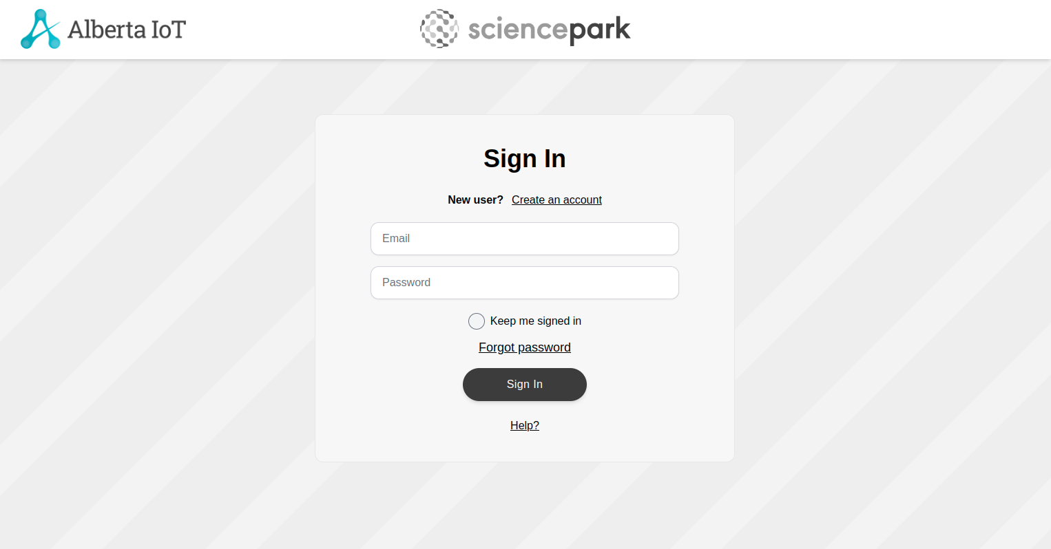
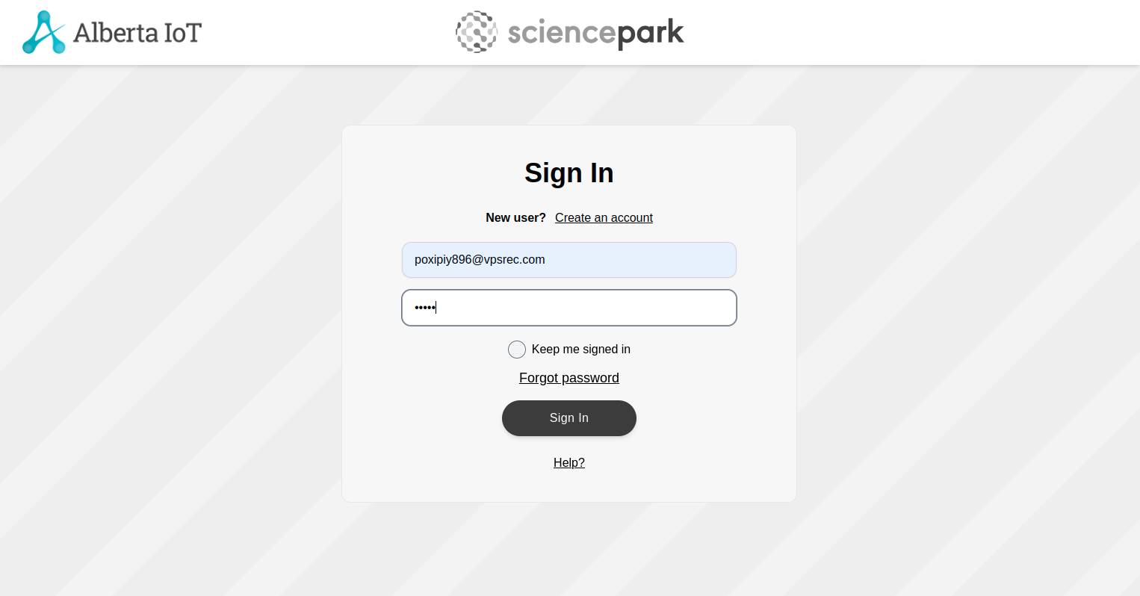
Profile Create Page:
Again after updation I’ve tested the Profile Create Page of the website in this sprint.
Expected Result :- The textboxes should be clickable and user should be able to enter the values.
Actual Result :- The textboxes are clickable and user is able to enter the values.

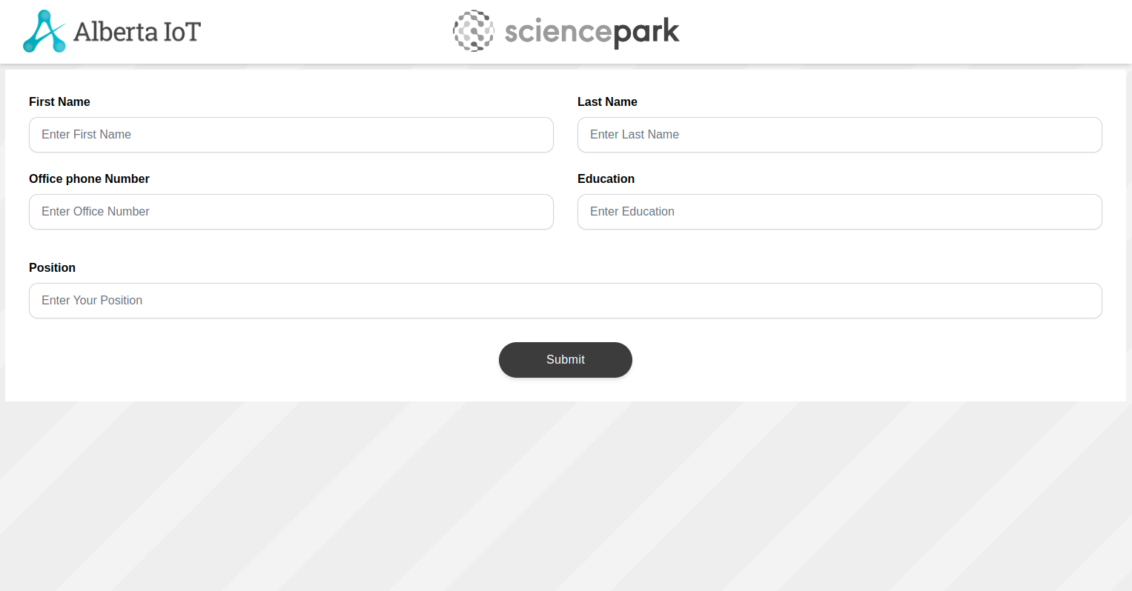

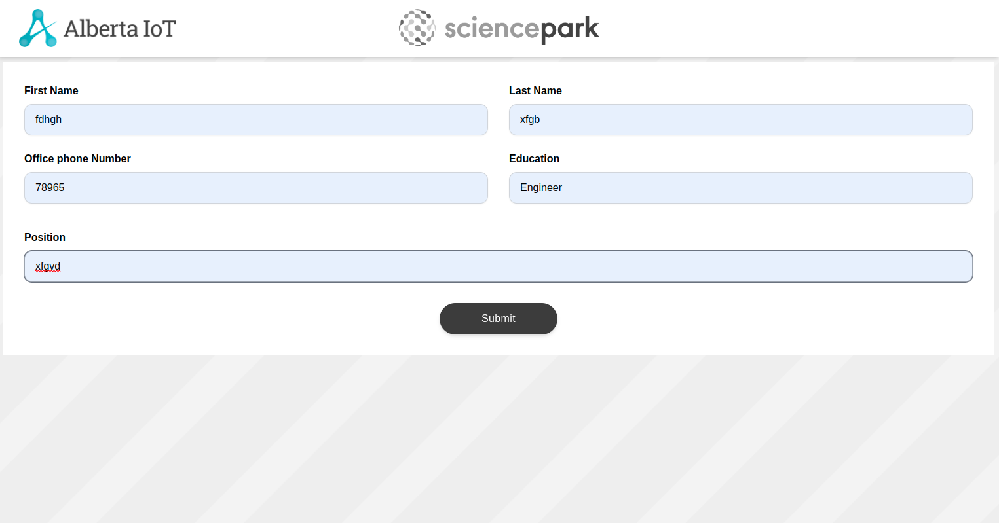

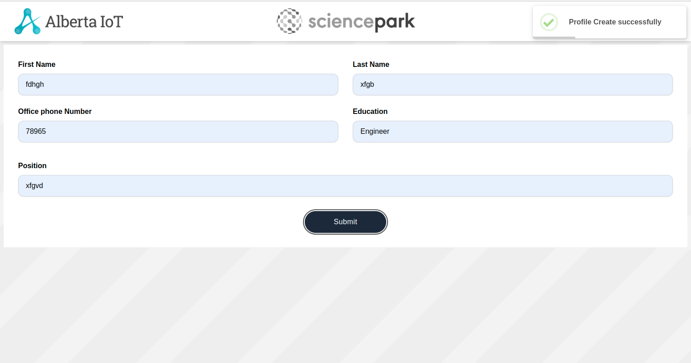

Edit Profile:
Have tested the Edit Profile page testboxes and by adding the values.
Expected Result :- The textboxes should be clickable and user should be able to enter the values.
Actual Result :- The textboxes are clickable and user is able to enter the values.

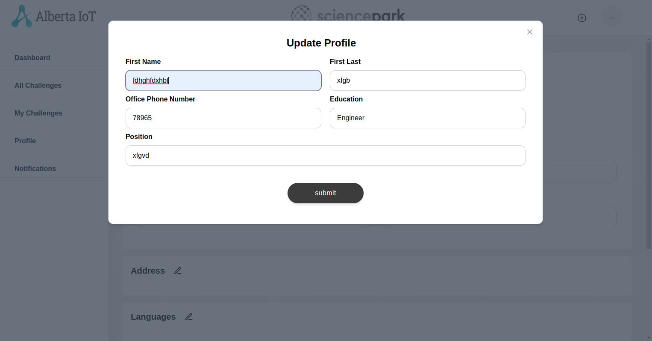

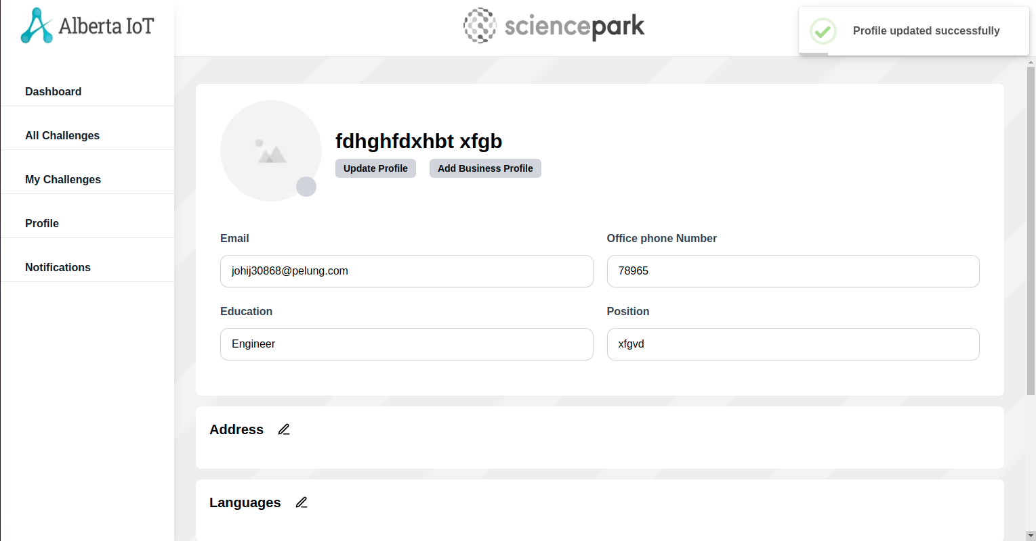

Business Profile Page
Have tested the Business Profile page testboxes, Dropdown and by adding the values.
Expected Result :- The textboxes and Dropdown should be clickable and user should be able to enter the values in the textboxes.
Actual Result :- The textboxes and Dropdown are clickable and user is able to enter the values in the textboxes.

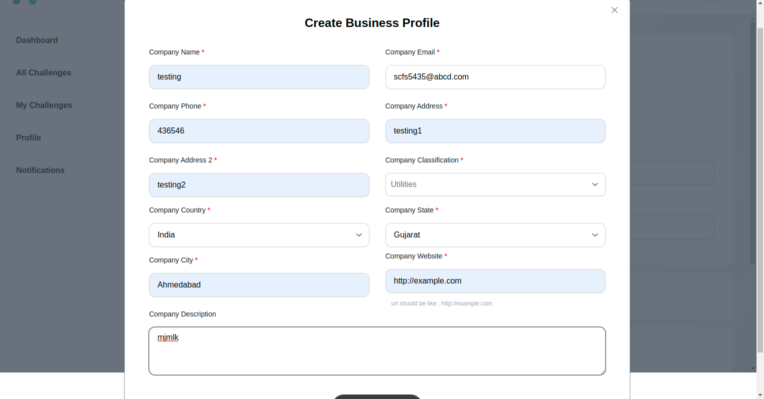
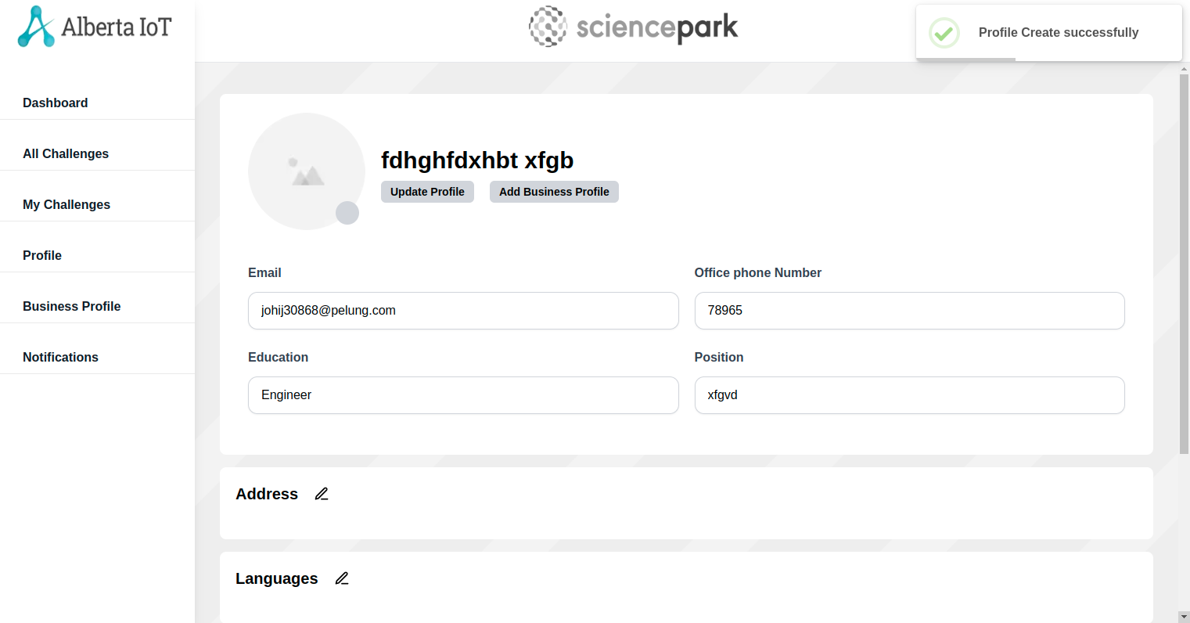

Update Business Profile

Have tested the Update business Profile testboxes, Dropdown and by updating the values.
Expected Result :- The textboxes and Dropdown should be clickable and user should be able to update the values in the textboxes.
Actual Result :- The textboxes and Dropdown are clickable and user is able to update the values in the textboxes.

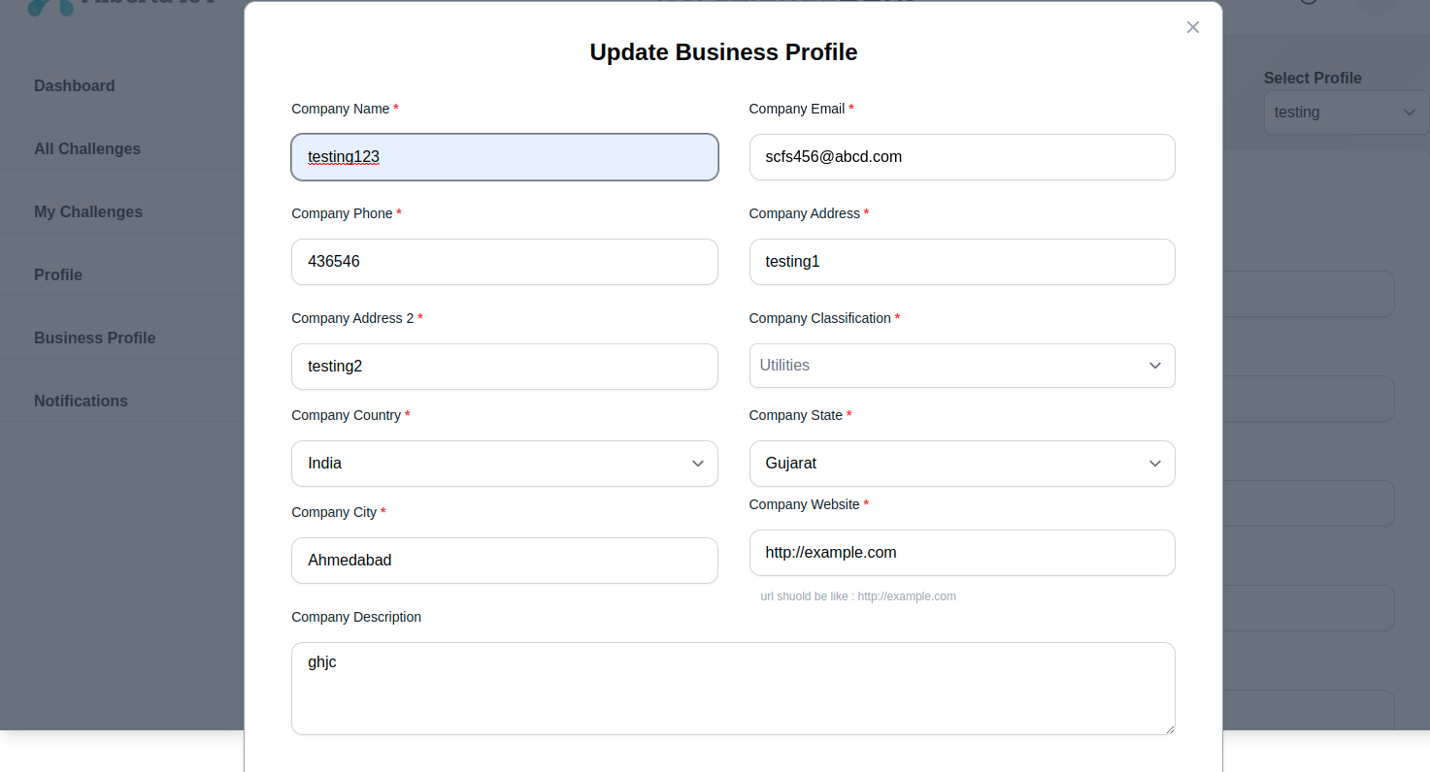
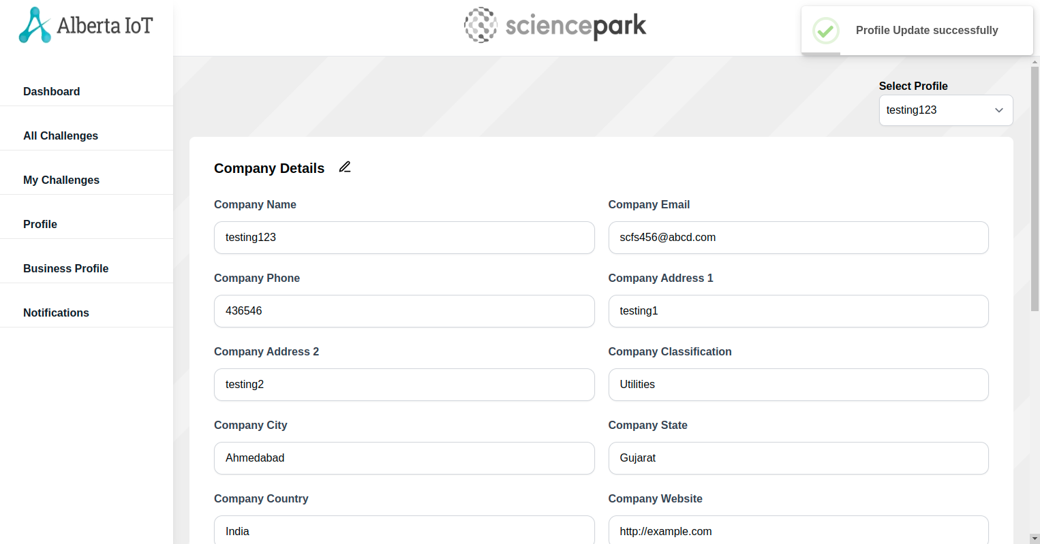

My Challenge Page:
Have tested the Create Challenge page testboxes, Dropdown, Checkboxes by adding the values.
Expected Result :- The textboxes, Dropdown and Checkboxes should be clickable and user should be able to enter the values in the textboxes.
Actual Result :- The textboxes, Dropdown and Checkboxes are clickable and user is able to enter the values in the textboxes.

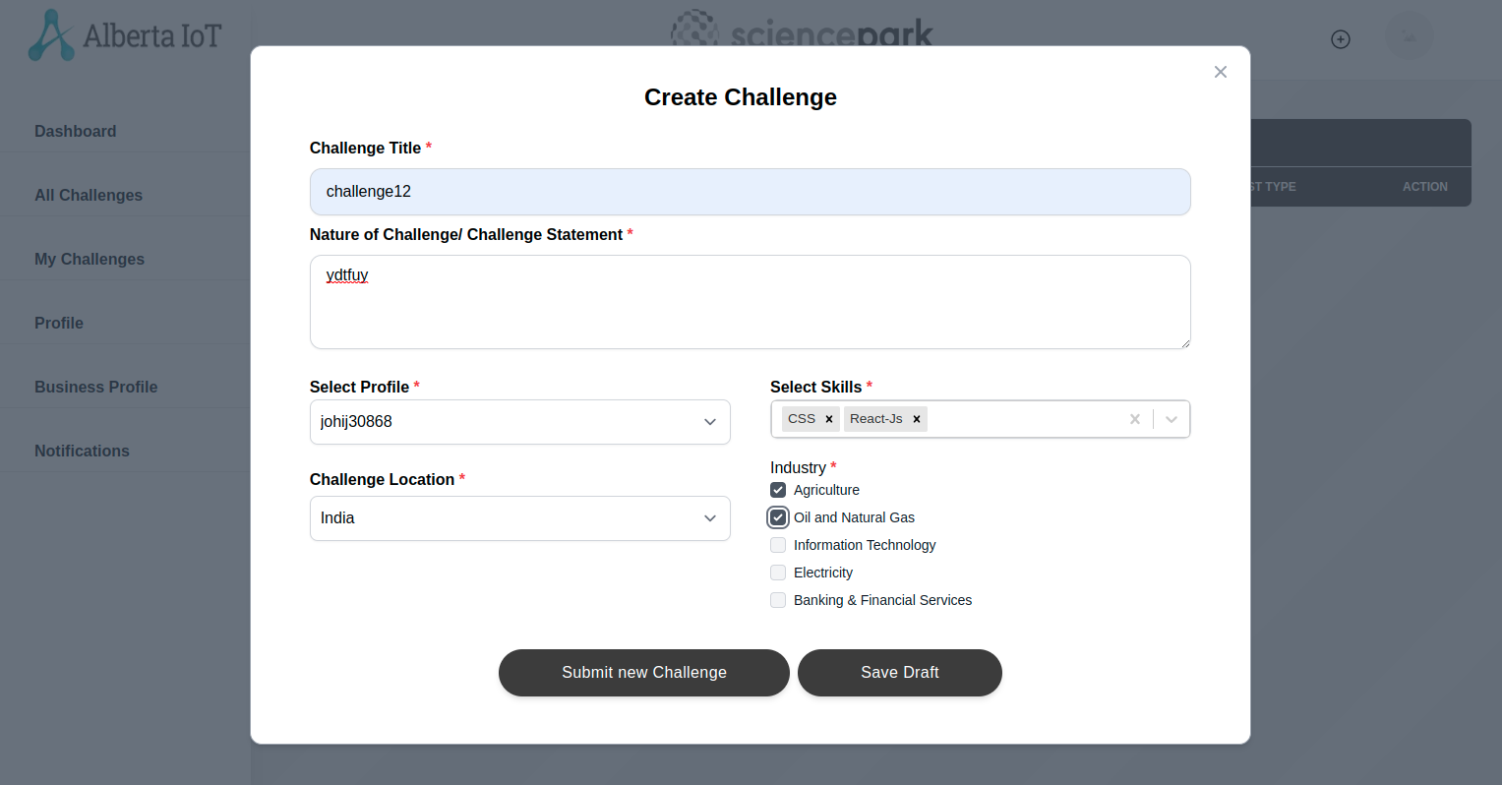

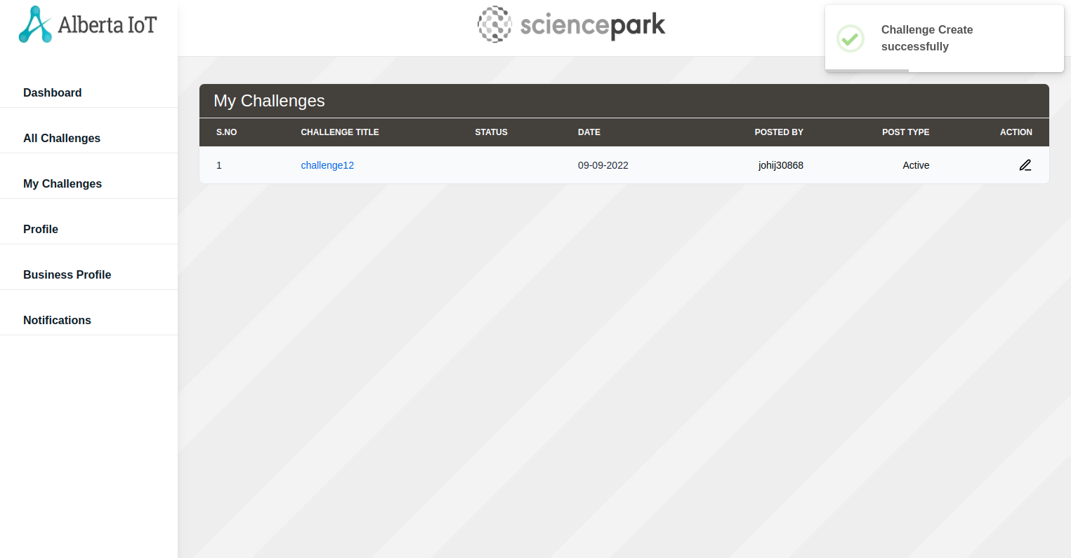
All Challenges Page:

Have tested the All Challenges Page
Expected Result :- All Challenges including My challenges should be there.
Actual Result :- All Challenges including My challenges are there.

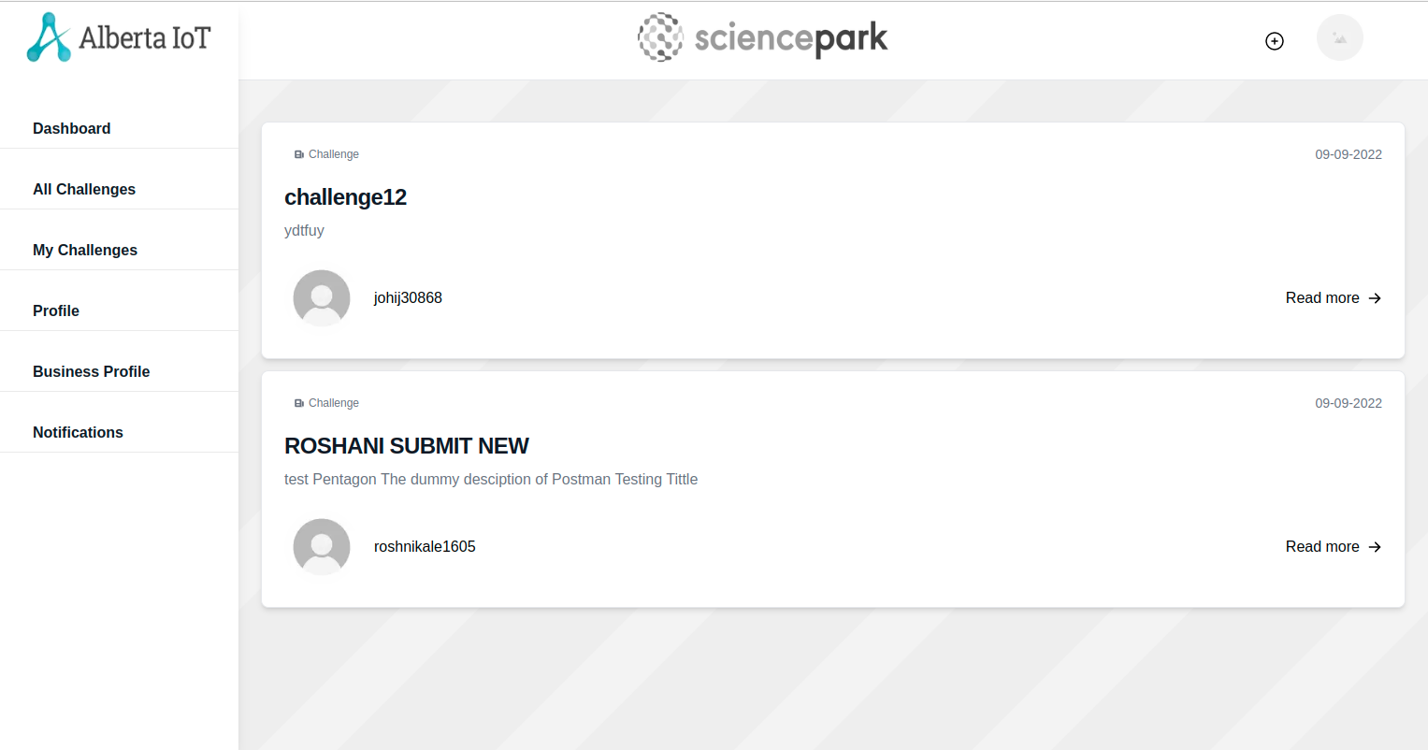

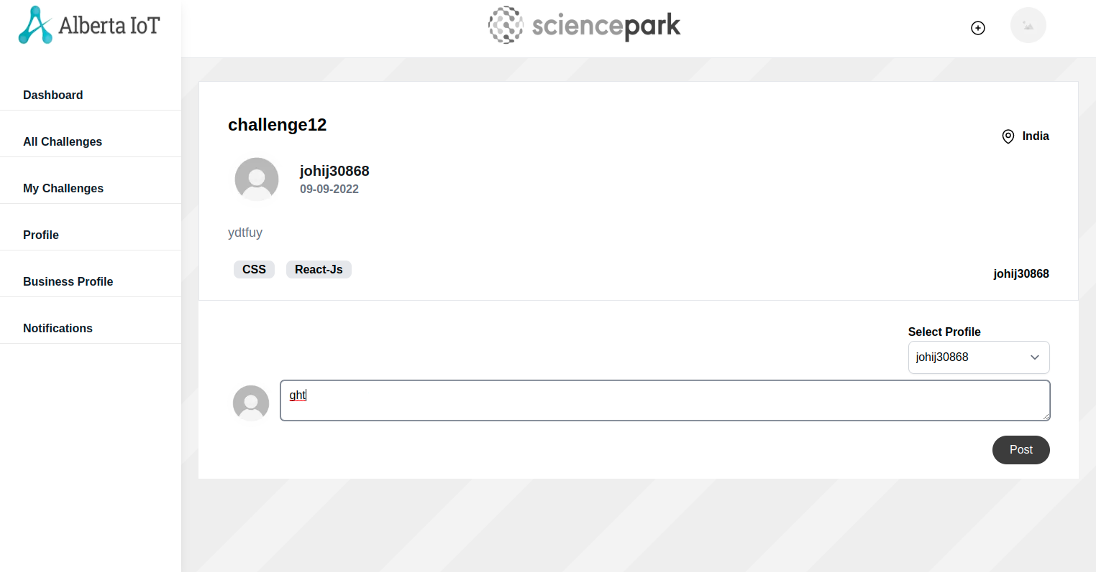

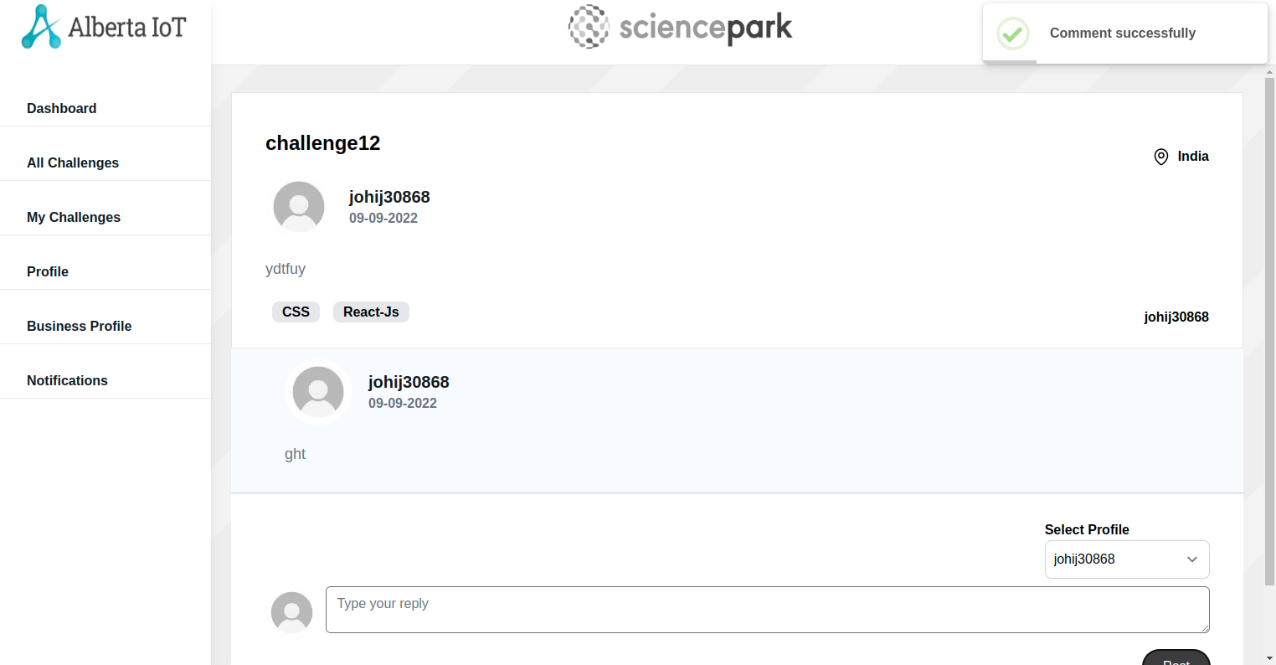

Invite Teams:
Have tested the Create Challenge page testboxes, Checkboxesby adding the values.
Expected Result :- The textboxes, Checkboxes should be clickable and user should be able to enter the values in the textboxes.
Actual Result :- The textboxes, Checkboxes are clickable and user is able to enter the values in the textboxes.

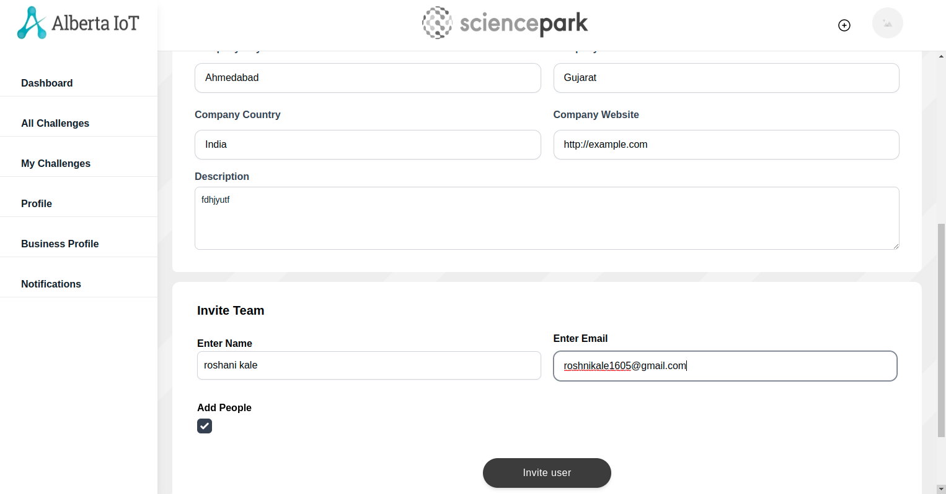

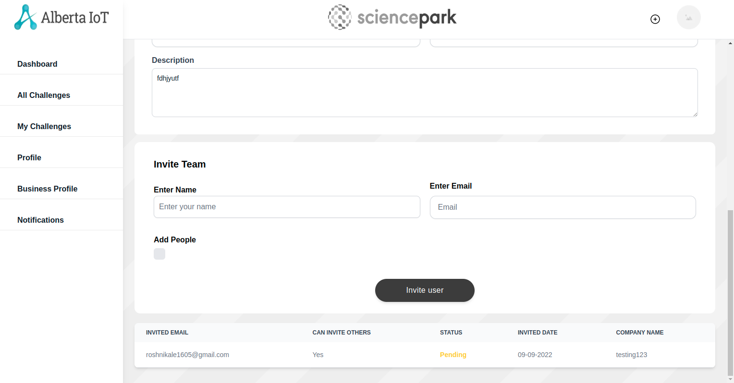

Notifications:

Expected Result :- All notifications should be shown
Actual Result :- All notifications are shown
