- Compatibility Testing:-
In this, we have to test the compatibility that the website is opening in the browser or not. So have tested the compatibility in the 3 of the top browsers named Google Chrome, Mozilla Firefox and Microsoft Edge. Name of the video is Compatibility_Testing.mkv

Google Chrome:
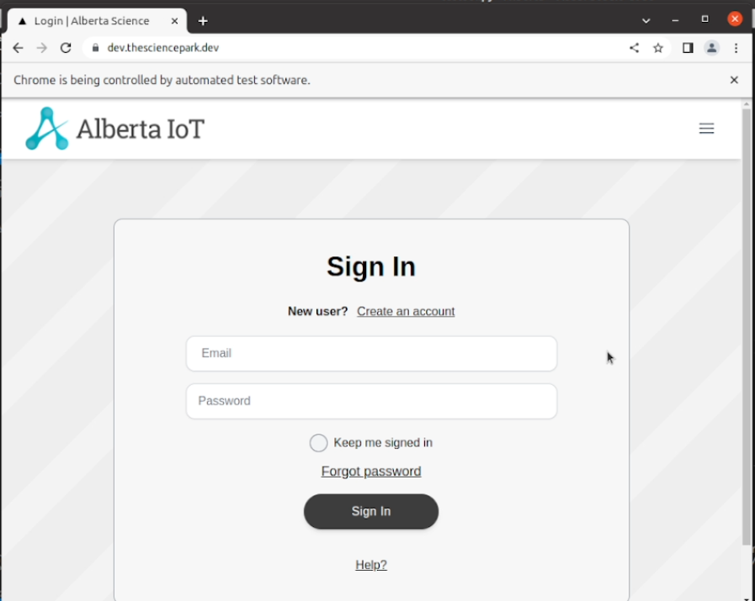

Mozilla Firefox:
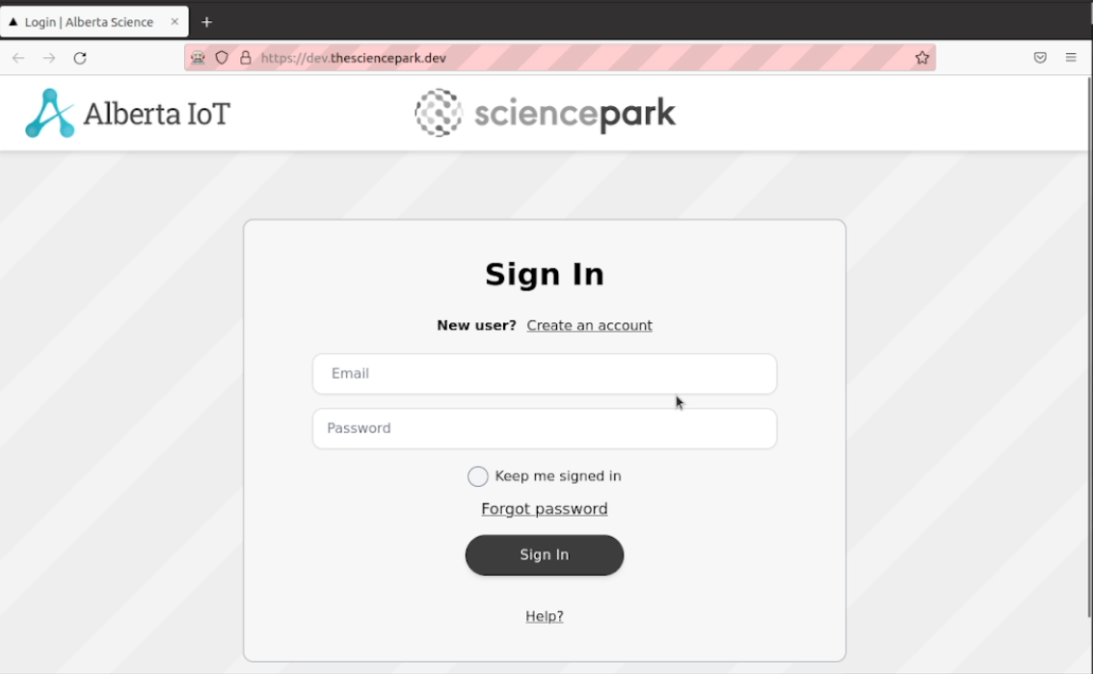

Microsoft Edge:
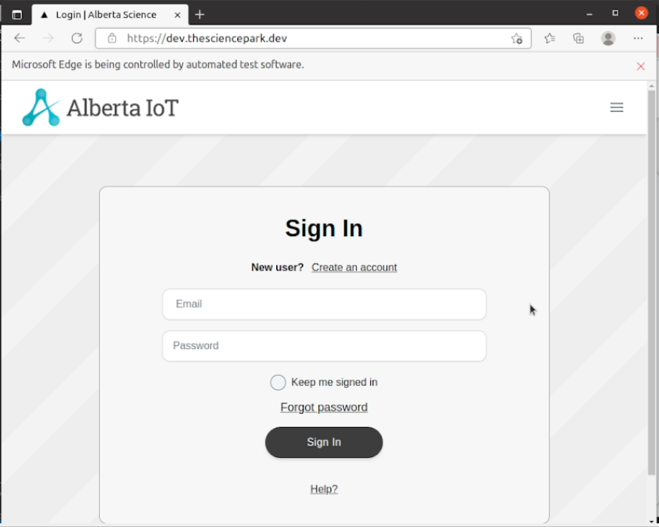

- Penetration Testing:-
In penetration testing, I have scanned the ports in the website from 1 to 50000. In this no any port is open. Name of the video is penetration_testing_port_scanner.mkv

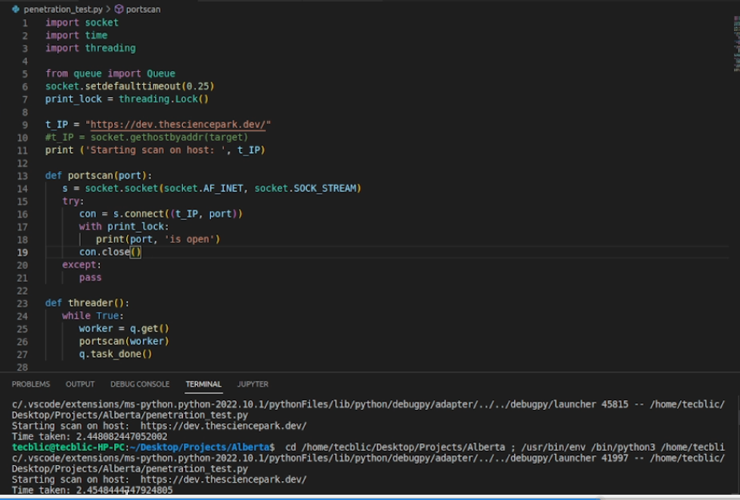

- GUI Testing:-
In this testing, we test the UI of the website. It generally evaluates the textboxes, buttons, links, icons, lists, etc. In this, I have tested Signup Page, Login Page, Create Profile Page, Edit Profile Page, Create Challenge and Business Profile Page. Names of the videos are signup_page.mkv, Login.mkv, Profile_Create.mkv, Edit_Profile.mkv, Business_Profile.mkv, Create_Challenge.mkv.
Signup Page
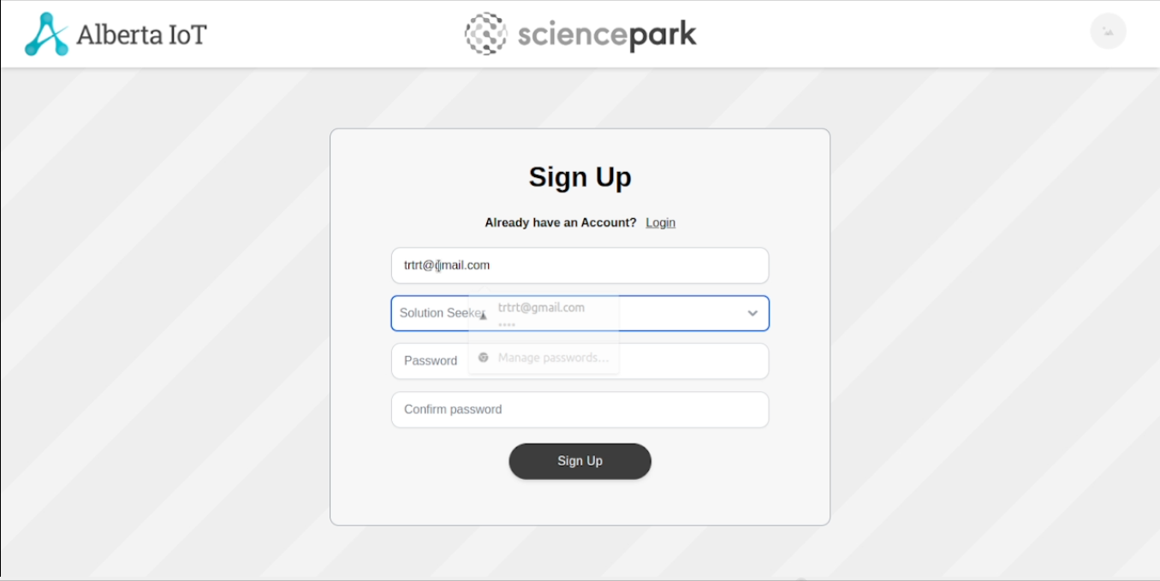
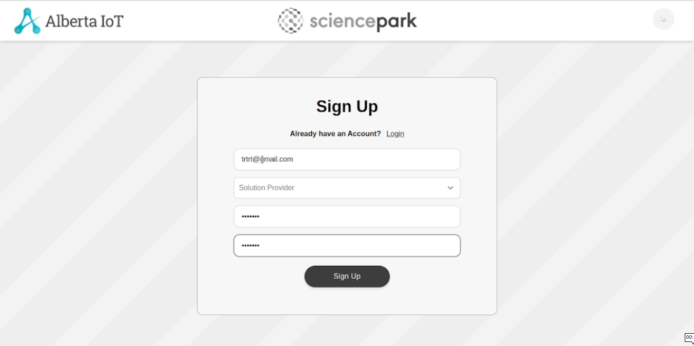
Login Page
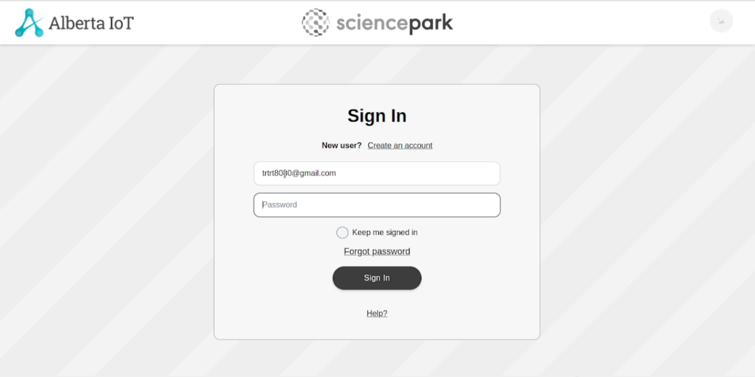
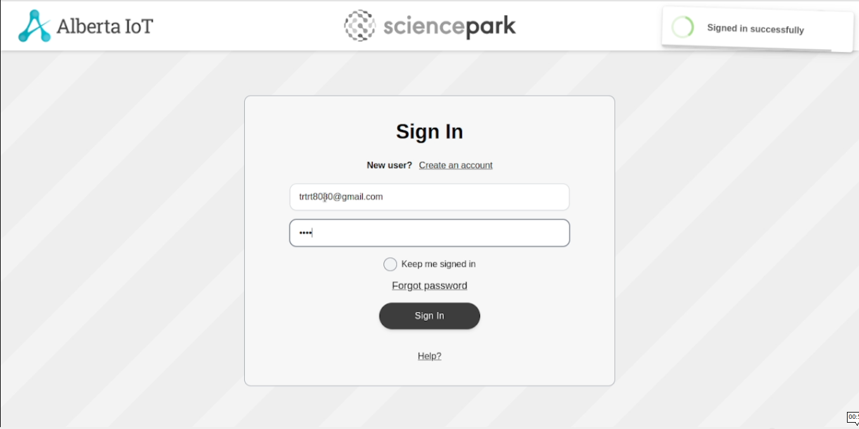
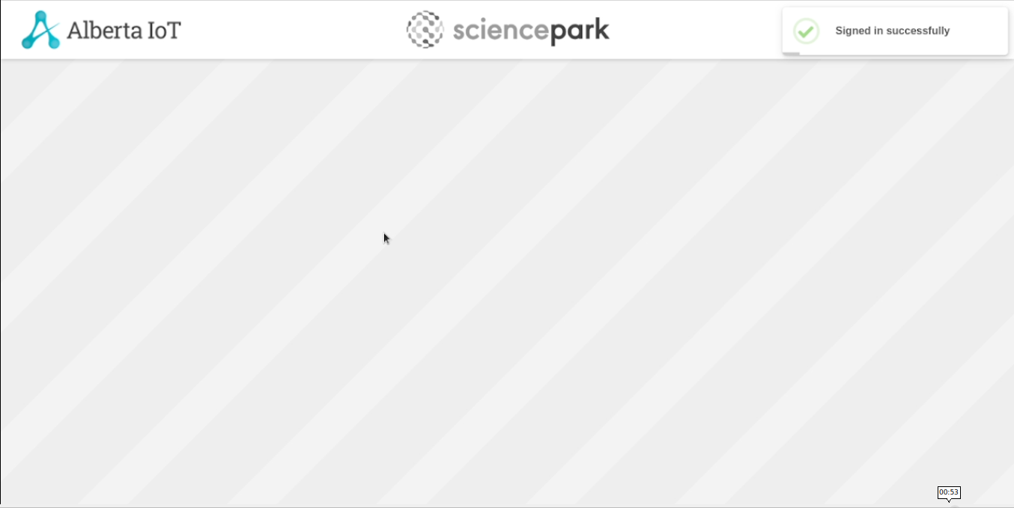
Profile Create Page:
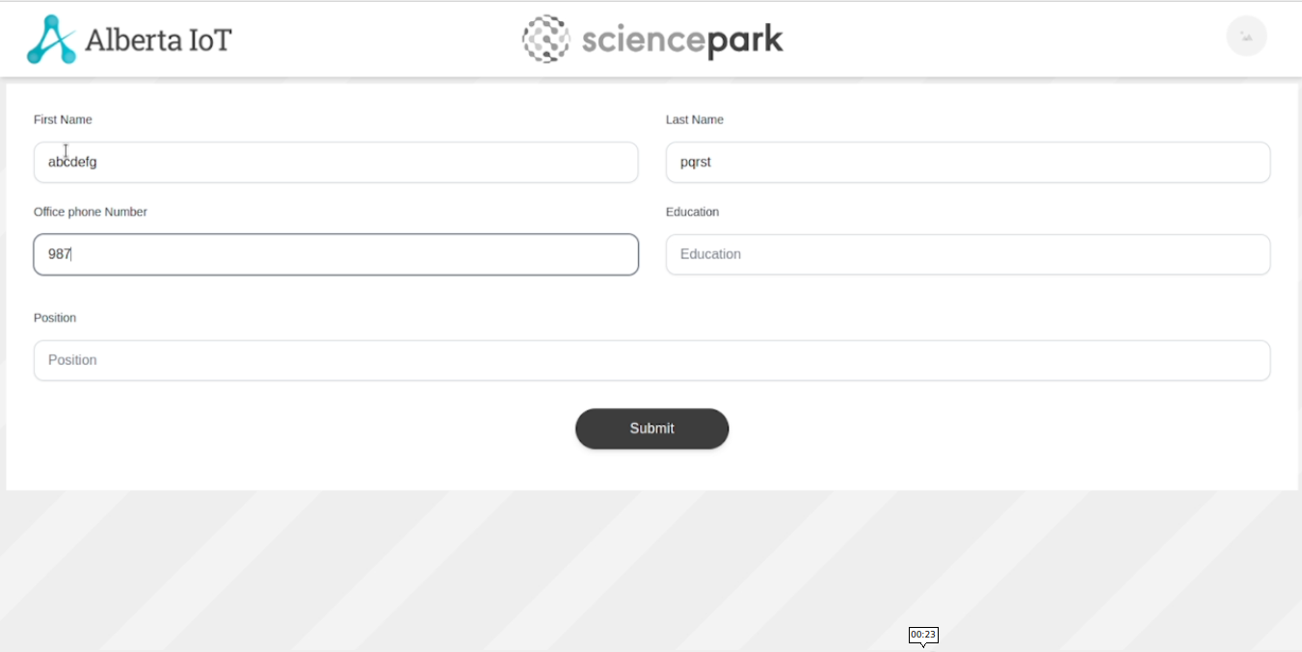
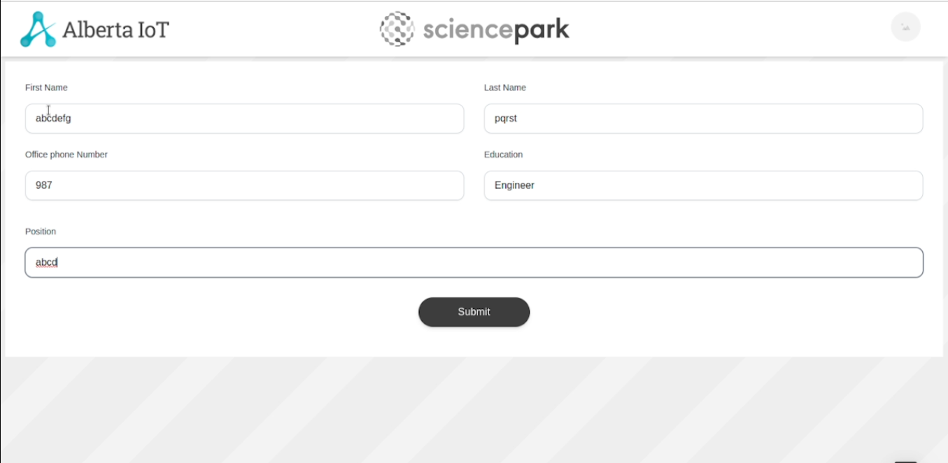
Edit Profile:
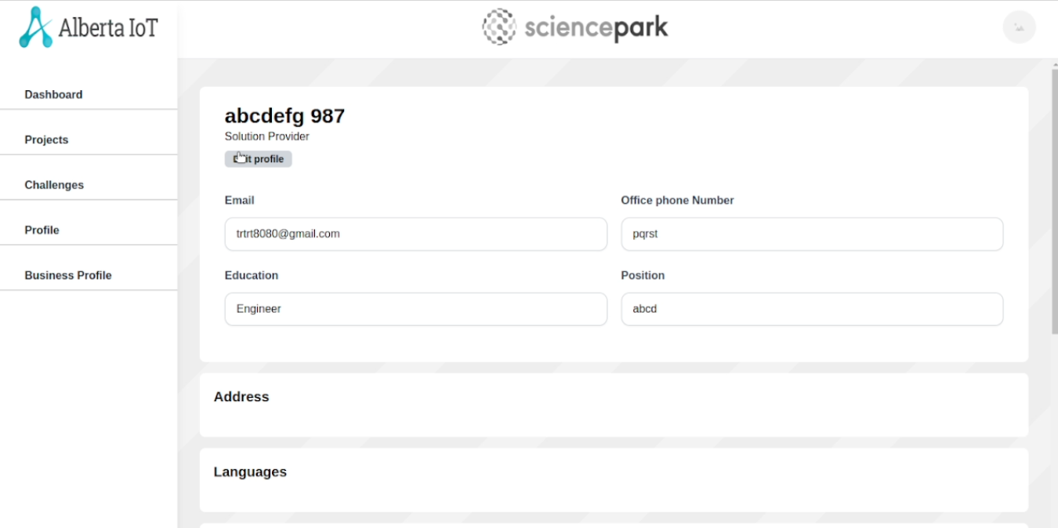

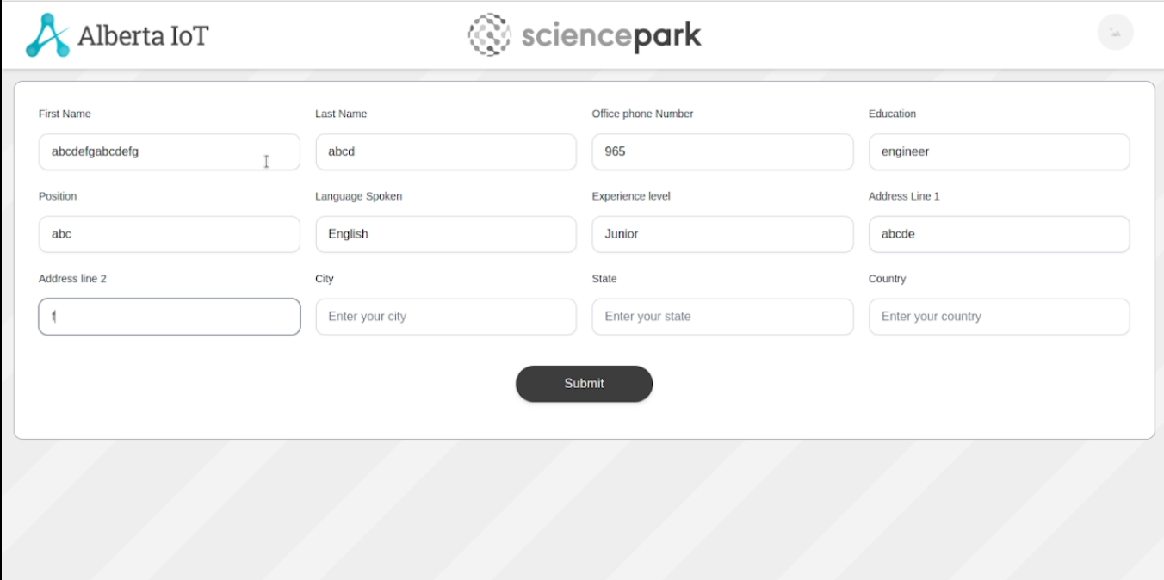

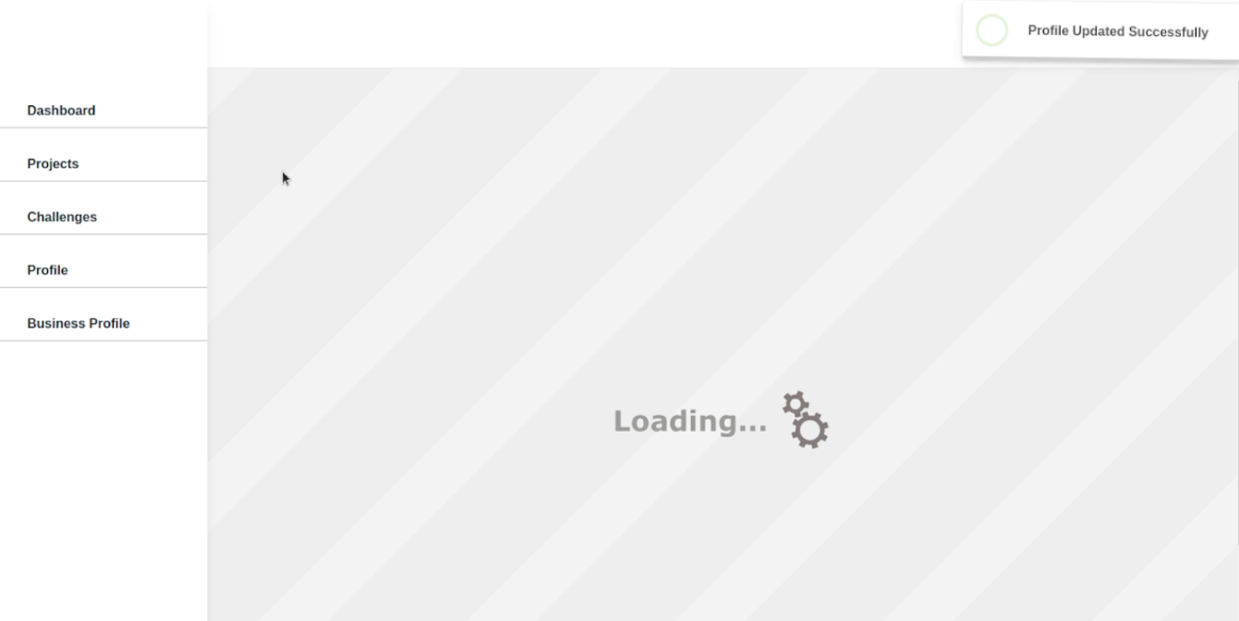

Business Profile Page
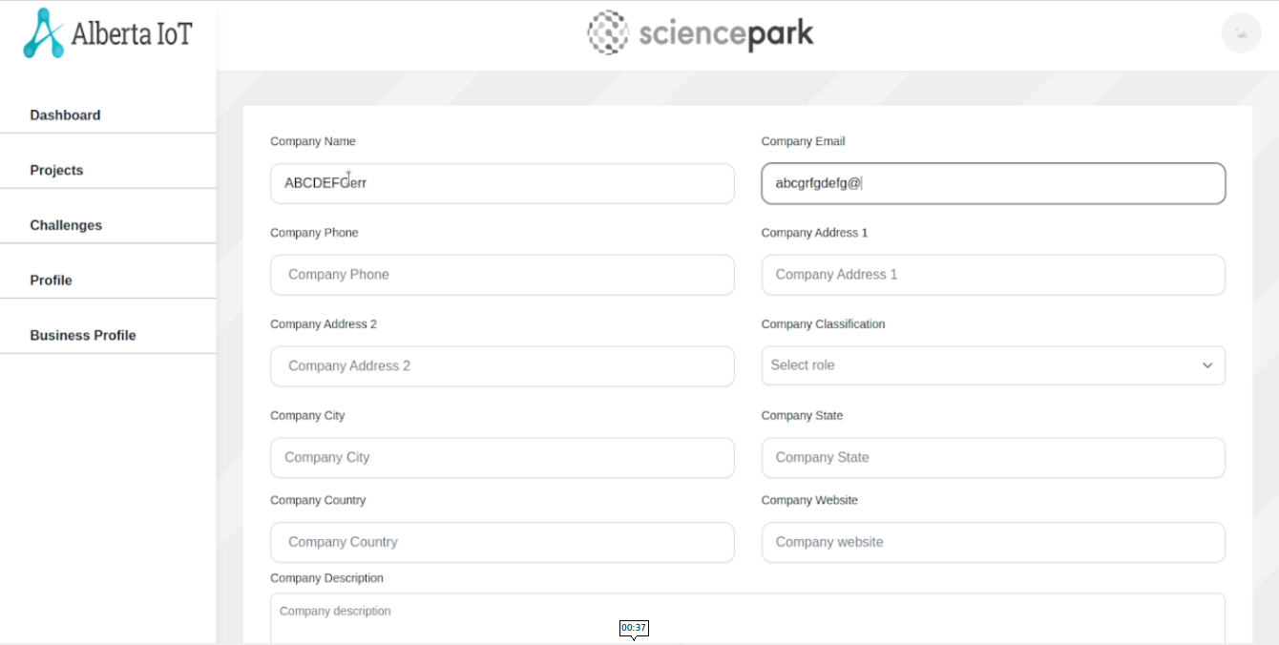
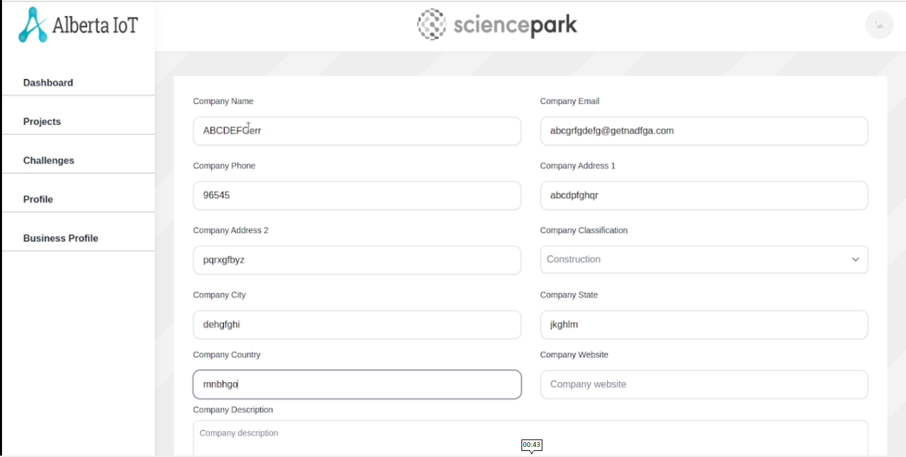
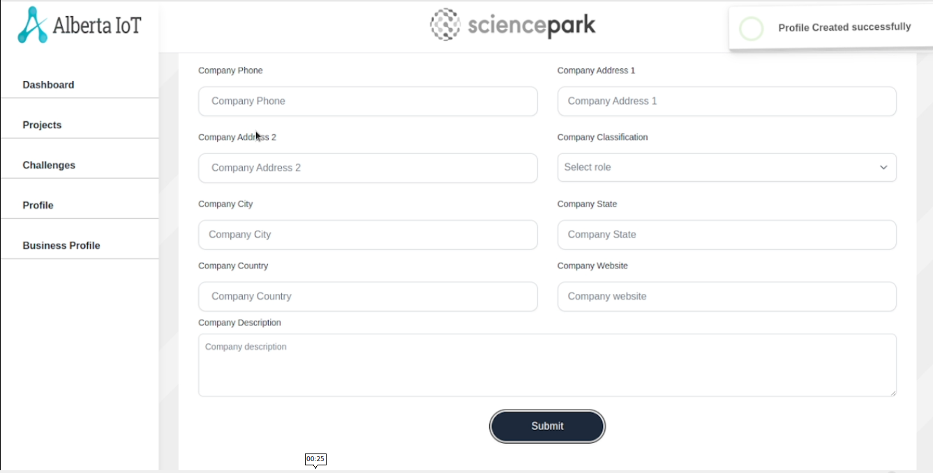
Create Challenge Page:

