Step–1 :- Install the following libraries using pip install.
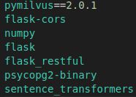

Step-2 :- Download the docker-compose(wget https://raw.githubusercontent.com/milvus-io/milvus/master/deployments/docker/standalone/docker-compose.yml -O docker-compose.yml) and run command sudo docker-compose up -d.
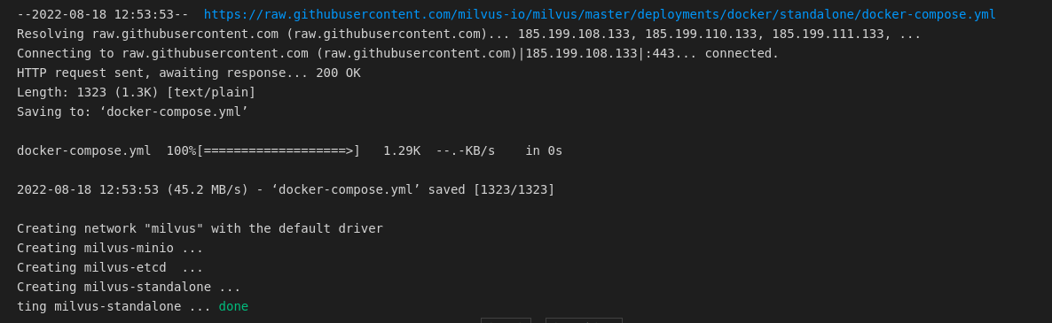
Step-3 :- Start the Postgres Server by command(!docker run --name postgres0 -d -p 5438:5432 -e POSTGRES_HOST_AUTH_METHOD=trust postgres)
Step-4 :- See the docker logs.
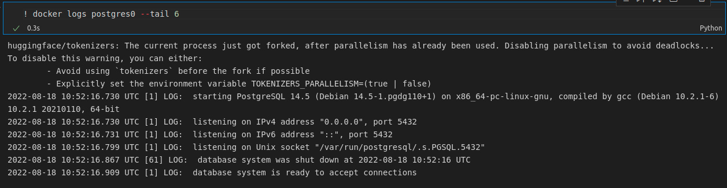

Step-5 :- Connect to Docker and postgres server.
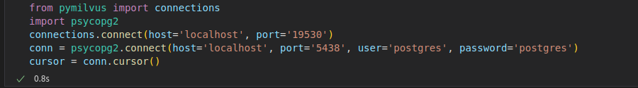
Step-6 :- Create the collection by giving the name of the collection and dimension of the vector.
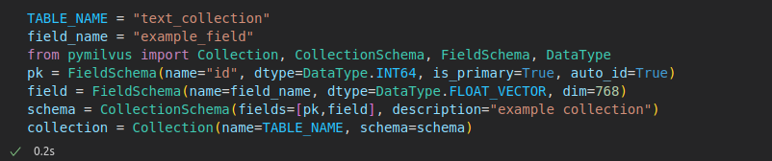
Step-7 :- Set the index. This can be done before or after inserting the data. If done before, indexes will be made as data comes in and fills the data segments.
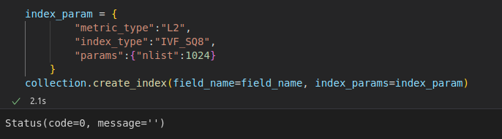
Step-8 :- Create the new table in PostgresSQL.
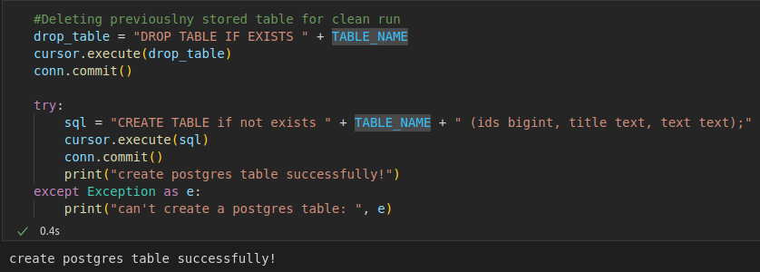

Step-9 :- Generate the embeddings, in this we are using the sentence_transformer library to encode the sentence into vectors. This library uses the modified BERT model to generate the embeddings.
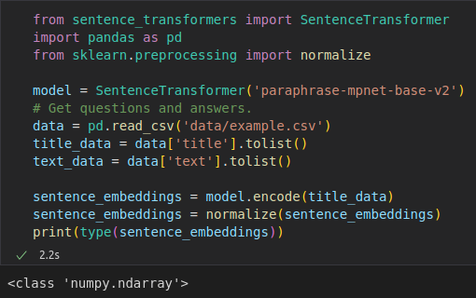
Step-10 :- Insert the vectors into Milvus.
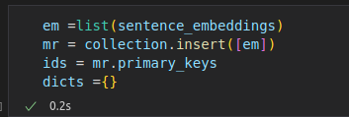

Step-11 :- Insert the data(ID, Title and Text) into PostgreSQL.
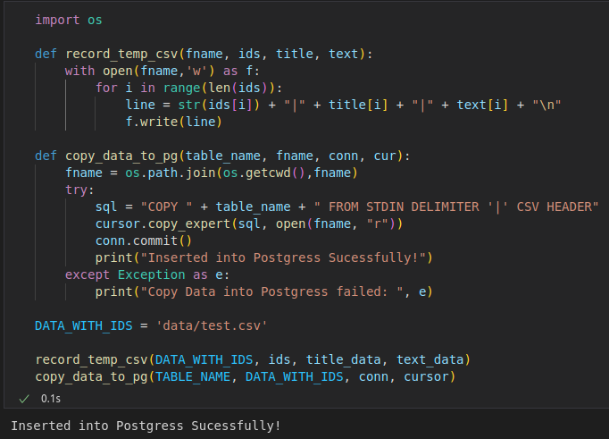
Step-12 :- Now, we will generate the embedding we want to search and then will search for the similiar Embeddings in the Milvus.
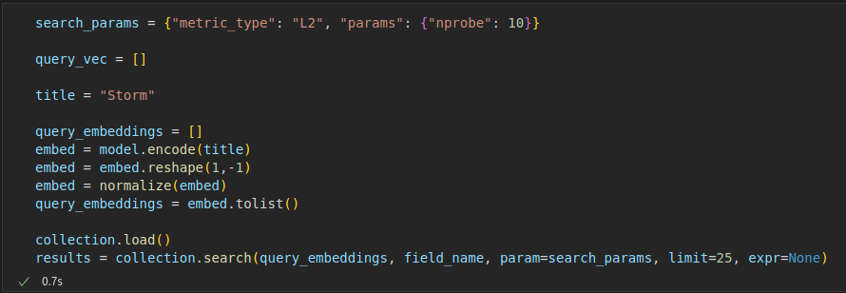

Step-13 :- Now, get the similar Titles. There may not have titles that are similar to the given one, so we have used the threshold value 0.5, when the most similar distance retrieved is less than this value, a hint that the system does not include the relevent information.
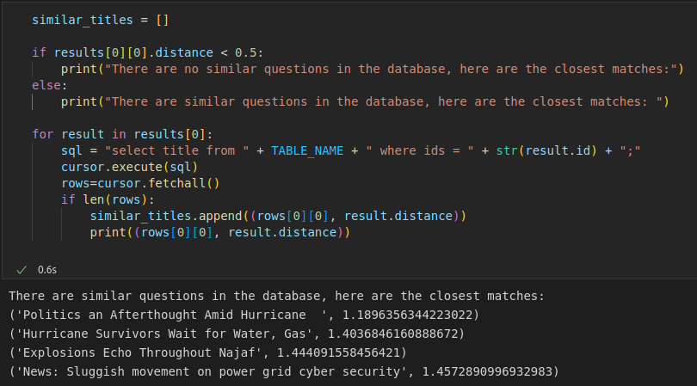
Step-14 :- Get the most closest Title.
