1. How to register an account  
Client Zone source   
You may need to register to fill in company related information first.  
可能需要先註冊填寫公司相關資料

(<https://client.yggdrasilgaming.com/>)

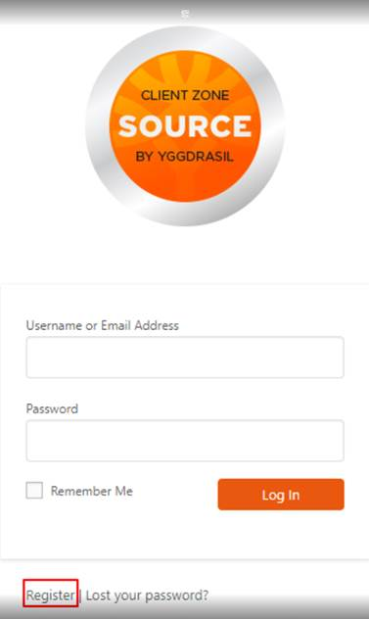

2. Please fill in the relevant information that needs to be registered.  
請填寫需要註冊之相關資訊

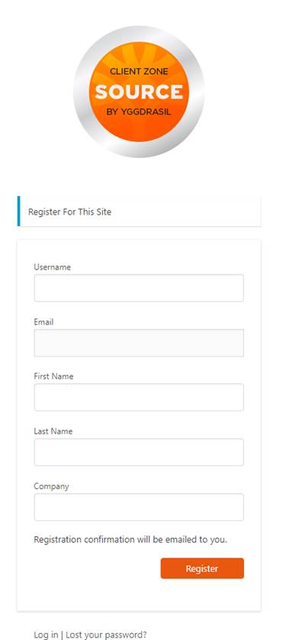

3. Please click on the registration (Regidter)請點選註冊(Regidter)

4. Registration confirmation will be sent to you by email (EML filled in above)

註冊完成後註冊確認將通過電子郵件(上述所填寫的EML)發送給您  
5. Please you provide your registered email DL in Skype chat or conversation group to provide us with the approve to YGG

麻煩您在Skype chat或對話群提供您所註冊的email DL 以提供於我們向YGG申請通過  
6.After applying, you will receive an email showing the application change password.申請通過將會收到郵件顯示申請變更密碼

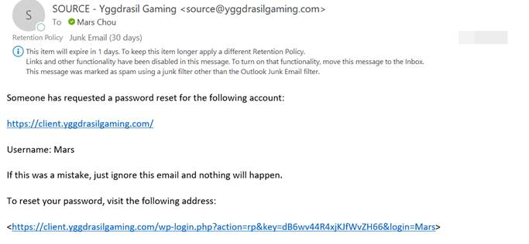

7.Click on the link below and Source will automatically jump to the website page and set a new password.

點選底下的連結，Source會自動跳轉到網站頁面，並且設定新密碼  
8.Complete完成



2.How to change Source PW (更改Source密碼):   
