**Sample chrome extension**

**Table of Contents**

* [Installation](https://github.com/v-adhithyan/AutoLogout#installation)
* [How to use?](https://github.com/v-adhithyan/AutoLogout#how-to-use)

**Installation**

* Download the code or clone it and after unzipping it on your computer.
* Open Chrome browser and go to extensions - chrome://extensions/
* Make sure Developer Mode is checked and then click on Load Unpacked Extension.

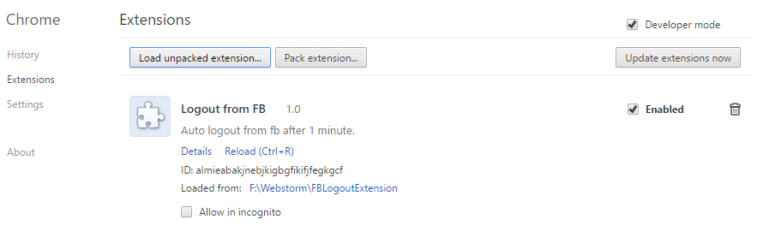

* After clicking on LoadUnpackedExtension will open a browse folder dialog and select the folder where you have downloaded the code. Like below image -

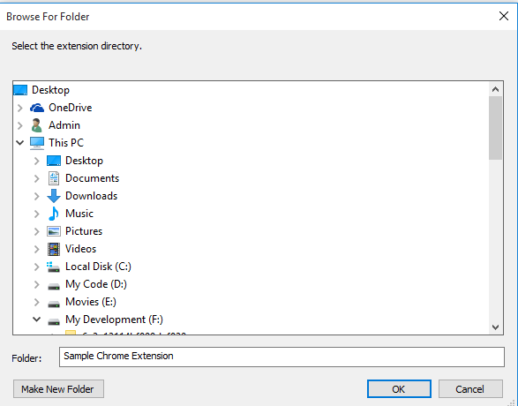

After choosing the folder it will add the extension like below and make sure it is enabled.–

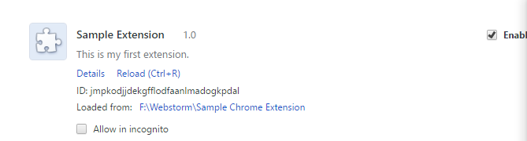

**How to use?**

* After installing, open browser, you will see the extension icon like below.



After clicking on the icon a pop up will be shown like below -

