**Algeria Invest freontend and backend permission management**

**Backend permission management:**

* First of all we have to check whether permission is present in database or not, if not present please add the concerning permission from **Admin Permission** tab and give the permission to corresponding user role fron **Role** tab
* Then after add below code into your controller’s constructor:

$this->middleware('permission:admin-list');

$this->middleware('permission:admin-create', ['only' => ['create','store']]);

$this->middleware('permission:admin-edit', ['only' => ['edit','update']]);

$this->middleware('permission:admin-delete', ['only' => ['destroy']]);

$this->middleware('permission:admin-change-password', ['only' => ['changePassword']]);

**Note:** Here admin-list is one of those permission which is added from**Admin Permission** tab and we group our methods in **only** array, permission is middleware so you’ve to add it as it is.

* Here is some screenshot of backend permission:

**Checking permission in db:**

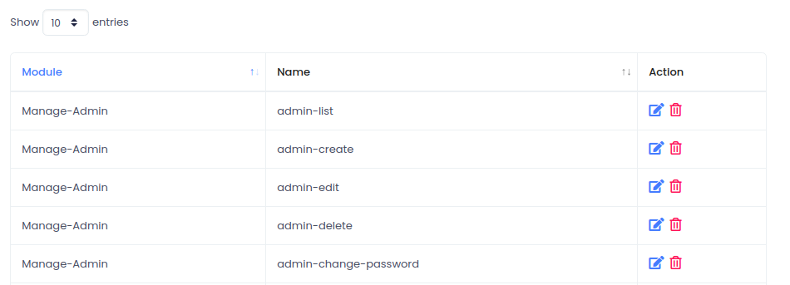

**Adding permission to role:**

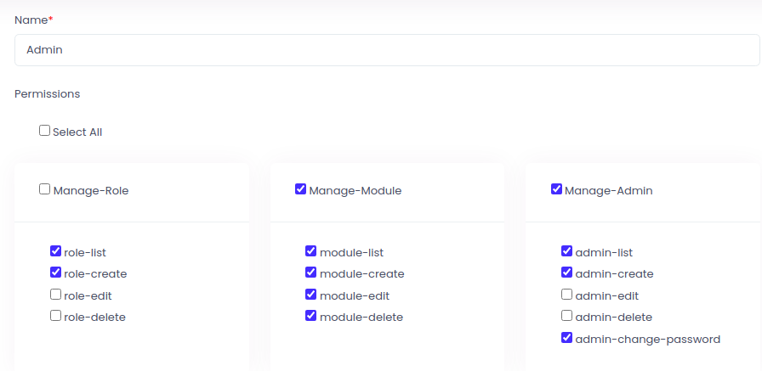

**Adding code into controllers constructor:**

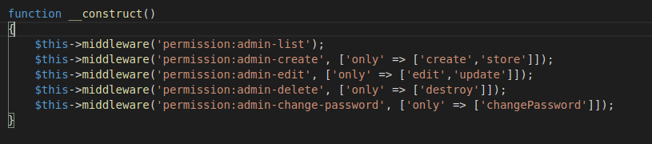

* Now you can use this permission in you blade simply by @can method

**Example:** @can('admin-list') Your code @endcan

**Note:** admin-list is name of permission which you have added from admin panel.

**Use permission in view:**

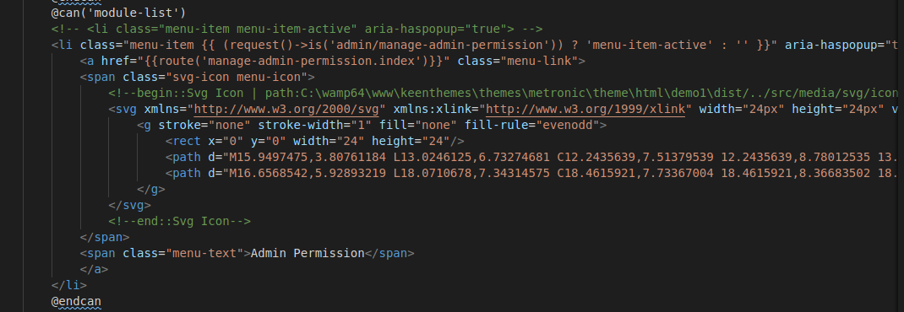

**Frontend Permission management:**

* Check the concerning permission if it is added in the database and corresponding subscription plan from **Subscription** tab if it is not present the add it from **Frontend Permission** tab

**Checking perminnsion in Frontend Permission:**

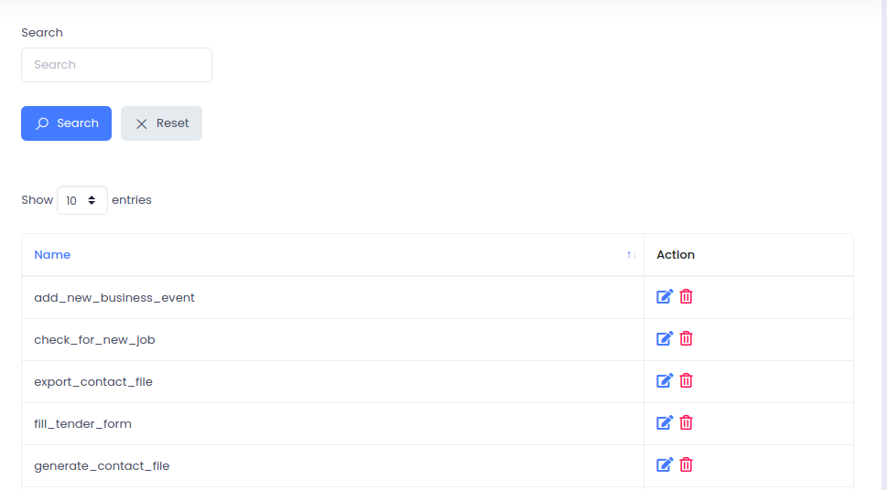

**Checking with subscription plan:**

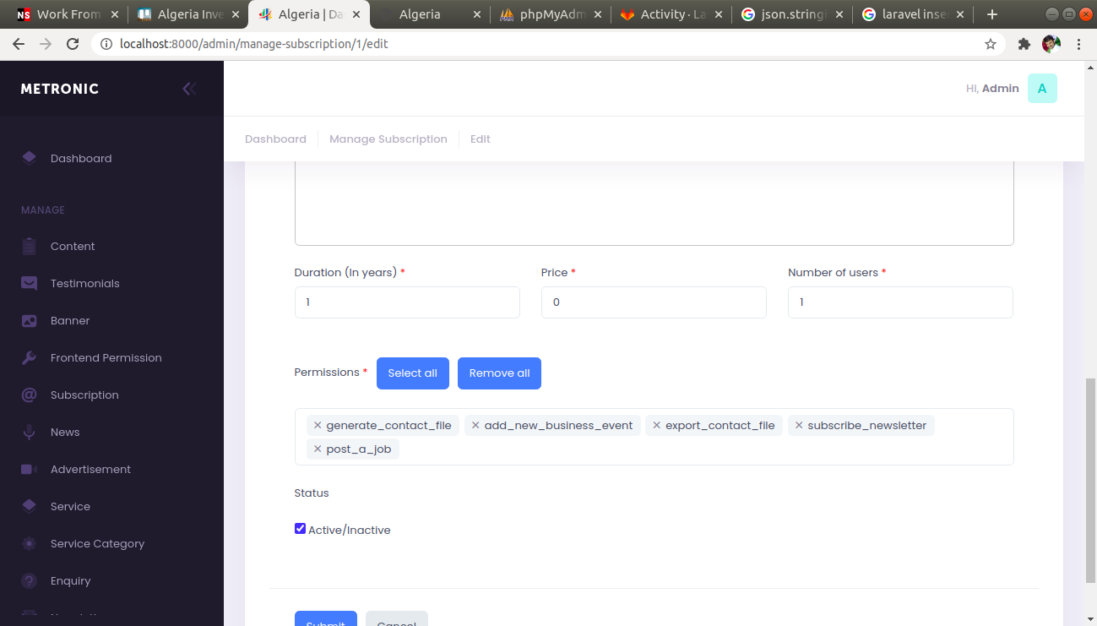

* Now you have to add this code in web.php for concerning route:

Route::get('/subscribe', 'HomeController@subscribe')->middleware('frontend-permission:add_new_business_event');

**Note:** frontend-permission is middleware so you’ve to use it as it is.

add_new_business_event is name of permission which you want to check for that user.

* Use this code in your balde file to generate dynamic content as per permission:

@php

$user = Auth::guard('customer')->user()

@endphp

@if($user->can('has-permission', ['add_new_business_event', $user]))

<li class="mt-2"><a href="{{url('/subscribe')}}">Subscribe</a></li>

@endif

**Note:** has-permission is name of method in Gate so you’ve to us it as it is and another two values of array will be permission to check and authenticated user data