**DHT11-ESP32-UBIDOTS**

To read temperature and humidity data using a DHT11 sensor with an ESP32 board and upload the data to Ubidots, you can follow these step-by-step instructions. This project will require some hardware components, including the ESP32, DHT11 sensor, and a computer to program the ESP32.

**Hardware Components:**

1. ESP32 board.

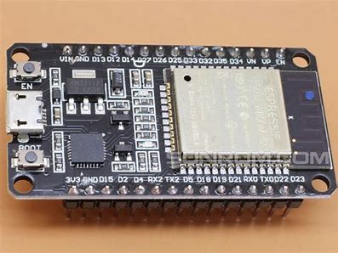

2. DHT11 temperature and humidity sensor.

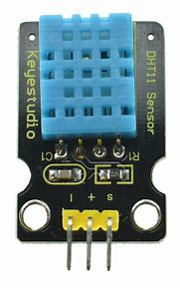

3. Micro-USB cable for programming the ESP32.

4. Breadboard and jumper wires.

**Software Requirements:**

1. Arduino IDE.

2. Arduino libraries:

i. <DHT.h>

ii. <UbidotsESP32Mqtt.h> - <https://github.com/ubidots/esp32/archive/main.zip>

**Step 1: Set up the Arduino IDE**

- Install the Arduino IDE on your computer if you haven't already.

- Open the Arduino IDE and go to "File" > "Preferences."

- In the "Additional Boards Manager URLs" field, add the ESP32 board manager URL: `<https://dl.espressif.com/dl/package_esp32_index.json>`

- Go to "Tools" > "Board" > "Boards Manager" and search for "esp32." Install the "ESP32 by Espressif Systems" package.

**Step 2: Install Required Libraries**

- In the Arduino IDE, go to "Sketch" > "Include Library" > "Manage Libraries."

- Search for and install the following libraries:

- DHT.h

- UbidotsESP32Mqtt.h

**Step 3: Wiring the Components**

- Connect the DHT11 sensor to your ESP32 as follows:

- DHT11 VCC to Vin on ESP32.

- DHT11 GND to GND on ESP32.

- DHT11 Data to GPIO pin (e.g., D26) on ESP32.

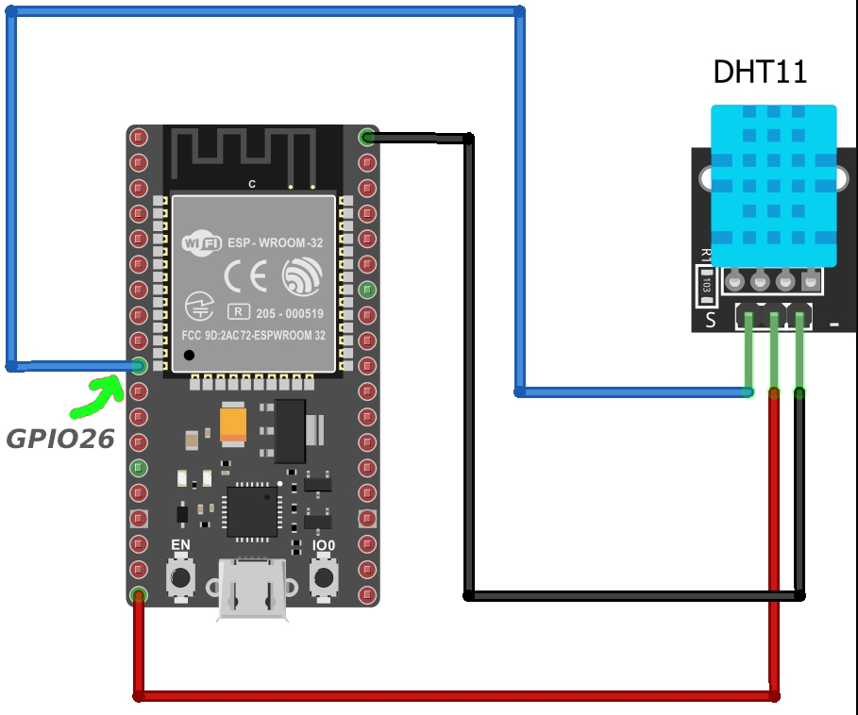

**Step 4: Create a Ubidots Account**

- If you don't have a Ubidots account, sign up for one at Ubidots (<https://ubidots.com/>).

**Step 5: Code for ESP32**

- Open the Arduino IDE and create a new sketch.

- Copy and paste the following code into the sketch. Replace `*******` with your Ubidots API token, WiFi name, Wifi password accordingly.

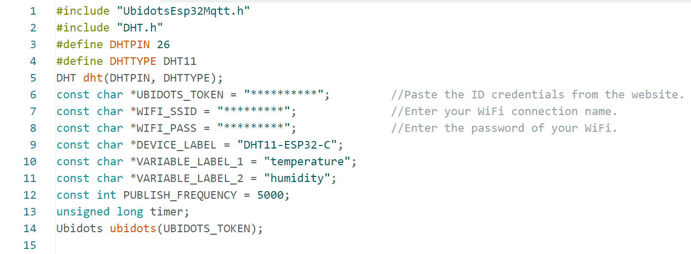

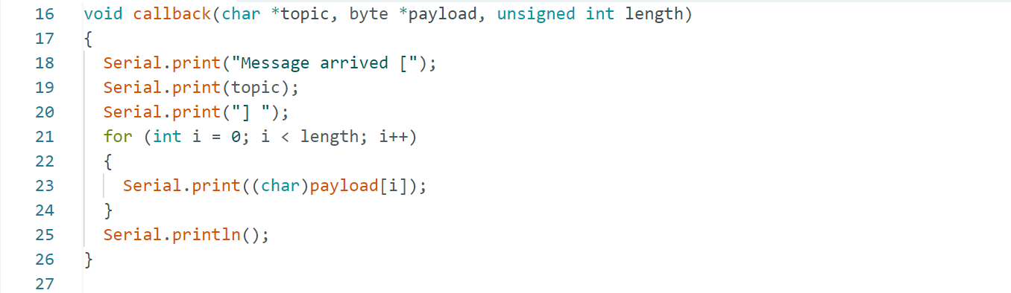

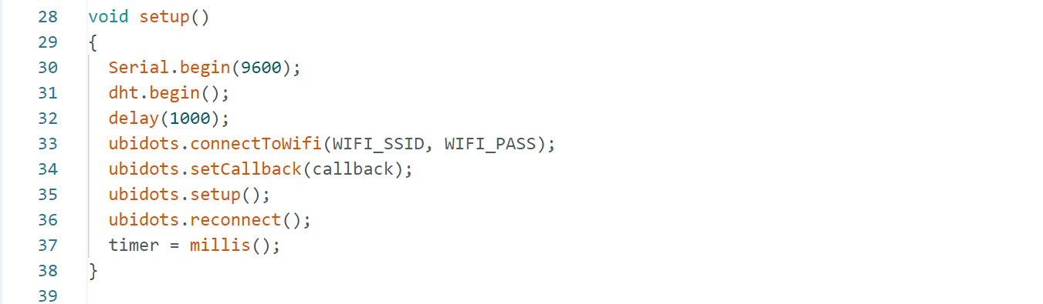

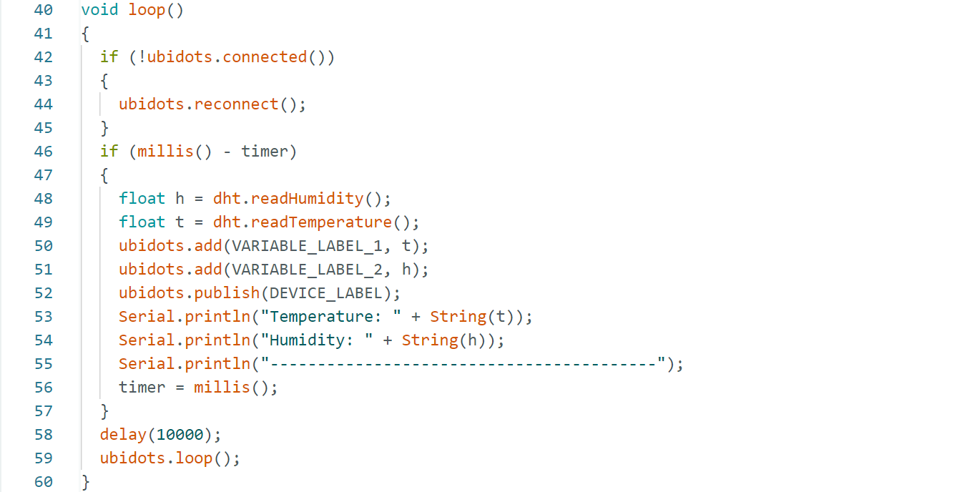

**Step 6: Upload the Code**

- Select your ESP32 board from "Tools" > "Board."

- Select the appropriate COM port from "Tools" > "Port."

- Click the "Upload" button to upload the code to the ESP32.

**Step 7: Monitor Data in Ubidots**

- Once the code is uploaded, open the Serial Monitor to view temperature and humidity readings.

- Visit your Ubidots account to see the data displayed in your Ubidots dashboard.

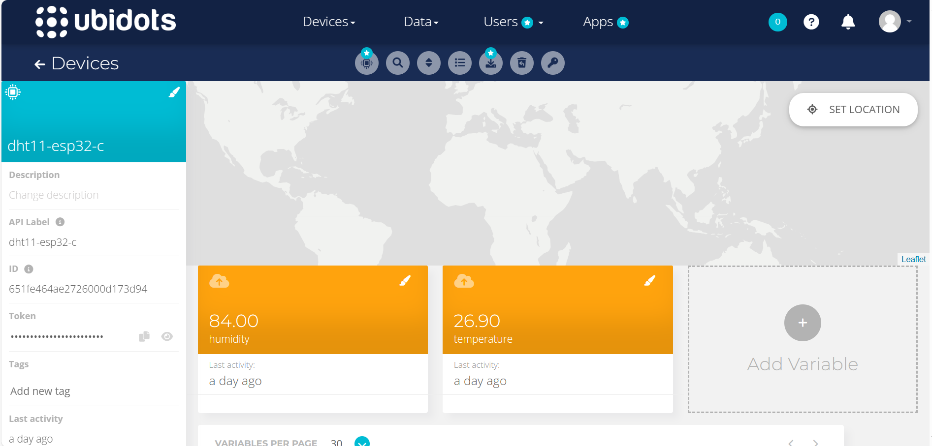

**That's it! You've successfully created a project to read temperature and humidity using a DHT11 sensor with an ESP32 board and upload the data to the Ubidots website.**