**Unit-3**

**Solar energy: what is it and how does it work?**

The sun does more than for our planet than just provide light during the daytime – each particle of sunlight (called a photon) that reaches Earth contains energy that fuels our planet. Solar energy is the ultimate source responsible for all of our weather systems and energy sources on Earth, and enough solar radiation hits the surface of the planet each hour to theoretically fill our global energy needs for nearly an entire year.

**Where does all of this energy come from?** Our sun, like any star in the galaxy, is like a massive nuclear reactor. Deep in the Sun’s core, nuclear fusion reactions produce massive amounts of energy that radiates outward from the Sun’s surface and into space in the form of light and heat.

Solar power can be harnessed and converted to usable energy using photovoltaics or solar thermal collectors. Although solar energy only accounts for a small amount of overall global energy use, the falling cost of installing solar panels means that more and more people in more places can take advantage of solar energy. Solar is a clean, renewable energy resource, and figures to play an important part in the global energy future.

# FUNDAMENTALS OF SOLAR RADIATION AND ITS MEASUREMENT ASPECTS

Solar radiation is a term used to describe visible and near-visible (ultraviolet and near-infrared) radiation emitted from the sun. The different regions are described by their wavelength range within the broad band range of 0.20 to 4.0 µm (microns). Terrestrial radiation is a term used to describe infrared radiation emitted from the atmosphere. The following is a list of the components of solar and terrestrial radiation and their approximate wavelength ranges:

* Ultraviolet: 0.20 – 0.39 µm
* Visible: 0.39 – 0.78 µm
* Near-Infrared: 0.78 – 4.00 µm
* Infrared: 4.00 – 100.00 µm

Approximately 99% of solar, or shortwave, radiation at the earth’s surface is contained in the region from 0.3 to 3.0 µm while most of terrestrial, or longwave, radiation is contained in the region from 3.5 to 50 µm.

Outside the earth’s atmosphere, solar radiation has an intensity of approximately 1370 watts/meter2. This is the value at mean earth-sun distance at the top of the atmosphere and is referred to as the Solar Constant. On the surface of the earth on a clear day, at noon, the direct beam radiation will be approximately 1000 watts/meter2 for many locations. While the availability of energy is affected by location (including latitude and elevation), season, and time of day, the biggest factors affecting the available energy are cloud cover and other meteorological conditions which vary with location and time.

**Basic physics of semiconductors**

A **semiconductor** is a substance **whose resistivity lies between the conductors and insulators**. The property of resistivity is not the only one that decides a material as a semiconductor, but it has few properties as follows.

* Semiconductors have the **resistivity which is less than** insulators and more than conductors.
* Semiconductors have **negative temperature co-efficient**. The resistance in semiconductors, increases with the decrease in temperature and vice versa.
* The Conducting properties of a **Semiconductor changes, when** a suitable metallic impurity is added to it, which is a very important property.

Semiconductor devices are extensively used in the field of electronics. The transistor has replaced the bulky vacuum tubes, from which the size and cost of the devices got decreased and this revolution has kept on increasing its pace leading to the new inventions like integrated electronics. The following illustration shows the classification of semiconductors.

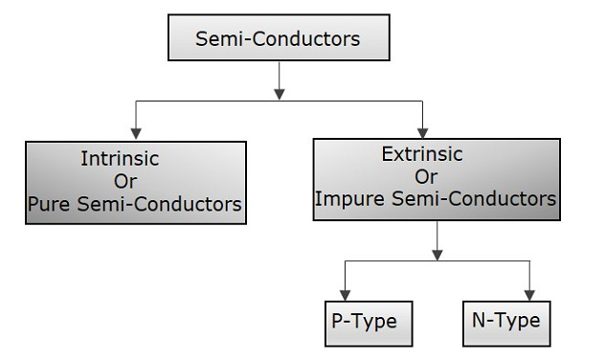

## Conduction in Semiconductors

After having some knowledge on the electrons, we came to know that the outermost shell has the **valence electrons** which are loosely attached to the nucleus. Such an atom, having valence electrons when brought close to the other atom, the valence electrons of both these atoms combine to form “**Electron pairs**”. This bonding is not so very strong and hence it is a **Covalent bond**.

For example, a germanium atom has 32 electrons. 2 electrons in first orbit, 8 in second orbit, 18 in third orbit, while 4 in last orbit. These 4 electrons are valence electrons of germanium atom. These electrons tend to combine with valence electrons of adjoining atoms, to form the electron pairs, as shown in the following figure.

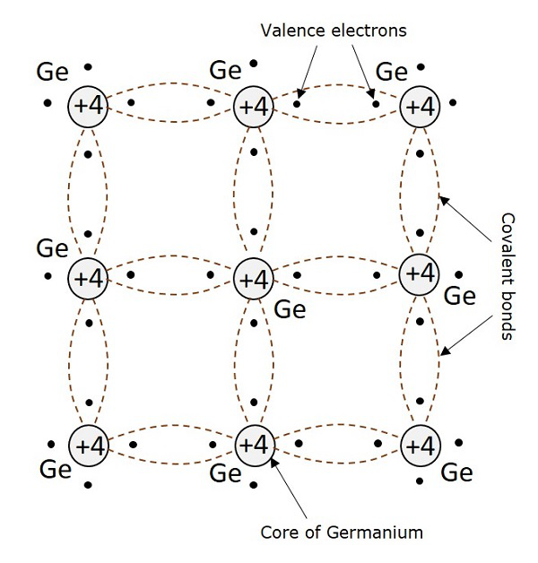

## Creation of Hole

Due to **the thermal energy supplied to the crystal, some electrons tend to move out of their place and break the covalent** bonds. These broken covalent bonds, result in free electrons which wander randomly. But the **moved away electrons** creates an empty space or valence behind, which is called as a **hole**.

This hole which represents a missing electron can be considered as a unit positive charge while the electron is considered as a unit negative charge. The liberated electrons move randomly but when some external electric field is applied, these electrons move in opposite direction to the applied field. But the holes created due to absence of electrons, move in the direction of applied field.

# Carrier Transport in Semiconductors

In thermal equilibrium, the mobile (CB) electrons are in random thermal motion with an average velocity, v = I x 107 cm sec-1 at 300 °K. However, due to the random thermal motion of electrons, no net current flows through the material. On the other hand, in the presence of an electric field E, electrons move opposite to the direction of E. This process is called electron drift and causes a net current flow through the material. Also, if there is a concentration gradient of carriers in the material, the carriers diffuse away from the higher concentration region to the lower concentration region producing a net current flow in the semiconductor. Thus, the carrier transport or current flow in a semiconductor is the result of two different mechanisms:

* 1. Drift of carriers (electrons and holes) caused by the presence of an electric field
* 2. Diffusion of carriers caused by the electron or hole concentration gradient in the semiconductor.

**Drift of Carriers: Carrier Motion in Electric Field**

The drift of carriers in a material depends on the crystal structure, level of impurities, and the strength of electric field that define the mobility of carriers, electrical conductivity of the material, and velocity saturation of carriers.

Carrier mobility: When an electric field is applied to a conducting medium containing free carriers, the carriers are accelerated in proportion to the force of the field. However, the accelerating carriers within a semiconductor will collide with various scattering centers including the atoms of the host lattice (lattice scattering), the impurity atoms (impurity scattering), and other carriers (carrier-carrier scattering). In the case of an electron, these different scattering mechanisms tend to redirect its momentum and, in many cases, tend to dissipate the energy gained from the electric field. Thus, under the influence of a uniform electric field, the process of energy gained from the field and energy loss due to the scattering balance each other and carriers attain a constant average velocity, called the drift velocity (vd). At low electric fields, vd is proportional to the electric field strength E and is given by



where:

p is the constant of proportionality and is called the mobility of the carriers in units of cm2 V"1 sec-1

The mobility is proportional to the time interval between collisions and inversely proportional to the effective mass of the carriers. The total mobility is determined by combining the mobilities for different scattering mechanisms such as mobility due to lattice scattering L, mobility due to ionized impurity scattering p„ and so on.

Electrical conductivity: The drift of charge carriers under an applied electric field E results in a current, called the drift current. If in a homogeneous //-type silicon there are n number of electrons per unit volume and each electron, carrying a charge q, flow with a drift velocity vd, then the electron drift current density is given by



where:

p„ is the electron mobility

We know from Ohm’s law that the resistivity p of a conducting material is defined as £//„; therefore, from Equation 2.45, the resistivity p„ due to electron current flow is given by



Similarly, for a /Муре silicon, the hole drift current density JIKdr,f, and resistivity pp are given by

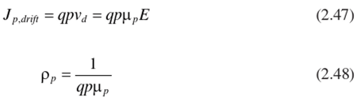

where:

p,, is hole mobility

If the silicon is doped with both donors and acceptors, then the total resistivity can be expressed as



Thus, the resistivity of a semiconductor depends on the electron and hole concentrations and their corresponding mobilities. For a uniformly doped silicon substrate, the plots of the resistivity versus impurity concentration at 300 °K . Since the electron mobility is higher than the hole mobility, the resistivity

## Generation and recombination of carriers

Generation of carriers (free electrons and holes)

The process by which [free electrons](https://www.physics-and-radio-electronics.com/electronic-devices-and-circuits/introduction/free-electrons.html) and [holes](https://www.physics-and-radio-electronics.com/electronic-devices-and-circuits/semiconductor/hole.html)are generated in pair is called generation of carriers.

When electrons in a valence band get enough [energy](https://www.physics-and-radio-electronics.com/physics/energy/what-is-energy.html), then they will absorb this energy and jumps into the conduction band. The electron which is jumped into a conduction band is called free electron and the place from where electron left is called hole. Likewise, two type of charge carriers (free electrons and holes) gets generated.

Recombination of carriers(free electrons and holes)

The process by which free electrons and the holes get eliminated is called recombination of carriers. When free electron in the conduction band falls in to a hole in the valence band, then the free electron and hole gets eliminated.

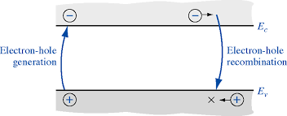

## Hole Current

It is already understood that when **a covalent bond is broken, a hole is created. Actually, there is a strong tendency of semiconductor crystal to form a covalent bond. So, a hole** doesn’t tend to exist in a crystal. This can be better understood by the following figure, showing a semiconductor crystal lattice.

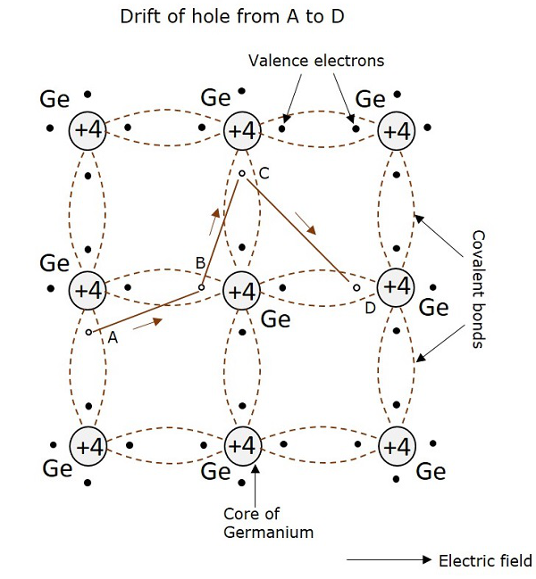

**An electron, when gets shifted from a place A, a hole is formed. Due to the tendency for the formation of covalent bond, an electron from B gets shifted to** A. Now, again to balance the covalent bond at B, an electron gets shifted from C to B. This continues to build a path. This **movement of hole in the absence of an a**pplied field is random. But when **electric field is applied, the hole drifts along the applied field, which constitutes the hole current.** This is called as hole current but not electron current because, the movement of holes contribute the current flow.

Electrons and holes while in random motion, may encounter with each other, to form pairs. This recombination results in the release of heat, which breaks another covalent bond. When the temperature increases, the rate of generation of electrons and holes increase, thus rate of recombination increases, which results in the increase of densities of electrons and holes. As a result, conductivity of semiconductor increases and resistivity decreases, which means the negative temperature coefficient.

## Intrinsic Semiconductors

A Semiconductor in its extremely **pure** form is said to be an **intrinsic semiconductor**. The properties of this pure semiconductor are as follows −

* The electrons and holes are solely created by thermal excitation.
* The number **of free electrons is equal to the number of holes**.
* The conduction capability is small at room temperature.

In order to increase the conduction capability of intrinsic semiconductor, it is better to add some impurities. This process of adding impurities is called as **Doping**. Now, this doped intrinsic semiconductor is called as an **Extrinsic Semiconductor**.

### Doping

The process of adding impurities to the semiconductor materials is termed as doping. The impurities added, are generally pentavalent and trivalent impurities.

**Pentavalent Impurities**

* The **pentavalent** impurities are the ones which has five valence electrons in **the outer** most orbit. Example: Bismuth, Antimony, Arsenic, Phosphorus
* The pentavalent atom is called as a **donor atom** because it **donates one electron** to the conduction band of pure semiconductor atom.

**Trivalent Impurities**

* The **trivalent** impurities are the ones which **has three valence electrons** in the outer most orbit. Example: Gallium, Indium, Aluminum, Boron
* The trivalent atom is called as an **acceptor atom** because it accepts one electron from the semicon**duct**or atom.

## Extrinsic Semiconductor

An impure semiconductor, which is formed by doping a pure semiconductor is called as an **extrinsic semiconductor**. There are two types of extrinsic semiconductors depending upon the type of impurity added. They are N-type extrinsic semiconductor and P-Type extrinsic semiconductor.

### N-Type Extrinsic Semiconductor

A small amount of pentavalent impurity is added to a pure semiconductor to result in Ntype extrinsic semiconductor. The added impurity has 5 valence electrons.

For example, if Arsenic atom is added to the germanium atom, four of the valence electrons get attached with the Ge atoms while one electron remains as a free electron.

### P-Type Extrinsic Semiconductor

A small amount of trivalent impurity is added to a pure semiconductor to result in P-type extrinsic semiconductor. The added impurity has 3 valence electrons. For example, if Boron atom is added to the germanium atom, three of the valence electrons get attached with the Ge atoms, to form three covalent bonds. But, one more electron in germanium remains without forming any bond. As there is no electron in boron remaining to form a covalent bond, the space is treated as a hole.

**SEMICONDUCTOR JUNCTIONS: METAL-SEMICONDUCTOR JUNCTION & P-N JUNCTION**

The metal-semiconductor (MS) contact is an important component in the performance of most semiconductor devices in the solid state. As the name implies, the MS junction is that a metal and a semiconductor material are contacted closely. Basically, there are two types of MS contacts that are widely used in semiconductor devices:

1. Rectifying Schottky Diodes
2. Non-rectifying Ohmic contact

Introduction

The principle of forming different types of the metal-semiconductor contact is the mismatch of the [Fermi energy](https://eng.libretexts.org/Bookshelves/Materials_Science/Supplemental_Modules_(Materials_Science)/Electronic_Properties/Fermi_Energy_and_Fermi_Surface) between metal and semiconductor material, which is due to the difference in work functions. Figure 1 shows the energy band diagram after the contact is made. As shown in Figure 1, the vacuum level E0, the minimum energy needed to release an electron from the material, is used to align the metal and the semiconductor together. The work function Φ is defined as the energy difference between the [Fermi energy](https://eng.libretexts.org/Bookshelves/Materials_Science/Supplemental_Modules_(Materials_Science)/Electronic_Properties/Fermi_Energy_and_Fermi_Surface) and the vacuum level. The electron affinity, χ is defined as the required energy for moving an electron from the vacuum level to the conduction band: χ=(E0−Ec)FB|surface

When a metal and a semiconductor material are brought together, an instant ideal MS contact is formed. If there is no electron movement during the contacting process, the band diagram for the contact will be as Figure 1, where there is a mismatch for the [Fermi energy](https://eng.libretexts.org/Bookshelves/Materials_Science/Supplemental_Modules_(Materials_Science)/Electronic_Properties/Fermi_Energy_and_Fermi_Surface) (EFM) in the metal and the [Fermi energy](https://eng.libretexts.org/Bookshelves/Materials_Science/Supplemental_Modules_(Materials_Science)/Electronic_Properties/Fermi_Energy_and_Fermi_Surface) in the semiconductor (EF). For the ideal MS contact, several assumptions are made:

1. The metal and the semiconductor are contacted intimately, which means that there is no oxide or charge layers between the contact on the atomic scale.
2. No intermixing and inter diffusion between the metal and the semiconductor.
3. There are no impurities at the MS interface.

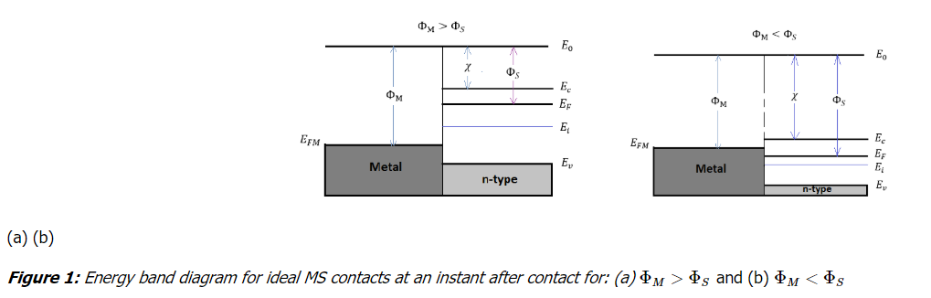

# Solar Radiation Measurement Methods using Pyrheliometer and Pyranometer

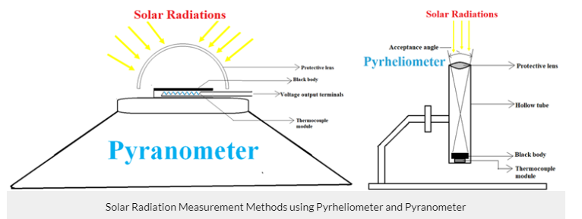

This energy is delivered by the sun in the form of Electromagnetic radiation which is usually called**solar radiation**. Some of the radiation is beneficial to humans while another radiation is harmful to all life.

To reach solar radiation to the earth's surface it must pass through the atmosphere where it gets absorbed, scattered, reflected, and transmitted which results in the reduction of the energy flux density. This reduction is very significant as more than 30% loss occurs on a sunny day and on a cloudy day it goes a high as 90%. So the maximum radiation which reaches the earth's surface through the atmosphere will never be higher than 80%.

Solar flux is very important to measure, as it is the basis of life on earth and is used in building many products whether its related to electronics, crops, medicines, cosmetics, etc. In this tutorial, we will learn about **solar radiation and its measurement**and will also learn about the two most **popular solar energy measuring instruments- Pyrheliometer and Pyranometer.**

**Beam Radiation and Diffuse Radiation**

The radiation which we perceive on the surface is both direct radiation and indirect radiation of the sun. The radiation that comes directly from the sun is direct radiation and it is called **beam radiation**. The scattered and reflected radiation that is sent to the earth's surface from all directions (reflected from molecules, particles, animal bodies, etc.) is indirect radiation and it is called **diffuse radiation**. And the sum of both, the beam and diffuse radiation, is defined as **global radiation or total radiation**.

It is important to differentiate between the beam radiation and diffuse radiation because the beam radiation can be concentrated while the diffuse radiation cannot. There are many **solar radiation measuring instruments** that are used to measure beam radiation and diffuse radiation.

**Solar radiation measuring instruments** are of two types:

1. Pyrheliometer
2. Pyranometer

### ****Pyrheliometer Working and Construction****

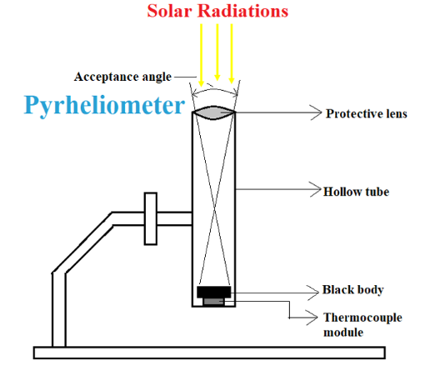

Here the lens is pointed towards the sun and the radiation will pass through the lens, tube and at the end falls on to the black object present at the bottom.  Now if we redraw the entire internal structure and circuit in a simpler manner it will look something like below.

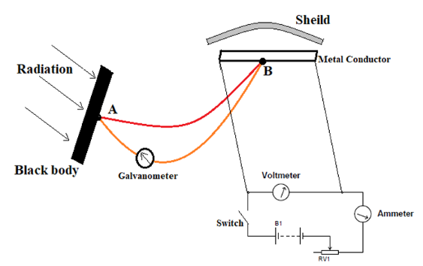

In the circuit, it can be seen that the black body absorbs the radiation falling from the lens and as discussed earlier a perfect black body completely absorbs any radiation falls on it, so the radiation falling into the tube gets absorbed by the black object entirely. Once the radiation gets absorbed the atoms in the body get excited because of the increasing temperature of the entire body. This temperature increase will also be experienced by the thermocouple junction ‘A’.  Now with **junction ‘A’ of the thermocouple at high temperature and junction ‘B’ at low temperature, a current flow takes place in its loop** as discussed in the working principle of the thermocouple. This current in the loop will also flow through the galvanometer which is in series and thereby causing a deviation in it. This **deviation is proportional to current, which in turn is proportional to temperature difference at junctions.**

### ****Pyranometer Working and Construction****

Pyranometer is a device that can be **used to measure both beam radiation and diffuse radiation**. In other words, it is used to measure total hemispherical radiation (beam plus diffuse on a horizontal surface). Here we will learn about **Pyranometer working principle and its construction.**

The device looks like a UFO saucer which is the best shape suited for its purpose. This device is more popular than the others and most of the solar resource data nowadays measured using it. You can see the original picture and internal structure of the Pyranometer below.

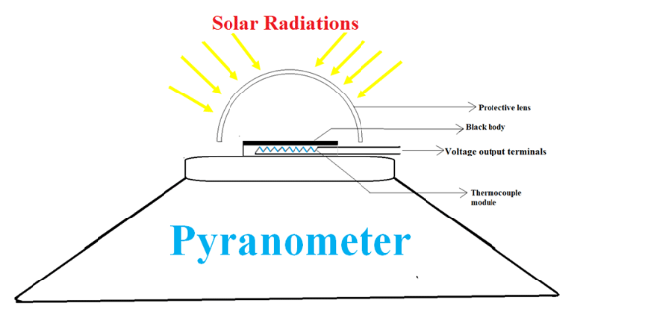

Here the radiation from the surrounding atmosphere passes through the glass dome and falls onto the blackbody situated at the center of the instrument. Like before, the temperature of the body rises after absorbing all the radiation and this rise will also be experienced by the Thermocouple chain or Thermocouple module present directly beneath the blackbody. So the one side of the module will be hot and another will be cold because of the heat sink. The thermocouple module generates a voltage and this can be seen at the output terminals. This voltage received at the output terminals is directly proportional to temperature difference according to the principle of a thermocouple.

Since we know that the temperature difference is related to radiation absorbed by the black body, we can say the output voltage is linearly proportional to the radiation.

Similar to the previous calculation, the value of total radiation can be easily obtained from this voltage value. Also by using the shade and following the same procedure, we can also obtain the diffuse radiation. With total radiation and diffuse radiation value, beam radiation value can also be calculated. Hence we can **calculate both diffuse solar radiation and total radiation using Pyranometer**.

**The P-N Junction**

If an abrupt change in impurity type from acceptors (p-type) to donors (n-type) occurs within a [single crystal](https://www.britannica.com/science/single-crystal) structure, a p-n junction is formed (see parts [B](https://www.britannica.com/science/boron-chemical-element) and C of the figure). On **the p side, the holes**[**constitute**](https://www.merriam-webster.com/dictionary/constitute)**the dominant** carriers and so are called **majority carriers**. A few thermally generated electrons will also exist in the p side; these are termed minority carriers. On the **n side, the electrons are the majority carriers**, while the holes are the minority carriers. Near the junction is a region having no free charge carriers. This region, called the depletion layer, behaves as an [insulator](https://www.britannica.com/science/insulator).

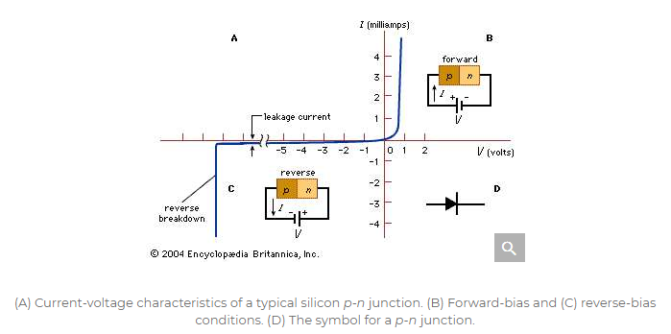

The most important characteristic of p-n junctions is that they rectify. Part A of the figure shows the current-voltage characteristics of a typical silicon p-n junction. When a **forward bias is applied to the p-n junction (i.e., a positive voltage applied to the p-side with respect to the n-side, as shown in part B of the figure), the majority charge carriers move across the junction so that a large current can flow. H**owever, when a **reverse bias is applied (as in part C of the figure), the charge carriers introduced by the impurities move in opposite directions away from the junction, and only a small leakage current flows**. As the reverse bias is increased, the leakage current remains very small until a critical voltage is reached, at which point the **current suddenly increases**. This sudden increase in current is referred to as the junction breakdown, usually a nondestructive phenomenon if the resulting power dissipation is limited to a safe value. The applied forward voltage is typically less than one volt, but the reverse critical voltage, called the breakdown voltage, can vary from less than one volt to many thousands of volts, depending on the impurity concentration of the junction and other device parameters.

**PN Junction Theory**

A PN-**junction is formed when an N-type material is fused together with a P-type material creating a semiconductor** diode

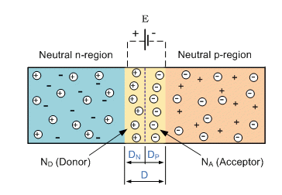

**What are solar cells?**

A solar cell is an electronic device that **catches sunlight and turns it directly into electricity. Solar cells are often bundled together to make larger units called solar** modules, themselves coupled into even bigger units known as solar panels. Just like the cells in a battery, the cells in a solar panel are designed to generate electricity; but where a battery's cells make electricity from chemicals, a solar panel's cells generate power by capturing sunlight instead. They are sometimes called photovoltaic (PV) cells because they use sunlight.

**How are solar cells made?**

A solar cell is a sandwich of two different layers of silicon that have been specially treated or doped so they will let electricity flow through them in a particular way. The lower layer is doped so it has slightly too few electrons. It's called p-type or positive-type silicon (because electrons are negatively charged and this layer has too few of them). The upper layer is doped the opposite way to give it slightly too many electrons. It's called n-type or negative-type silicon.

When we place a layer of n-type silicon on a layer of p-type silicon, a barrier is created at the junction of the two materials. No electrons can cross the barrier so, even if we connect this silicon sandwich to a flashlight, no current will flow: the bulb will not light up. But if we shine light onto the sandwich, something remarkable happens. We can think of the light as a stream of energetic "light particles" called photons. As photons enter our sandwich, they give up their energy to the atoms in the silicon. The incoming energy knocks electrons out of the lower, p-type layer so they jump across the barrier to the n-type layer above and flow out around the circuit. The more light that shines, the more electrons jump up and the more current flows.

**How do solar cells work?**

A solar cell is a sandwich of n-type silicon (blue) and p-type silicon (red). It generates electricity by using sunlight to make electrons hop across the junction between the different flavors of silicon:

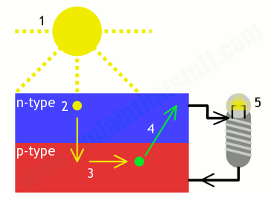

1. When sunlight shines on the cell, photons (light particles) bombard the upper surface.
2. The photons (yellow blobs) carry their energy down through the cell.
3. The photons give up their energy to electrons (green blobs) in the lower, p-type layer.
4. The electrons use this energy to jump across the barrier into the upper, n-type layer and escape out into the circuit.
5. Flowing around the circuit, the electrons make the lamp light up.

**Solar Cell I-V Characteristic**

Solar Cell I-V Characteristic Curves show the current and voltage ( I-V ) characteristics of a particular photovoltaic ( PV ) cell, module or array giving a detailed description of its solar energy conversion ability and efficiency. Knowing the electrical I-V characteristics (more importantly Pmax) of a solar cell, or panel is critical in determining the device’s output performance and solar efficiency.

Photovoltaic solar cells convert the suns radiant light directly into electricity. With increasing demand for a clean energy source and the sun’s potential as a free energy source, has made solar energy conversion as part of a mixture of renewable energy sources increasingly important. As a result, the demand for efficient solar cells, which convert sunlight directly into electricity, is growing faster than ever before.

Photovoltaic ( PV ) cells are made made almost entirely from silicon that has been processed into an extremely pure crystalline form that absorbs the photons from sunlight and then releases them as electrons, causing an electric current to flow when the photoconductive cell is connected to an external load. There are a variety of different measurements we can make to determine the solar cell’s performance, such as its power output and its conversion efficiency.

The main electrical characteristics of a PV cell or module are summarized in the relationship between the current and voltage produced on a typical solar cell I-V characteristics curve. The intensity of the solar radiation (insolation) that hits the cell controls the current ( I ), while the increases in the temperature of the solar cell reduces its voltage ( V ).

Solar cells produce direct current (DC) electricity and current times voltage equals power, so we can create solar cell I-V curves representing the current versus the voltage for a photovoltaic device.

*Solar Cell I-V Characteristics Curves* are basically a graphical representation of the operation of a solar cell or module summarising the relationship between the current and voltage at the existing conditions of irradiance and temperature. I-V curves provide the information required to configure a solar system so that it can operate as close to its optimal peak power point (MPP) as possible.

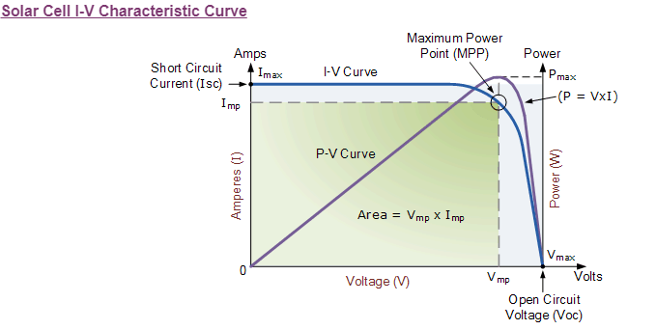

The above graph shows the current-voltage ( I-V ) characteristics of a typical silicon PV cell operating under normal conditions. The power delivered by a solar cell is the product of current and voltage ( I x V ). If the multiplication is done, point for point, for all voltages from short-circuit to open-circuit conditions, the power curve above is obtained for a given radiation level.

With the solar cell open-circuited, that is not connected to any load, the current will be at its minimum (zero) and the voltage across the cell is at its maximum, known as the solar cells **open circuit voltage**, or Voc. At the other extreme, when the solar cell is short circuited, that is the positive and negative leads connected together, the voltage across the cell is at its minimum (zero) but the current flowing out of the cell reaches its maximum, known as the solar cells **short circuit current**, or Isc.

Then the span of the solar cell I-V characteristics curve ranges from the short circuit current ( Isc ) at zero output volts, to zero current at the full open circuit voltage ( Voc ). In other words, the maximum voltage available from a cell is at open circuit, and the maximum current at closed circuit. Of course, neither of these two conditions generates any electrical power, but there must be a point somewhere in between were the solar cell generates maximum power.

However, there is one particular combination of current and voltage for which the power reaches its maximum value, at Imp and Vmp. In other words, the point at which the cell generates maximum electrical power and this is shown at the top right area of the green rectangle. This is the “maximum power point” or **MPP**. Therefore the ideal operation of a photovoltaic cell (or panel) is defined to be at the maximum power point.

The maximum power point (MPP) of a solar cell is positioned near the bend in the I-V characteristics curve. The corresponding values of Vmp and Imp can be estimated from the open circuit voltage and the short circuit current: Vmp ≅ (0.8–0.90)Voc and Imp ≅ (0.85–0.95)Isc. Since solar cell output voltage and current both depend on temperature, the actual output power will vary with changes in ambient temperature.

Thus far we have looked at **Solar Cell I-V Characteristic Curve** for a single solar cell or panel. But many photovoltaic arrays are made up of smaller PV panels connected together. Then the I-V curve of a PV array is just a scaled up version of the single solar cell I-V characteristic curve as shown.

**Solar Panel I-V Characteristic Curves**

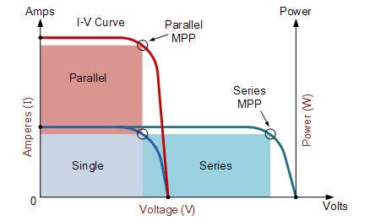

Photovoltaic panels can be wired or connected together in either series or parallel combinations, or both to increase the voltage or current capacity of the solar array. If the array panels are connected together in a series combination, then the voltage increases and if connected together in parallel then the current increases. The electrical power in Watts, generated by these different photovoltaic combinations will still be the product of the voltage times the current, ( P = V x I ). However the solar panels are connected together, the upper right hand corner will always be the maximum power point (MPP) of the array.

**The Electrical Characteristics of a Photovoltaic Array**

Solar Array Parameters

• VOC = open-circuit voltage: – This is the maximum voltage that the array provides when the terminals are not connected to any load (an open circuit condition). This value is much higher than Vmp which relates to the operation of the PV array which is fixed by the load. This value depends upon the number of PV panels connected together in series.

• ISC = short-circuit current – The maximum current provided by the PV array when the output connectors are shorted together (a short circuit condition). This value is much higher than Imp which relates to the normal operating circuit current.

• MPP = maximum power point – This relates to the point where the power supplied by the array that is connected to the load (batteries, inverters) is at its maximum value, where MPP = Imp x Vmp. The maximum power point of a photovoltaic array is measured in Watts (W) or peak Watts (Wp).

• FF = fill factor – The fill factor is the relationship between the maximum power that the array can actually provide under normal operating conditions and the product of the open-circuit voltage times the short-circuit current, (Voc x Isc) This fill factor value gives an idea of the quality of the array and the closer the fill factor is to 1 (unity), the more power the array can provide. Typical values are between 0.7 and 0.8.

• %eff = percent efficiency – The efficiency of a photovoltaic array is the ratio between the maximum electrical power that the array can produce compared to the amount of solar irradiance hitting the array. The efficiency of a typical solar array is normally low at around 10-12%, depending on the type of cells (monocrystalline, polycrystalline, amorphous or thin film) being used.

**How Does a Solar Power Plant Work?**

[A solar power plant](https://www.dw.com/en/how-does-a-solar-power-plant-work/a-5073142) is any type of facility that converts sunlight either directly, like Photovoltaics, or indirectly, like Solar Thermal plants, into electricity.

1. Solar PV power plants work in the same manner as small domestic-scale PV panels or the tiny one on your calculator but on steroids.

Most solar PV panels are made from semiconductor materials, usually some form of silicon. When photons from sunlight hit the semiconductor material free electrons are generated which can then flow through the material to produce a direct electrical current. This is known as the photo-effect in physics. The DC current then needs to be converted to alternating current (AC) using an inverter before it can be directly used or fed into the electrical grid. PV panels are distinct from other solar power plants as they use the photo-effect directly without the need for other processes or devices. For example, no liquid heat-carrying agent, like water, is needed as in solar thermal plants. PV panels do not concentrate energy they simply convert photons into electricity that is then transmitted somewhere else.

**SOLAR THERMAL POWER PLANTS**

Solar Thermal power plants, on the other hand, focus or collect sunlight in such a manner as to generate steam to feed a turbine and generate electricity. Solar thermal power plants can also be subdivided into a further three distinct types: -

* 1. **Parabolic trough systems:-** Parabolic troughs use parabola-shaped reflectors that are able to focus between 30 and 100 times normal sunlight levels on to the collector. The method is used to heat a special type of fluid, which is then collected at a central location to generate high-pressure, superheated steam. These systems tilt to keep track of the sun throughout the day. Because of their parabolic shape, these kinds of reflectors are able to focus between 30 and 100 times the normal sunlight intensity on the collector.

**How does it work?**

These kinds of solar thermal power plant work by focussing sunlight from long parabolic mirrors onto receiver tubes that run the length of the mirror at their focal point. This concentrated solar energy heats up a fluid that continuously flows through the tubes. This heated fluid is then sent to a heat exchanger to boil water in a conventional steam-turbine generator to generate electricity.

* 1. **Linear concentrating systems:-** Linear concentrating systems, sometimes called Fresnel reflectors, also consist of large 'fields' of sun-tracking mirrors that tend to be aligned in a north-south orientation to maximize sunlight capture. This setup allows the banks of mirrors to track the sun from east to west throughout the day.

**How does it work?**

Much like their parabolic mirror cousins, linear concentrating systems collect solar energy using long, rectangular, U-shaped mirrors. Unlike parabolic systems, however, linear Fresnel reflector systems, place the receiver tube above several mirrors to allow the mirrors greater mobility in tracking the sun.These types of systems use the Fresnel lens effect that allows for the use of a large concentrating mirror with a large aperture and short focal length. This setup allows these kinds of systems to focus sunlight approximately 30 times the normal intensity.

* 1. **Solar Dishes and engines:-** Solar dishes also use mirrors to focus the suns energy onto a collector. These tend to consist of oversized satellite dishes that are clad in a mosaic of small mirrors that focus energy onto a receiver at the focal point.

**How does it work?**

Like the parabolic and linear systems, the dish-shaped, mirror clad, surface directs and concentrates sunlight onto a thermal receiver at the dish's focal point. This receiver transfers the heat generated to an engine generator.

The most common type of heat engine used in dish/engine systems is the Stirling engine. Heated fluid from the dishes receiver is used to move pistons in the engine to create mechanical power.

This mechanical power then runs to a generator or alternator to generate electricity.

Solar dish/engine systems always point straight at the sun and concentrate the solar energy at the focal point of the dish. A solar dish's concentration ratio is much higher than linear concentrating systems, and it has a working fluid temperature higher than 749 degrees Celsius.

### First Generation Solar Cells

Traditional solar cells are made from silicon, are currently the most efficient solar cells available for residential use and account for around 80+ percent of all the solar panels sold around the world. Generally silicon based solar cells are more efficient and longer lasting than non silicon based cells. However, they are more at risk to lose some of their efficiency at higher temperatures (hot sunny days), than thin-film solar cells.

There are currently four types of silicon based cells used in the production of solar panels for residential use. The types are based on the type of silicon used, specifically:

**1. Monocrystalline Silicon Cells:-** The oldest solar cell technology and still the most popular and efficient are solar cells made from thin wafers of silicon. These are called monocrystalline solar cells because the cells are sliced from large single crystals that have been painstakingly grown under carefully controlled conditions. Typically, the cells are a few inches across, and a number of cells are laid out in a grid to create a panel.

Relative to the other types of cells, they have a higher efficiency (up to 24.2%), meaning you will obtain more electricity from a given area of panel. This is useful if you only have a limited area for mounting your panels, or want to keep the installation small for aesthetic reasons. However, growing large crystals of pure silicon is a difficult and very energy-intensive process, so the production costs for this type of panel have historically are the highest of all the solar panel types.

**2**. **Polycrstalline Silicon Cells** :- It is cheaper to produce silicon wafers in molds from multiple silicon crystals rather than from a single crystal as the conditions for growth do not need to be as tightly controlled. In this form, a number of interlocking silicon crystals grow together. Panels based on these cells are cheaper per unit area than monocrystalline panels - but they are also slightly less efficient (up to 19.3%).

**3.** **Amorphous Silicon Cells:-** Instead of growing silicon crystals as is done in making the two previous types of solar cells, silicon is deposited in a very thin layer on to a backing substrate – such as metal, glass or even plastic. Sometimes several layers of silicon, doped in slightly different ways to respond to different wavelengths of light, are laid on top of one another to improve the efficiency. The production methods are complex, but less energy intensive than crystalline panels, and prices have been coming down as panels are mass-produced using this process.

One advantage of using very thin layers of silicon is that the panels can be made flexible. The disadvantage of amorphous panels is that they are much less efficient per unit area (up to 10%) and are generally not suitable for roof installations you would typically need nearly double the panel area for the same power output. Having said that, for a given power rating, they do perform better.

### 4 Hybrid Silicon Cells:- One recent trend in the industry is the emergence of hybrid silicon cells and several companies are now exploring ways of combining different materials to make solar cells with better efficiency, longer life, and at reduced costs.

### SECOND GENERATION SOLAR CELLS

Second-generation solar cells are usually called **thin-film solar** cells because when compared to crystalline silicon based cells they are made from layers of semiconductor materials only a few **micrometers thick**. The combination of using **less material and lower cost manufacturing processes allow the manufacturers of solar panels** made from this type of technology to produce and sell panels at a much lower cost.

There are basically three types of solar cells that are considered in this category, **amorphous silicon (mentioned above), and two that are made from non-silicon materials namely cadmium telluride (CdTe), and copper indium gallium diselenide (CIGS).** Together they accounted for around 16.8% of the panels sold in 2009.

**THIRD GENERATION SOLAR CELLS**

This new generation of solar cells are being made from variety of new materials besides silicon, including nanotubes, silicon wires, solar inks using conventional printing press technologies, organic dyes, and conductive plastics. The goal of course is to improve on the solar cells already commercially available – by making solar energy more efficient over a wider band of solar energy (e.g., including infrared), less expensive so it can be used by more and more people, and to develop more and different uses.

Currently, most of the work on third generation solar cells is being done in the laboratory, and being developed by new companies and for the most part is not commercially available.

**Soar to electricity with components**

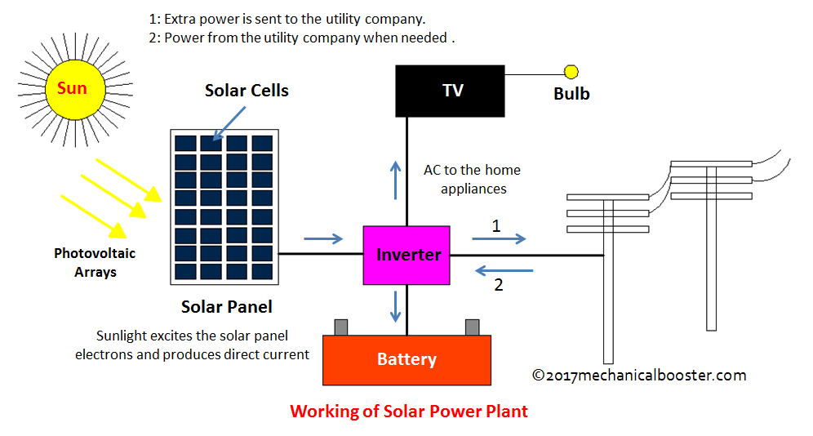

1. **Solar Panels:- Solar panels are the most noticeable component of a residential solar electric system. The solar panels are installed outside the home, typically on the roof and convert sunlight into electricity.**
2. **Solar Array Mounting Racks:- Solar panels are joined into arrays and commonly mounted in one of three ways: on roofs; on poles in free standing arrays; or directly on the ground.**
3. **Inverter:-** Solar panels and batteries produce DC (direct current) power. Standard home appliances use AC (alternating current). An inverter converts the DC power produced by the solar panels and batteries to the AC power required by appliances.
4. **Battery Pack :-** Solar power systems produce electricity during the daytime, when the sun is shining. Your home demands electricity at night and on cloudy days – when the sun isn’t shining. To offset this mismatch, batteries can be added to the system.
5. **Backup Generator:-** For systems that are not tied to the utility grid, a backup generator is used to provide power during periods of low system output due to poor weather or high household demand.
6. **Charge Controller:-** The charge controller – also known as charge regulator – maintains the proper charging voltage for system batteries.