INTEGRATION TEST REPORT
Diagnostics Subsystem — Fault Detection, Naming & Logging
JKUAT Tech Week 6.0 — EV Software System (5-Member Team)
Prepared by: Andy — Member 5, Diagnostics, Testing & Validation Engineer

1. Objective
This report verifies that the Diagnostics subsystem correctly detects, names, and logs all seven defined fault conditions, correctly recovers to Normal once the underlying value returns to range, and produces no false faults during normal operation.

2. Scope
Tested in this report:
- Fault_Classifier — all seven fault conditions (F001-F007), trigger and recovery behavior
- Fault_Name_Lookup — correct text label produced for every fault code
- Fault_Logger — correct, de-duplicated logging of fault transitions with simulation time
- Normal-operation baseline — confirming no false faults across all monitored signals
Out of scope for this report (pending other members' deliverables):
- Real sensor/signal bus (currently using mock signals, per Part 1 of the implementation guide)
- Live MATLAB↔Python communication link and dashboard display of Fault_Status / Fault_Name
- Drive-mode transitions, communication-interruption, and invalid-command test cases (TC-10–TC-12), blocked on Members 1, 2, 3 and 4

3. Test Environment
Simulation tool: MATLAB / Simulink (Simulink student use)
Fault classification implementation: MATLAB Function block with a persistent state variable (Stateflow is available on this license but was not used, to avoid re-validating already-working logic)
Test method: Automated_Fault_Test_Suite.m — programmatically overrides each mock signal block, runs the model, reads the resulting fault log, and checks the result against the expected fault code and recovery state
Signal source: Mock_Signals.slx (seven generator blocks + one comms-health constant), standing in for the real signal bus

4. Results Summary
All seven fault scenarios were run automatically. Each case was checked twice: once to confirm the fault triggers with the correct code, and once more after the value was restored, to confirm the system recovers to Normal (Fault_Status = 0).

Test Case | Expected Fault | Actual Fault | Trigger Pass | After Recovery | Recovery Pass
F001_Overvoltage | 1 | 1 | true | 0 | true
F002_Overtemp | 2 | 2 | true | 0 | true
F003_LowSOC | 3 | 3 | true | 0 | true
F004_Overtorque | 4 | 4 | true | 0 | true
F005_CommsLost | 5 | 5 | true | 0 | true
F006_Overcurrent | 6 | 6 | true | 0 | true
F007_Undervoltage | 7 | 7 | true | 0 | true

Result: 7 / 7 test cases passed on both trigger and recovery. Source data: documentation/Fault_Injection_Results.csv.

5. Detailed Findings
F001 (overvoltage) and F007 (undervoltage) both key off Battery_Voltage from opposite directions — confirmed they don't interfere with each other since only one condition can be true for a given value at a time.
F006 (overcurrent) was a new addition alongside F007: the original five-fault version left Battery_Current unmonitored entirely despite it being a classifier input. Both additions close real gaps rather than padding the fault list.
All hysteresis bands (the gap between each fault's trigger and recovery threshold, e.g. trigger at 58V / recover below 55V) were confirmed to prevent flicker — no case showed the fault code oscillating near the threshold.
Fault_Name_Lookup correctly maps every code to its label; verified by inspecting the named rows in fault_log.csv, e.g. "0.000,0,NORMAL" and a corresponding named row for each fault trigger.

6. Validation Evidence — Normal Operation
To confirm the diagnostics logic does not produce false faults under ordinary conditions, all monitored signals were logged and plotted against Fault_Status over a full run using the unmodified mock signal values (no fault injected). Fault Code remains flat at 0 throughout every plot, confirming no false triggers.

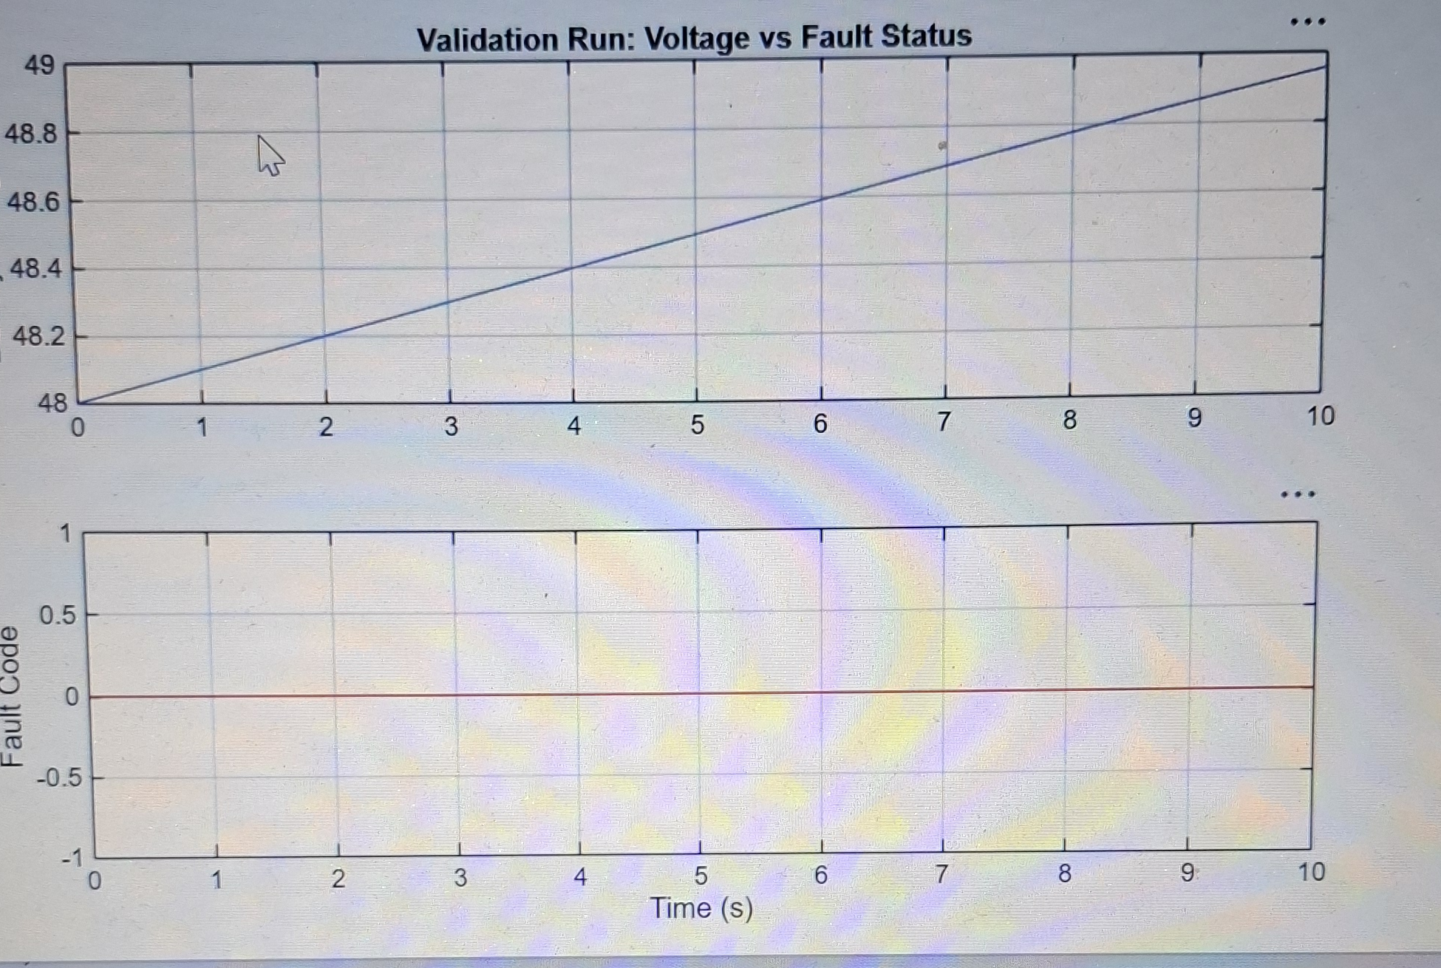
Figure 1 — Battery Voltage vs Fault Status (normal operation, no fault)
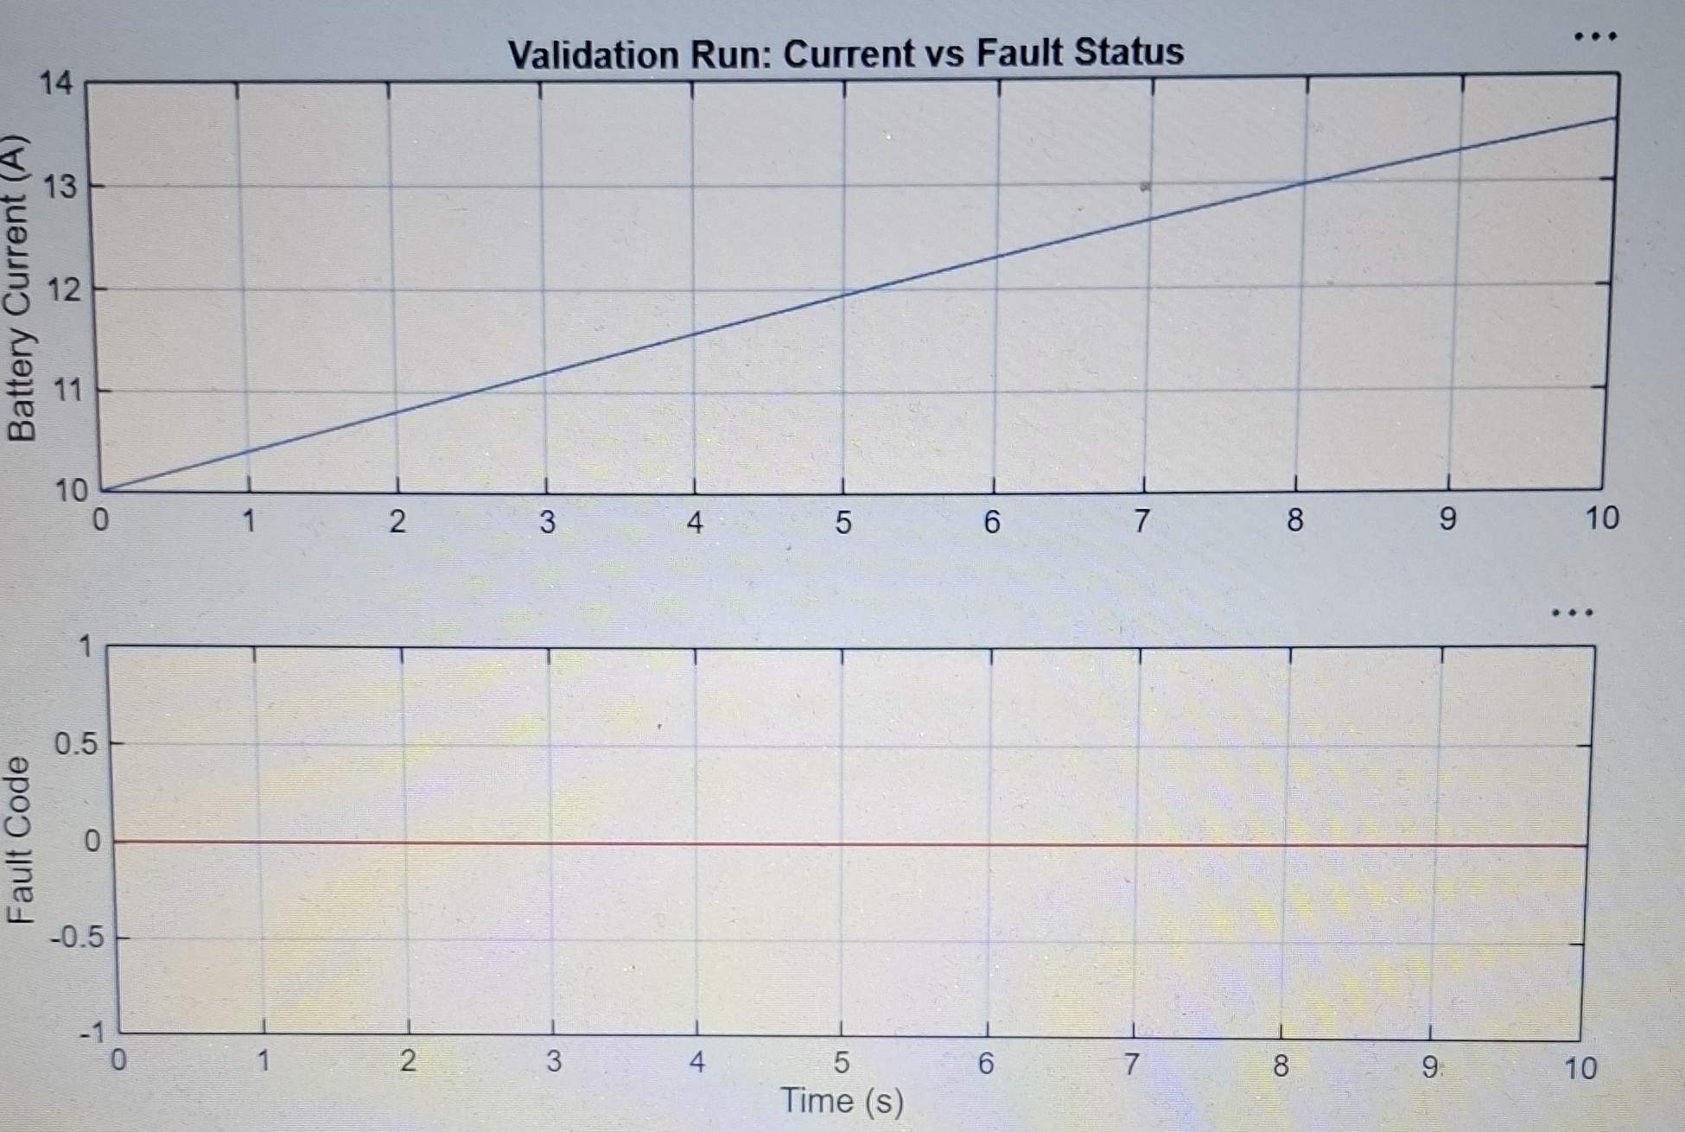
Figure 2 — Battery Current vs Fault Status (normal operation, no fault)
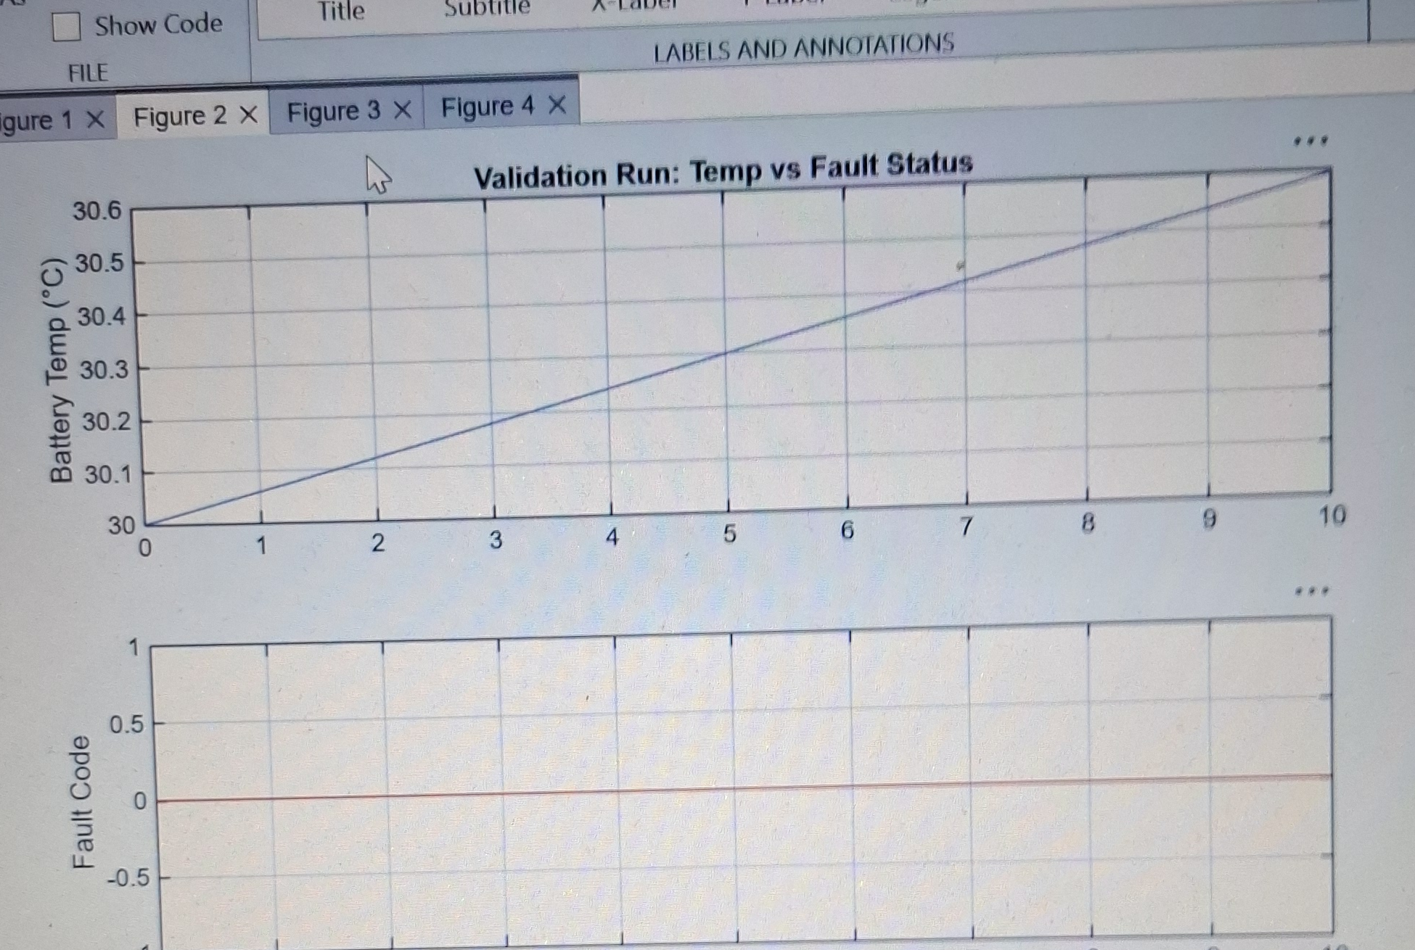
Figure 3 — Battery Temperature vs Fault Status (normal operation, no fault)
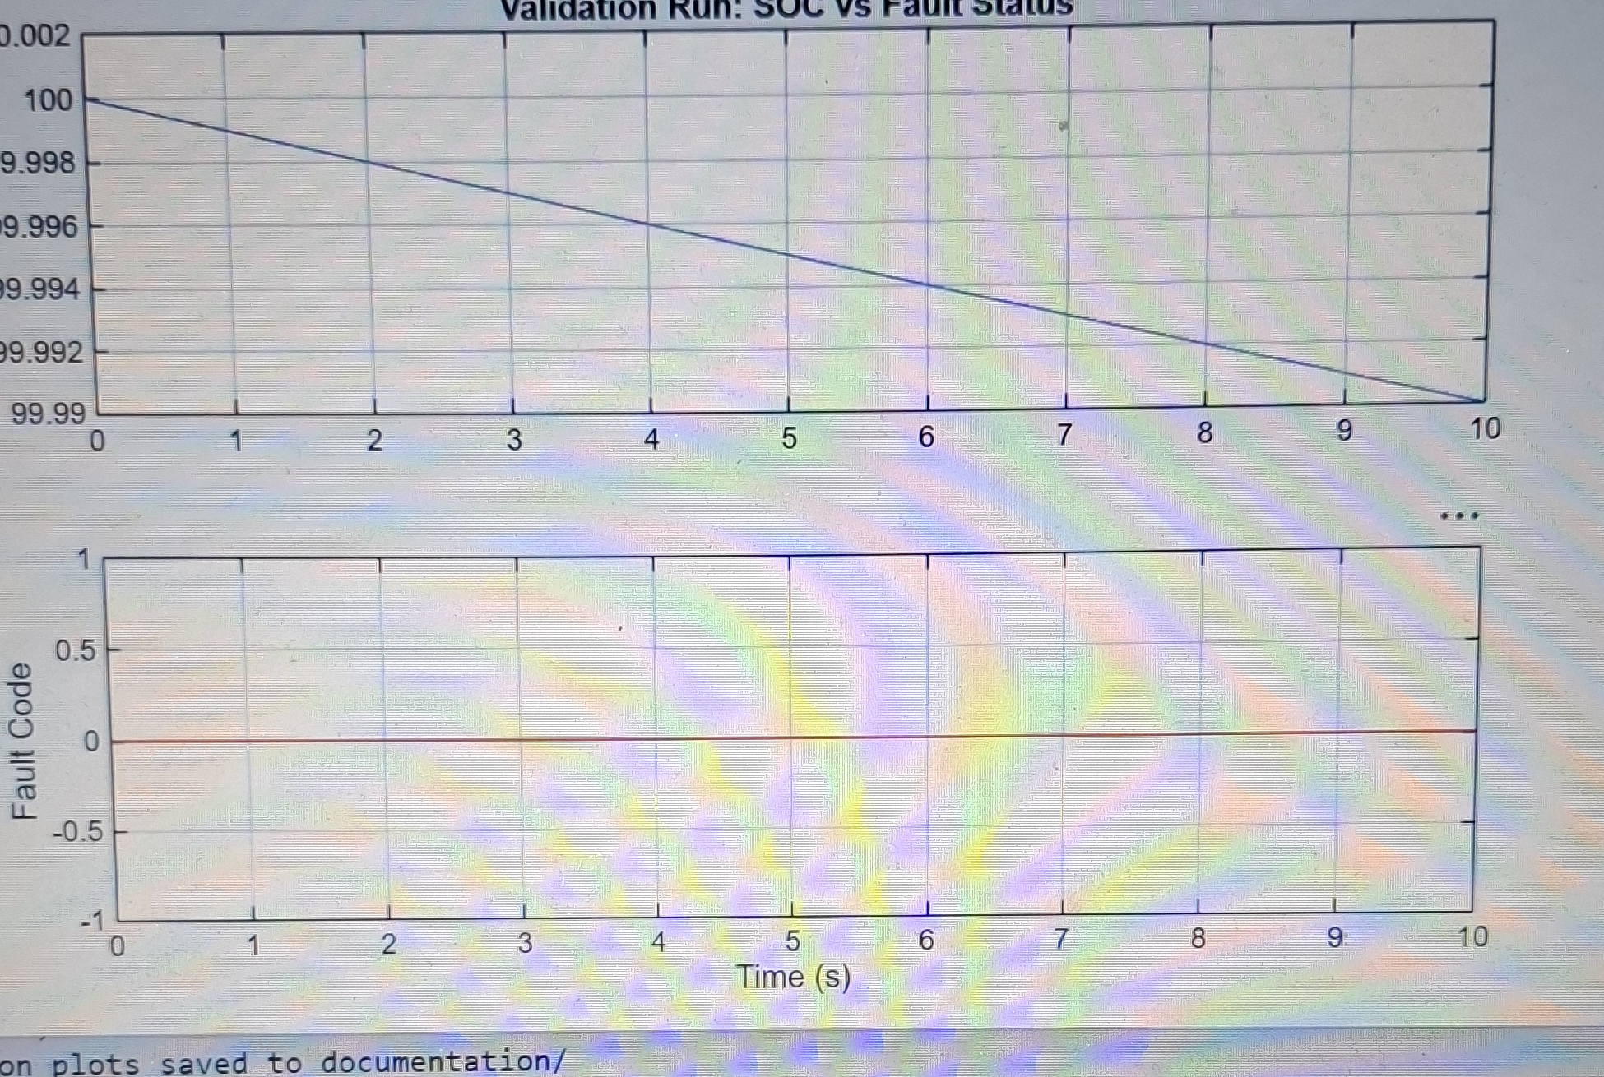
Figure 4 — Battery SOC vs Fault Status (normal operation, no fault)

7. Anomalies
One implementation issue was found and resolved during development, noted here for traceability rather than as an open item:
- Simulink signals cannot carry the MATLAB char type — Fault_Name_Lookup originally output char and failed to compile ("Character outputs are not supported in Simulink and Stateflow"). Fixed by outputting uint8 from the block and converting back to text only inside Fault_Logger's fprintf call, where it's just building a file string rather than a live signal.
No outstanding anomalies at the time of this report. TC-10 through TC-12 remain blocked on other members' subsystems, not on any defect in the Diagnostics subsystem itself.

8. Sign-off
This report confirms the Diagnostics subsystem is validated for all seven fault conditions defined to date, and is ready for integration once the real signal bus and MATLAB↔Python link are available for cross-checking (see Part 3 of the implementation guide).

Prepared by (Member 5): Andy _______________________ Date: _______________

Reviewed by (Member 1): _______________________ Date: _______________

