**Technology’s Influence on Gaming**

**Sacha Al Nouar**

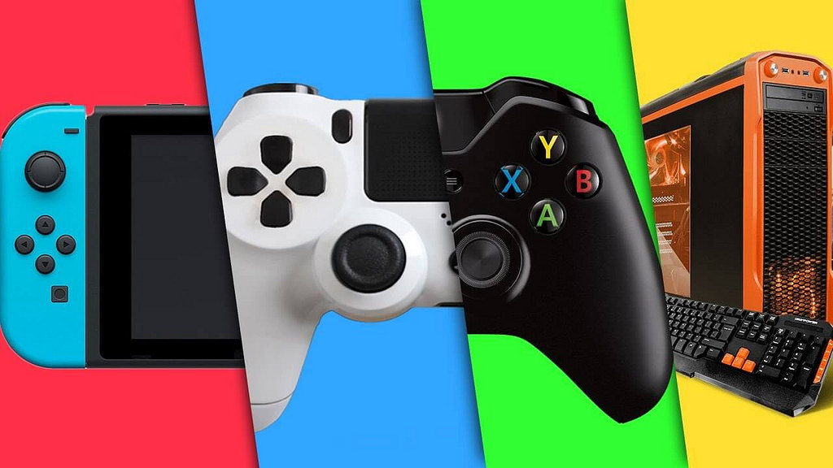

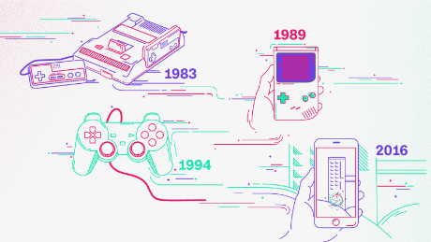

With the expansion of new sets of technologies, gaming consoles and devices are evolving as well. This image illustrated shows the development of devices through years and decades. As we know, the first gaming console created was Atari. Its concepts and features have evolved in time in order to create new consoles such as Nintendo, Xbox, Play Station and PC.

Moreover, the episode Striking Vipers in Black Mirror reflects the impact of the future science on gaming. During the movie, the main characters plugged a ship into their heads in order to be stimulated in the video game. This form of technology projects the similarities of the emotions and feelings felt and the actions done by the characters in both real and virtual worlds.

Furthermore, the expansion of technology did not only influence the gaming devices, as much as it has impacted the content of the games, consisting of the development and enlargement of the stories, the avatars, the characters, as well as the spatial features.

Since the improvement of technology has influenced the gaming industry, the graphics, the displays, the gestures, the voices and facial recognitions have also changed and evolved.

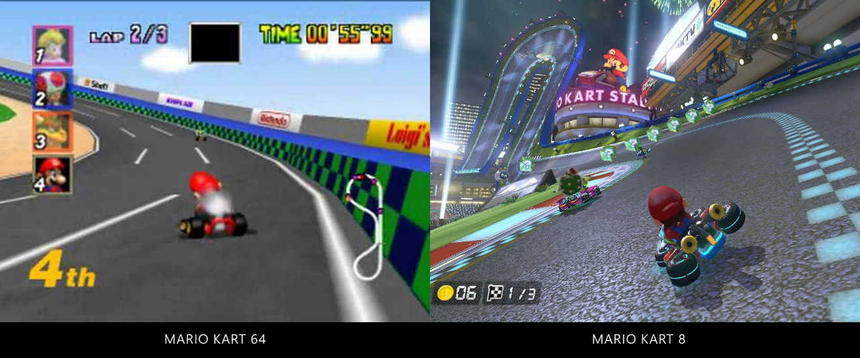

For example, Mario Kart has expanded its features and design in order to adapt to the innovation of high technology.