# SheCare - AI-Powered Menstrual & Fertility Tracking

## 1. Planning & Analysis

### Feasibility Study

SheCare is an AI-driven menstrual tracking system designed to assist users with cycle predictions, ovulation tracking, and personalized health insights. The feasibility study evaluates its viability in terms of technology, operation, and economics.

**Economic Feasibility**

The platform ensures financial viability through structured cost analysis and revenue models.

• Cost Analysis: AI development, third-party integrations (telehealth, SMS alerts), and regulatory compliance (HIPAA/GDPR).

• Revenue Model:

- Subscription-Based: Patients and doctors pay for AI-driven insights.

- Commission-Based: Doctors earn from AI-referred consultations (e.g., ₹450 per ₹500 consultation).

- Freemium Model: Basic services are free; premium AI analytics are monetized.

**Operational Feasibility**

• User adoption analysis (ease of use for non-tech-savvy demographics).

• Integration with existing health platforms (Apple Health, Fitbit).

**Legal Feasibility**

• Compliance with HIPAA, GDPR, and FDA (if applicable for medical-grade predictions).

• Data privacy policies for sensitive health data (menstrual cycles, pregnancy status).

### Requirement Documentation

#### Functional Requirements

✔ Secure user authentication (Signup/Login)  
✔ Intelligent menstrual cycle tracking  
✔ AI-driven fertility predictions  
✔ Personalized health recommendations  
✔ AI chatbot for menstrual health queries

#### Non-Functional Requirements

✔ Data security & user privacy  
✔ Fast and optimized performance  
✔ Scalability for future expansions  
✔ Responsive and user-friendly UI/UX

## 2. System Requirements Definition

### Software Requirement Specification (SRS)

SheCare is an AI-driven menstrual tracking system that predicts cycles, ovulation, and offers AI-based health recommendations. The chatbot provides real-time support to users.

## 3. System Design

### High-Level Design (HLD)

#### System Architecture

The system consists of the following components: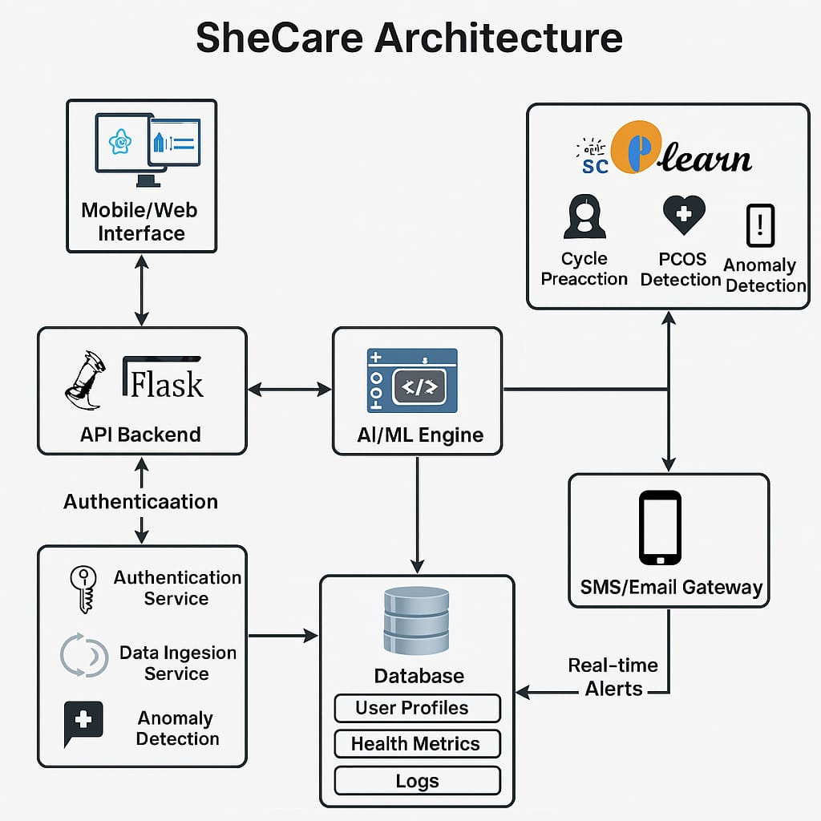

### Low-Level Design (LLD)

#### Data Flow Process

1. User logs into SheCare  
2. Inputs menstrual cycle details  
3. AI processes data and predicts upcoming cycles  
4. Results displayed using Chart.js visualizations

## Security & Compliance

🔹 User Authentication: OAuth-based authentication with secure API keys.  
🔹 Data Privacy: GDPR-compliant handling of sensitive user data.  
🔹 AI Model Security: Frequent updates to maintain ethical AI predictions.

## Conclusion

SheCare follows a structured SDLC methodology, ensuring a scalable and AI-driven solution for women's health tracking. Future enhancements include real-time wearable integration, community health insights, and advanced hormonal analysis.