Login to Kubernetes cluster or use any kubernetes playground

Argocd Install Setup and manual synchronization

Steps 1: Install ArgoCD in your Kubernetes cluster
- Create the argocd namespace:
$kubectl create namespace argocd
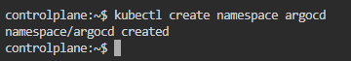

- Apply the ArgoCD installation manifest:
# kubectl apply -n argocd -f https://raw.githubusercontent.com/argoproj/argo-cd/stable/manifests/install.yaml

- List the ArgoCD pods
# kubectl get pods -n argocd

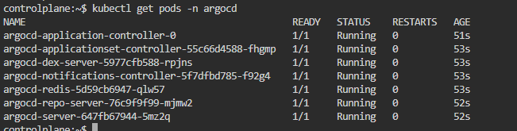

- Expose the ArgoCD API server through ArgoCD UI in the background
# kubectl port-forward svc/argocd-server -n argocd 8080:443 &

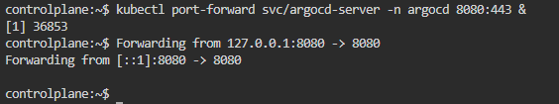

- Verify the ArgoCD UI is running
# wget –no-check-certificate https://localhost:8080

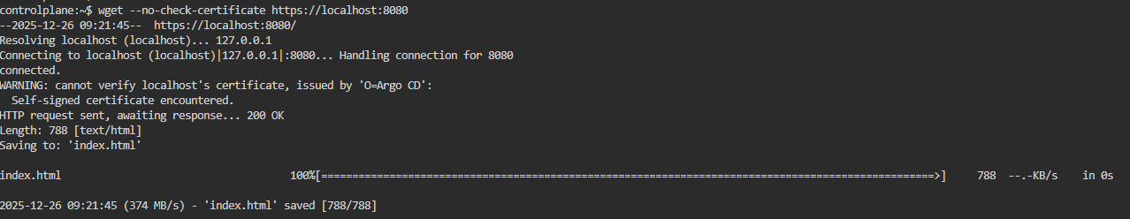

Step 2. Install and configure argocd commands line interface:
- Download the CLI:
# curl -sSL -o argocd https://github.com/argoproj/argo-cd/releases/latest/download/argocd-linux-amd64
# chmod +x argocd
# sudo mv argocd /usr/local/bin/
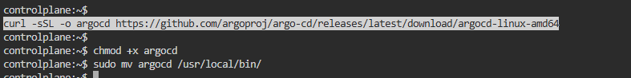

- Get the initial admin password
# argocd admin initial-password -n argocd
OR
# kubectl -n argocd get secret argocd-initial-admin-secret
# kubectl -n argocd get secret argocd-initial-admin-secret -o jsonpath="{.data.password}" | base64 -d

- Login to Argo CD, replacing <password> with the admin password you got earlier
# argocd login localhost:8080 --username admin --password <password> --insecure

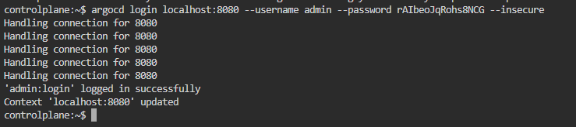

- Once logged in Successfully , Check argocd version
#argocd version

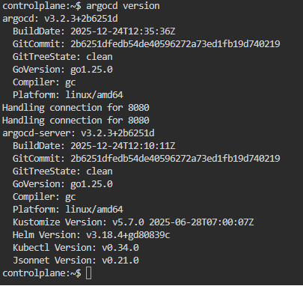

Step 3: Login to your Github repository
- Create a New Repository Name it
- Add deployment.yaml, namespace.yaml and service.yaml file
Content:
Deployment.yaml

apiVersion: apps/v1
kind: Deployment
metadata:
name: gitops
namespace: gitops
spec:
replicas: 4
selector:
matchLabels:
app: gitops
template:
metadata:
labels:
app: gitops
spec:
containers:
- name: gitops
image: nginx:1.27.5
ports:
- containerPort: 80

Service.yaml

apiVersion: v1
kind: Service
metadata:
name: gitops
namespace: gitops
spec:
selector:
app: gitops
ports:
- protocol: TCP
port: 80
targetPort: 80
type: ClusterIP

namespace.yaml

apiVersion: v1
kind: Namespace
metadata:
name: gitops

Commit it all

- Create a fine grained personal access token
Steps to create
- Click your profile picture in the top-right corner and select Settings.
- At the bottom of the left sidebar, click Developer settings <>.
- Click Personal access tokens then Fine-grained tokens.
- Click Generate new token.
- Enter a Token name of GitOps Lab Token.
- Under Repository access, select Only select repositories, then select the repository you just created
- Under Permissions click + Add permissions, then select Contents.
- On the right of the new Contents row that's added, click the drop-down and select Read and write.
- Click Generate token, and on the pop-up click Generate token again.
- Copy your personal access token immediately and store it securely.

Step 4: Connect your personal Github repository to Argo CD.
- Export the token:

# export GH_TOKEN=< PAT TOKEN PASTE HERE YOU GENERATED>

# argocd repo add <url of your GITHUB REPOSITORY> --username <github_username> --password $GH_TOKEN
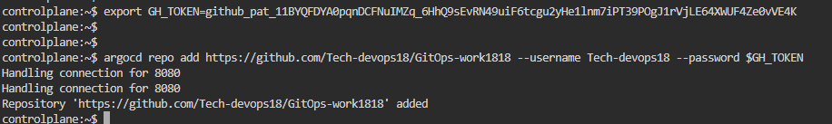

- Verify the repository is added
# argocd repo list

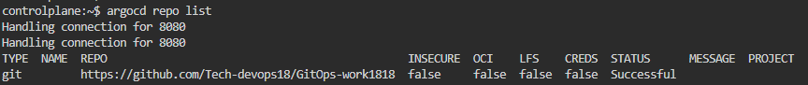

- Fetch the Kubernetes context details and add Kubernetes cluster into argocd
# kubectl config get-contexts
# argocd cluster add Kubernetes-admin@kubernetes --name Kubernetes
#argocd cluster list

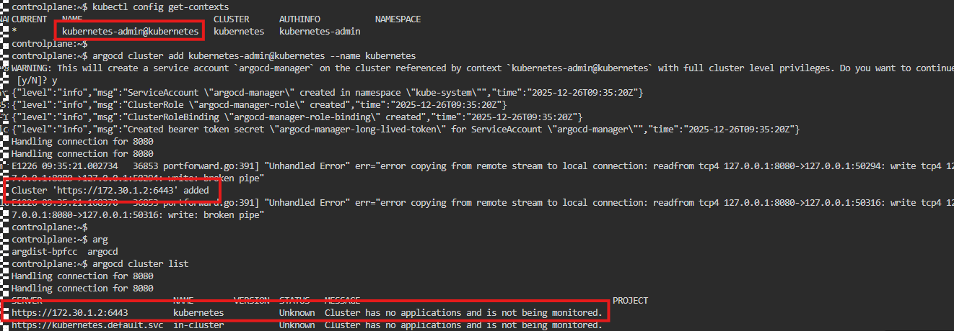

- Create an Argo CD application named gitops and Integrate Github repository with Argocd
# argocd app create gitops --repo <github_repository_url> --path . --dest-namespace gitops --dest-server <Kubernetes_cluster_url>:6443 --sync-policy=manual

- Check the application status using argocd cli:
# argocd get app gitops

- Synchronize your application
#argocd app sync gitops

- Inspect and verify the deployed application:
# argocd app get gitops

View resources in Kubernetes
# kubectl get all -n argocd

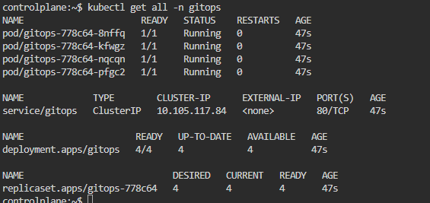

Step 5: Now we will test, we will execute git operations to manage applications lifecycle by modifying the deployment manifest files, committing the changes, and synchronizing the applications with argo CD
- Open the deployment.yaml in Github repository
Navigate to the line replicas: 4 and change to replicas: 2
- Commit the changes
- Synchronize the application
#argocd app sync gitops

Step 6: Verify now
#kubectl get deploy -n gitops
#kubectl get pods -n gitops
You will see now 2 pods is running

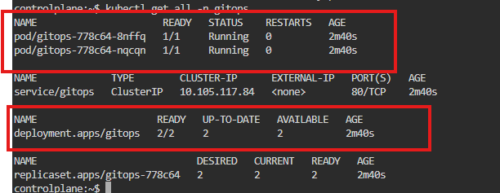

Additional commands:
The sync is manual, now make the synchronization automated
- To check the current application sync policy
# argocd app get gitops | grep “Sync Policy”
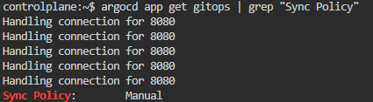
- Enabled automated sync
--self-heal re-apply if cluster drifts from the desired state
--auto-prune delete resource which is removed from Git
# argocd app set gitops --sync-policy automated --self-heal --auto-prune
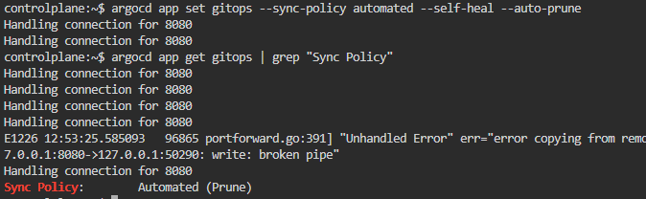

- View argocd application history
# argocd app history gitops

