Automate the nightly shutdown of Amazon EC2 instances using Amazon EventBridge Scheduler.
Step 1. Create an EC2 instance and Copy the instance ID ( Store this locally as you will use this later on )

Step 2.
- Navigate to the Amazon EventBridge service.
- From the left navigation pane, select Schedules.
- Click Create schedule.
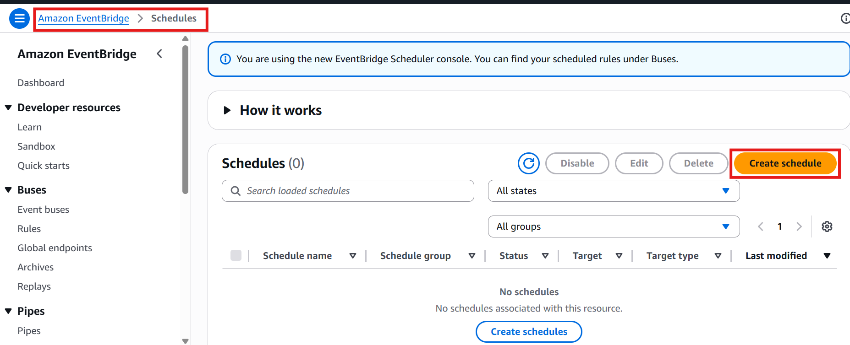

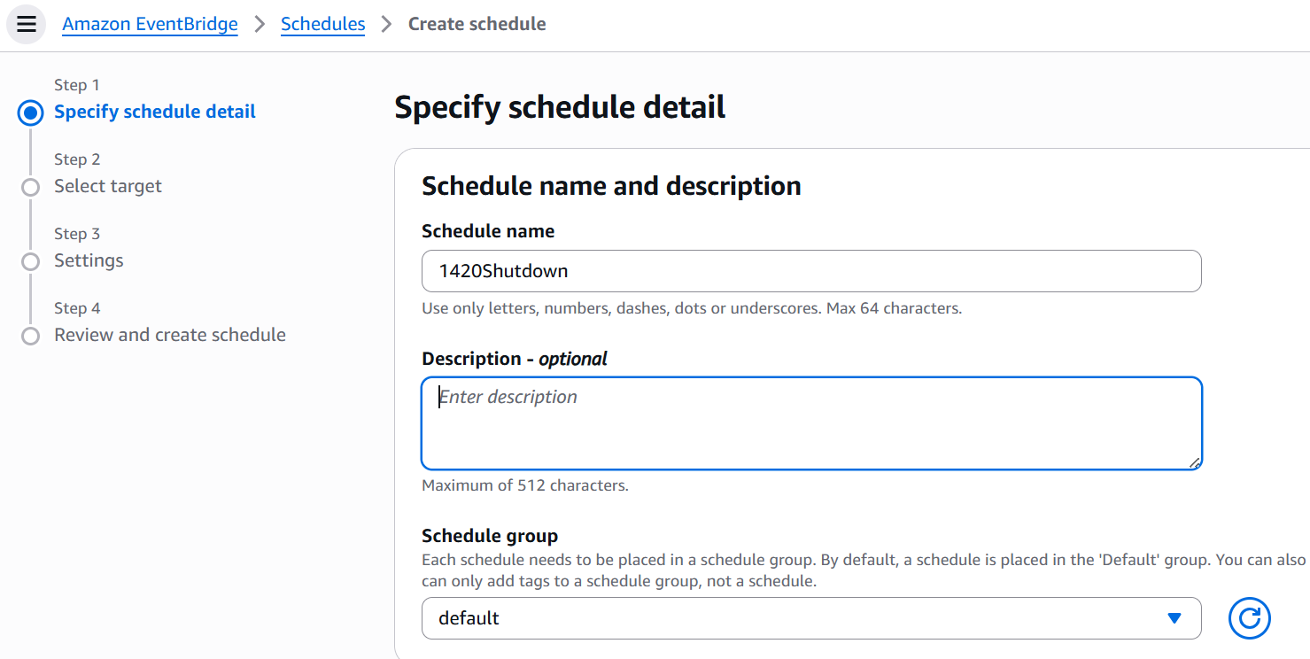

Configure the following:
- Schedule name: Enter 1440PMshutdown
- Schedule pattern > : Select Recurring schedule.
- Schedule pattern > Cron expression: Enter 40 14 * * ? *
To experiment, you can enter a time closer to you.
You can copy and paste the previous expression into the separate text fields here, but the following more specifically indicates what is entered.
  - Minutes: 0
  - Hours: 22
  - Day of month: *
  - Month: *
  - Day of the week: ?
  - Year: *
That Cron expression configures the trigger for 10:00 PM (22:00) every day of every month (and every year).

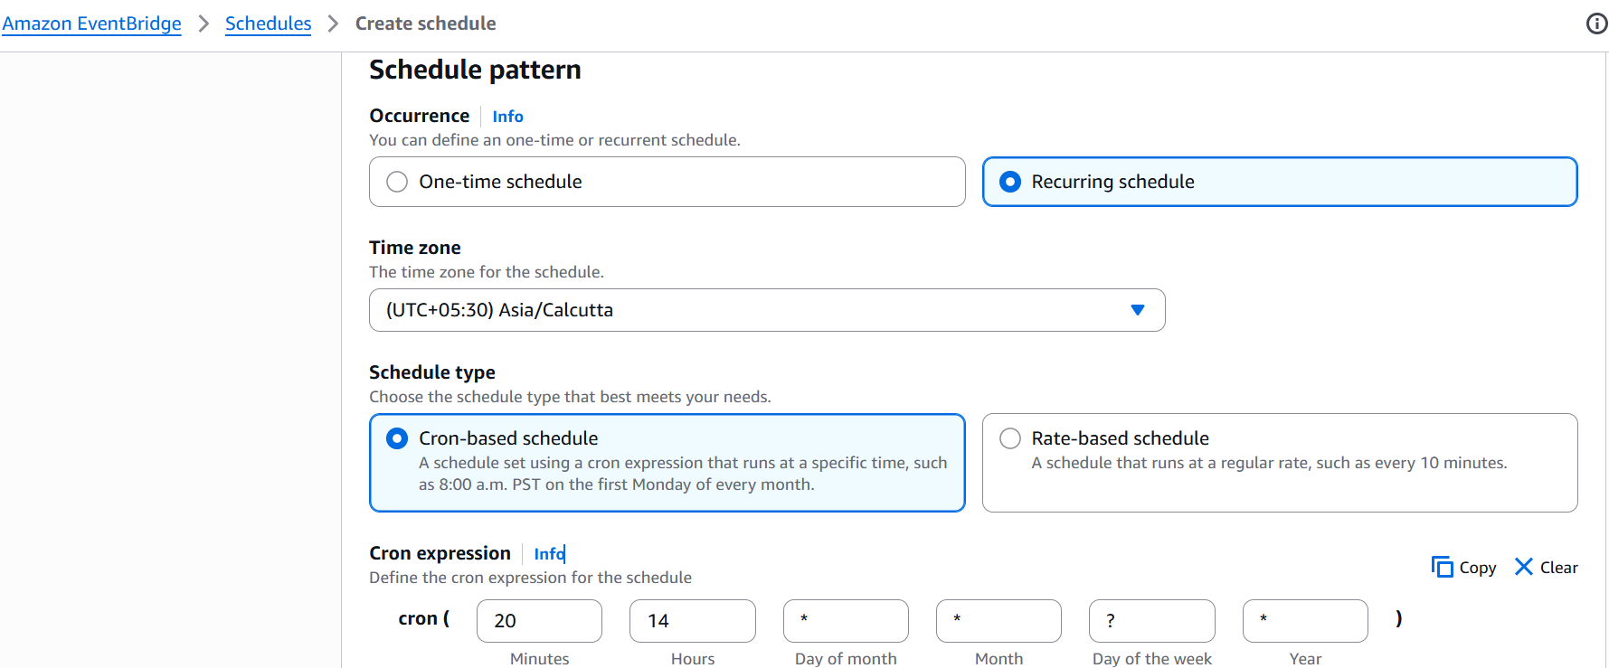

- Flexible time window: Select 5 minutes.

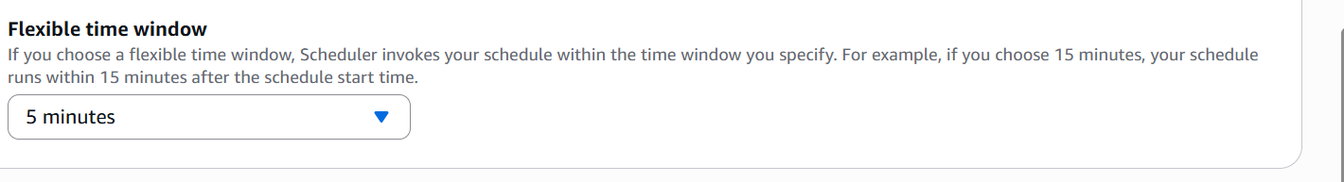

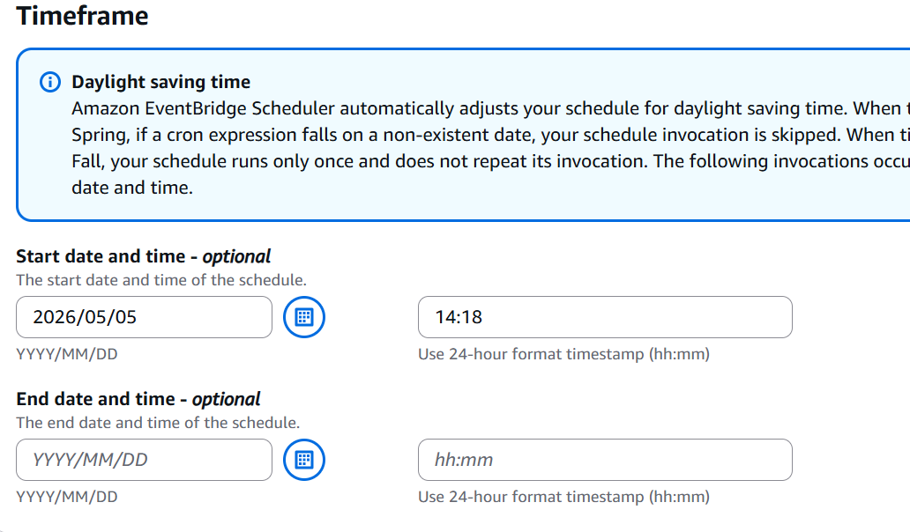

- At the bottom of the page click Next.
- Under Target API, select All APIs.
- In the search field, type EC2 and select Amazon EC2.
- In the Find API search field, type StopInstances and select it.
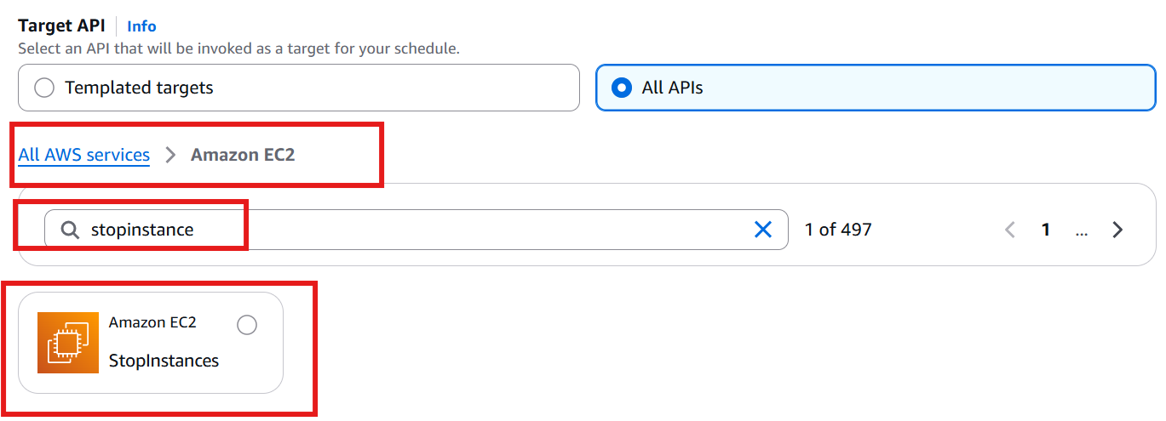

In the Input section (the JSON editor), replace the placeholder MyData and replace it with the Instance ID you copied earlier over the string, ensuring it remains inside the quotes.
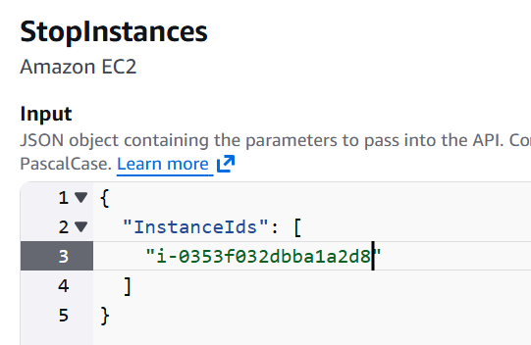

- Click Next.
- On the Settings page, set Action after schedule completion to NONE.

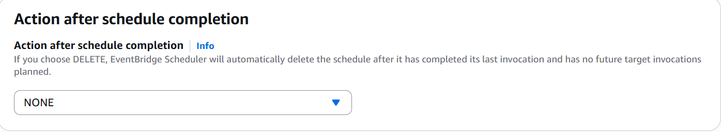

Step 3:
Configure Permissions (IAM Role)
- Under the Permissions section, click the Go to IAM console button.
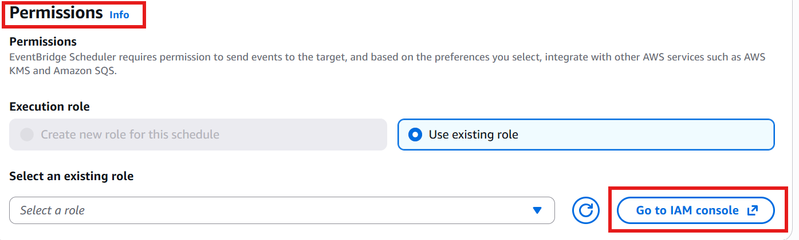
This'll open a new browser tab. Keep the EventBridge browser tab open, as you'll return to it shortly.
- At the IAM Roles page, click Create role.
- Under Trusted entity type, select Custom trust policy.
- In the Custom trust Policy JSON editor, overwrite the principal line with the following:
"Principal": { "Service": "scheduler.amazonaws.com" },

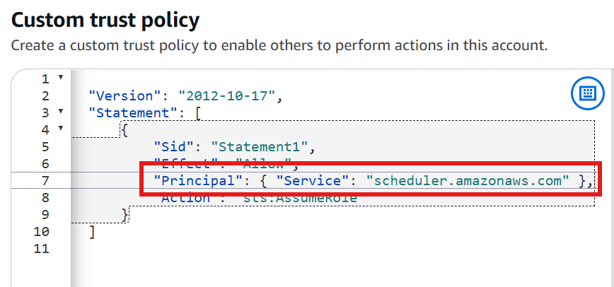

- At the bottom of the page, click Next.
- On the Add permissions page, under Permissions policies, search for AmazonEC2FullAccess.
- Select AmazonEC2FullAccess.
- Click Next.

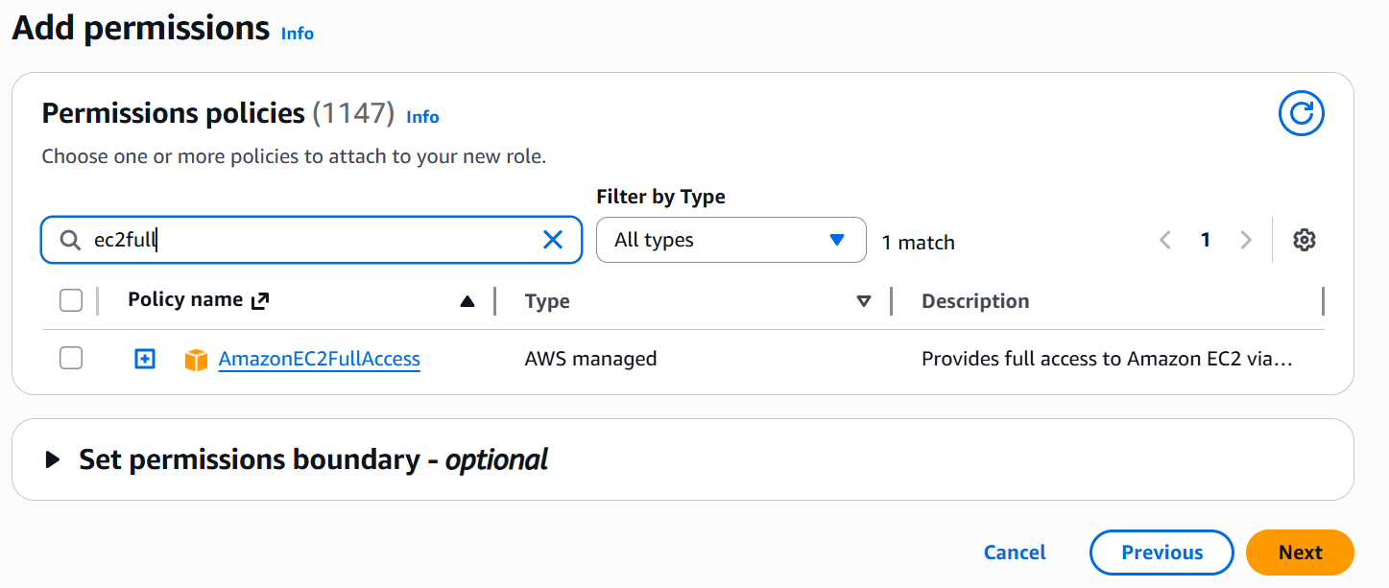

- Role name, enter eventbridge-shutdown
- Scroll to the bottom, and click Create role.
Navigate back to the EventBridge browser tab.

At the bottom of the page click the refresh button.

From the drop-down to the left of the refresh button, select the newly created role eventbridge-shutdown

This'll be the bottom option. You could also search for it.

Click Next.

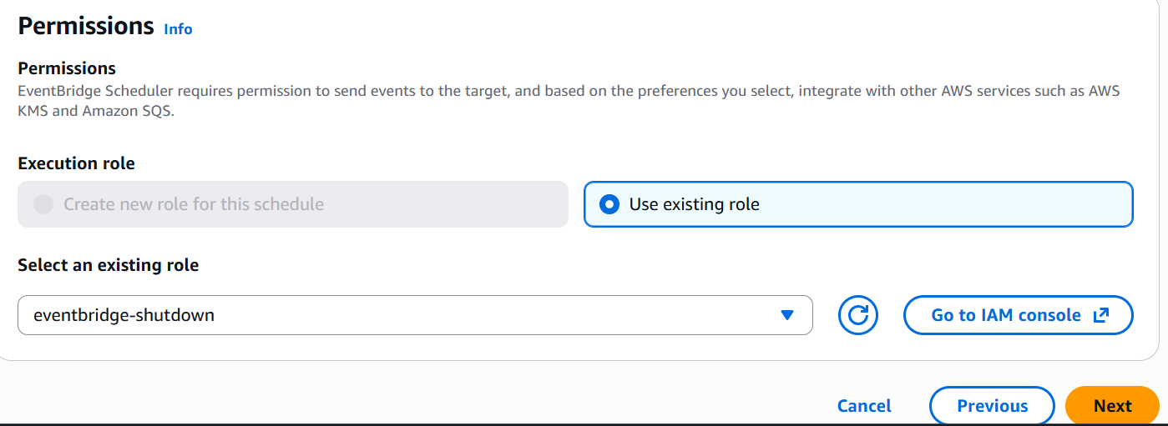

Review the schedule details on the final page, and at the bottom click Create schedule.

Wait for the scheduled time, You may need to click the Refresh instances button.
You'll see Instance state has changed, and it will soon settle on a state of Stopped.

