3 Tier Applications Setup Guide
This document provides a complete manual setup for 3-tier applications with the following components.

Client → DNS -> NGINX (Server 1) → Node.js API (Server 2) → MariaDB (Server 3)

Step 1.
Launch 3 instance in AWS (Ubuntu server)
- Nginx server (FRONTEND)
- Nodejs application server (Backend)
- Mysql server (Database server)
Step 2.
Open Port in security group
Nginx – 80
Nodejs – 3000
Mysql – 3306
Click on instance -> security -> security groups id -> click on sg-id -> edit inbound rules -> add rule
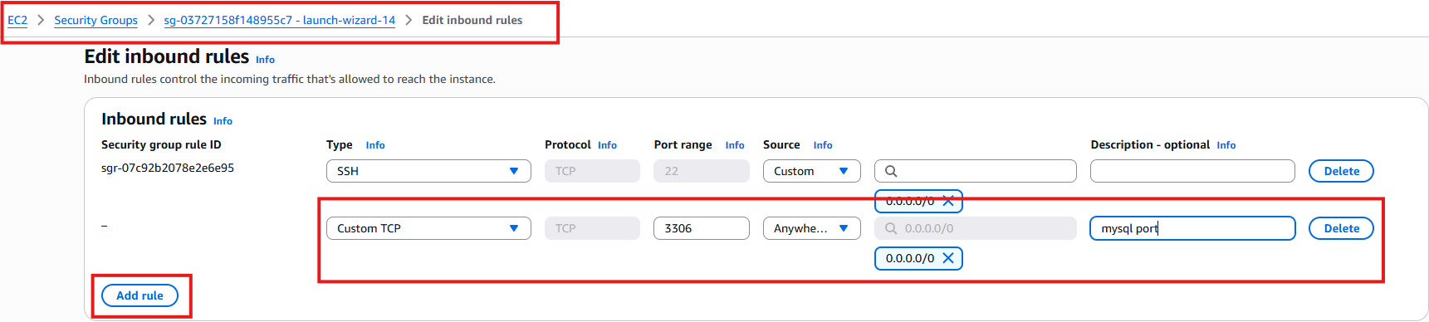

SImilary add for nginx server and mysql server
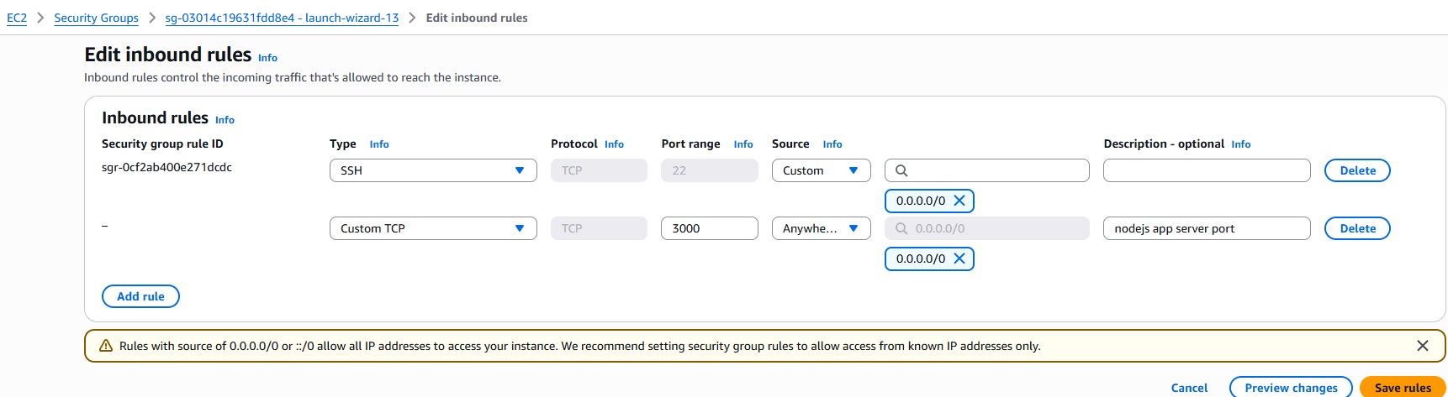

Open port for nginx server 80

Step 3.
Login to app server using public ip, I am using mobaxterm terminal
Switch to root user
#sudo -i
Set Hostname
# hostnamectl set-hostname nodejs-appserver
#su –
Install nodejs
#apt update -y
#apt install nodejs -y
#apt install npm
Project structure will be followed as:
/nodejs
|-- package.json
|-- .env
|-- server.js
|-- db.js
|-- public/
|-- index.html

#mkdir nodejs && cd nodejs
#vi package.json
{
"name": "simple-three-tier-api",
"version": "1.0.0",
"main": "server.js",
"type": "module",
"dependencies": {
"express": "^4.19.2",
"mariadb": "^3.2.0",
"dotenv": "^16.3.1"
}
}
Install npm dependencies
#npm install
#vi .env
PORT=3000-
DB_HOST=<DATABASE PRIVATE IP>
DB_USER=<DB user>
DB_PASS=<DB_PASSWORD>
DB_NAME=<DATABASE NAME>
We will create later database and add here

#vi db.js
import mariadb from "mariadb";
import dotenv from "dotenv";
dotenv.config();

export const pool = mariadb.createPool({
host: process.env.DB_HOST,
user: process.env.DB_USER,
password: process.env.DB_PASS,
database: process.env.DB_NAME,
connectionLimit: 5
});

export async function insert(sql, params) {
let conn;
try {
conn = await pool.getConnection();
return await conn.query(sql, params);
} finally {
if (conn) conn.release();
}
}

#mkdir public
#vi public/index.html
<!DOCTYPE html>
<html>
<head>
<title>Simple Webpage</title>
</head>
<body>
<h1>Welcome to the 3-Tier Application</h1>
<form id="orderForm">
<input type="text" id="name" placeholder="Customer Name" required><br><br>
<input type="text" id="item" placeholder="Item" required><br><br>
<input type="number" id="amount" placeholder="Amount" required><br><br>
<button type="submit">Add Order</button>
</form>

<p id="message"></p>

<script>
document.getElementById("orderForm").addEventListener("submit", async (event) => {
event.preventDefault();

const data = {
customer_name: document.getElementById("name").value,
item: document.getElementById("item").value,
amount: parseFloat(document.getElementById("amount").value)
};

const res = await fetch("/add-order", {
method: "POST",
headers: { "Content-Type": "application/json" },
body: JSON.stringify(data)
});

const result = await res.json();
document.getElementById("message").innerText = result.message || result.error;
});
</script>
</body>
</html>

#vi server.js
import express from "express";
import { insert } from "./db.js";
import dotenv from "dotenv";
dotenv.config();

const app = express();
app.use(express.json());

// ▶ Serve webpage from /public
app.use(express.static("public"));

// ▶ API: Insert Order
app.post("/add-order", async (req, res) => {
const { customer_name, item, amount } = req.body;

try {
const result = await insert(
"INSERT INTO orders (customer_name, item, amount) VALUES (?, ?, ?)",
[customer_name, item, amount]
);

res.json({
success: true,
message: "Order inserted successfully!",
id: result.insertId
});

} catch (error) {
res.status(500).json({ error: "Database error", details: error.message });
}
});

app.listen(process.env.PORT, () => {
console.log(`Node API running on port ${process.env.PORT}`);
});
Step 4.
Login to Database server
#sudo -i
# hostnamectl set-hostname database-server
#su -
#apt update -y
#apt install mariadb* -y
#systemctl restart mariadb
#mysql -u root -p
Will ask for password , enter directly
MariaDB [(none)]> create database appdb;
MariaDB [(none)]> CREATE USER 'appuser'@'%' IDENTIFIED BY 'P@ssword123';
MariaDB [(none)]> GRANT ALL PRIVILEGES ON appdb.* TO 'appuser'@'%';
MariaDB [(none)]> USE appdb;

CREATE TABLE orders (
id INT AUTO_INCREMENT PRIMARY KEY,
customer_name VARCHAR(100),
item VARCHAR(100),
amount DECIMAL(10,2),
created_at TIMESTAMP DEFAULT CURRENT_TIMESTAMP
);

MariaDB [appdb]> flush privileges;
#
# vi /etc/mysql/mariadb.conf.d/50-server.cnf
Change bind address from 127.0.0.1 to bind-address = 0.0.0.0
# systemctl restart mariadb
# systemctl status mariadb
In Application server .env add database server private ip, username, password, database name which we created in mysql server
#vi .env
PORT=3000
DB_HOST=172.31.79.9
DB_USER=appuser
DB_PASS=P@ssword123
DB_NAME=appdb
Now start application server
#npm start &
OR
#node server.js
Now you can check in browser http://<application_private_IP>:3000
Application is running and we can input the value it will automatically reflects in databases

Login to database
Mysql -u root -p
Use appdb;
Select * from orders;

But the issue is client and developers will never use 3000 port to access , client will use domain and internal developers will use IP for testing
Let’s configure nginx and map to domain DNS
Step 6.
Login to nginx server
#sudo -i
#hostnamectl set-hostname nginx-webserver
#su –
#apt update -y
#apt install nginx -y
# # vi /etc/nginx/sites-available/nodeapp.conf
server {
listen 80;
server_name yourdomain.com;

location / {
proxy_pass http://10.0.0.2:3000; # Node.js server IP

proxy_http_version 1.1;
proxy_set_header Upgrade $http_upgrade;
proxy_set_header Connection 'upgrade';
proxy_set_header Host $host;
proxy_cache_bypass $http_upgrade;

proxy_read_timeout 300;
proxy_connect_timeout 300;
}
}
Yourdomain.com -> if you have any domain register than add here
If you don’t have any domain register than add server_name _; this will resolve via IP
Proxypass http://<nodejs_application_privateip>:3000
# ln -s /etc/nginx/sites-available/nodeapp.conf /etc/nginx/sites-enabled/
# systemctl restart nginx
If server_name _; than you can check with your nginx IP:
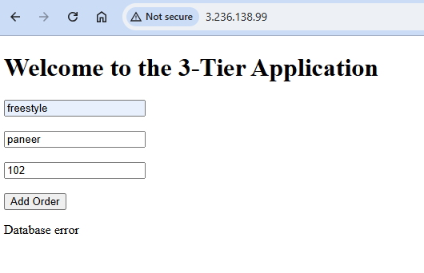
Map the nginx server to DNS
