CICD project
Tools: Jenkins, Tomcat server, AWS
Steps:
- Launch an Ec2 instance for Jenkins and Tomcat server in Aws Ec2
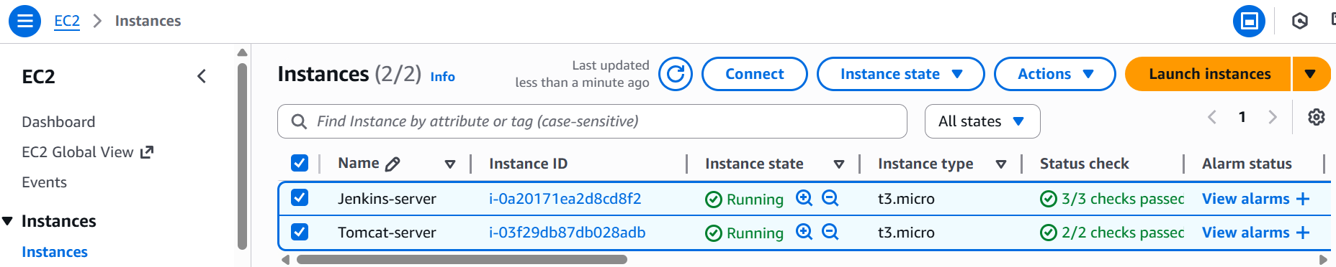
- Jenkins and Tomcat server both run on port 8080, so we have to enable in security group
Click on Jenkins server Security Security groups id Inbound rules Edit Inbound rules
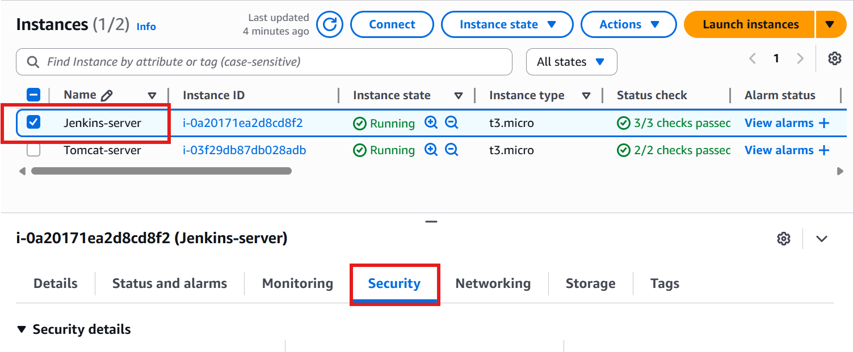
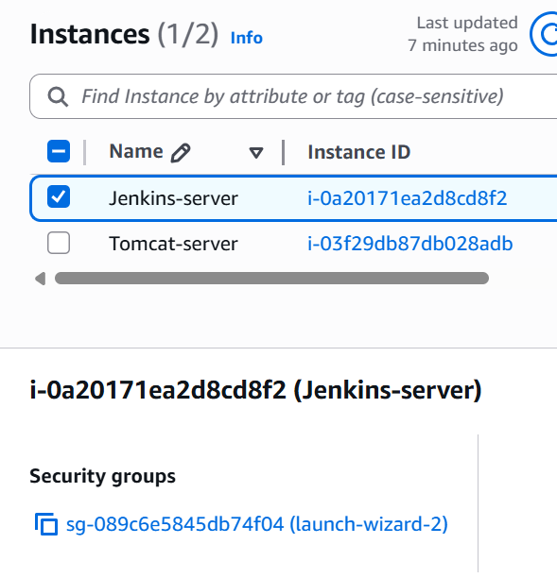
Click on Security groups ID
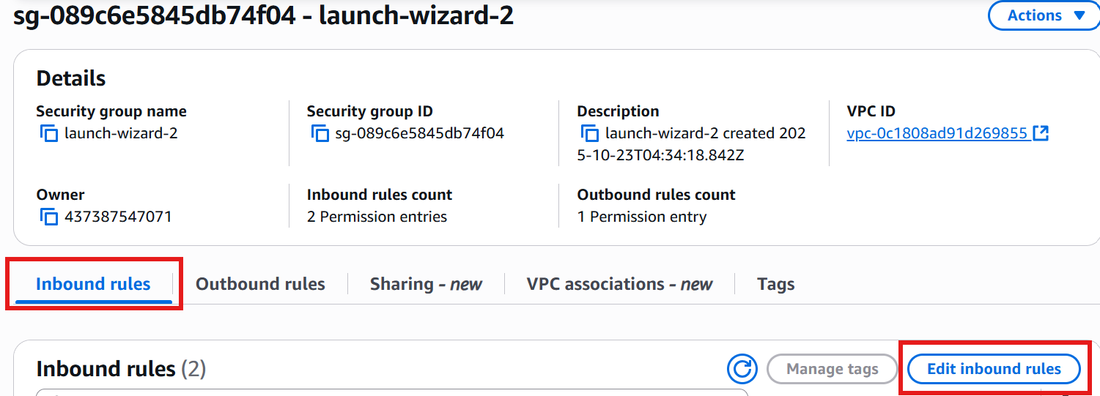
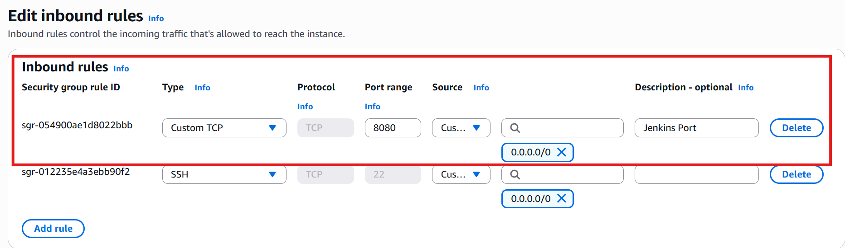For learning allow from anywhere but in company its not recommended.

Note: Same need to be performed for Tomcat server

Now login to Jenkins server and install Jenkins server, I am using mobaxterm
#hostnamectl set-hostname Jenkins-server
#sudo -i
#apt update -y
#apt upgrade -y

Use url to install Jenkins in ubuntu: https://www.jenkins.io/doc/book/installing/linux/#debianubuntu

#apt install fontconfig openjdk-21-jre -y
#java -version
#wget -O /etc/apt/keyrings/jenkins-keyring.asc \
https://pkg.jenkins.io/debian-stable/jenkins.io-2023.key
echo "deb [signed-by=/etc/apt/keyrings/jenkins-keyring.asc]" \
https://pkg.jenkins.io/debian-stable binary/ | sudo tee \
/etc/apt/sources.list.d/jenkins.list > /dev/null

#apt update -y
#apt install jenkins -y
#systemctl status jenkins
#systemctl enable jenkins

Copy Jenkins server Public IP and paste the url in browser with port 8080
<Ec2_Public_IP>:8080 example: http://50.16.159.64:8080/
You will get the Jenkins page get the password from ( cat /var/lib/jenkins/secrets/initialAdminPassword ) and install suggested plugins it will ask for Create first admin user give your username and password Save and continue ALL DONE
Jenkins is ready now!
===========Install and Configure Maven==================================
https://maven.apache.org/install.html
cd /opt
# wget https://dlcdn.apache.org/maven/maven-3/3.9.11/binaries/apache-maven-3.9.11-bin.tar.gz
#tar -xvzf apache-maven-3.9.11-bin.tar.gz
#ls
# mv apache-maven-3.9.11 maven
#cd maven/bin
#./mvn -v
#cd ~
#vi .bashrc
Add below lines in the last
export MAVEN_HOME=/opt/maven
export MAVEN_BIN=/opt/maven/bin
export JAVA_HOME=/usr/lib/jvm/java-21-openjdk-amd64
export PATH=$PATH:$MAVEN_HOME:$MAVEN_BIN:$JAVA_HOME/bin
:wq!
#source .bashrc
#echo $PATH

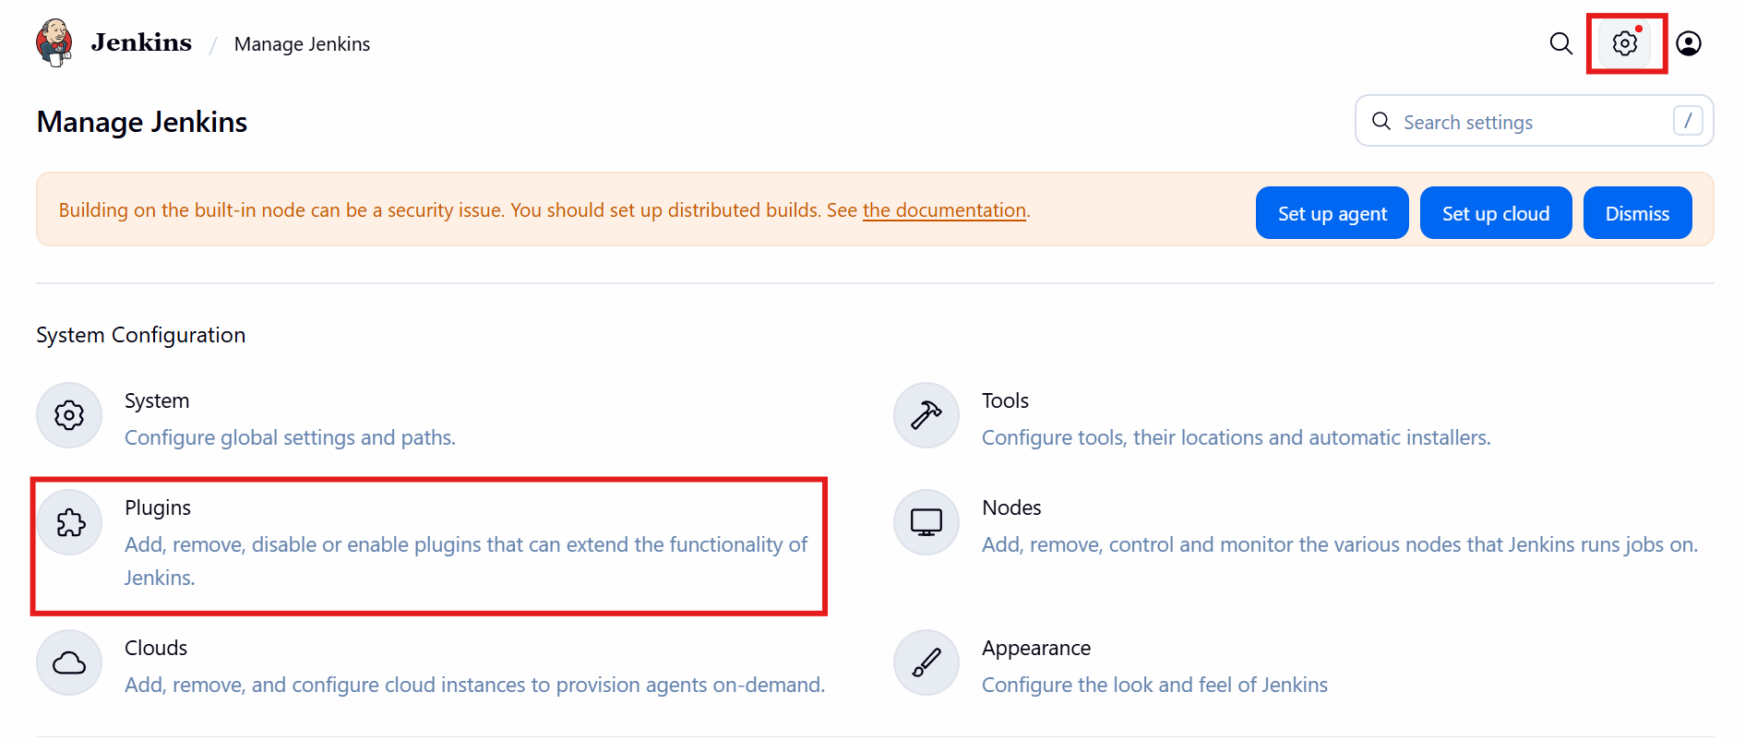

Install maven plugin
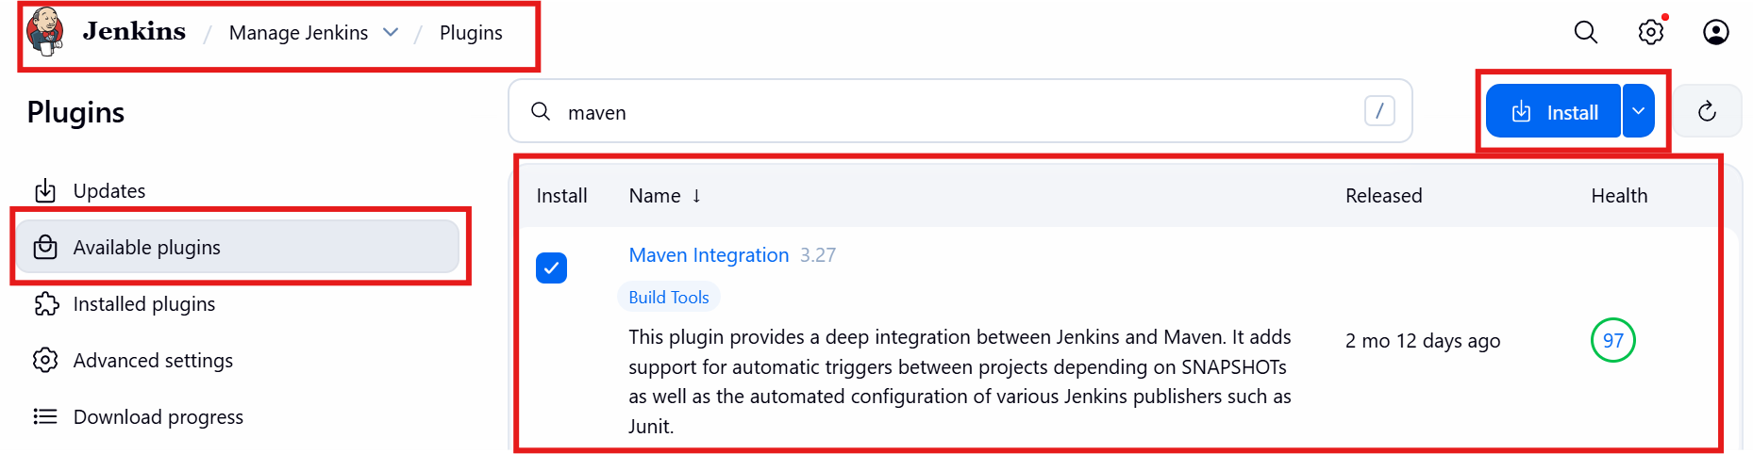

In plugins section, install github plugins ( Generic Webhook TriggerVersion2.4.1, GitHub Integration , GitHub Authentication, Pipeline: GitHubVersion2.8-162.382498405fdc, Pipeline Maven Integration, Ssh , Ssh agent, Publish over SSH, SSH pipeline steps, Deploy to container )

You can restart Jenkins by adding this in url <IP>/restart http://50.16.159.64:8080/restart

Now add the tools for maven and jdk installed path
Jenkins Manage Jenkins tools
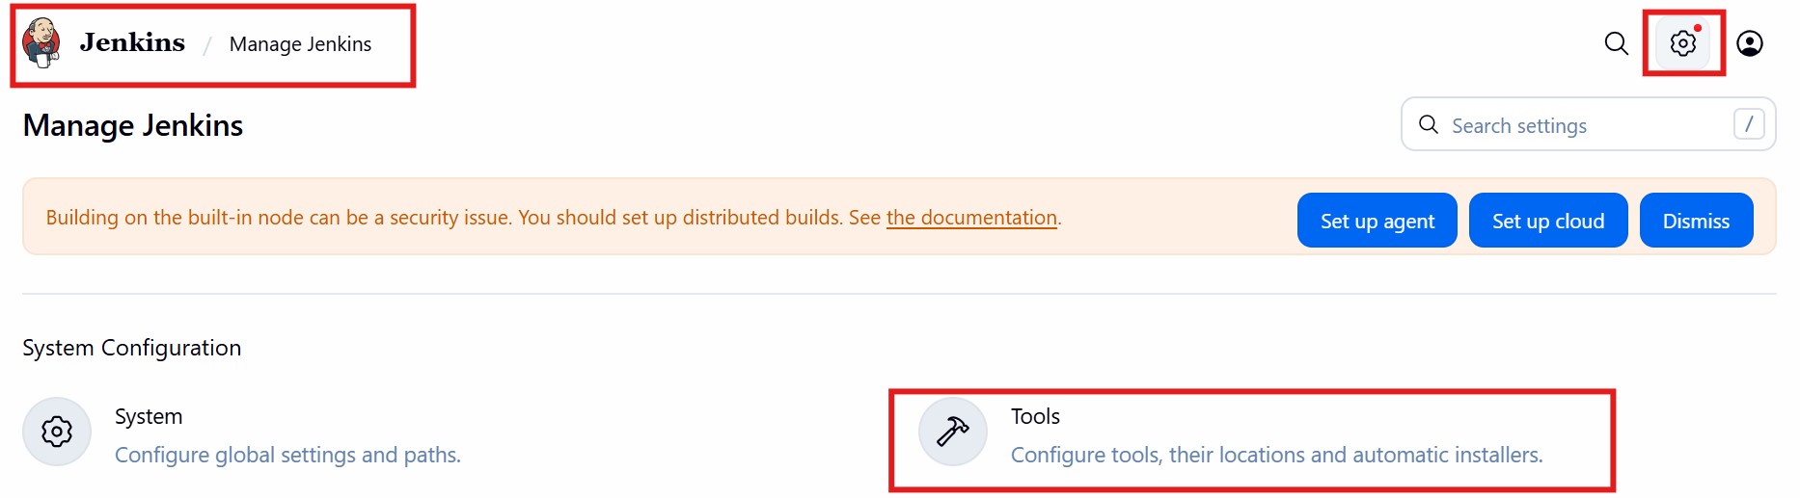

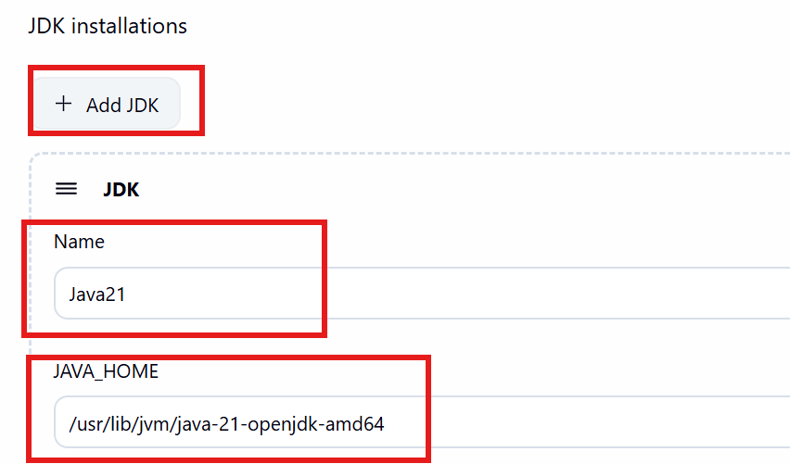
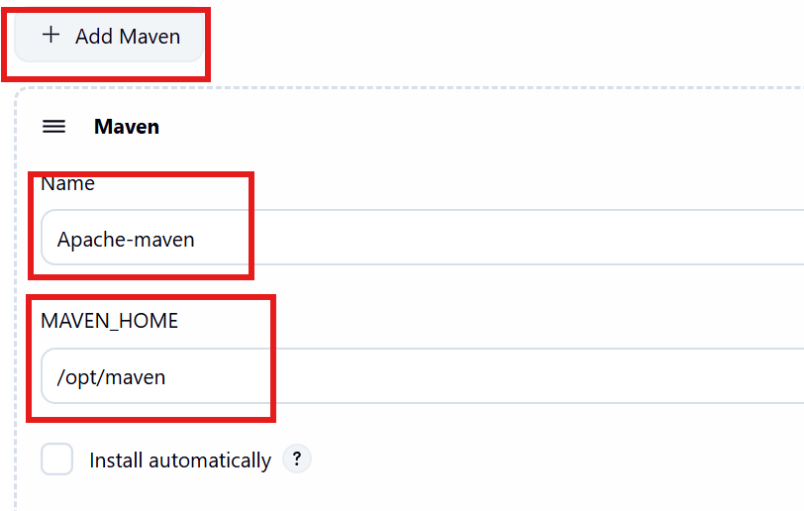

APPLY and SAVE

################################################################
Copy the download link from https://maven.apache.org/download.cgi
Now install Tomcat server

Login to tomcat server
#sudo hostnamectl set-hostname tomcat-server
#sudo -i
#apt update -y ; apt upgrade -y
# apt install openjdk-21-jre -y
Copy url: https://dlcdn.apache.org/tomcat/tomcat-10/v10.1.48/bin/apache-tomcat-10.1.48.tar.gz
#cd /opt/
#wget https://dlcdn.apache.org/tomcat/tomcat-10/v10.1.48/bin/apache-tomcat-10.1.48.tar.gz
#apache-tomcat-10.1.48 directory will get extracted
#rename to tomcat : #mv apache-tomcat-10.1.48 tomcat
#cd /opt/tomcat/bin/
#./startup.sh

Check in browser with tomcat Public IP: http://3.88.175.89:8080/

Tomcat server should be up and running.
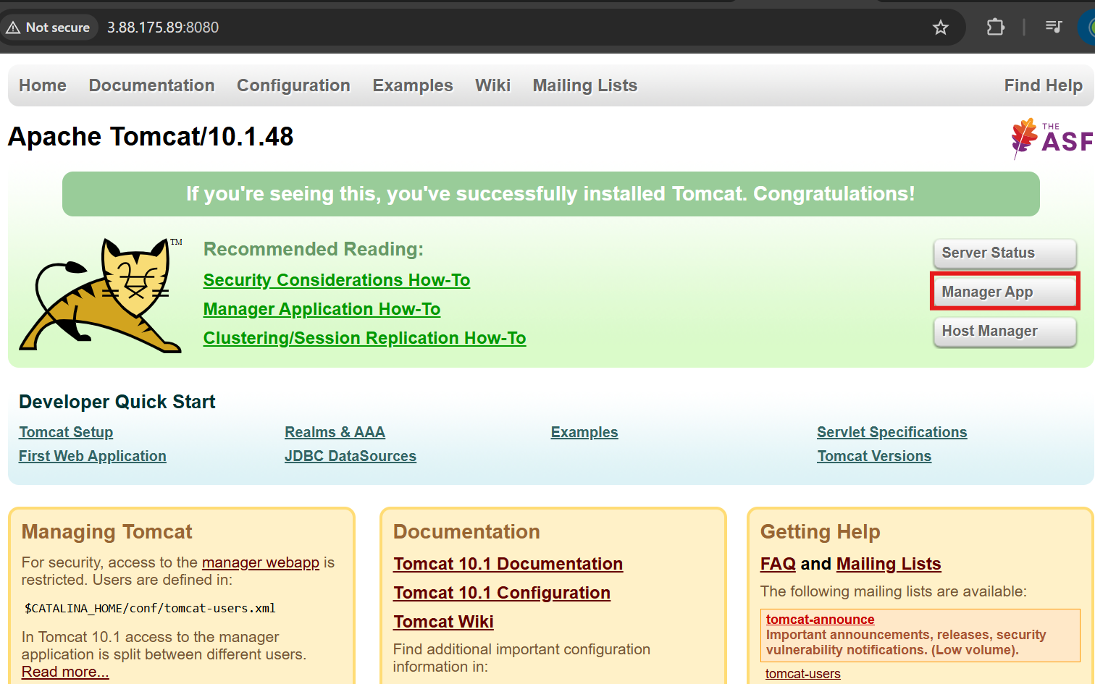

Click on the manager app,bydefault the user don’t have an access it is restricted only loop address can be accessed.

Go to
vi opt/tomcat/webapps/host-manager/META-INF/context.xml
vi opt/tomcat/webapps/manager/META-INF/context.xml
Go to last line and comment below lines
<!-- <Valve className="org.apache.catalina.valves.RemoteAddrValve"
allow="3\\.88\\.175\\.89" /> -->
To comment xml file we have to add starting <!-- and ending with -->
#cd /opt/tomcat/conf/tomcat-users.xml file and add user and roles
<role rolename="manager-gui"/>
<role rolename="manager-script"/>
<role rolename="manager-jmx"/>
<role rolename="manager-status"/>
<user username="admin" password="admin" roles="manager-gui, manager-script, manager-jmx, manager-status"/>
<user username="deployer" password="deployer" roles="manager-script"/>
<user username="tomcat" password="s3cret" roles="manager-gui"/>
</tomcat-users>
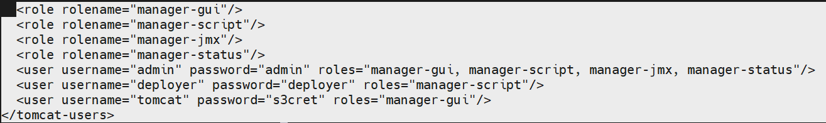
#cd /opt/tomcat/bin
#./shutdown.sh
#./startup.sh

Refresh the tomcat webpage and click on Manager app
Username: admin
password: admin
###################################################################
Jenkins
Go to Jenkins webpage
New item Name: Maven Project Select Maven project
Configure Source Code management
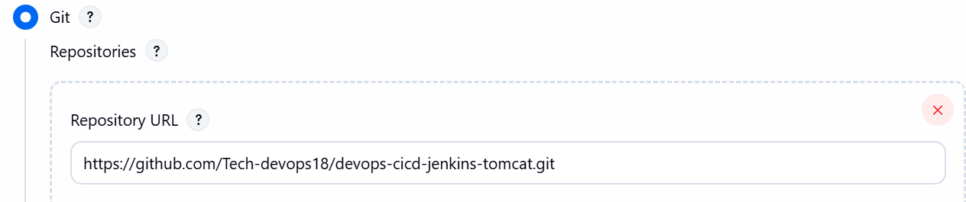
Slect branch as main
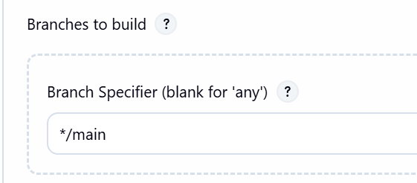
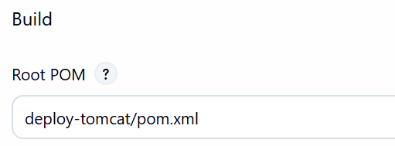
Check the deploy to container plugin is installed
In Post build action, select deploy war to container
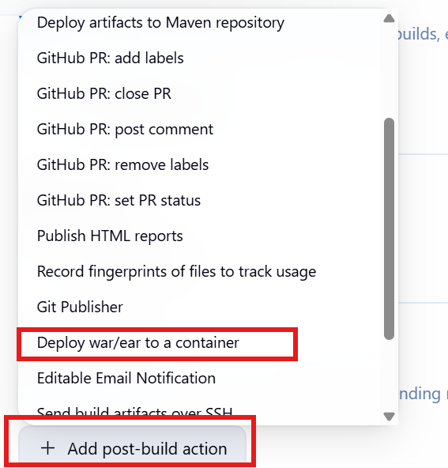
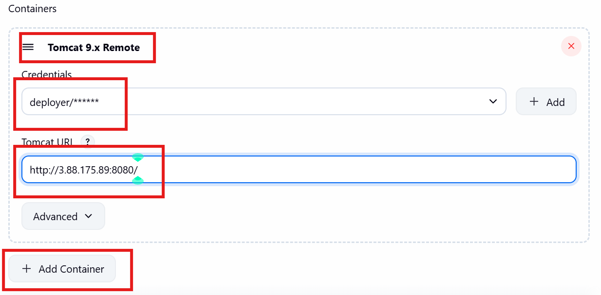
For credentials add it username and password as deployer

Apply and save
Build now

