Set-Up Cross-Region S3 Bucket Replication

Introduction
In this lab, you are going to dive into how to create Cross-Region Bucket Replication! This replication is done to have files protected, plus, if a region wide event takes down S3, you will always be able to access your files!

Step 1:
Search for S3 in AWS Management Console, Click on S3
Make sure you're using the us-east-1 region, United States (N. Virginia)
Create an S3 Bucket
- At the S3 , click on the Create bucket
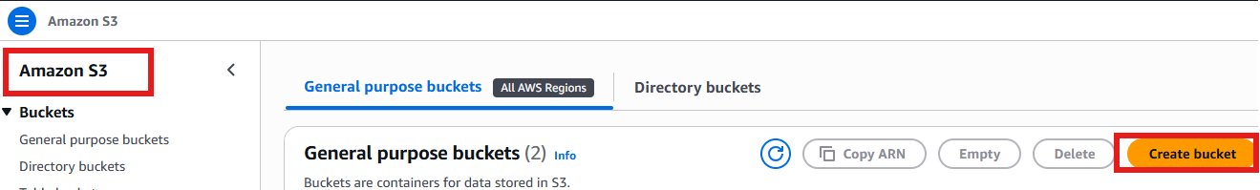
- Under Bucket name type in cross-region-source-from (It needs to be unique, replace <numbers> appropriately)
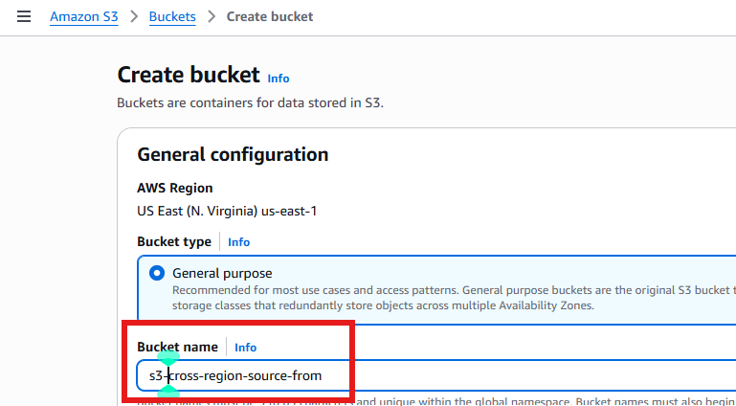
- Scroll down a bit, and under Bucket Versioning, click Enable
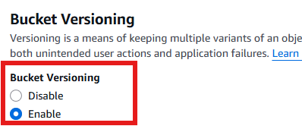
- Click Create bucket

Upload image file

- Click on the bucket you created
- Click on the upload button
- Select Add files
- Select any files or images from you local desktop
- Click on Upload

Create a destination S3 bucket
First change from United States (N. Virginia) to United States (Oregon us-west-2)
Follow the same to create a destination bucket in Oregon
- Under Bucket name type in cross-region-destination<numbers>
- Click Enable under Bucket Versioning
- Click Create bucket

Click on the source bucket that 1st you created
Select the management Tab
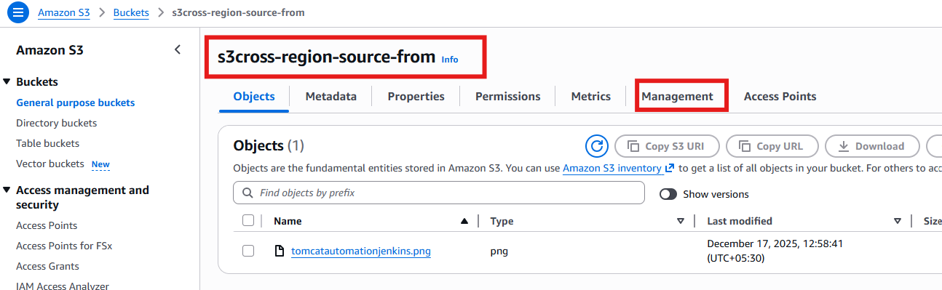

- Click on Create replication rule
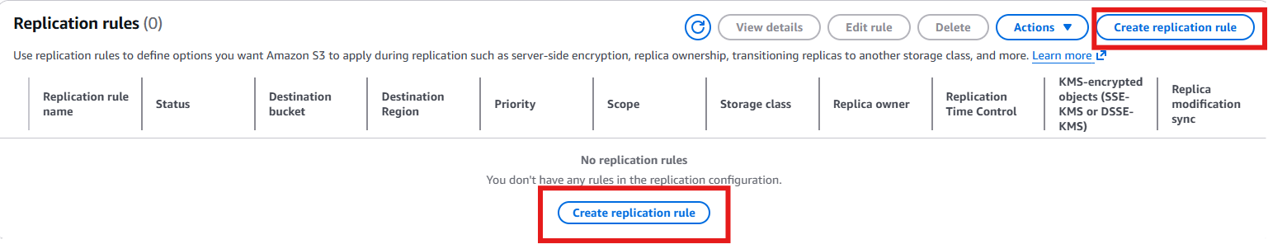
- Under Replication rule name type data-replication
- Select Apply to all objects in the bucket
- In Destination Click on Browse and Select the destination bucket you created
- Select Create New role in Iam Role Options
- Click on Save
- On the Replicate existing objects? Pop-up, select Yes, replicate existing objects. Then Submit
- Under Completion report destination hit Browse S3
- Under Permission, select Create new role
- Hit Save
- Wait for the Status to get completed, clicking Refresh periodically.
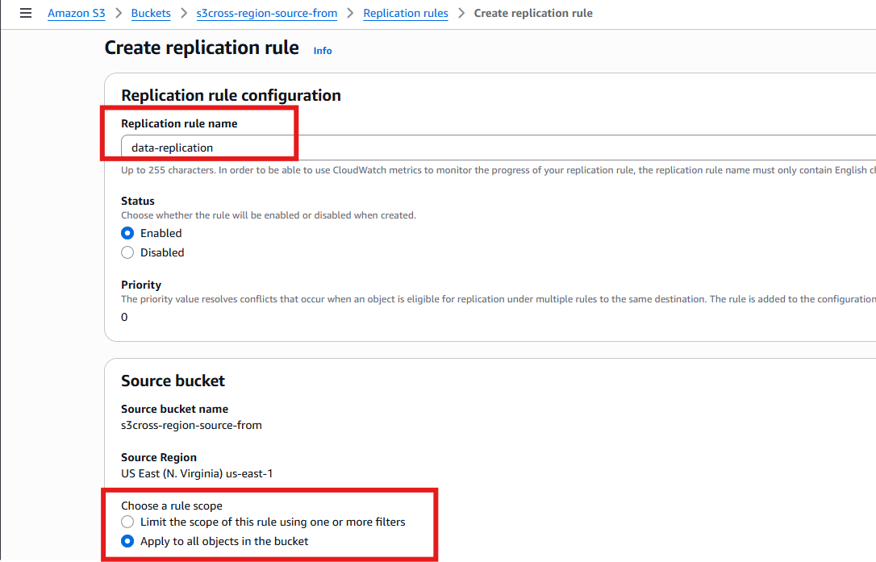
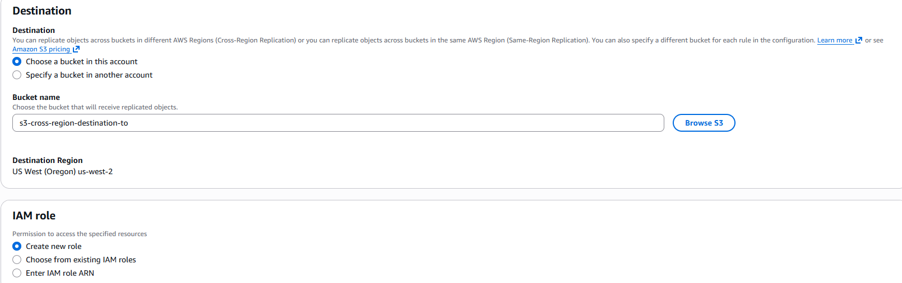

Click on Save

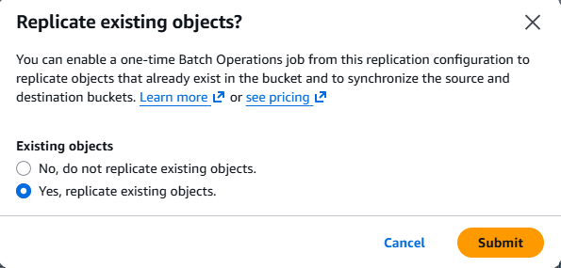
Tick on yes option and submit.
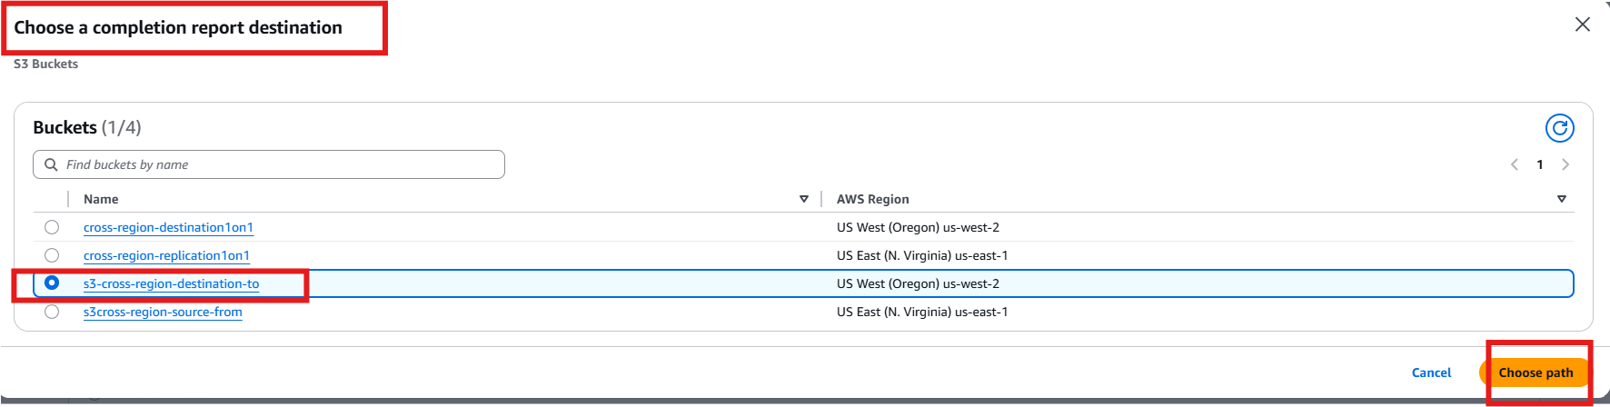
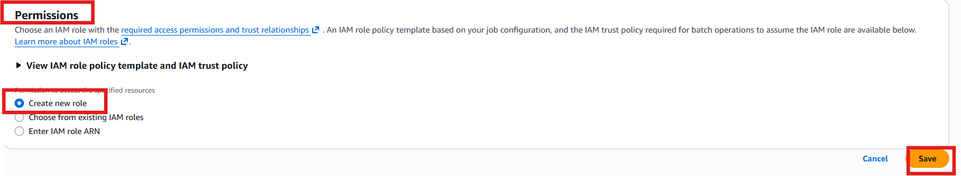

The replication is confirmed as source image appears in the destination bucket too!

Confirm replication
Click the cross-region-source bucket link
- Click on the Upload Button
- Click Add files
- Click the Upload button
- Select the Buckets link in the top left of the screen
- Select the cross-region-destination bucket
- Hit the Refresh button until the files shows up in the destination bucket. It will either appear right away, or will take about 30 seconds to appear.

