RMA System Illustrated User Guide
  - Receiving shipping inventory and administration
English edition | 9 October 2026
Use this guide to receive and label each returned unit, record photos and inspection, prepare pallets, ship eligible units, and review the results. It also covers inventory, historical records, account approval, and administrator settings.
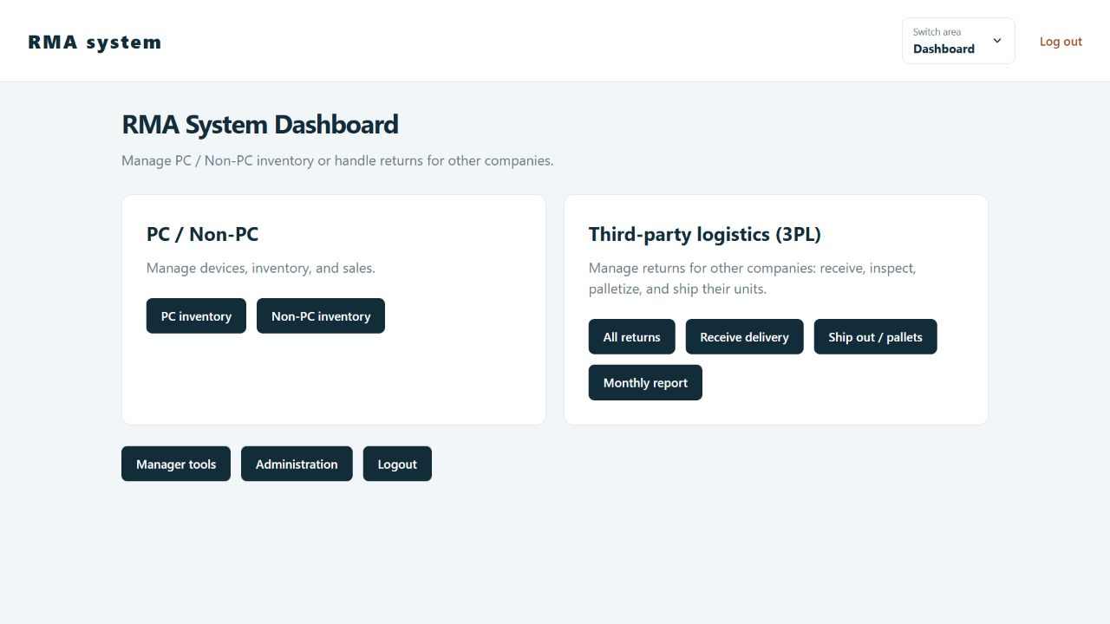
The Dashboard separates your inventory from Third-party logistics (3PL), which manages returns for other companies.

The daily workflow
Receive > Record > Photograph > Inspect > Palletize > Ship > Report
Each unit has its own internal ID and printed File Number. Units arriving together form a delivery; matching tracking numbers appear together in Returns. Always check the physical item against its File Number before updating it.
For training: Screens show a separate training copy with sample companies, accounts, and records. Follow your workplace receiving, grading, packing, and dispatch procedures alongside these software instructions. Screens and data available to you depend on both company access and action permissions. Most screenshots show a training admin view.

Start here

Find the task you need
Understand your company access 3
Find and sort returns 4
Receive a delivery 5
Add unit photos and save 6
Open records and print labels 7
Inspect a unit 8
Photograph and classify saved units 9
Prepare pallets 10
Ship eligible units 11
Review shipment history 12
Read monthly reports 13
Work with previous records 14
Manage and restore returns 15
Maintain types and companies 16
Use PC inventory 17
Use Non PC inventory 18
Manage accounts 19
Assign company access 20
Set department permissions 21
Review history exports and backups 22
Use the older SnowBell workflow 23
Permission reference 24
Troubleshooting and shift checklist 25

Register and sign in
Open the address supplied by your administrator. Choose Register, enter a username, a password of 12 to 255 characters, and the displayed Pending assignment department. An admin assigns your department and company access before approving your registration. Log in only after approval and while your account is Active. Use Log out when finished on a shared device.

Navigate the app
Choose Switch area for Dashboard, Third-party logistics (3PL), PC inventory, Non-PC, Reports, or Admin. The 3PL tabs retain their names: Returns, Ship out, Monthly report, Previous records, Manage records, and Types & companies. Swipe or scroll the tab row when it does not fit.
On a phone, forms stack vertically. Scroll within wide tables for more columns. Back to listing returns to the list you opened the item from, keeping filters and page position where supported. On another device, localhost means that device; use the server address supplied by your administrator.

Understand your company access
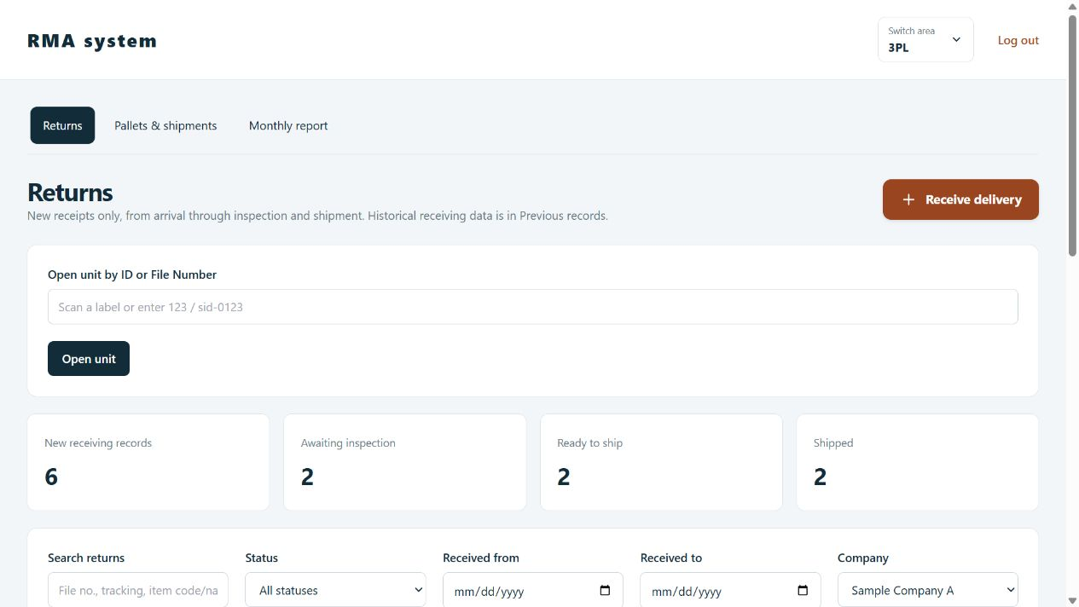
Customer A sees only Sample Company A in company options and returned records. Other customers are not listed.
Your department determines which companies you can access and which actions you can perform. You need both. Being assigned a company does not automatically allow receiving, inspection, shipping, or exports.
1. Use the Company filter or receiving Company field. Only companies assigned to your department are offered. A single available company is selected automatically when receiving.
2. Search or open a File Number within your assigned company data. A direct link to another company does not grant access and may show Record not found.
3. Read counts as totals for the data you can access. Records, photos, historical lists, pallets, shipment contents, reports, and exports follow the same company limits.
4. If your company or records are missing, ask an admin to check your account department, company assignment, and action permissions. Do not create a second company or guess another company name.
An account with no company assignment and no all-company grant cannot see or receive company data. Unspecified records are available only to admins and internal departments with all-company access.
A mixed-company pallet shows only your accessible units. Customer departments cannot add units to a pallet containing items outside their company access or change the status of that shared pallet. Ask warehouse staff to handle shared pallets.
Admin accounts can access all companies. PC inventory, Non-PC inventory, the older SnowBell workflow, inventory reports, and the staff directory require internal all-company access as well as their action permissions.

Find and sort returns
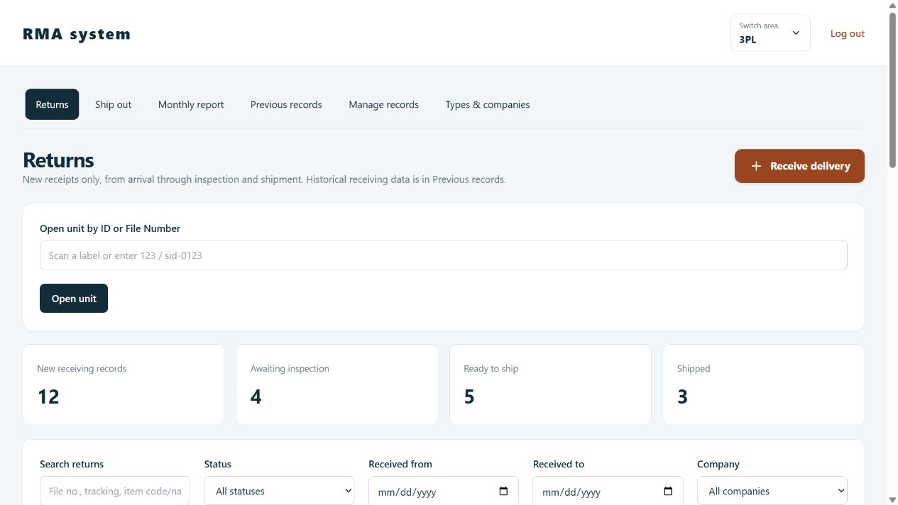
Returns provides unit lookup, filters, sorting, and tracking-number groups.
1. Open Third-party logistics (3PL) > Returns. This list contains receipts entered through the new receiving workflow. Imported historical receiving data is in Previous records.
2. Use Open unit by ID or File Number, enter an exact number such as 9 or sid-0009, and choose Open unit. This lookup can also open an accessible historical unit by its identity.
3. Use Search returns, Status, Received from/to, Company, Bulk type filter, and Pallet filter together. The received-date range includes both endpoints. Filters update as you type or select.
4. Click a column heading to change sorting, or use Sort by and Sort direction. Sorting applies before pagination. Matching tracking numbers stay in one group; expand or collapse a group by its header.
5. Use Refresh, Clear filters, Previous, and Next as needed. Each page contains up to 50 tracking/delivery groups, so it can show more than 50 units.
Read the counts: Quantity describes the accessible matching group; a filtered result may show only some units. Blank tracking numbers stay grouped by their own delivery. Separate deliveries sharing a tracking number retain separate unit identities.

Receive a delivery
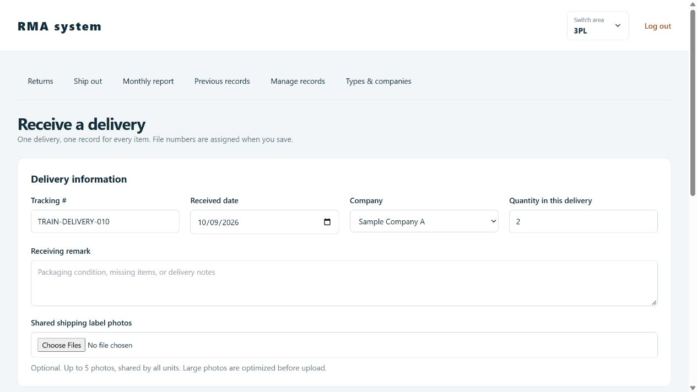
Delivery information is shared by the units saved together. The training example has a quantity of two.
Open: Dashboard > Receive delivery, or Returns > the prominent Receive delivery button. You need Receive deliveries permission; photos also require Add unit photos permission.
1. Scan or enter Tracking # if available. Check the required Received date and choose Company. Choose an assigned company. Only admins and internal staff with all-company access can use Unspecified.
2. Enter Quantity in this delivery, from 1 to 100. The form creates one item row for each physical unit. + Add item and Remove last item also adjust the quantity.
3. Add a Receiving remark describing packaging, missing items, or delivery notes.
4. Optionally choose Shared shipping label photos. These photos belong to the entire delivery, not one item. Up to five JPEG or PNG files are allowed.
5. Continue to the item rows below. Enter a separate serial number for each item if available; pallet assignments are made during inspection.
Check quantity first. Reducing the quantity removes the last unsaved unit rows and their entered information. Reusing a tracking number creates additional records; it does not replace an earlier delivery.

Add unit photos and save
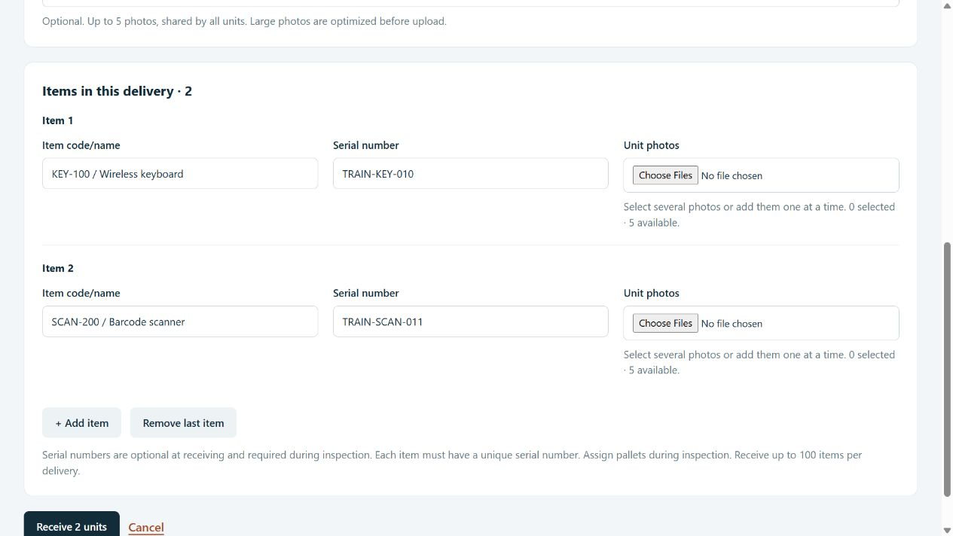
Each item has its own Item code/name, Serial number, and Unit photos fields.
1. Enter Item code/name for each item, such as KEY-100 / Wireless keyboard. Receiving supports general items, not only laptops.
2. Enter its Serial number if available. It is optional at receiving and required during inspection. Nonblank serials must be unique, including across different letter case; a duplicate rejects the delivery.
3. Choose Unit photos for that item. Select several photos or add them one at a time. Review the selected filenames; remove an incorrect unsaved selection before saving.
4. Check every unit row and the delivery quantity. Choose Receive N units once and wait for the received confirmation.
5. The confirmation provides one permanent File Number per unit. Use Print all file labels if you have printing permission, then match each label to the correct physical unit.
6. Open a File Number to continue, choose View returns, or choose Receive another delivery for the next parcel.
Photo limits: JPEG and PNG only. Each unit can have up to five photos in total; the delivery can have up to five shared label photos. Large 3PL photos are optimized before upload, and each resulting file must be no larger than 4 MB.
Uncertain save: If the connection fails before you see the result, search for the tracking number and received date before submitting again. Another successful submission creates another set of units.

Open records and print labels
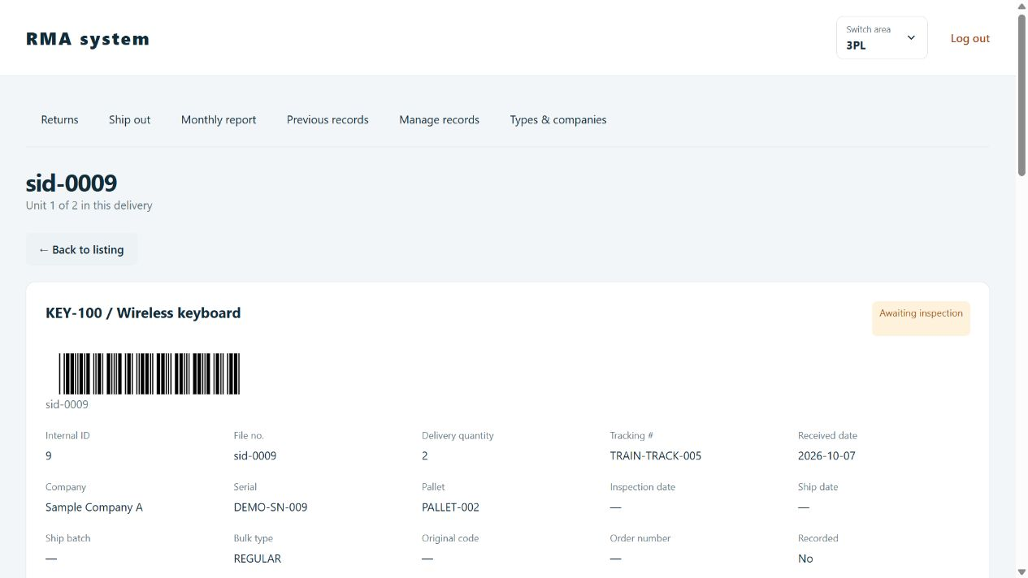
The File Number and barcode identify one unit throughout receiving, inspection, and shipping.
1. Open the unit from Returns, a pallet, a shipment, or the ID/File Number lookup. Match the displayed item code/name and tracking information to the physical item.
2. Review its delivery quantity, company, serial, pallet, inspection date, ship date, batch, bulk type, and remarks. Historical fields such as original code and order number remain available.
3. Choose Print file label for a unit label, or Print unit record for the full record. At receiving confirmation, Print all file labels prints every unit from that delivery.
4. For 3PL labels, use 100 x 50 mm paper and check scaling in the browser print dialog. Test one label and its barcode with your scanner before printing a larger set.
5. Use Other items in this delivery to open a sibling, or Back to listing to resume the originating list.
The numeric internal ID and sid-prefixed File Number identify the same unit. They stay fixed when authorized staff edit a record. A parcel tracking number can be shared by many units; it is not a substitute for an individual File Number.

Inspect a unit
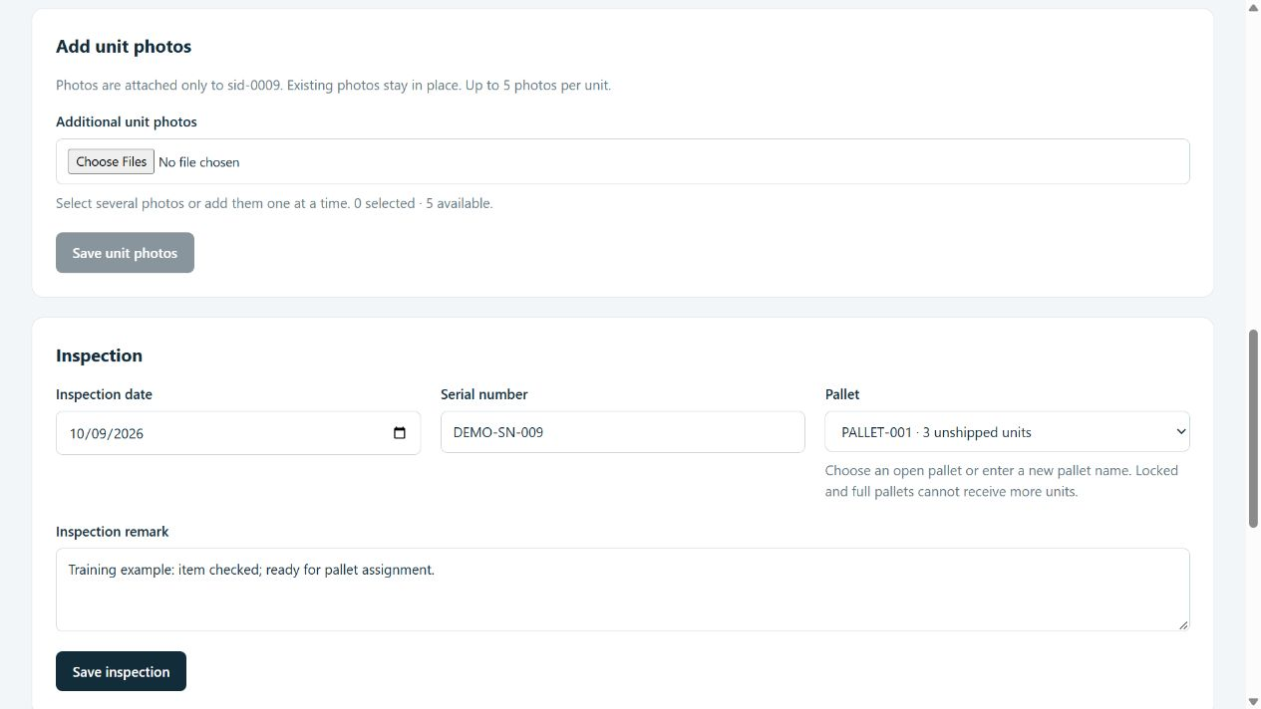
Inspection reuses a serial captured at receiving and records the inspection date and pallet. Adding photos has its own Save button.
1. Open the correct File Number and scroll to Inspection. If the record says quantity is not recorded, an authorized receiver must first confirm the delivery quantity.
2. Enter Inspection date and check Serial number. A serial saved at receiving is prefilled; otherwise enter it now. Both fields are required. The serial must not already belong to another unit, including one using different letter case.
3. Choose an existing open Pallet, choose Enter a new pallet and enter its name, or leave it Unassigned. Inspection can be saved without a pallet, but the pallet shipping screen needs a pallet assignment.
4. Enter an Inspection remark with findings or handling instructions. Choose Save inspection and wait for Inspection saved.
5. Check the saved status and pallet. Save photo changes separately with Save unit photos.
Duplicate serial: Check the serial against the item and search your accessible records. Ask an admin to investigate conflicts outside your company access. Do not invent a serial to bypass the check.
Locked and Full pallets cannot accept new assignments. Shipped units have a completed inspection screen; use authorized record management for corrections. Shipping is a separate action.

Photograph and classify saved units
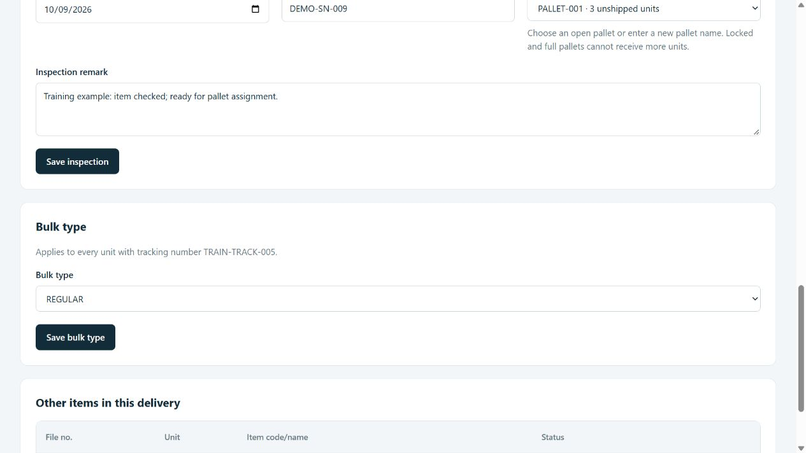
Bulk classification applies to accessible units with the displayed tracking number.

Add more photos
On the unit record, review Shipping label photos and Unit photos. Click a thumbnail to open it larger. Under Add unit photos, choose additional files and select Save unit photos. Existing photos stay attached and count toward the five-photo limit. Removing a filename from the picker only removes an unsaved selection; this form does not delete saved unit photos.

Change the bulk type
1. Choose an available Bulk type. REGULAR is the default; BULK_NEW is another preset. Admins maintain the available options.
2. Read the tracking-number notice, then choose Save bulk type.
3. Check the confirmation and updated-unit count. With a nonblank tracking number, classification applies to matching units within your company access, including separate receipts and historical units. It cannot update another company outside your access. With no tracking number, it applies only to this unit.
Bulk type is classification. It does not inspect the unit, assign a pallet, or mark it shipped. Changing company/type options is an admin task in Types & companies; choosing an existing type requires classification permission.

Prepare pallets
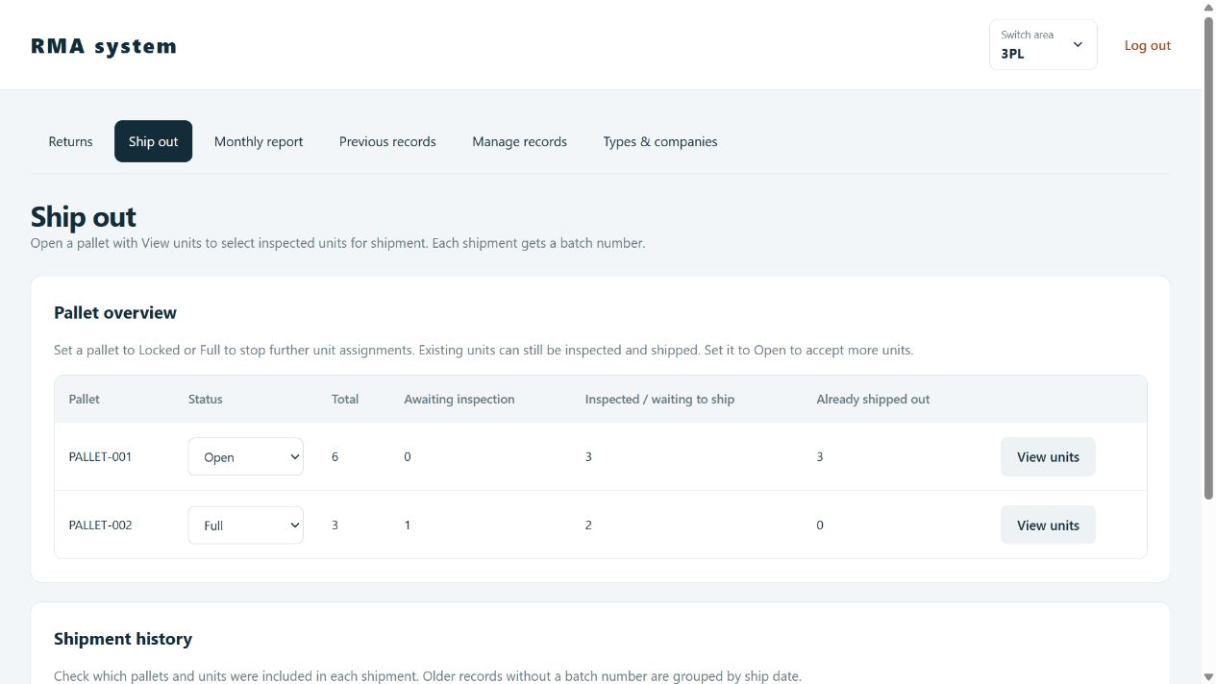
Pallet overview counts accessible units, including those already shipped.
Open Ship out. Staff who can view pallets but cannot ship see Pallets & shipments instead. Choose View units to open a pallet immediately in a dialog.
Column or status | Meaning
Total | Accessible units still associated with this pallet.
Awaiting inspection | Units without a completed inspection and not shipped.
Inspected / waiting to ship | Inspected units not yet shipped.
Already shipped out | Units already marked shipped. Review them without shipping again.
Open | Accepts new unit assignments.
Locked or Full | Blocks additional unit assignments. Existing units can still be inspected and shipped.

With Lock, fill, and reopen pallets permission, choose a status in the pallet row and wait for confirmation. Full or Locked does not mean shipped. Company-limited users cannot change the status of a pallet containing items outside their access.

Ship eligible units
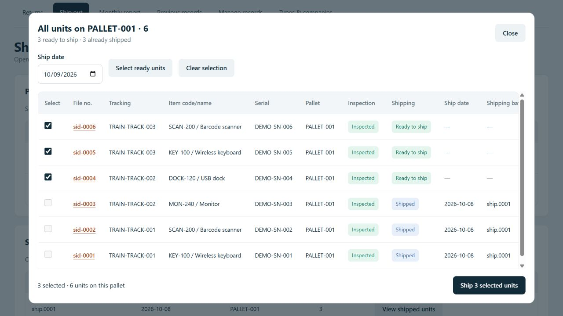
The pallet dialog keeps the ship date, selection tools, unit details, and shipment button together. This example is selected but not submitted.
1. Choose View units on the intended pallet. Only units within your company access appear. Check the pallet name, File Numbers, serials, and counts.
2. Enter the correct Ship date. Select eligible units individually or choose Select ready units. Clear selection starts the selection again.
3. Review the selected count and the physical pallet. Uninspected units and units already shipped are not eligible. At most 1,000 units can be submitted in one selection.
4. Choose Ship N selected units once. The server checks eligibility, creates a shipping batch, and marks eligible units shipped. Wait for the shipped count and batch number.
5. Close the dialog and review the updated pallet and Shipment history. If only part of a pallet shipped, its remaining units can ship in another batch later.
If another staff member changed a unit, the server may skip it. Refresh and verify the actual shipped count and batch contents before retrying. The screen records dispatch; it does not book a carrier or create a carrier shipping label.
Staff with viewing permission can open the same contents without shipping controls. Pallet-status permission and Ship units permission are separate.

Review shipment history
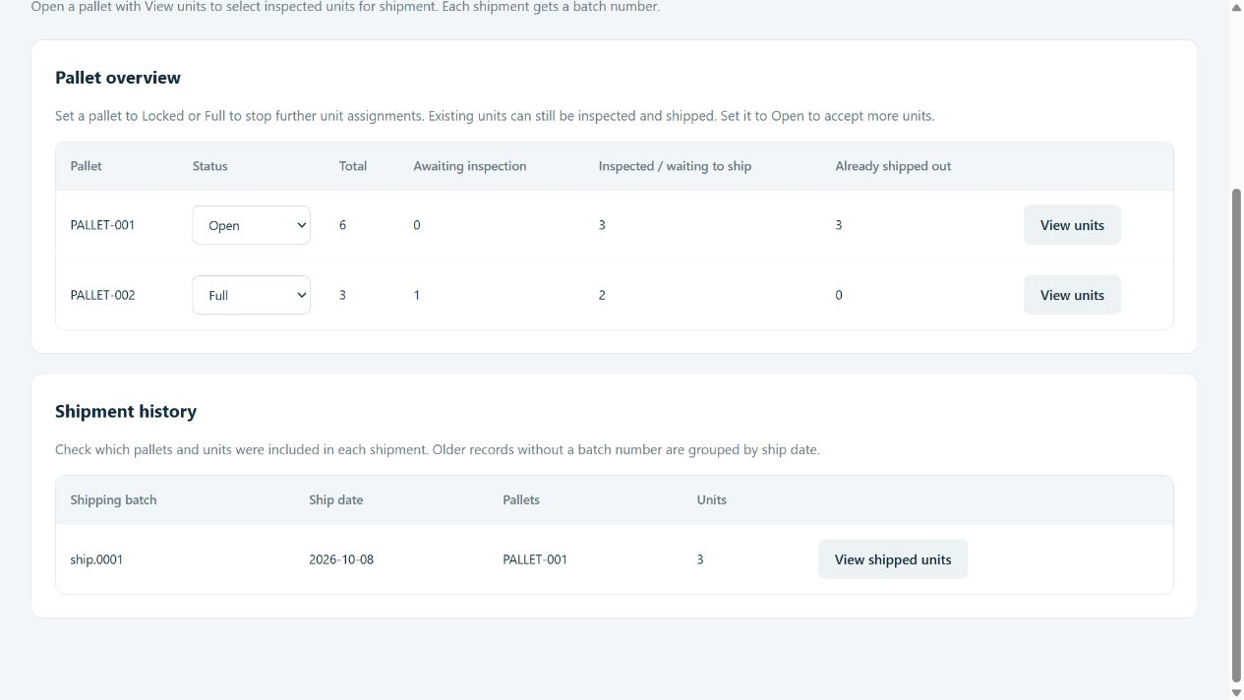
Shipment history links each shipping batch to its dates, pallets, and individual units.
1. Open Ship out or Pallets & shipments and find Shipment history below the pallet overview.
2. Read the Shipping batch, Ship date, Pallets, and Units columns. Use Previous shipments and Next shipments for additional pages.
3. Choose View shipped units to open the batch units within your company access. Review File Number, tracking, serial, pallet, inspection/shipping status, ship date, and batch.
4. Open a File Number if you need the full unit record. Use Back to listing to return to the shipping page.
A batch is a shipment event, not a pallet name. One pallet can appear in several batches if shipped in parts. Older shipped records without a batch number appear as No batch recorded and are grouped by ship date.
The history dialog is for review and has no second shipment action. Viewing pallet and shipment details is enough for this task; Ship units permission is not required.

Before handing over a shipment
Check the physical unit count, the saved shipped count, and the File Numbers in the batch. Give the batch identifier to the next person according to your workplace process. If the outcome of a save was unclear, verify history before submitting again.

Read monthly reports
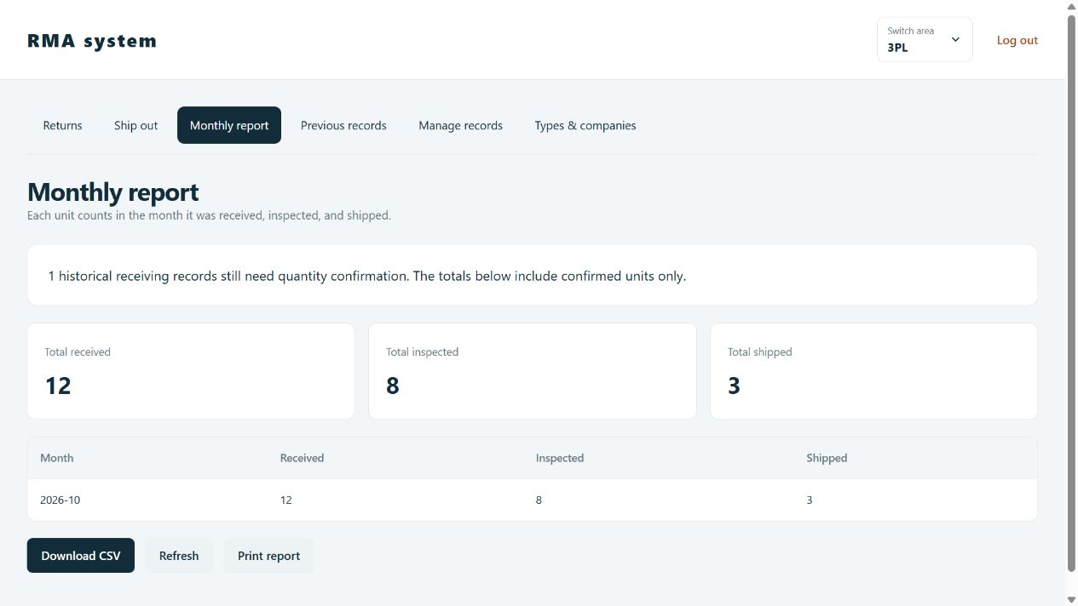
Monthly report separates received, inspected, and shipped events. Historical records with unknown quantities are identified separately.
1. Open Monthly report. Read overall Total received, Total inspected, and Total shipped.
2. Review each month. A unit counts by its received date for Received, inspection date for Inspected, and ship date for Shipped. These events can occur in different months.
3. Use Refresh for current totals, Download CSV for the summary, or Print report.
Historical quantities: The report includes confirmed units within your company access from the shared receiving data, including confirmed historical units. Historical records still awaiting quantity confirmation are excluded from unit totals and shown in a separate notice. Confirming a historical quantity does not move it into the new Returns list.
Removed returns are excluded until restored. PC and Non-PC inventory use their own reports. The Returns list summary covers new receipts only, so it may differ from the monthly report and management totals.

Inventory reports
With internal all-company access and report permission, choose Reports in Switch area or Manager tools on the Dashboard. Export PDF and Export Excel use the department mapping: Tech for technical monthly counts, Accounting for stock/order reporting, and Sale for grade-based sales and stock totals. Other or renamed departments need report configuration, even when export permission is enabled.

Work with previous records
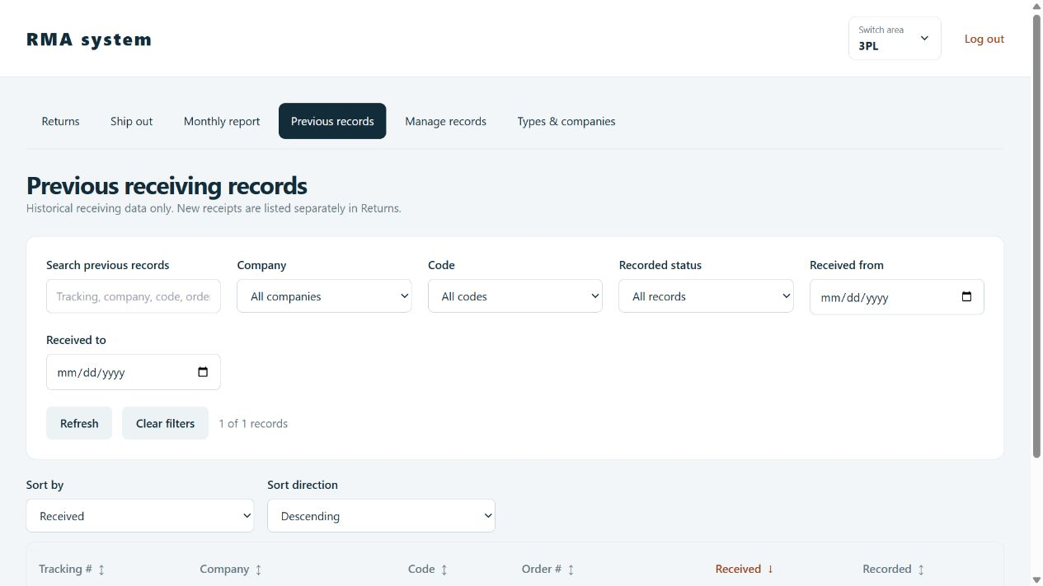
Previous records contains imported historical receiving entries and retains the earlier record fields.
1. Open Previous records. Search tracking, company, code, order, or notes. Combine Company, Code, Recorded status, and Received from/to filters.
2. Click a column heading or use Sort by and Sort direction. Use Refresh, Clear filters, and pagination. This list shows up to 50 historical records per page.
3. Open a tracking link. Depending on company and permissions, use Edit, Record, Input PC, Input Non-PC, or the legacy Input action. Inventory entry creates a separate inventory record.

Confirm an old delivery quantity
Use a historical unit's File Number or internal ID from record management in the Returns lookup. On its unit detail page, Confirm delivery quantity appears if its original quantity was not recorded. Check the physical records, enter 1 to 100, and choose Confirm quantity. Receive deliveries permission is required.
The original ID/File Number is preserved, and additional units receive their own File Numbers. Confirmation is a one-time step; it is not a general quantity editor. You can then inspect the confirmed units. Original and additional units remain historical and do not appear in the new Returns list.
The lists are separated by their receiving workflow, not a date cutoff. Editing an old record keeps it old; entering a backdated receipt through Receive delivery keeps it in Returns. The data remains in the existing receiving table.

Manage and restore returns
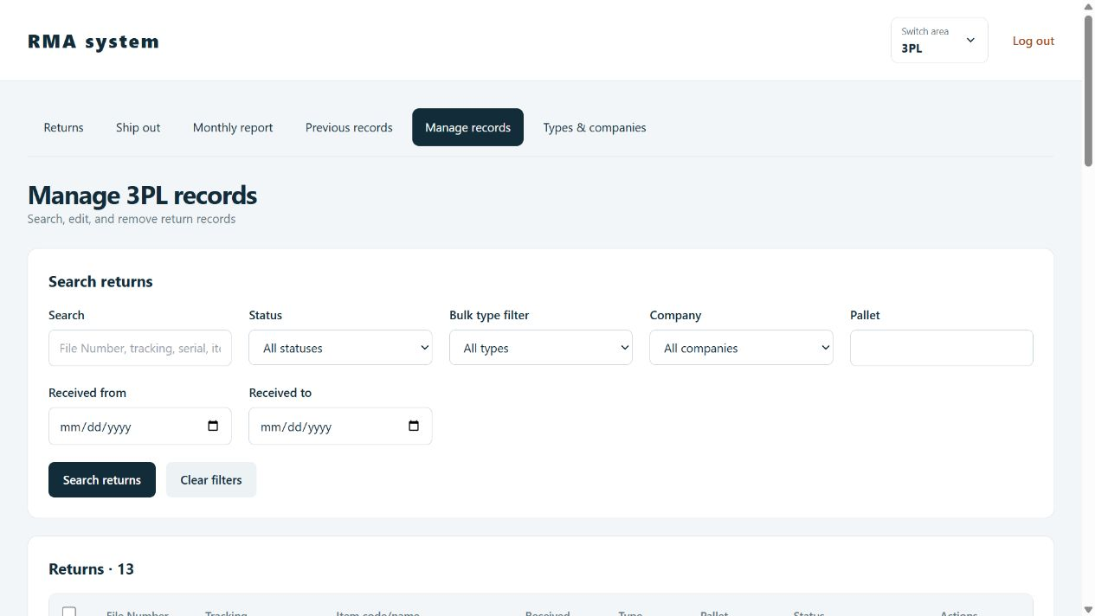
Manage records provides search and permitted changes across receiving records, including historical units.
1. Open Manage records. Combine Search, Status, Bulk type filter, Company, Pallet, and received-date range, then choose Search returns.
2. Use Edit / remove to correct a unit. Choose Save record and check the result. ID and File Number remain fixed; inspection, classification, and shipping fields need their own permissions.
3. For several units, select rows and choose a Bulk action: Change bulk type, Assign pallet, or Remove selected records. Select all affects only the current page.
4. Review Apply to selected carefully. Bulk type changes also affect matching tracking numbers within your company access. Shipped units cannot move pallets, and Locked/Full pallets cannot accept additional units.

Remove and restore
Single removal requires the exact File Number. Bulk removal requires the displayed REMOVE N text. Other units in the delivery remain. A removed snapshot retains the original identity and photo links.
Use Removed records in Manage records if you have restore permission, or Admin > History > Removed records. Review the saved details and choose Restore. Resolve any serial conflict first. Use Ship out for a new shipment; record editing is for authorized corrections. PC/Non-PC deletions are not restored through this tool.

Maintain types and companies
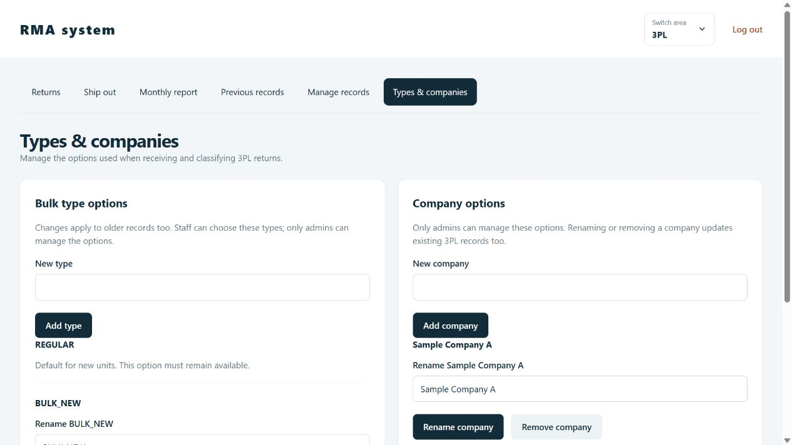
Types & companies keeps both option editors together inside the third-party logistics workspace.
Only admins maintain these options. Staff can choose permitted values for their assigned companies when their action permissions allow it.
1. Open Types & companies. Enter New type or New company, then choose Add type or Add company.
2. To rename an option, edit Rename [name] and choose Rename or Rename company. Existing receiving records using that value are updated too.
3. To remove an option, choose Remove type or Remove company, select a replacement, and review before confirming. Company removal also offers Unspecified.
4. After saving, return to receiving or filtering and check the updated options. Refresh an already open list and clear any outdated filter.
REGULAR is the protected default bulk type. BULK_NEW is another preset, and admins can add other types. A type does not change inspection or shipping status.
A company rename preserves its department access grants. Removing or merging a company revokes grants for the removed name; review company assignments before allowing access to a replacement company.
Renaming an option is the right way to update an old name. Adding a second name does not automatically rename records. Option updates affect their corresponding company/bulkType fields in shared receiving data; older original Code fields and separate PC, Non-PC, or SnowBell workflows are not automatically reclassified.

Use PC inventory
Internal workspace: Admin or all-company access and the relevant PC action permission are required.
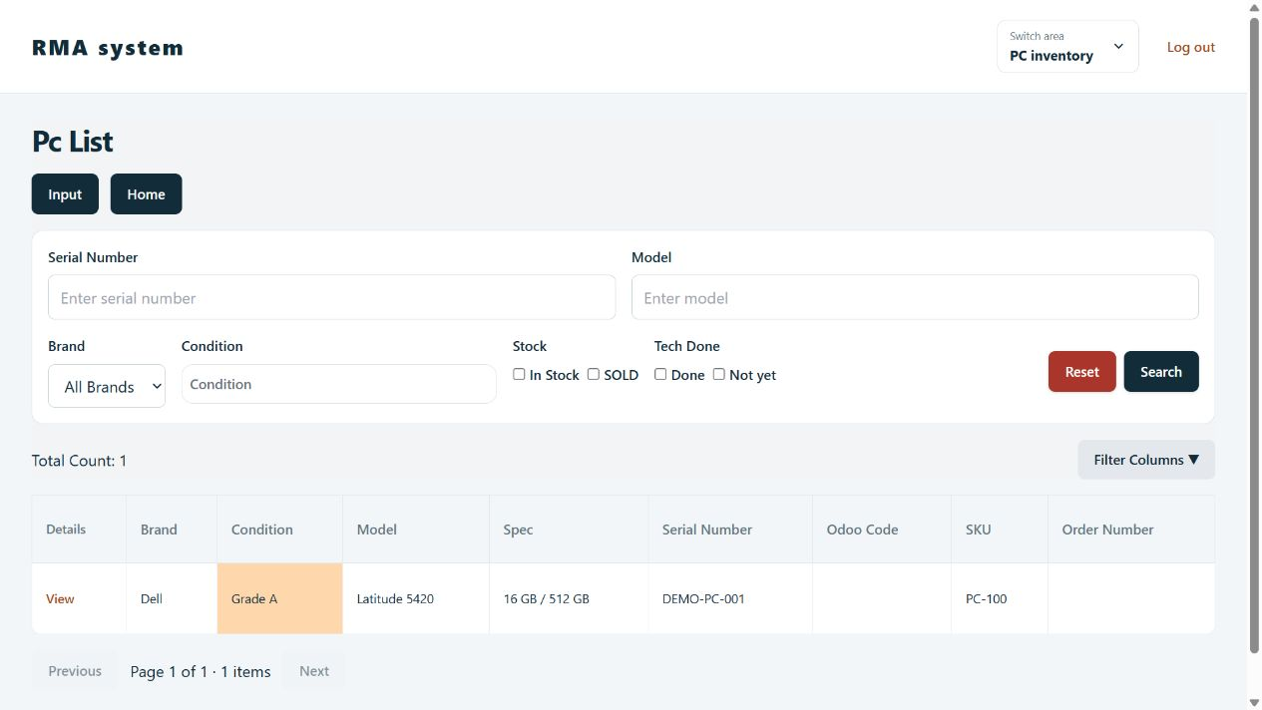
PC inventory has device filters, column selection, sorting, and a separate inventory workflow.
1. Choose PC inventory from the Dashboard or Switch area. Search Serial Number or Model, filter Brand, Condition, Stock, and Tech Done, then choose Search. Use Reset, Filter Columns, sortable headings, and pagination.
2. Choose Input to add a computer. Complete the required Brand, Model, RAM, Storage, Serial Number, and Condition. Enter Odoo Code, Sealed, Odoo Record, Remark, and photos where relevant, then Submit.
3. Open a record and choose Edit for corrections. Use Save Changes and check the saved device, stock, sales information, and last-edit details.
4. For a sale, choose Sales, enter the required Order Number, and adjust RAM/Storage if the sold specification differs. Submit and verify SOLD status. A sold device cannot be sold again through the normal action.
Technical completion: The detail-page Done button requires technical-completion permission, a SOLD device, and Tech Done not already set.
Photos and deletion: Authorized editors can upload or remove photos and use Delete Item with confirmation. Uploads accept up to five JPEG/PNG files per upload, no larger than 4 MB each. PC deletion is not covered by the 3PL restore history. Follow your company's grading rules; the condition labels do not define a physical inspection standard.

Use Non PC inventory
Internal workspace: Admin or all-company access and the relevant Non-PC action permission are required.
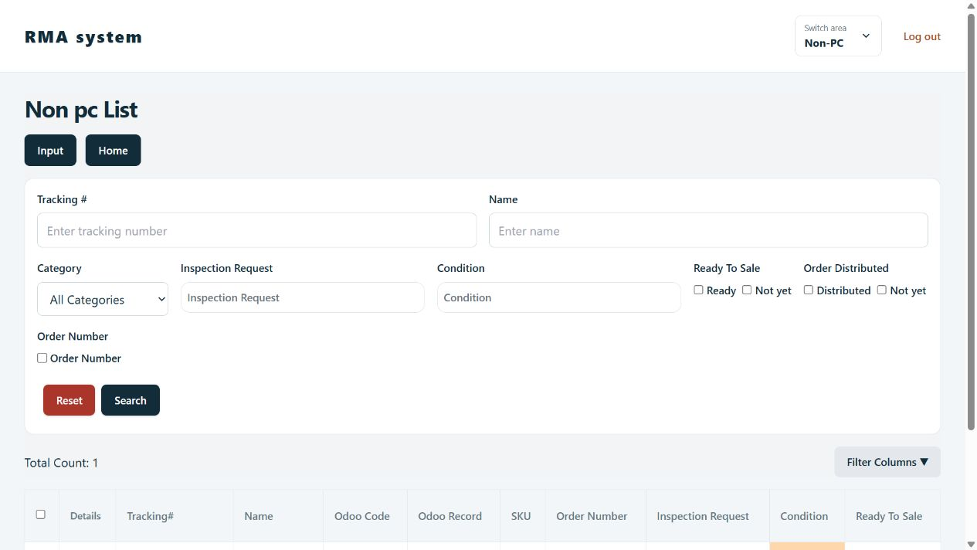
Non-PC filters keep inspection requests, sale readiness, and order distribution distinct.
1. Choose Non-PC in Switch area. Search Tracking # or Name and filter Category, Inspection Request, Condition, Ready To Sale, Order Distributed, or Order Number. Use Search, Reset, Filter Columns, sorting, and pagination.
2. Choose Input. Complete required Tracking #, Received Date, Category, Name, and Odoo Code. Review Condition, Location, Odoo Record, Remark, and required photos. No Tracking Number generates a reference when needed.
3. Set Qty from 1 to 1,000, then Submit. The system creates that many records with shared entered information. Verify the quantity before saving.
4. Select intended rows and open Actions (N selected). Details Check records a Full inspection request. Ready To Sale separately records sale readiness; select all affects the current page only.
5. Open a device > Sales, enter Order Number, and submit. Distributed marks an existing order distributed when permitted and not already marked.
Use Edit and Save Changes for corrections or photos. Photo and deletion permissions are separate. Photos can be shared by tracking reference, so check their scope before removal. Uploads accept up to five JPEG/PNG files per upload, at most 4 MB each. These statuses do not create a 3PL shipping batch.

Manage accounts
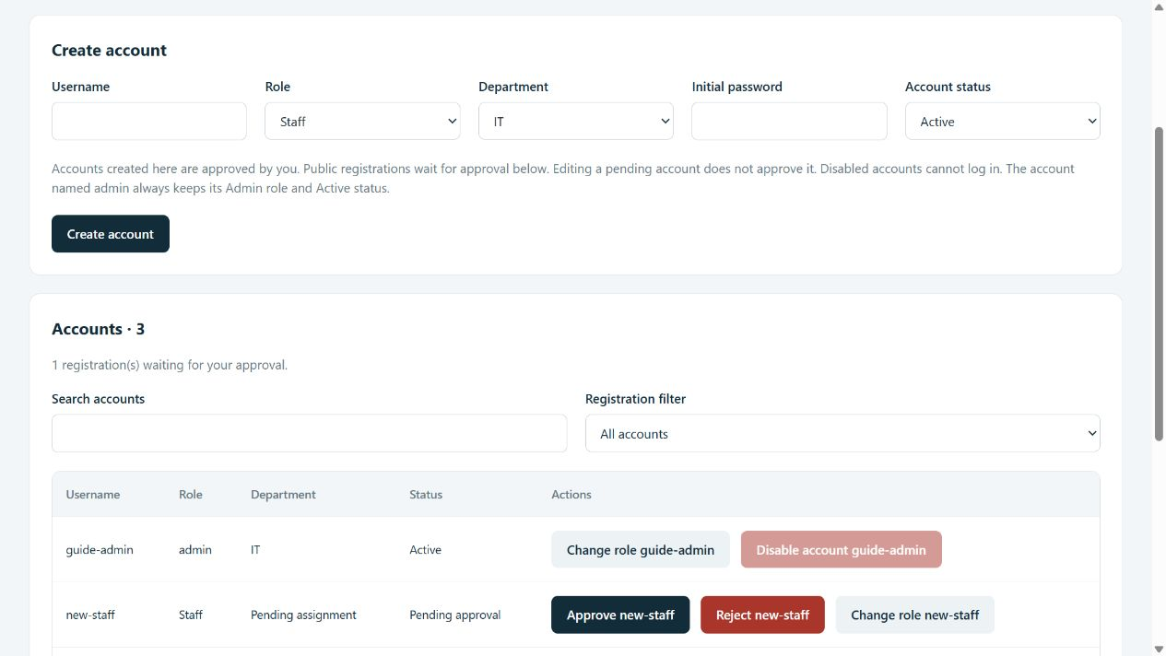
Admin > Accounts separates account creation from approval of public registrations.
1. Open Admin > Accounts. Use Registration filter > Pending approval and search for a username. Check the person. For Pending assignment, use Change role [username], select the correct department, and Save account. Verify that company access for that department, then Approve [username] or Reject [username].
2. To create an account directly, enter Username, Role, Department, Initial password, and Account status, then Create account. This admin-created account is approved by that action.
3. Choose Change role [username] to update Role or Department, then Save account. Usernames stay fixed. Editing a pending account does not approve it.
4. Use Disable account or Enable account and confirm. Active/Disabled and Pending/Approved/Rejected are separate states; login requires approval and Active status.
Passwords: Initial/reset passwords need 12 to 255 characters. Leave Reset password blank to preserve it. Use Change your admin password with current/new passwords for your own password and sign in again afterward.
Protected admin: The account named admin keeps its Admin role and Active status. You cannot disable or demote your own admin account, and at least one active approved admin must remain. Staff and Manager accounts follow department permissions; Admin has full access.

Assign company access
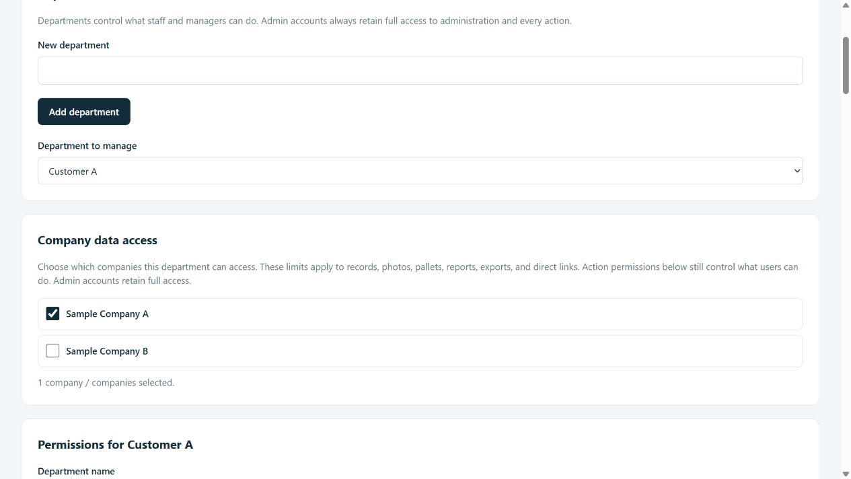
Training example: Customer A is assigned Sample Company A. Only admins see the full option list here.
1. Open Admin > Departments & permissions and select Department to manage.
2. For an outside-company department, leave Access all companies (internal staff only) off. Under Company data access, check only its allowed company or companies.
3. Enable the required action permissions as well. Company assignment alone does not grant View returns, Receive deliveries, Ship units, or any other action.
4. Choose Save department permissions. Assign each account to the correct department in Admin > Accounts. Test with a Staff or Manager account; an Admin account always sees all companies.
No selected companies means no company data access. For trusted internal departments, the explicit Access all companies (internal staff only) permission includes all companies and Unspecified records. Do not grant it to customer departments.
Allow all actions does not newly grant all-company access. If all-company access is already checked, that shortcut keeps it checked. Review company access separately from action permissions before saving.
Server checks use the saved grants on each request. Open screens refresh their session on navigation, focus, and periodically; refresh after an access change. A company rename keeps grants, while removing or merging its name requires an admin to review replacement access.

Set department permissions
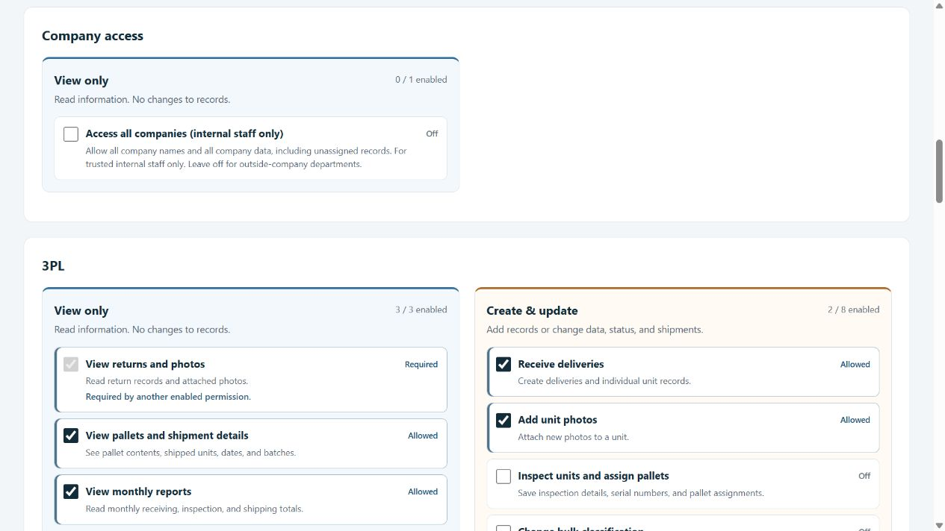
The permission editor distinguishes reading from changes, deletion, and downloads. Shown settings are examples, not a recommended access policy.
1. Open Admin > Departments & permissions. Select Department to manage, or enter New department and choose Add department. Set Company data access before choosing actions.
2. Review View only, Create & update, Delete, and Download / print. Use Find a permission to narrow the display without changing permissions.
3. Check or clear the needed actions. You may update Department name. Review Unsaved changes, then choose Save department permissions or Discard changes.
Allow viewing without shipping: Enable View pallets and shipment details and its required return viewing access. Leave Ship units off. For read-only access, also leave pallet status, other updates, and deletion off. Check the result with a Staff or Manager account; admins always have full access.
Required viewing is needed by another selected action. Included viewing comes through shipping or pallet management. Allowed is enabled; Off is not granted. Allow all actions and Clear all permissions modify the draft until saved. Company access is a separate check; allowing an action cannot bypass company limits.
Rename departments carefully because inventory reports use exact department names. Move accounts out before removing a department, then confirm removal. Switching departments with unsaved changes asks whether to discard them.

Review history exports and backups
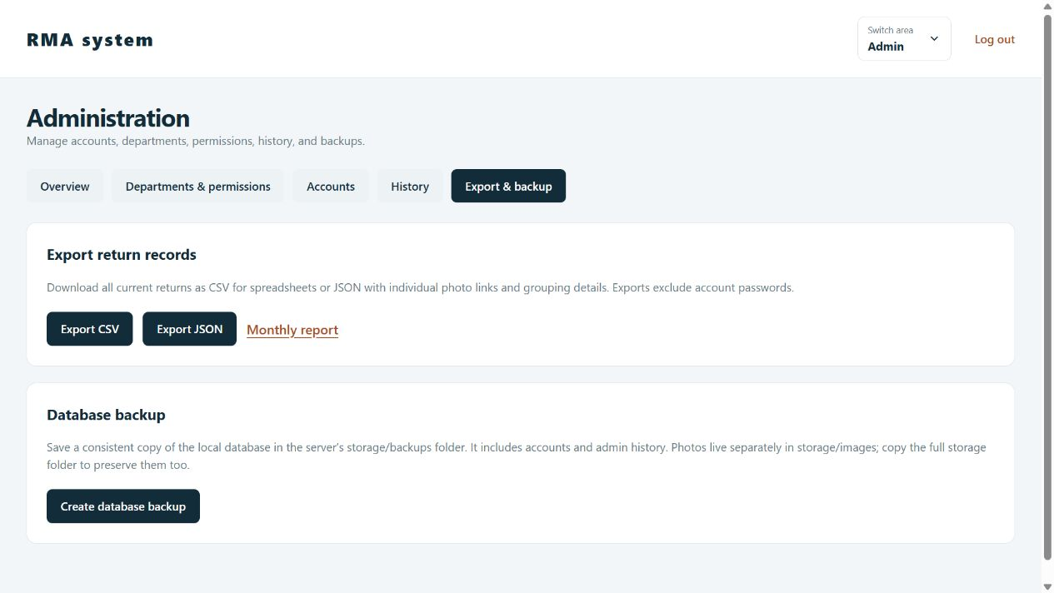
Export & backup creates record exports or a local database backup. Photos remain separate files.

Overview and history
Admin > Overview shows receiving status totals, pallets, accounts, pending registrations, removed records, and type usage. Refresh overview for current counts. History filters recorded admin actions by username, action, or target; expand View saved details. This is admin history, not a complete log of every staff click. Removed records supports restoration of return snapshots.

Exports
Choose Export CSV for spreadsheet fields or Export JSON for richer records with grouping and photo links. Exports include current returns within your company access, exclude account passwords, and do not package image files. Authorized staff can also export from Manage records. Monthly report CSV is a separate summary export.

Backups
Create database backup works in local SQLite mode and saves a file in the server storage/backups folder; it is not automatically downloaded. For SQL Server deployments, use the administrator's SQL Server backup procedure. Database backups and exports do not contain the actual photo files; those need separate backup.
There is no full-database restore button in the app. The server maintainer handles recovery and checks photo storage. Keep account backups and customer/device exports in the approved storage location.

Use the older SnowBell workflow
This is a separate legacy workflow, not the new third-party logistics receiving list. It remains at /xie for admins or internal teams with all-company access and the appropriate legacy permissions. Company-limited customer accounts cannot open this unscoped workflow. The Dashboard no longer has a separate SnowBell tile.

Find old records
Search order number, tracking number, serial number, or Return ID and filter Return Type. Records group by tracking number. Open the tracking details for associated items and shared photos. Access requires internal all-company access and legacy permissions, or an Admin account.

Enter a legacy delivery when required
1. Use Input where available, or Input from a qualifying SnowBell entry in Previous records. The SnowBell department does not see the list-level Input button.
2. Check tracking, received date, and return type. Enter a quantity from 1 to 100.
3. Complete each required laptop name, serial, condition, and inspection date. Review order, customer, location, remarks, and Return ID where shown.
4. Choose Submit and wait for success. Print Return ID opens the older label view. Printing by itself does not save records.
Legacy Return ID labels use 90 x 29 mm, different from the new 100 x 50 mm File Number labels. Allow the print pop-up if your browser blocks it. Reducing quantity can remove entered rows; review the confirmation.

Earlier receiving actions
On Previous records, eligible entries offer Record, Input PC, Input Non-PC, Input, and legacy classification controls such as Mark As BULK_NEW or Mark As REGULAR. These depend on company and permissions. Do not create both legacy and new records for the same work unless your process specifically requires them.

Current limitation
SnowBell Request is not configured to save submissions. A submission reports that limitation rather than a saved request. Ask your administrator for the agreed process. Legacy permissions in the catalog do not by themselves create a working screen or integration.

Permission reference
Use these groups with company assignments to assign duties. Viewing does not grant changes. A separate permission can expose a screen while workflow checks still prevent an action, such as shipping an uninspected unit.
Workspace | Available actions
Company access | Admins assign companies separately from actions. Access all companies is for trusted internal departments; customer departments need selected companies.
3PL view | View returns and photos; view pallets and shipment details; view monthly reports.
3PL create and update | Receive deliveries; add unit photos; inspect and assign pallets; change bulk classification; lock/fill/reopen pallets; ship units; edit records; restore removed records.
3PL delete and output | Remove return records; export return records; print file labels and records.
PC inventory | View; create; edit; delete; upload/remove photos; mark technical work complete; record sales; export inventory reports.
Non PC inventory | View; create; edit; delete; upload/remove photos; set inspection requests; mark ready for sale; record sales; mark orders distributed.
Previous receiving | View previous records; create previous records; edit/record previous records; upload/remove previous receiving photos.
SnowBell | View; create; update; submit requests when configured; upload photos. See the legacy workflow limitation.
Staff directory | View staff names for record attribution.

Administration is separate
Accounts, approvals, roles, departments, global admin history, backups, and Types & companies are administrator tasks. Giving Staff or Manager update permissions does not grant Admin status. Admin accounts are not restricted by department checkboxes.

Common combinations
- Receiver: return viewing, receiving, photos, and printing as needed.
- Inspector: return viewing and inspection; add photos or classification only when the job needs them.
- Shipment reviewer: return viewing and pallet/shipment viewing, with Ship units off.
- Shipping operator: required viewing plus Ship units; pallet-status changes require their own permission.
View monthly reports also provides that screen's CSV and print controls. Export return records controls the full CSV/JSON export. Required viewing dependencies are retained with their actions. Review grants against the person's actual duties before saving.

Troubleshooting and shift checklist
Problem | Next action
Cannot log in after registration | Ask an admin to assign your department, verify company access, approve registration, and check Active status. Do not register repeatedly.
Company or records are missing | Check the account department, selected companies, and View permission. Direct links cannot bypass company access.
Button or tab is missing | Check the account role and department permissions. Refresh or sign in again after changes.
Cannot find an old receiving entry | Open Previous records and clear filters. Use its ID/File Number for the unit workflow if available.
Quantity not recorded | Verify the old delivery and use Confirm quantity before inspection. Do not assume one unit.
Serial already used | Verify the item and search your records. Ask an admin to resolve conflicts outside your company access.
Pallet cannot be selected | Check Locked/Full status and available unshipped pallets. Use another open pallet or request reopening.
Cannot select a unit for shipment | It must be inspected and not already shipped. Confirm the pallet and your Ship units permission.
Photo upload rejected | Use JPEG/PNG, check the five-photo total for a 3PL unit, and reduce image size.
Company or type option looks outdated | Wait for the admin save, refresh the list, and clear an old filter value.
Save or shipment result is uncertain | Search the record or shipment history before retrying to avoid duplicate work.
Report export fails | Check permission and the configured Tech, Accounting, or Sale department mapping.
Database backup fails on SQL Server | The app backup button is for SQLite. Contact the SQL Server maintainer.
Label is clipped or will not scan | Check paper size and scaling. Test one label before printing the full set.

Before finishing a shift
Match received units to their labels. Confirm inspection saves and pallet assignments. Compare shipments against their batch contents and counts. Leave clear remarks for incomplete work, close unsaved forms, and log out of shared devices.

Ask for help with useful details
Provide the page name, exact error, approximate time, and relevant File Number, tracking number, pallet, or batch. Explain whether the screen confirmed success. Include a screenshot if useful; never include passwords.

