Enhancing Medulloblastoma Identification in MRI Images using Feature Pyramid Enhanced Mamba Architecture
Simbiat Adetoro (sadetoro) | Samuel Adeniji (sadeniji)

Abstract
Medulloblastoma (MB) is the most common malignant brain tumor in children, and early detection plays an essential role in improving patient outcomes[1]. While Magnetic Resonance Imaging (MRI) provides a non-invasive method for brain tumor analysis, accurate identification of medulloblastoma from MRI scans remains challenging due to the variability in tumor size, contrast, and spatial characteristics. Deep learning approaches, particularly Convolutional Neural Networks (CNNs), have demonstrated strong performance in medical imaging tasks.
Previous work such as InceptentionNet combines Inception modules with self-attention mechanisms to capture multi-scale features and contextual relationships for MB classification[7]. However, recent developments in computer vision show that transformer-based architectures outperform traditional CNN-based methods for multi-scale representation learning. Vision Transformers address several limitations of CNN architectures but suffer from quadratic computational complexity and limited scalability when modeling long-range dependencies in large medical imaging datasets. Recently, the Mamba architecture has been introduced as a more efficient alternative, using state space models to capture long-range dependencies with linear complexity. Despite this advantage, Mamba-based approaches may suffer from spatial information loss when processing 2D or 3D medical images due to their sequential scanning mechanisms. [2]
In this work, we propose a Feature Pyramid enhanced Mamba architecture to improve spatial feature preservation while maintaining efficient long-range dependency modeling. Our baseline implementation reproduces the InceptentionNet architecture; however, our experimental results did not match the performance reported in the original paper due to training inefficiencies and incomplete configuration details.

Introduction
Medulloblastoma (MB) is the most common malignant pediatric brain tumor, accounting for nearly 20% of childhood brain tumors [1]. It originates in the cerebellum and can lead to severe neurological complications such as nausea, motor dysfunction, and brain herniation if not detected early [4]. The gold standard for diagnosis is histopathological examination through biopsy or surgical resection. However, these procedures are invasive and may not always be feasible for all patients [5].
Magnetic Resonance Imaging (MRI) provides a non-invasive alternative for brain tumor evaluation. Despite its clinical usefulness, accurate interpretation of MRI scans remains challenging even for experienced neuroradiologists due to the complexity of tumor structures and similarities between different tumor types [6].
Deep learning methods, particularly CNN-based models, have recently shown promising results in medical image analysis. Architectures such as Inception, ResNet, and DenseNet have been widely applied to brain tumor classification tasks. More recent approaches integrate attention mechanisms to enhance the model's ability to focus on tumor-relevant regions within MRI images.
One such approach is InceptentionNet, which integrates Inception modules with a multi-head self-attention mechanism for medulloblastoma classification. Although this architecture achieves strong performance, it still relies on CNN-based feature hierarchies that may lose spatial information through repeated downsampling [7].
During the course of this project, we found that combining Feature Pyramid Networks (FPN) with self-attention mechanisms is no longer considered a state-of-the-art solution for multi-scale representation learning. Instead, transformer-based architectures have become the dominant paradigm in computer vision tasks. However, transformers introduce new computational challenges, particularly quadratic complexity with respect to input size [2].
To address this limitation, recent research proposes the Mamba architecture, which uses selective state space models to capture long-range dependencies more efficiently. While Mamba improves computational efficiency, it introduces a new challenge: spatial information loss when applied to 2D image data [2].
Therefore, the focus of this project shifted toward designing a hybrid architecture that combines the efficiency of Mamba with the spatial preservation capability of Feature Pyramid Networks.

Related Works
Several studies have explored deep learning approaches for brain tumor classification using MRI images.
Sathwik et al. [8] proposed an ensemble CNN framework combining ResNet50, MobileNetV2, and Xception models to classify medulloblastoma subtypes. Their ensemble approach achieved an accuracy of 93.33%, demonstrating that combining multiple CNN models can improve classification performance.
Rasheed et al. [9] introduced a CNN-based architecture augmented with hybrid attention mechanisms for multi-class brain tumor classification. Their approach applies spatial and channel attention mechanisms to highlight tumor-relevant regions in MRI images, achieving an accuracy of 98.33%. However, the architecture remains constrained by the hierarchical structure of CNNs, which may reduce sensitivity to small lesions.
Apostolopoulos et al. [10] proposed the AFF-VGG19 architecture, which integrates attention-based feature fusion into the VGG19 network. This approach combines features from different network depths to capture both local and global information. While the model demonstrated improved performance compared to standard CNN models, it did not explicitly address multi-scale lesion representation.
Zhu et al. [11] introduced an improved Feature Pyramid Network (ImFPN) that enhances feature fusion through split-attention mechanisms and similarity-based weighting. Their work demonstrated improved object detection performance by allowing the network to learn adaptive importance across pyramid levels.
The work most closely related to our study is InceptentionNet proposed by Fang et al. [7], which integrates Inception modules with multi-head self-attention for medulloblastoma classification. The architecture achieved strong results with an accuracy of 98.07% during cross-validation and 90.94% on external validation data.
Despite these improvements, the architecture still applies attention only to a single high-level feature map, which may limit its ability to detect small or low-contrast tumors. Furthermore, newer research in computer vision suggests that transformer-based architectures provide more effective multi-scale representation learning [3].
However, Vision Transformers suffer from quadratic computational complexity and may not scale efficiently for large medical imaging datasets. The recently proposed Mamba architecture addresses this limitation by using state space models to capture long-range dependencies with linear complexity. Nevertheless, the sequential scanning mechanism used by Mamba can result in spatial information loss when applied to 2D images [2].
These limitations motivate our proposed approach of combining Feature Pyramid Networks with Mamba to improve spatial feature preservation.

Dataset Description
This research uses the Brain Tumor MRI Dataset with 14 Classes available on Kaggle. The dataset contains MRI images from multiple brain tumor categories including medulloblastoma, glioma, meningioma, ependymoma, and normal brain tissue.
Following the dataset preparation procedure used in the baseline study:
- 106 medulloblastoma images are used as the positive class
- 630 images from other tumor categories are used as the negative class.
- Duplicate images were removed using perceptual hash comparison and manual verification.
- The final dataset contains 736 images.
Figure 1 shows the distribution of the dataset, the pixel intensity distribution and then some samples of images from the two classes (MB and Non-MB)

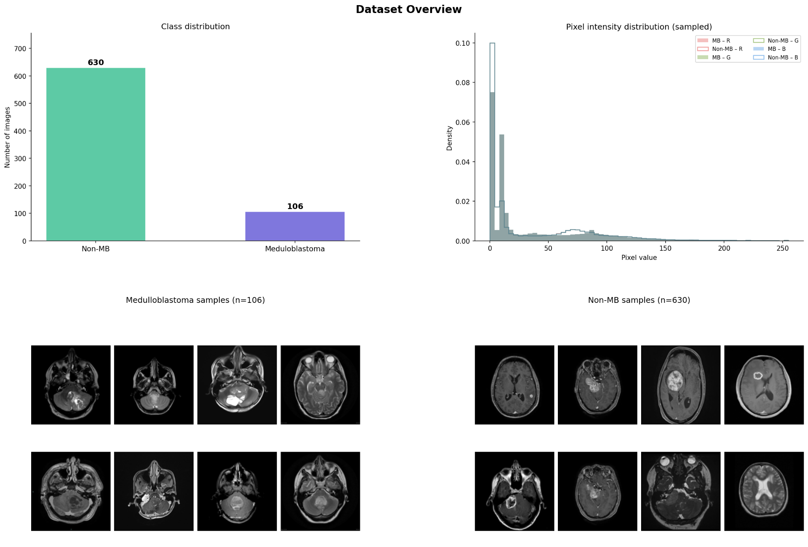
Figure 1: Dataset Description and Visualization
To increase the effective dataset size and reduce overfitting, data augmentation was applied, expanding the dataset to 2,944 images. Augmentation techniques include:
- Random rotation (0–10 degrees)
- Horizontal flipping
- Zooming (0.8–1.2)
- Histogram equalization
- Gaussian filtering for noise reduction
The task is formulated as a binary classification problem: Medulloblastoma vs non-Meduloblastoma.

Baseline Implementation and Results
To reproduce the baseline performance reported by Fang et al. [7], we implemented the InceptentionNet architecture in PyTorch. The model performs binary classification, distinguishing Medulloblastoma (MB) from non-MB brain tumor classes.

Dataset Preparation
The dataset was drawn from a 14-class brain tumor collection. 106 MB images and 630 non-MB images were used, giving a roughly 1:6 class imbalance. To prevent the model from being biased toward the majority class during training, a WeightedRandomSampler was applied so that each class was sampled proportionally within every batch.

Preprocessing and Augmentation
All images were resized to 224×224 pixels. A Gaussian blur (radius 0.7) followed by histogram equalization was applied to both training and evaluation images to reduce noise and normalize contrast. During training only, random horizontal flips, rotations of up to ±10°, and small brightness and contrast jitter were added to improve generalization.

Model Architecture
The network consists of three sequential stages. First, a stem layer applies a single 3×3 convolution with batch normalization and ReLU activation to extract low-level spatial features from the input. Second, a modified Inception block processes the stem output in parallel through four branches using 1×1, 3×3, and 5×5 convolutions alongside a strided 3×3 convolution, capturing features at multiple scales simultaneously. The four branch outputs are concatenated and passed through a strided convolution to reduce spatial dimensions. Third, a Squeeze-and-Excitation (SE) block recalibrates channel-wise feature responses by learning which channels are most informative, followed by a multi-head self-attention module (4 heads) that models spatial relationships across the feature map. Global average pooling then reduces the spatial dimensions to a single vector, which is passed to a two-layer fully connected classifier with dropout (p=0.3) producing a single logit for binary classification.

Training Setup
Training used the AdamW optimizer with a learning rate of 1×10⁻⁴ and weight decay of 1×10⁻⁴. A cosine annealing scheduler adjusted the learning rate across a maximum of 40 epochs, with early stopping triggered after 10 epochs of no improvement in training loss. Binary cross-entropy with logits was used as the loss function. Mixed precision training (torch.cuda.amp) was enabled to reduce memory usage and training time. Training was distributed across two GPUs using DataParallel, with a batch size of 16. Each epoch processed approximately 294 training batches and completed in roughly 1 minute and 20 seconds.

Evaluation
Model performance was measured using 5-fold stratified cross-validation to ensure each fold maintained the original class distribution. On each validation fold, accuracy, precision, recall, F1 score, and AUC were computed. Final reported metrics are the mean values across all five folds.

Baseline Results
The results obtained from our reproduction experiment are summarized in table 1:
Paper Result | Metric | Our Result
98.07% | Accuracy | 93.07%
91.43% | Precision | 69.55%
96.03% | Recall | 94.37%
93.54% | F1 Score | 79.90%
0.994 | AUC | 0.9847

Table 1: Comparison of Baseline Metric
The results show a discrepancy between the reported performance in the original paper and the performance obtained in our reproduction experiment.
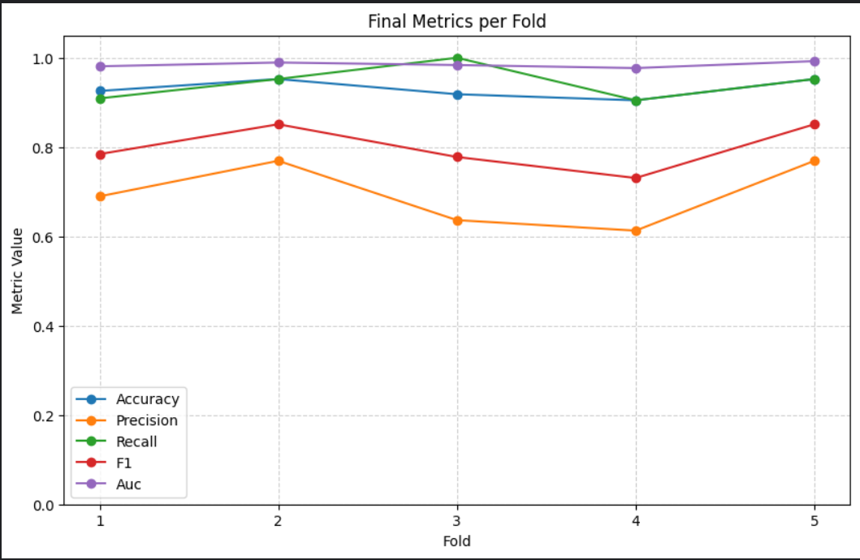
Figure 2: Metrics of the Reproduced Baseline

Comparison with Original Paper
The results show a discrepancy between the reported performance in the original paper and the performance obtained in our reproduction experiment.
Two major challenges were identified:
- Slow training time, which limited experimentation and hyperparameter tuning.
- Incomplete training configuration details in the baseline paper, making exact reproduction difficult.
Additionally, the model appears to have suffered from severe class prediction imbalance, leading to low precision for the positive class.
These issues motivated further investigation into alternative architectures that may provide more robust performance and improved computational efficiency.

Proposed Methodology
After analyzing the limitations of the baseline model and reviewing recent developments in computer vision architectures, we propose a new hybrid architecture combining Feature Pyramid Networks with the Mamba architecture.

Motivation
While Vision Transformers improve multi-scale representation learning, they suffer from quadratic computational complexity and require large datasets for effective training.
Mamba architectures address this limitation by using selective state space models that capture long-range dependencies with linear computational complexity.
However, when applied to image data, Mamba processes images using sequential scanning mechanisms, which may lead to spatial information loss, especially when handling 2D or 3D medical images.

Proposed Architecture: FPN-Mamba
To address this limitation, we propose integrating a Feature Pyramid Network (FPN) into the Mamba architecture.
The key idea is to construct a multi-scale feature hierarchy before sequential processing occurs. The FPN extracts features at multiple spatial resolutions and combines them through top-down connections and lateral feature fusion.
This design ensures that both:
- high-level semantic information and
- fine-grained spatial details
are preserved before the features are processed by the Mamba blocks.
The proposed architecture therefore includes:
- CNN-based feature extractor: A standard convolutional backbone (InceptionNet) processes the input MRI image and produces feature maps at different depths, where shallow layers capture edges and textures and deeper layers capture higher-level tumor structure.
- Feature Pyramid Network for multi-scale representation: Takes those multi-depth feature maps and connects them through a top-down pathway, so high-level semantic information from deep layers is combined with fine spatial detail from shallow layers. This ensures small or low-contrast tumor regions are not lost before further processing.
- Mamba blocks for efficient long-range dependency modeling: Once the FPN produces enriched multi-scale features, Mamba processes them sequentially using selective state space models to capture long-range spatial dependencies across the image, doing so more efficiently than a transformer would on this input size.
- Classification head for MB vs Non-MB prediction: A fully connected layer takes the final feature representation and outputs a single prediction: MB or non-MB.
This hybrid architecture aims to maintain the computational efficiency of Mamba while mitigating spatial information loss through multi-scale feature fusion.

Proposed Methodology for Limited Dataset
One of the key challenges identified in this project is the small dataset size. With only 736 images, any model risks overfitting and results become sensitive to how the data is split. We will be exploring the method below to address this.

Transfer Learning
Rather than training the CNN feature extractor from scratch on 736 images, we will initialize it with weights pretrained on a large dataset. ImageNet pretraining is the standard starting point, as it gives the backbone a general understanding of visual features such as edges, textures, and shapes before any medical data is seen. Where possible, we will also explore backbones pretrained on medical imaging datasets, which may transfer more effectively to MRI data.
During fine-tuning, the early convolutional layers, which capture low-level features that generalize well, will be frozen, and only the later layers will be updated on our dataset. This reduces the number of parameters the model needs to learn from scratch, making effective training feasible even with limited data.
This strategy aims to make the FPN-Mamba architecture trainable and evaluable on the available dataset without compromising the validity of the experimental results.

Division of Work
The project was carried out collaboratively by both team members.
Simbiat Adetoro
- Investigated transformer-based and state space architectures
- Performed dataset preprocessing and augmentation
- Analyzed baseline results
Samuel Adeniji
- Conducted literature review on CNN and attention-based medical imaging architectures
- Implemented the baseline InceptentionNet model
- Analyzed baseline results
Both members jointly contributed to experiment design, discussion of results, and preparation of this report

References
[1] Mahapatra S, Amsbaugh MJ. Medulloblastoma. [Updated 2023 Jun 26]. In: StatPearls [Internet]. Treasure Island (FL): StatPearls Publishing; 2025 Jan-. Available from: https://www.ncbi.nlm.nih.gov/books/NBK431069/
[2] S. Bansal et al., “A Comprehensive Survey of Mamba Architectures for Medical Image Analysis: Classification, Segmentation, Restoration and Beyond,” Oct. 10, 2025, arXiv: arXiv:2410.02362. doi: 10.48550/arXiv.2410.02362.
[3] O. N. Manzari, H. Ahmadabadi, H. Kashiani, S. B. Shokouhi, and A. Ayatollahi, “MedViT: A robust vision transformer for generalized medical image classification,” Comput. Biol. Med., vol. 157, p. 106791, May 2023, doi: 10.1016/j.compbiomed.2023.106791.
[4] Ostrom QT, Price M, Neff C, Cioffi G, Waite KA, Kruchko C, Barnholtz-Sloan JS. CBTRUS Statistical Report: Primary Brain and Other Central Nervous System Tumors Diagnosed in the United States in 2015-2019. Neuro Oncol. 2022 Oct 5;24(Suppl 5):v1-v95. doi: 10.1093/neuonc/noac202. PMID: 36196752; PMCID: PMC9533228.
[5] Tseng LJ, Matsuyama A, MacDonald-Dickinson V. Histology: The gold standard for diagnosis? Can Vet J. 2023 Apr;64(4):389-391. PMID: 37008634; PMCID: PMC10031787.
[6] Guo X, Liu T, Chi Q. Brain tumor diagnosis in MRI scans images using Residual/Shuffle Network optimized by augmented Falcon Finch optimization. Sci Rep. 2024 Nov 13;14(1):27911. doi: 10.1038/s41598-024-77523-2. PMID: 39537654; PMCID: PMC11560930.
[7] Fang C, Li C, Liu H, Zhou Q, Li S, Chen H, Chen X, Shen Z. Precise identification of medulloblastoma in MRI images using a convolutional neural network integrated with a self-attention mechanism. Digit Health. 2025 Jul 23;11:20552076251351536. doi: 10.1177/20552076251351536. PMID: 40718405; PMCID: PMC12290381.
[8] T. Sathwik, T. S. Vishruth Reddy, T. Charitha, R. P. Singh, and S. Kanchan, “An Ensemble Based Convolutional Neural Network Modelling for Classifying Medulloblastoma Subtype,” in 2024 5th International Conference for Emerging Technology (INCET), May 2024, pp. 1–6. doi: 10.1109/INCET61516.2024.10593256.
[9] Rasheed, Z.; Ma, Y.-K.; Ullah, I.; Al-Khasawneh, M.; Almutairi, S.S.; Abohashrh, M. Integrating Convolutional Neural Networks with Attention Mechanisms for Magnetic Resonance Imaging-Based Classification of Brain Tumors. Bioengineering 2024, 11, 701. https://doi.org/10.3390/bioengineering11070701
[10] I. D. Apostolopoulos, S. Aznaouridis, and M. Tzani, “An Attention-Based Deep Convolutional Neural Network for Brain Tumor and Disorder Classification and Grading in Magnetic Resonance Imaging,” Information, vol. 14, no. 3, p. 174, Mar. 2023, doi: 10.3390/info14030174.
[11] L. Zhu, F. Lee, J. Cai, H. Yu, and Q. Chen, “An improved feature pyramid network for object detection,” Neurocomputing, vol. 483, pp. 127–139, Apr. 2022, doi: 10.1016/j.neucom.2022.02.016.

