CprE 381, Computer Organization and

Assembly Level Programming

Lab 1 Report

Student Name: Riley Lawson

Submit a typeset pdf version of this on Canvas by the due date. Refer to the highlighted language in the lab document for the context of the following questions.

[Part 1.c] Think of three more cases and record them in your lab report.
Case 1: Setting your date of birth:
- Initialize the weight by setting iW to 10 and iLdW to 1 and hold them. Set the activation input iX to 1 and the partial sum input iY to 2
- I expect that after one cycle the output oX will remain 1 and the partial sum output oY will be 12=10*1+2.

Case 2: Making a specific amount of subs at a sub shop
- Leave the weight initialized to 10 and iLdW to 1. Set the activation input to 2 and the partial sum input iY to 20.
- I expect that after two cycles oX will be 3 and the partial sum oY will be 50=10*3+20
Case 3: Amount of sleep required for the week
- Disable the weight by setting iW to 5 by leaving iLdW at 1. Set the activation input iX to 7 and leaving the partial sum input to 0
- I expect that after 7 cycles the output oX will be 1 and the partial sum output will be 35=7*5+0
Case 4: Overflow
Case 5: Negative Numbers
[Part 1.e] For labels 9, 20, 32, and 33, specify where (VHDL file and line number) these values are located – some will be found in more than one place. Also attempt to explain the functionality of each label as it occurs in the code
9 – tb_TPU_MV_Element.vhd, RegLd.vhd specified output on line 31 oQ. oQ is set on line 44 and 46. This is connected to line 11 on the diagram s_W.
20 – Reg.vhd specified on line 30 oQ and set on line 40. This is connected to line 25 on the diagram and leads to the output of oX.
32 – Adder.vhd specified on line 26. the g_Add1 is set on line 39 and leads to the output of oY and adds specific numbers together from the inputs iA and iB and iCLK.
33 – TPU_MV_Element.vhd on line 23, its set on line 35 and contains all the logic and circuitry of all lines.

[Part 1.g.v] In your lab report, include a screenshot of the waveform. Describe, in plain English, any differences between what you expected and what the simulation showed.
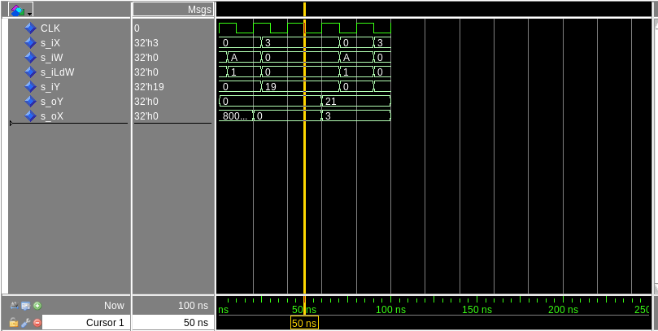

This is supposed to equal 55 however it equals 56 and this difference is strange to me… However, everything else is exactly where its supposed to be including the clock and the iLdW.

[Part 1.h] In your lab report, include a screenshot of the waveform. Describe, in plain English, how your waveform matches the expected result (e.g., reference the specific cycles and times). In your submission zip file, provide the completed TPU_MV_Element.vhd file in a folder called ‘MAC’.

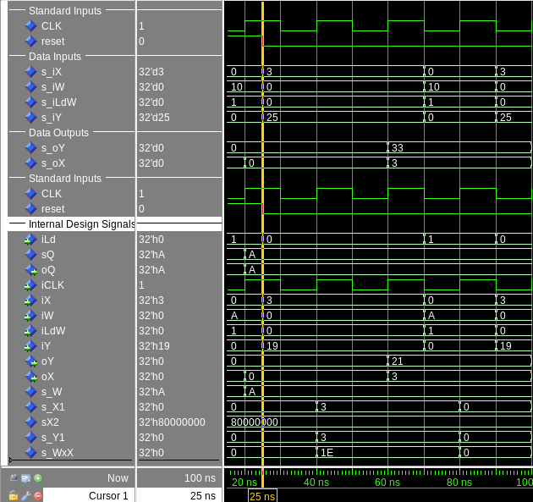

The numbers all add up to 55 including the 10 from iW, the 3 from iX, and 25 from iY. There are no miscalculated errors and everything did as expected.

[Part 3.a] Draw the truth table, Boolean equation, and Boolean circuit equivalent (using only two-input gates) that implements a 2:1 mux. Include this in your lab report.

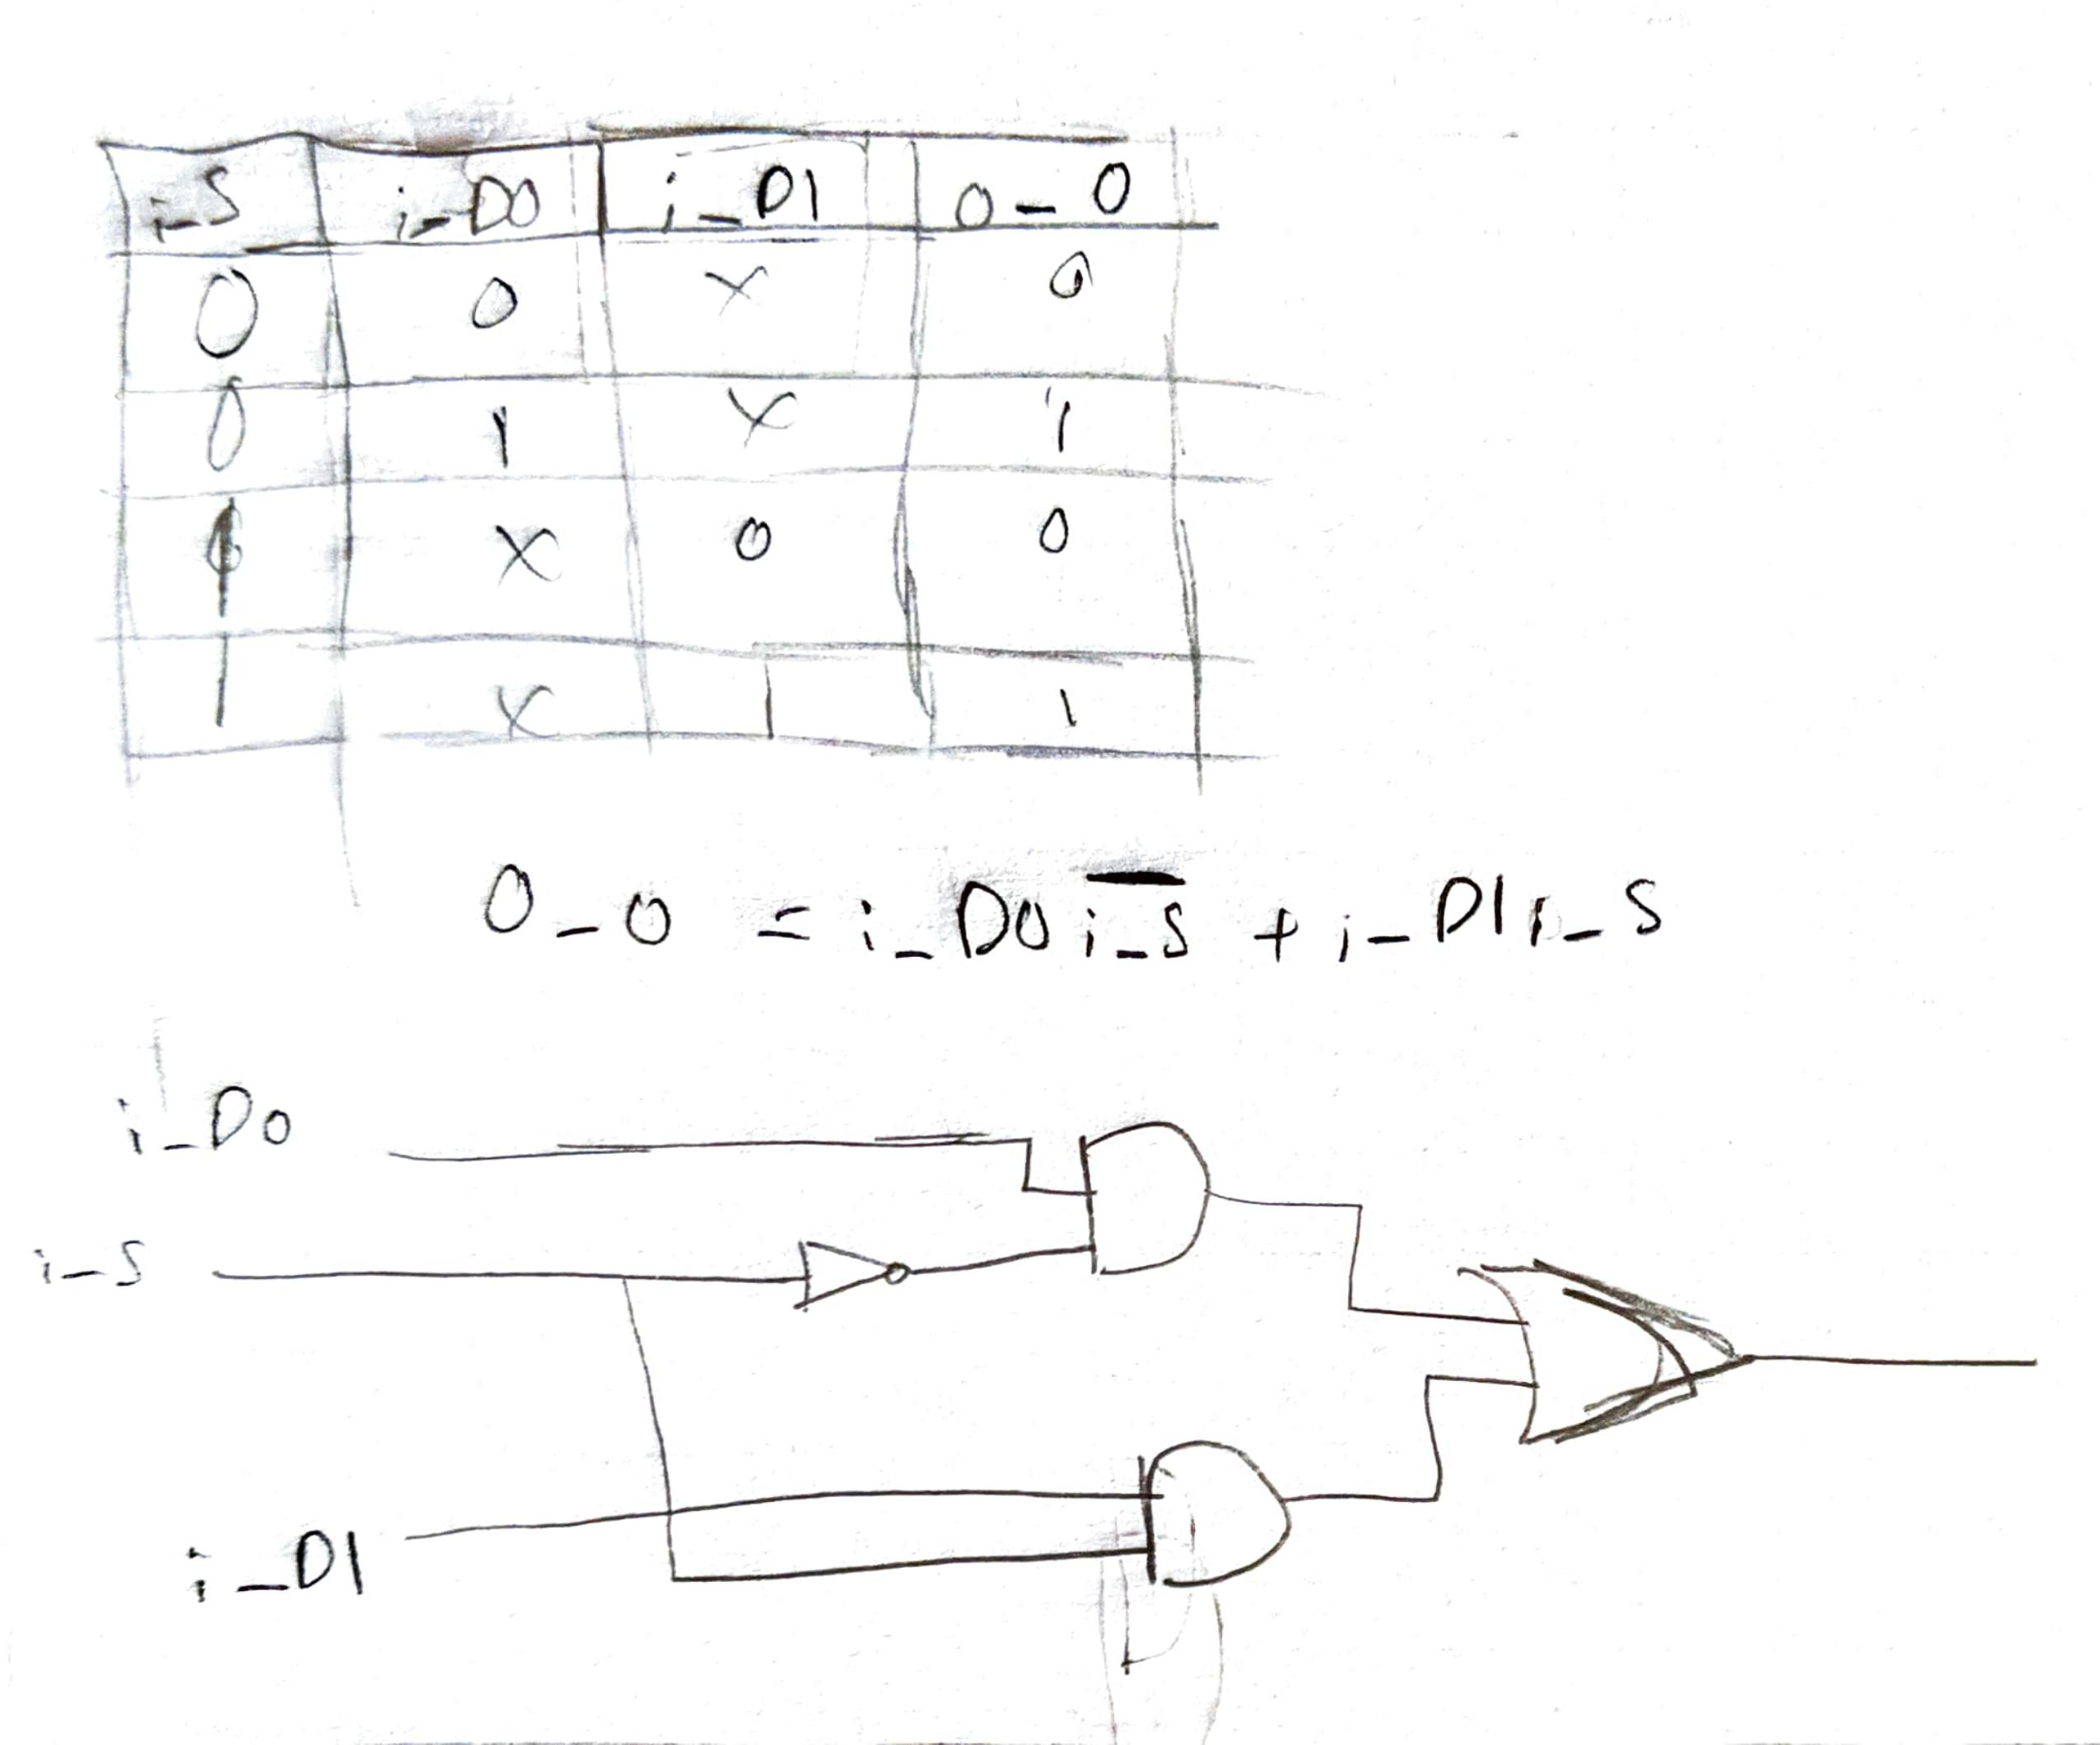

[Part 3.d] In your lab report, include a screenshot of the waveform. Make sure to label the screenshot with which module it is testing.
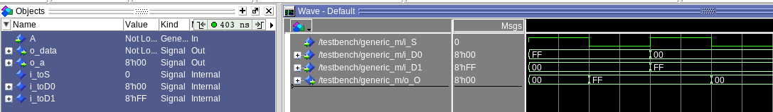

[Part 3.e] Again, in your lab report, include a labeled screenshot of the waveform showing the dataflow mux implementation working.

[Part 4] Include a waveform screenshot and corresponding description demonstrating it is working correctly.
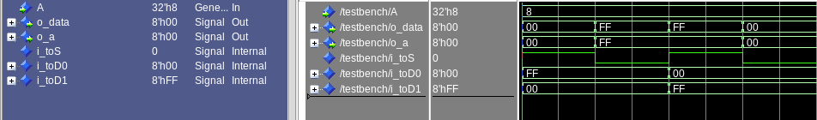

[Part 5.b] Include a waveform screenshot and description in your lab report.

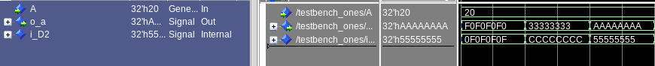

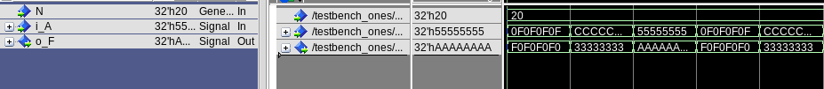
Ones compliments both screenshots include structural vhdl and both are 32bits

[Part 6.a] A full adder takes three single-bit inputs and produces two single-bit outputs – a sum and carry for the addition of the three input bits. Draw the truth table, Boolean equation, and Boolean circuit equivalent (using only two-input gates) that implements a 1-bit full adder. Include this in your report.

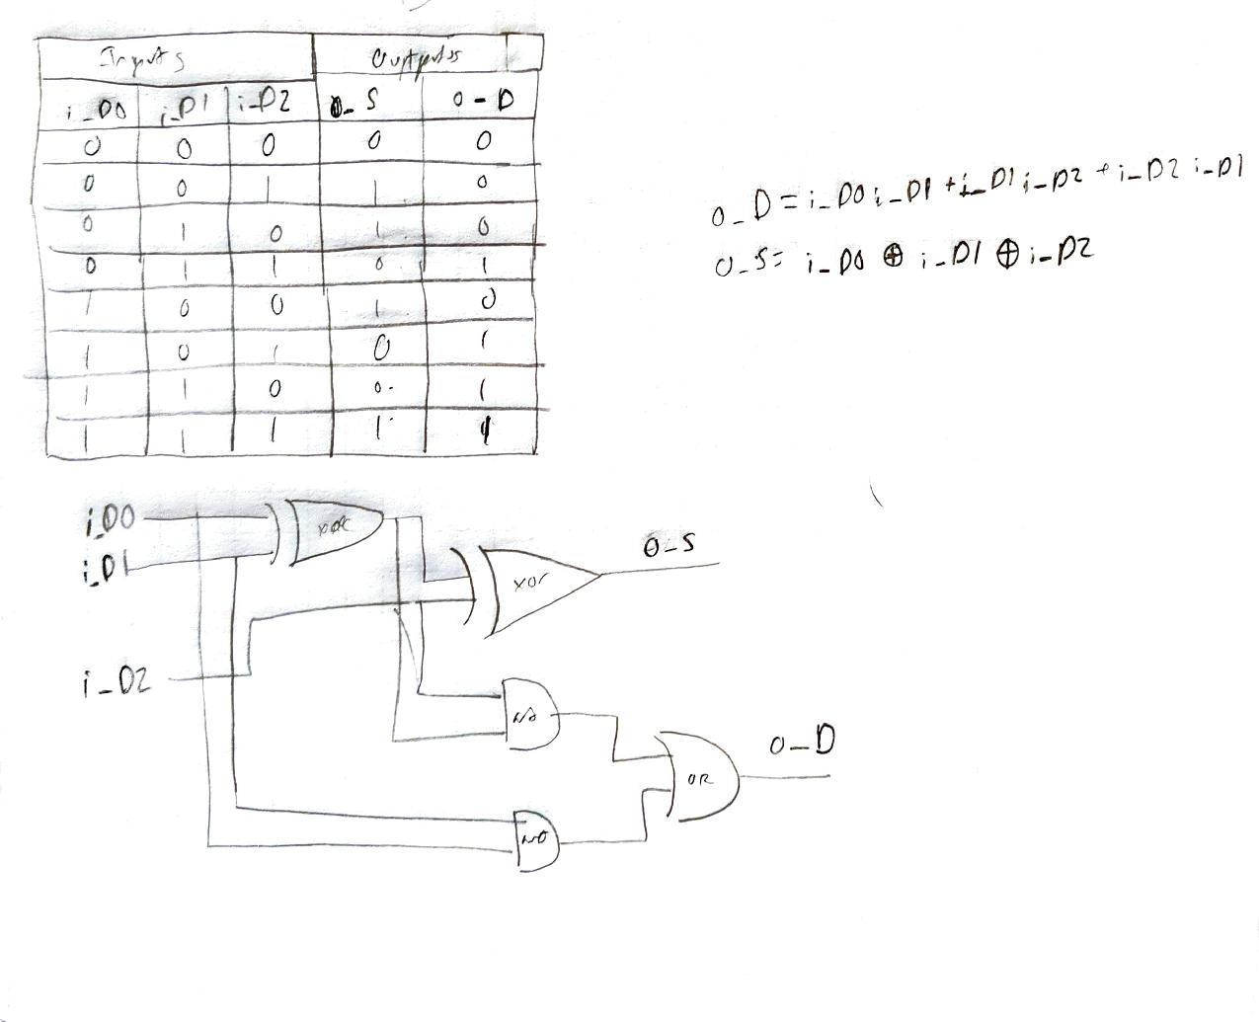

[Part 6.c] Then draw a schematic of the intended design, including inputs and outputs and at least the 0, 1, N-2, and N-1 stages. Include this in your report.

[Part 6.d] Include an annotated waveform screenshot in your write-up.
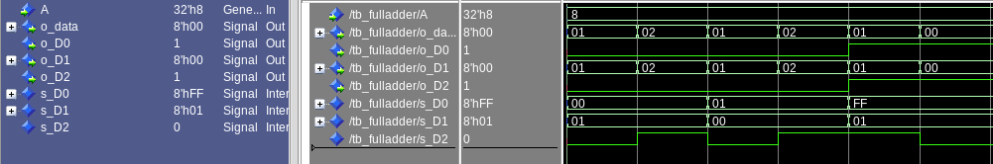
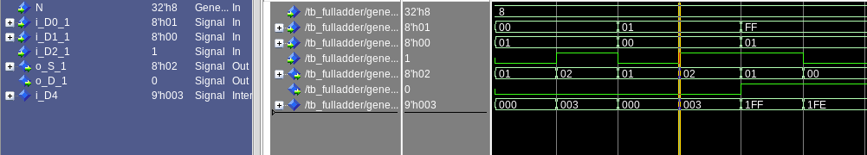
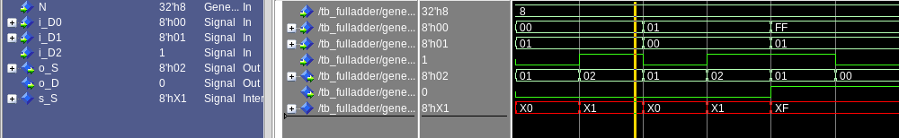

[Part 7.a] Draw a schematic (don’t use a schematic capture tool) showing how an N-bit adder/subtractor with control can be implemented using only the three main components designed in earlier parts of this lab (i.e., the N-bit inverter, N-bit 2:1 mux, and N-bit adder). How is the ‘nAdd_Sub’ bit used? Include this in your report.

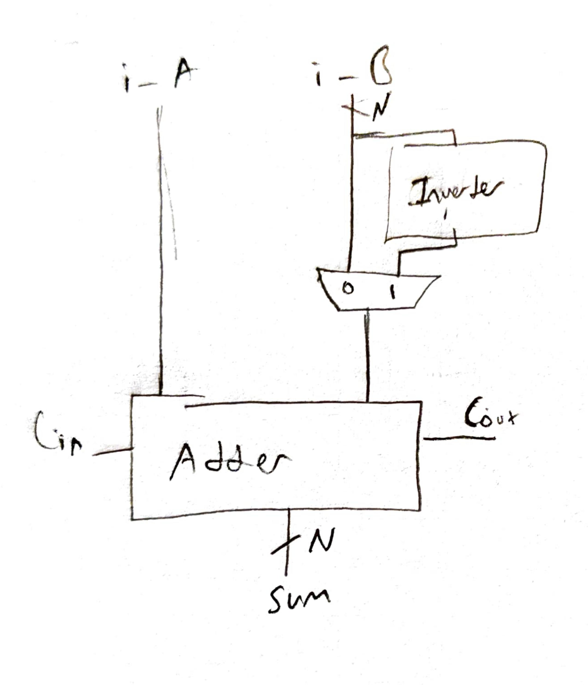
The nAdd_Sub bit is used to regulate when it is adding or subtracting any given value at any time whether that would be 0 for addition or 1 for subtraction

[Part 7.c] Provide multiple waveform screenshots in your write-up to confirm that this component is working correctly. What test-cases did you include and why?

I included testcases that enable different inputs individually and also did the same for the signal bit to differentiate the different edges.

Simple addition to test out how it works, overflow to see how it would react,

