Project Application Research

**Name**: Riley Lawson

**Lab Partner/Team Member Name(s) (if you worked together and are submitting the same document or mostly the same answers):**

**Lab Section**: Section 9-E

**Submit your document as a PDF file in Canvas under the corresponding project assignment.**

1. Find one or more articles on an embedded system application that you are interested in that involves mobile robots or autonomous vehicles. Your article can be about a ground robot like the iRobot in lab, or it can be about an air, underwater, surface, or space vehicle. It could also be about science fiction or future micro/nano vehicles, like in the movie the Fantastic Voyage. Examples of several applications are in the Google Drive folder for the labs under Lab Project – AV-application-ideas:  
   <https://drive.google.com/drive/folders/1tgEsTem9PLCHmHqmOta_oaA0nJTsNy_1?usp=sharing>

Notes:

You can search anywhere for applications. You are not limited to the examples in the folder.

You will not be required to use this application for your project. You will consider ideas for your project in collaboration with your team members. For now, just browse and find something that interests you.

1. Properly cite the article.

The following instructions were given in Homework 1 for proper formatting of a citation. See the IEEE citation reference manual:   
https://ieee-dataport.org/sites/default/files/analysis/27/IEEE%20Citation%20Guidelines.pdf .

1. In Piazza, create a New Post and assign it to the folder “project-research”. In your post, include the following information:
2. List your name(s), major(s), and lab section for those contributing to this post.
3. Link to the article(s) that you chose.
4. Provide the properly formatted citation(s) from #2.
5. Briefly describe the embedded system, a problem it is solving, and at least one user of the system.
6. 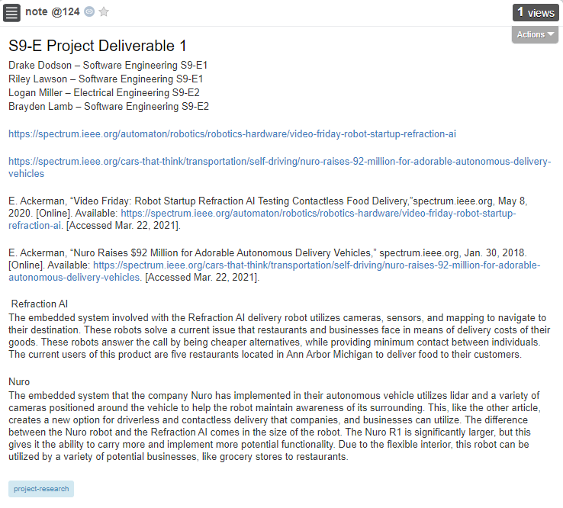Include the Piazza post identifier (@#) and URL here. Also take a screen of or print your post and include it with this submission.

https://piazza.com/class/kkcvmmxtr501m5?cid=124