SANDHI SETU
AI & Sensor-Assisted Knee Osteoarthritis Screening System

Hardware Prototype Simulation
and Technical Documentation
Motion & Gait Module (Wokwi) • Foot-Pressure Module (Tinkercad)

Field | Details
Project | Sandhi Setu — Hardware Screening Pathway
Prepared by | Team apex
Team / Institution | DYPIU
Guide / Supervisor | Dr . Babuskin
Version | 1.0
Date | 25/7/26
Table of Contents
1. Introduction 4
1.1 Intended Physical Hardware 4
1.2 Simulation Modules 4
1.3 Objectives 4
2. Rationale for Splitting the Simulation 5
2.1 Wokwi — Motion Module 5
2.2 Tinkercad — Pressure Module 5
2.3 Final Hardware Target 5
3. Overall Hardware Architecture 6
4. Module A — Motion and Gait Analysis (Wokwi) 7
4.1 Overview 7
4.2 Components List 7
4.3 Sensor Placement 7
4.4 Why Three IMUs Are Used 7
4.5 MPU6050 I2C Address Configuration 7
4.6 ESP32 I2C Configuration 8
4.7 Complete Pin Configuration 8
4.8 Wokwi Circuit Simulation 8
4.9 SSD1306 OLED Display 9
5. Motion Processing Algorithms 10
5.1 Input Data 10
5.2 Pitch Calculation 10
5.3 Knee Angle Calculation 10
5.4 Knee Range of Motion (ROM) 10
5.5 Cadence Calculation 10
5.6 Foot Movement Detection 11
5.7 Movement Asymmetry 11
5.8 Motion Screening Logic 11
5.9 Motion Module Software 11
6. Module B — Foot Pressure / Load Analysis (Tinkercad) 13
6.1 Overview 13
6.2 Components List 13
6.3 Why the Arduino Uno Is Used 13
6.4 FSR Working Principle 13
6.5 FSR Voltage Divider 13
6.6 Pin Configuration 13
6.7 16×2 I2C LCD 14
6.8 Tinkercad Circuit Simulation 14
7. Pressure Processing Algorithms 16
7.1 ADC Reading 16
7.2 ADC Averaging 16
7.3 Normalized Load 16
7.4 Pressure / Load Asymmetry 16
7.5 Pressure Screening Logic 16
7.6 Pressure Module Software Flow 17
7.7 Expected Outputs 17
8. Simulation Test Cases and Results 18
8.1 Motion Module Test Cases (Wokwi) 18
8.2 Pressure Module Test Cases (Tinkercad) 18
9. Comparison of the Two Simulation Modules 19
10. Integration into the Final Hardware 20
10.1 Integrated Architecture 20
10.2 Proposed ESP32 Pin Map for Integration 20
10.3 Consolidated Parameters 20
10.4 Rule-Based Hardware Pathway 21
11. Hardware Simulation Validation Sequence 22
12. Engineering Advantages and Limitations 23
12.1 Advantage of the Modular Approach 23
12.2 Technical Limitations 23
12.3 Future Work 23
13. Conclusion 24
Appendix A — Wokwi Source Code (Motion Module) 25
Appendix B — Tinkercad Source Code (Pressure Module) 26
Appendix C — Glossary 27

Right-click the table above and choose "Update Field" in Word to refresh page numbers after inserting screenshots.

1. Introduction
Sandhi Setu is an AI-assisted and sensor-assisted screening system designed to support preliminary assessment of knee osteoarthritis (OA)-related movement and loading abnormalities. The hardware pathway is a rule-based screening system in which measurements from inertial sensors and foot-pressure sensors are converted into clinically meaningful motion and loading parameters.

1.1 Intended Physical Hardware
- ESP32 microcontroller
- Three IMU sensors (thigh, shin, foot)
- Two FSR pressure sensors (left, right)
- 0.96-inch SSD1306 OLED display
- Battery-powered wearable electronics
- Rule-based screening algorithm

1.2 Simulation Modules
For the prototype development stage, the hardware was divided into two independent simulation modules:
Module | Platform | Purpose
Module A — Motion & Gait Analysis | Wokwi | Knee angle, ROM, cadence, movement symmetry
Module B — Foot Pressure / Load Analysis | Tinkercad | Normalized load and left–right pressure asymmetry

The two simulations represent different sections of the same final hardware system. They are separated only because the required combination of components is not available on a single simulation platform.

1.3 Objectives
- Develop and verify the motion-processing algorithm (IMU → knee angle → ROM → cadence → symmetry).
- Develop and verify the pressure-processing algorithm (FSR → load → asymmetry).
- Define prototype rule-based screening thresholds for each parameter.
- Establish a clear path for integrating both modules onto a single ESP32 wearable.

2. Rationale for Splitting the Simulation
The final Sandhi Setu hardware operates on one ESP32 microcontroller and integrates both motion and pressure sensing. During simulation, however, the required components are distributed across different platforms.

2.1 Wokwi — Motion Module
Wokwi was selected because it provides an ESP32 simulation environment and an MPU6050 sensor model. The motion simulation contains an ESP32, 3 × MPU6050 and a 0.96-inch SSD1306 OLED, allowing the motion-processing algorithm to be developed before moving to physical hardware.

2.2 Tinkercad — Pressure Module
Tinkercad was selected because the FSR-based voltage-divider circuit can be simulated there. The pressure simulation contains an Arduino Uno, 2 × FSR, 2 × 10 kΩ resistors and a 16×2 I2C LCD. The Arduino Uno is used only as the simulation controller; the final hardware does not use an Arduino Uno.

2.3 Final Hardware Target
SANDHI SETU
│
┌─────────┴─────────┐
MOTION SENSING PRESSURE SENSING
│ │
3 × IMU Sensors 2 × FSR Sensors
└─────────┬─────────┘
│
ESP32
│
Signal Processing
│
Rule-Based Screening
┌─────────┴─────────┐
OLED Display Dashboard

Note: The two simulations are not two separate final products. They are two simulation modules of the same proposed Sandhi Setu hardware architecture.

3. Overall Hardware Architecture
The final hardware architecture is organized into four layers.
Layer | Function | Contents
1 — Sensing | Acquire raw signals | Thigh orientation, shin orientation, foot movement, foot loading, left–right load distribution
2 — Processing | ESP32 signal processing | Knee angle, knee ROM, cadence, movement symmetry, load distribution, pressure asymmetry
3 — Rule-Based Screening | Threshold comparison | Parameters compared against predefined prototype thresholds to raise flags
4 — Output | Present results | SSD1306 OLED, Web/Streamlit dashboard, consolidated screening report

4. Module A — Motion and Gait Analysis (Wokwi)

4.1 Overview
The first simulation module is implemented in Wokwi and simulates the movement-sensing part of the Sandhi Setu wearable. The circuit contains an ESP32, a THIGH MPU6050, a SHIN MPU6050, a FOOT MPU6050 and an SSD1306 OLED.

4.2 Components List
S. No. | Component | Qty | Role
1 | ESP32 DevKit V1 | 1 | Main controller, dual I2C
2 | MPU6050 (6-axis IMU) | 3 | Thigh, shin and foot orientation
3 | SSD1306 0.96" I2C OLED (128×64) | 1 | Local display of results
4 | Jumper connections | — | I2C buses and power

4.3 Sensor Placement
THIGH
│
[ MPU6050 ] ← 0x68, Bus 1
│
KNEE
│
[ MPU6050 ] ← 0x69, Bus 1
│
SHIN
│
[ MPU6050 ] ← 0x68, Bus 2
│
FOOT

In the physical prototype, the sensors are mounted on the corresponding body segments so that relative segment orientation can be used to estimate knee movement.

4.4 Why Three IMUs Are Used
- THIGH IMU — provides the orientation of the upper leg.
- SHIN IMU — provides the orientation of the lower leg.
- FOOT IMU — provides foot movement information, used to derive movement transitions and cadence.
The relative orientation of the thigh and shin is particularly important because the knee joint lies between these two segments.

4.5 MPU6050 I2C Address Configuration
The MPU6050 communicates over I2C. When several identical MPU6050 sensors share one bus they conflict, because all default to address 0x68. The address can be changed to 0x69 by pulling the AD0 pin HIGH. Since only two addresses are available, the third sensor is placed on a separate I2C bus.
Sensor | AD0 Pin | Address | I2C Bus
THIGH MPU6050 | GND / LOW | 0x68 | Bus 1 (Wire)
SHIN MPU6050 | 3.3 V / HIGH | 0x69 | Bus 1 (Wire)
FOOT MPU6050 | GND / LOW | 0x68 | Bus 2 (Wire1)

4.6 ESP32 I2C Configuration
The ESP32 provides two hardware I2C controllers, both of which are used in the simulation.
Bus | SDA | SCL | Devices (Address)
Primary (Wire) | GPIO 21 | GPIO 22 | THIGH (0x68), SHIN (0x69), OLED (0x3C)
Secondary (Wire1) | GPIO 25 | GPIO 26 | FOOT (0x68)

// Dual I2C initialisation on ESP32
Wire.begin(21, 22); // Bus 1: THIGH, SHIN, OLED
Wire1.begin(25, 26); // Bus 2: FOOT

mpuThigh.begin(0x68, &Wire);
mpuShin.begin(0x69, &Wire);
mpuFoot.begin(0x68, &Wire1);
display.begin(SSD1306_SWITCHCAPVCC, 0x3C);

4.7 Complete Pin Configuration
Device | VCC | GND | SDA | SCL | AD0 | Address
THIGH MPU6050 | 3.3V | GND | GPIO 21 | GPIO 22 | GND | 0x68
SHIN MPU6050 | 3.3V | GND | GPIO 21 | GPIO 22 | 3.3V | 0x69
FOOT MPU6050 | 3.3V | GND | GPIO 25 | GPIO 26 | GND | 0x68
SSD1306 OLED | 3.3V | GND | GPIO 21 | GPIO 22 | — | 0x3C

4.8 Wokwi Circuit Simulation
Item | Details
Wokwi project link | https://wokwi.com/projects/________________
Board | ESP32 DevKit V1
Libraries | Adafruit MPU6050, Adafruit SSD1306, Adafruit GFX, Adafruit Unified Sensor

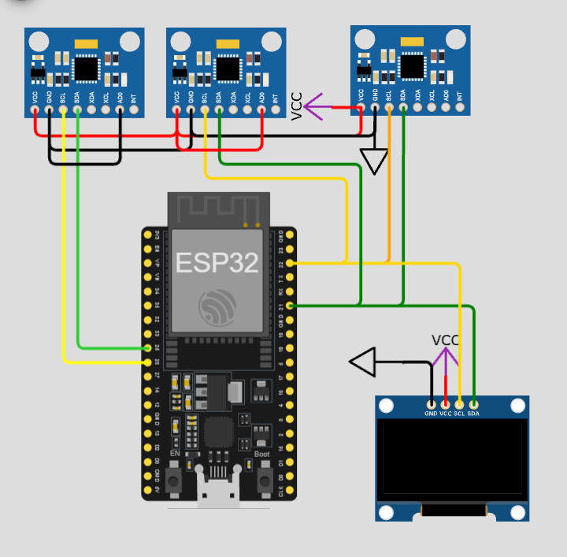
Figure 1: Wokwi circuit — ESP32 with THIGH, SHIN and FOOT MPU6050 sensors and SSD1306 OLED

4.9 SSD1306 OLED Display
The 0.96-inch SSD1306 I2C OLED (address 0x3C) provides local feedback and shares the primary I2C bus with the THIGH and SHIN sensors. Connections: VCC → 3.3V, GND → GND, SDA → GPIO 21, SCL → GPIO 22. The OLED cycles through three screens:
Screen 1 | Screen 2 | Screen 3
KNEE ANALYSIS | GAIT ANALYSIS | SCREENING
Angle: 82° | Cadence: 96 | ROM: REFERENCE
ROM: 121° | Asym: 8.2% | MOVEMENT: SYMMETRIC

5. Motion Processing Algorithms

5.1 Input Data
The MPU6050 provides 3-axis accelerometer and 3-axis gyroscope data. For the prototype simulation, the accelerometer components ax, ay and az are used to estimate each sensor's pitch (static tilt).

5.2 Pitch Calculation
Pitch = atan2( aₓ , √(a_y² + a_z²) ) × (180 / π)
- aₓ, a_y, a_z — acceleration along the X, Y and Z axes
- atan2() — computes the angle while preserving quadrant information
- 180/π — converts radians into degrees
float getPitch(sensors_event_t &a) {
return atan2(a.acceleration.x,
sqrt(a.acceleration.y * a.acceleration.y +
a.acceleration.z * a.acceleration.z)) * 180.0 / PI;
}

5.3 Knee Angle Calculation
The relative angle between the thigh and shin is used as the prototype knee angle:
Knee Angle = | Thigh Pitch − Shin Pitch |
Worked example: Thigh Pitch = 25°, Shin Pitch = −50° → Knee Angle = |25 − (−50)| = 75°. The absolute value gives a positive joint-angle magnitude, and the result is limited to a maximum of 180°.

5.4 Knee Range of Motion (ROM)
Knee ROM = Maximum Knee Angle − Minimum Knee Angle
Worked example: Minimum = 15°, Maximum = 135° → ROM = 135 − 15 = 120°. A larger ROM indicates a larger measured movement excursion.
Knee ROM | Prototype Interpretation
≥ 120° | REFERENCE
100° – 119° | REDUCED
< 100° | LOW

Note: ROM values are prototype reference thresholds and must not be interpreted as validated diagnostic cut-offs.

5.5 Cadence Calculation
Cadence (steps/min) = 60 / Step Interval (s)
Worked example: if one step is detected every 0.75 s, Cadence = 60 / 0.75 = 80 steps/min.

5.6 Foot Movement Detection
The FOOT IMU monitors foot pitch. A movement threshold of approximately 8° separates meaningful movement from small fluctuations. When the pitch crosses this threshold, a valid movement event is registered and the step interval is calculated:
Step Interval = Current Step Time − Previous Step Time
if (footPitch > STEP_THRESHOLD && !stepArmed) { // STEP_THRESHOLD = 8.0
unsigned long now = millis();
float interval = (now - lastStepTime) / 1000.0;
if (interval > 0.3 && interval < 3.0) cadence = 60.0 / interval;
lastStepTime = now;
stepArmed = true;
}
if (footPitch < STEP_THRESHOLD) stepArmed = false;

5.7 Movement Asymmetry
The simulation maintains two exponentially smoothed quantities — positive and negative foot movement:
Positiveₙ = 0.9 × Positiveₙ₋₁ + 0.1 × |Positive Foot Pitch|
Negativeₙ = 0.9 × Negativeₙ₋₁ + 0.1 × |Negative Foot Pitch|
The factor 0.9 weights previous measurements, while 0.1 incorporates the newest one, reducing sudden fluctuations. The asymmetry is then:
Movement Asymmetry (%) = |Pos − Neg| / ((Pos + Neg) / 2) × 100
Worked example: Positive = 20°, Negative = 18° → Average = 19, Difference = 2 → Asymmetry = 2/19 × 100 ≈ 10.53%.
Note: Because the Wokwi prototype uses only one FOOT IMU, this value is a prototype movement-symmetry indicator — not a validated left-versus-right clinical gait asymmetry. True bilateral asymmetry requires a left-foot IMU and a right-foot IMU.

5.8 Motion Screening Logic
Parameter | Example Value | Interpretation
Knee ROM | 123° | REFERENCE
Cadence | 96 steps/min | Reduced / reference (per configured criteria)
Movement Asymmetry | 7% | SYMMETRIC

The hardware pathway is entirely rule-based. No machine-learning model is required.

5.9 Motion Module Software

Libraries
#include <Wire.h>
#include <Adafruit_MPU6050.h>
#include <Adafruit_SSD1306.h>
#include <Adafruit_Sensor.h>
#include <math.h>

Program Flow
- Initialize ESP32 and both I2C buses
- Initialize THIGH, SHIN and FOOT MPU6050
- Initialize SSD1306 OLED
- Read accelerometer data from all IMUs
- Calculate pitch for each segment
- Calculate knee angle and track min/max
- Calculate knee ROM
- Detect foot movement events and compute cadence
- Calculate movement asymmetry
- Apply screening rules
- Display results on OLED and Serial Monitor

6. Module B — Foot Pressure / Load Analysis (Tinkercad)

6.1 Overview
The second simulation, implemented in Tinkercad, simulates the foot-loading pathway using an Arduino Uno, a left FSR, a right FSR, two 10 kΩ resistors and a 16×2 I2C LCD.

6.2 Components List
S. No. | Component | Qty | Role
1 | Arduino Uno R3 (simulation only) | 1 | Simulation controller
2 | Force Sensitive Resistor (FSR) | 2 | Left and right foot load
3 | Resistor 10 kΩ | 2 | Voltage-divider pull-down
4 | 16×2 LCD with I2C backpack (0x27) | 1 | Local display of results

6.3 Why the Arduino Uno Is Used
The Arduino Uno is used only because it is the available controller for this Tinkercad configuration. It is not the final Sandhi Setu controller. The final design uses the ESP32, and the mathematical processing developed in Tinkercad transfers directly.
Stage | Signal Path
Tinkercad simulation | FSR → Arduino Uno → LCD
Final hardware | FSR → ESP32 → OLED / Dashboard

6.4 FSR Working Principle
A Force Sensitive Resistor changes its resistance as applied force changes: more force → lower FSR resistance → higher voltage-divider output → higher ADC reading → higher load index. The FSR is therefore used to estimate relative loading.

6.5 FSR Voltage Divider
Each FSR is connected in series with a 10 kΩ resistor. The mid-point voltage is read by the analog input:
V_out = 5 V × R_fixed / (R_FSR + R_fixed)
5V 5V
│ │
LEFT FSR RIGHT FSR
│ │
├──── A0 ├──── A1
│ │
10 kΩ 10 kΩ
│ │
GND GND

6.6 Pin Configuration
Component | Connection
Left FSR (one leg) | 5V
Left FSR (other leg) + 10 kΩ junction | A0
Right FSR (one leg) | 5V
Right FSR (other leg) + 10 kΩ junction | A1
Both 10 kΩ resistors (free end) | GND
LCD VCC | 5V
LCD GND | GND
LCD SDA | A4
LCD SCL | A5

6.7 16×2 I2C LCD
The I2C LCD (address 0x27) needs only SDA and SCL, unlike a parallel 16×2 LCD which requires separate pins for RS, E, D4, D5, D6 and D7. On the Arduino Uno, A4 is SDA and A5 is SCL.
#include <Wire.h>
#include <LiquidCrystal_I2C.h>
LiquidCrystal_I2C lcd(0x27, 16, 2);
const int FSR_LEFT = A0;
const int FSR_RIGHT = A1;

6.8 Tinkercad Circuit Simulation
Item | Details
Tinkercad project link | https://www.tinkercad.com/things/________________
Board | Arduino Uno R3
Libraries | Wire, LiquidCrystal_I2C (Adafruit_LiquidCrystal if the I2C library is unavailable)

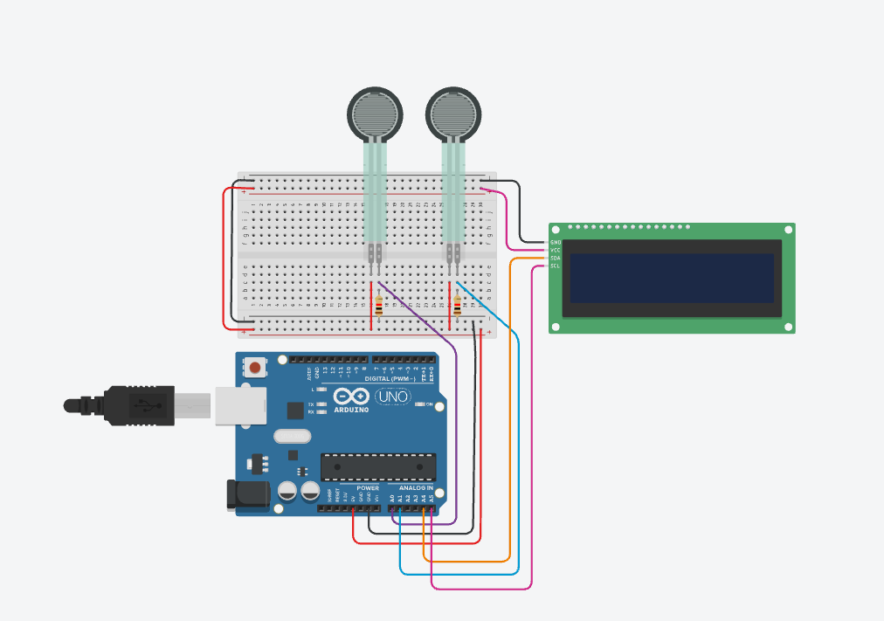
Figure 2: Tinkercad circuit — Arduino Uno with two FSR voltage dividers and 16×2 I2C LCD

7. Pressure Processing Algorithms

7.1 ADC Reading
The Arduino Uno has a 10-bit ADC, so each analog input produces values from 0 to 1023, representing 0–5 V from the voltage divider.

7.2 ADC Averaging
FSR readings fluctuate, so the prototype averages 10 samples:
Average ADC = (ADC₁ + ADC₂ + … + ADC₁₀) / 10
int readAvg(int pin) {
long sum = 0;
for (int i = 0; i < 10; i++) { sum += analogRead(pin); delay(5); }
return sum / 10;
}

7.3 Normalized Load
Load (%) = ADC / 1023 × 100
Worked example: ADC = 512 → Load = 512/1023 × 100 ≈ 50.05% ≈ 50%.
Note: This is a normalized load/pressure index, not a physical pressure. The system must not report values such as "50 kPa" or "50 N" from the raw ADC. Actual force requires calibration with known loads: Known Force → FSR Reading → Calibration Curve → ADC-to-Newtons.

7.4 Pressure / Load Asymmetry
Let L = left normalized load and R = right normalized load.
Pressure Asymmetry (%) = |L − R| / ((L + R) / 2) × 100
Worked example: L = 46%, R = 51% → Average = 48.5, Difference = 5 → Asymmetry = 5/48.5 × 100 ≈ 10.3%.
float leftLoad = (readAvg(FSR_LEFT) / 1023.0) * 100.0;
float rightLoad = (readAvg(FSR_RIGHT) / 1023.0) * 100.0;
float avg = (leftLoad + rightLoad) / 2.0;
float asymmetry = (avg > 1.0) ? (abs(leftLoad - rightLoad) / avg) * 100.0 : 0.0;

7.5 Pressure Screening Logic
Pressure Asymmetry | Prototype Status | Example
≤ 10% | BALANCED | 5% → BALANCED
> 10% and ≤ 15% | MILD ASYMMETRY | 12% → MILD ASYM
> 15% | HIGH ASYMMETRY | 20% → HIGH ASYM

Note: These are prototype decision thresholds, not clinical diagnostic thresholds.

7.6 Pressure Module Software Flow
- Initialize Arduino and I2C LCD
- Read left and right FSR (10-sample average)
- Convert ADC to normalized load
- Calculate left/right asymmetry
- Apply screening threshold
- Display result on LCD
- Send detailed result to Serial Monitor
- Repeat

7.7 Expected Outputs

LCD
Display 1 | Display 2
L:46% R:51% | Pressure:
Asym:10.3% | MILD ASYM

Serial Monitor
---- Pressure Analysis ----
Left Raw: 472
Right Raw: 518
Left Load: 46.1%
Right Load: 50.6%
Asymmetry: 9.3%
Status: BALANCED

8. Simulation Test Cases and Results
Record the observed simulation values in the tables below. Expected values are calculated from the formulas in Sections 5 and 7.

8.1 Motion Module Test Cases (Wokwi)
Test | Thigh Pitch | Shin Pitch | Expected Angle | Observed Angle | Pass/Fail
M1 | 25° | −50° | 75°
M2 | 0° | 0° | 0°
M3 | 40° | −45° | 85°
M4

Test | Min Angle | Max Angle | Expected ROM | Observed ROM | Status
R1 | 15° | 135° | 120° (REFERENCE)
R2 | 20° | 125° | 105° (REDUCED)
R3 | 30° | 110° | 80° (LOW)

8.2 Pressure Module Test Cases (Tinkercad)
Test | Left Load | Right Load | Expected Asym. | Expected Status | Observed | Pass/Fail
P1 | 50% | 52% | 3.9% | BALANCED
P2 | 46% | 51% | 10.3% | MILD ASYM
P3 | 40% | 55% | 31.6% | HIGH ASYM
P4

9. Comparison of the Two Simulation Modules
Parameter | Motion Module | Pressure Module
Platform | Wokwi | Tinkercad
Simulation controller | ESP32 | Arduino Uno
Final controller | ESP32 | ESP32
Sensors | 3 × MPU6050 | 2 × FSR
Display | SSD1306 OLED | 16×2 I2C LCD
Main purpose | Motion / gait | Foot loading
Outputs | Knee angle, ROM, cadence, movement asymmetry | Normalized load, pressure asymmetry
Processing | Rule-based | Rule-based

10. Integration into the Final Hardware

10.1 Integrated Architecture
The final Sandhi Setu hardware does not require two controllers. Both pathways are integrated onto one ESP32:
ESP32
│
┌───────────┴───────────┐
3 × IMU Sensors 2 × FSR Sensors
└───────────┬───────────┘
│
Sensor Processing
┌─────────┼─────────┐
Motion Gait Pressure
ROM Cadence Asymmetry
└─────────┼─────────┘
Rule-Based Screening
│
Final Report

10.2 Proposed ESP32 Pin Map for Integration
Signal | ESP32 Pin | Notes
I2C Bus 1 SDA / SCL | GPIO 21 / 22 | THIGH (0x68), SHIN (0x69), OLED (0x3C)
I2C Bus 2 SDA / SCL | GPIO 25 / 26 | FOOT (0x68)
Left FSR divider | GPIO 34 (ADC1_CH6) | Input-only ADC1 pin; works with Wi-Fi active
Right FSR divider | GPIO 35 (ADC1_CH7) | Input-only ADC1 pin; works with Wi-Fi active
FSR supply | 3.3 V | Divider powered from 3.3 V, not 5 V

Note: When porting from the Uno: the ESP32 ADC is 12-bit (0–4095) and runs at 3.3 V, so the normalization becomes Load (%) = ADC / 4095 × 100. Use ADC1 pins (GPIO 32–39) because ADC2 pins are unavailable when Wi-Fi is active for the dashboard.

10.3 Consolidated Parameters
Parameter | Sensor Source
Knee angle | Thigh + Shin IMUs
Knee ROM | Thigh + Shin IMUs
Cadence | Foot IMU
Movement symmetry indicator | Foot IMU
Left load | Left FSR
Right load | Right FSR
Pressure asymmetry | Two FSRs

These parameters can be combined with patient history and other screening information in the wider Sandhi Setu system.

10.4 Rule-Based Hardware Pathway
Sensor Data → Signal Processing → Feature Extraction → Threshold Comparison → Screening Flag

Knee ROM < prototype threshold → ROM FLAG
Pressure asymmetry > prototype threshold → LOAD FLAG

11. Hardware Simulation Validation Sequence
Stage | Task | Verification Criterion | Status
1 | IMU communication | THIGH, SHIN, FOOT → READY (SHIN at 0x69) | ☐
2 | IMU data | AX, AY, AZ values received | ☐
3 | Orientation | Thigh, shin and foot pitch calculated | ☐
4 | Knee angle | |Thigh Pitch − Shin Pitch| correct | ☐
5 | ROM | Max − Min tracked correctly | ☐
6 | Cadence | 60 / step interval calculated | ☐
7 | Movement asymmetry | Symmetry indicator calculated | ☐
8 | FSR sensing | A0 (left), A1 (right) read | ☐
9 | Load calculation | ADC → normalized load % | ☐
10 | Pressure asymmetry | |L − R| / average × 100 | ☐
11 | Display | Values shown on OLED / LCD | ☐
12 | Final integration | Logic transferred to physical ESP32 | ☐

12. Engineering Advantages and Limitations

12.1 Advantage of the Modular Approach
Splitting the simulation reduces development complexity. Instead of debugging the entire wearable at once, each subsystem is developed independently:
- Motion: IMU → Angle → ROM → Cadence → Movement
- Pressure: FSR → Load → Left/Right comparison → Asymmetry
Once both pathways work correctly, they are merged onto one ESP32, making debugging and physical integration considerably more manageable.

12.2 Technical Limitations
# | Limitation | Implication
1 | Simulation is not clinical validation | Demonstrates architecture logic only; does not establish diagnostic accuracy.
2 | FSR requires calibration | Normalized % supports relative comparison only; not equivalent to N or kPa.
3 | IMU orientation depends on mounting | Angle depends on sensor orientation, placement, attachment, movement direction and calibration.
4 | Accelerometer-only pitch | Static tilt estimate is affected by dynamic acceleration during walking; a gyro-fused filter (complementary/Kalman) is recommended for hardware.
5 | Single-foot asymmetry | Movement asymmetry is a prototype indicator; true bilateral asymmetry needs both feet instrumented.
6 | Prototype thresholds | Thresholds are engineering decision rules and must be refined with clinical/reference data.

12.3 Future Work
- Integrate both modules onto a single ESP32 wearable with battery power.
- Add gyroscope fusion (complementary or Kalman filter) for dynamic knee angle.
- Add a second foot IMU for true bilateral gait asymmetry.
- Calibrate FSRs against known loads to report force in Newtons.
- Stream results to the Streamlit dashboard over Wi-Fi.
- Refine thresholds using clinical reference data.

13. Conclusion
The Sandhi Setu hardware prototype has been divided into two simulation modules to overcome the limitations of a single simulation environment.
The Wokwi simulation covers the motion pathway using an ESP32, three MPU6050 sensors and an SSD1306 OLED, calculating thigh and shin orientation, knee angle, knee ROM, cadence and a prototype movement-symmetry indicator.
The Tinkercad simulation covers the pressure pathway using an Arduino Uno, two FSRs and a 16×2 I2C LCD, calculating normalized left/right load and pressure asymmetry. The Arduino Uno is only a simulation controller, and the MPU6050 is a simulation-compatible representation of the intended inertial-sensing pathway.
The final physical hardware combines both pathways into one ESP32-based wearable:
3 × IMU + 2 × FSR → ESP32 → Feature Extraction → Rule-Based Screening → OLED / Dashboard
This provides a modular route from individual sensor simulation → subsystem validation → physical integration → consolidated screening system.

