***EXPERIMENT*** ***NO.*** ***3***

**AIM:** To prepare DATA FLOW DIAGRAM for project Level 0 and Level 1

**REQUIREMENTS:**

**Hardware** **Interfaces**

▪ Pentium(R) 4 CPU 2.26 GHz, 128 MB RAM

▪ Screen resolution of at least 800 x 600 required for proper and complete viewing of screens. Higher resolution would not be a problem.

▪ CD ROM Driver

**Software** **Interfaces**

▪ Any window-based operating system (Windows 95/98/2000/XP/NT) ▪ WordPad or Microsoft Word

* Star UML

***THEORY***

Data flow diagrams illustrate how data is processed by a system in terms of inputs and outputs.

**LEVEL – 0**

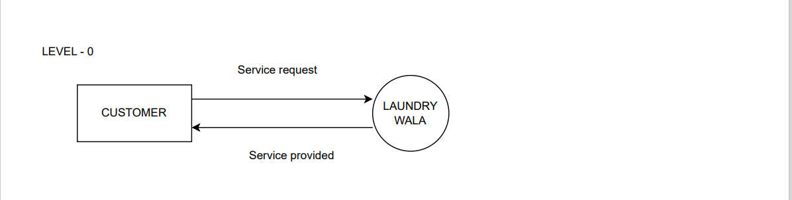

**LEVEL -1**

