HR Intelligence Platform
User Manual

Version 1.0
2026-08-06
Techberry Infotech Pvt. Ltd.
Enterprise Customer Documentation
Document ID: HR_Intelligence_Platform_User_Manual

CONFIDENTIAL — Documents only features implemented in this release

Document History
Revision history for this customer-facing user manual.
Version | Author | Date | Description
1.0 | Technical Publications | 2026-08-06 | Complete enterprise manual rebuilt from live routes and screenshots

Table of Contents
Use this table to locate each chapter in the manual.
No. | Section | Page
1 | Introduction | 4
2 | Home | 5
3 | Authentication | 6
4 | Jobs (Public Board & Apply) | 7
5 | Support | 8
6 | Head HR Overview Dashboard | 9
7 | Admins | 10
8 | Head HR Candidates | 11
9 | Head HR Jobs | 12
10 | Head HR Job Details & Applied Candidates | 13
11 | Candidate Evaluation (Profile & Match) | 14
12 | Bulk Resume Parser (Head HR) | 15
13 | Integrations (Head HR) | 16
14 | Head HR Settings | 17
15 | Recruiter Dashboard | 18
16 | Applied Candidates (Recruiter) | 19
17 | Bulk Resume Parser (Recruiter) | 20
18 | Feedback Admin | 21
19 | Integrations (Staff) | 22
20 | Settings (Staff) | 23
21 | CEO / Executive Dashboard | 24
22 | Logout | 25
23 | Forms, Fields, and Buttons Reference | 26
24 | Troubleshooting | 27
25 | FAQs | 28
26 | Appendix | 29

1. Introduction
HR Intelligence Platform is an AI-assisted recruitment application for publishing jobs, receiving applications, parsing resumes and job descriptions, scoring candidate–job fit, and enabling Recruiters, Head of HR, and Executives (CEO) to evaluate applicants.
This user manual walks through every shipped screen with live screenshots. Follow each chapter in order, or jump from the Table of Contents to a specific module. Only features that exist in the current product are documented.
How to use this manual
- Start with Home, then Authentication, then the modules for your role (Recruiter, Head HR, or CEO).
- Each chapter lists Purpose, Navigation Path, Accessible Roles, then step-by-step actions with screenshots.
- Supported staff roles: RECRUITER, HEAD_HR, and CEO (read-only). Admin Login authenticates these roles.
- Recommended browsers: Chrome, Edge, Firefox, or Safari (latest). Desktop resolution 1280×720 or higher.

2. Home
Purpose
Public landing experience that introduces the product and routes users to Jobs.
Navigation Path
/
Accessible Roles
Public
Description / Business Purpose
This chapter documents the live UI for Home. Each step includes a full screenshot captured from the running application.

Step 1
Action:
- Open the application URL
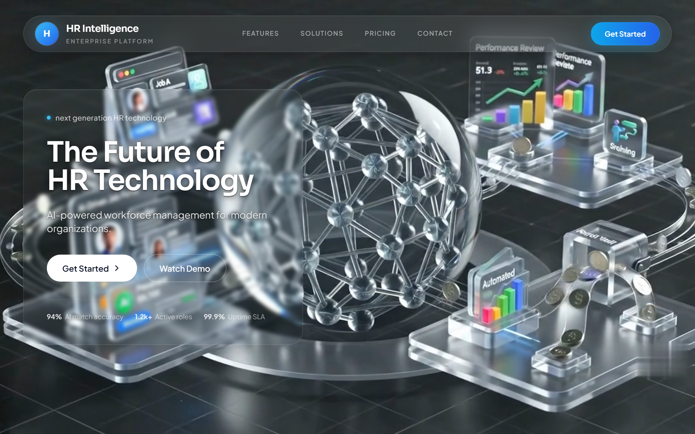
Figure 2.1 Home / Landing page
Description:
- Home / Landing page
Expected Result:
- Landing page loads with product branding and Get Started CTA
Notes
- If a control is disabled, complete required fields first.
- Match scores depend on parsed JD and resume content.

3. Authentication
Purpose
Staff login, signup, and password recovery for Recruiter, Head HR, and CEO accounts.
Navigation Path
/login → /login/admin
Accessible Roles
Public (unauthenticated); after login: RECRUITER | HEAD_HR | CEO
Description / Business Purpose
This chapter documents the live UI for Authentication. Each step includes a full screenshot captured from the running application.

Step 1
Action:
- Open /login
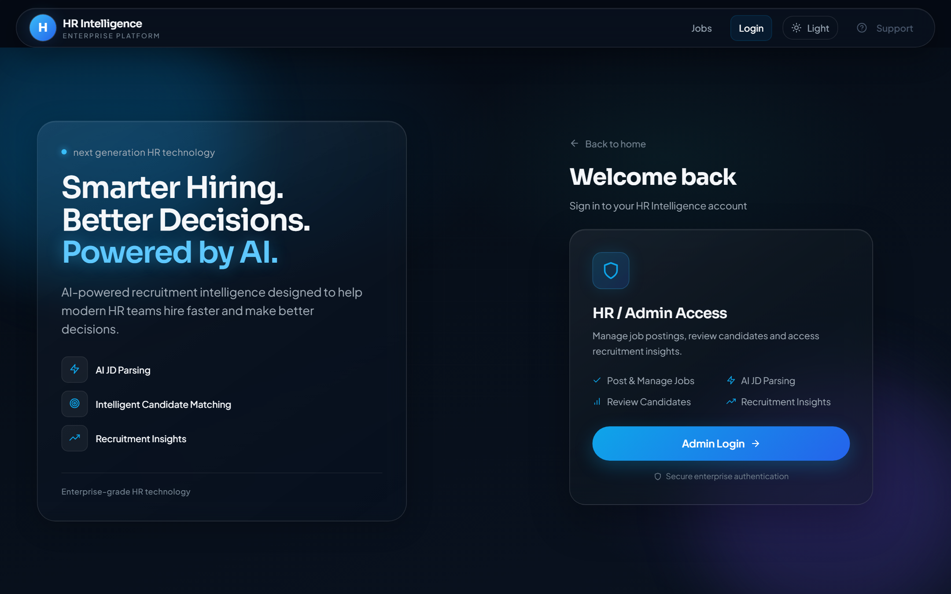
Figure 3.1 Login chooser
Description:
- Login chooser
Expected Result:
- Login landing with Admin Login entry point

Step 2
Action:
- Open Admin Login
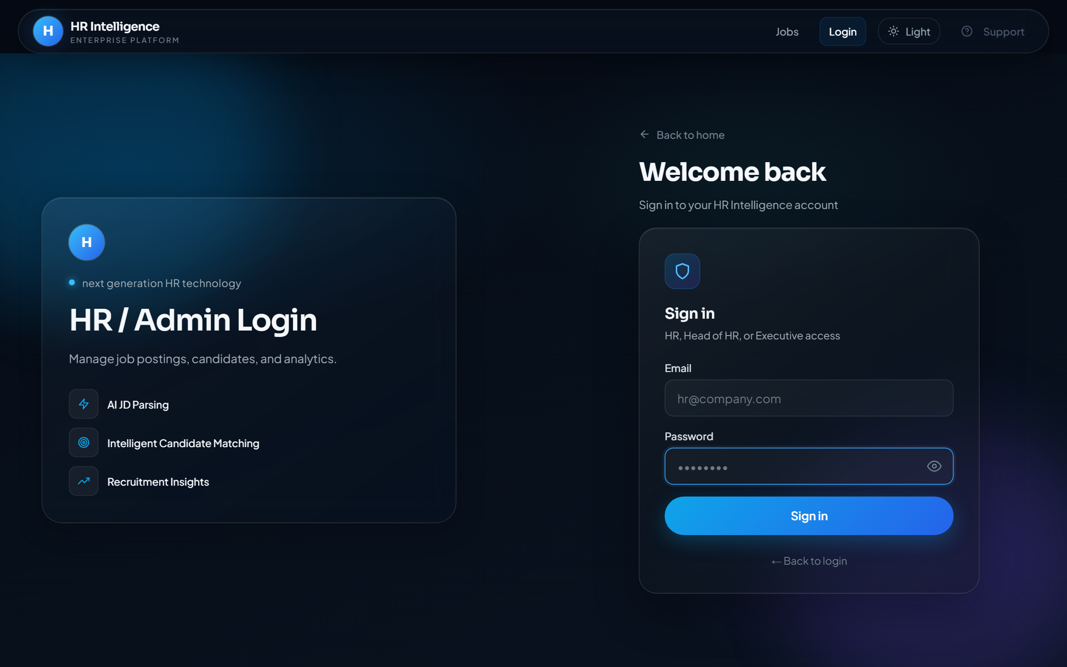
Figure 3.2 Admin login form (empty)
Description:
- Admin login form (empty)
Expected Result:
- Email and password fields with Sign in button

Step 3
Action:
- Enter staff email address
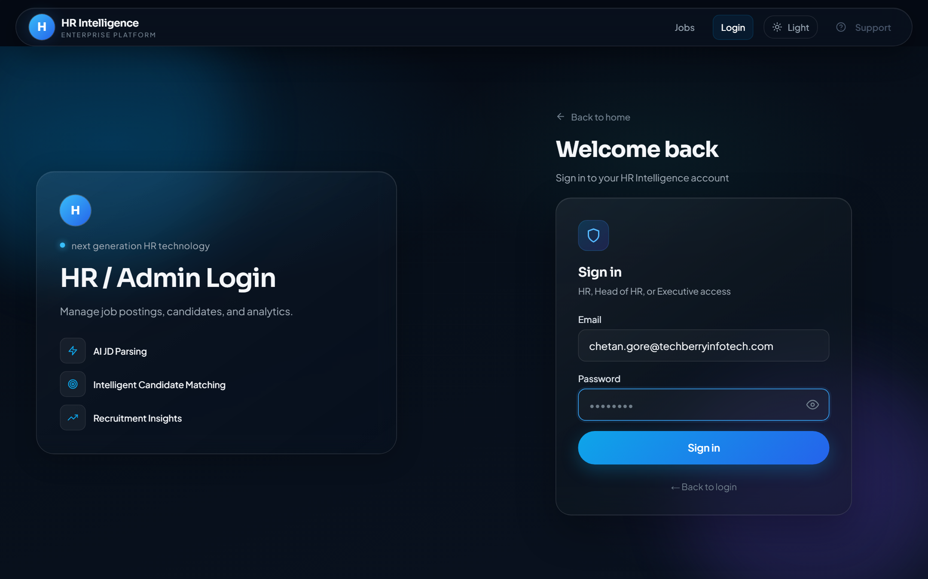
Figure 3.3 Email entered
Description:
- Email entered
Expected Result:
- Email field shows the entered address; password still empty

Step 4
Action:
- Enter password
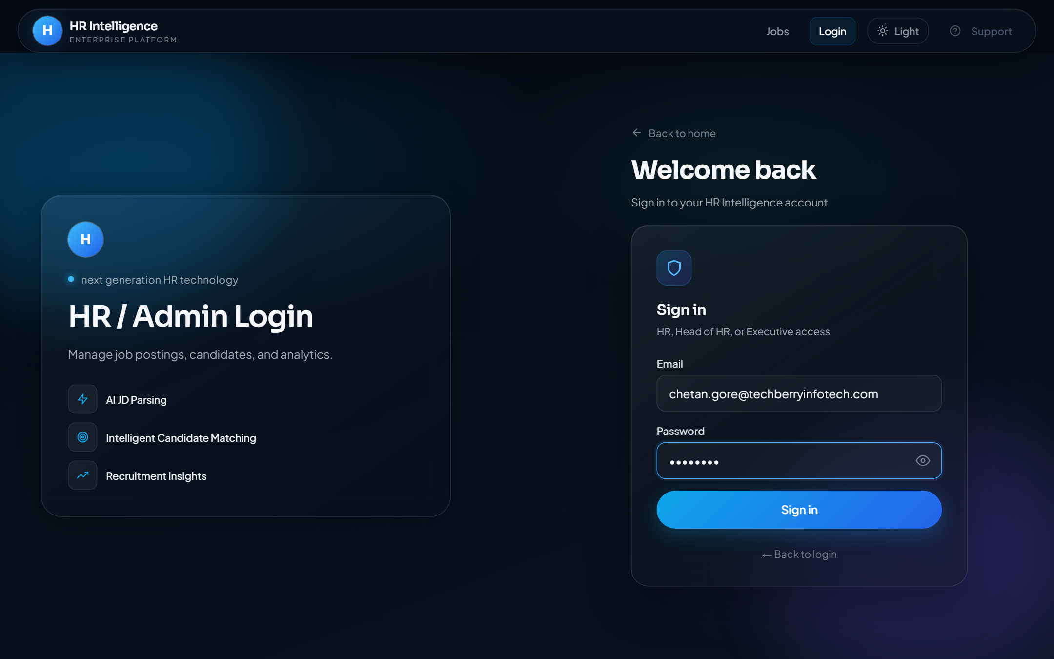
Figure 3.4 Password entered
Description:
- Password entered
Expected Result:
- Password field is filled (masked)

Step 5
Action:
- Open Forgot Password (admin variant)
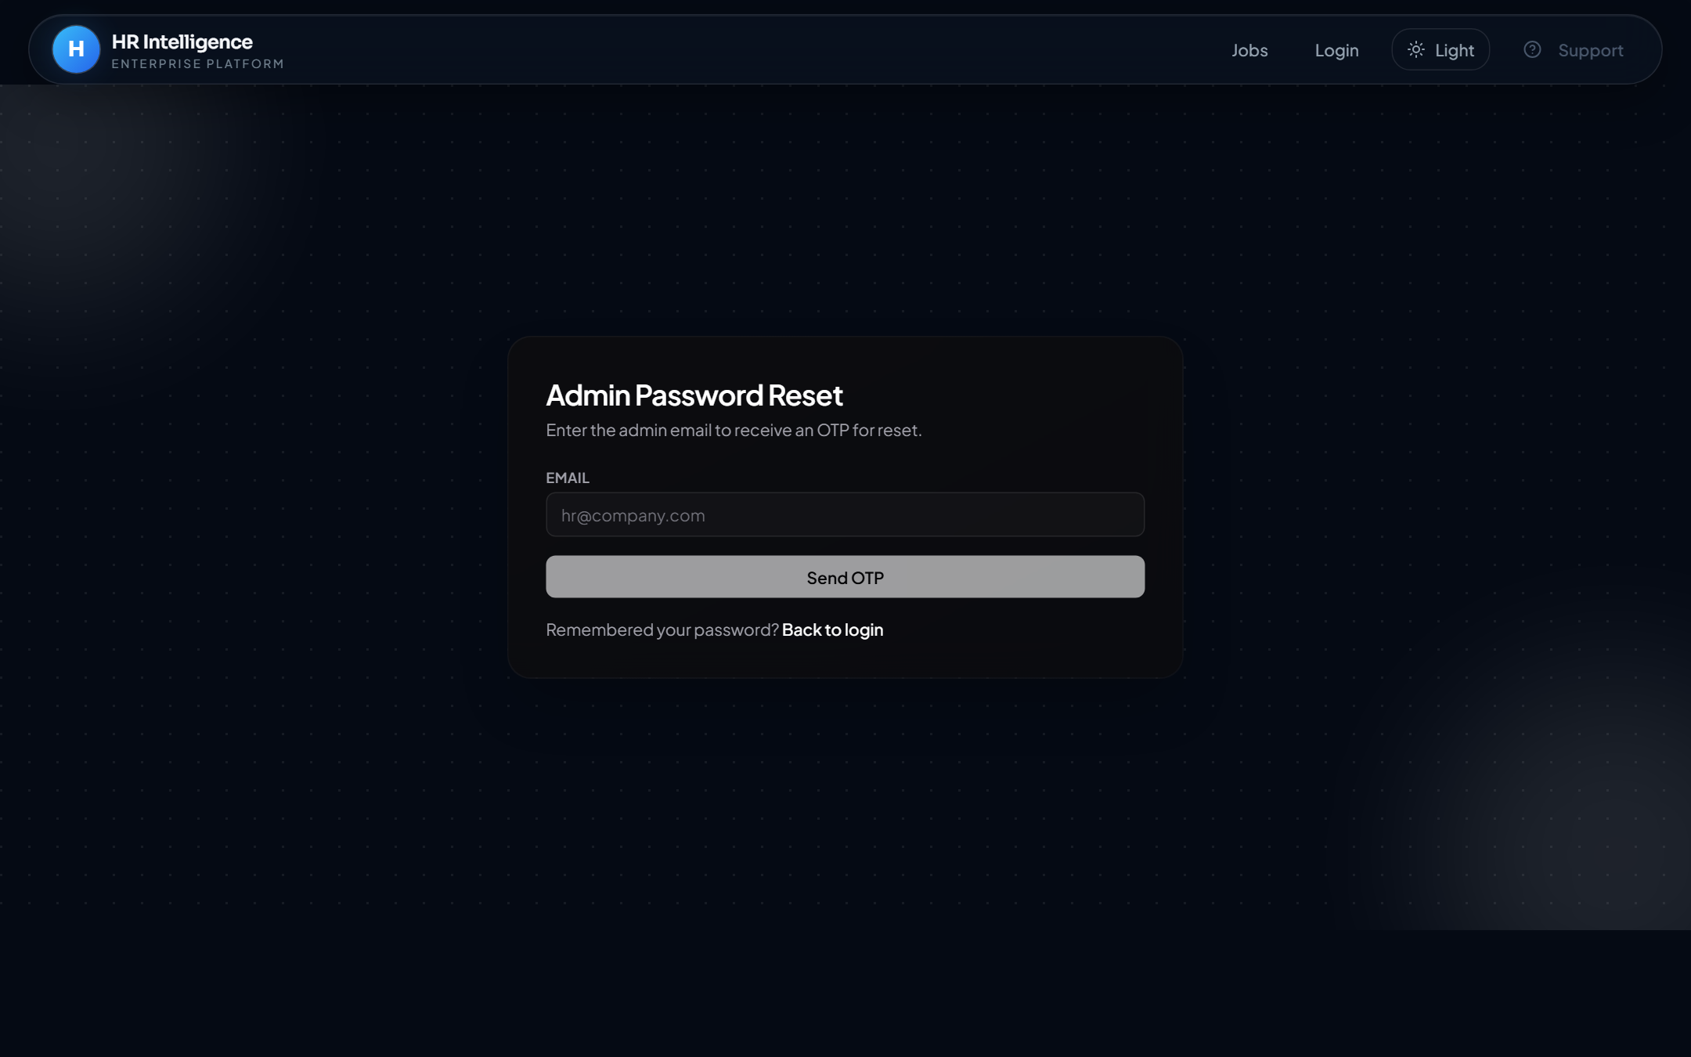
Figure 3.5 Forgot password
Description:
- Forgot password
Expected Result:
- Password recovery request form

Step 6
Action:
- Open Sign Up as Admin
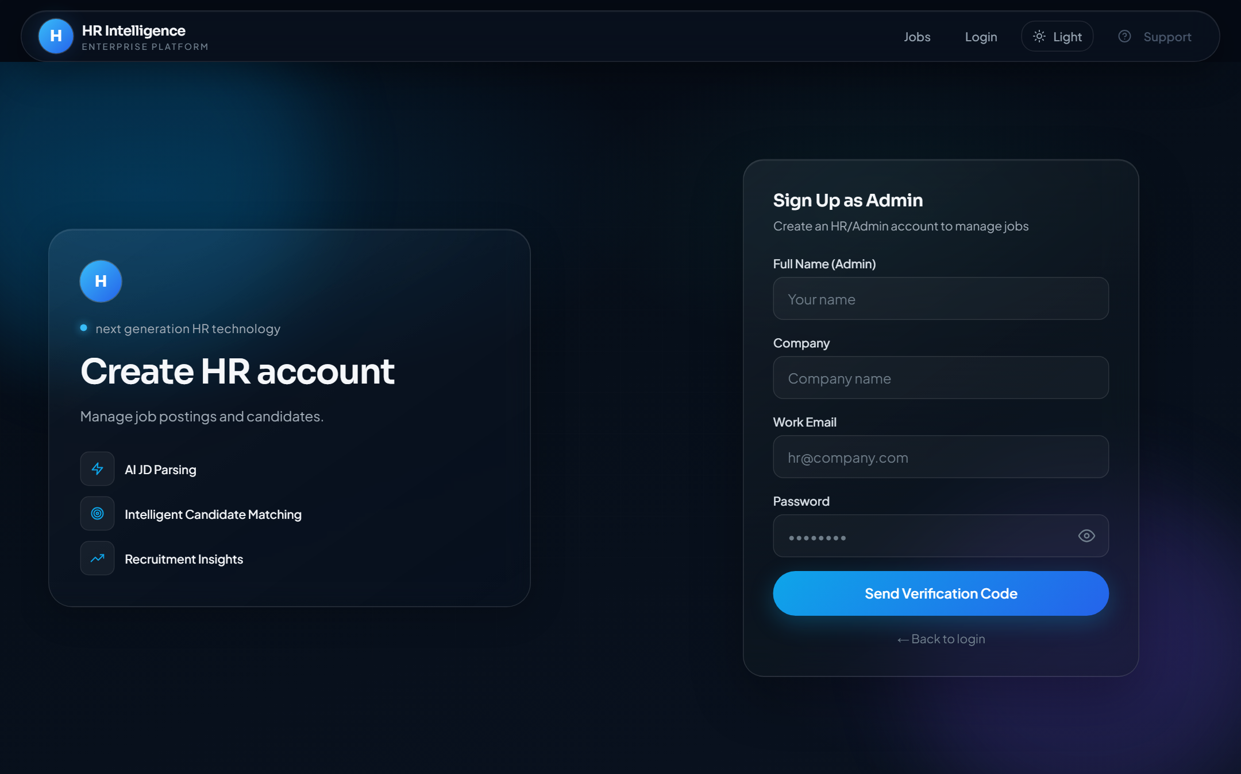
Figure 3.6 Admin signup
Description:
- Admin signup
Expected Result:
- HR signup form (name, company, email, password) with OTP step
Notes
- If a control is disabled, complete required fields first.
- Match scores depend on parsed JD and resume content.

4. Jobs (Public Board & Apply)
Purpose
Browse published jobs and submit applications via the apply modal.
Navigation Path
/jobs
Accessible Roles
Public (apply); staff may browse but cannot apply while signed in as staff
Description / Business Purpose
This chapter documents the live UI for Jobs (Public Board & Apply). Each step includes a full screenshot captured from the running application.

Step 1
Action:
- Open Jobs from the navigation bar (or Get Started)
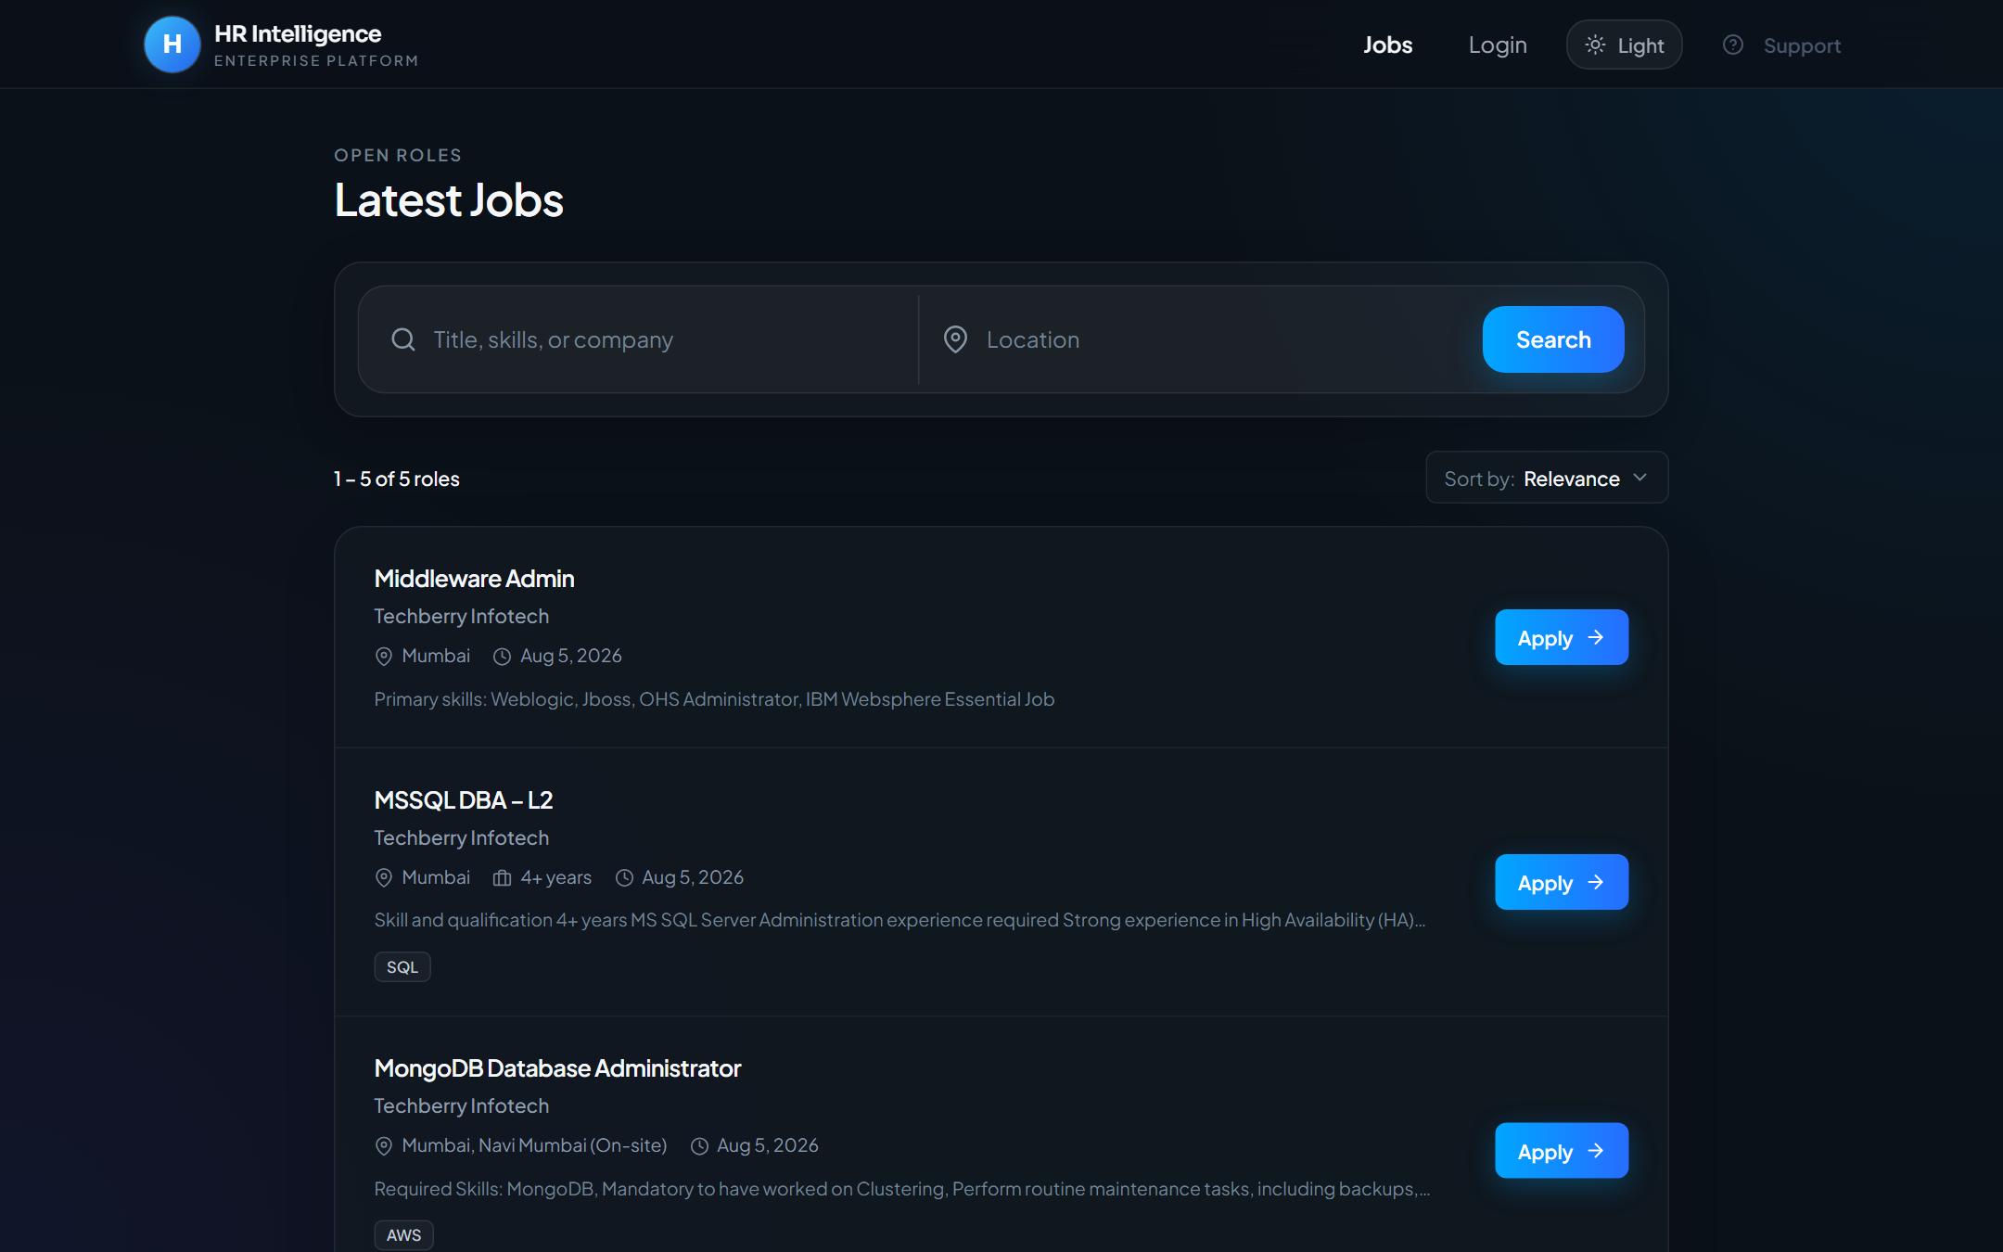
Figure 4.1 Public jobs board
Description:
- Public jobs board
Expected Result:
- List of published jobs with search/filter controls

Step 2
Action:
- Click Apply on a job card
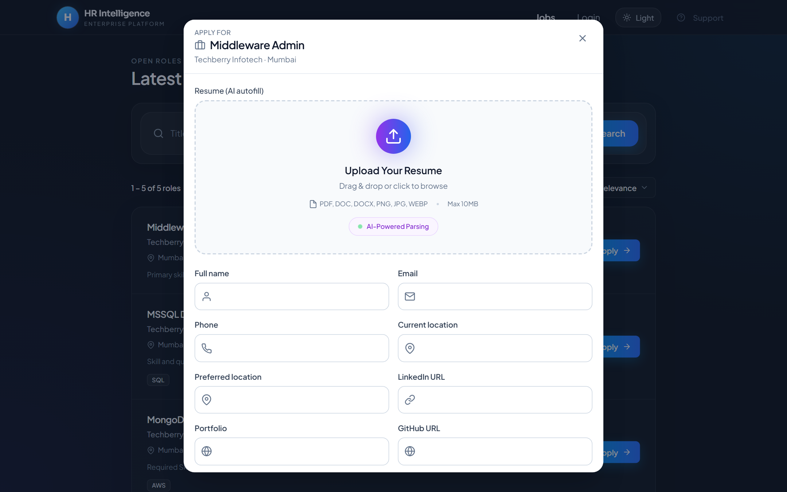
Figure 4.2 Apply to job modal
Description:
- Apply to job modal
Expected Result:
- Application modal opens with resume upload and profile fields
Notes
- If a control is disabled, complete required fields first.
- Match scores depend on parsed JD and resume content.

5. Support
Purpose
FAQ, Contact Us, and HRMS Testing Feedback channels.
Navigation Path
/support/faq · /support/contact · /support/hrms-feedback
Accessible Roles
Public
Description / Business Purpose
This chapter documents the live UI for Support. Each step includes a full screenshot captured from the running application.

Step 1
Action:
- Open Support → FAQ
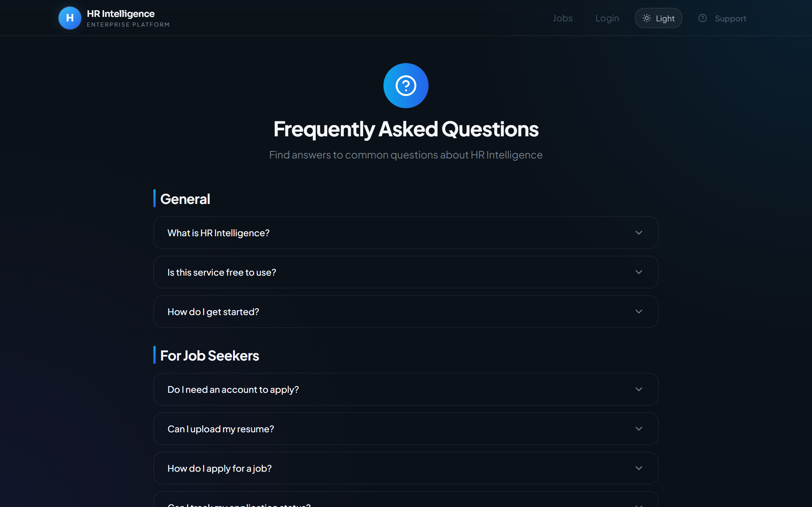
Figure 5.1 FAQ
Description:
- FAQ
Expected Result:
- FAQ accordion page with common questions

Step 2
Action:
- Open Support → Contact Us
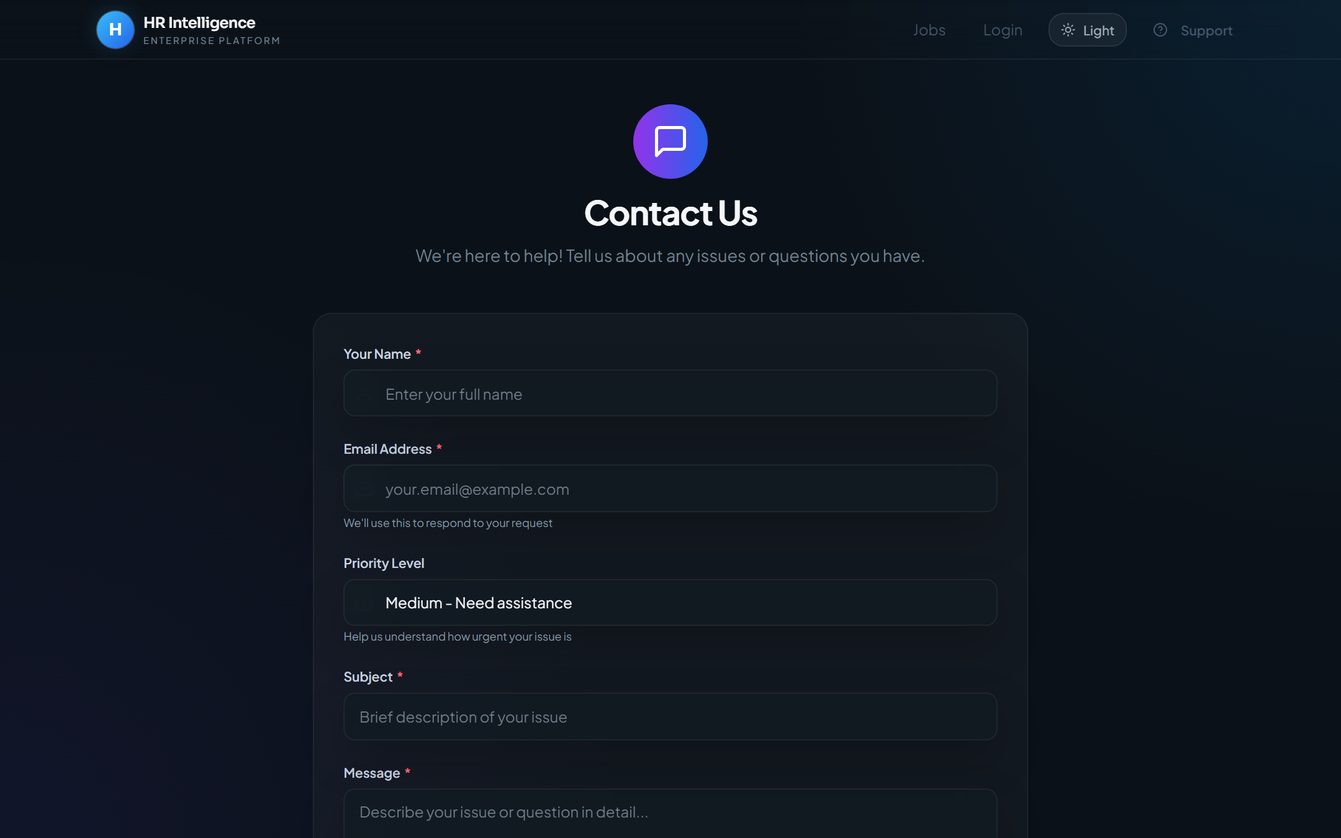
Figure 5.2 Contact Us
Description:
- Contact Us
Expected Result:
- Support request form (name, email, subject, message, priority)

Step 3
Action:
- Open Support → HRMS Testing Feedback
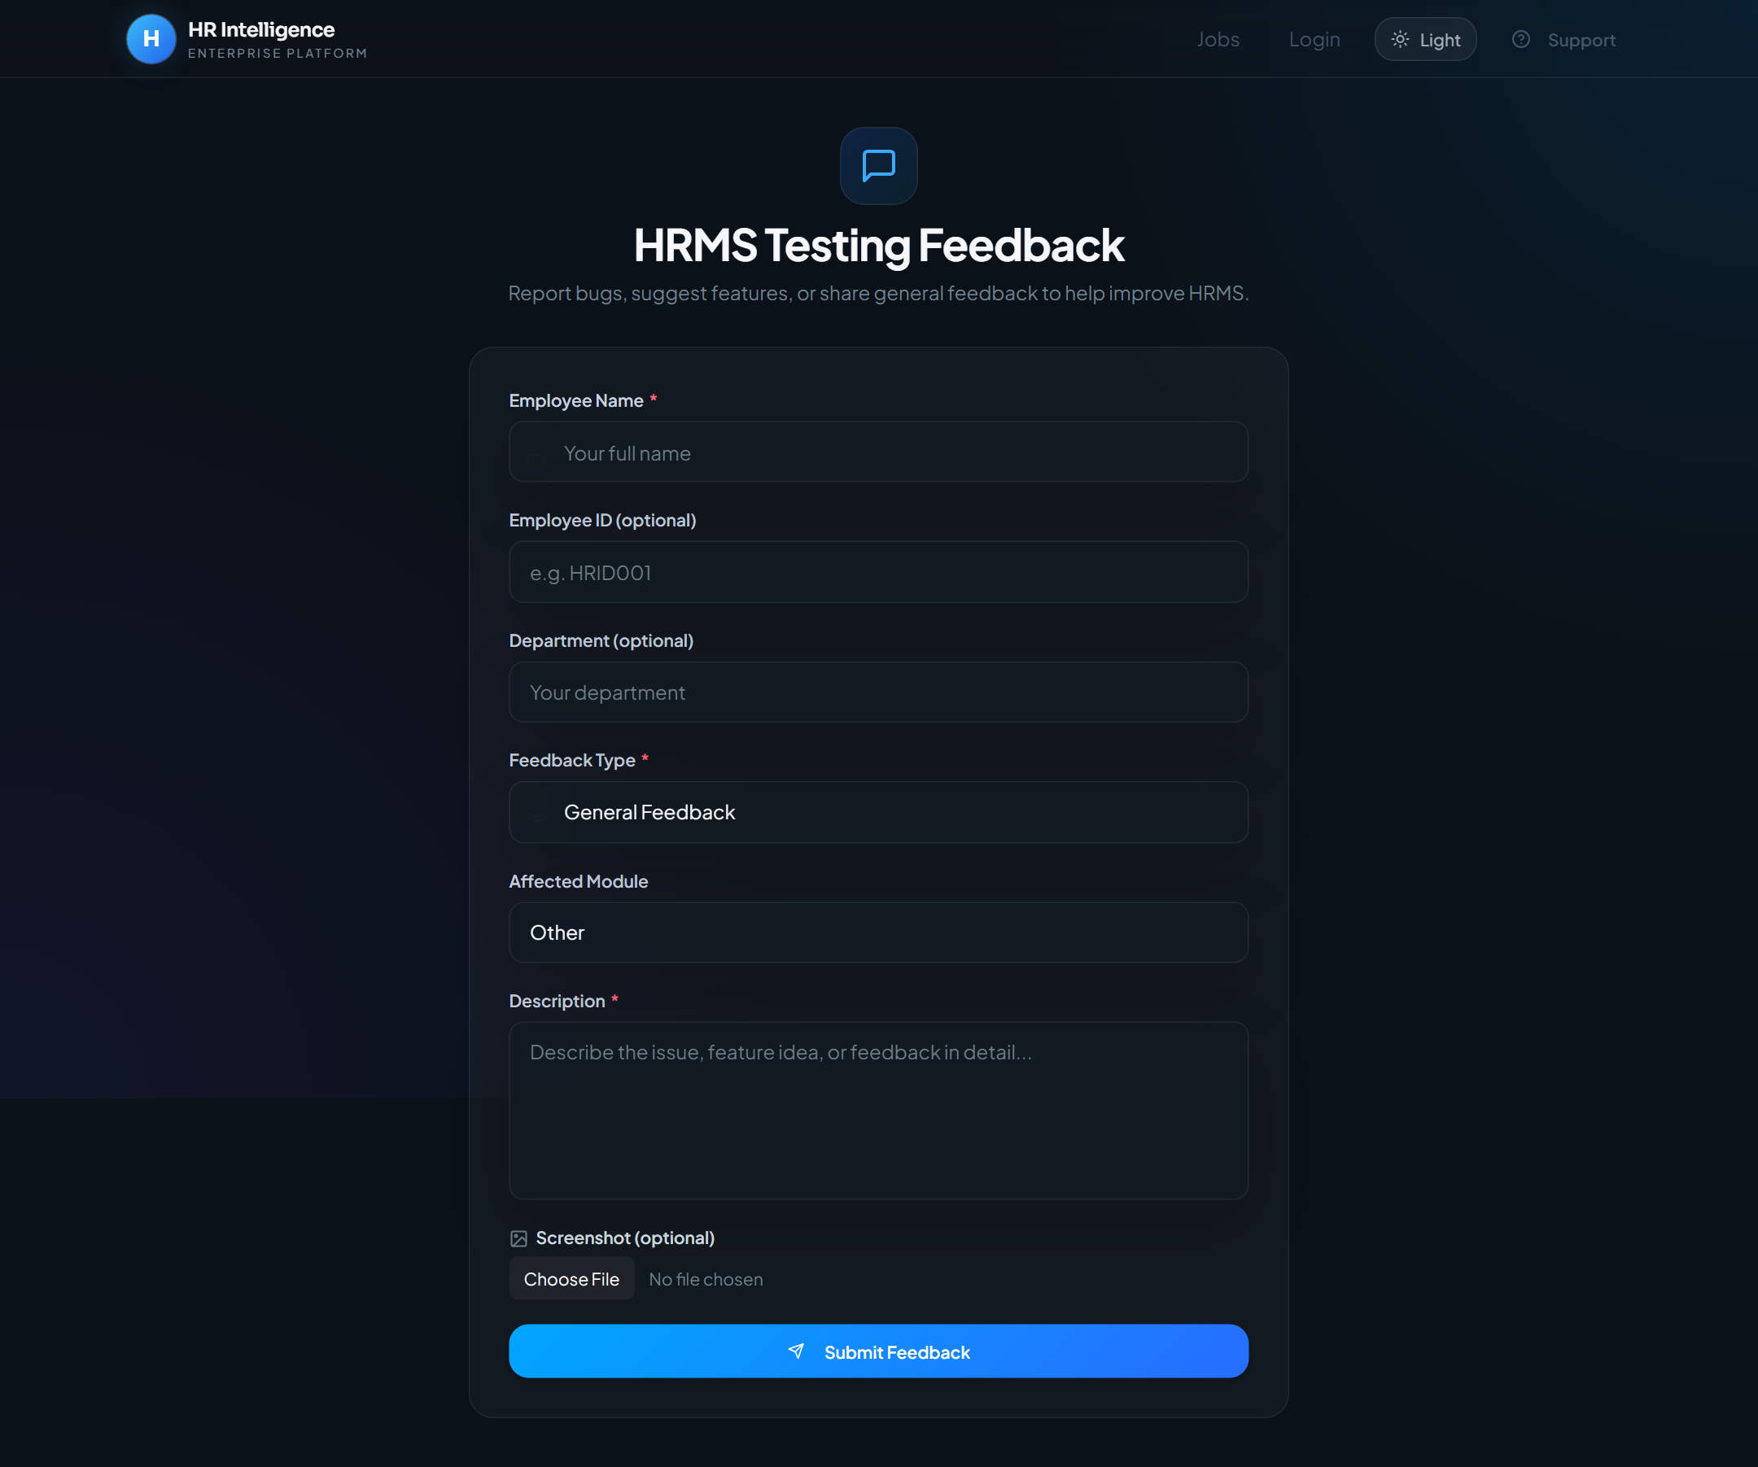
Figure 5.3 HRMS Testing Feedback
Description:
- HRMS Testing Feedback
Expected Result:
- Feedback form for type, module, severity, description, screenshot
Notes
- If a control is disabled, complete required fields first.
- Match scores depend on parsed JD and resume content.

6. Head HR Overview Dashboard
Purpose
Organization overview and Head HR panel entry point.
Navigation Path
/head-hr
Accessible Roles
HEAD_HR
Description / Business Purpose
This chapter documents the live UI for Head HR Overview Dashboard. Each step includes a full screenshot captured from the running application.

Step 1
Action:
- Sign in as Head HR (or open /head-hr)
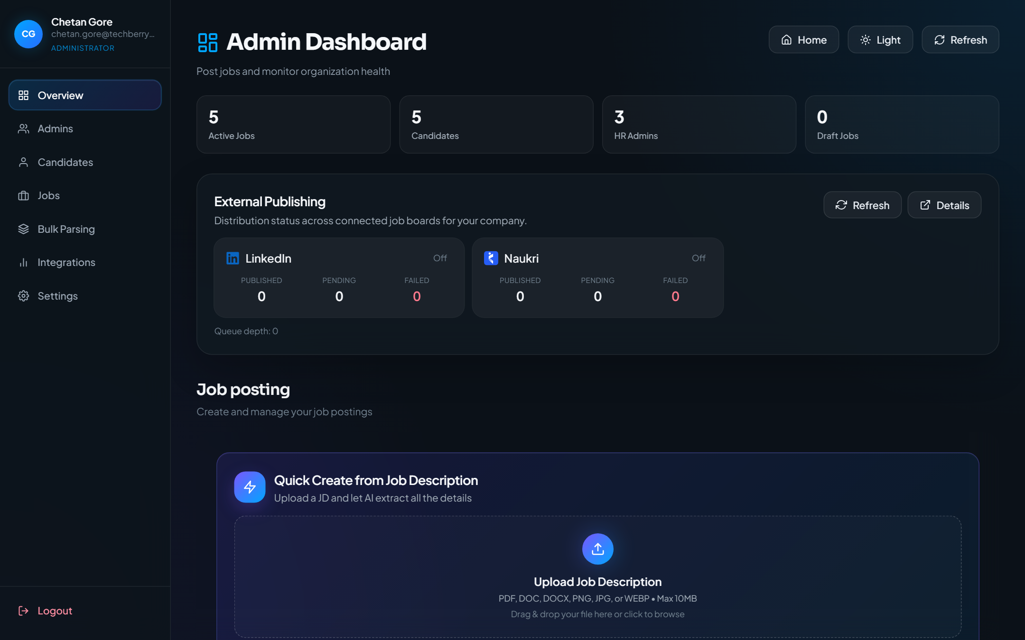
Figure 6.1 Head HR Overview Dashboard
Description:
- Head HR Overview Dashboard
Expected Result:
- Organization overview with sidebar navigation and posting tools
Notes
- If a control is disabled, complete required fields first.
- Match scores depend on parsed JD and resume content.

7. Admins
Purpose
Create and manage recruiter/admin HR accounts for the organization.
Navigation Path
/head-hr/admins
Accessible Roles
HEAD_HR
Description / Business Purpose
This chapter documents the live UI for Admins. Each step includes a full screenshot captured from the running application.

Step 1
Action:
- Sidebar → Admins
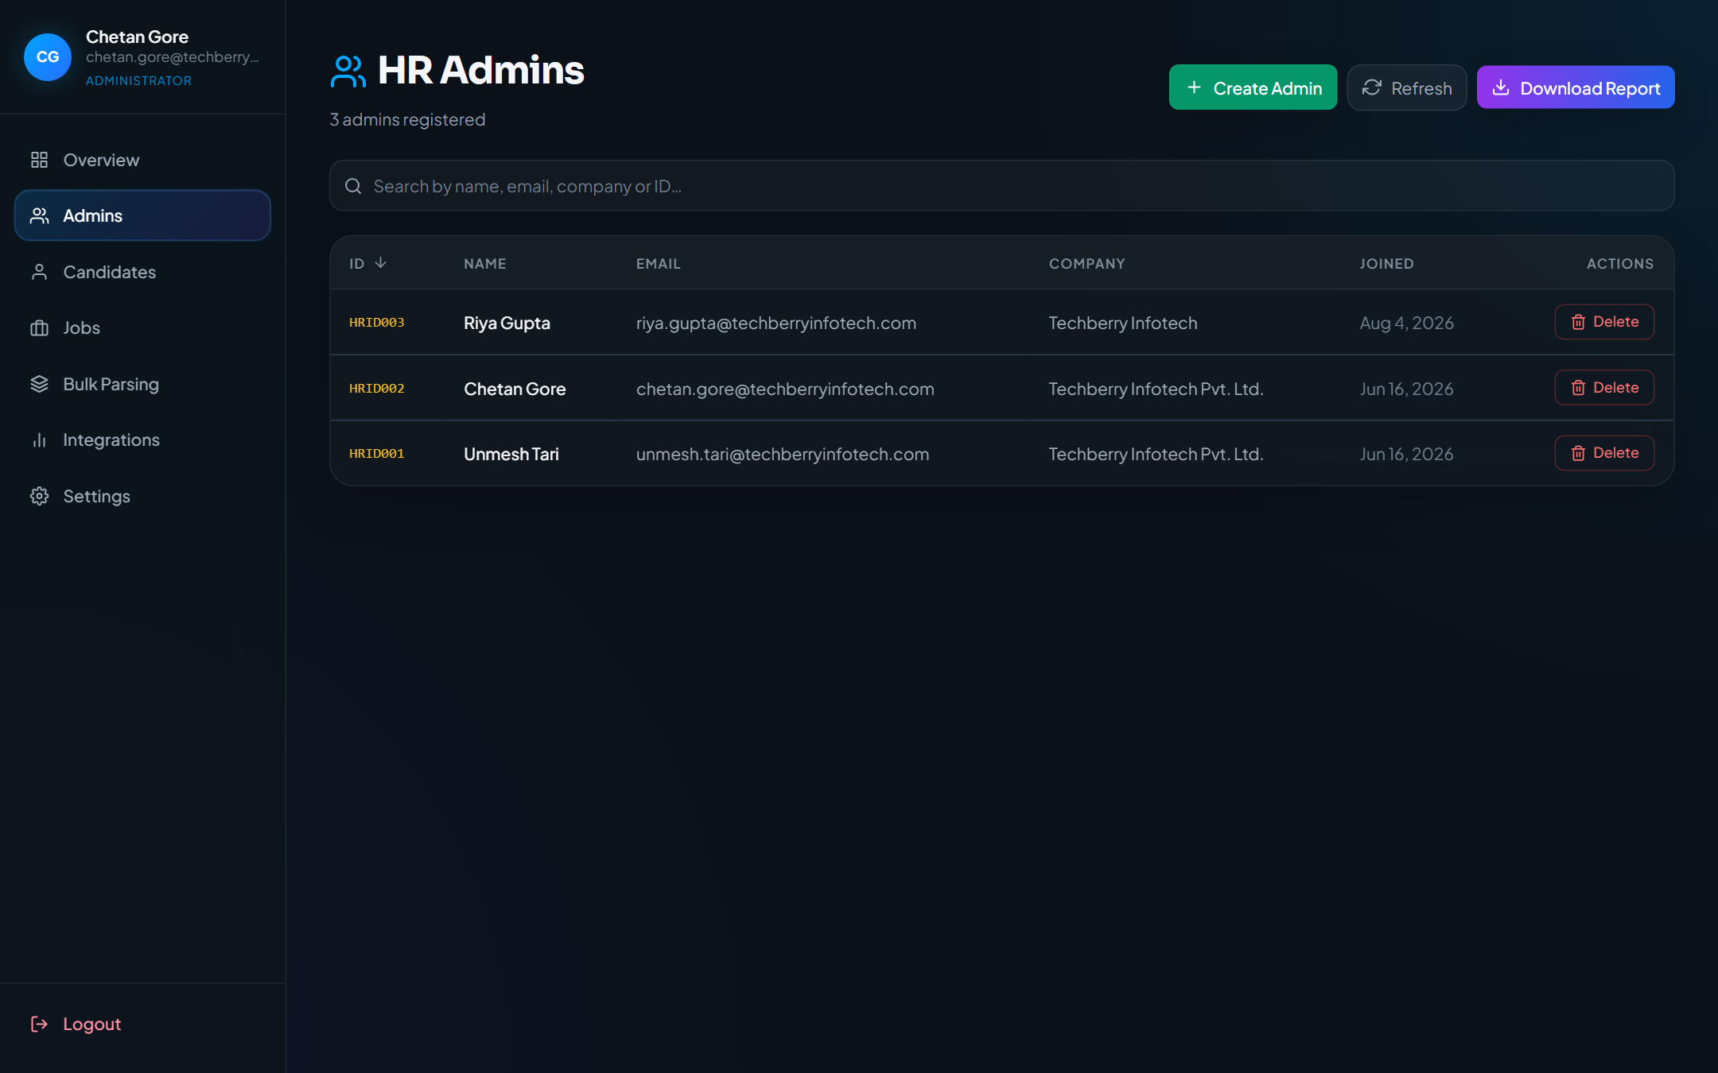
Figure 7.1 Admins management
Description:
- Admins management
Expected Result:
- Table of HR admin/recruiter accounts with create/delete actions
Notes
- If a control is disabled, complete required fields first.
- Match scores depend on parsed JD and resume content.

8. Head HR Candidates
Purpose
Org-wide candidate list and candidate detail.
Navigation Path
/head-hr/candidates · /head-hr/candidates/:cid
Accessible Roles
HEAD_HR (CEO uses /ceo/candidates read-only)
Description / Business Purpose
This chapter documents the live UI for Head HR Candidates. Each step includes a full screenshot captured from the running application.

Step 1
Action:
- Sidebar → Candidates
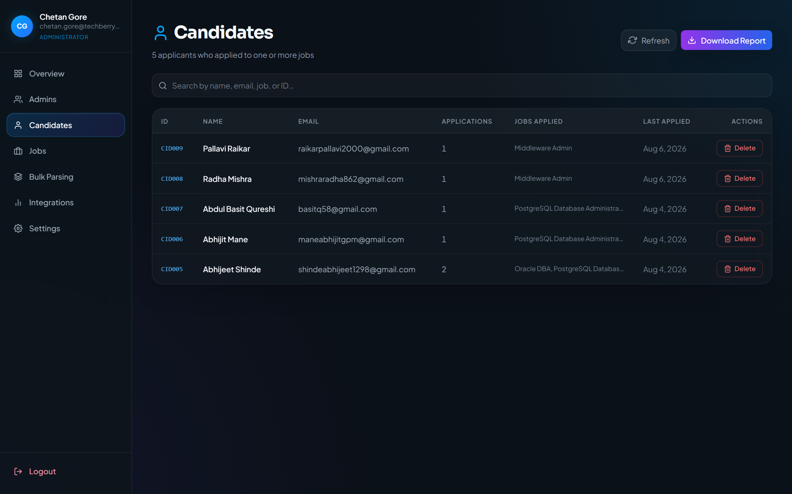
Figure 8.1 Candidates list
Description:
- Candidates list
Expected Result:
- Org-wide candidate table with search and row actions

Step 2
Action:
- Open candidate CID007 from the candidates list
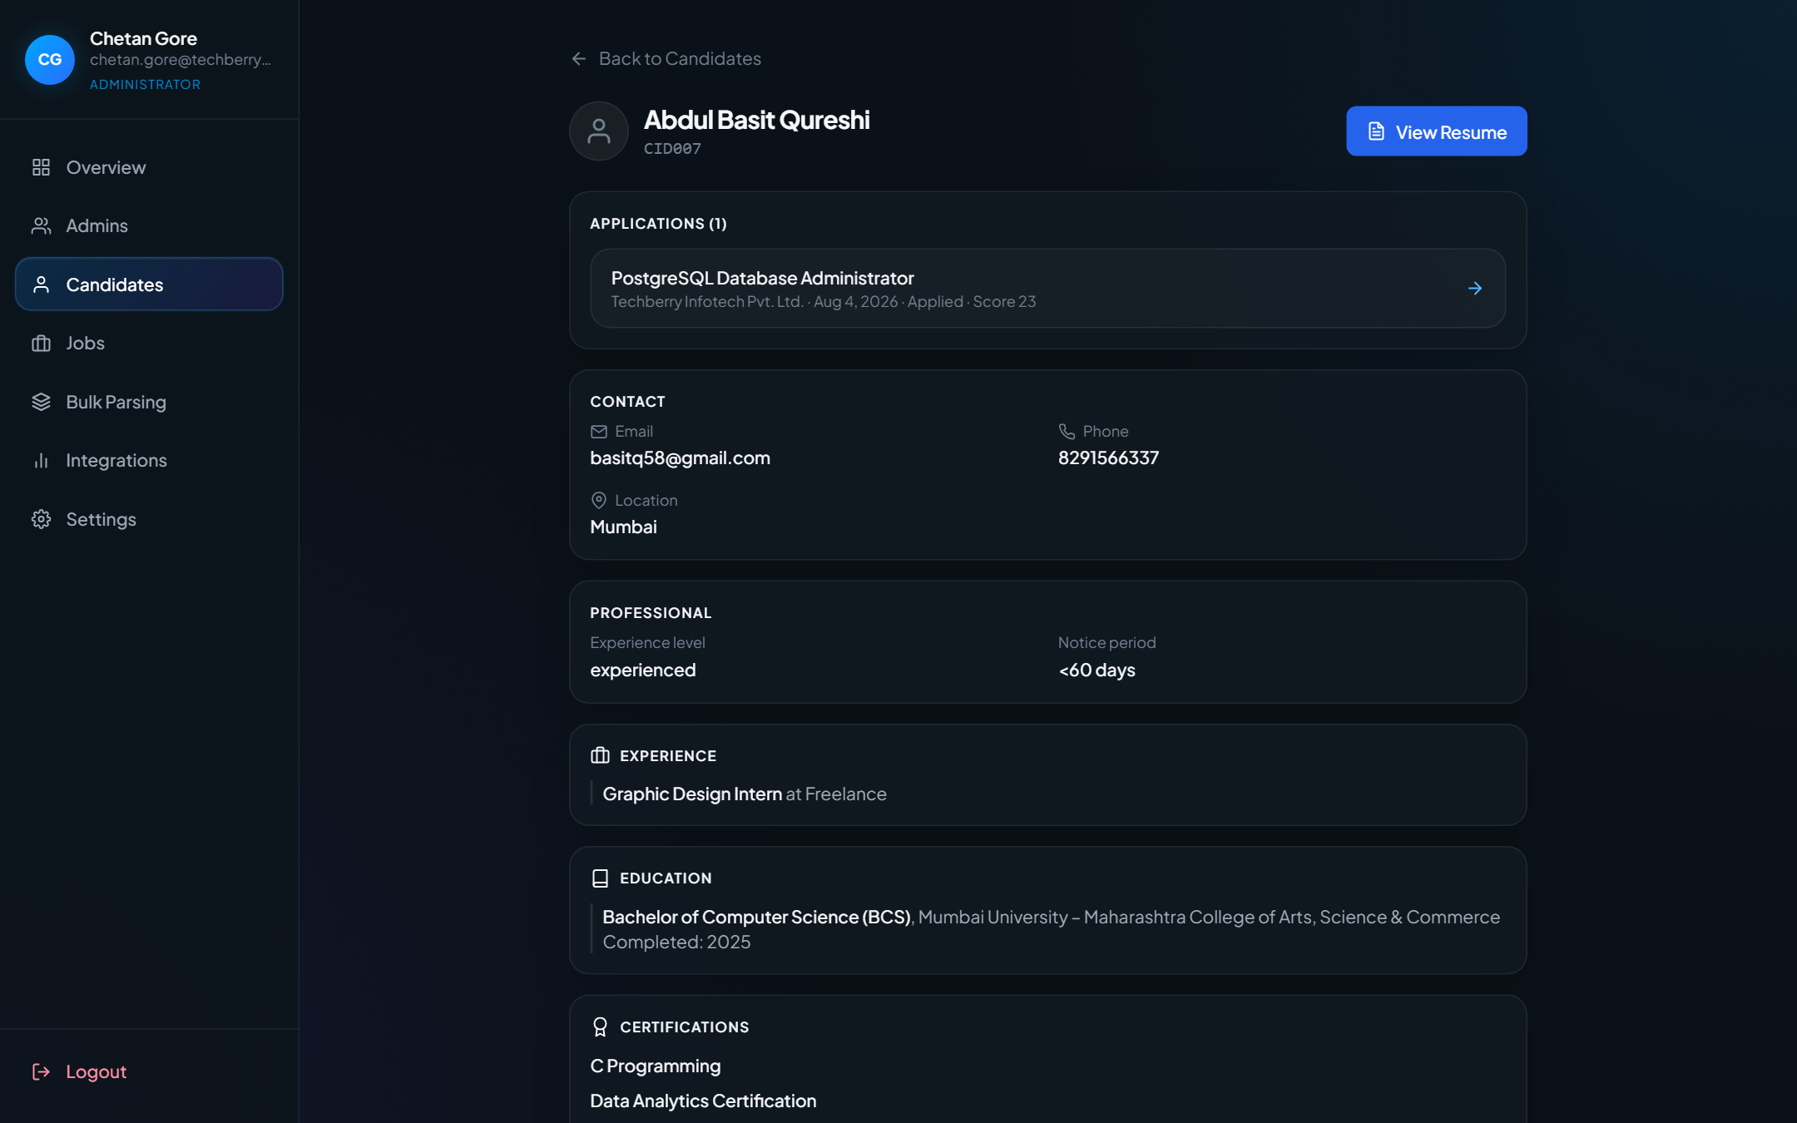
Figure 8.2 Candidate detail
Description:
- Candidate detail
Expected Result:
- Candidate profile detail for the selected CID
Notes
- If a control is disabled, complete required fields first.
- Match scores depend on parsed JD and resume content.

9. Head HR Jobs
Purpose
Organization job inventory with search and management actions.
Navigation Path
/head-hr/jobs
Accessible Roles
HEAD_HR
Description / Business Purpose
This chapter documents the live UI for Head HR Jobs. Each step includes a full screenshot captured from the running application.

Step 1
Action:
- Sidebar → Jobs
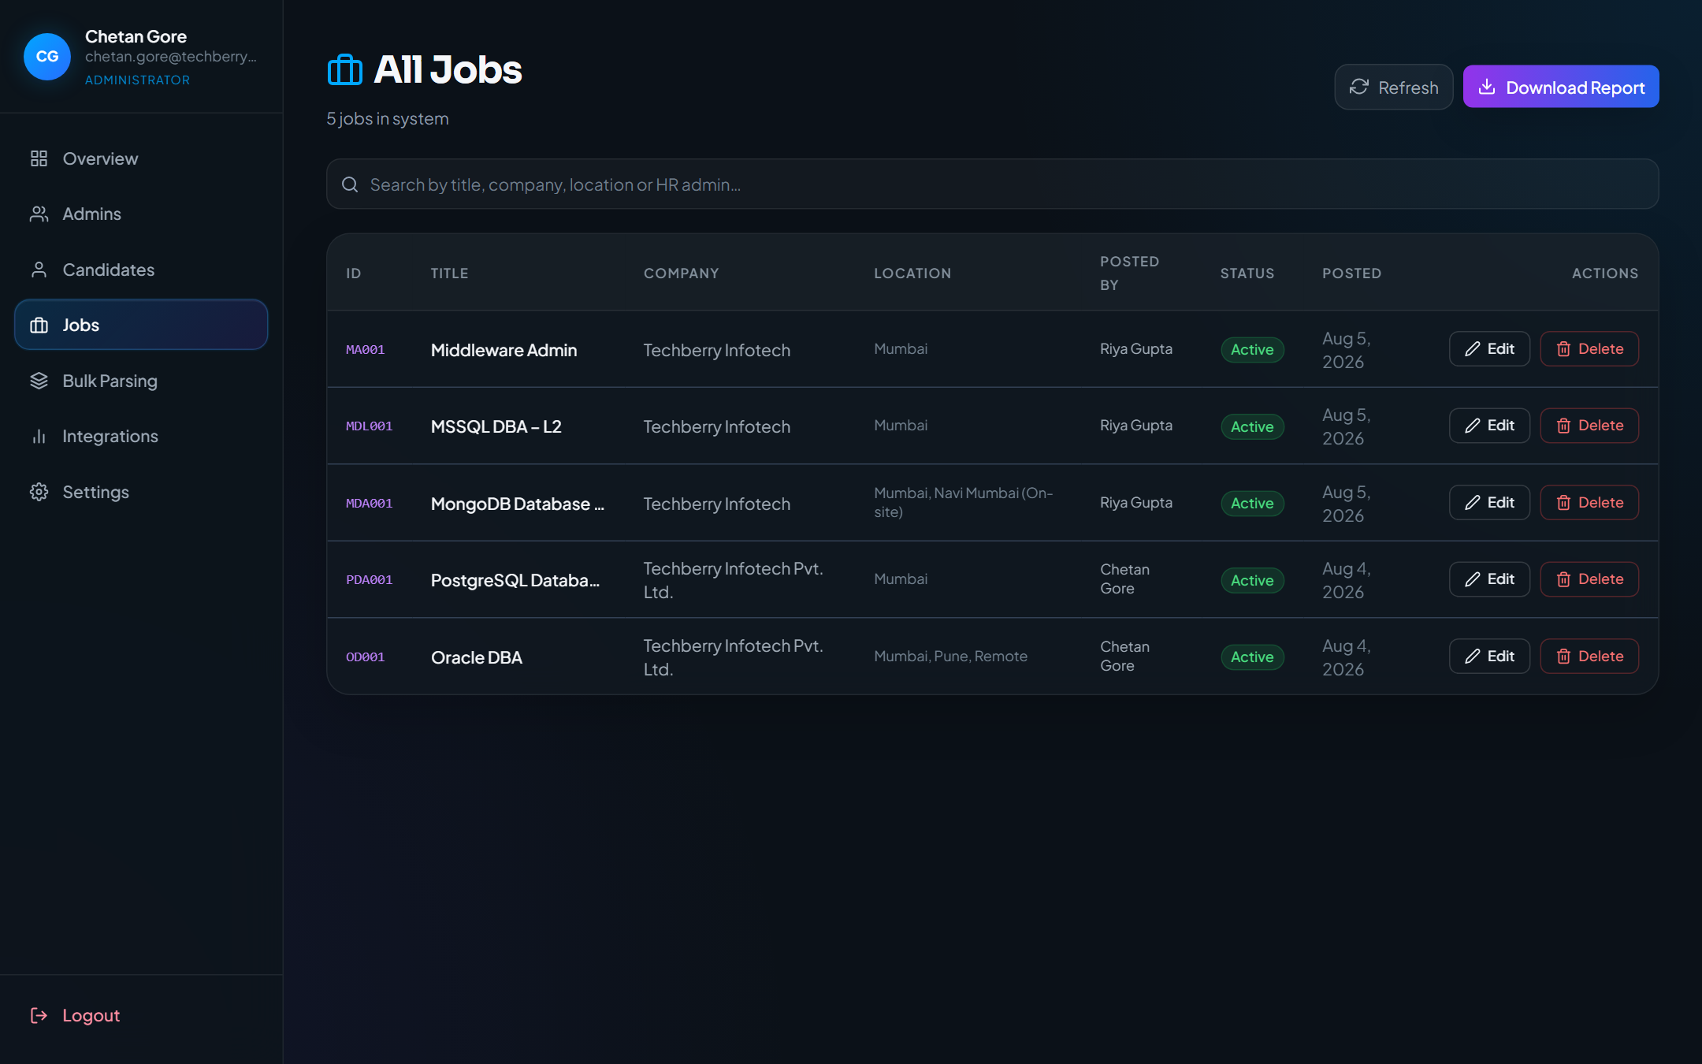
Figure 9.1 Head HR Jobs list
Description:
- Head HR Jobs list
Expected Result:
- Organization job list with search, refresh, edit/delete (Head HR)
Notes
- If a control is disabled, complete required fields first.
- Match scores depend on parsed JD and resume content.

10. Head HR Job Details & Applied Candidates
Purpose
Inspect a job and its applicants.
Navigation Path
/head-hr/jobs/:jdid
Accessible Roles
HEAD_HR (CEO: /ceo/jobs/:jdid read-only)
Description / Business Purpose
This chapter documents the live UI for Head HR Job Details & Applied Candidates. Each step includes a full screenshot captured from the running application.

Step 1
Action:
- Open job PDA001 from the jobs list
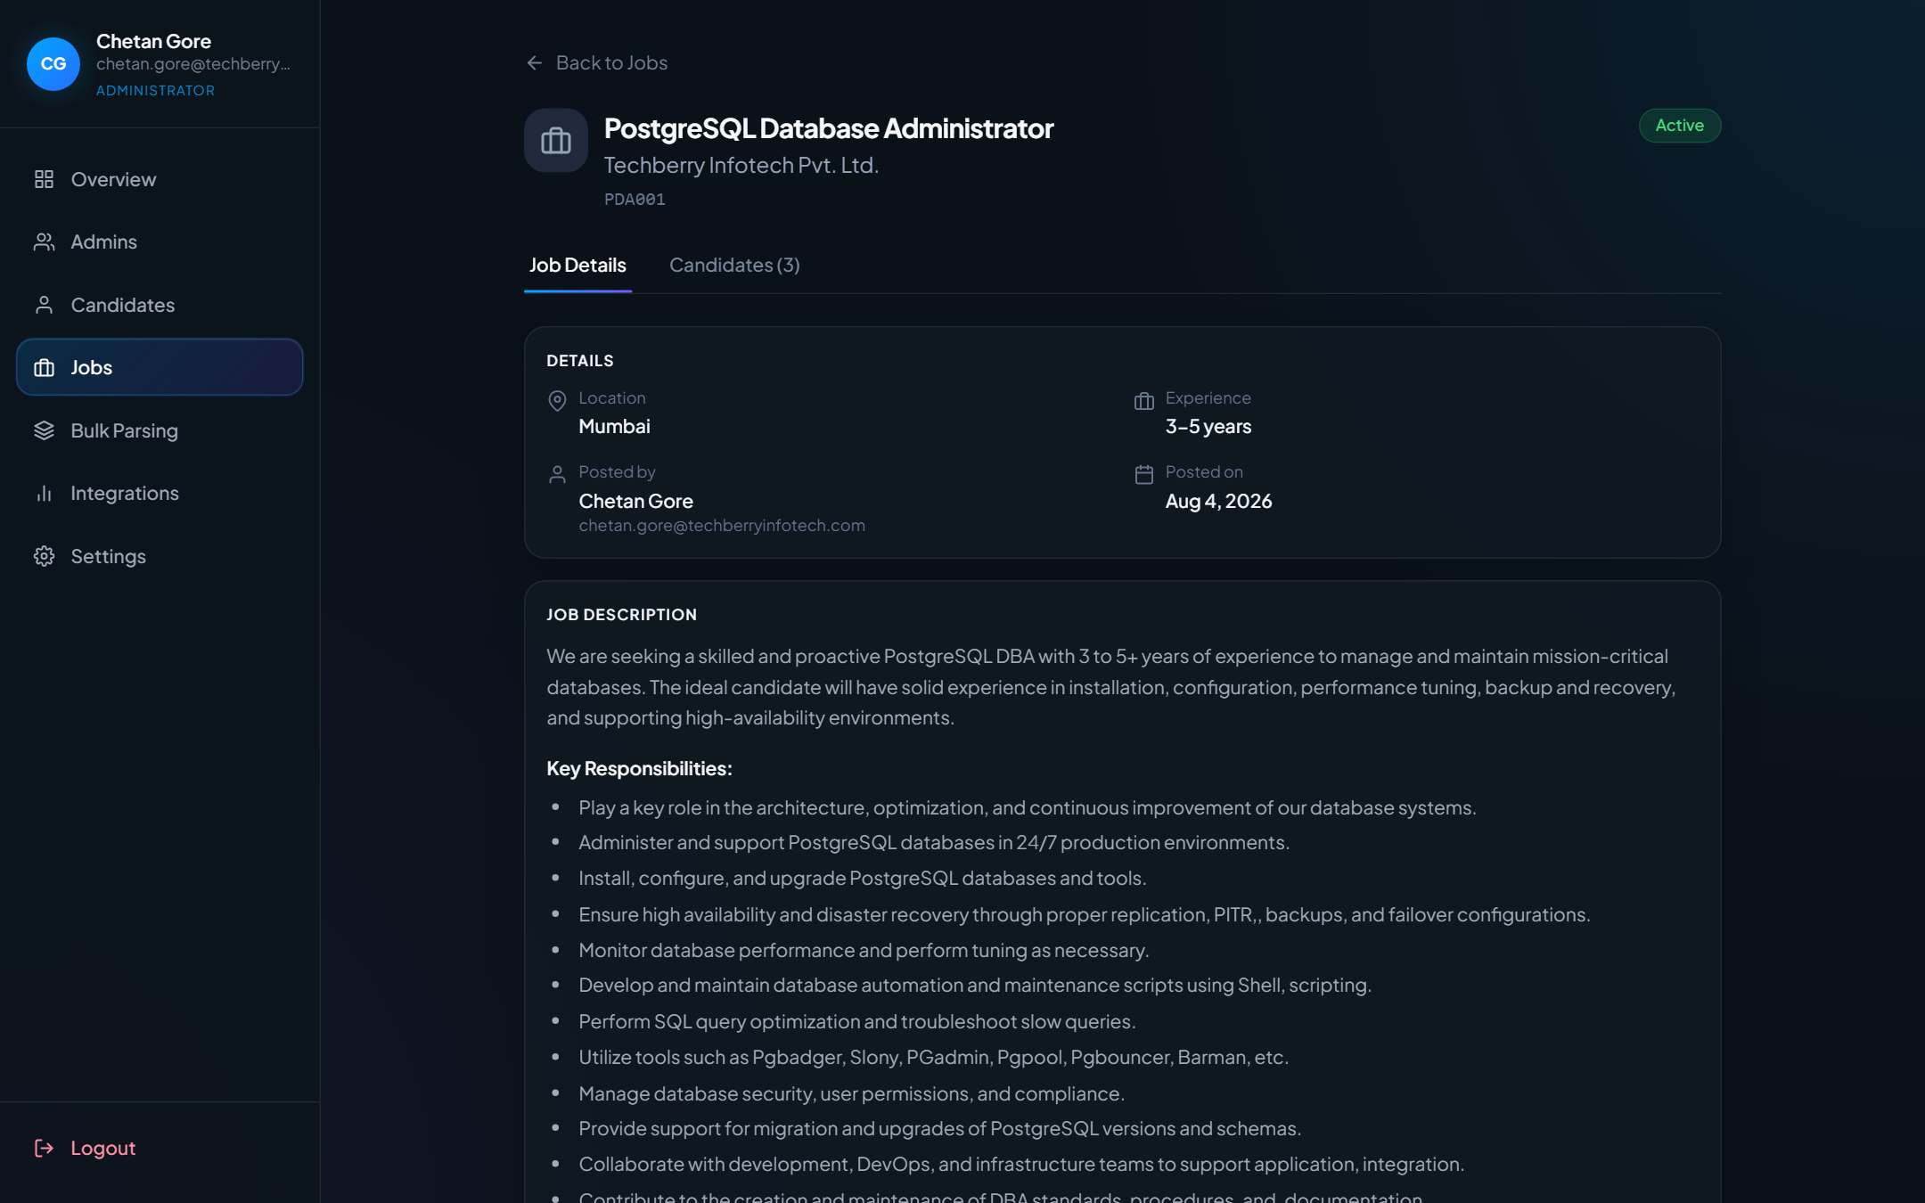
Figure 10.1 Job details with applicants
Description:
- Job details with applicants
Expected Result:
- Job Details / Candidates tabs with applicant rows

Step 2
Action:
- Open the Candidates tab on job detail
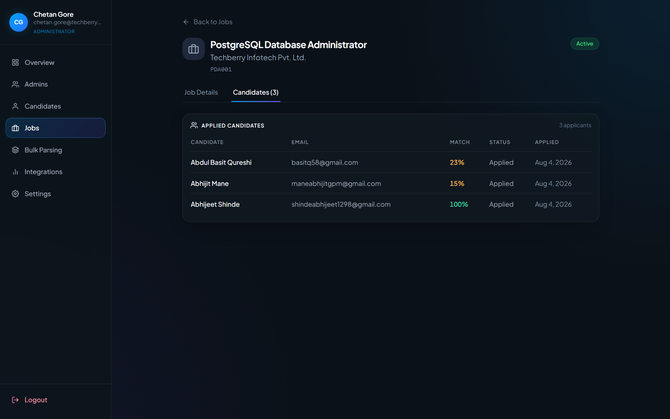
Figure 10.2 Applied candidates for job
Description:
- Applied candidates for job
Expected Result:
- Table of applicants for this job
Notes
- If a control is disabled, complete required fields first.
- Match scores depend on parsed JD and resume content.

11. Candidate Evaluation (Profile & Match)
Purpose
Review applicant profile and ATS match analysis for a job application.
Navigation Path
/head-hr/jobs/:jdid/candidates/:cid
Accessible Roles
HEAD_HR; CEO read-only under /ceo/…
Description / Business Purpose
This chapter documents the live UI for Candidate Evaluation (Profile & Match). Each step includes a full screenshot captured from the running application.

Step 1
Action:
- Open applicant CID007 for job PDA001
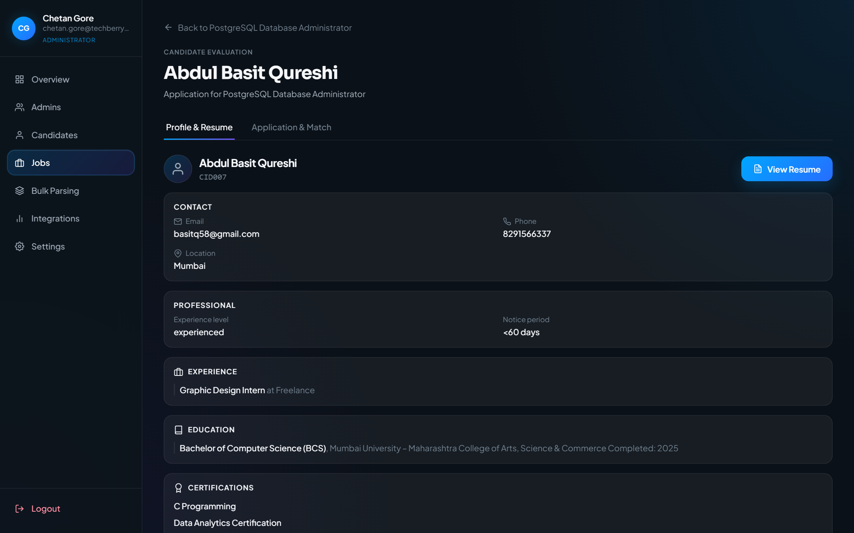
Figure 11.1 Candidate Evaluation — Profile & Resume
Description:
- Candidate Evaluation — Profile & Resume
Expected Result:
- Profile & Resume tab with candidate identity and resume actions

Step 2
Action:
- Open Application & Match tab
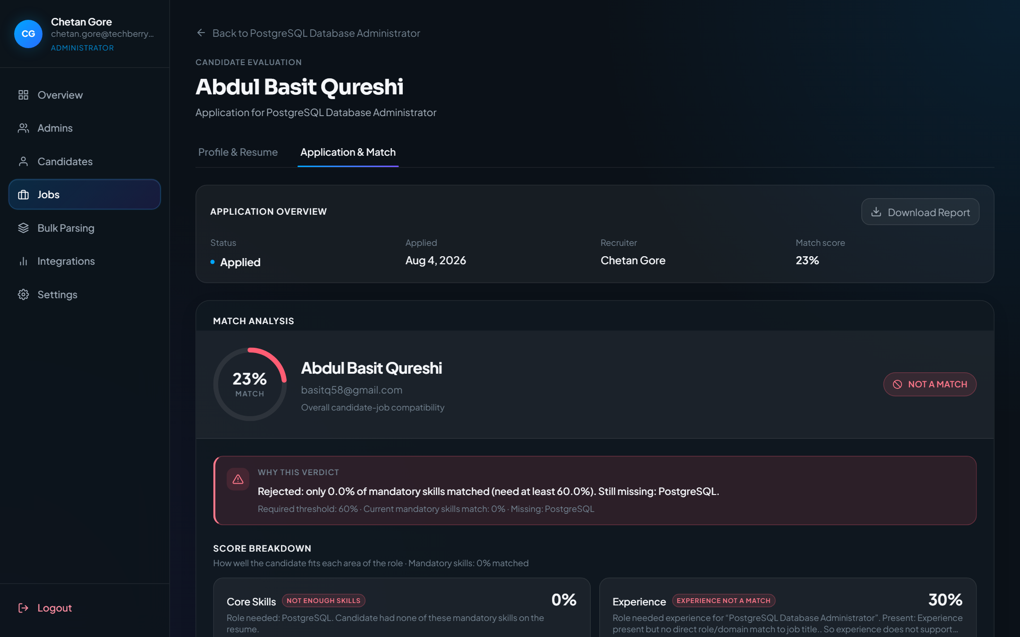
Figure 11.2 Candidate Evaluation — Application & Match
Description:
- Candidate Evaluation — Application & Match
Expected Result:
- ATS score, verdict, and match breakdown
Notes
- If a control is disabled, complete required fields first.
- Match scores depend on parsed JD and resume content.

12. Bulk Resume Parser (Head HR)
Purpose
Batch-parse resumes from ZIP/files.
Navigation Path
/head-hr/bulk-parsing
Accessible Roles
HEAD_HR
Description / Business Purpose
This chapter documents the live UI for Bulk Resume Parser (Head HR). Each step includes a full screenshot captured from the running application.

Step 1
Action:
- Sidebar → Bulk Parsing
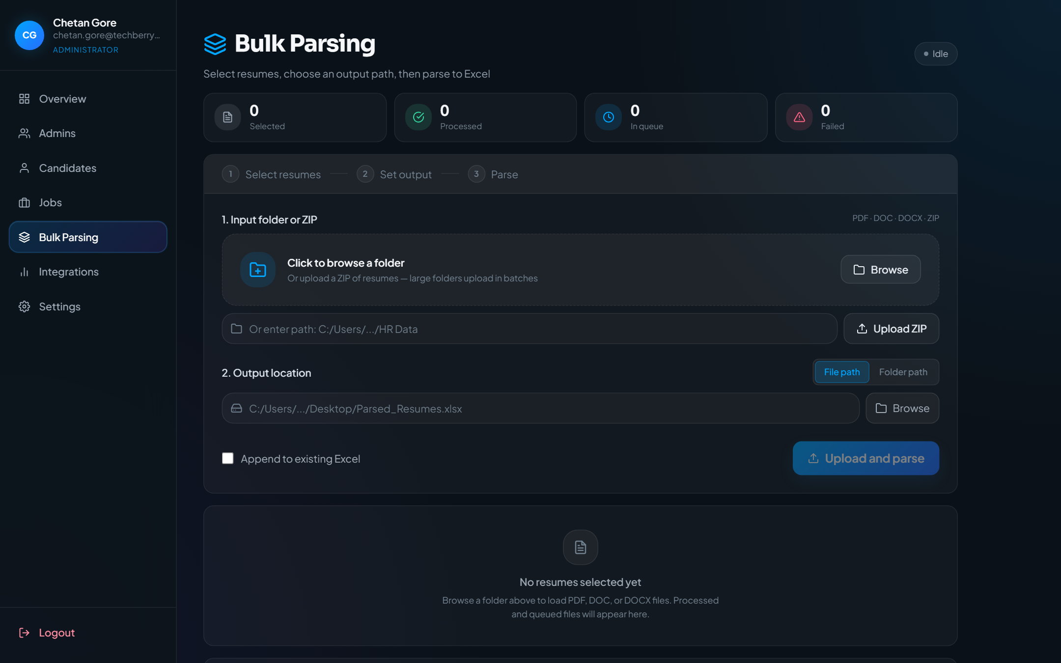
Figure 12.1 Bulk Resume Parser (Head HR)
Description:
- Bulk Resume Parser (Head HR)
Expected Result:
- Bulk upload workspace (ZIP/files, output, parse controls)

Step 2
Action:
- Click Browse or Upload ZIP and choose files in the system file dialog
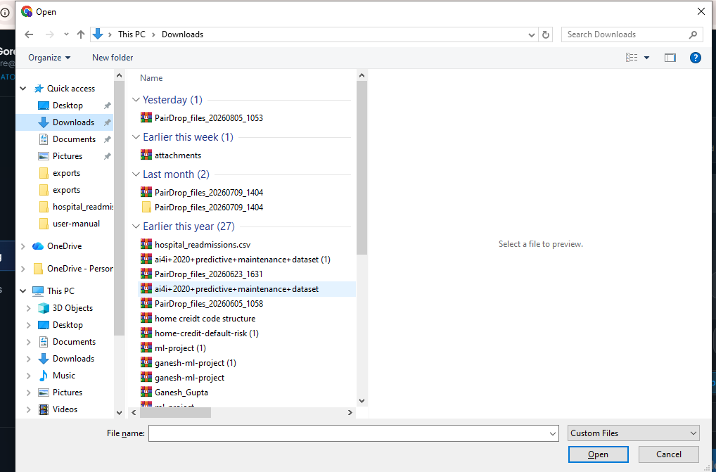
Figure 12.2 Browse and select ZIP or resume files
Description:
- Browse and select ZIP or resume files
Expected Result:
- Windows Open dialog appears so you can select a ZIP or resume files from your computer

Step 3
Action:
- After selecting input and output, start Parse and watch progress
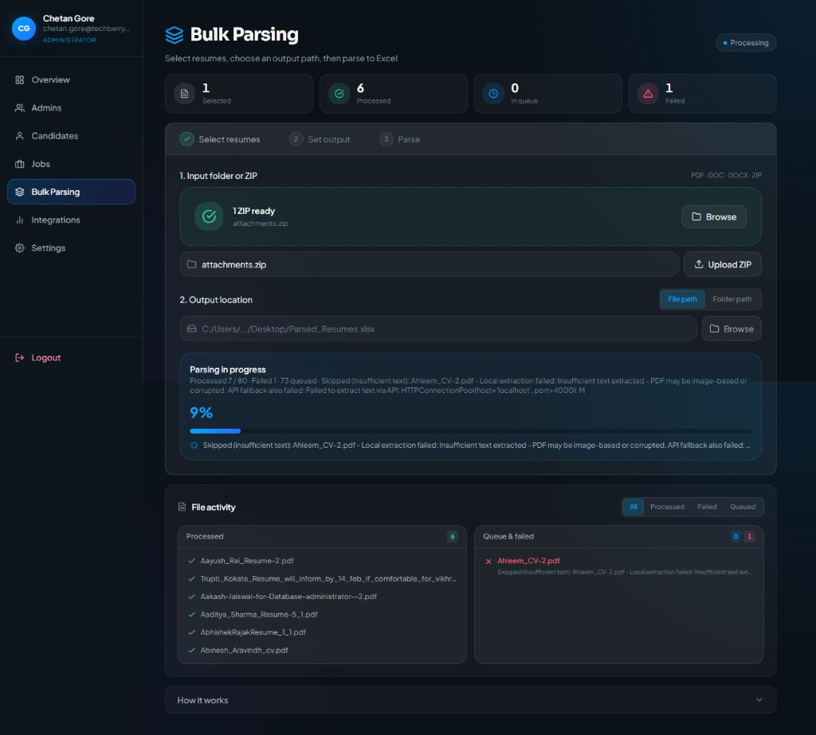
Figure 12.3 Bulk parsing in progress
Description:
- Bulk parsing in progress
Expected Result:
- Processing status, progress bar, processed/failed/queued counts, and file activity lists update live
Notes
- If a control is disabled, complete required fields first.
- Match scores depend on parsed JD and resume content.

13. Integrations (Head HR)
Purpose
Monitor external publishing integrations.
Navigation Path
/head-hr/integrations
Accessible Roles
HEAD_HR
Description / Business Purpose
This chapter documents the live UI for Integrations (Head HR). Each step includes a full screenshot captured from the running application.

Step 1
Action:
- Sidebar → Integrations
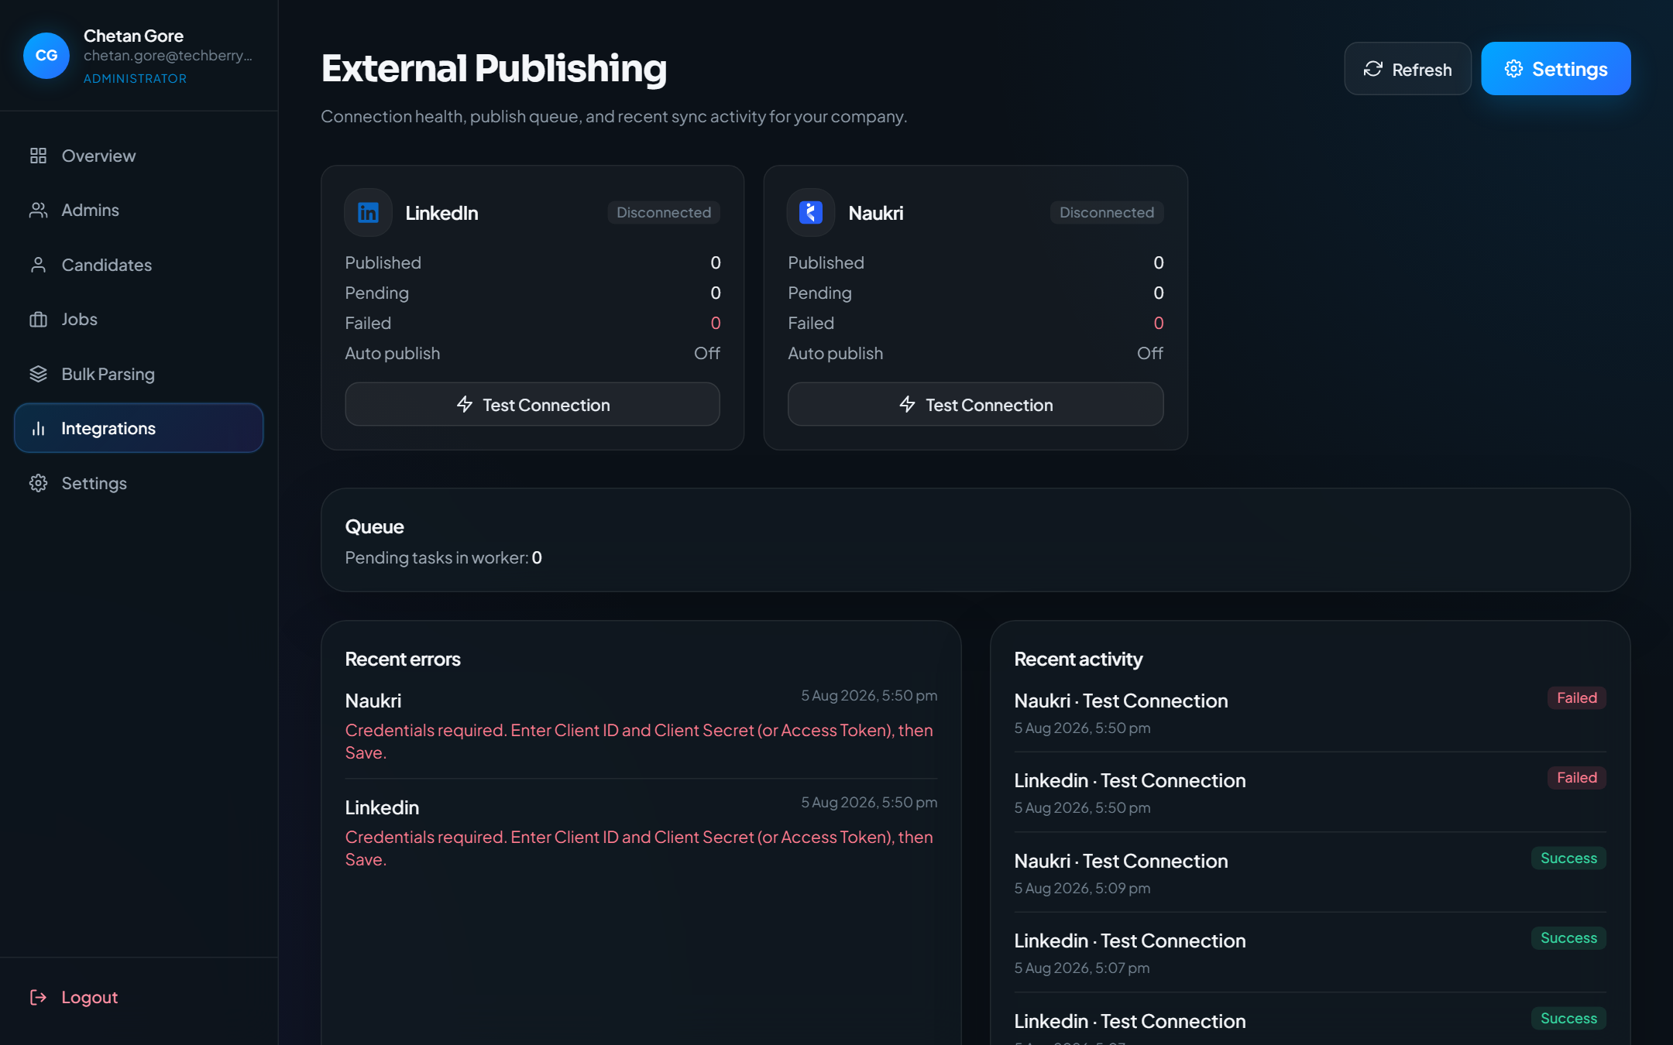
Figure 13.1 Integrations (Head HR)
Description:
- Integrations (Head HR)
Expected Result:
- External publishing / integrations dashboard
Notes
- If a control is disabled, complete required fields first.
- Match scores depend on parsed JD and resume content.

14. Head HR Settings
Purpose
Security (password) and integrations settings for Head HR.
Navigation Path
/head-hr/settings
Accessible Roles
HEAD_HR
Description / Business Purpose
This chapter documents the live UI for Head HR Settings. Each step includes a full screenshot captured from the running application.

Step 1
Action:
- Sidebar → Settings
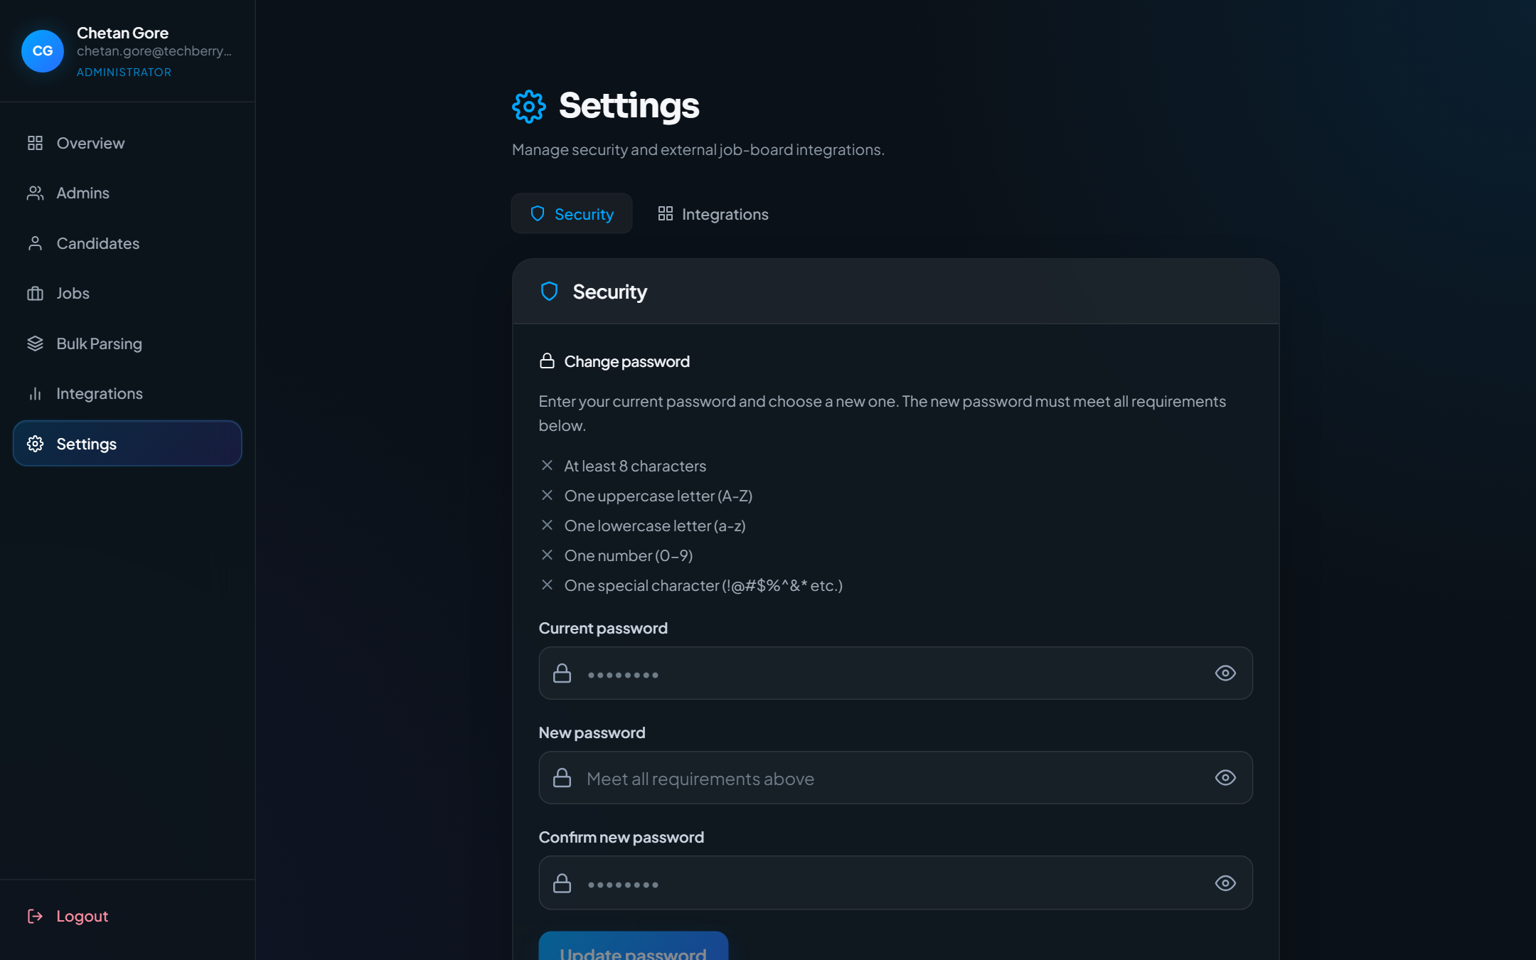
Figure 14.1 Head HR Settings
Description:
- Head HR Settings
Expected Result:
- Settings page with Security / Integrations tabs
Notes
- If a control is disabled, complete required fields first.
- Match scores depend on parsed JD and resume content.

15. Recruiter Dashboard
Purpose
Recruiter home for creating, editing, publishing, and managing own jobs.
Navigation Path
/dashboard
Accessible Roles
RECRUITER
Description / Business Purpose
This chapter documents the live UI for Recruiter Dashboard. Each step includes a full screenshot captured from the running application.

Step 1
Action:
- Sign in as Recruiter (lands on /dashboard)
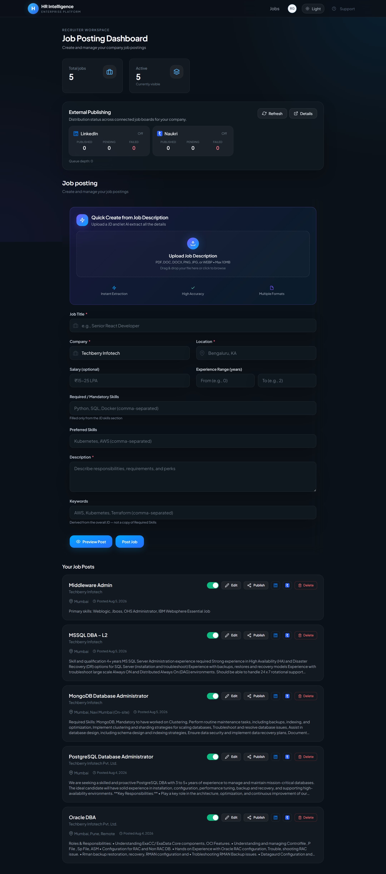
Figure 15.1 Recruiter Dashboard
Description:
- Recruiter Dashboard
Expected Result:
- Recruiter stats, publishing section, and job create/list workspace
Notes
- If a control is disabled, complete required fields first.
- Match scores depend on parsed JD and resume content.

16. Applied Candidates (Recruiter)
Purpose
Shortlist/reject applicants and view match reasons for recruiter jobs.
Navigation Path
/candidates
Accessible Roles
RECRUITER
Description / Business Purpose
This chapter documents the live UI for Applied Candidates (Recruiter). Each step includes a full screenshot captured from the running application.

Step 1
Action:
- Navbar avatar menu → Candidates
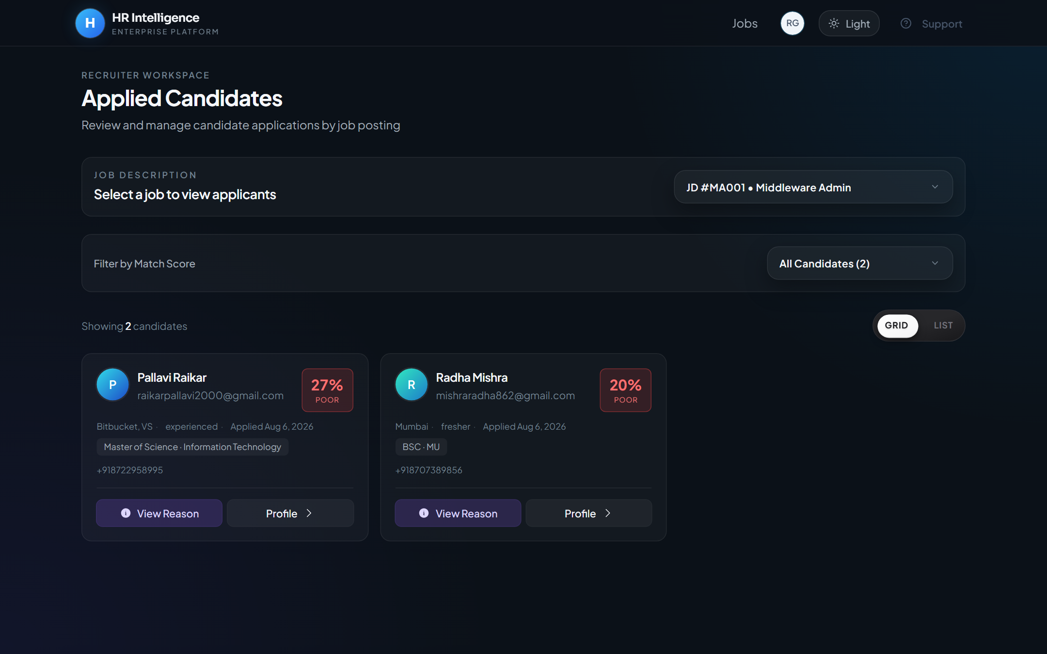
Figure 16.1 Applied Candidates (Recruiter)
Description:
- Applied Candidates (Recruiter)
Expected Result:
- Applicants for recruiter jobs with shortlist/reject and match reason
Notes
- If a control is disabled, complete required fields first.
- Match scores depend on parsed JD and resume content.

17. Bulk Resume Parser (Recruiter)
Purpose
Recruiter entry to the bulk resume parser.
Navigation Path
/admin/bulk-resume-parser
Accessible Roles
RECRUITER
Description / Business Purpose
This chapter documents the live UI for Bulk Resume Parser (Recruiter). Each step includes a full screenshot captured from the running application.

Step 1
Action:
- Navbar avatar menu → Bulk Resume Parser
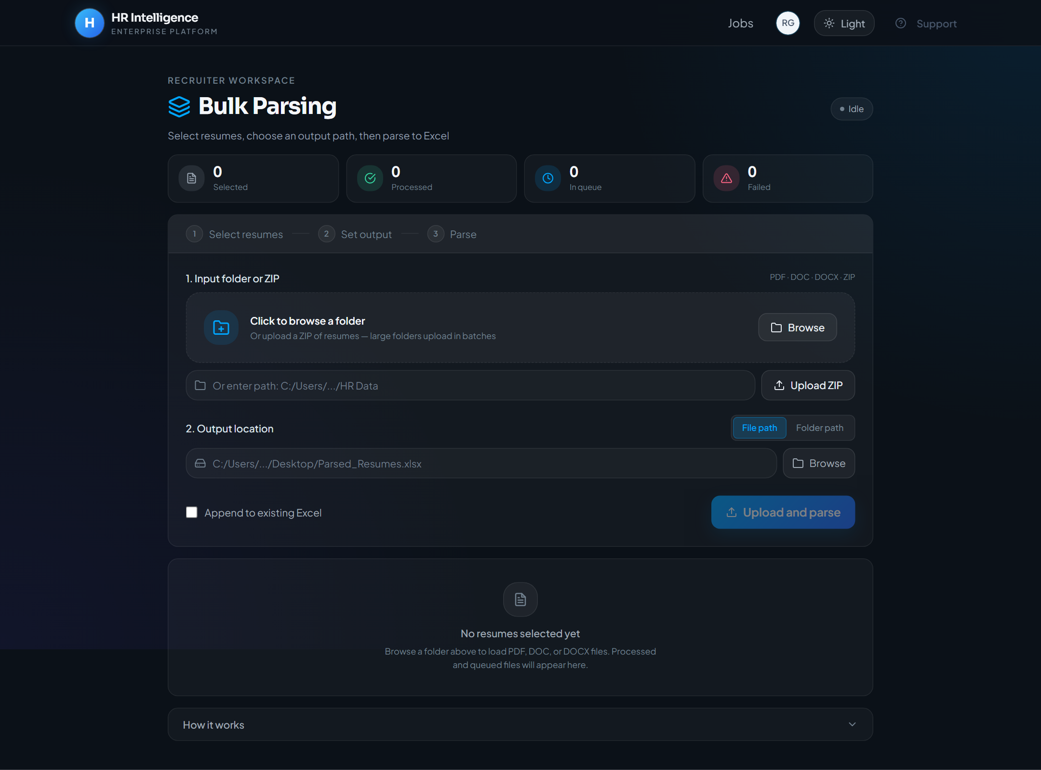
Figure 17.1 Bulk Resume Parser (Recruiter)
Description:
- Bulk Resume Parser (Recruiter)
Expected Result:
- Same bulk parsing workspace under /admin/bulk-resume-parser
Notes
- If a control is disabled, complete required fields first.
- Match scores depend on parsed JD and resume content.

18. Feedback Admin
Purpose
Review HRMS testing feedback submissions.
Navigation Path
/admin/feedback
Accessible Roles
RECRUITER
Description / Business Purpose
This chapter documents the live UI for Feedback Admin. Each step includes a full screenshot captured from the running application.

Step 1
Action:
- Navbar avatar menu → Feedback (Admin)
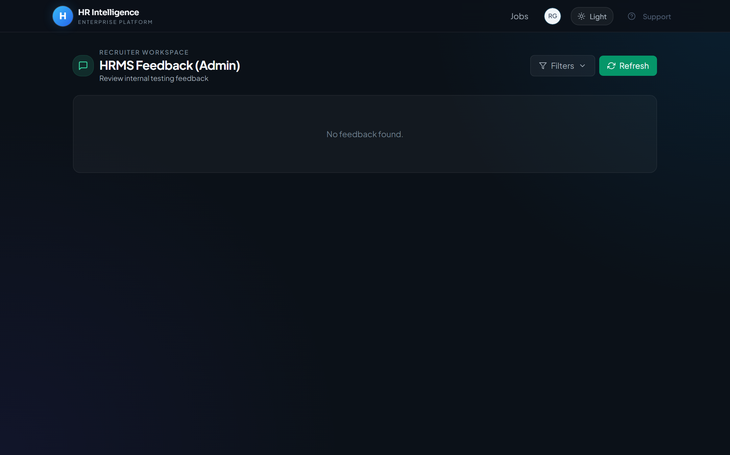
Figure 18.1 Feedback Admin
Description:
- Feedback Admin
Expected Result:
- Feedback inbox with filters and refresh
Notes
- If a control is disabled, complete required fields first.
- Match scores depend on parsed JD and resume content.

19. Integrations (Staff)
Purpose
Integrations dashboard available to signed-in staff via navbar/settings routes.
Navigation Path
/integrations
Accessible Roles
RECRUITER | HEAD_HR | CEO
Description / Business Purpose
This chapter documents the live UI for Integrations (Staff). Each step includes a full screenshot captured from the running application.

Step 1
Action:
- Navbar avatar menu → Integrations
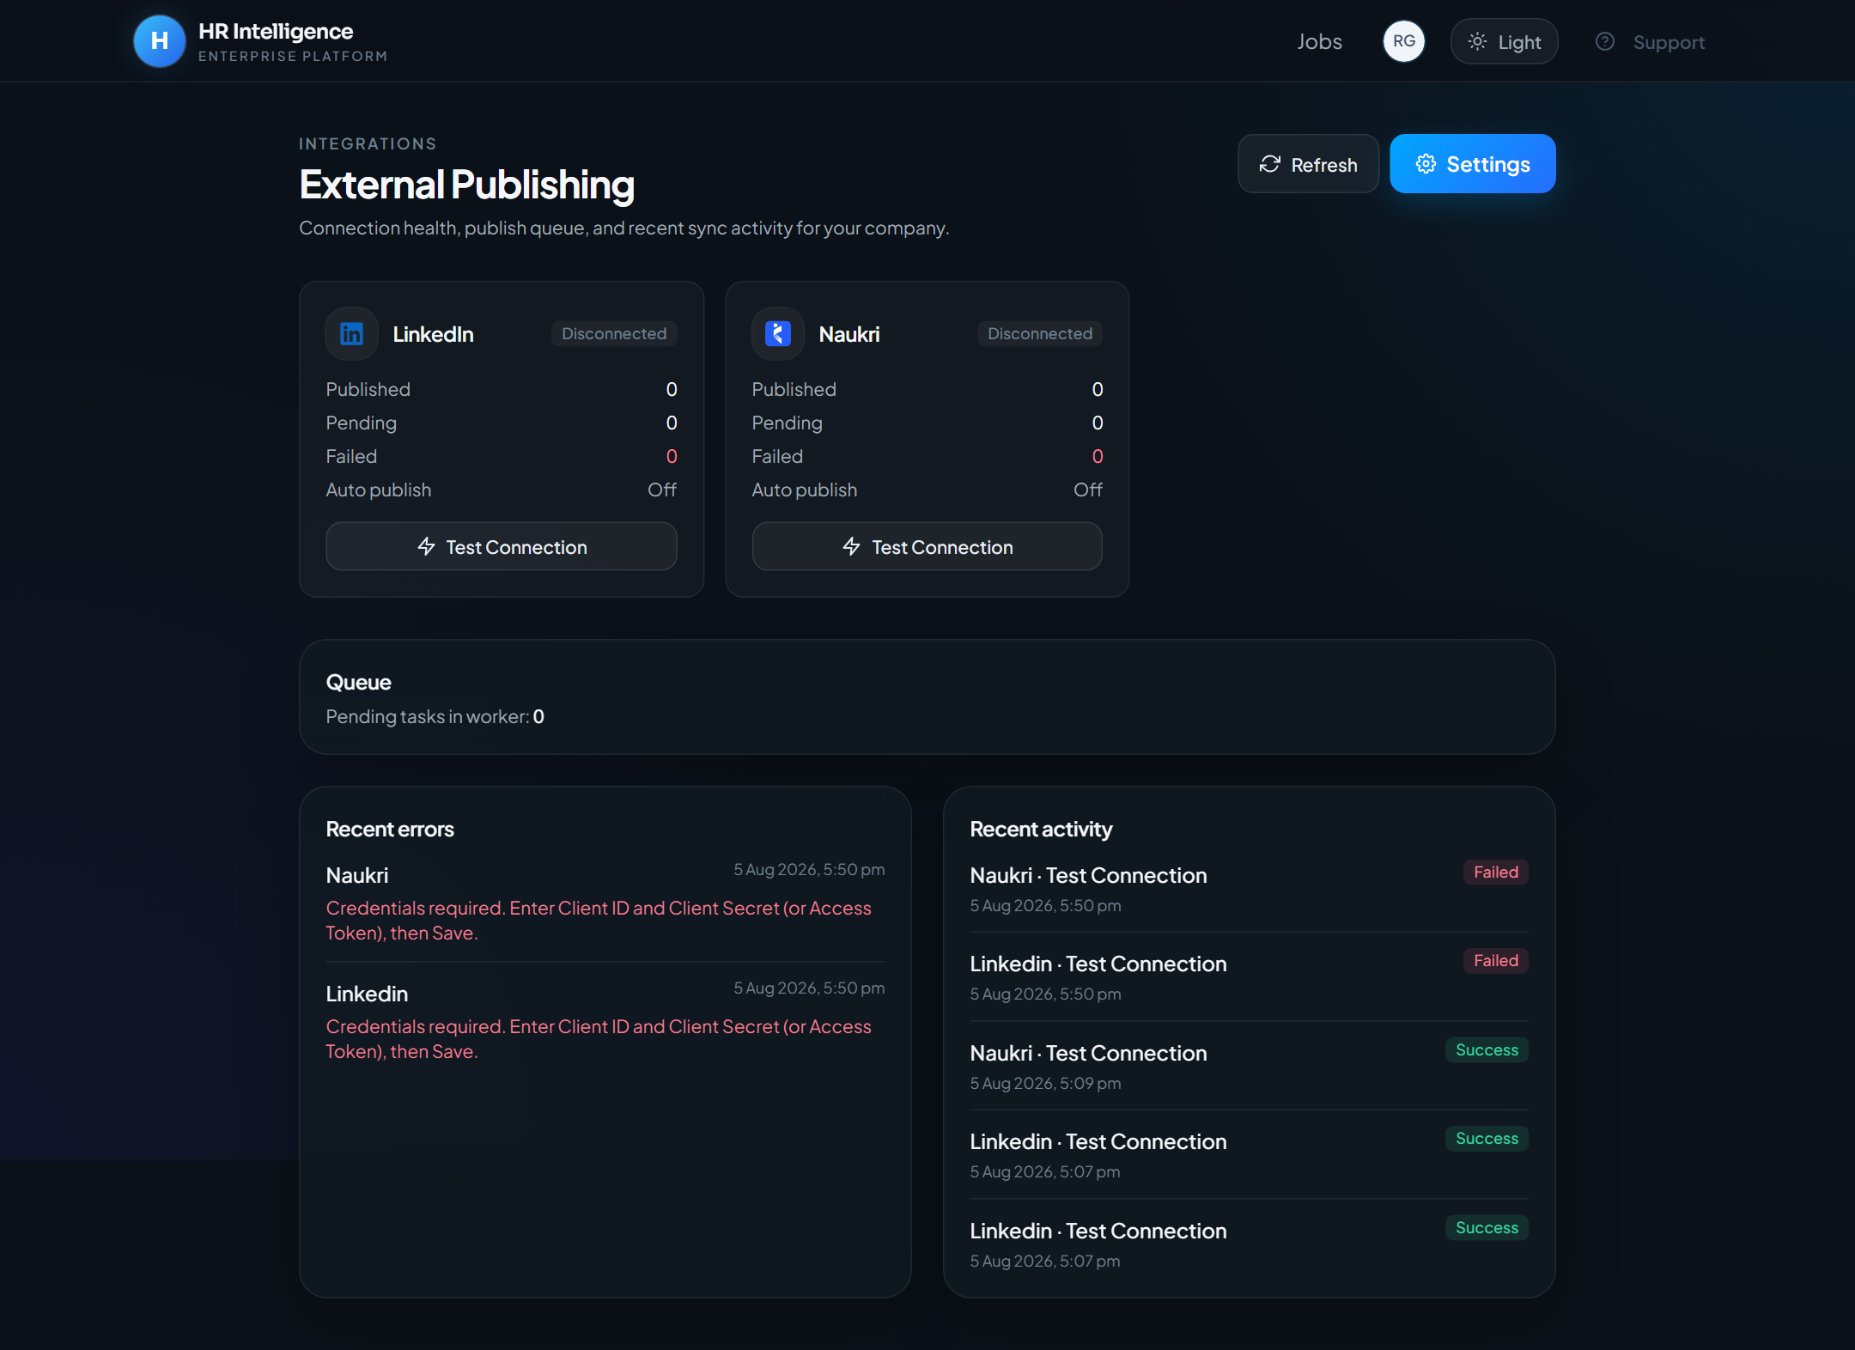
Figure 19.1 Integrations (Recruiter)
Description:
- Integrations (Recruiter)
Expected Result:
- Integrations dashboard for the recruiter session
Notes
- If a control is disabled, complete required fields first.
- Match scores depend on parsed JD and resume content.

20. Settings (Staff)
Purpose
Account security settings for signed-in staff.
Navigation Path
/settings
Accessible Roles
RECRUITER | HEAD_HR | CEO
Description / Business Purpose
This chapter documents the live UI for Settings (Staff). Each step includes a full screenshot captured from the running application.

Step 1
Action:
- Navbar avatar menu → Settings
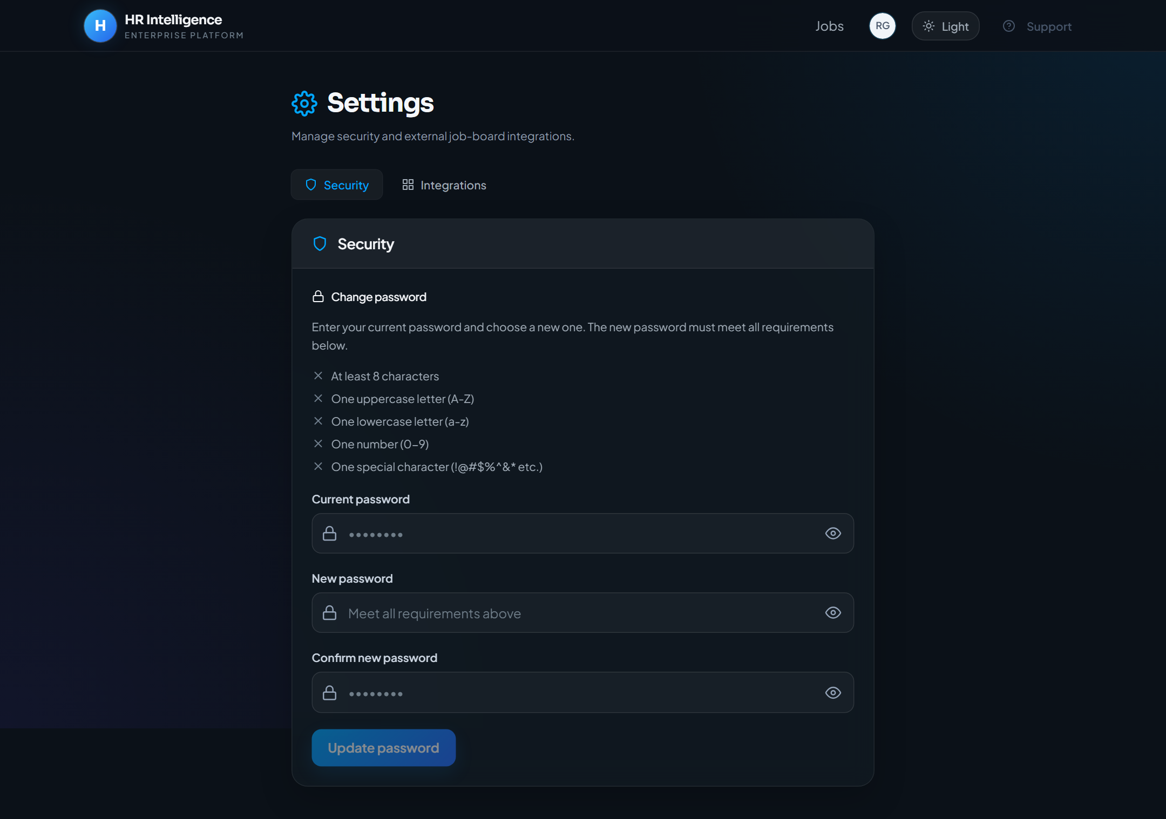
Figure 20.1 Settings (Recruiter)
Description:
- Settings (Recruiter)
Expected Result:
- Security password change and integrations settings tabs
Notes
- If a control is disabled, complete required fields first.
- Match scores depend on parsed JD and resume content.

21. CEO / Executive Dashboard
Purpose
Read-only executive views of overview, jobs, candidates, and evaluation.
Navigation Path
/ceo · /ceo/jobs · /ceo/candidates
Accessible Roles
CEO
Description / Business Purpose
This chapter documents the live UI for CEO / Executive Dashboard. Each step includes a full screenshot captured from the running application.

Step 1
Action:
- Sign in as CEO (lands on /ceo)
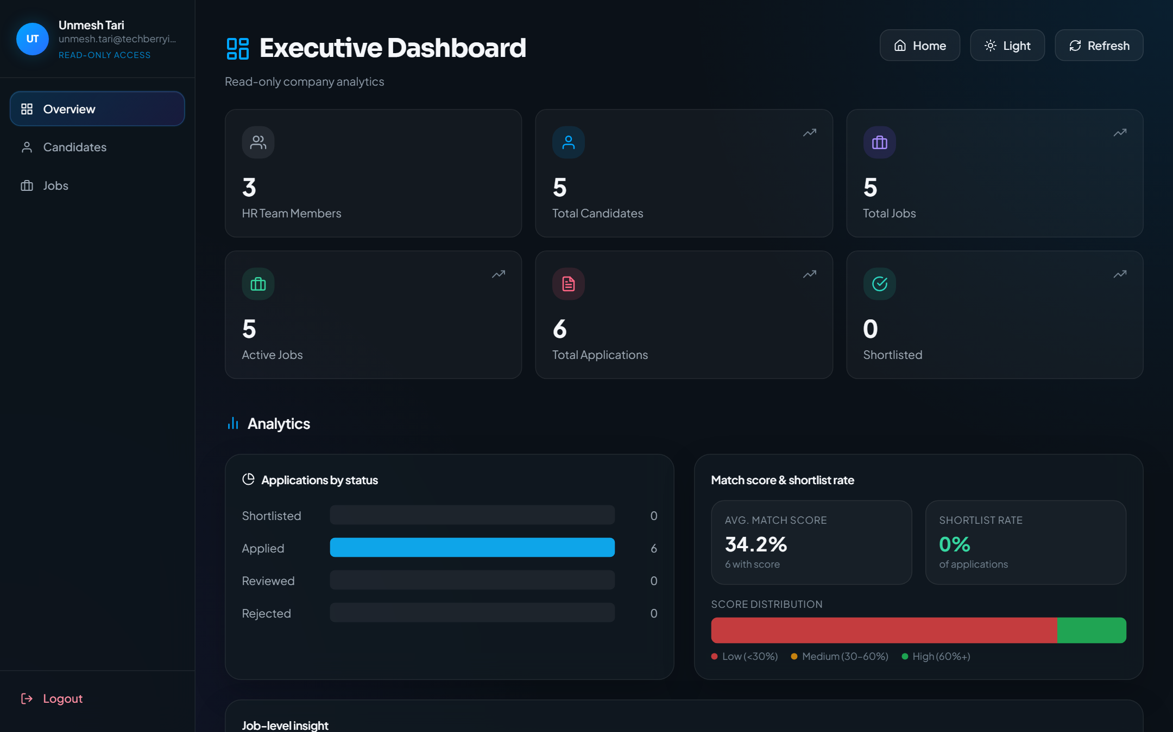
Figure 21.1 CEO / Executive Overview
Description:
- CEO / Executive Overview
Expected Result:
- Read-only executive overview (no Admins / Bulk / Settings in sidebar)

Step 2
Action:
- Sidebar → Jobs
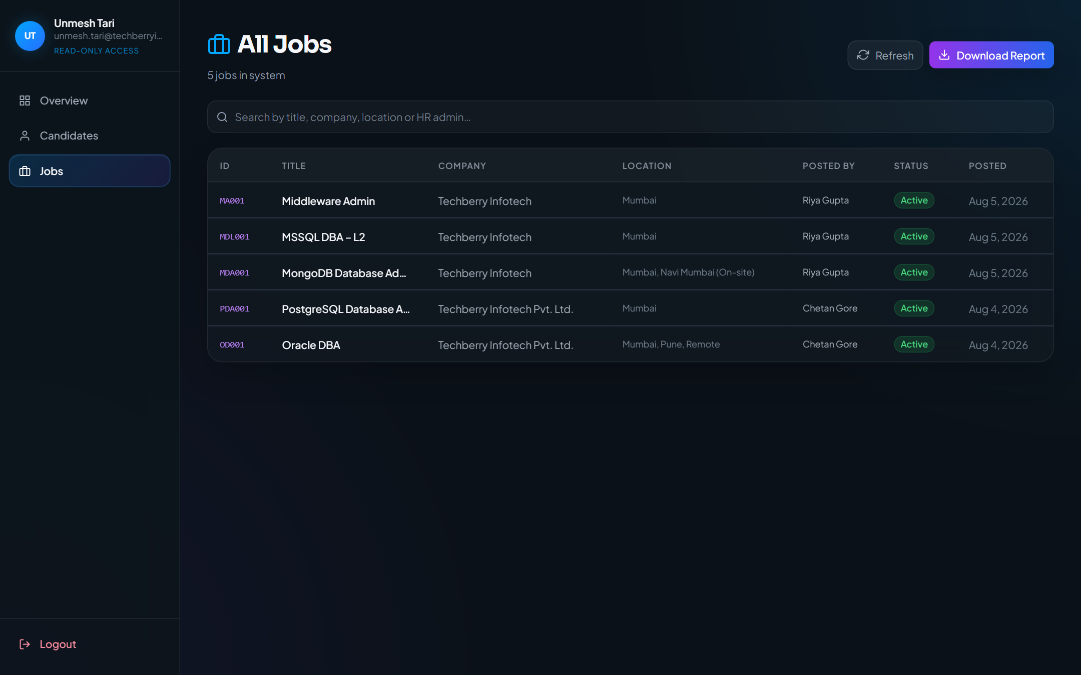
Figure 21.2 CEO Jobs (read-only)
Description:
- CEO Jobs (read-only)
Expected Result:
- Jobs list without destructive create/delete controls

Step 3
Action:
- Sidebar → Candidates
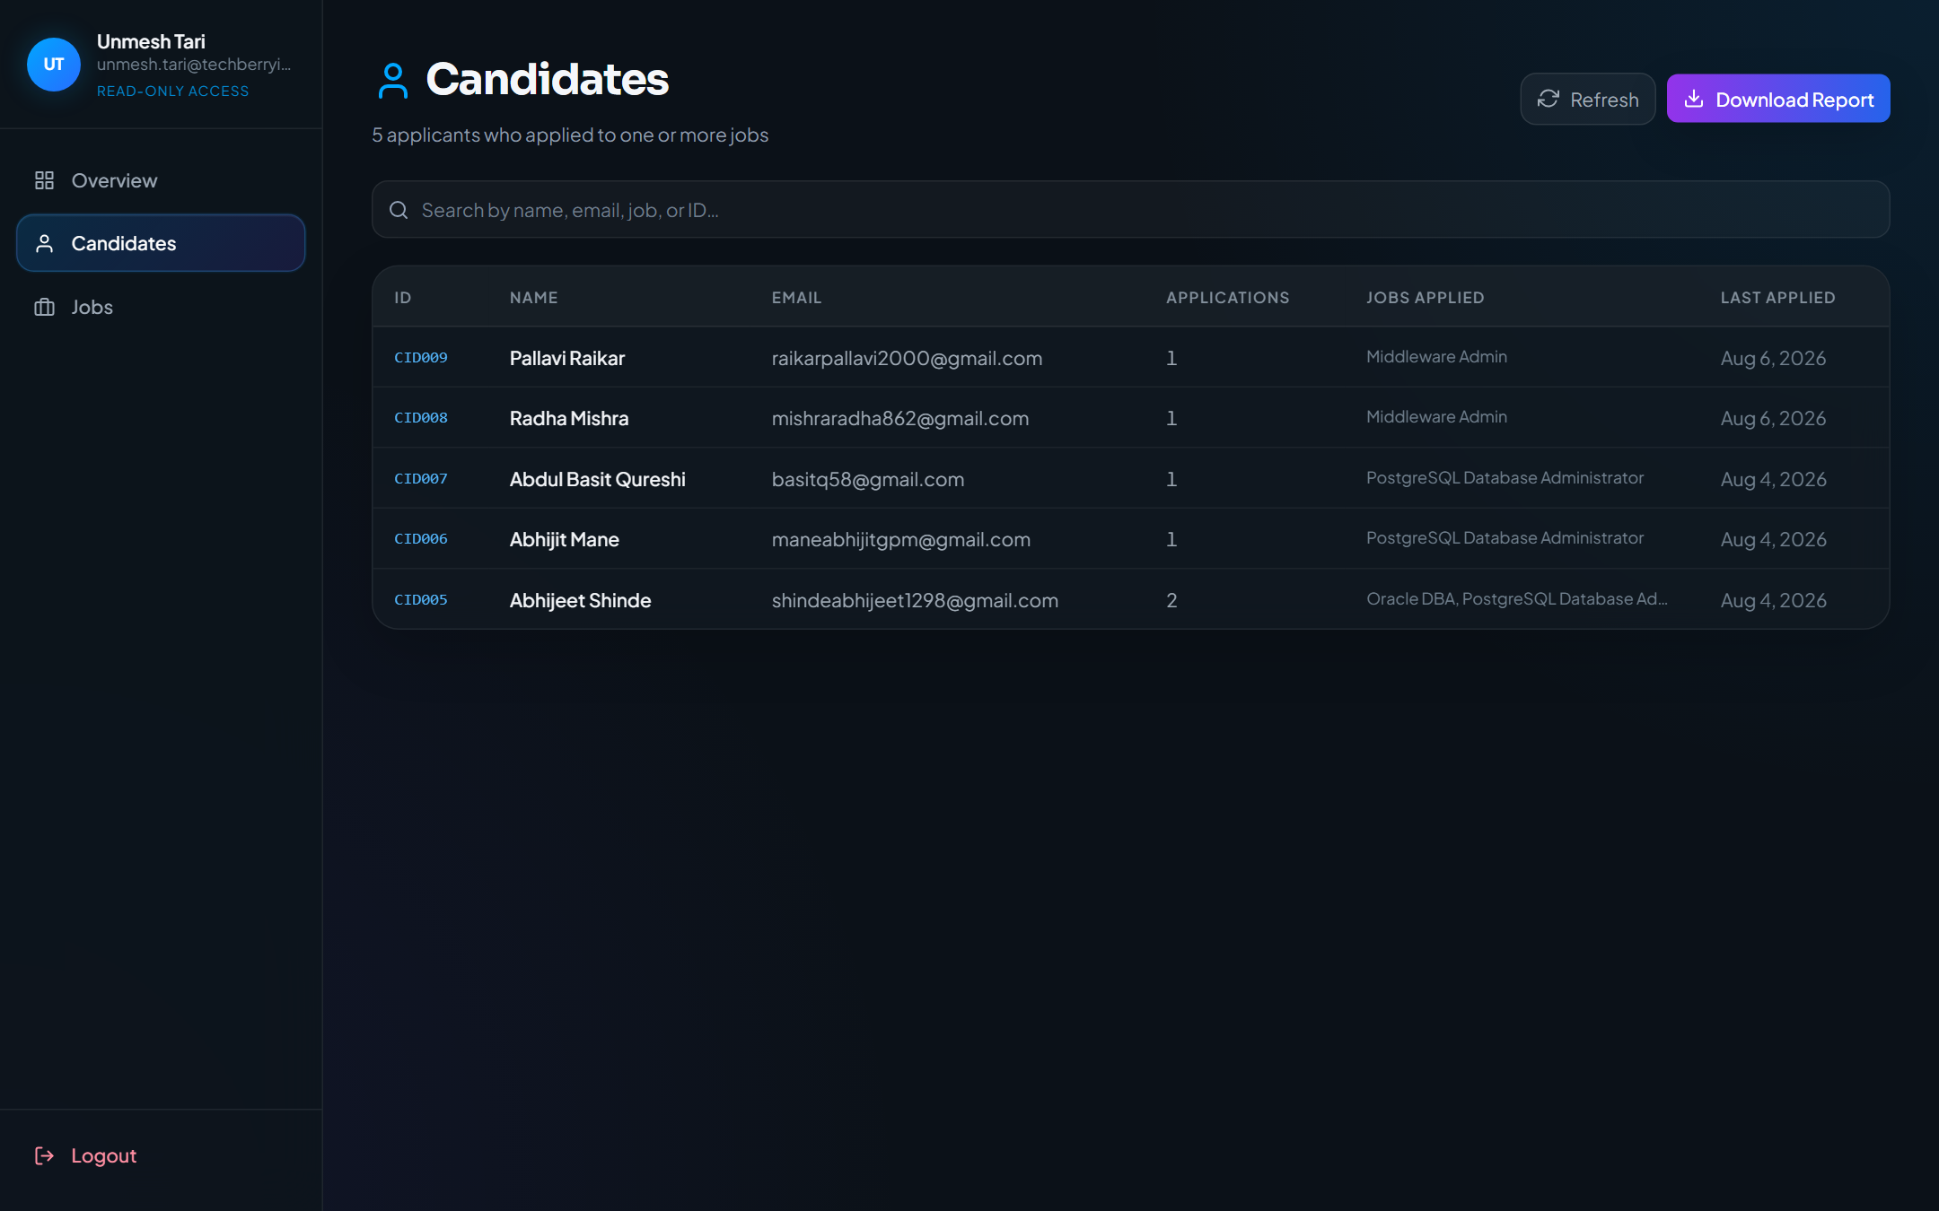
Figure 21.3 CEO Candidates (read-only)
Description:
- CEO Candidates (read-only)
Expected Result:
- Candidates list in read-only executive mode

Step 4
Action:
- Open /ceo/jobs/PDA001/candidates/CID007
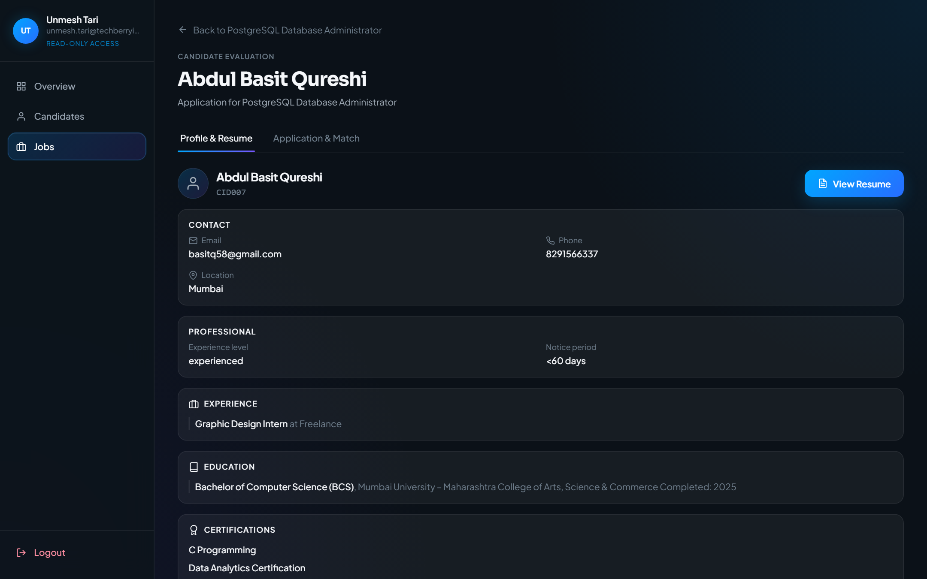
Figure 21.4 CEO candidate evaluation (read-only)
Description:
- CEO candidate evaluation (read-only)
Expected Result:
- Same evaluation UI as Head HR, without write actions
Notes
- If a control is disabled, complete required fields first.
- Match scores depend on parsed JD and resume content.

22. Logout
Purpose
End the authenticated session and return to login.
Navigation Path
Sidebar Logout (Head HR/CEO) or Navbar Logout (Recruiter)
Accessible Roles
RECRUITER | HEAD_HR | CEO
Description / Business Purpose
This chapter documents the live UI for Logout. Each step includes a full screenshot captured from the running application.

Step 1
Action:
- Locate Logout in the Head HR sidebar

Figure 22.1 Logout control
Description:
- Logout control
Expected Result:
- Logout control is visible in the panel chrome

Step 2
Action:
- Click Logout
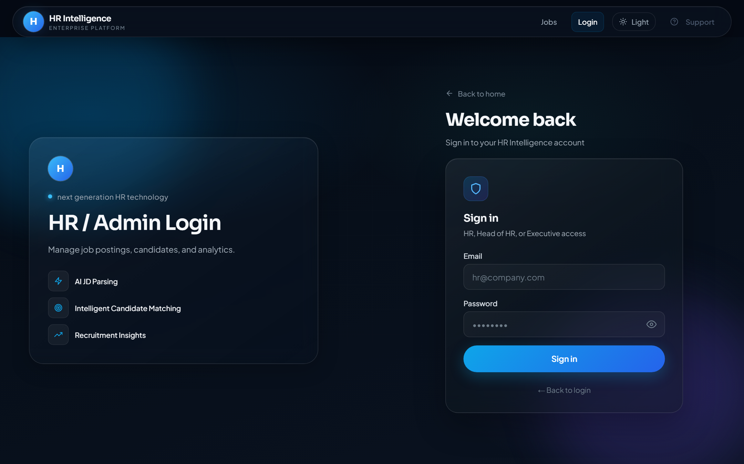
Figure 22.2 After logout
Description:
- After logout
Expected Result:
- Session cleared; user returned to admin login (or public home for recruiter)
Notes
- If a control is disabled, complete required fields first.
- Match scores depend on parsed JD and resume content.

23. Forms, Fields, and Buttons Reference
The following reference covers controls present in the shipped UI.
Job create / edit (Recruiter dashboard & Head HR overview posting)
Field | Purpose / notes
Job Title | Required display name of the role
Company | Usually from the staff account company
Location | City / region / remote indicator
Salary | Optional compensation text
Experience Range | Minimum and maximum years
Required / Mandatory Skills | Used by ATS skills gate
Preferred Skills | Nice-to-have skills
Description | Full job description
Keywords | Search/match context keywords

Primary buttons
Button | Behavior
Sign in | Authenticate staff at /login/admin
Get Started | Navigate from landing to /jobs
Apply | Open apply modal on public jobs board
Preview Post / Post Job | Preview and publish a job (Recruiter / Head HR)
Shortlist / Reject | Application status actions (Recruiter Applied Candidates)
Create Admin | Provision HR account (Head HR Admins)
Upload / Parse | Bulk resume parser actions
Logout | End session

24. Troubleshooting
Problem | What to try
Cannot sign in | Confirm email/password; use Forgot Password; verify role in hr_signup
Redirected away from a page | Role guards send users to their home panel (/dashboard, /head-hr, /ceo)
Job not on /jobs | Ensure the job is enabled/published
CEO cannot create jobs | Expected — CEO panel is read-only
Staff cannot Apply | Expected — signed-in staff are blocked from public apply
Match score unexpected | Confirm mandatory skills on JD and resume content

25. FAQs
Q: Is there a Super Admin role?
A: No separate SUPER_ADMIN enum. Admin Login authenticates RECRUITER, HEAD_HR, or CEO.
Q: Do candidates create accounts?
A: Public apply is passwordless via /jobs. Candidate JWT sessions are cleared.
Q: Can CEO edit jobs?
A: No — CEO routes share Head HR pages in read-only mode.
Q: Where is Feedback Admin?
A: Recruiter navbar → Feedback (Admin) at /admin/feedback.
Q: Where is HRMS Testing Feedback?
A: Public Support menu → /support/hrms-feedback.

26. Appendix
From repository root with the app running, regenerate this manual with:
- python docs/user-manual/capture.py
- python docs/user-manual/build.py

