Assignment-2
-Rohit Dhanotia (210001059)

Que1)
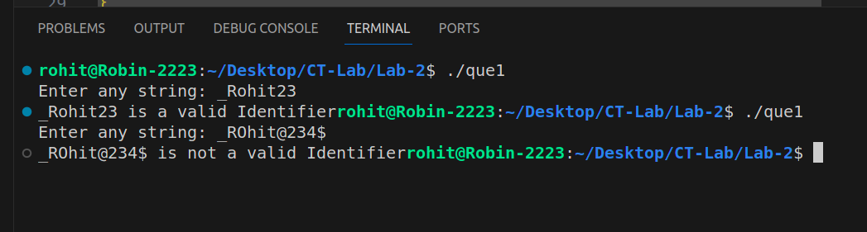
Que-2)
Program.txt:

void main() {
int x, y, z;
z = (x + y)/2;
}
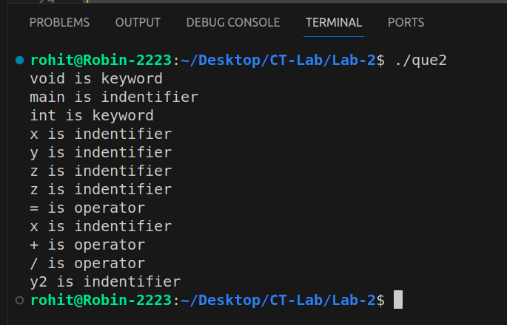
Que-3)
sample.txt:

Hello this is a sample program.
I am Iron Man!

