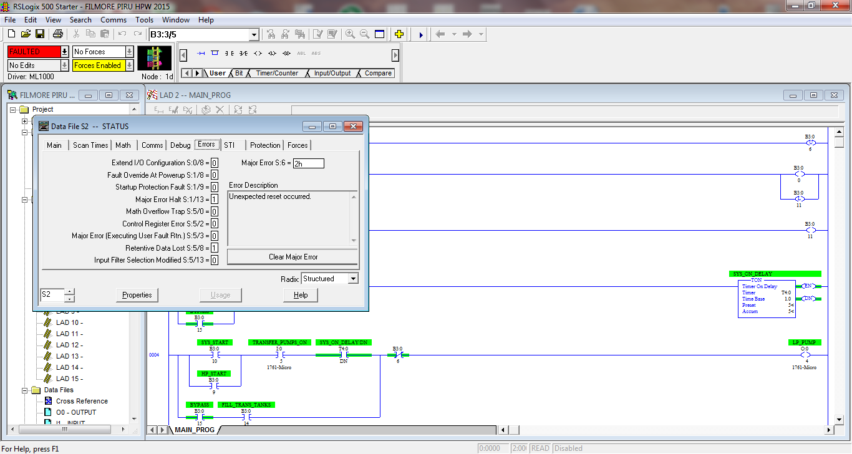

This fault would be cleared then put back into run mode and then the fault would come back. I tried power cycling and then clearing the fault but it would jump back into fault.

So, as a hail Mary, I just downloaded the same program to the PLC and the fault went away….pretty weird…. But it worked.