WORKING PAPER · EDUCATIONAL SERIES
Diversification by Economic Driver
A teaching paper on All-Weather portfolio construction,
risk parity logic, and the seven jobs of a multi-regime household
Nini · The Seven Jobs series
August 2026
Education only. Not investment advice. Not Bridgewater Associates.
Not a recommendation to buy or sell any security or wrapper.

Abstract
Most popular investment writing asks the reader to forecast. Which market will win. Which year we are in. Which central bank will cut. This paper teaches a different question: what do you own if the forecast is wrong? The All-Weather idea, associated publicly with Ray Dalio and Bridgewater Associates, is not a promise of smoothness. It is a claim about economic structure. Asset prices are not independent lottery tickets. They are claims on cash flows whose value changes when growth and inflation surprise relative to what was already priced. If those two surprises can each go up or down, there are four broad environments. No single liquid asset owns all four. A portfolio that is meant to last for decades therefore hires several economic jobs rather than several versions of the same job.
The paper is written as a teaching document. It explains the Economic Machine at three timescales; maps the four regimes; derives why duration, real yields, breakevens, commodities and gold are not interchangeable hedges; shows why the 60/40 heuristic failed a particular exam in 2022; and separates philosophy from implementation. Example weights used later — thirty, eighteen, fifteen, fourteen, ten, seven and six — are a classroom object, not a prescription. Funds, fees, currency hedges, tax wrappers and personal circumstances can all overturn a pretty pie chart.
Principle. Do not memorise seven tickers. Memorise seven jobs, the weather each job is hired for, and the evidence that would prove the job description wrong.

1. Purpose, method and limits

1.1 What this paper is
This is an explanatory essay in the style of a teaching working paper. It is written for a serious non-specialist who is willing to sit with mechanisms rather than slogans. The voice is that of a seminar, not a product brochure. Where a formula helps, a formula is given. Where a number is only a sketch, it is labelled as a sketch.

1.2 What this paper is not
It is not personal financial advice. It is not an interpretation of regulation. It is not a forecast of the next recession, the next inflation print, or the next move in gilt yields. It is not Bridgewater's proprietary All Weather fund, which uses leverage, risk parity overlays, derivatives and operational machinery that a retail stocks-and-shares ISA cannot copy. A retail exchange-traded fund mix can borrow the philosophy. It cannot borrow the engine room.

1.3 Method
The method is causal mapping. Every asset is asked three questions. What cash-flow or scarcity claim does it represent. Which economic surprise changes the value of that claim. What would have to be true for the job description to be false. Correlation matrices are treated as observations, not laws. Correlations are regime-dependent. That is the whole point of hiring more than one employee.

2. The Economic Machine

2.1 Three forces, three clocks
Dalio's public account of the Economic Machine is useful because it refuses to treat 'the economy' as one blob. Three processes run at once, on different clocks, and prices are the simultaneous clearing of all three.

Force | What it is | Clock | What you watch
Productivity growth | Real output per unit of input. The only durable source of rising living standards. | Decades | Output per hour, TFP, industrial production, real GDP per head
Short-term debt cycle | Credit expands, spending exceeds income, inflation rises, the central bank tightens, credit contracts, spending falls below income, the bank eases, repeat. | About 5–8 years | Policy rate, CPI, credit spreads, curve slope, PMI, labour market
Long-term debt cycle | Debt accumulates across expansions until it cannot be serviced from income. Ends in a deleveraging that can be ugly or, with the right mix of levers, less ugly. | About 50–75 years | Debt to GDP, current account, FX reserves, long yields, gold
Table 1. Three forces. Prices are the clearing of all three at once.
Productivity is slow and compounding. It is why a diversified claim on human enterprise has a positive expected real return over very long horizons. The short-term debt cycle is the heartbeat the newspapers live on. The long-term debt cycle is the thing people ignore until they cannot. A portfolio built only for the current heartbeat will be surprised by the longer clock.

2.2 Credit is future spending pulled forward
The most important sentence in the Machine is also the easiest to forget. Credit creates purchasing power that did not previously exist. When a bank extends credit, the borrower can spend more than current income. Aggregate spending therefore exceeds aggregate income during expansions financed by rising debt. When credit contracts, spending falls below income. That is why recessions are not merely 'bad sentiment'. They are the arithmetic of a stock of promises being reduced.
Principle. If debt is rising faster than the income that must service it, the cycle will eventually have to reverse. Always ask: who owes what to whom, in what currency, at what duration.

2.3 The short-term cycle in six rooms
A usable classroom map of the short-term cycle is six rooms, not two. Early expansion after cuts. Mid expansion as earnings catch fire. Late expansion as inflation overshoots and the bank hikes. Inversion as the curve prices the future slowdown. Recession as spending and employment give way. Recovery as cuts work and credit starts again. Equities like rooms one, two and six. Long nominal duration likes rooms five and the arrival into six. Gold is unreliable as a calendar employee but tends to be awake in rooms three and four, and sometimes five. Commodities like rooms two and three, and hate room five if demand is the thing that broke.
The map is a map. Fiscal shocks, wars, pandemics and sudden changes in the monetary regime can skip rooms or trap the system in one room for longer than the textbook. That is not an argument against the map. It is an argument against treating the map as a clock.

3. Four weathers, not one forecast

3.1 Why two surprises make four rooms
Asset pricing is not a story about 'good news' and 'bad news'. It is a story about news relative to what was already in the price. The two news items that dominate most liquid markets are growth surprises and inflation surprises. Each can arrive higher or lower than expected. The two-by-two is therefore not a marketing diagram. It is the smallest taxonomy that is still honest.
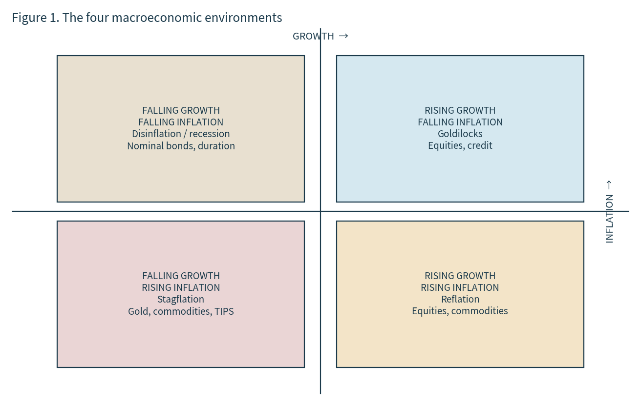
Figure 1. Four environments generated by the sign of growth and inflation surprises.

Regime | Growth | Inflation | What tends to be paid | What tends to be fined
Goldilocks | Rising | Falling | Equities, credit | Gold, many commodities
Reflation | Rising | Rising | Equities, commodities | Long nominal bonds
Stagflation | Falling | Rising | Gold, commodities, TIPS | Equities and nominal bonds together
Disinflation / recession | Falling | Falling | High-quality duration, sometimes gold | Equities, cyclicals, commodities
Table 2. Pedagogical regime map. 'Tends' is doing a lot of work. Implementation still matters.

3.2 The sentence that does the work
No liquid asset owns all four seasons. That is the entire argument for a team.
If one asset owned all four, diversification by economic driver would be a waste of expected return. It does not. Equities are a claim on residual corporate profits. Those profits like real growth and dislike unexpected inflation that compresses margins or forces a violent rise in the discount rate. A nominal government bond is a claim on a fixed number of currency units. That claim is precious when growth and inflation undershoot, and expensive when they overshoot. Inflation-linked bonds change the units. Commodities are claims on real goods. Gold is a scarce non-credit asset with no coupon. Cash is an option on tomorrow. Long duration is a leveraged bet on a fall in long-term yields. These are different animals. Putting them in one pie does not make them one animal.

3.3 Risk parity is a sentence about risk, not a sentence about weights
A common confusion is to treat All Weather as 'equal money in four buckets'. That is not the idea. The idea, in public Bridgewater language and in the broader risk-parity literature, is closer to this: assets have very different volatilities. If you give the same cash weight to equities and to intermediate bonds, you have not given them the same risk weight. The equity sleeve will dominate the portfolio's variance. Risk parity tries to equalise the contribution of each economic environment — or each asset class — to total risk, often using leverage at the institutional level so that the lower-volatility sleeves can speak at the same volume as equities.
A retail ISA usually cannot apply that leverage cleanly. The honest translation is therefore not 'copy the institutional weights'. It is 'do not let one job shout down the others merely because it is louder per pound'. That is why an educational pie often gives equities less than sixty percent even for a young saver, and why long Treasuries appear as a small specialist sleeve rather than as half the portfolio. The small sleeve can still matter because its duration is large.
Principle. If two holdings are paid by the same surprise, you do not have two employees. You have one employee wearing two uniforms.

4. The language the machine speaks: rates

4.1 A yield is a price
A yield is not a vibe. It is the internal rate of return that equates a bond's promised payments to its market price. When the yield rises, the price of an existing bond falls. When the yield falls, the price rises. Everything else in this paper that mentions 'bonds rally' is only that sentence wearing a coat.

4.2 Duration
Modified duration is the first-order sensitivity of price to a change in yield. A duration of eight means that, to a first approximation, a one percentage point rise in yield knocks about eight percent off the price. Convexity is the second-order term: for a vanilla option-free bond, the price rise when yields fall is a little larger than the price fall when yields rise by the same amount. For teaching purposes the first-order term is enough to understand why a thirty-year bond and an overnight bill are not the same defensive asset.
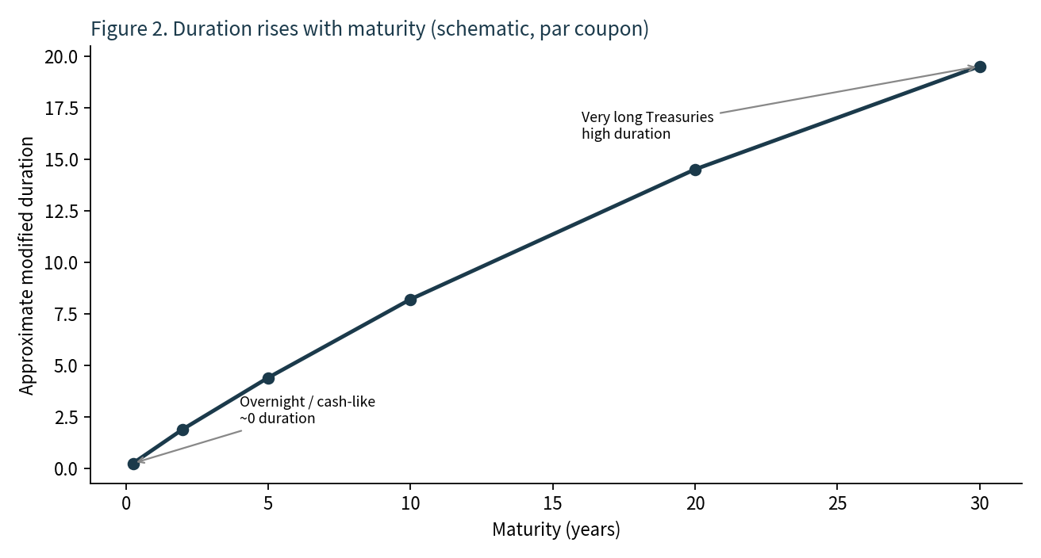
Figure 2. Schematic: longer maturity, higher duration. Coupons, yield level and curve shape all change the exact number.
This is why 'bonds' is a sloppy word. An overnight sterling fund, a five-year investment-grade book, a ten-year gilt and a twenty-five-year Treasury future are four different duration machines. In a disinflationary recession the long machine can do enormous work. In an inflation shock the same machine can be the fire. 2022 was a reminder written in public.

4.3 The curve as a distributed forecast
A simple textbook curve is upward sloping because a lender who ties money up for ten years wants compensation that a lender for two years does not. Call that the term premium plus the path of expected short rates. When the two-year yield sits above the ten-year yield, the curve is inverted. Markets are then saying, in a noisy way, that current policy is restrictive enough to produce weaker growth and lower future short rates. Historically, deep inversions have often preceded recessions, with a long and variable lag. Historically is not a promise. Fiscal expansions, foreign demand for duration, and changes in the term premium can all distort the signal.
The teaching use of the curve is therefore not 'sell everything when 2s10s goes negative'. It is: the curve is one of the few market objects that is explicitly a path of expected policy. Read it as a path. Then ask whether the other rooms of the Machine agree.

4.4 Real yields and breakevens
A nominal Treasury yield can be split, approximately, into a real yield and an inflation breakeven. The real yield is what a TIPS investor accepts in inflation-adjusted terms. The breakeven is the inflation rate that would make an investor indifferent, before premia, between the nominal bond and the matched TIPS.
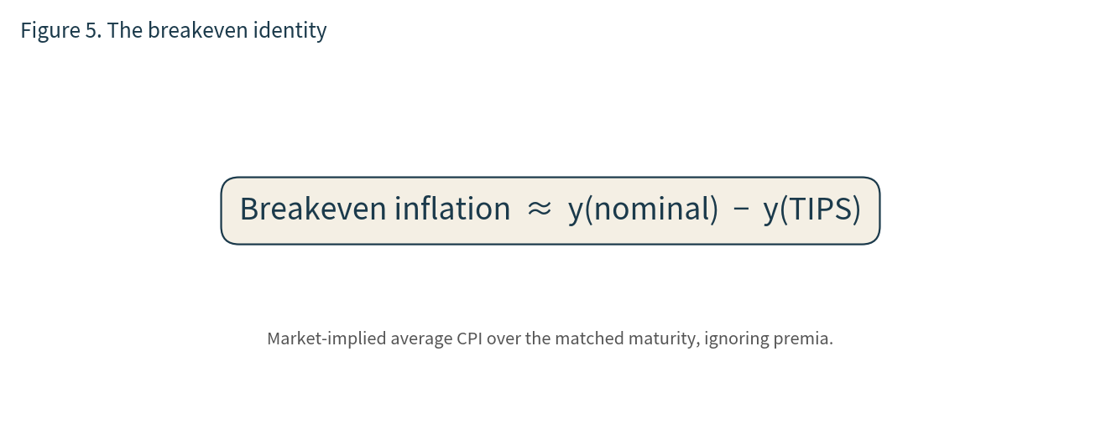
Figure 5. The classroom identity. Liquidity premia, inflation risk premia and index differences keep it approximate.
If realised inflation runs hotter than the breakeven, the TIPS path tends to look better after the fact. If realised inflation undershoots, the nominal bond tends to look better. That is why TIPS are not a magic 'inflation always wins' button. They are a claim whose principal is contractually tied to a specific consumer-price index, and whose market price still jumps when real yields jump. In 2022 real yields rose violently. TIPS therefore fell even as inflation prints were high. The job was not 'make money whenever the CPI is high this month'. The job was 'own a contract that restores purchasing power if inflation surprises and you can hold through the mark-to-market'.
Principle. Market signals are observations, not portfolio constants. Never hard-code a live 2s10s print or a live breakeven into the doctrine.

5. Equities as the wealth builder
A share is a residual claim on a firm's profits after other claimants have been paid. Over long horizons, a diversified basket of those residual claims has compounded because human beings have found ways to produce more per hour and because retained earnings have been reinvested. That is the productivity clock showing up in a price.
The same residual claim is fragile on the short clock. In a recession, revenues fall, operating leverage cuts the other way, and the equity risk premium demanded by frightened holders rises. Prices can therefore fall much more than one year's earnings. In an inflation shock, two things can happen at once: margins are squeezed by input costs, and the discount rate applied to remaining cash flows rises because nominal and sometimes real yields have gone up. Growth-style equities, whose value sits further into the future, are more exposed to that discount-rate move than short-duration value cash cows. This is why 'shares' is also a sloppy word, though less sloppy than 'bonds'.
A global equity sleeve earns its keep as the household's compounding engine. It is not the household's insurance. Treating it as insurance is how people end up with a single-employee firm and call it a portfolio.
Principle. Job of world equities: make the household richer slowly when enterprise is being rewarded. Failure mode: a long recession or a violent rise in the discount rate. Do not fire it for a bad decade if the job is still the job. Do review whether you hired a concentrated theme by accident.

6. Nominal bonds as the stabiliser
A high-quality nominal bond is primarily a promise: coupons and principal in currency units that do not grow with the price level. That promise is a different economic engine from residual profits. When growth disappoints and the central bank eases, expected short rates fall, the curve often bull-steepens or bull-rallies, and existing bonds reprice higher. Income arrives while you wait. Volatility is usually lower than equity volatility. None of this makes the promise sacred.
The failure mode is unexpected inflation and the rise in yields that accompanies a determined tightening cycle. Because duration is the transmission, a long bond can lose more in a year than a short bond loses in a cycle. Credit risk is a second failure mode: if you reach for yield into lower-quality paper, you have quietly hired a bit of the equity employee and called it a bond.
Currency is a third failure mode for a sterling household. An unhedged global bond fund is a bond view plus a foreign-exchange view. Sometimes that is intended. Often it is accidental. A sterling-hedged investment-grade book is a closer match to the classroom job 'stabilise the household when the wealth builder is having a bad year, without taking a second job as a dollar speculator'.
Principle. Job of diversified high-quality nominal bonds: keep the household steadier when growth undershoots and policy eases. Failure mode: a rise in yields driven by inflation or fiscal supply. Do not confuse this employee with the fire brigade. Different duration, different brief.

7. Gold as the night watchman
Gold is the employee with no wage. It pays no coupon. It pays no dividend. It does not represent a residual claim on a mine's earnings unless you have bought the miner instead of the metal, which is a different security. The metal's teaching value is exactly that absence. When confidence in financial promises — currencies, long-duration nominal claims, the political willingness to keep real rates honest — becomes fragile, a scarce non-credit asset can be bid simply because it is not somebody else's liability.
This is why gold is a poor inflation switch. It can fall while CPI is high if real yields are rising and the dollar is strong. It can rise while CPI is quiet if real yields are falling or geopolitics is loud. Empirical studies disagree about gold's average inflation beta depending on the sample. That disagreement is information. The broader brief is: stay awake when paper looks less trustworthy. Not: print money every time a petrol station changes its board.
Gold miners are not gold. They are equities with operational leverage to the gold price, plus equity beta, plus mine-plan risk. Substituting miners for metal because a platform will not list a physically-backed ETC is how a household accidentally fires the night watchman and hires a cyclical stock.
Principle. Job of gold: remain a scarce non-credit asset when confidence in financial promises is stressed. Failure mode: long calm expansions with rising real yields. Do not judge the watchman by how bored he looks on a sunny Tuesday.

8. Inflation-linked bonds as the bodyguard
An ordinary gilt or Treasury promises currency. An index-linked gilt or a TIPS issue promises currency that is contractually adjusted by a consumer-price index, subject to a lag and to the details of the linker. That contractual difference is the whole product. It is also why this employee is not gold, not commodities, and not a short bill.
Two prices live inside a linker. One is the real yield, set in the market. The other is the inflation accretion along the way. If real yields jump, the mark-to-market of a long-duration linker can be ugly even as inflation prints are hot. Holders who needed a one-year inflation trade discover they had bought a long-duration real-rate trade. Holders who needed a multi-year defence of purchasing power may still have the right contract, provided they can sit through the mark.
Breakevens, already introduced, are the relative price of the two siblings. A falling breakeven means the market is marking down its inflation path or marking up the inflation risk premium's inverse. Neither reading is a trading instruction. Both readings tell you whether the bodyguard is expensive or cheap relative to the nominal sibling today. Cheap and expensive are not the same as useful.
Principle. Job of linkers: defend real purchasing power against inflation that was not already in the price, accepting that real-rate volatility still moves the market value. Failure mode: treating last month's CPI as a scoreboard for a long-duration instrument.

9. Commodities as the shock absorber
A diversified commodity sleeve is a claim on a basket of real goods and the futures curves that express them: energy, industrial metals, agriculture, sometimes livestock and precious metals. These are inputs. When they become scarce, the same shock that hurts consumers, corporate margins and nominal bonds can lift the sleeve that owns the inputs. That is the job. Own a little of the thing that is causing the inflation, so the household is not only on the paying side of the heatwave.
The job is seasonal in a deeper sense than weather. Commodity futures are not a vault of barrels. They are a rolling set of contracts. Backwardation can pay a roll yield. Contango can tax it. A fund that has spent a decade rolling in contango can look dead while the spot stories in newspapers sound dramatic. Costs, collateral yield and index construction all sit between the cartoon barrel and the NAV.
Commodities also divide by cause. A demand boom in a healthy expansion lifts industrial metals and oil with growth. A supply shock lifts oil and food while growth is already sick. The first is reflation. The second is closer to stagflation. A diversified sleeve tries to be present for both without pretending to know which barrel matters next month.
Principle. Job of diversified commodities: if the stuff everyone needs becomes the problem, own a little of the stuff. Failure mode: long quiet demand gluts and expensive roll. This is not a permanent return machine.

10. Cash-like holdings as the parking bay
Cash is not 'nothing'. In a modern portfolio it is duration near zero, credit risk near zero if the vehicle is honest, and a call option on rebalancing. When another employee is marked down violently, the parking bay is what you sell in order to buy the one that has become cheap. Without a bay, rebalancing becomes a theory you practise only on paper.
The failure mode is the quiet thief. Over long horizons, a broad rise in the price level reduces what a pound in a current account will buy. That is why a household that parks everything 'until the crash' is not being conservative. It is taking a concentrated bet that a particular date will arrive before inflation and missed compounding have done their work. The date is not on the calendar.
In a UK ISA, cash inside the wrapper and cash outside the wrapper are different legal objects. Some platforms also offer short-duration sterling funds or public money-market funds that can sit as a slice. The classroom job does not care which eligible instrument carries the water. It cares that some water is carried, and that the slice is not so large that the wealth builder is starved, nor so small that a sell-off leaves nothing to rebalance with.
Principle. Job of cash-like exposure: stay available. Do not try to be a hero. Failure mode: confusing the parking bay with the whole car park.

11. Long Treasuries as the fire brigade
A very long government bond is a specialist tool. Its modified duration can be the better part of two decades. That means a one-point fall in long yields can produce a double-digit price gain, and a one-point rise can produce a double-digit loss. In a classic demand-destruction recession — growth collapsing, inflation undershooting, the central bank cutting hard — this is one of the few liquid instruments that can pay a lot while equities are being marked down. That is the fire the brigade was hired for.
It is the wrong brigade for a fiscal inflation fire or a supply-shock fire. Then long yields can rise as the inflation risk premium and the term premium wake up. 2022 was such a year in several developed markets. Calling long Treasuries 'safe' in every crisis is a category error. They are safe for one crisis shape. That is why a household that hires them also hires linkers, commodities and gold. Different fires.
Principle. Job of long nominal duration: respond to a deflationary growth crash, then stand down when the fire is somewhere else. Failure mode: using a six-percent sleeve as if it were a sixty-percent blanket.

12. A classroom household
The seven-job pie used in the companion episode is a teaching object. The weights below are not sacred, not optimal, and not personalised. They exist so that a reader can see seven different engines in one place without any one engine being a rounding error, and without equities being so large that the other jobs cannot be heard.

Sleeve | Classroom weight | Job | Paid when | Fined when
World equities | 30% | Wealth builder | Real growth, expanding profits | Recession, panic, sharp rise in discount rates
Global IG bonds | 18% | Stabiliser | Growth undershoots, policy eases | Inflationary yield rise; unhedged FX if not intended
Gold | 15% | Night watchman | Stress to paper promises, falling real yields, some geopolitics | Calm expansions with rising real yields
Linkers / TIPS | 14% | Bodyguard | Inflation above what was priced, if held through real-rate noise | Rising real yields; inflation that was already in the breakeven
Commodities | 10% | Shock absorber | Supply or demand shocks in real goods | Gluts, expensive roll, deep demand recessions
Cash-like | 7% | Parking bay | Need for liquidity and rebalancing dry powder | Long stretches of inflation plus missed compounding
Long Treasuries | 6% | Fire brigade | Deflationary growth crash, falling long yields | Inflationary or fiscal rise in long yields
Table 3. Classroom allocation. Weights sum to 100. Replace any line and you must replace the job, not only the letters.
A younger saver with a high human-capital stream — future wages still ahead — can often bear more equity risk than this classroom object shows, because the labour market is itself a growth asset. That is a separate conversation about the household's full balance sheet, not a licence to delete the insurance jobs. Human capital does not pay out on the day the listed wealth builder is marked down twenty percent.

13. They are supposed to disagree
The psychologically hard part of the framework is not the diagram. It is the year in which three employees look stupid. In a sunny growth year gold looks like a pet rock and long bonds look like a mistake. In a recession the wealth builder looks like a saboteur. In an inflation shock the stabiliser and the fire brigade look as if they have joined the other side. If you score each employee against the best employee of that year, you will fire the person you needed for the next weather.
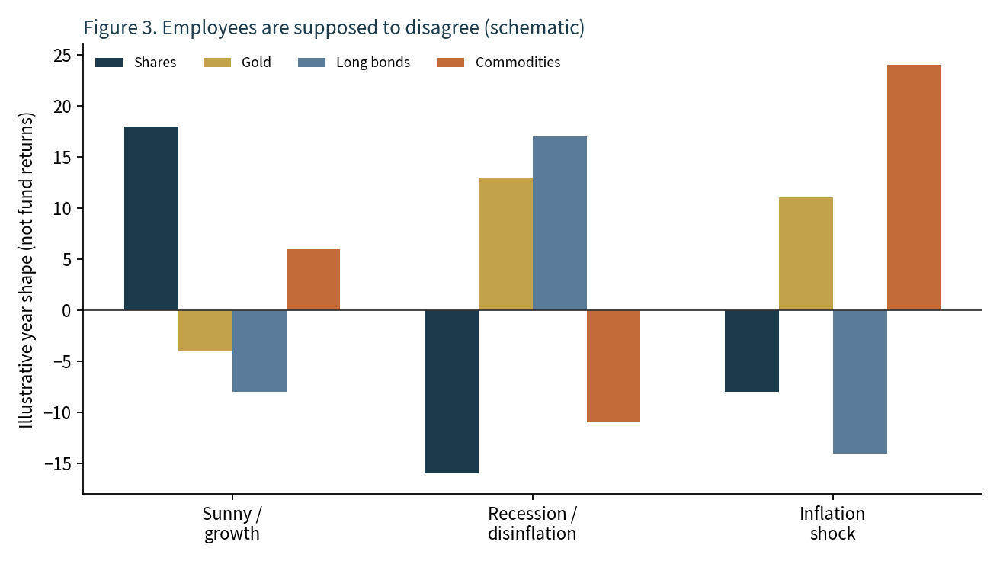
Figure 3. Schematic year-shapes. Not fund returns. The point is the pattern of disagreement, not the height of any bar.
Performance chasing is how diversification dies in public. The better audit is: when its weather arrived, did the employee do the job on the contract? If gold failed to respond to a genuine stress in financial promises, that is information about the instrument you hired, the currency you hired it in, or the brief. If gold sat quiet through a roaring equity year, that is the brief working.
Principle. The question is not 'why did this asset underperform the winner'. The question is 'did this asset perform the job it was hired to do when its weather arrived'.

14. The year a simple mix sat the wrong exam
A sixty-forty mix of shares and nominal bonds is a reasonable classroom object for a world in which growth shocks dominate and inflation shocks are rare. In that world the two employees often negatively correlate: when growth dies, policy eases, bonds pay while equities hurt. The 1970s and 2022 were reminders that the world also contains inflation shocks. In those years the two employees can fall together. Diversification that lived only on the growth axis had no one at home on the inflation axis.
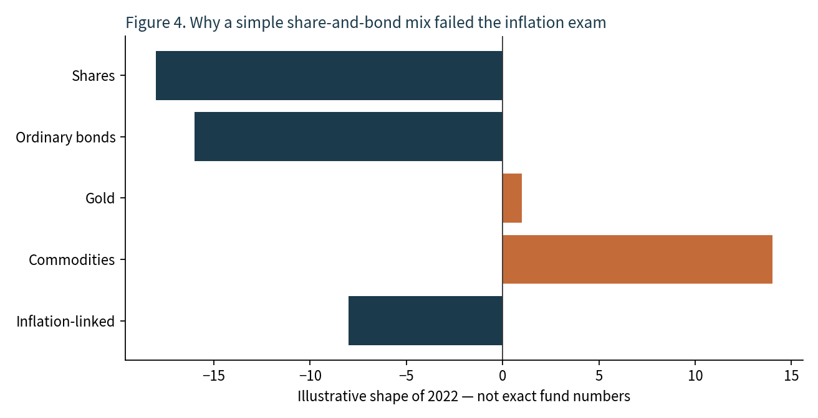
Figure 4. Classroom sketch of 2022's shape. Bars are not the returns of any named fund.
The lesson is not 'buy last year's winner'. Commodities had a loud year; they also have quiet decades. The lesson is structural. If your mix only works when inflation stays boring, you do not have an all-weather mix. You have a good-weather mix with an optimistic name.

15. Correlations that hold, and correlations that break
A correlation is a sample statistic. It is not a law of nature. The useful teaching list is the list of relationships that have repeated often enough to deserve a seat, plus the list of crises in which they stopped repeating.

When this happens | This often follows | Where it breaks
Curve inverts deeply | Higher odds of recession with a long lag | Fiscal thrust or foreign demand for duration can delay or mute
VIX jumps into panic | Equities fall; quality duration and sometimes gold are bid | Stagflation: bonds sold with equities
Oil shock persists | Headline CPI up; consumers squeezed; policy dilemma | Demand shock versus supply shock lead to opposite growth paths
Credit spreads gap wider | Equity risk often follows | Idiosyncratic sector wrecks without a macro cycle
Policy pivots to cuts | Duration first, then risk assets if the cut is not a panic cut | Cutting into a collapsing real economy can see equities fall further first
Real yields jump | Pressure on gold, long linkers, long-duration growth equity | Geopolitical bid can overwhelm the real-yield channel for a time
Table 4. Repeated relationships, and the rooms in which they have failed.
The crisis breaks are the reason the household has more than two adults. Equities and bonds can go to one. Gold and the dollar can rise together. Emerging and developed equities can decouple when the dollar is the weapon. A model that treats last decade's correlation matrix as next decade's physics will be punctual and wrong.

16. Implementation is not philosophy

16.1 Instruments
A job can be done by more than one instrument. World equities can be a single accumulating global UCITS fund or a set of regional funds. Gold can be a physically-backed ETC or, in some wrappers, a different eligible vehicle. Linkers can be US TIPS funds or index-linked gilts; those are not the same inflation index and not the same currency. Commodities can be a broad futures-based UCITS or a narrower energy product. The brief survives a change of ticker. It does not survive a change of economic exposure dressed up as a change of ticker.

16.2 Currency
A sterling household consuming in sterling has a natural home bias in the unit of account. Unhedged foreign bonds add dollar or euro risk on top of duration risk. Unhedged foreign equities add an equity risk plus an FX risk that has sometimes cushioned a local drawdown and sometimes amplified it. There is no universal right answer. There is only the requirement that the FX decision be a decision. Accidental dollar exposure in the 'defensive' sleeve is how a household discovers that its stabiliser is also a currency trader.

16.3 Fees, tracking, structure
Ongoing charges, bid-offer spreads, tracking difference, sampling versus full replication, accumulating versus distributing share classes, and the legal form of an ETC versus an ETF all sit between the cartoon and the compound return. Two funds with the same index name can be different products. Read the document that describes the product, not the nickname on a pie slice.

16.4 The UK wrapper, in one page
A UK stocks-and-shares ISA is a tax wrapper, not an asset class. Contributions use an annual allowance set by Parliament. Growth and withdrawals from a flexible ISA are not taxed as capital gains or dividends inside the wrapper under present rules, which is why compounding inside it is treated differently from compounding in a general dealing account. Eligibility rules restrict what may sit in the wrapper. That is why some instruments that would complete an institutional All Weather book never appear in a retail pie, and why substitutions must be checked against the job, not against a social-media list. None of this is legal advice. Rules change. The wrapper is not the portfolio.

16.5 Rebalancing
Rebalancing is how disagreement is harvested. When the wealth builder runs ahead, a rule that trims it and tops up the quiet employees is a rule that sells expensive-relative and buys cheap-relative without requiring a forecast. Too frequent and you harvest noise and pay costs. Too rare and the household silently becomes a one-employee firm again. Annual, or a band around each weight, is a common classroom answer. The precise calendar is less important than the refusal to skip the meeting after a loud year.

17. Behaviour: the actual risk
The largest risk in an All-Weather design is not a particular coefficient. It is the holder. A design that is only bearable when every employee is winning is not a design. It is a mood. The operational rules that keep the mood from wrecking the design are boring, which is why they work.
Do not fire the quiet employee because another employee had a beautiful year. Do not wait for a crash whose date you do not have. Do not add an eighth theme fund because a story is loud. Do not replace gold with miners and keep the word gold. Do not judge a long linker by a three-month CPI print. Do look once a year at whether each line still does the job on its contract. Funds close. Indices change. Fees change. Circumstances change. Jobs are the durable object.
The most robust portfolio is not the one that looks smartest in one particular year. It is the one you can still understand, and still hold, when the weather changes.

18. What the framework does not promise
It does not promise that you cannot lose money. Several defensive assets can fall together. Gold can sell off on the first day of a crash as holders raise cash. Commodities can sleep for a decade. Cash can lose purchasing power in silence. Long bonds can have a historic drawdown. Equities can take more than a decade to reclaim a peak in real terms. Diversification reduces dependence on one economic outcome. It does not abolish market risk, sequence risk, implementation risk, or the risk that the holder abandons the design at the low.
It does not promise institutional All Weather returns. Leverage, overlays, internal funding, and the ability to short or swap exposures are not available in the same form inside a typical retail ISA. An unlevered seven-fund mix will behave like an unlevered seven-fund mix.
It does not promise that the classroom weights are right for a particular person. Age, labour income, housing, pensions, debt, currency of spending, and the ability to add fresh savings after a drawdown all dominate pie-chart arguments. A thirty-year-old with rising wages and a thirty-year-old without them are not the same household.

19. A study path
If the aim is to learn rather than to decorate a platform, a year of reading beats a weekend of tickers. Month one: the public Economic Machine essay and the four-regime table until you can assign a news item to a room without checking. Month two: duration, yield, real yield, breakeven, and why 2022 hurt 60/40. Month three: what an ETF, an ETC and a money-market fund legally are. Month four: currency hedging. Month five: a single cycle history — 1970s, 2008, 2020 or 2022 — written out as a table of which jobs were paid. Month six: sit with a year in which your own mix would have looked wrong, and write the principle before you touch a weight.
Primary public starting points, none of which are endorsements: Dalio's 'How the Economic Machine Works'; the public Bridgewater notes on All Weather and risk parity; Antti Ilmanen's work on expected returns across asset classes; standard fixed-income chapters on duration and the expectations hypothesis; the literature on the bond-equity correlation's regime dependence. Read the disagreements. A framework that cannot survive a smart opponent is a slogan.

20. Glossary

Term | Classroom meaning
All Weather | A design that tries to hold jobs for all four growth/inflation rooms rather than predict the next room.
Risk parity | Sizing so that risk contributions, not cash weights, are balanced. Institutions often use leverage. Retail usually cannot copy that part.
Duration | First-order sensitivity of a bond price to a change in yield.
Real yield | Nominal yield minus inflation expectation (approximately). The TIPS rate is a market real yield.
Breakeven | Nominal yield minus matched real yield. A noisy implied inflation path.
Term premium | Extra yield for holding duration beyond expected short rates. Not directly observable.
Inversion | Short yield above long yield. A noisy signal that policy is tight relative to expected future growth.
TIPS / linker | Government bond whose principal is indexed to a consumer-price index, with a lag.
ETC | Exchange-traded commodity product. Not the same legal object as an equity ETF.
Roll yield | Profit or cost from maintaining a futures position as contracts expire. Sign depends on curve shape.
UCITS | European fund structure common in UK retail platforms.
ISA | UK tax wrapper. Not an asset. Eligibility and allowance are set by law and change.

21. Closing principles
Write these on the fridge if the pie is going to last longer than a mood.
One. Start with the question 'what do I own if I am wrong', not 'what will win'.
Two. Growth and inflation can each surprise in either direction. Four rooms. No asset owns all four.
Three. Hire jobs, not stories. If two lines are paid by the same surprise, one of them is costume.
Four. Duration is a tool and a risk. Name it. Do not hide it inside the word bonds.
Five. Gold is not CPI. Linkers are not gold. Commodities are not linkers. Cash is not duration. Long Treasuries are not cash.
Six. They are supposed to disagree. Rebalance. Do not fire the quiet one.
Seven. Remember the jobs when the tickers change.
Seven jobs. Four weathers. One household. The forecast does not have to be perfect. The team does have to be complete.
This paper is for education only. It is not a recommendation to buy or sell any investment, to use any platform, or to adopt any wrapper. Past patterns are not future results. A classroom weight is not a personal plan.

