GRAPHICNALYSIS

Challenge/Opportunity
As nowadays almost all projects are running as Scrum projects. Creating tasks, estimations, resource bandwidth analysis is a long and tedious process.

Desired Goal/Outcome
Automate the analysis of data in graphic format which can be used by management and to provide meaningful statistics based on graphs and charts methods. The goal is to cut down the processing time for analysis of scrum data.

Solution
Supply a web-based solution to ingest raw data and output reporting charts, trends, and other statistics at will.
Please find attached screenshots :-

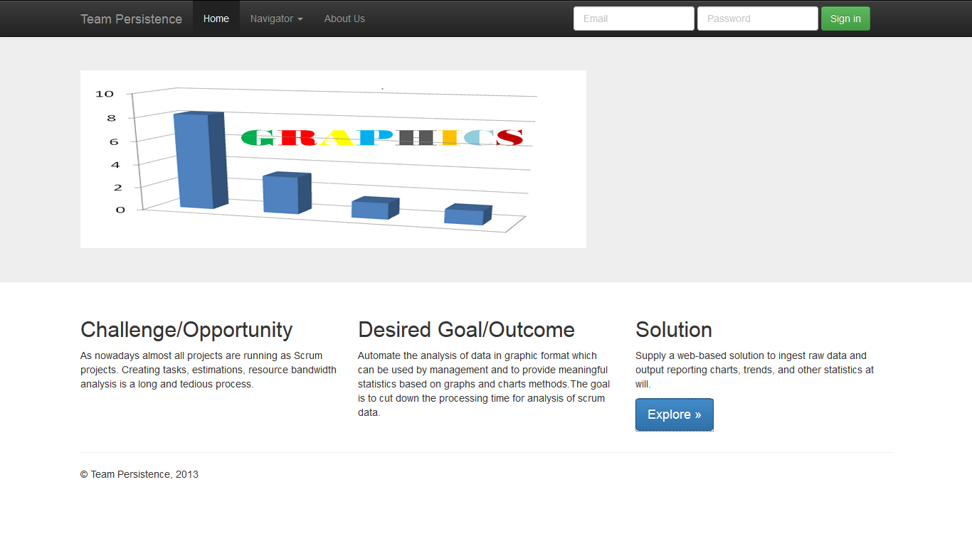

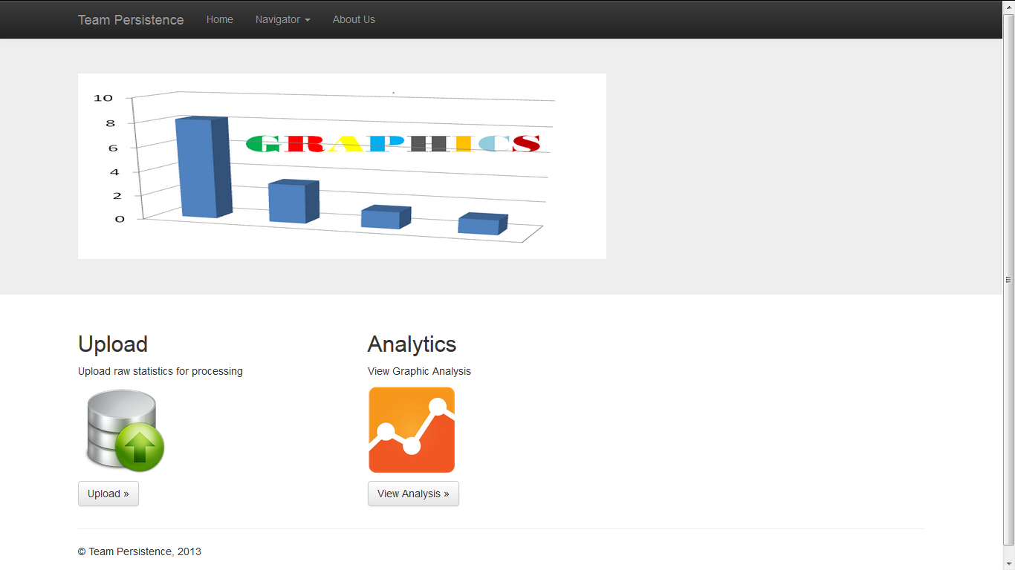
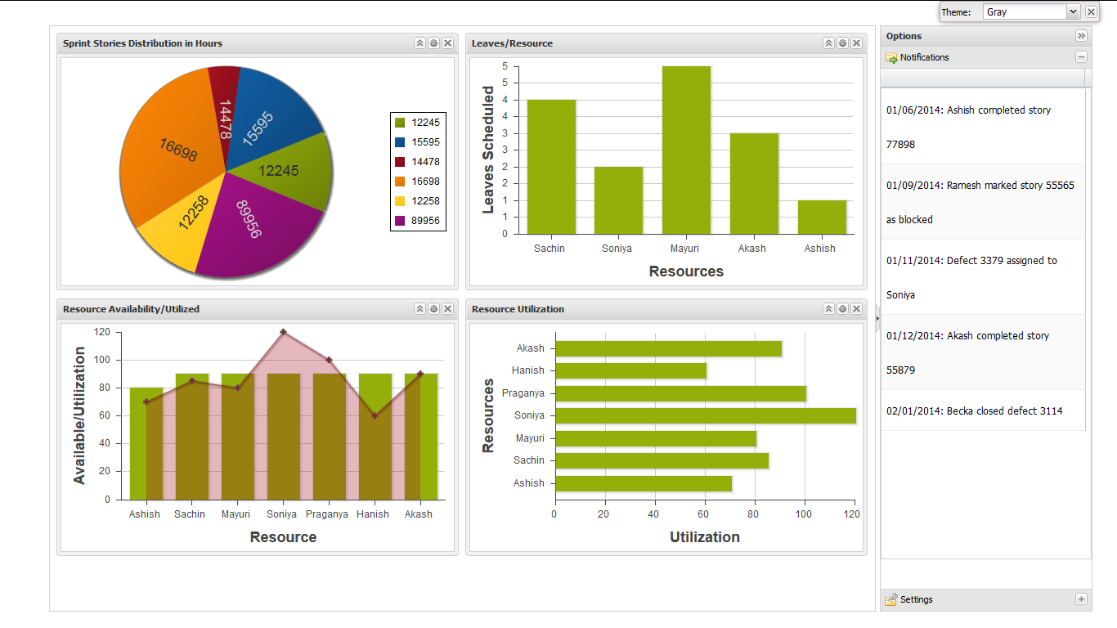

Team Members
- Ashish Sahu
- Mayuri Golatkar

