Greedy
Introduction to Greedy Algorithms
Greedy is an algorithmic paradigm that builds up a solution piece by piece, always choosing the next piece that offers the most obvious and immediate benefit. The problems where choosing a locally optimal solution at every step also leads to the globally optimal solution are best suited for the greedy approach.
Characteristics of Greedy Algorithms
- Makes the best possible choice at the current step.
- Does not reconsider or backtrack on previous decisions.
- Usually simpler and more efficient than Dynamic Programming.
- Works only when the problem exhibits:
  - Greedy Choice Property: A global optimum can be reached by making locally optimal choices.
  - Optimal Substructure: An optimal solution can be constructed from optimal solutions of its subproblems.
General Approach
- Identify all possible choices.
- Select the choice that appears best at the current step.
- Add it to the solution.
- Repeat until the problem is solved.
Advantages
- Easy to implement.
- Often provides efficient solutions with low time complexity.
- Requires less memory compared to Dynamic Programming.
Limitations
- A locally optimal choice may not always produce a globally optimal solution.
- Cannot be applied to every optimization problem.
- Correctness often requires a formal proof.

Common Greedy Algorithms:
- Activity Selection Problem
- Fractional Knapsack
- Huffman Coding
- Prim's Minimum Spanning Tree Algorithm
- Kruskal's Minimum Spanning Tree Algorithm
- Dijkstra's Shortest Path Algorithm (for non-negative weights)
- Job Sequencing with Deadlines
- Coin Change Problem (for certain coin systems)
Example: Coin Change Problem
public static void main(String[] args) {
int[] input = {10,2,1,5};
int res = minNoOfCoins(input,52);
System.out.println("Amount 52, result : "+res);
int res1 = minNoOfCoins(input,57);
System.out.println("Amount 57, result : "+res1);
}
public static int minNoOfCoins(int[] coins, int amount){
List<Integer> list = Arrays.stream(coins).boxed().sorted(Collections.reverseOrder()).toList();
int count = 0;
for (int i : list){
int rem = amount / i;
count += rem;
amount = amount - (i * rem);
if (amount == 0 ){
break;
}
}
return count;
}
}
Coins: {10, 5, 2, 1} Amount: 57

Greedy choices:
57 → Take 10 (5 times) → Remaining = 7
7 → Take 5 (1 time) → Remaining = 2
2 → Take 2 (1 time) → Remaining = 0
Time Complexity
Sorting: O(n log n)
Traversal: O(n)
Overall: O(n log n)
Activity Selection Problem
Given n activities with start and finish times, select the maximum number of non-overlapping activities that can be performed by a single person.
Greedy Strategy: Always select the activity that finishes earliest among the remaining activities.
Algorithm:
- Sort activities by finish time.
- Select the first activity.
- For each remaining activity:
  - If its start time is greater than or equal to the finish time of the last selected activity, select it.
- Continue until all activities are processed.
Why does greedy work?
Choosing the activity with the earliest finish time leaves the maximum amount of time available for future activities, increasing the chances of selecting more activities overall.
Arrays.sort(activities, Comparator.comparingInt(a -> a.finish));
Example:
public class _02ActivitySelection {
static class Activity{
int start;
int finish;
public Activity(int start,int finish){
this.start = start;
this.finish = finish;
}
}
public static List<Activity> getMaxActivity(Activity[] activities){
List<Activity> result = new ArrayList<>();
Arrays.sort(activities, Comparator.comparingInt(a->a.finish));
int finish = activities[0].finish;
result.add(activities[0]);
for (int i = 1 ; i < activities.length ; i++){
if (activities[i].start >= finish){
result.add(activities[i]);
finish = activities[i].finish;
}
}
return result;
}
public static void main(String[] args) {
Activity[] input = {
new Activity(12, 25),
new Activity(10, 20),
new Activity(20, 30)
};
List<Activity> result = getMaxActivity(input);
for (Activity activity : result){
System.out.println(activity.start +" "+activity.finish);
}
}
}
Time Complexity: O (n log n)
Space Complexity: O(n) // including result list
: O (1) // excluding output list
Fractional Knapsack Problem
Given the weights and values of N items, put these items in a knapsack of capacity W to get the maximum total value in the knapsack. In Fractional Knapsack, we can break items for maximizing the total value of the knapsack
Note: In the 0-1 Knapsack problem, we are not allowed to break items. We either take the whole item or don’t take it.

Input:
Items as (value, weight) pairs
arr[] = {{60, 10}, {100, 20}, {120, 30}}
Knapsack Capacity, W = 50
Output: Maximum possible value = 240
Explanation: by taking items of weight 10 and 20 kg and 2/3 fraction of 30 kg.
Hence total price will be 60+100+(2/3)(120) = 240

Input:
Items as (value, weight) pairs
arr[] = {{500, 30}}
Knapsack Capacity, W = 10
Output: 166.667
Naive Approach: Try all possible subsets with all different fractions but that will be very inefficient.
Greedy approach for fractional knapsack problem:
An efficient solution is to use the greedy approach. The basic idea of the greedy approach is to calculate the ratio value/weight for each item and sort the item based on this ratio. Then take the item with the highest ratio and add them until we can’t add the next item as a whole and at the end add the next item as much as we can. Which will always be the optimal solution to this problem.
Follow the given steps to solve the problem using the above approach:
- Calculate the ratio(value/weight) for each item.
- Sort all the items in decreasing order of the ratio.
- Initialize res =0, curr_cap = given_cap.
- Do the following for every item “i” in the sorted order:
  - If the weight of the current item is less than or equal to the remaining capacity, then add the value of that item into the result
  - else add the current item as much as we can and break out of the loop
- Return res
Below is the implementation of the above approach:
public class _03FractionalKnapsackProblem {
static class Item implements Comparable<Item>{
int weight;
int value;
public Item(int weight,int value){
this.weight = weight;
this.value = value;
}
public int compareTo(Item item){
return (item.value/item.weight) - (this.value/this.weight);
}
}
public static double getMaxWeight(Item[] items, int weight){
Arrays.sort(items);
double result = 0;
for (int i = 0 ; i < items.length ; i++){
if (items[i].weight <= weight){
result += items[i].value;
weight -= items[i].weight;
}else {
result += (weight * ((double) items[i].value /items[i].weight));
break;
}
}
return result;
}
public static void main(String[] args) {
Item[] items = {
new Item(10,60),
new Item(40,40),
new Item(20,100),
new Item(30,120)
};
double maxValue = getMaxWeight(items, 50 );
System.out.println("Maximum weight : "+maxValue);
}
}
Time Complexity: O (N log N)
Auxiliary Space: O(N)
Job Sequencing Problem
Given an array of jobs where every job has a deadline and associated profit if the job is finished before the deadline. It is also given that every job takes a single unit of time, so the minimum possible deadline for any job is 1. How to maximize total profit if only one job can be scheduled at a time.
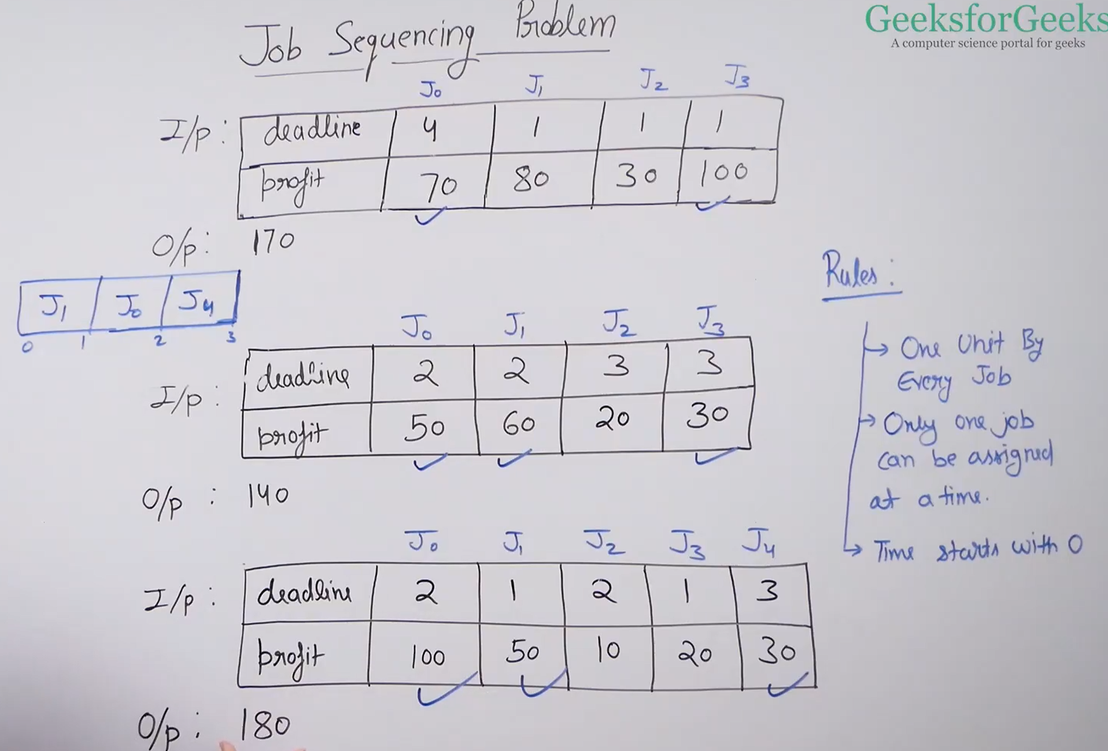

Example 1: [J3, -, -, J0] Profit = 170
Example 2: [J0, J1, J3] Profit = 140
Example 3: [J1, J0, J4] Profit = 180
This is a standard Greedy Algorithm problem. Following is the greedy algorithm to solve the above problem:
1) Sort all jobs in decreasing order of profit.
2) Initialize the result sequence as the first job in sorted jobs.
3) Do following for remaining n-1 jobs
.......a) If the current job can fit in the current result sequence
without missing the deadline, add the current job to the result.
Else ignore the current job.
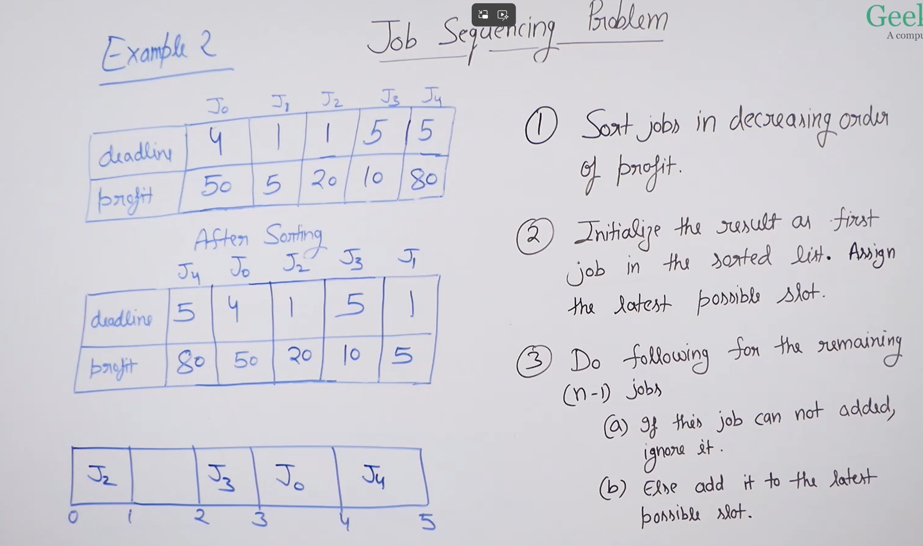
Java Implementation:
public class _04JobSequence {
static class Job{
char id;
int deadline;
int profit;
public Job(char id,int deadline, int profit){
this.id = id;
this.deadline = deadline;
this.profit = profit;
}
}
public static int maxProfit(Job[] jobs){
int maxProfit = 0;
Arrays.sort(jobs,(a,b)->b.profit-a.profit);
int maxDeadline = 0 ;
for (Job job : jobs){
maxDeadline = Math.max(maxDeadline, job.deadline);
}
boolean[] slot = new boolean[maxDeadline];
for (Job job : jobs){
for (int j = job.deadline-1 ; j >= 0; j--){
if (!slot[j]){
slot[j] = true;
maxProfit += job.profit;
break;
}
}
}
return maxProfit;
}
public static void main(String[] args) {
Job jobs[] = {new Job('a', 2, 100),
new Job('b', 1, 19),
new Job('c', 2, 27),
new Job('d', 1, 25),
new Job('e', 3, 15)};
int maxProfit = maxProfit(jobs);
System.out.println("Max profit : "+maxProfit);
}
}
Output: Max profit: 142
Complexity:
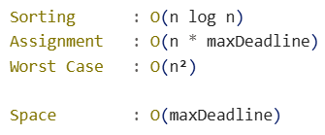
Huffman Coding
Huffman coding is a lossless data compression algorithm. The idea is to assign variable-length codes to input characters, lengths of the assigned codes are based on the frequencies of corresponding characters. The most frequent character gets the smallest code and the least frequent character gets the largest code.
The variable-length codes assigned to input characters are Prefix Codes, means the codes (bit sequences) are assigned in such a way that the code assigned to one character is not the prefix of code assigned to any other character. This is how Huffman Coding makes sure that there is no ambiguity when decoding the generated bitstream.
Let us understand prefix codes with a counter example. Let there be four characters a, b, c and d, and their corresponding variable length codes be 00, 01, 0 and 1. This coding leads to ambiguity because code assigned to c is the prefix of codes assigned to a and b. If the compressed bit stream is 0001, the de-compressed output may be "cccd" or "ccb" or "acd" or "ab".
See this for applications of Huffman Coding.
There are mainly two major parts in Huffman Coding
- Build a Huffman Tree from input characters.
- Traverse the Huffman Tree and assign codes to characters.
Steps to build Huffman Tree
Input is an array of unique characters along with their frequency of occurrences and output is Huffman Tree.
- Create a leaf node for each unique character and build a min heap of all leaf nodes (Min Heap is used as a priority queue. The value of frequency field is used to compare two nodes in min heap. Initially, the least frequent character is at root)
- Extract two nodes with the minimum frequency from the min heap.
- Create a new internal node with a frequency equal to the sum of the two nodes frequencies. Make the first extracted node as its left child and the other extracted node as its right child. Add this node to the min heap.
- Repeat steps#2 and #3 until the heap contains only one node. The remaining node is the root node and the tree is complete.
Let us understand the algorithm with an example:
character Frequency
a 5
b 9
c 12
d 13
e 16
f 45
Step 1. Build a min heap that contains 6 nodes where each node represents root of a tree with single node.
Step 2 Extract two minimum frequency nodes from min heap. Add a new internal node with frequency 5 + 9 = 14.
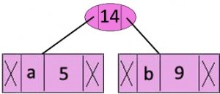
Now min heap contains 5 nodes where 4 nodes are roots of trees with single element each, and one heap node is root of tree with 3 elements
character Frequency
c 12
d 13
Internal Node 14
e 16
f 45
Step 3: Extract two minimum frequency nodes from heap. Add a new internal node with frequency 12 + 13 = 25
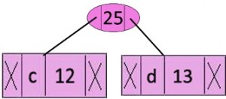
Now min heap contains 4 nodes where 2 nodes are roots of trees with single element each, and two heap nodes are root of tree with more than one node
character Frequency
Internal Node 14
e 16
Internal Node 25
f 45
Step 4: Extract two minimum frequency nodes. Add a new internal node with frequency 14 + 16 = 30
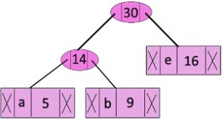
Now min heap contains 3 nodes.
character Frequency
Internal Node 25
Internal Node 30
f 45
Step 5: Extract two minimum frequency nodes. Add a new internal node with frequency 25 + 30 = 55
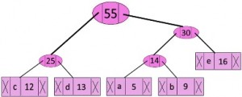
Now min heap contains 2 nodes.
character Frequency
f 45
Internal Node 55
Step 6: Extract two minimum frequency nodes. Add a new internal node with frequency 45 + 55 = 100
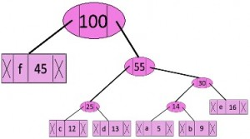
Now min heap contains only one node.
character Frequency
Internal Node 100
Since the heap contains only one node, the algorithm stops here.
Steps to print codes from Huffman Tree:
Traverse the tree formed starting from the root. Maintain an auxiliary array. While moving to the left child, write 0 to the array. While moving to the right child, write 1 to the array. Print the array when a leaf node is encountered.
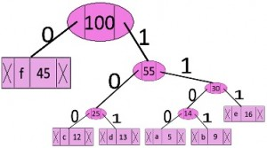
The codes are as follows:
character code-word
f 0
c 100
d 101
a 1100
b 1101
e 111
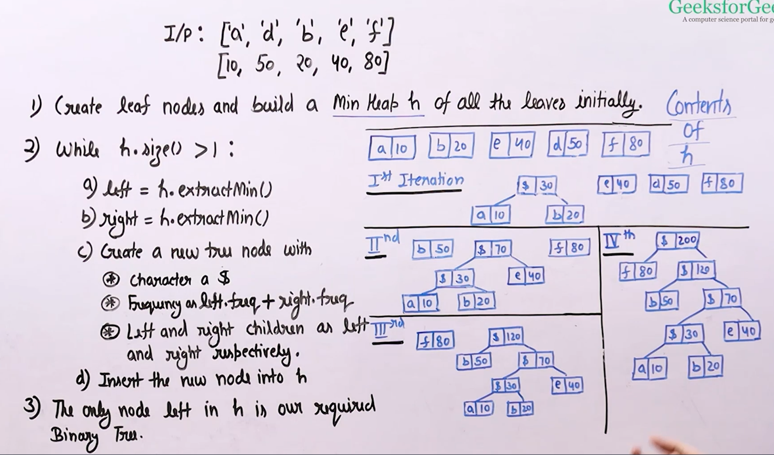
Java Implementation:
public class _05HuffmanCoding {
static class Node{
char ch;
int freq;
Node left;
Node right;
public Node(char ch, int freq, Node left, Node right){
this.ch = ch;
this.freq = freq;
this.left = left;
this.right = right;
}
}
public static void printHuffmanCodes(char[] chars, int[] frequencies){
if (chars.length != frequencies.length){
throw new IllegalArgumentException("Invalid Input");
}
PriorityQueue<Node> minheap = new PriorityQueue<>((a,b)->a.freq-b.freq);
for (int i = 0 ; i < chars.length ; i++){
minheap.add(new Node(chars[i],frequencies[i],null,null ));
}
while (minheap.size() > 1){
Node left = minheap.poll();
Node right = minheap.poll();
minheap.add(new Node('$', left.freq+ right.freq,left,right ));
}
recursivePrint(minheap.peek(),"");
}
public static void recursivePrint(Node root, String s){
if (root == null){
return;
}
if (root.left == null && root.right == null){
System.out.println(root.ch+" "+s);
}
recursivePrint(root.left,s+"0");
recursivePrint(root.right,s+"1");
}
public static void main(String[] args) {
char[] charArray = { 'a', 'b', 'c', 'd', 'e', 'f' };
int[] charfreq = { 5, 9, 12, 13, 16, 45 };
printHuffmanCodes(charArray,charfreq);
}
}
Output:
f 0
c 100
d 101
a 1100
b 1101
e 111
Time complexity: O(nlogn) where n is the number of unique characters. If there are n nodes, extractMin() is called 2*(n - 1) times. extractMin() takes O(logn) time as it calles minHeapify(). So, overall complexity is O(nlogn).
If the input array is sorted, there exists a linear time algorithm. We will soon be discussing in our next post.
Applications of Huffman Coding:
- They are used for transmitting fax and text.
- They are used by conventional compression formats like PKZIP, GZIP, etc.
- Multimedia codecs like JPEG, PNG, and MP3 use Huffman encoding (to be more precise the prefix codes).
It is useful in cases where there is a series of frequently occurring characters.

Backtracking
Backtracking can be defined as a general algorithmic technique that explores all possible solutions by building them step by step and abandoning a solution as soon as it is determined that it cannot lead to a valid result.
What is Backtracking Algorithm?
Backtracking is an algorithmic technique used to solve problems recursively by constructing a solution incrementally, one decision at a time. If at any stage the current solution violates the problem's constraints or cannot lead to a valid solution, the algorithm "backs up" (backtracks) and tries a different choice.
It can be viewed as a depth-first search (DFS) of the solution space, where invalid paths are pruned to reduce unnecessary computation.
Types of Backtracking Algorithm
Backtracking problems are generally classified into three categories:
- Decision Problem
- Determine whether at least one feasible solution exists.
- Example: Determining if a path exists in a maze.
- Optimization Problem
  - Find the best solution among all feasible solutions.
  - Example: Finding the minimum-cost path.
- Enumeration Problem
  - Generate or list all feasible solutions.
  - Example: Generating all permutations of a string.
General Steps in Backtracking
- Choose a candidate.
- Check if the candidate is valid.
- If it forms a complete solution, record the result.
- Otherwise, recursively explore further choices.
- Backtrack by undoing the current choice and try the next possibility.
Time Complexity
- Worst Case: $O(b^{d})$
  - $b$= branching factor
  - $d$= depth of the search tree
- In many problems, pruning significantly reduces the number of states explored.
Common Applications
- N-Queens Problem
- Rat in a Maze
- Sudoku Solver
- Graph Coloring
- Knight's Tour
- Generating Permutations and Combinations
- Subset Sum Problem
Example 1:
Print subsets of ABC which does not contains AB.
/**
* Generate all permutations of a string
* while avoiding permutations that contain the substring "AB".
*
* Example:
* Input : ABC
* Output : ACB, BAC, BCA, CBA
*
* Permutations like ABC and CAB are skipped
* because they contain "AB".
*/
public class _01PermuteOfStringWithoutGivenSubString {
public static void permute(String string, int l, int r) {
// Base case:
// All positions have been fixed.
if (l == r) {
System.out.println(string);
return;
}
// Try every possible character at position 'l'
for (int i = l; i <= r; i++) {
// Prune invalid branches before recursion
if (isSafe(string, l, i, r)) {
// Place character at index 'i' to position 'l'
string = swap(string, i, l);
// Recur for the remaining positions
permute(string, l + 1, r);
// Backtrack:
// Restore original string state before next iteration
string = swap(string, l, i);
}
}
}
/**
* Swaps characters at indices i and j.
*
* Example:
* swap("ABC", 0, 2) -> "CBA"
*/
public static String swap(String string, int i, int j) {
char[] chars = string.toCharArray();
char temp = chars[i];
chars[i] = chars[j];
chars[j] = temp;
return new String(chars);
}
/**
* Checks whether choosing the current character
* can potentially lead to an invalid permutation.
*
* This function is responsible for pruning
* the recursion tree early.
*/
public static boolean isSafe(String string, int l, int i, int r) {
/*
* Case 1:
* If previous character is 'A'
* and current fixed character becomes 'B',
* then substring "AB" is formed
* Example:
* A B _
* ^
* Invalid, so stop exploring this branch.
*/
if (l != 0 &&
string.charAt(l - 1) == 'A' &&
string.charAt(l) == 'B') {
return false;
}
/*
* Case 2:
* Special optimization when only two positions remain.
*
* Example:
* _ A B
*
* If choosing current character results in
* the final pair being "AB", prune immediately.
*/
if (l == r - 1 &&
string.charAt(i) == 'A' &&
string.charAt(r) == 'B') {
return false;
}
return true;
}
public static void main(String[] args) {
String input = "ABC";
// Generate permutations without substring "AB"
permute(input, 0, input.length() - 1);
}
}
Complexity
- Time Complexity: O (n! × n)
- Auxiliary Space: O(n) due to recursion stack
Rat in a Maze
Let us discuss Rat in a Maze as another example problem that can be solved using Backtracking.
A Maze is given as N*N binary matrix of blocks where source block is the upper left most block i.e., maze [0][0] and destination block is lower rightmost block i.e., maze[N-1] [N-1]. A rat starts from source and must reach the destination. The rat can move only in two directions: forward and down.
In the maze matrix, 0 means the block is a dead end and 1 means the block can be used in the path from source to destination. Note that this is a simple version of the typical Maze problem. For example, a more complex version can be that the rat can move in 4 directions, and a more complex version can be with a limited number of moves.
Following is an example maze.
Gray blocks are dead ends (value = 0).
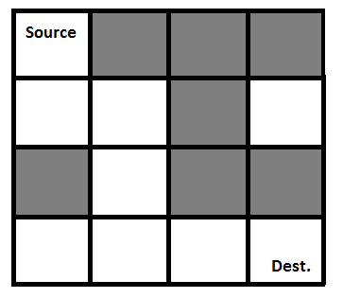
Following is a binary matrix representation of the above maze.
{1, 0, 0, 0}
{1, 1, 0, 1}
{0, 1, 0, 0}
{1, 1, 1, 1}
Following is a maze with highlighted solution path.
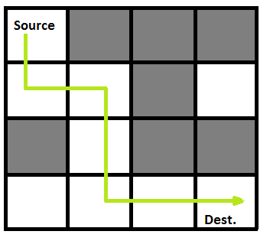
Following is the solution matrix (output of program) for the above input matrix.
{1, 0, 0, 0}
{1, 1, 0, 0}
{0, 1, 0, 0}
{0, 1, 1, 1}
All entries in solution path are marked as 1.
Backtracking Algorithm: Backtracking is an algorithmic technique for solving problems recursively by trying to build a solution incrementally. Solving one piece at a time and removing those solutions that fail to satisfy the constraints of the problem at any point of time (by time, here, is referred to the time elapsed till reaching any level of the search tree) is the process of backtracking.
Approach: Form a recursive function, which will follow a path and check if the path reaches the destination or not. If the path does not reach the destination, then backtrack and try other paths.
Algorithm:
- Create a solution matrix, initially filled with 0’s.
- Create a recursive function, which takes initial matrix, output matrix and position of rat (i, j).
- if the position is out of the matrix or the position is not valid then return.
- Mark the position output[i][j] as 1 and check if the current position is destination or not. If destination is reached print the output matrix and return.
- Recursively call for position (i+1, j) and (i, j+1).
- Unmark position (i, j), i.e. output[i][j] = 0.
Complexity Analysis:
- Time Complexity: O(2^(n^2)).
The recursion can run upper-bound 2^(n^2) times.
- Space Complexity: O(n^2).
Output matrix is required so an extra space of size n*n is needed.
Java Implementation
public class _RatInAMaze {
public static void print(int[][] solution, int N){
for (int i = 0 ; i < N ; i++){
for (int j = 0 ; j < N ; j++){
System.out.print(solution[i][j]+" ");
}
System.out.println();
}
}
public static boolean solveMaze(int[][] maze){
int N = maze.length;
int[][] sol = new int[N][N];
if (solveMazeRec(maze,0,0,sol,N)){
print(sol,N);
return true;
}
System.out.println("No solution present");
return false;
}
public static boolean solveMazeRec(int[][] maze,int i,int j,int[][] sol, int N){
if (i == N-1 && j == N-1 ){
sol[i][j] = 1;
return true;
}
if (isSafe(maze, i, j,N)){
sol[i][j] = 1;
if (solveMazeRec(maze, i+1, j, sol, N)){
return true;
}
if (solveMazeRec(maze, i, j+1, sol, N)){
return true;
}
sol[i][j] = 0;
}
return false;
}
public static boolean isSafe(int[][] maze,int i, int j,int N){
return (i < N && j < N && maze[i][j] == 1);
}
public static void main(String[] args) {
int maze[][] = { { 1, 0, 0, 0 },
{ 1, 1, 0, 1 },
{ 0, 1, 0, 0 },
{ 1, 1, 1, 1 } };
solveMaze(maze);
}
}
Complexity Analysis:
- Time Complexity: O(2^(n^2)).
The recursion can run upper-bound 2^(n^2) times.
- Space Complexity: O(n^2).
Output matrix is required so an extra space of size n*n is needed.
N-Queen Problem
Let us discuss N Queen as another example problem that can be solved using backtracking.
The N Queen is the problem of placing N chess queens on an N×N chessboard so that no two queens attack each other. For example, the following is a solution for the 4 Queen problem.
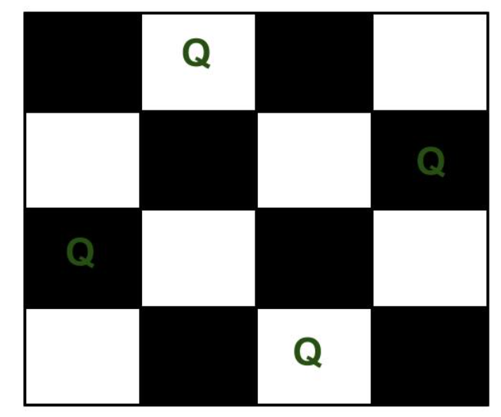
The expected output is a binary matrix that has 1s for the blocks where queens are placed. For example, the following is the output matrix for the above 4 queen solution.
{ 0, 1, 0, 0}
{ 0, 0, 0, 1}
{ 1, 0, 0, 0}
{ 0, 0, 1, 0}
Naive Algorithm
Generate all possible configurations of queens on board and print a configuration that satisfies the given constraints.
while there are untried configurations
{
generate the next configuration
if queens don't attack in this configuration, then
{
print this configuration;
}
}
Backtracking Algorithm
The idea is to place queens one by one in different columns, starting from the leftmost column. When we place a queen in a column, we check for clashes with already placed queens. In the current column, if we find a row for which there is no clash, we mark this row and column as part of the solution. If we do not find such a row due to clashes, then we backtrack and return false.
1) Start in the leftmost column
2) If all queens are placed
return true
3) Try all rows in the current column.
Do following for every tried row.
a) If the queen can be placed safely in this row
then mark this [row, column] as part of the
solution and recursively check if placing
queen here leads to a solution.
b) If placing the queen in [row, column] leads to
a solution then returns true.
c) If placing queen doesn't lead to a solution then
unmark this [row, column] (Backtrack) and go to
step (a) to try other rows.
4) If all rows have been tried and nothing worked,
return false to trigger backtracking.
Implementation of Backtracking solution
public class _03NQueenProblem {
public static int N = 4;
public static int[][] board = new int[N][N];
public static void printBoard(){
for (int i = 0 ; i < N ; i++){
for (int j = 0 ; j < N ; j++){
System.out.print(board[i][j]+" ");
}
System.out.println();
}
}
public static boolean isSafe(int row, int col){
int i,j;
for (i = 0 ; i < col ; i++){
if (board[row][i]==1){
return false;
}
}
for (i = row,j=col; i >= 0 && j>=0; i--,j--){
if (board[i][j] == 1){
return false;
}
}
for (i = row,j=col;i<N && j>=0;i++,j--){
if (board[i][j]==1){
return false;
}
}
return true;
}
public static boolean solveRec(int col){
if (col == N){
return true;
}
for (int i = 0 ; i < N ; i++){
if (isSafe(i,col)){
board[i][col] = 1;
if (solveRec(col+1)){
return true;
}
board[i][col] = 0;
}
}
return false;
}
public static boolean solve(){
if (!solveRec(0)){
System.out.println("No solution exist!");
return false;
}
printBoard();
return true;
}
public static void main(String[] args) {
solve();
}
}
Time Complexity: O(N!)
Auxiliary Space: O(N²)
Sudoku Problem
Given a partially filled 9x9 2D array 'grid[9][9]', the goal is to assign digits (from 1 to 9) to the empty cells so that every row, column, and subgrid of size 3x3 contains exactly one instance of the digits from 1 to 9.
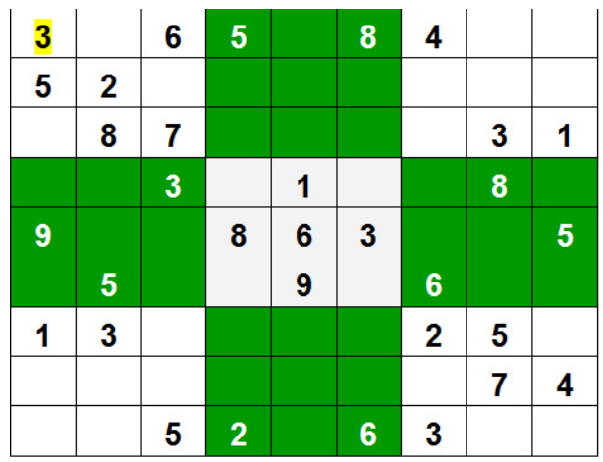
Example:
Input:
grid = { {3, 0, 6, 5, 0, 8, 4, 0, 0},
{5, 2, 0, 0, 0, 0, 0, 0, 0},
{0, 8, 7, 0, 0, 0, 0, 3, 1},
{0, 0, 3, 0, 1, 0, 0, 8, 0},
{9, 0, 0, 8, 6, 3, 0, 0, 5},
{0, 5, 0, 0, 9, 0, 6, 0, 0},
{1, 3, 0, 0, 0, 0, 2, 5, 0},
{0, 0, 0, 0, 0, 0, 0, 7, 4},
{0, 0, 5, 2, 0, 6, 3, 0, 0} }
Output:
3 1 6 5 7 8 4 9 2
5 2 9 1 3 4 7 6 8
4 8 7 6 2 9 5 3 1
2 6 3 4 1 5 9 8 7
9 7 4 8 6 3 1 2 5
8 5 1 7 9 2 6 4 3
1 3 8 9 4 7 2 5 6
6 9 2 3 5 1 8 7 4
7 4 5 2 8 6 3 1 9
Explanation: Each row, column and 3*3 box of
the output matrix contains unique numbers.
Input:
grid = { { 3, 1, 6, 5, 7, 8, 4, 9, 2 },
{ 5, 2, 9, 1, 3, 4, 7, 6, 8 },
{ 4, 8, 7, 6, 2, 9, 5, 3, 1 },
{ 2, 6, 3, 0, 1, 5, 9, 8, 7 },
{ 9, 7, 4, 8, 6, 0, 1, 2, 5 },
{ 8, 5, 1, 7, 9, 2, 6, 4, 3 },
{ 1, 3, 8, 0, 4, 7, 2, 0, 6 },
{ 6, 9, 2, 3, 5, 1, 8, 7, 4 },
{ 7, 4, 5, 0, 8, 6, 3, 1, 0 } };
Output:
3 1 6 5 7 8 4 9 2
5 2 9 1 3 4 7 6 8
4 8 7 6 2 9 5 3 1
2 6 3 4 1 5 9 8 7
9 7 4 8 6 3 1 2 5
8 5 1 7 9 2 6 4 3
1 3 8 9 4 7 2 5 6
6 9 2 3 5 1 8 7 4
7 4 5 2 8 6 3 1 9
Explanation: Each row, column and 3*3 box of
the output matrix contains unique numbers.
Approach:
Like all other Backtracking problems, Sudoku can be solved by one by one assigning numbers to empty cells. Before assigning a number, check whether it is safe to assign. Check that the same number is not present in the current row, current column and current 3X3 subgrid. After checking for safety, assign the number, and recursively check whether this assignment leads to a solution or not. If the assignment doesn't lead to a solution, then try the next number for the current empty cell. And if none of the number (1 to 9) leads to a solution, return false and print no solution exists.
Algorithm:
- Create a function that checks after assigning the current index the grid becomes unsafe or not. Keep Hashmap for a row, column and boxes. If any number has a frequency greater than 1 in the hashMap return false else return true; hashMap can be avoided by using loops.
- Create a recursive function that takes a grid.
- Check for any unassigned location. If present then assign a number from 1 to 9, check if assigning the number to current index makes the grid unsafe or not, if safe then recursively call the function for all safe cases from 0 to 9. if any recursive call returns true, end the loop and return true. If no recursive call returns true, then return false.
- If there is no unassigned location, then return true.
public class _04SudokuProblem {
public static void printBoard(int[][] board){
int N = board.length;
for (int i = 0 ; i < N ; i++){
for (int j = 0 ; j < N ; j++){
System.out.print(board[i][j]+" ");
}
System.out.println();
}
}
public static boolean solveSudoku(int[][] board,int N){
int i = 0,j = 0;
boolean isEmptyCellFound = false;
// Find the first empty cell in row-major order.
for (i = 0 ; i < N ; i++){
for (j = 0 ; j < N ; j++){
if (board[i][j] == 0){
isEmptyCellFound = true;
break;
}
}
if (isEmptyCellFound){
break;
}
}
// No empty cell remains, so the board is completely solved.
if (i == N){
return true;
}
// Try every possible value for the selected empty cell.
for (int x =1 ; x <=N ; x++){
if (isSafe(i,j,x,board,N)){
board[i][j] = x;
// Recursively solve the remaining board after this placement.
if (solveSudoku(board, N)){
return true;
}
// Backtrack when the current placement does not lead to a solution.
board[i][j] = 0;
}
}
return false;
}

public static boolean isSafe( int i, int j, int x,int[][] board,int N){
// Check whether the value already exists in the same row or column.
for (int k =0 ; k < N ; k++){
if (board[i][k] == x || board[k][j] == x){
return false;
}
}
// Locate the top-left cell of the sub-square containing board[i][j].
int subSqare = (int) Math.sqrt(N);
int subSqareRow = i - i%subSqare;
int subSqareCol = j - j%subSqare;
// Check whether the value already exists in the same sub-square.
for (i =0 ; i < subSqare ; i++){
for (j=0 ; j < subSqare; j++){
if (board[i+subSqareRow][j+subSqareCol] == x){
return false;
}
}
}
return true;
}

public static void main(String[] args) {
int grid[][] = { { 3, 0, 6, 5, 0, 8, 4, 0, 0 },
{ 5, 2, 0, 0, 0, 0, 0, 0, 0 },
{ 0, 8, 7, 0, 0, 0, 0, 3, 1 },
{ 0, 0, 3, 0, 1, 0, 0, 8, 0 },
{ 9, 0, 0, 8, 6, 3, 0, 0, 5 },
{ 0, 5, 0, 0, 9, 0, 6, 0, 0 },
{ 1, 3, 0, 0, 0, 0, 2, 5, 0 },
{ 0, 0, 0, 0, 0, 0, 0, 7, 4 },
{ 0, 0, 5, 2, 0, 6, 3, 0, 0 } };

if (solveSudoku(grid, grid.length))
printBoard(grid);
else
System.out.println("No Solution exists");
}
}
Complexity Analysis:
- Time complexity: O(9^(n*n)).
For every unassigned index, there are 9 possible options, so the time complexity is O(9^(n*n)). The time complexity remains the same but there will be some early pruning so the time taken will be much less than the naive algorithm, but the upper bound time complexity remains the same.
- Space Complexity: O(n*n).
To store the output array a matrix is needed.

