GRAPHS
Introduction to Graphs
A Graph is a data structure that consists of the following two components:
- A finite set of vertices also called nodes.
- A finite set of ordered pair of the form (u, v) called as edge. The pair is ordered because (u, v) is not the same as (v, u) in case of a directed graph(digraph). The pair of the form (u, v) indicates that there is an edge from vertex u to vertex v. The edges may contain weight/value/cost.
Graphs are used to represent many real-life applications:
- Graphs are used to represent networks. The networks may include paths in a city or telephone network or circuit network. For example, Google GPS
- Graphs are also used in social networks like linkedIn, Facebook. For example, in Facebook, each person is represented with a vertex(or node). Each node is a structure and contains information like person id, name, gender and locale.
Directed and Undirected Graphs
Directed Graphs: The Directed graphs are such graphs in which edges are directed in a single direction. For Example, the below graph is a directed graph: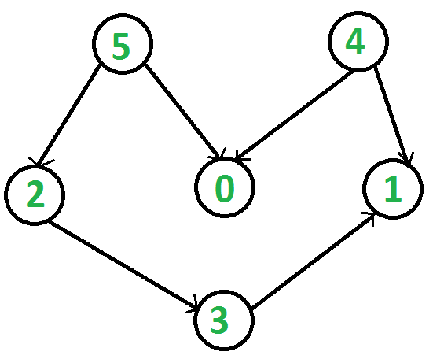
- Undirected Graphs: Undirected graphs are such graphs in which the edges are directionless or in other words bi-directional. That is, if there is an edge between vertices u and v then it means we can use the edge to go from both u to v and v to u. Following is an example of an undirected graph with 5 vertices:

Representing Graphs
Following two are the most commonly used representations of a graph:
- Adjacency Matrix.
- Adjacency List.
1. Adjacency Matrix: The Adjacency Matrix is a 2D array of size V x V where V is the number of vertices in a graph. Let the 2D array be adj[][], a slot adj[i][j] = 1 indicates that there is an edge from vertex i to vertex j. Adjacency matrix for undirected graph is always symmetric. Adjacency Matrix is also used to represent weighted graphs. If adj[i][j] = w, then there is an edge from vertex i to vertex j with weight w. The adjacency matrix for the above example undirected graph is:
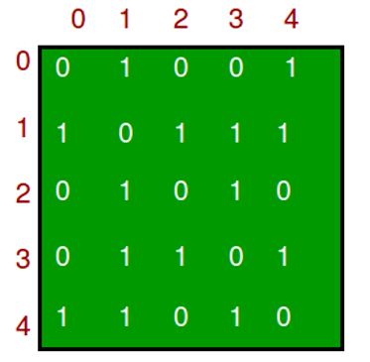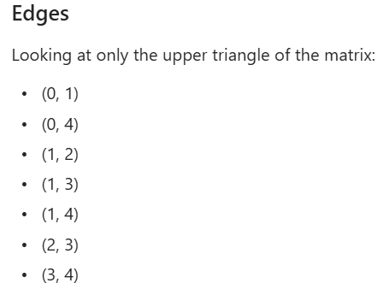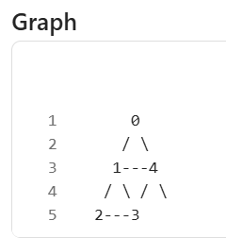
Pros : Representation is easier to implement and follow. Removing an edge takes O(1) time. Queries like whether there is an edge from vertex 'u' to vertex 'v' are efficient and can be done O(1).
Cons: Consumes more space O(V^2). Even if the graph is sparse(contains less number of edges), it consumes the same space. Adding a vertex is O(V^2) time. Please see this for a sample Python implementation of adjacency matrix.
Example:
public class _01UndirectedMatrixGraph {
private int vertex;
private int edges;
private int[][] matrix;
public _01UndirectedMatrixGraph(int vertex){
this.vertex = vertex;
this.edges = 0;
this.matrix = new int[vertex][vertex];
}
public void addEdge(int u,int v){
if (u < 0 || u >= vertex || v < 0 || v >= vertex){
System.out.println("Invalid vertex.");
return;
}
if (matrix[u][v] == 0){ Condition to avoid edges count increment if the edge already present.
matrix[u][v] = 1;
matrix[v][u] = 1;
edges++;
}
}
public void printGraph(){
System.out.println("Adjacent graph with vertex "+vertex+" and edges "+edges);
for (int i=0;i<vertex;i++){
for (int j=0;j<vertex;j++){
System.out.print(matrix[i][j]+" ");
}
System.out.println();
}
}
public static void main(String[] args) {
_01UndirectedMatrixGraph graph = new _01UndirectedMatrixGraph(5);
graph.addEdge(0, 1);
graph.addEdge(0, 4);
graph.addEdge(1, 2);
graph.addEdge(1, 3);
graph.addEdge(1, 4);
graph.addEdge(2, 3);
graph.addEdge(3, 4);
graph.printGraph();
}
}

2.Adjacency List: Graph can also be implemented using an array of lists. That is every index of the array will contain a complete list. Size of the array is equal to the number of vertices and every index i in the array will store the list of vertices connected to the vertex numbered i . Let the array be array[]. An entry array[i] represents the list of vertices adjacent to the i th vertex. This representation can also be used to represent a weighted graph. The weights of edges can be represented as lists of pairs. Following is the adjacency list representation of the above example undirected graph.Below is the implementation of the adjacency list representation of Graphs:
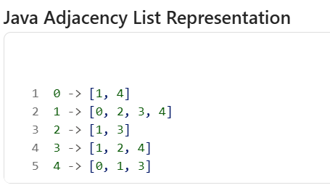
Note: In below implementation, we use dynamic arrays (vector in C++/ArrayList in Java) to represent adjacency lists instead of a linked list. The vector implementation has advantages of cache friendliness.
Pros : Saves space O(|V|+|E|). In the worst case, there can be C(V, 2) number of edges in a graph thus consuming O(V^2) space. Adding a vertex is easier.
Cons: Queries like whether there is an edge from vertex u to vertex v are not efficient and can be done O(V).
public class _02UndirectedListGraph {
private final int vertices;
private int edges;
private List<List<Integer>> lists;
_02UndirectedListGraph(int vertices){
this.vertices = vertices;
this.edges = 0;
this.lists = new ArrayList<>();
for (int i = 0 ;i < vertices ; i++){
lists.add(new ArrayList<>());
}
}
public void addEdge(int u, int v){
if (u < 0 || u >= vertices || v < 0 || v >= vertices){
System.out.println("Invalid vertex.");
return;
}
if (!lists.get(u).contains(v)){
lists.get(u).add(v);
lists.get(v).add(u);
edges++;
}
}
public void printGraph(){
System.out.println("Vertices: " + vertices);
System.out.println("Edges: " + edges);
for (int i=0 ; i< vertices; i++){
System.out.print(i + " -> ");
for (int neighbour : lists.get(i)){
System.out.print(neighbour+" ");
}
System.out.println();
}
}
public static void main(String[] args) {
_02UndirectedListGraph graph = new _02UndirectedListGraph(5);
graph.addEdge(0, 1);
graph.addEdge(0, 4);
graph.addEdge(1, 2);
graph.addEdge(1, 3);
graph.addEdge(1, 4);
graph.addEdge(2, 3);
graph.addEdge(3, 4);
graph.printGraph();
}
}
Vertices: 5
Edges: 7
0 -> 1 4
1 -> 0 2 3 4
2 -> 1 3
3 -> 1 2 4
4 -> 0 1 3
Adjacency Matrix and List Comparison
Operations | AdjacencyMatrix | Adjacency List
Storage Space | This representation makes use of VxV matrix, so space required in worst case is O(|V|²). | In this representation, for every vertex we store its neighbours. In the worst case, if a graph is connected O(V) is required for a vertex and O(E) is required for storing neighbours corresponding to every vertex .Thus, overall space complexity is O(|V|+|E|).
Adding a vertex | In order to add a new vertex to VxV matrix the storage must be increases to (|V|+1)². To achieve this we need to copy the whole matrix. Therefore the complexity is O(|V|²). | There are two pointers in adjacency list first points to the front node and the other one points to the rear node.Thus insertion of a vertex can be done directly in O(1) time.
Adding an edge | To add an edge say from i to j, matrix[i][j] = 1 which requires O(1) time. | Similar to insertion of vertex here also two pointers are used pointing to the rear and front of the list. Thus, an edge can be inserted in O(1)time.
Removing a vertex | In order to remove a vertex from V*V matrix the storage must be decreased to |V|² from (|V|+1)². To achieve this we need to copy the whole matrix. Therefore the complexity is O(|V|²). | In order to remove a vertex, we need to search for the vertex which will require O(|V|) time in worst case, after this we need to traverse the edges and in worst case it will require O(|E|) time.Hence, total time complexity is O(|V|+|E|).
Removing an edge | To remove an edge say from i to j, matrix[i][j] = 0 which requires O(1) time. | To remove an edge traversing through the edges is required and in worst case we need to traverse through all the edges.Thus, the time complexity is O(|E|).
Querying | In order to find for an existing edge the content of matrix needs to be checked. Given two vertices say i and j matrix[i][j] can be checked in O(1) time. | In an adjacency list every vertex is associated with a list of adjacent vertices. For a given graph, in order to check for an edge we need to check for vertices adjacent to given vertex. A vertex can have at most O(|V|) neighbours and in worst can we would have to check for every adjacent vertex. Therefore, time complexity is O(|V|) .

Breadth First Traversal of a Graph
The Breadth First Traversal or BFS traversal of a graph is similar to that of the Level Order Traversal of Trees.
The BFS traversal of Graphs also traverses the graph in levels. It starts the traversal with a given vertex, visits all of the vertices adjacent to the initially given vertex and pushes them all to a queue in order of visiting. Then it pops an element from the front of the queue, visits all of its neighbours and pushes the neighbours which are not already visited into the queue and repeats the process until the queue is empty or all of the vertices are visited.
The BFS traversal uses an auxiliary boolean array say visited[] which keeps track of the visited vertices. That is if visited[i] = true then it means that the i-th vertex is already visited.
Complete Algorithm:
- Create a boolean array say visited[] of size V+1 where V is the number of vertices in the graph.
- Create a Queue, mark the source vertex visited as visited[s] = true and push it into the queue.
- Until the Queue is non-empty, repeat the below steps:
  - Pop an element from the queue and print the popped element.
  - Traverse all of the vertices adjacent to the vertex poped from the queue.
  - If any of the adjacent vertex is not already visited, mark it visited and push it to the queue.
Consider the graph shown in the below Image. The vertices marked blue are not-visited vertices and the vertices marked yellow are visited. The vertex numbered 1 is the source vertex, i.e. the BFS traversal will start from the vertex 1.
Following the BFS algorithm:
- Mark the vertex 1 visited in the visited[] array and push it to the queue.
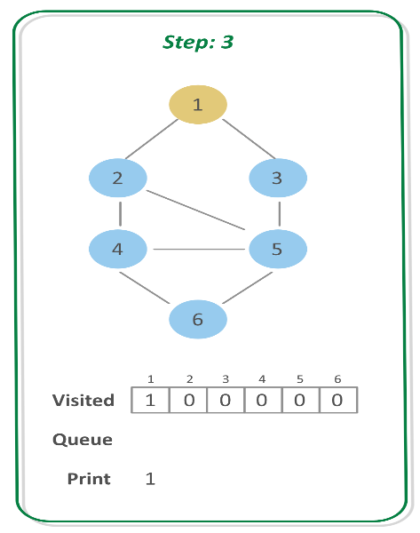
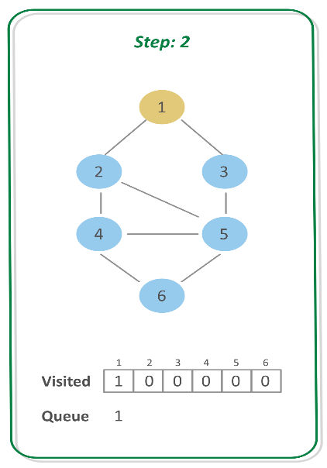
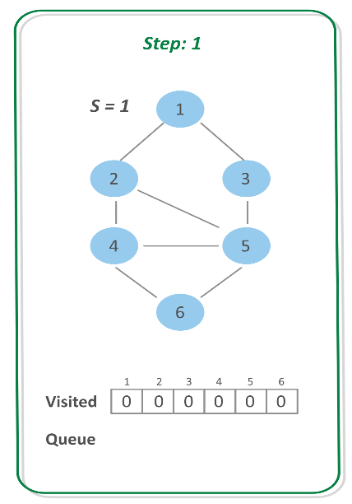

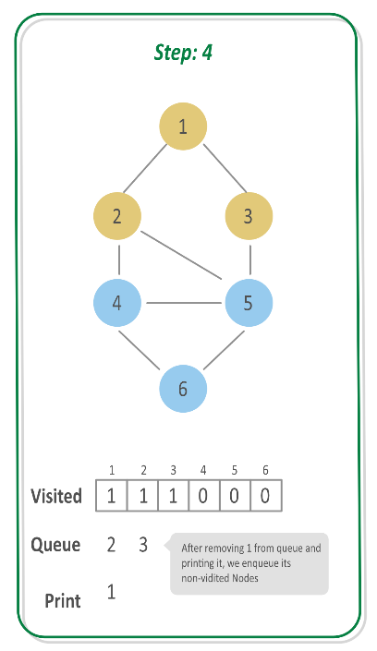
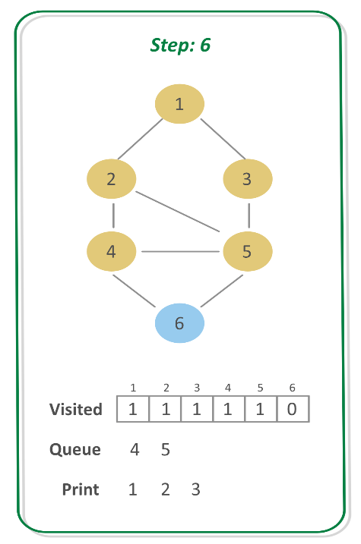
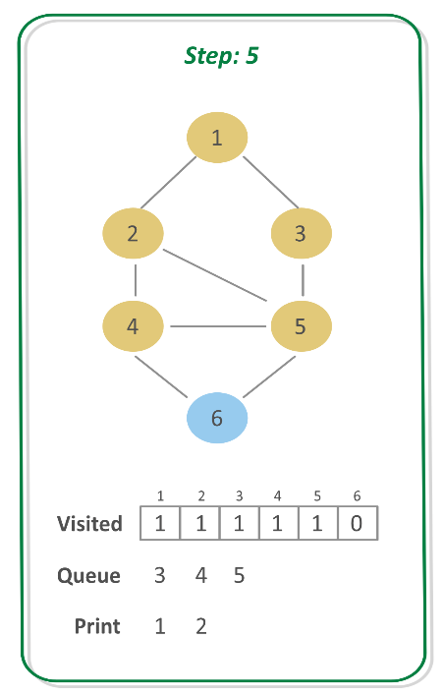

Step 7:
- POP the vertex at front that is 4 and print it.
Step 8:
- Check if the adjacent vertices of 4 are not already visited. If not, mark them visited and push them to queue. So, push 6 to the queue
Step 9:
- POP the vertex at front, that is 5 and print it.
- Since, all of its adjacent vertices are already visited, donot push anything.
Step 10:
- POP the vertex at front, that is 6 and print it.
- Since all its adjacent vertices are already visited, donot push anything.
03BreadthFirstSearch_BFS
public void bfs(List<List<Integer>> adj, int vertex, int start){
boolean[] visited = new boolean[vertex+1];
Deque<Integer> queue = new ArrayDeque<>();
visited[start] = true;
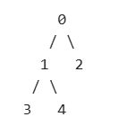
queue.add(start);
while (!queue.isEmpty()){
int curr = queue.poll();
System.out.print(curr+" ");
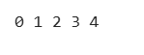
for (int v : adj.get(curr)){
if (!visited[v]){
queue.add(v);
visited[v] = true;
}
}
}
}
BreadthFirstSearch_Disjoint_BFS
public class _04BreadthFirstSearch_Disjoint_BFS {
public void bfsDisjoint(List<List<Integer>> adj, int vertices){
boolean[] visited = new boolean[vertices+1];
for (int i = 0 ; i < vertices ; i++){
if (!visited[i]){
bfs(adj,i,visited);
}
}
}
public void bfs(List<List<Integer>> adj,int start,boolean[] visited){
Deque<Integer> deque = new ArrayDeque<>();
deque.add(start);
visited[start] = true;
while (!deque.isEmpty()){
int curr = deque.poll();
System.out.print(curr+" ");
for (int v : adj.get(curr)){
if (!visited[v]){
deque.add(v);
visited[v] = true;
}
}
}
}
}
Time Complexity: O(V + E)
Space Complexity: O(V)
NoOfIslands
public class _05NoOfIslands {
public int noOfIsland(List<List<Integer>> adj,int vertices){
int count = 0;
boolean[] visited = new boolean[vertices];
for (int i=0;i<vertices;i++){
if (!visited[i]){
count++;
bfs(adj,i,visited);
}
}
return count;
}
public void bfs(List<List<Integer>> adj,int start, boolean[] visited){
Deque<Integer> deque = new ArrayDeque<>();
deque.add(start);
visited[start] = true;
while (!deque.isEmpty()){
int curr = deque.poll();
for (int v : adj.get(curr)){
if (!visited[v]){
deque.add(v);
visited[v] = true;
}
}
}
}
}
Applications of BFS
We have earlier discussed Breadth First Traversal Algorithm for Graphs. We have also discussed Applications of Depth First Traversal. In this article, applications of Breadth First Search are discussed.
- Shortest Path and Minimum Spanning Tree for unweighted graph In an unweighted graph, the shortest path is the path with least number of edges. With Breadth First, we always reach a vertex from given source using the minimum number of edges. Also, in case of unweighted graphs, any spanning tree is Minimum Spanning Tree and we can use either Depth or Breadth first traversal for finding a spanning tree.
- Peer to Peer Networks. In Peer to Peer Networks like BitTorrent, Breadth First Search is used to find all neighbor nodes.
- Crawlers in Search Engines: Crawlers build index using Breadth First. The idea is to start from source page and follow all links from source and keep doing same. Depth First Traversal can also be used for crawlers, but the advantage with Breadth First Traversal is, depth or levels of the built tree can be limited.
- Social Networking Websites: In social networks, we can find people within a given distance 'k' from a person using Breadth First Search till 'k' levels.
- GPS Navigation systems: Breadth First Search is used to find all neighboring locations.
- Broadcasting in Network: In networks, a broadcasted packet follows Breadth First Search to reach all nodes.
- In Garbage Collection: Breadth First Search is used in copying garbage collection using Cheney's algorithm. Refer this and for details. Breadth First Search is preferred over Depth First Search because of better locality of reference:
- Cycle detection in undirected graph: In undirected graphs, either Breadth First Search or Depth First Search can be used to detect cycle. We can use BFS to detect cycle in a directed graph also,
- Ford–Fulkerson algorithm In Ford-Fulkerson algorithm, we can either use Breadth First or Depth First Traversal to find the maximum flow. Breadth First Traversal is preferred as it reduces worst case time complexity to O(VE²).
- To test if a graph is Bipartite We can either use Breadth First or Depth First Traversal.
- Path Finding We can either use Breadth First or Depth First Traversal to find if there is a path between two vertices.
- Finding all nodes within one connected component: We can either use Breadth First or Depth First Traversal to find all nodes reachable from a given node.
Many algorithms like Prim's Minimum Spanning Tree and Dijkstra's Single Source Shortest Path use structure similar to Breadth First Search.
There can be many more applications as Breadth First Search is one of the core algorithms for Graphs.
Depth First Traversal of a Graph
The Depth-First Traversal or the DFS traversal of a Graph is used to traverse a graph depth wise. That is, it in this traversal method, we start traversing the graph from a node and keep on going in the same direction as far as possible. When no nodes are left to be traversed along the current path, backtrack to find a new possible path and repeat this process until all of the nodes are visited.
We can implement the DFS traversal algorithm using a recursive approach. While performing the DFS traversal the graph may contain a cycle and the same node can be visited again, so in order to avoid this we can keep track of visited array using an auxiliary array. On each step of the recursion mark, the current vertex visited and call the recursive function again for all the adjacent vertices.
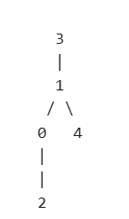
Adjacent List:
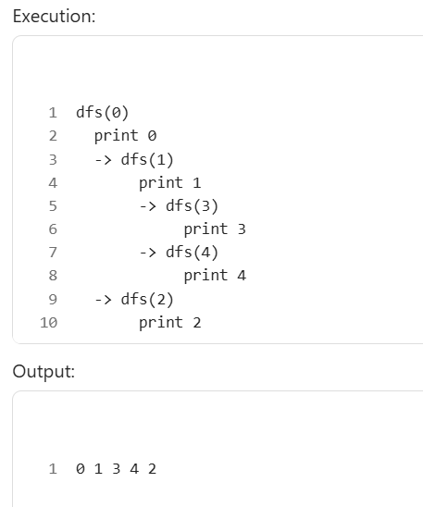
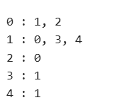

public class _06DepthFirstSearch_DFS {
public void dfs(List<List<Integer>> adj,int vertices,int start){
boolean[] visited = new boolean[vertices];
dfsRecursive(adj,start,visited);
}
public void dfsRecursive(List<List<Integer>> adj, int start,boolean[] visited){
visited[start] = true;
System.out.print(start+" ");
for (int v : adj.get(start)){
if (!visited[v]){
dfsRecursive(adj, v, visited);
}
}
}
}
Time Complexity: O(V+E)
Space Complexity: O(V)
DFS for Disjoint Graph
public class _07DepthFirstSearch_Disjoint_DFS {
public void dfs(List<List<Integer>> adj,int vertices){
boolean[] visited = new boolean[vertices];
for (int i = 0 ; i < vertices ; i++){
if (!visited[i]){
dfsRecursive(adj,i,visited);
}
}
}
public void dfsRecursive(List<List<Integer>> adj, int start, boolean[] visited){
System.out.print(start+" ");
visited[start] = true;
for (int v : adj.get(start)){
if (!visited[v]){
dfsRecursive(adj, v, visited);
}
}
}
}
public class _08DepthFirstSearch_UsingStack {
public void dfs(List<List<Integer>> adj, int vertices, int start) {
boolean[] visited = new boolean[vertices];
Stack<Integer> stack = new Stack<>();
stack.push(start);
while (!stack.isEmpty()) {
int current = stack.pop();
if (!visited[current]) {
visited[current] = true;
System.out.print(current + " ");

// Push neighbors in reverse order
for (int i = adj.get(current).size() - 1; i >= 0; i--) {
int neighbour = adj.get(current).get(i);
if (!visited[neighbour]) {
stack.push(neighbour);
}
}
}
}
}
}
Applications, Advantages and Disadvantages of DFS
Depth First Search is a widely used algorithm for traversing a graph. Here we have discussed some applications, advantages, and disadvantages of the algorithm.
Applications of Depth First Search:
1. Detecting cycle in a graph: A graph has a cycle if and only if we see a back edge during DFS. So we can run DFS for the graph and check for back edges.
2. Path Finding: We can specialize the DFS algorithm to find a path between two given vertices u and z.
- Call DFS(G, u) with u as the start vertex.
- Use a stack S to keep track of the path between the start vertex and the current vertex.
- As soon as destination vertex z is encountered, return the path as the contents of the stack
3. Topological Sorting: Topological Sorting is mainly used for scheduling jobs from the given dependencies among jobs. In computer science, applications of this type arise in instruction scheduling, ordering of formula cell evaluation when recomputing formula values in spreadsheets, logic synthesis, determining the order of compilation tasks to perform in makefiles, data serialization, and resolving symbol dependencies in linkers.
4. To test if a graph is bipartite: We can augment either BFS or DFS when we first discover a new vertex, color it opposite its parents, and for each other edge, check it doesn’t link two vertices of the same color. The first vertex in any connected component can be red or black.
5. Finding Strongly Connected Components of a Graph: A directed graph is called strongly connected if there is a path from each vertex in the graph to every other vertex. (See this for DFS-based algo for finding Strongly Connected Components)
6. Solving puzzles with only one solution: such as mazes. (DFS can be adapted to find all solutions to a maze by only including nodes on the current path in the visited set.).
7. Web crawlers: Depth-first search can be used in the implementation of web crawlers to explore the links on a website.
8. Maze generation: Depth-first search can be used to generate random mazes.
9. Model checking: Depth-first search can be used in model checking, which is the process of checking that a model of a system meets a certain set of properties.
10. Backtracking: Depth-first search can be used in backtracking algorithms.
Advantages of Depth First Search:
- Memory requirement is only linear with respect to the search graph. This is in contrast with breadth-first search which requires more space. The reason is that the algorithm only needs to store a stack of nodes on the path from the root to the current node.
- The time complexity of a depth-first Search to depth d and branching factor b (the number of children at each node, the outdegree) is O(bd) since it generates the same set of nodes as a breadth-first search, but simply in a different order. Thus practically depth-first search is time-limited rather than space-limited.
- If the depth-first search finds a solution without exploring much in a path then the time and space it takes will be very less.
- DFS requires less memory since only the nodes on the current path are stored. By chance, DFS may find a solution without examining much of the search space at all.
Disadvantages of Depth First Search:
- The disadvantage of Depth-First Search is that there is a possibility that it may down the left-most path forever. Even a finite graph can generate an infinite tre One solution to this problem is to impose a cutoff depth on the search. Although the ideal cutoff is the solution depth d and this value is rarely known in advance of actually solving the problem. If the chosen cutoff depth is less than d, the algorithm will fail to find a solution, whereas if the cutoff depth is greater than d, a large price is paid in execution time, and the first solution found may not be an optimal one.
- Depth-First Search is not guaranteed to find the solution.
- And there is no guarantee to find a minimal solution if more than one solution.
Shortest path in an Unweighted graph
Given an unweighted graph, a source, and a destination, we need to find the shortest path from source to destination in the graph in the most optimal way.
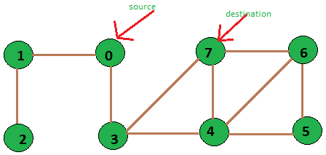
unweighted graph of 8 vertices
Input: source vertex = 0 and destination vertex is = 7.
Output: Shortest path length is:2
Path is::
0 3 7
Input: source vertex is = 2 and destination vertex is = 6.
Output: Shortest path length is:5
Path is: 2 1 0 3 4 6
public class _09ShortestPathInUnweightedGraph {
public int[] shortestPath(List<List<Integer>> adj, int start,int vertices){
int[] path = new int[vertices];
Arrays.fill(path,-1);
boolean[] visited = new boolean[vertices];
Deque<Integer> queue = new ArrayDeque<>();
queue.add(start);
path[start] = 0;
visited[start] = true;
while (!queue.isEmpty()){
int curr = queue.poll();
for (int v : adj.get(curr)){
if (!visited[v]){
queue.add(v);
visited[v] = true;
path[v] = path[curr]+1;
}
}
}
return path;
}
}
Return only the shortest distance
public int shortestPath(List<List<Integer>> adj, int start, int dest, int vertices) {
int[] distance = new int[vertices];
Arrays.fill(distance, -1);
Queue<Integer> queue = new ArrayDeque<>();
queue.add(start);
distance[start] = 0;
while (!queue.isEmpty()) {
int curr = queue.poll();
if (curr == dest) {
return distance[curr];
}
for (int v : adj.get(curr)) {
if (distance[v] == -1) {
distance[v] = distance[curr] + 1;
queue.add(v);
}
}
}
return -1; // Destination not reachable
}
Time Complexity: O(V + E)
Space Complexity: O(V)
Detect cycle in Undirected graph
Given an undirected graph, the task is to check if there is a cycle in the given graph.
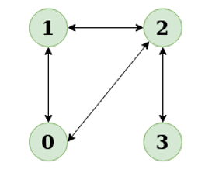
Example:
Input: N = 4, E = 4
Output: Yes
Explanation: The diagram clearly shows a cycle 0 to 2 to 1 to 0

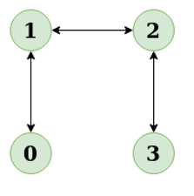
Input: N = 4, E = 3 , 0 1, 1 2, 2 3
Output: No
Explanation: There is no cycle in the given graph

Find cycle in undirected Graph using DFS:
Use DFS from every unvisited node. Depth First Traversal can be used to detect a cycle in a Graph. There is a cycle in a graph only if there is a back edge present in the graph. A back edge is an edge that is indirectly joining a node to itself (self-loop) or one of its ancestors in the tree produced by DFS.
To find the back edge to any of its ancestors keep a visited array and if there is a back edge to any visited node then there is a loop and return true.
Follow the below steps to implement the above approach:
- Iterate over all the nodes of the graph and Keep a visited array visited[] to track the visited nodes.
- Run a Depth First Traversal on the given subgraph connected to the current node and pass the parent of the current node. In each recursive
  - Set visited[root] as 1.
  - Iterate over all adjacent nodes of the current node in the adjacency list
    - If it is not visited then run DFS on that node and return true if it returns true.
    - Else if the adjacent node is visited and not the parent of the current node then return true.
  - Return false.
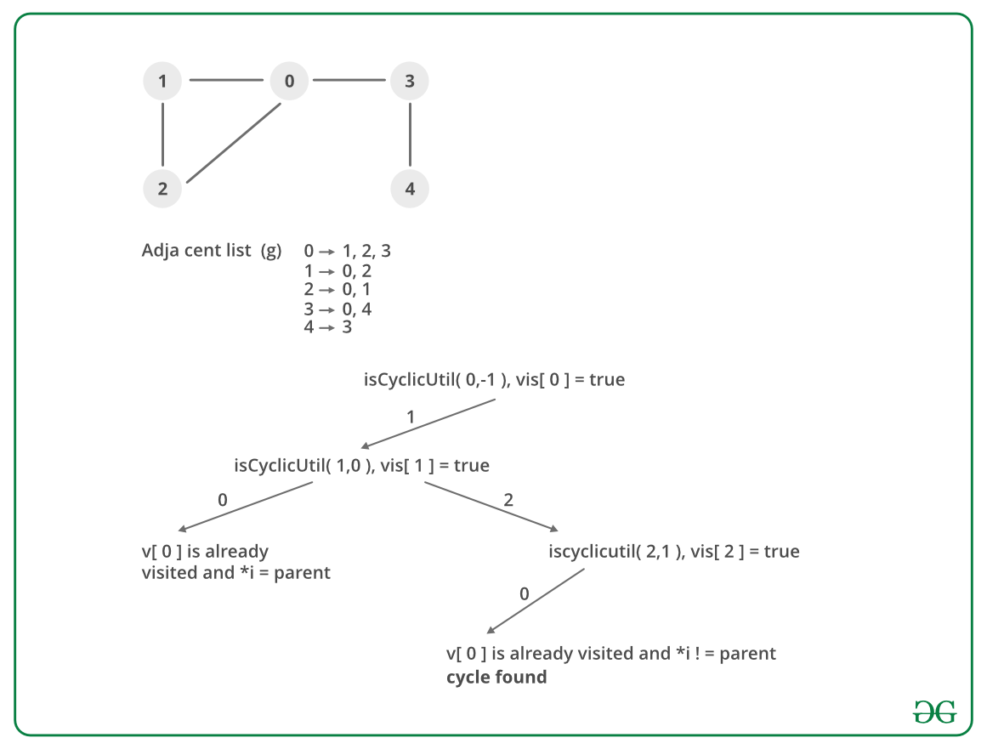
Another possible scenario:
If No cycle is detected after running Depth First Traversal for every subgraph the there exists no cycle as shown below
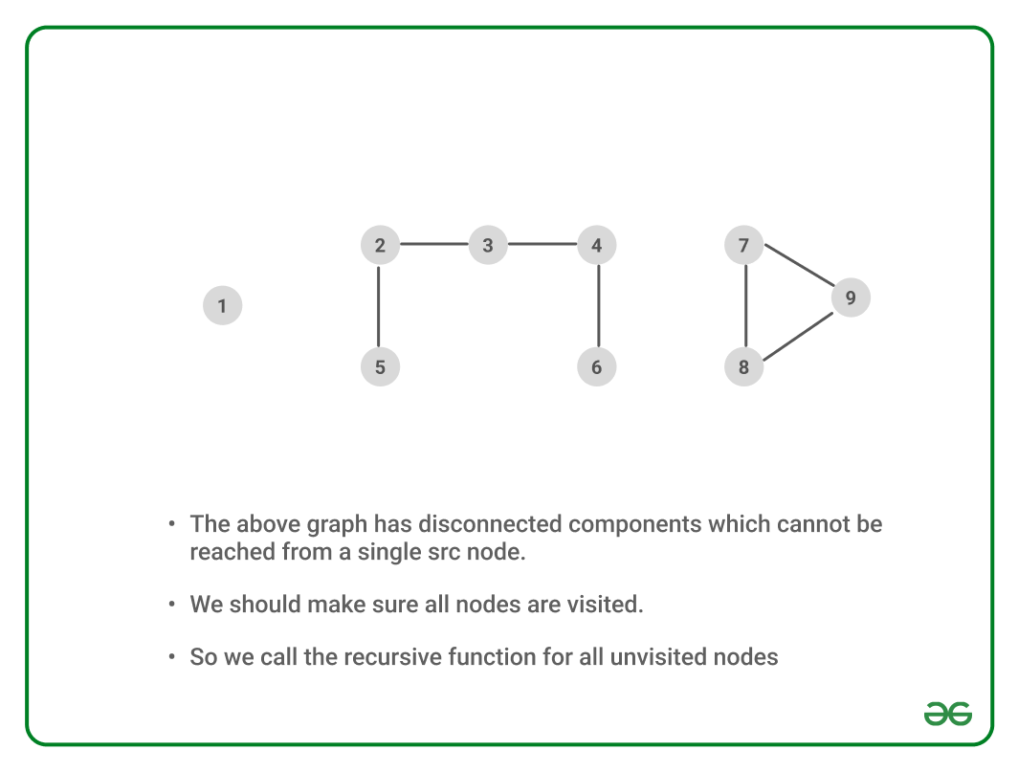
public class _10DetectCycleInUndirectedGraph {
public boolean dfs(List<List<Integer>> adj,int vertices){
boolean[] visited = new boolean[vertices];
for (int i =0 ; i< vertices ; i++){
if (!visited[i]){
if (dfsRecursion(adj,i,visited,-1)){ // for start node use -1 as parent
return true;
}
}
}
return false;
}
public boolean dfsRecursion(List<List<Integer>> adj,int start,boolean[] visited,int parent){
visited[start] = true;
for (int v : adj.get(start)){
if (!visited[v]){
if (dfsRecursion(adj, v, visited, start)){
return true;
}
} else if (v != parent) {
return true;
}
}
return false;
}
}
Time Complexity: O(V+E), The program does a simple DFS Traversal of the graph which is represented using an adjacency list. So the time complexity is O(V+E).
Auxiliary Space: O(V), To store the visited array O(V) space is required.
Detect Cycle in a Directed Graph DFS
Given the root of a Directed graph, The task is to check whether the graph contains a cycle if yes then return true, return false otherwise.
Examples:
Input: N = 4, E = 6
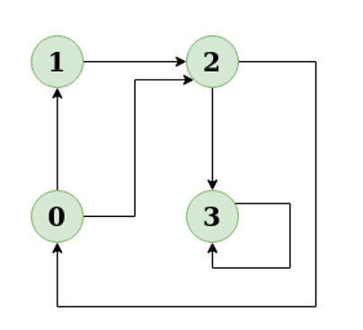
Output: Yes
Explanation: The diagram clearly shows a cycle 0 -> 2 -> 0
Input: N = 4, E = 4
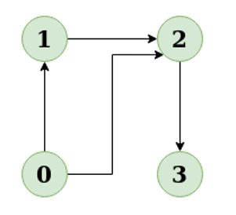
Output: No
Explanation: The diagram clearly shows no cycle
There is a cycle in a graph only if there is a back edge present in the graph. Depth First Traversal can be used to detect a cycle in a Graph, DFS for a connected graph produces a tree.
If the graph is disconnected then get the DFS forest and check for a cycle in individual trees by checking back edges. To detect a back edge, keep track of vertices currently in the recursion stack of function for DFS traversal. If a vertex is reached that is already in the recursion stack then there is a cycle in the tree.
Note: A Back edge is an edge that is from a node to itself (self-loop) or one of its ancestors in the tree produced by DFS. Thus the edge that connects the current vertex to the vertex in the recursion stack is a back edge.
Illustration:
In the following graph, there are 3 back edges, marked with a cross sign. Observe that these 3 back edges indicate 3 cycles present in the graph.
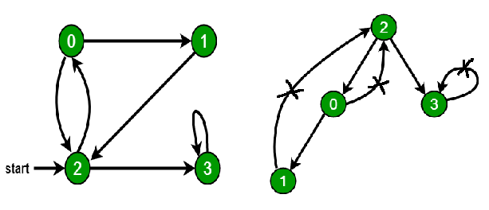
Use recStack[] array to keep track of vertices in the recursion stack.
Dry run of the above approach:
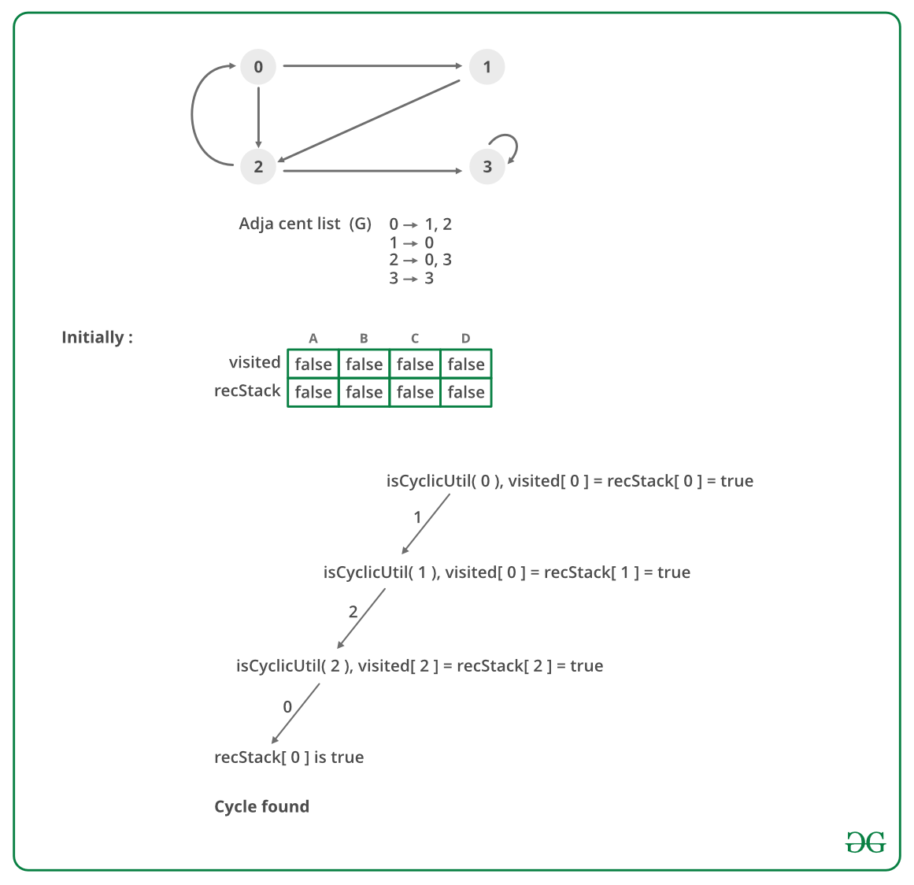
Follow the below steps to Implement the idea:
- Create the graph using the given number of edges and vertices.
- Create a recursive function that initializes the current vertex, visited array, and recursion stack.
- Mark the current node as visited and also mark the index in the recursion stack.
- Find all the vertices which are not visited and are adjacent to the current node and recursively call the function for those vertices
  - If the recursive function returns true, return true.
  - If the adjacent vertices are already marked in the recursion stack then return true.
- Create a wrapper function, that calls the recursive function for all the vertices, and
  - If any function returns true return true.
  - Else if for all vertices the function returns false return false.
Below is the implementation of the above approach:
public class _11DetectCycleInDirectedGraph_DFS {
public boolean dfs(List<List<Integer>> adj, int vertices){
boolean[] visited = new boolean[vertices];
boolean[] recStack = new boolean[vertices];
for (int i = 0 ; i < vertices ; i++){
if (!visited[i]){
if (dfsRecursion(adj,i,visited,recStack)){
return true;
}
}
}
return false;
}
public boolean dfsRecursion(List<List<Integer>> adj, int start,boolean[] visited,
boolean[] recStack){
visited[start] = true;
recStack[start] = true;
for (int v : adj.get(start)){
if (!visited[v]){
if (dfsRecursion(adj, v, visited, recStack)){
return true;
}
} else if (recStack[v]) {
return true;
}
}
recStack[start] = false;
return false;
}
}
Time Complexity: O(V+E), the Time Complexity of this method is the same as the time complexity of DFS traversal which is O(V+E).
Auxiliary Space: O(V). To store the visited and recursion stack O(V) space is needed.

