Introduction to Dynamic Programming
Dynamic Programming is an algorithmic approach to solve some complex problems easily and save time and number of comparisons by storing the results of past computations. The basic idea of dynamic programming is to store the results of previous calculation and reuse it in future instead of recalculating them.
We can also see Dynamic Programming as dividing a particular problem into subproblems and then storing the result of these subproblems to calculate the result of the actual problem.
Consider the problem to find the N-th Fibonacci number.
We know that n-th fibonacci number fib(n) can be defined as:
fib(n) = fib(n-1) + fib(n-2), where n >= 2.
and,
fib(0) = 0
fib(1) = 1
We can see that the above function fib() to find the nth fibonacci number is divided into two subproblems fib(n-1) and fib(n-2) each one of which will be further divided into subproblems and so on.
The first few Fibonacci numbers are:
1, 1, 2, 3, 5, 8, 13, 21, 34,........
The recursive program to find N-th Fibonacci number is shown below:
int fib(int n)
{
if (n <= 1)
return n;

return fib(n-1) + fib(n-2);
}
Below is the recursion tree for the recursive solution to find the N-th Fibonacci number:
fib(5)
/ \
fib(4) fib(3)
/ \ / \
fib(3) fib(2) fib(2) fib(1)
/ \ / \ / \
fib(2) fib(1) fib(1) fib(0) fib(1) fib(0)
/ \
fib(1) fib(0)
We can see that the function fib(3) is being called 2 times. If we would have stored the value of fib(3), then instead of computing it again, we could have reused the old, stored value.
The time complexity of the recursive solution is exponential. However, we can improve the time complexity by using Dynamic Programming approach and storing the results of the subproblems as shown below:
public class _01FibonancciSeries {
public static int N = 10;
public static int[] memory = new int[N + 1];
public static int fibonancci(int n) {
if (memory[n] == -1) { // Calculate only if not already computed
if (n == 0 || n == 1) {
memory[n] = n;
} else {
memory[n] = fibonancci(n - 1) + fibonancci(n - 2);
}
}
return memory[n];
}
public static void main(String[] args) {
Arrays.fill(memory, -1);
System.out.println(fibonancci(N));
// Print series
for (int i = 0; i <= N; i++) {
System.out.print(fibonancci(i) + " ");
}
}
}
The time complexity of the above solution is linear.
Properties of a Dynamic Programming Problem
There are two main properties of any problem which identifies a problem that it can be solved using the dynamic programming approach:
- Overlapping Subproblem Property
- Optimal Substructure Property
Let us look at each one of these properties in details:
- Overlapping Subproblems: Like Divide and Conquer, Dynamic Programming combines solutions to sub-problems. Dynamic Programming is mainly used when solutions of the same subproblems are needed again and again. In dynamic programming, computed solutions to subproblems are stored in a table so that these don’t have to be recomputed. So Dynamic Programming is not useful when there are no common (overlapping) subproblems because there is no point storing the solutions if they are not needed again. For example, Binary Search doesn’t have common subproblems. If we take an example of following the recursive program for Fibonacci Numbers, there are many subproblems which are solved again and again.
/* simple recursive program for Fibonacci numbers */
int fib(int n)
{
if ( n <= 1 )
return n;
return fib(n-1) + fib(n-2);
}
Recursion tree for execution of fib(5):
fib(5)
/ \
fib(4) fib(3)
/ \ / \
fib(3) fib(2) fib(2) fib(1)
/ \ / \ / \
fib(2) fib(1) fib(1) fib(0) fib(1) fib(0)
/ \
fib(1) fib(0)

We can see that the function fib(3) is being called 2 times. If we would have stored the value of fib(3), then instead of computing it again, we could have reused the old stored value.
- Optimal Substructure: A given problem has Optimal Substructure Property if an optimal solution of the given problem can be obtained by using optimal solutions of its subproblems. For example, the Shortest Path problem has the following optimal substructure property: If a node x lies in the shortest path from a source node u to destination node v then the shortest path from u to v is combination of shortest path from u to x and shortest path from x to v. The standard All Pair Shortest Path algorithms like Floyd–Warshall and Bellman-Ford are typical examples of Dynamic Programming. On the other hand, the Longest Path problem doesn’t have the Optimal Substructure property. Here, by Longest Path we mean longest simple path (path without cycle) between any two nodes. Consider the following unweighted graph given in the CLRS book. There are two longest paths from q to t: q->r->t and q->s->t. Unlike shortest paths, these longest paths do not have the optimal substructure property. For example, the longest path q->r->t is not a combination of the longest path from q to r and longest path from r to t, because the longest path from q to r is q->s->t->r and the longest path from r to t is r->q->s->t.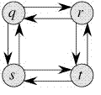
Tabulation vs Memoization
There are two different ways to store the values so that the values of a sub-problem can be reused. Here, will discuss two patterns of solving dynamic programming (DP) problems:
- Tabulation: Bottom Up
- Memoization: Top Down
Before getting to the definitions of the above two terms consider the following statements:
- Version 1: I will study the theory of DP from GeeksforGeeks, then I will practice some problems on classic DP and hence I will master DP.
- Version 2: To Master DP, I would have to practice Dynamic problems and practice problems - Firstly, I would have to study some theories of DP from GeeksforGeeks
Both versions say the same thing, the difference simply lies in the way of conveying the message and that's exactly what Bottom-Up and Top-Down DP do. Version 1 can be related to Bottom-Up DP and Version-2 can be related as Top-Down DP.
Tabulation Method - Bottom-Up Dynamic Programming
As the name itself suggests starting from the bottom and accumulating answers to the top. Let's discuss in terms of state transition.
Let's describe a state for our DP problem to be dp[x] with dp[0] as base state and dp[n] as our destination state. So, we need to find the value of destination state i.e dp[n].
If we start our transition from our base state i.e dp[0] and follow our state transition relation to reach our destination state dp[n], we call it the Bottom-Up approach as it is quite clear that we started our transition from the bottom base state and reached the topmost desired state.
Now, Why do we call it the tabulation method?
To know this let's first write some code to calculate the factorial of a number using a bottom-up approach. Once, again as our general procedure to solve a DP we first define a state. In this case, we define a state as dp[x], where dp[x] is to find the factorial of x.
Now, it is quite obvious that dp[x+1] = dp[x] * (x+1)
// Tabulated version to find factorial x.
int dp[MAXN];
// base case
int dp[0] = 1;
for (int i = 1; i< =n; i++)
{
dp[i] = dp[i-1] * i;
}
Example:-
public class _02FibonancciSeries {
public static int fibonacci(int n) {
if (n <= 1) {
return n;
}
int[] table = new int[n + 1];
table[0] = 0;
table[1] = 1;
for (int i = 2; i <= n; i++) {
table[i] = table[i - 1] + table[i - 2];
}
return table[n];
}
public static void main(String[] args) {
System.out.println(fibonacci(6)); // 8
}
}
The above code clearly follows the bottom-up approach as it starts its transition from the bottom-most base case dp[0] and reaches its destination state dp[n]. Here, we may notice that the DP table is being populated sequentially and we are directly accessing the calculated states from the table itself and hence, we call it the tabulation method.
Memoization Method - Top-Down Dynamic Programming
Once, again let's describe it in terms of state transition. If we need to find the value for some state say dp[n] and instead of starting from the base state that i.e dp[0] we ask our answer from the states that can reach the destination state dp[n] following the state transition relation, then it is the top-down fashion of DP.
Here, we start our journey from the top most destination state and compute its answer by taking in count the values of states that can reach the destination state, till we reach the bottom-most base state.
Once again, let's write the code for the factorial problem in the top-down fashion
// Memoized version to find factorial x.
// To speed up we store the values
// of calculated states
// initialized to -1
int dp[MAXN]
// return fact x!
int solve(int x)
{
if (x==0)
return 1;
if (dp[x]!=-1)
return dp[x];
return (dp[x] = x * solve(x-1));
}
As we can see we are storing the most recent cache up to a limit so that if next time we got a call from the same state we simply return it from the memory. So, this is why we call it memoization as we are storing the most recent state values.
In this case, the memory layout is linear that's why it may seem that the memory is being filled in a sequential manner like the tabulation method, but you may consider any other top-down DP having 2D memory layout like Min Cost Path, here the memory is not filled in a sequential manner.
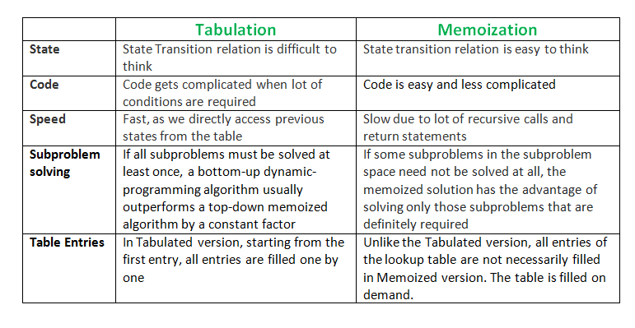
Longest Common Subsequence
LCS Problem Statement: Given two sequences, find the length of longest subsequence present in both of them. A subsequence is a sequence that appears in the same relative order, but not necessarily contiguous. For example, "abc", "abg", "bdf", "aeg", '"acefg", .. etc are subsequences of "abcdefg".
In order to find out the complexity of brute force approach, we need to first know the number of possible different subsequences of a string with length n, i.e., find the number of subsequences with lengths ranging from 1,2,..n-1. Recall from theory of permutation and combination that number of combinations with 1 element are ^{n}C₁. Number of combinations with 2 elements are ^{n}C₂ and so forth and so on. We know that ^{n}C₀ + ^{n}C₁ + ^{n}C₂ + ... ^{n}C_{n} = 2^{n}. So a string of length n has 2^{n}-1 different possible subsequences since we do not consider the subsequence with length 0. This implies that the time complexity of the brute force approach will be O(n * 2^{n}). Note that it takes O(n) time to check if a subsequence is common to both the strings. This time complexity can be improved using dynamic programming.
It is a classic computer science problem, the basis of diff (a file comparison program that outputs the differences between two files), and has applications in bioinformatics.
Examples:
LCS for input Sequences "ABCDGH" and "AEDFHR" is "ADH" of length 3.
LCS for input Sequences "AGGTAB" and "GXTXAYB" is "GTAB" of length 4.
The naive solution for this problem is to generate all subsequences of both given sequences and find the longest matching subsequence. This solution is exponential in term of time complexity. Let us see how this problem possesses both important properties of a Dynamic Programming (DP) Problem.
Naïve Solutions:
public class _03LongestCommonSubsequence_Naive {
public static int lcs(String s1, String s2,int m, int n){
if (m == 0 || n == 0){
return 0;
}
if (s1.charAt(m-1) == s2.charAt(n-1)){
return 1 + lcs(s1,s2,m-1,n-1);
}
return Math.max(lcs(s1,s2,m,n-1),lcs(s1,s2,m-1,n));
}
public static void main(String[] args) {
String s1 = "ABCD";
String s2 = "ADCFH";
int result = lcs(s1,s2,s1.length(),s2.length());
System.out.println("Result : "+result);
}
}
Using Dynamic Programming - Top Down (Memoization)
public class _03LongestCommonSubsequence_TopDown {
public static void main(String[] args) {
String s1 = "ABCD";
String s2 = "ADCFH";
int m = s1.length();
int n = s2.length();
int[][] memory = new int[m + 1][n + 1];
for (int[] row : memory) {
Arrays.fill(row, -1);
}
int result = lcs(s1, s2, m, n, memory);
System.out.println("Result : " + result);
}
public static int lcs(String s1, String s2,
int m, int n,
int[][] memory) {
if (m == 0 || n == 0) {
return 0;
}
if (memory[m][n] != -1) {
return memory[m][n];
}
if (s1.charAt(m - 1) == s2.charAt(n - 1)) {
memory[m][n] =
1 + lcs(s1, s2, m - 1, n - 1, memory);
} else {
memory[m][n] =
Math.max(
lcs(s1, s2, m, n - 1, memory),
lcs(s1, s2, m - 1, n, memory)
);
}
return memory[m][n];
}
}
Time : O(m × n)
Space : O(m × n)

LONGEST COMMON SUBSEQUENCE (LCS) - BOTTOM UP DP (TABULATION)
public class _04LongestCommonSubsequence_BottomUp {
public static void main(String[] args) {
String s1 = "ABCD";
String s2 = "ADCFH";
int result = lcs(s1,s2);
System.out.println("Result : "+result);
}
public static int lcs(String s1, String s2 ){
int m = s1.length();
int n = s2.length();
int[][] table = new int[m + 1][n + 1];
for (int i =0 ; i <=m ; i ++){
table[i][0] = 0;
}
for (int j =0 ; j <=n ; j++){
table[0][j] = 0;
}
for (int i = 1 ; i <=m ; i++){
for (int j = 1; j <=n ; j++){
if (s1.charAt(i-1) == s2.charAt(j-1)){
table[i][j] = 1 + table[i-1][j-1];
}else {
table[i][j] = Math.max(
table[i][j-1],
table[i-1][j]
);
}
}
}
return table[m][n];
}
}
Variations of Longest Common Subsequence (LCS) - Interview Notes
LCS Master Formula
If characters match: dp[i][j] = 1 + dp[i-1][j-1]; otherwise dp[i][j] = max(dp[i-1][j], dp[i][j-1]).
- Diff Utility
Uses LCS to identify unchanged characters between two strings/files. Characters not in the LCS are insertions or deletions. Used by Git and file comparison tools.
Interview Tip: Understand the reduction of this problem to standard LCS and memorize the relevant formula.
- Minimum Insertions and Deletions
For strings of lengths m and n with LCS length L:
Deletions = m-L and Insertions = n-L
Interview Tip: Understand the reduction of this problem to standard LCS and memorize the relevant formula.
- Shortest Common Supersequence (SCS)
Shortest string containing both strings as subsequences.
Length(SCS)=m+n-LCS
Interview Tip: Understand the reduction of this problem to standard LCS and memorize the relevant formula.
- Longest Palindromic Subsequence (LPS)
Find LCS between the string and its reverse.
LPS = LCS(s, reverse(s)).
Complexity O(n^2).
Interview Tip: Understand the reduction of this problem to standard LCS and memorize the relevant formula.
- Longest Repeating Subsequence (LRS)
Run LCS on the same string with the condition i != j.
Finds a subsequence occurring more than once.
Interview Tip: Understand the reduction of this problem to standard LCS and memorize the relevant formula.

- Space Optimized LCS
Only previous and current DP rows are required. Time O(m*n), Space O(n).
Interview Tip: Understand the reduction of this problem to standard LCS and memorize the relevant formula.
- Printing LCS
Build the DP table and backtrack from dp[m][n]. Move diagonally on matches and move toward the larger neighbor otherwise.
Interview Tip: Understand the reduction of this problem to standard LCS and memorize the relevant formula.
Coin Change
Given a value sum, if we want to make change for sum cents, and we have an infinite supply of each of coins[] = { coins1, coins2, .. , coins_{n}} valued coins, how many ways can we make the change? The order of coins doesn't matter.
Examples:
Input: sum = 4, coins[] = {1,2,3},
Output: 4
Explanation: there are four solutions: {1, 1, 1, 1}, {1, 1, 2}, {2, 2}, {1, 3}.
Input: sum = 10, coins[] = {2, 5, 3, 6}
Output: 5
Explanation: There are five solutions:
{2,2,2,2,2}, {2,2,3,3}, {2,2,6}, {2,3,5} and {5,5}.
1) Optimal Substructure
To count the total number of solutions, we can divide all set solutions into two sets.
- Solutions that do not contain n^{th} coin (or S[n-1]).
- Solutions that contain at least one S[n-1].
Let count(coins[], n, sum) be the function to count the number of solutions, then it can be written as sum of count(coins[], n-1, sum) and count(coins[], n, sum-coins[n-1]).
Therefore, the problem has optimal substructure property as the problem can be solved using solutions to subproblems.
2) Overlapping Subproblems
Following is a simple recursive implementation of the Coin Change problem. The implementation simply follows the recursive structure mentioned above.
3) Approach (Algorithm)
See, here each coin of a given denomination can come an infinite number of times. (Repetition allowed), this is what we call UNBOUNDED KNAPSACK. We have 2 choices for a coin of a particular denomination, either i) to include, or ii) to exclude. But here, the inclusion process is not for just once; we can include any denomination any number of times until sum<0.
Basically, If we are at coins[n-1], we can take as many instances of that coin ( unbounded inclusion ) i.e count(coins, n, sum - coins[n-1] ); then we move to coins[n-2]. After moving to coins[n-2], we can't move back and can't make choices for coins[n-1] i.e count(coins, n-1, sum ).
Finally, as we have to find the total number of ways, so we will add these 2 possible choices, i.e count(coins, n, sum - coins[n-1] ) + count(coins, n-1, sum ); which will be our required answer.
public class _05CoinChange_Naive {
public static int countWays(int[] coins, int n, int sum){
if (sum == 0){
return 1;
} else if (sum < 0) {
return 0;
} else if (n == 0) {
return 0;
}
return countWays(coins,n,sum-coins[n-1])
+ countWays(coins,n-1,sum);
}
public static void main(String[] args) {
int coins[] = { 1, 2, 3 };
int n = coins.length;
System.out.println(countWays(coins, n, 4));
}
}
Time Complexity: O(2^{sum})
Space Complexity: O(target) - Auxiliary stack space
It should be noted that the above function computes the same subproblems again and again. See the following recursion tree for coins[] = {1, 2, 3} and n = 5.
The function C({1}, 3) is called two times. If we draw the complete tree, then we can see that there are many subproblems being called more than once.
C() --> count()
C({1,2,3}, 5)
/ \
/ \
C({1,2,3}, 2) C({1,2}, 5)
/ \ / \
/ \ / \
C({1,2,3}, -1) C({1,2}, 2) C({1,2}, 3) C({1}, 5)
/ \ / \ / \
/ \ / \ / \
C({1,2},0) C({1},2) C({1,2},1) C({1},3) C({1}, 4) C({}, 5)
/ \ / \ /\ / \
/ \ / \ / \ / \
. . . . . . C({1}, 3) C({}, 4)
/ \
/ \
. .
Since same subproblems are called again, this problem has Overlapping Subproblems property. So the Coin Change problem has both properties (see this and this) of a dynamic programming problem. Like other typical Dynamic Programming(DP) problems, recomputations of same subproblems can be avoided by constructing a temporary array table[][] in bottom up manner.
Dynamic Programming Solution
public class _06CoinChange_DP {
public static int coinChange(int[] coins, int sun, int n){
int[] table = new int[sun+1];
table[0] = 1;
for (int i = 0 ; i < n ; i++){
for (int j = coins[i] ; j <= sun ; j++ ){
if (j - coins[i] >= 0){
table[j] += table[j-coins[i]];
}
}
}
return table[sun];
}
public static void main(String[] args) {
int coins[] = { 1, 2, 3 };
int n = coins.length;
int sum = 4;
System.out.println(coinChange(coins, sum, n));
}
}
Time Complexity: O (n * sum)
Following is a simplified version of method 2. The auxiliary space required here is O(sum) only.
Following is another Top Down DP Approach using memoization:
public class CoinChangeMemoization {
static int coinChange(int[] coins, int targetSum,
int numberOfCoins, int[][] memo) {
if (targetSum == 0) {
return memo[numberOfCoins][targetSum] = 1;
}
if (numberOfCoins == 0) {
return 0;
}
if (memo[numberOfCoins][targetSum] != -1) {
return memo[numberOfCoins][targetSum];
}
if (coins[numberOfCoins - 1] <= targetSum) {
// Include current coin or exclude it
return memo[numberOfCoins][targetSum] =
coinChange(coins,
targetSum - coins[numberOfCoins - 1],
numberOfCoins,
memo)
+
coinChange(coins,
targetSum,
numberOfCoins - 1,
memo);
}
// Exclude current coin
return memo[numberOfCoins][targetSum] =
coinChange(coins,
targetSum,
numberOfCoins - 1,
memo);
}
public static void main(String[] args) {
int[] coins = {1, 2, 3};
int targetSum = 4;
int numberOfCoins = coins.length;
int[][] memo = new int[numberOfCoins + 1][targetSum + 1];
for (int[] row : memo) {
Arrays.fill(row, -1);
}
int result = coinChange(
coins,
targetSum,
numberOfCoins,
memo);
System.out.println(result);
}
}
Time Complexity: O(M*sum)
Auxiliary Space: O(M*sum)
Edit Distance Problem
Given two strings str1 and str2 and below operations that can be performed on str1. Find minimum number of edits (operations) required to convert 'str1' into 'str2'.
- Insert
- Remove
- Replace
All of the above operations are of equal cost.
Examples:
Input: str1 = "geek", str2 = "gesek"
Output: 1
We can convert str1 into str2 by inserting a 's'.
Input: str1 = "cat", str2 = "cut"
Output: 1
We can convert str1 into str2 by replacing 'a' with 'u'.
Input: str1 = "sunday", str2 = "saturday"
Output: 3
Last three and first characters are same. We basically
need to convert "un" to "atur". This can be done using
below three operations.
Replace 'n' with 'r', insert t, insert a
What are the subproblems in this case?
The idea is to process all characters one by one starting from either from left or right sides of both strings.
Let us traverse from right corner, there are two possibilities for every pair of character being traversed.
m: Length of str1 (first string)
n: Length of str2 (second string)
- If last characters of two strings are same, nothing much to do. Ignore last characters and get count for remaining strings. So we recur for lengths m-1 and n-1.
- Else (If last characters are not same), we consider all operations on 'str1', consider all three operations on last character of first string, recursively compute minimum cost for all three operations and take minimum of three values.
  - Insert: Recur for m and n-1
  - Remove: Recur for m-1 and n
  - Replace: Recur for m-1 and n-1
Below is implementation of above Naive recursive solution.
public class _07EditDistance_Naive {
public static int editDistance(String s1, String s2, int m, int n){
if (m == 0){
return n;
}
if (n == 0 ){
return m;
}
if (s1.charAt(m-1) == s2.charAt(n-1)){
return editDistance(s1,s2,m-1,n-1);
}
return 1 + Math.min(
Math.min(
editDistance(s1,s2,m,n-1),
editDistance(s1,s2,m-1,n)
)
,
editDistance(s1,s2,m-1,n-1)
);
}
public static void main(String[] args) {
String str1 = "sunday";
String str2 = "saturday";
System.out.println(editDistance(
str1, str2, str1.length(), str2.length()));
}
}
The time complexity of above solution is exponential. In worst case, we may end up doing O(3^{m}) operations. The worst case happens when none of characters of two strings match. Below is a recursive call diagram for worst case.

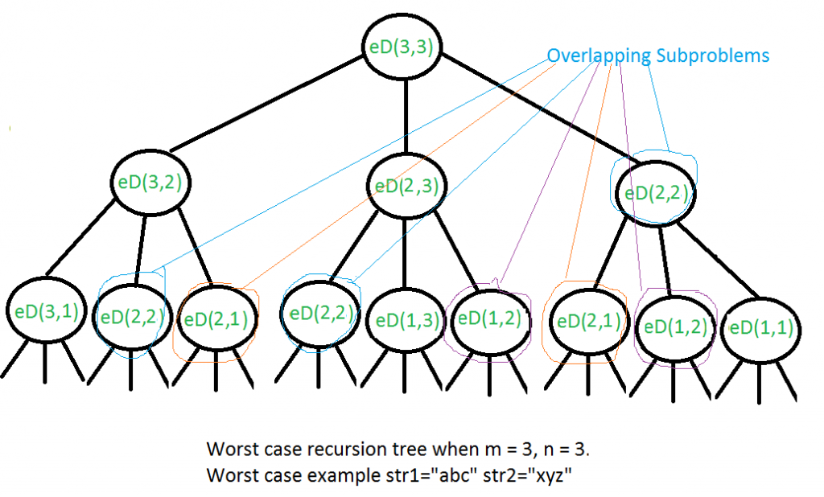
We can see that many subproblems are solved, repeatedly, for example, eD(2, 2) is called three times. Since same subproblems are called again, this problem has Overlapping Subproblems property. So, Edit Distance problem has both properties (see this and this) of a dynamic programming problem. Like other typical Dynamic Programming (DP) problems, precomputations of same subproblems can be avoided by constructing a temporary array that stores results of subproblems.
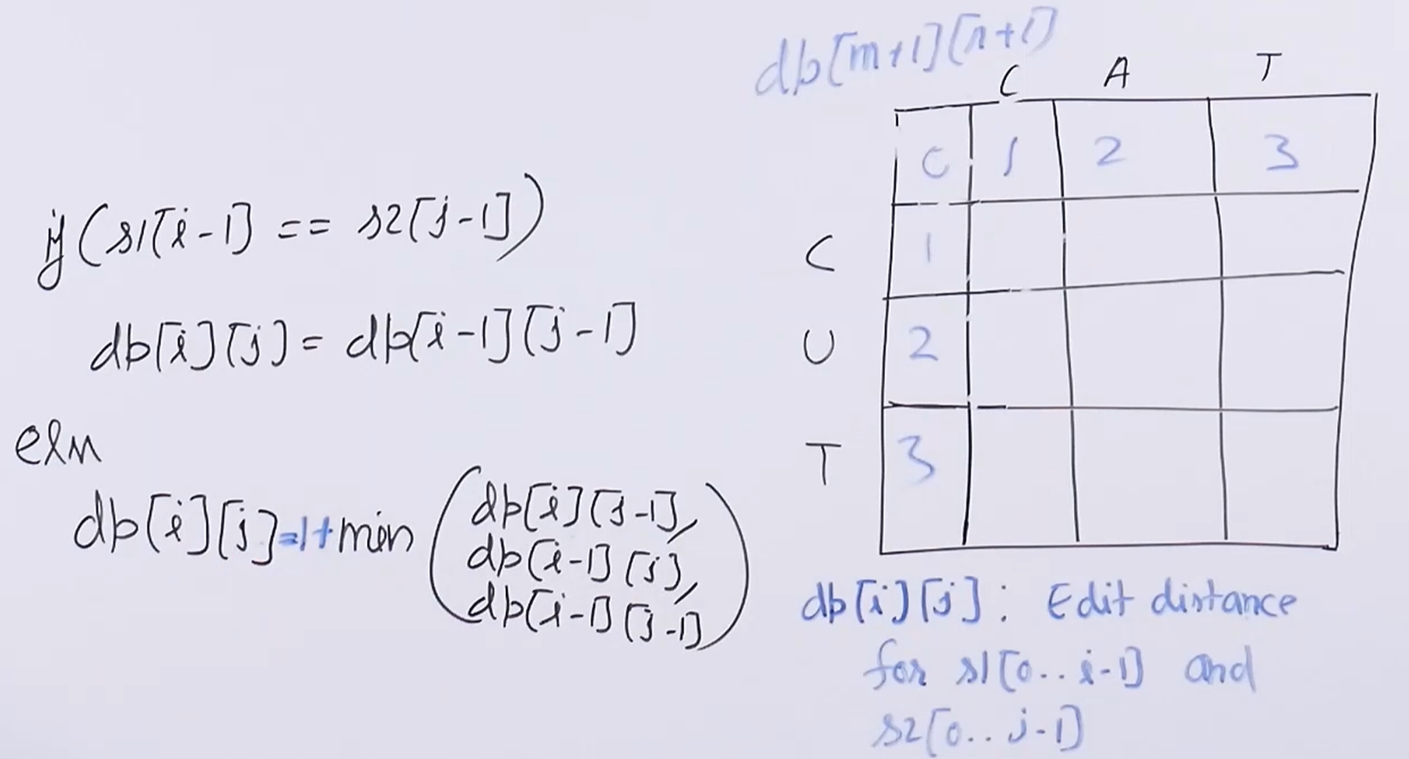
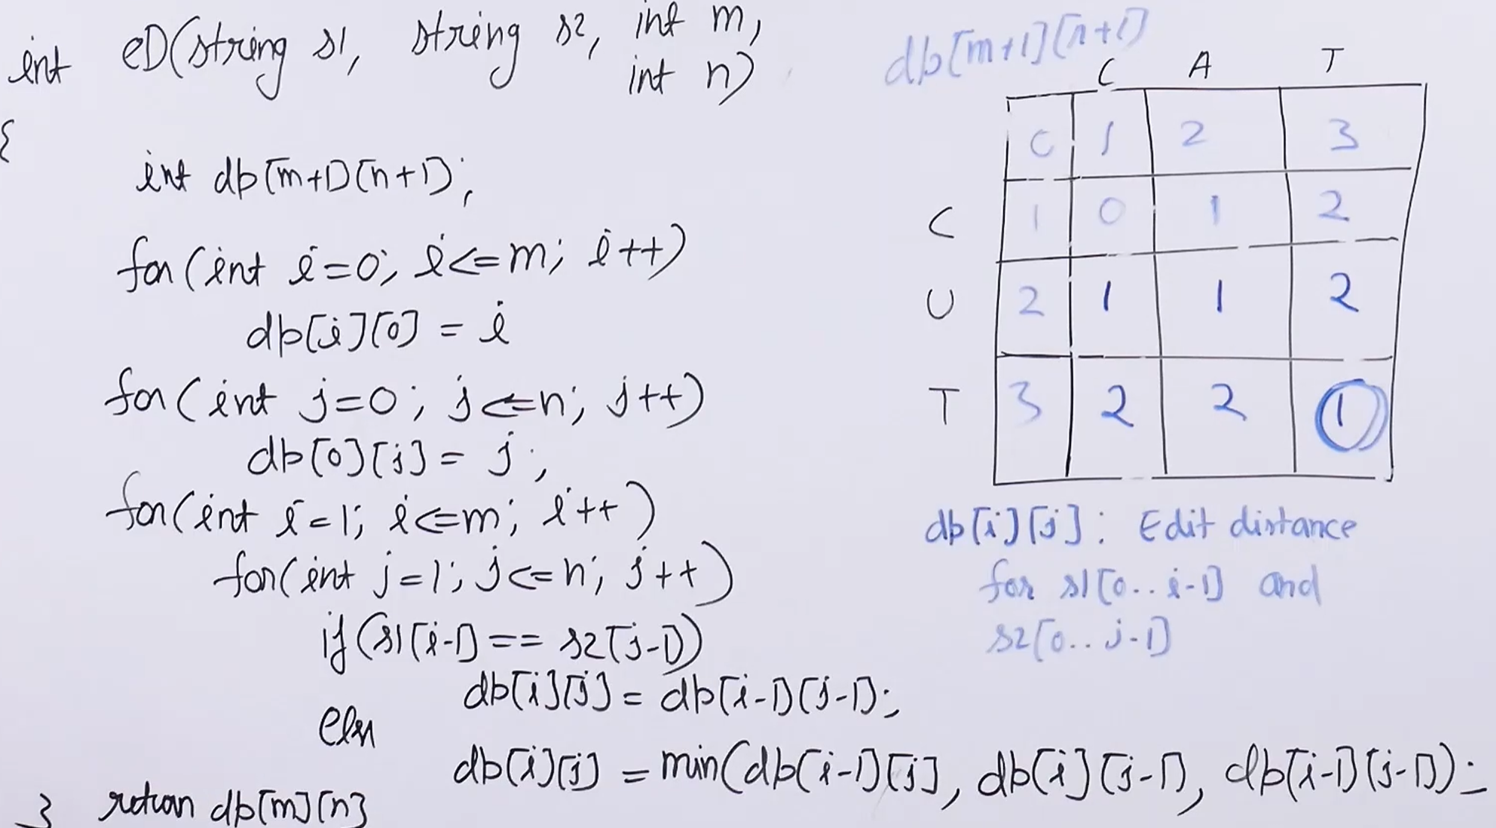
Note: In else part add 1 + min ();
public class _08EditDistance_DP {
public static int editDist(String s1, String s2, int m, int n){
int[][] dp = new int[m+1][n+1];
for (int i = 0 ; i <=m ; i ++){
dp[i][0] = i;
}
for (int j = 0 ; j <=n ; j++){
dp[0][j]=j;
}
for (int i = 1 ; i <=m ;i++){
for (int j =1 ; j <=n ; j++){
if (s1.charAt(i-1) == s2.charAt(j-1)){
dp[i][j] = dp[i-1][j-1];
}else {
dp[i][j] = 1 + Math.min(
Math.min(
dp[i][j-1],
dp[i-1][j]
)
,
dp[i-1][j-1]
);
}
}
}
return dp[m][n];
}
public static void main(String[] args) {
String str1 = "sunday";
String str2 = "saturday";
System.out.println(editDist(
str1, str2, str1.length(), str2.length()));
}
}
Time Complexity: O(m x n)
Auxiliary Space: O( m *n)+O(m+n)
(m*n) extra array space and (m+n) recursive stack space.
Applications: There are many practical applications of edit distance algorithm, refer Lucene API for sample. Another example, display all the words in a dictionary that are near proximity to a given word incorrectly spelled word.
Longest Increasing Subsequence
The Longest Increasing Subsequence (LIS) problem is to find the length of the longest subsequence of a given sequence such that all elements of the subsequence are sorted in increasing order. For example, the length of LIS for {10, 22, 9, 33, 21, 50, 41, 60, 80} is 6 and LIS is {10, 22, 33, 50, 60, 80}.
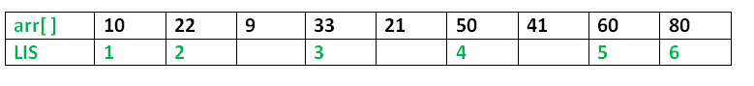
Examples:
Input: arr[] = {3, 10, 2, 1, 20}
Output: Length of LIS = 3
The longest increasing subsequence is 3, 10, 20

Input: arr[] = {3, 2}
Output: Length of LIS = 1
The longest increasing subsequences are {3} and {2}

Input: arr[] = {50, 3, 10, 7, 40, 80}
Output: Length of LIS = 4
The longest increasing subsequence is {3, 7, 40, 80}
Dynamic Programming solution for Longest Increasing Subsequence
public class _09LongestIncreasingSubsequence_DP {
public static int lis(int[] arr){
int n = arr.length;
int[] lis = new int[n];
Arrays.fill(lis,1);
for (int i =1 ; i < n ; i++){
for (int j = 0 ; j < i ; j++){
if (arr[j] < arr[i] ){
lis[i] = Math.max(lis[i],lis[j]+1);
}
}
}
int result = Integer.MIN_VALUE;
for (int i : lis){
result = Math.max(i,result);
}
return result;
}
public static void main(String[] args) {
int arr[] = { 10, 22, 9, 33, 21, 50, 41, 60 };
System.out.println("Length of lis is " + lis(arr));
}
}
Complexity Analysis:
Time Complexity: O(n²)
Space Complexity: O(n)

