AT&T API Platform Adapters for IBM® Worklight®

Installation and Setup Guide

Publication Date: May, 2014

This document and the information contained herein (collectively, the "**Information**") is provided to you (both the individual receiving this document and any legal entity on behalf of which such individual is acting) ("**You**" and "**Your**") by AT&T, on behalf of itself and its affiliates ("**AT&T**") for informational purposes only. AT&T is providing the Information to You because AT&T believes the Information may be useful to You. The Information is provided to You solely on the basis that You will be responsible for making Your own assessments of the Information and are advised to verify all representations, statements and information before using or relying upon any of the Information. Although AT&T has exercised reasonable care in providing the Information to You, AT&T does not warrant the accuracy of the Information and is not responsible for any damages arising from Your use of or reliance upon the Information. You further understand and agree that AT&T in no way represents, and You in no way rely on a belief, that AT&T is providing the Information in accordance with any standard or service (routine, customary or otherwise) related to the consulting, services, hardware or software industries.

AT&T DOES NOT WARRANT THAT THE INFORMATION IS ERROR-FREE. AT&T IS PROVIDING THE INFORMATION TO YOU "AS IS" AND "WITH ALL FAULTS." AT&T DOES NOT WARRANT, BY VIRTUE OF THIS DOCUMENT, OR BY ANY COURSE OF PERFORMANCE, COURSE OF DEALING, USAGE OF TRADE OR ANY COLLATERAL DOCUMENT HEREUNDER OR OTHERWISE, AND HEREBY EXPRESSLY DISCLAIMS, ANY REPRESENTATION OR WARRANTY OF ANY KIND WITH RESPECT TO THE INFORMATION, INCLUDING, WITHOUT LIMITATION, ANY REPRESENTATION OR WARRANTY OF DESIGN, PERFORMANCE, MERCHANTABILITY, FITNESS FOR A PARTICULAR PURPOSE OR NON-INFRINGEMENT, OR ANY REPRESENTATION OR WARRANTY THAT THE INFORMATION IS APPLICABLE TO OR INTEROPERABLE WITH ANY SYSTEM, DATA, HARDWARE OR SOFTWARE OF ANY KIND. AT&T DISCLAIMS AND IN NO EVENT SHALL BE LIABLE FOR ANY LOSSES OR DAMAGES OF ANY KIND, WHETHER DIRECT, INDIRECT, INCIDENTAL, CONSEQUENTIAL, PUNITIVE, SPECIAL OR EXEMPLARY, INCLUDING, WITHOUT LIMITATION, DAMAGES FOR LOSS OF BUSINESS PROFITS, BUSINESS INTERRUPTION, LOSS OF BUSINESS INFORMATION, LOSS OF GOODWILL, COVER, TORTIOUS CONDUCT OR OTHER PECUNIARY LOSS, ARISING OUT OF OR IN ANY WAY RELATED TO THE PROVISION, NON-PROVISION, USE OR NON-USE OF THE INFORMATION, EVEN IF AT&T HAS BEEN ADVISED OF THE POSSIBILITY OF SUCH LOSSES OR DAMAGES.

Contents

1 Introduction 1

2 Architectural Overview 2

3 Installing the Worklight Adapters Components 3

3.1 Installing the Tools 3

3.1.1 Importing Projects 4

3.1.2 Registering your Application 5

3.1.3 Configuring your Worklight Application 6

4 Building Worklight Adapters 7

5 Deploying Adapters to a Worklight Application 7

6 Receiving SMS Messages 9

7 Building and Deploying the Kitchen Sink Sample App 9

7.1 Running the Android App 11

7.2 Running the iOS App 11

8 Using the Adapters to Create a New Worklight Application 13

# 

Figure 1: AT&T Worklight Architecture 2

Figure 2: “Existing Projects and Workspace” location 4

Figure 3: Adapter Project and Application Project folder locations 5

Figure 4: Available adapters. 7

Figure 5: Building a Worklight Adapter 7

Figure 7: IBM Worklight Console **Error! Bookmark not defined.**

Figure 9: Selecting the ATTWLKitchenSink app. 10

Figure 10: Building and deploying applications. 10

Figure 11: Details of the deployed application. 11

Figure 12: Running the app on iOS 11

Table 1: Configuration properties for Worklight 6

Table 2: invocationData Object Properties 13

Table 3: Options Object Properties 14

Example 1: Creating an invocationData object 13

Example 2: Creating an Options object 13

# Introduction

The AT&T API Platform Adapter for IBM® Worklight® provides a simplified way for Worklight developers to access the AT&T API Platform and RESTful APIs. By significantly reducing the complexity of building applications that use the AT&T API Platform, the adapter helps developers quickly bring robust hybrid mobile applications to market.

The adapter facilitates access to the following AT&T Platform RESTful APIs:

• Advertising

• Device Capabilities

• In App Messaging

• OAuth 2.0 Authentication Management

• SMS

• Speech to Text

• Text to Speech

Note: To learn more about the AT&T API Platform, see the [AT&T Developer Program website](http://developer.att.com/developer/forward.jsp?passedItemId=100006).

# Architectural Overview

Figure 1 shows the relationship between the mobile device where the app is running, the Worklight server, and the AT&T API platform.

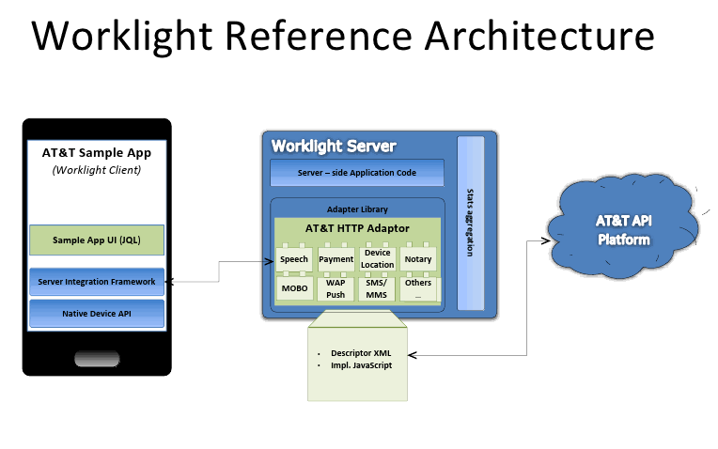

Figure : AT&T Worklight Architecture

# Installing the Worklight Adapters Components

You must complete the following steps to create and test applications (apps) using the adapters on your development system.

* Download Worklight Studio
* Download the AT&T API Platform Adapters for IBM® Worklight®
* Register you application with AT&T and get application keys
* Build and deploy the adapters
* Use the adapters and keys in your mobile app
* Deploy your app to the Worklight server

## Installing the Tools

Perform the following steps to install the required tools for creating an adapter app.

1. Download the AT&T Worklight project code from GitHub at:

<https://github.com/attdevsupport/ATT_APIPlatform_Worklight>

1. If you have not already installed Worklight Studio, follow the “Setting up your Environment” section on the “Getting Started” page from IBM at <http://www.ibm.com/developerworks/mobile/worklight/getting-started.html>

### Importing Projects

Perform the following steps to import the adapter and application projects into Eclipse

1. From Eclipse, click File, Import.
2. Expand the General folder, choose Existing Projects Into Workspace as shown in Figure 2.
3. Click Next.

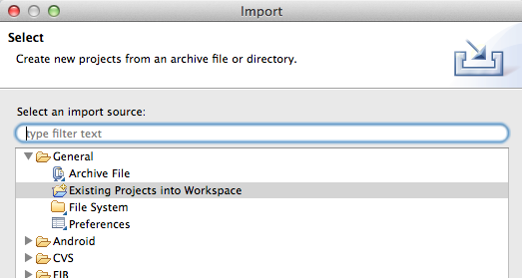

Figure : “Existing Projects and Workspace” location

1. Choose Select root directory, and click Browse.
2. Select the ATTWLAdapterProject folder, the ATTWLApplicationProject, ATT_WL_InAppMessaging, and the ATT_WL_Banking folder as shown in Figure 3.
3. Make sure the “Copy projects into workspace” is checked
4. Click Open.
5. Click Finish.

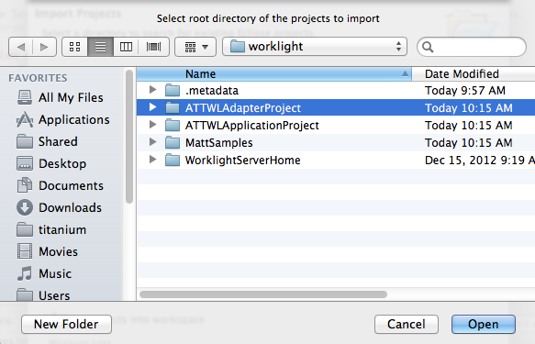

Figure : Adapter Project and Application Project folder locations

### Registering your Application

Before you can access the AT&T Platform services, you must register your application for the services that you want to access and to get an API key and secret key. These keys are necessary to call the underlying AT&T RESTful APIs that access the services.

Perform the following steps to register an application.

1. Create a new developer account on the [AT&T Developer website](https://developer.att.com), or login to an existing account.
2. Select My Apps from the bar at the top of the page
3. Click Setup a New Application.
4. Chose the APIs you want your application to support.

After your application is registered, you have an API key and Secret key. These keys are necessary to get your applications working with the AT&T Platform APIs.

### Configuring your Worklight Application

Perform the following steps to configure your Worklight application and an AT&T sample application:

1. In the application project, open server/conf/worklight.properties.
2. Add the property values from the following table. All values are case-sensitive and should be separated by commas.

| **Property** | **Value** | **Description** |
| --- | --- | --- |
| appKey | App Key | API key that you received when you registered your application. |
| secretKey | Secret Key | Secret key that you received when you registered your application. |
| scope | ADS  DC  IMMN  MIM  SMS  SPEECH  TTS | Reference to the ATT service that is invoked by your application, for example,   * Advertising is ADS * Device Capabilities is DC * In App Messaging is IMMN,MIM * SMS is SMS * Speech To Text is SPEECH * Text To Speech is TTS |

Table : Configuration properties for Worklight

# Building Worklight Adapters

Perform the following steps to build an AT&T Worklight adapter.

1. Expand the ATTWLAdapterProject in the Eclipse project explorer.
2. Expand the adapters folder to see the available adapters, as shown in the following figure.

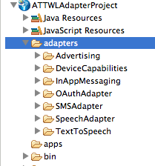

Figure : Available adapters.

1. Right click on an adapter folder and click Run As -> Deploy Worklight Adapter, as shown in the following figure. Repeat this for each adapter folder. This builds the .adapter file in the /bin folder.

These steps build the Worklight adapter and deploy it to the enclosing project. If your application is in a separate Worklight project, the adapters need to be redeployed using the console. This is described in the next section.

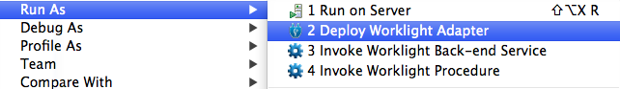

Figure : Building a Worklight Adapter

# Deploying Adapters to a Worklight Application

Perform the following steps to deploy adapters to the sample application or other application.

1. Within the IBM Worklight Developer Studio, right click on the application project folder and chose Open Worklight Console as in this figure:

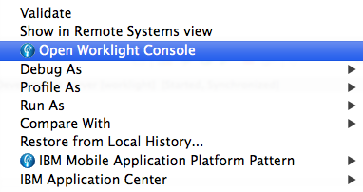

The IBM Worklight Console opens in a Catalog page that lets you work with Applications and Adapters, as shown in the following figure:

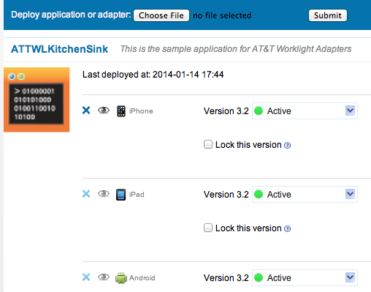

1. Click Choose File and select an adapter from the bin folder of the ATTWLAdapterProject:

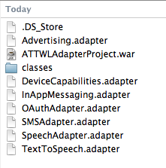

1. Click Submit.

Worklight displays a message that indicates whether the deployment action succeeded or failed. Repeat this procedure for each adapter.

The deployed adapter is added to the console. Refresh the page to see the details.

# Receiving SMS Messages

Optionally, perform the following steps to be able to receive SMS messages in the Kitchen Sink sample application.

1. Navigate to the /apps/ATTWLKitchenSink/common/js/sms.js file.
2. Specify your own short code in the shortCode variable that is declared at the top of the file.

# Building and Deploying the Kitchen Sink Sample App

Perform the following steps to build and deploy the sample application.

1. Open the ATTWLApplicationProject folder in Project Explorer.
2. Expand the apps folder.
3. Select ATTWLKitchenSink.

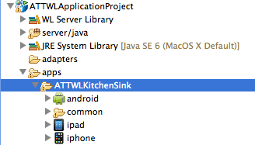

Figure : Selecting the ATTWLKitchenSink app.

1. Right click on ATTWLKitchenSink, click *Run As*, then *Build All Environments*. When that build completes, click *Run on Worklight Development Server* from the same menu, as shown in the following figure:

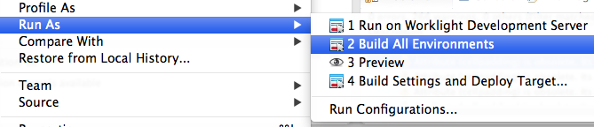

Figure : Building and deploying applications.

1. The details of the deployed application are added to the catalog and can be accessed at http://localhost:10080/ATTWLApplicationProject/console, as shown in the following figure.

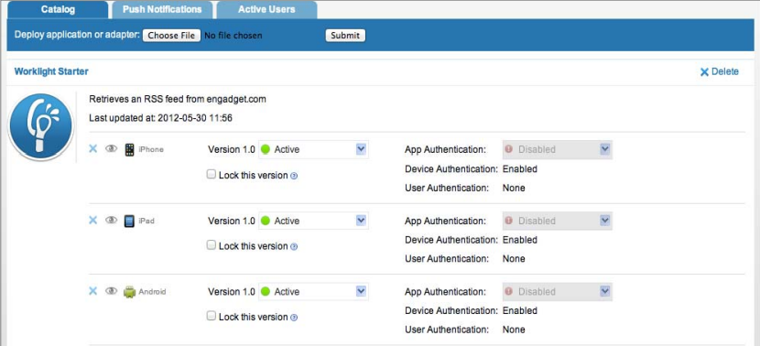

Figure : Details of the deployed application.

## Running the Android App

For the android environment, the following new android project is created automatically after *Build All Environments* is run.

For the kitchen sink sample application, the name of the project is:

ATTWLApplicationProjectATTWLKitchenSinkAndroid

This project can be executed as a normal android application by right clicking on it, selecting Run As, then Android Application:

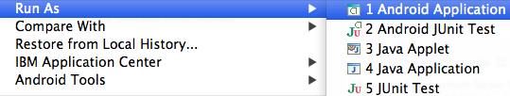

## Running the iOS App

For the iPhone or iPad environments, right click on the iphone or ipad folder, and select Run As -> Xcode project, as shown in the following figure. This opens Xcode, where the app can be executed.

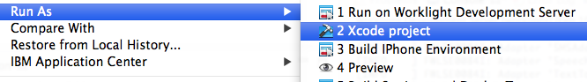

Figure : Running the app on iOS

# Using the Adapters to Create a New Worklight Application

To create a new Worklight application, see [Working with Worklight](http://www.ibm.com/developerworks/mobile/library/mo-aim1206-working-with-worklight-1/index.html).

1. In your application, invoke the ATT adapters from Java Script. Worklight applications can invoke adapter procedures to communicate with any data source without being subjected to same origin constraints.
2. Invoke an adapter procedure to create an invocationData object.

|  |  |  |
| --- | --- | --- |
| **invocationData Object Code Sample** | | |
| 1 | | | var invocationData = { |
| 2 | | | adapter : ‘SMSAdapter’, |
| 3 | | | procedure : ‘sendSMS’, |
| 4 | | | parameters : [{'body' : { “outboundSMSMessage”: {"Message" : |
| 5 | | | “Hello All”, "Address" : “555-555-1212”}}, |
| 6 | | | 'contentType' : 'application/json', 'accept' : 'application/json', |
| 7 | | | 'accessToken':'Bearer ' + window.localStorage.accessToken}] |
| 8 | | | }; |

Example : Creating an invocationData object

The invocationData object consists of the following JSON block of properties:

| **Property** | **Description** |
| --- | --- |
| adapter | A string that contains the name of the adapter as specified in the <wl:adapter> element of the adapter xml file. |
| procedure | Procedure name as defined in the adapter xml file. |
| parameters | An array of parameters passed on to the remote procedure. |

Table : invocationData Object Properties

1. Define the failure and success behavior in an options object.

|  |  |  |
| --- | --- | --- |
| **Options Object Code Sample** | | |
| 1 | | | var options = { |
| 2 | | | onSuccess : yourSuccessCallback, |
| 3 | | | onFailure : yourFailureCallback, |
| 4 | | | InvocationContext {} |
| 8 | | | }; |

Example : Creating an Options object

The options object consists of the following JSON block of properties:

| **Property** | **Description** |
| --- | --- |
| onSuccess | The function to be invoked on successful completion of the asynchronous call. |
| onFailure | The function to be invoked on failure. |
| invocationContext | Optional parameter. object that is returned to the success and failure handlers. |

Table : Options Object Properties

1. Invoke the procedure using the invocationData object and options object.

WL.Client.invoke.Procedure(invocationData, options)

To learn more about installing Worklight adapters, see the server side development instructions at:

<http://www.ibm.com/developerworks/mobile/worklight/getting-started.html#server-side-development>