**Bookstore App**

Technologies:

1. AngularJS
2. Bootstrap for styling

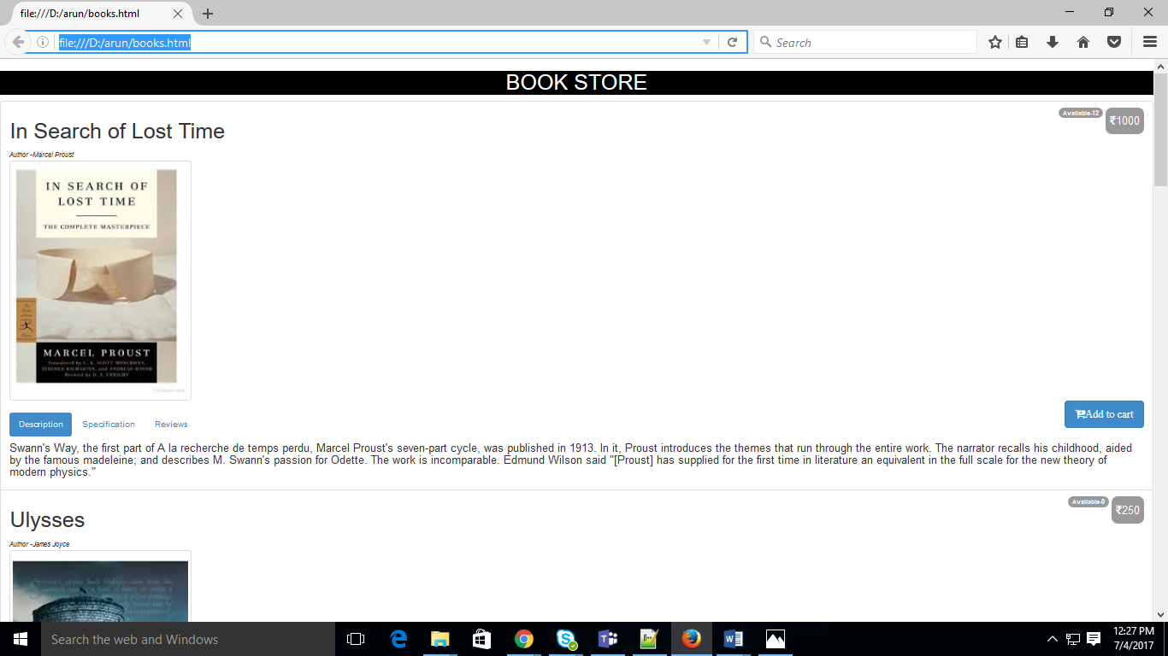

(Fig 1: Bookstore App’s client side component which looks like above)

**Details/Requirements:**

1. All book details are stored in the data store, which is an array [an array of objects]

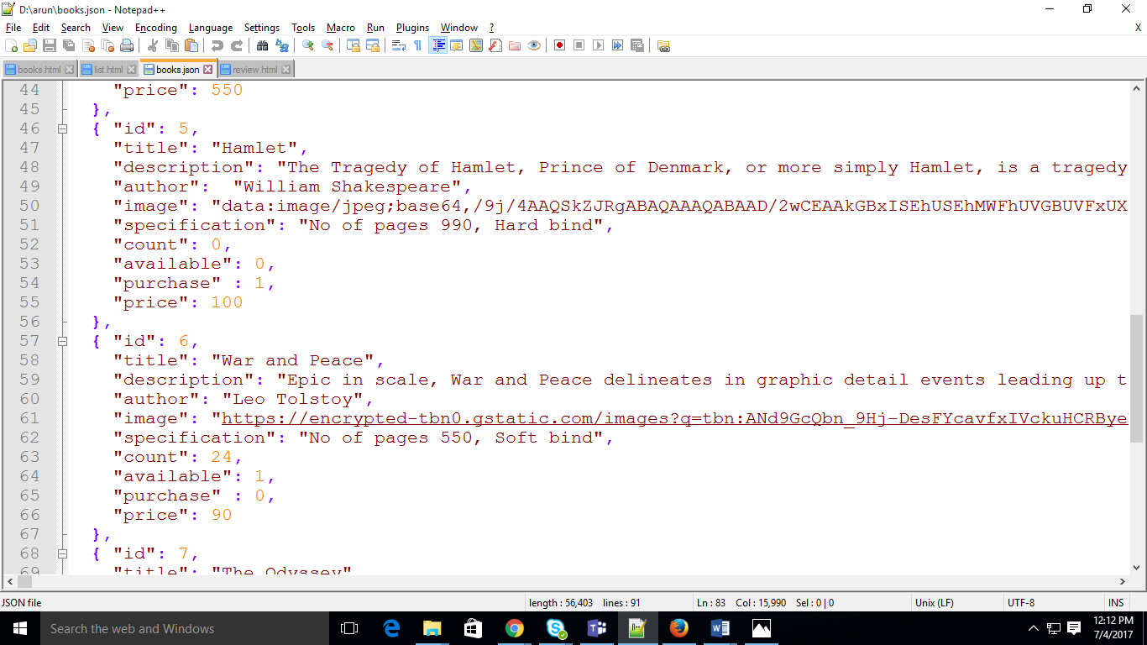

(Fig 2: Array structure-books.json)

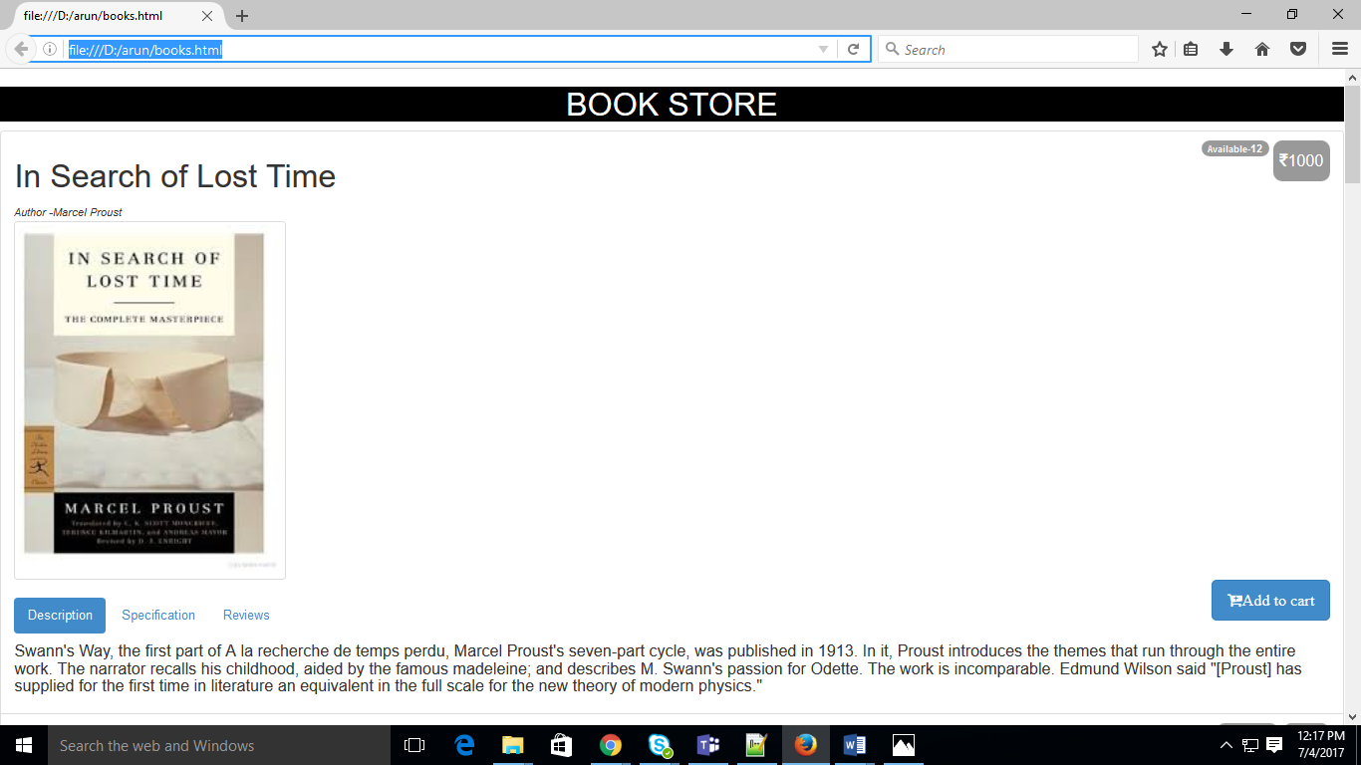

(Fig 3: Each book in a list)

1. The page shows list of books as above with details like Title, description, image of the book.

**Refer Fig 3**

1. Price of the book should be shown towards the right side. Currency should be Indian Rupee(INR)

**Refer Fig 3**

1. If the book is ‘sold out’, then the button “add to cart” should not be visible for that book (E.g.: For the **“hamlet”** book below, the “add to cart” button is not visible.

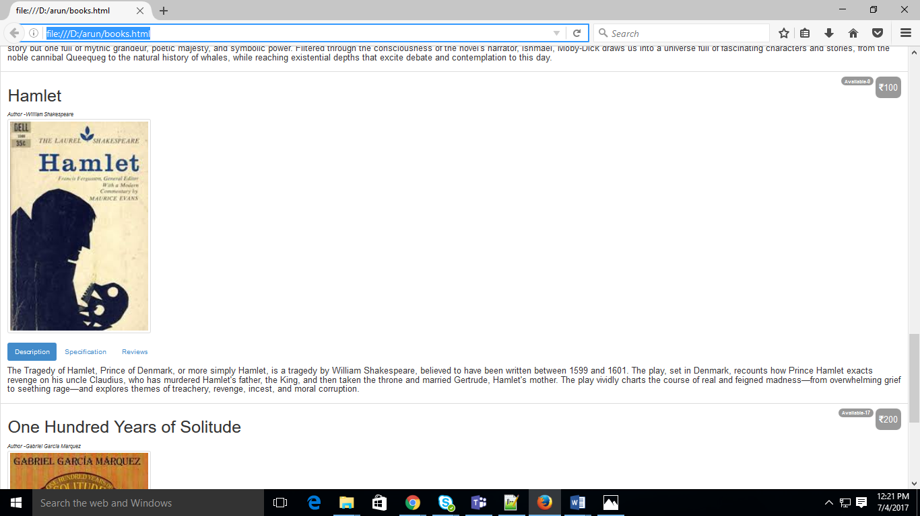

(Fig4: Add to Cart is not visible)

**In reference to fig 1, array is structured such a way that if available=0 then add to cart button will not be visible**

1. If the book ‘cannot be purchased’, then it should not get listed at all in this listing (E.g.: Data store has details of the book called **‘War and peace’** which is not listed here at all because it cannot be purchased).

**Refer fig 4 and fig 1, array is structured such a way that if purchase=0 then book will not be visible in list**

**Additional Requirements:**

1. Every book should also have the below tabs just aligned below the book image

* **Description tab**: have a short description about the book.

**Refer Fig 3**

* **Specifications tab**: contain the specifications about the book like hardbound/paperback, No. of pages etc.,

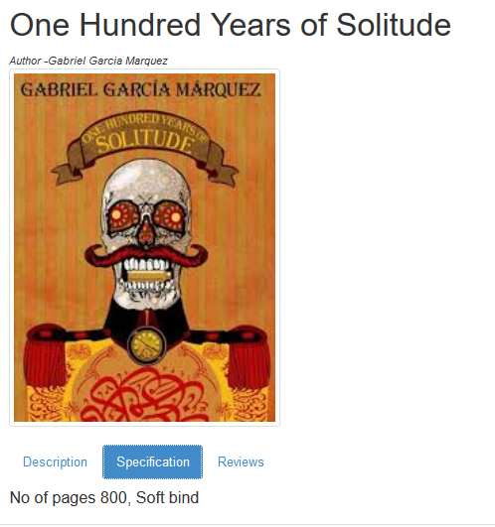

(Fig 5: Specification)

* **Reviews tab**: look like below:

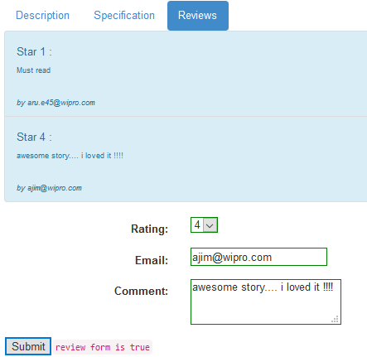(Fig 6: Review)

1. Reviews tab should already show reviews by other readers as above.---- **Refer fig 6**
2. Should also allow the current user to enter the review about the book like:
   1. Rate the Book: A drop down should show rating as 1 star, 2 star etc., till 5 stars.
   2. Short review of the book
   3. Email id

(All above details are mandatory. If the data entered into the fields are invalid, the text area or text box should be shown with a red border and (reviewForm status should be set as false) and only on successful validation, the review form should be set as true and further allowed to submit the form. Upon successful submission the review details should get appended to the already existing list of reviews for that book.

Sample states of the review form looks like below:

Success form:

**Refer fig 6**

Invalid form entry (note the red border and the reviewForm status shown as false

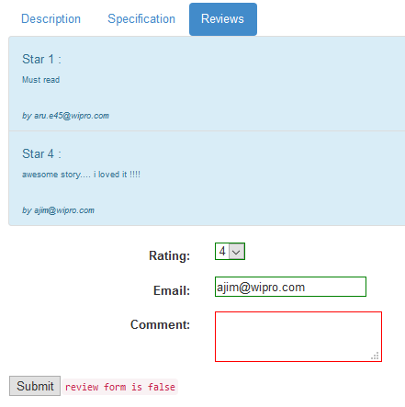

Successful entry should append the review details to the existing list of Reviews.

