UXP-AJS-L2-0001: CRUD application

**Case Study – CRUD Application**

Visual:

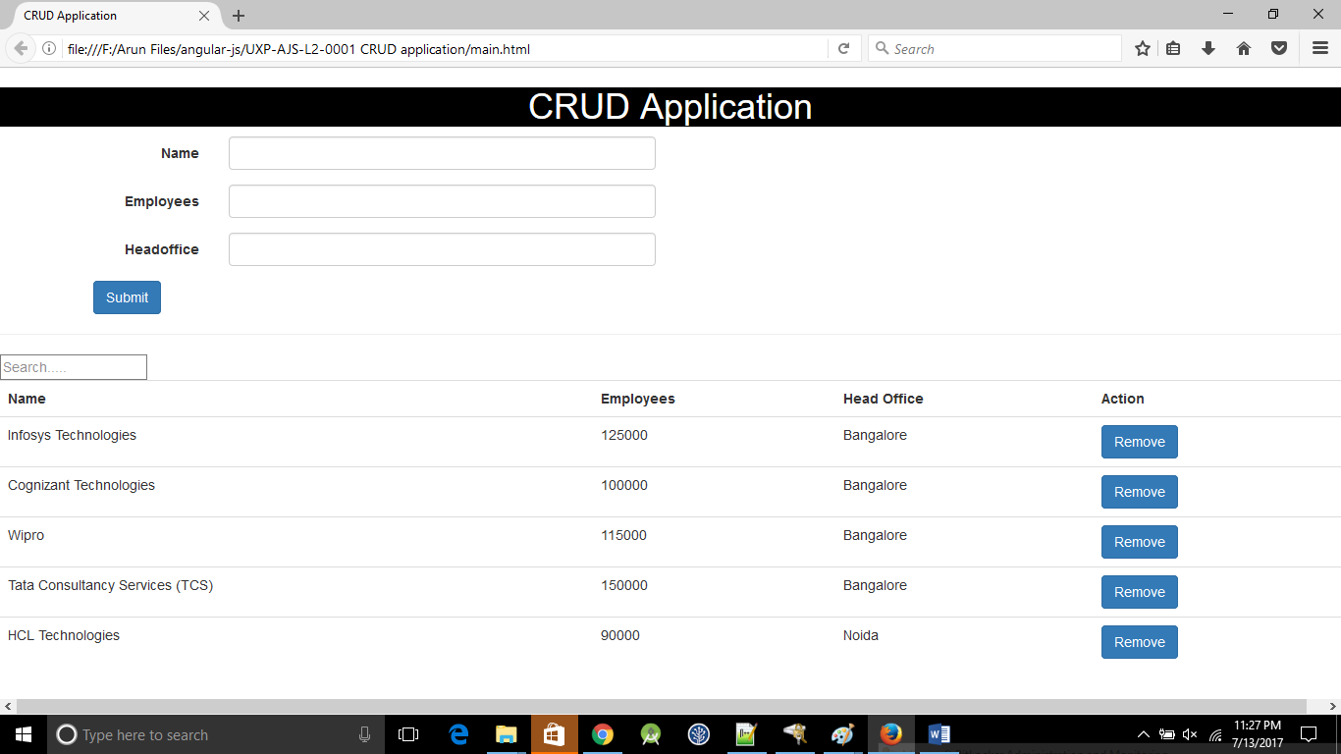

**Additional notes:**

* Create a table in HTML5.
* To bootstrap your angular application, declare **ng-app**.
* Construct your table the "angular" way, e.g. using the directive **ng-repeat** on **tr** tag.
* Add the directive **datatable** with the value ng on your table in order to make it rendered with DataTables.
* You can also fetch the data from a server using an Ajax call
* You can also fetch the data from a server using a function that returns a promise.
* Create a sample JSON data based on the attributes of the datatable.
* Create a form and on click of submit the user should be able to add the new record in the data table
* The user should be able to delete the record on selecting particular record in the datatable.
* The user should be able to perform search function in the datatable.

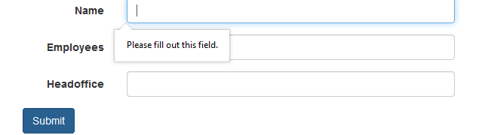

Figure Mandatory field validation

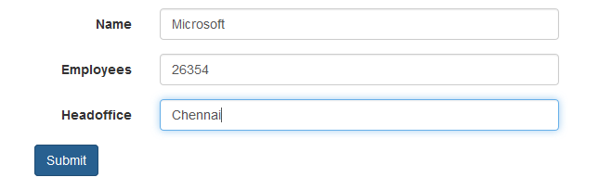

Figure Adding microsoft field to table

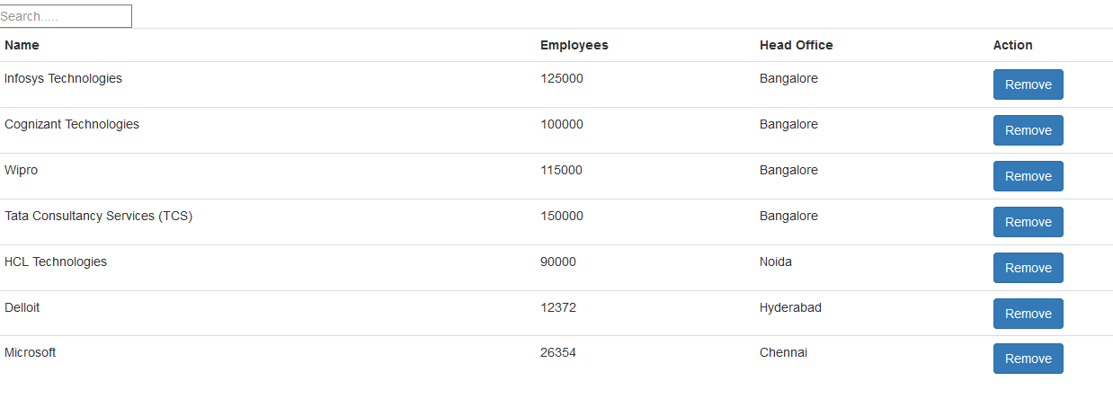

Figure Microsoft field added

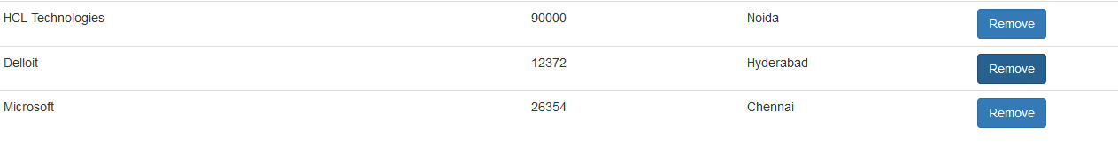

Figure Deleting delloite row

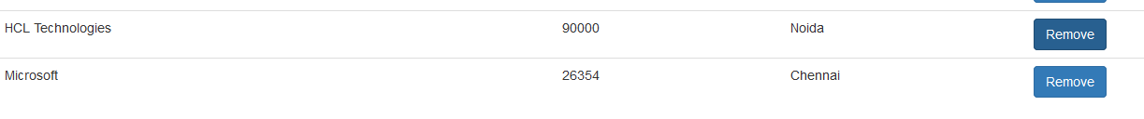

Figure delloite row deleted

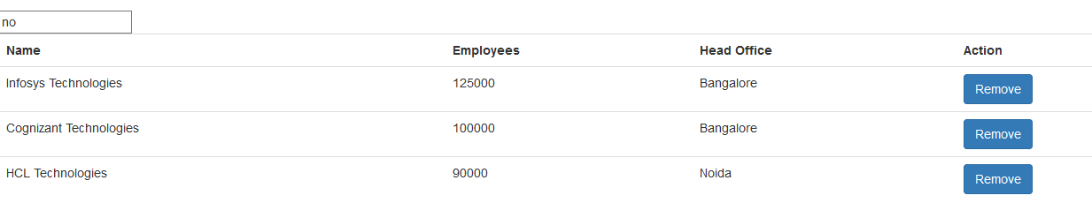

Figure Search= no

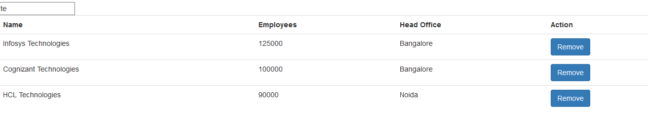

Figure Search=te