UXP-AJS-L1-0002: Instant Search

Level: L1

Technologies: Angular JS, HTML5, Css3, Bootstrap**.**

Case Study: To Create Instant Search for a page. Google style instant search and search suggest should be displayed. The data should be JSON data. The Search Function should work onKeypress also.

**Case Study – Instant Search**

Visual:

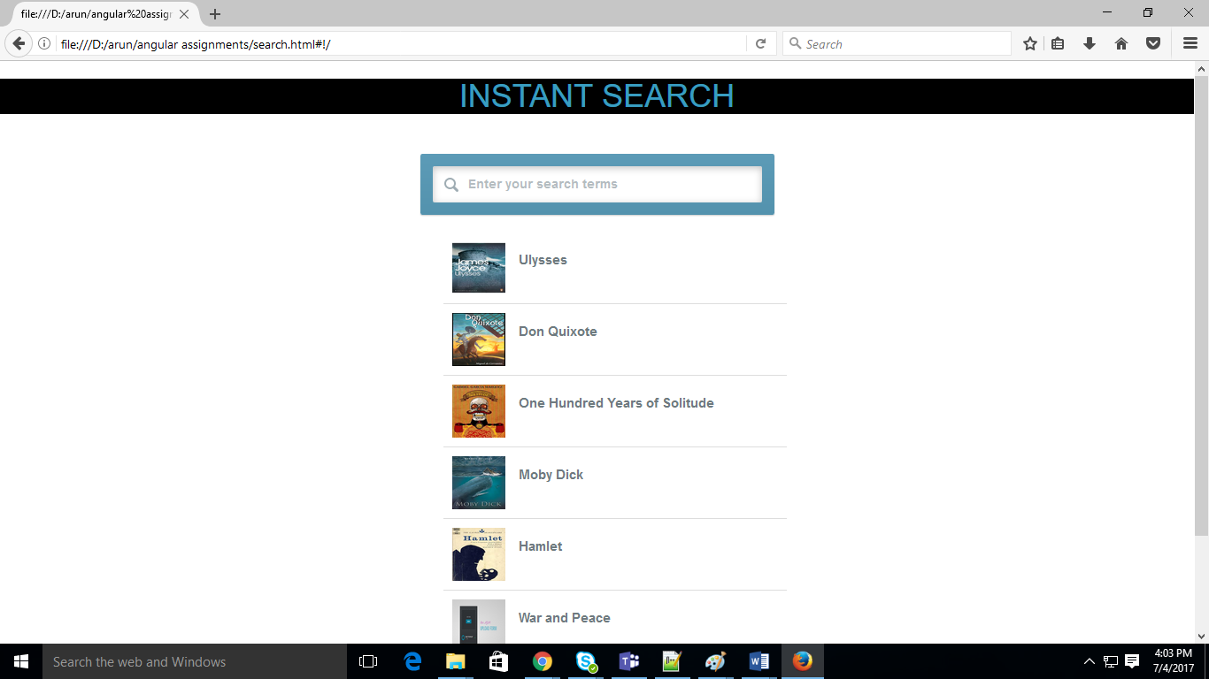

**Additional notes:**

* list is created in HTML5 ,bootstrap your angular application, declare **ng-app as “appSearch”**.
* ng-view directives to display the search suggested by user in list 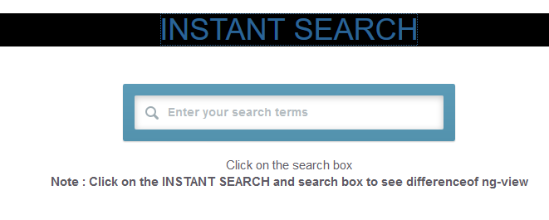
* Design a Search box which calls the search function by click of search and onKeypress.
* Search Suggests can be displayed using ng-repeat directive.

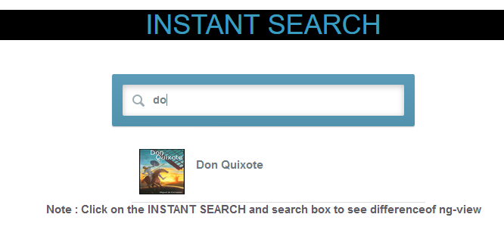

* Create a sample JSON data and fetch the Search Suggest.

