UXP-AJS-L1-0001: Table with Sort function

Level: L1

Technologies: Angular, HTML5, Css3, Bootstrap**.**

Case Study: To Create a simple Data table and load the JSON data. The Data table should be Sortable and the user should be able to filter the data in the table.

**Case Study – Table with Sort function**

Visual:

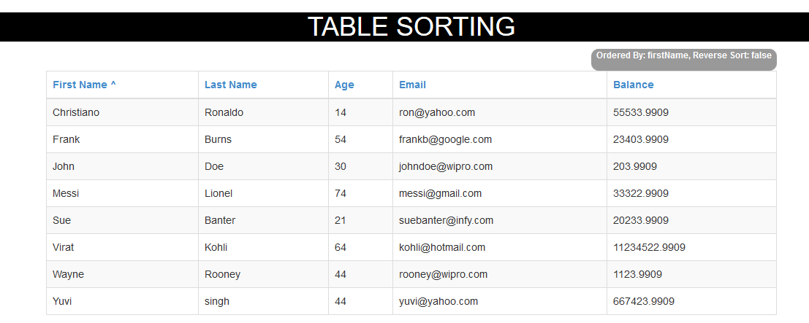

**Additional notes:**

* Table is created in HTML5, bootstrap, angular application, declare **ng-app** **as “appSort”**
* fetch the data from a server using an **Ajax call - $http**
* You can also fetch the data from a server using a function that returns a promise.
* Employee.JSON data is created based on the attributes of the datatable the data is displayed.
* Sorting and Filtering the records based on click of table heading

**Based on lastname**

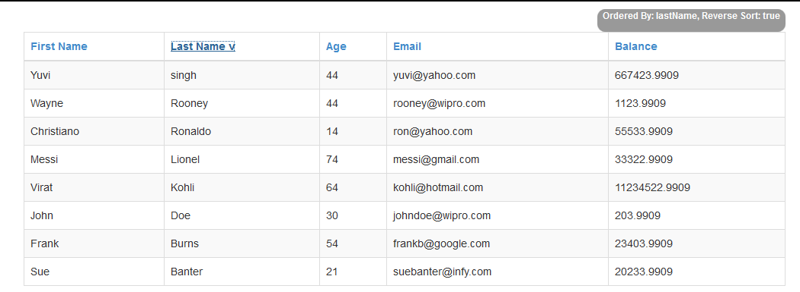

**Based on Age**

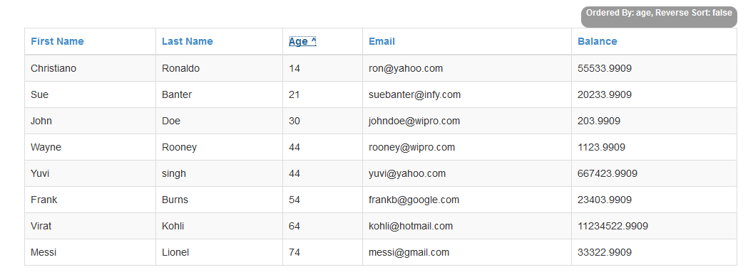

**Note: Similarly all columns can be sorted ..**