UXP-AJS-L2-0002: User Registration Form

**Case Study – User Registration Form**

Visual:

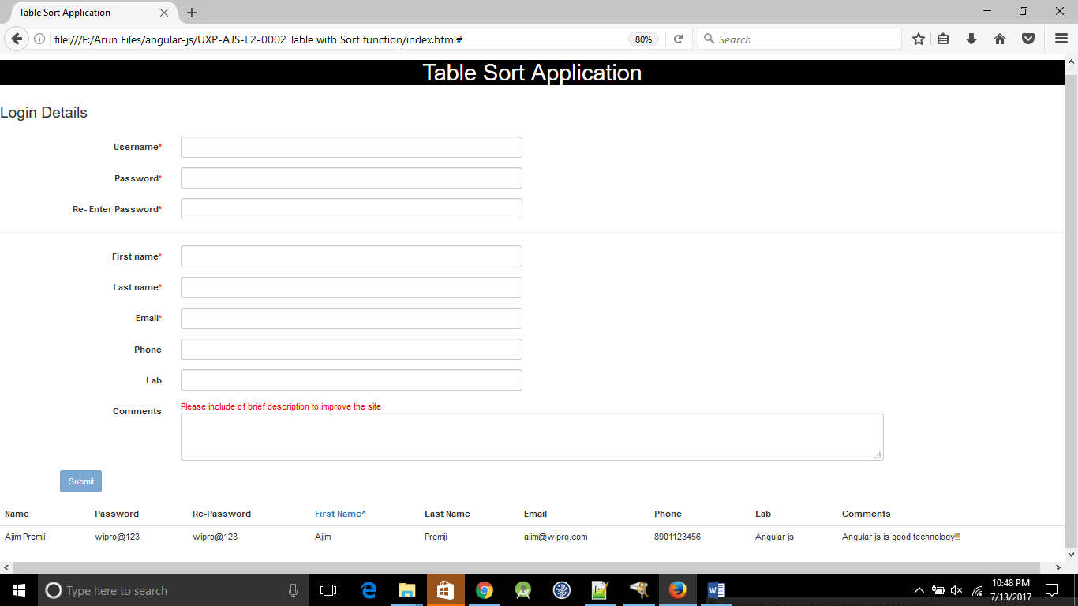

**Additional notes:**

* Created a table using HTML5, bootstrap, angular application, and declared **ng-app**.
* Created a Form with the fields as shown in the Picture above.
* Check for Validations on the mandatory fields, Angular Form Properties $valid, $invalid, $pristine, $dirty can be used to implement validations.



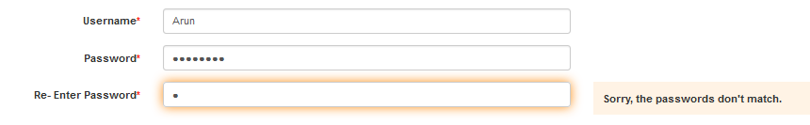

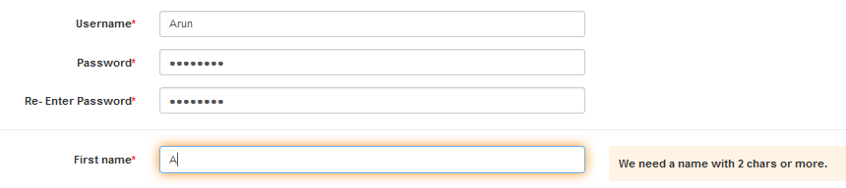

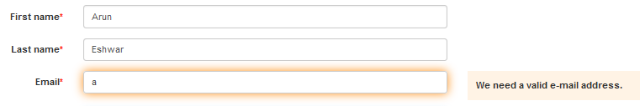



(Disabled button mandatory field are not filled)🡺(Enabled button for valid)

* Construct your table the "angular" way, e.g. using the directive **ng-repeat** on **tr** tag.
* Add the directive **datatable** with the value ng on your table in order to make it rendered with DataTables.
* Using Sort the table should be sortable by the user’s first name. (click on firstname to sort)

