French Baguette Quantity: 24 loaves
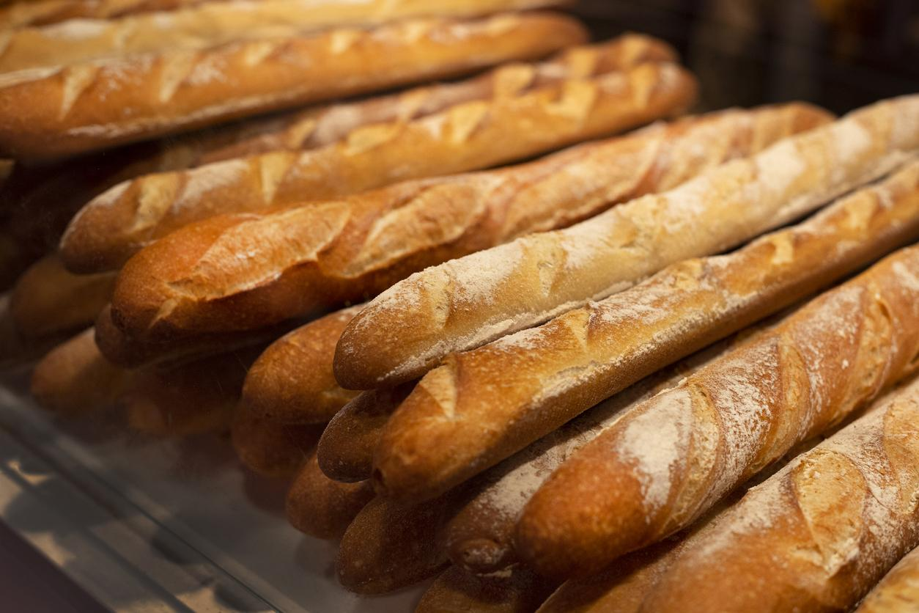

Ingredients
- 0.75 gallons water
- 8 pounds bread flour
- 5.25 ounces white sugar
- 2.4 ounces salt
- 1.56 ounces bread machine yeast
- 1 dozen egg yolks
- 2.3 ounces water

Directions

Step 1
Place 1 cup water, bread flour, sugar, salt and yeast into bread machine pan in the order recommended by manufacturer. Select Dough cycle, and press Start.

Step 2
When the cycle has completed, place dough in a greased bowl, turning to coat all sides. Cover, and let rise in a warm place for about 30 minutes, or until doubled in bulk. Dough is ready if indentation remains when touched.

Step 3
Punch down dough. On a lightly floured surface, roll into a 16x12 inch rectangle. Cut dough in half, creating two 8x12 inch rectangles. Roll up each half of dough tightly, beginning at 12 inch side, pounding out any air bubbles as you go. Roll gently back and forth to taper end. Place 3 inches apart on a greased cookie sheet. Make deep diagonal slashes across loaves every 2 inches, or make one lengthwise slash on each loaf. Cover, and let rise in a warm place for 30 to 40 minutes, or until doubled in bulk.

Step 4
Preheat oven to 375 degrees F (190 degrees C). Mix egg yolk with 1 tablespoon water; brush over tops of loaves.

Step 5
Bake for 20 to 25 minutes in the preheated oven, or until golden brown.

Content adapted from https://www.allrecipes.com/recipe

