**What is Java?**

Java is popular OBJ programming language, created in 1995.

It is owned by Oracle, and more than 3 billion devices run Java.

**It is used for:**

* Mobile applications (especially Android apps)
* Desktop applications
* Web applications
* Web servers and application servers
* Games
* Database connection
* And much, much more!

**Why Use Java?**

* Java works on different platforms (Windows, Mac, Linux, Raspberry Pi, etc.)
* It is one of the most popular programming languages in the world
* It has a large demand in the current job market
* It is easy to learn and simple to use
* It is open-source and free
* It is secure, fast and powerful
* It has huge community support (tens of millions of developers)
* Java is an object-oriented language which gives a clear structure to programs and allows code to be reused, lowering development costs

**Java Variables**

Variables are containers for storing data values.

In Java, there are different **types** of variables, for example:

* String - stores text, such as "Hello". String values are surrounded by double quotes
* int - stores integers (whole numbers), without decimals, such as 123 or -123
* float - stores floating point numbers, with decimals, such as 19.99 or -19.99
* char - stores single characters, such as 'a' or 'B'. Char values are surrounded by single quotes
* boolean - stores values with two states: true or false

**Data types are divided into two groups:**

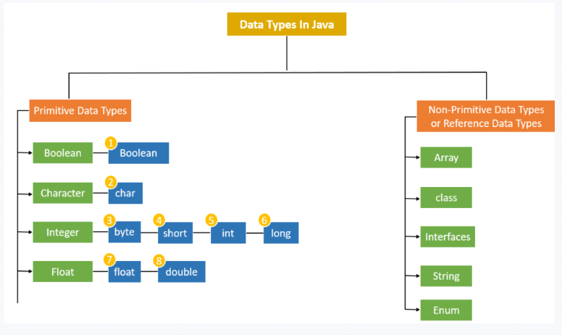

**https://www.geekster.in/articles/java-data-types/**

* **Primitive data types** –
* includes byte, short, int, long, float, double, Boolean and char
* Non-primitive data types - such as [String](https://www.w3schools.com/java/java_strings.asp), [Arrays](https://www.w3schools.com/java/java_arrays.asp) and [Classes](https://www.w3schools.com/java/java_classes.asp) (you will learn more about these in a later chapter)