**Arrays**

1. Arrays is the collection of an elements of similar data types.
2. Each item in an array is called as an element, each element of an array access by numerical Index starts from 0.
3. The length of array is established when it is created, means we need to define the size of an array to allocate the memory.

**Example**: Array size is 5



1. In an array the size is fixed we can not add element more than the array size. **ArrayList is the we don’t need to worry about the size and also, we don’t need to**

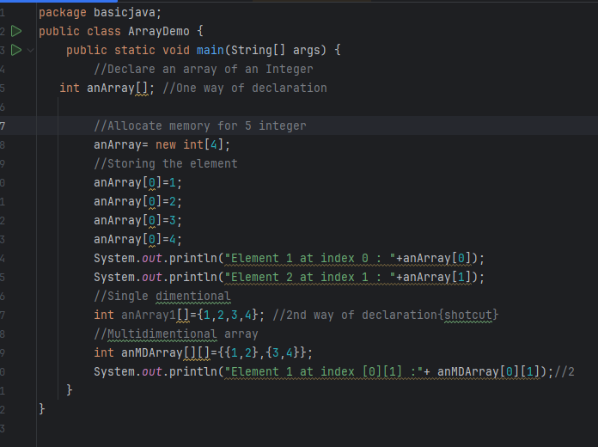

Similarly, you can declare an arrays of other data types:

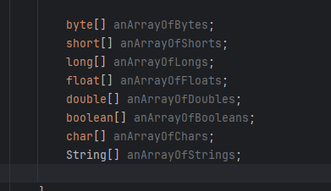

**The while and do while loop**

**While loop: Execute the block of code until the condition is not getting false.**

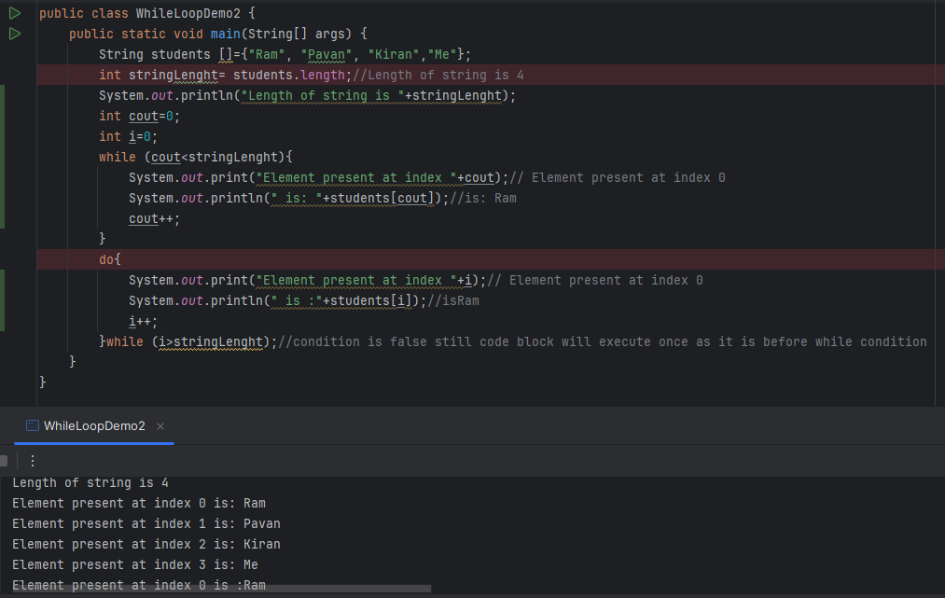

**do while:**

In do while loop code block will execute at least once even if the condition is false. See above e.g where condition is (0>4) false still it is executing the block once.

If – else statement

break keyword🡪 Use to break or end the loop and take the control outside the loop, see below example :

When the condition is true, it ending the loop and not printing the value of remaining element.

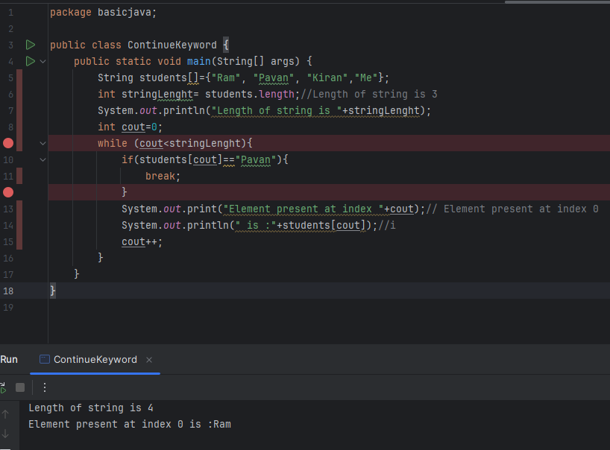

**Continue: Use to skip the current iteration of the loop and proceed to the next iteration.**

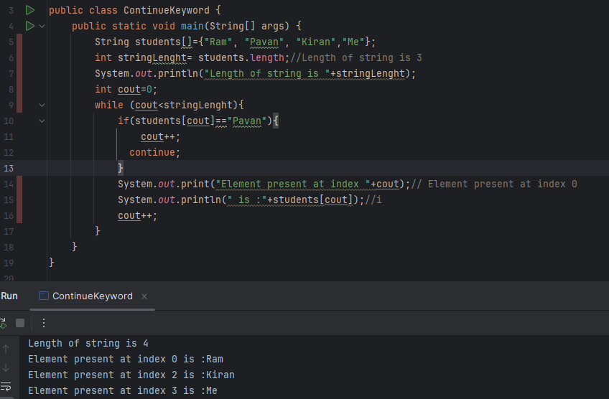

**Here in above example when if condition became true, continue keywork takes control back to line no 9 and continue the execution.**