**Java Constructor**

Its use to initialize an object of a class, it is called when instance of a class(object) is created.

**Types of constructors**

1. Default Constructor (No Argument)

**Implicit Default Constructor:**

If no constructor is defined in a class, the Java compiler automatically provides a default constructor. This constructor doesn’t take any parameters and initializes the object with default values, such as 0 for numbers, null for objects.

**Explicit Default Constructor:**

If we define a constructor that takes no parameters, it’s called an explicit default constructor. This constructor replaces the one the compiler would normally create automatically. Once you define any constructor (with or without parameters), the compiler no longer provides the default constructor for you.

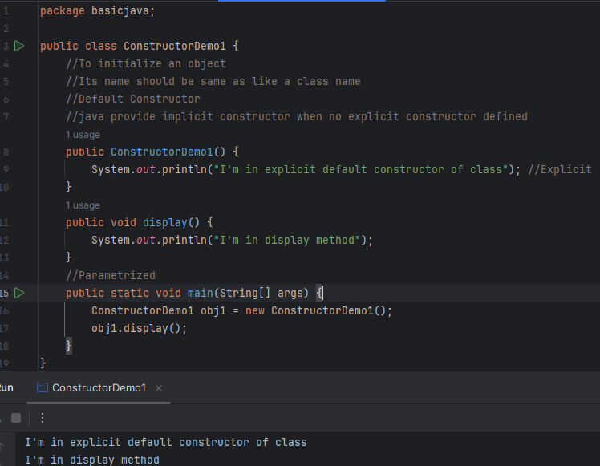

1. Parametrize Constructor/ (With Argument/)

Key Uses of Parameterized Constructors:

1. **Initialization with Specific Values:**

Parameterized constructors allow you to pass arguments to the constructor, which are then used to initialize the object's attributes.

1. **Object Creation with Different States:**

By providing different sets of parameters, you can create objects with different initial states, making the class more versatile.

1. **Code Reusability and Maintainability:**

Parameterized constructors can be used to create objects with different initializations, reducing code duplication and making the code easier to understand and maintain.

1. **Flexibility in Object Creation:**

They offer flexibility in how objects are created, allowing you to tailor the initial state of the object to specific needs.

1. **Avoiding Default Initialization:**

If you don't define any constructors in your class, Java provides a default (parameter less) constructor. However, if you define any constructors (including parameterized ones), the default constructor is no longer automatically provided

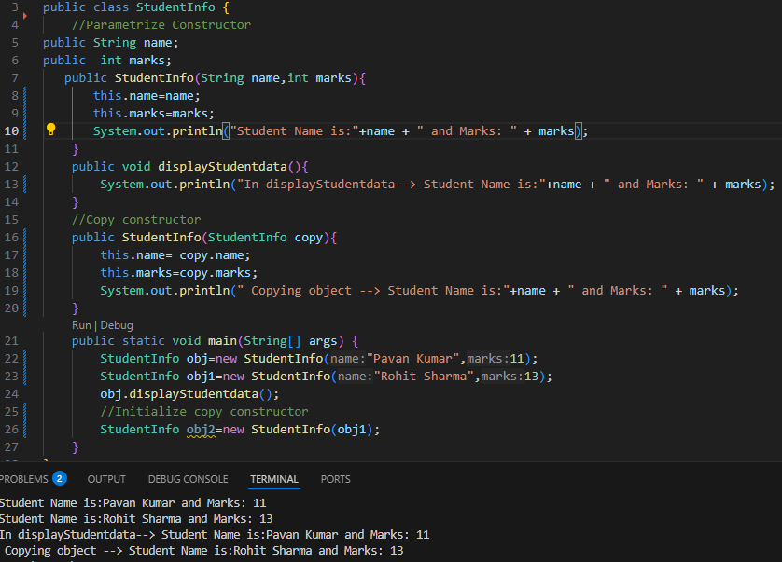

1. **Copy Constructor**

creates a new object by copying the values of an existing object of the same class. (See above example)

Key Uses of Parameterized Constructors:

Key Uses of Parameterized Constructors:

1. **Creating Independent Copies:**

Copy constructors ensure that changes made to the copied object do not affect the original object.

1. **Maintaining Object State:**

Copy constructors are useful when you need to preserve the state of an object for later use without altering the original object.

* **Keys Points**
* It has the same name as a class name
* Don’t need to mention the return type in constructor not even void.
* java provides Default Constructor if no constructor explicitly defines.

**This Keywork:**

**This Keyword is use to refer the current instance (object) of a class.**

**In above example if don’t use this keyword it will print null and 0 outside the constructor.**

(Try it in you IDE)

**Repo path:** <https://github.com/TechGuyy1/basicjava.git>

