**VISVESVARAYA TECHNOLOGICAL UNIVERSITY**

**“Jnana Sangama”, Belagavi – 590 018**

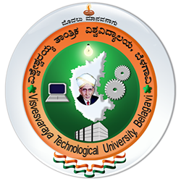

**A MINI PROJECT  
On**

**ALPERS**

*Submitted in partial fulfilment of the requirements for the award of degree*

Bachelor of Engineering  
In  
**Computer Science and Engineering**

Submitted by

**a**

**b**

**c**

**d**

Under the guidance of  
**ANIME**



**DEPARTMENT OF COMPUTER SCIENCE AND ENGINEERING**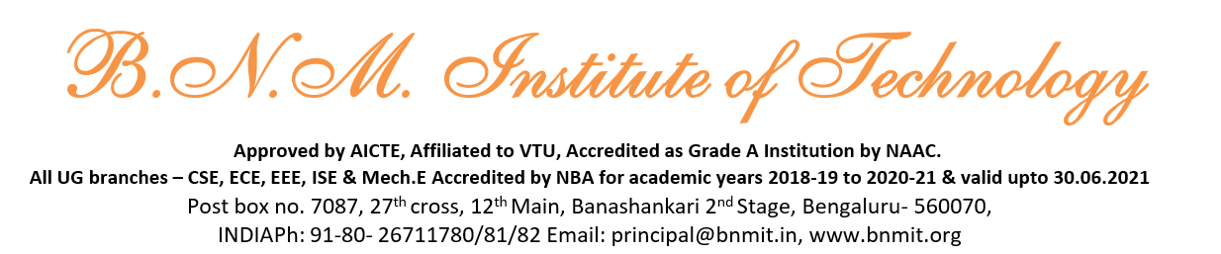



**DEPARTMENT OF COMPUTER SCIENCE AND ENGINEERING**



**CERTIFICATE**

This is to certify that the Mini project work entitled ALPERS has been successfully completed and is a bonafide work carried out by aaaaaaaaaaaaaa aaaaaaaaaa aaaaaaaaaaaaa aaaaaaaaaaaaaa aaaaaaaaaaaaaaaa aaaaaaaaaaaaaaa aaaaaaaaaaa aaaaaaaaaaaa aaaaaaaaaaaaaaa aaaaaaaaaaaaaa aaaaaaaaaaaaa aaaaaaaaaaaa aaaaaaaaaaaaa aaaaaaaaaaaaaaa aaaaaaaaaa aaaaaaaaaaaa aaaaaaaaa aaaaaaaaaaaa aaaaaa bonafide students of V Semester B.E., B.N.M. Institute of Technology, an Autonomous Institution under Visvesvaraya Technological University, Belagavi submitted in partial fulfilment for the award of **Bachelor of Engineering in COMPUTER SCIENCE AND ENGINEERING,** during the year 2024-25 It is certified that all corrections / suggestions indicated for Internal Assessment have been incorporated in the Report. The report has been approved as it satisfied the academic requirements in respect project work prescribed by the said degree.

|  |  |  |
| --- | --- | --- |
| **Dr. Anitha N** | **Dr. Chayadevi M L** | **Dr. S Y Kulkarni** |
| Professor, | Professor and HOD, | Additional Director |
| Dept. of CSE, | Dept. of CSE, | and Principal, |
| BNMIT, Bengaluru | BNMIT, Bengaluru | BNMIT, Bengaluru |

|  |  |  |
| --- | --- | --- |
|  | **Name** | **Signature with Date** |

|  |  |  |
| --- | --- | --- |
| **Examiner 1:** |  |  |
| **Examiner 2:** |  |  |

**ACKNOWLEDGEMENT**

I take this opportunity to express my heartfelt gratitude to all those who supported and guided me throughout the development of this project, the Automatic License Plate Recognition System. Their contributions and encouragement were invaluable to the successful completion of this endeavour.

First and foremost, I would like to extend my sincere thanks to the Dean of our institution, Prof. Eishwar N Maanay, for providing the resources and a conducive environment to undertake this project. Their constant support and emphasis on innovation inspired me to push my boundaries.

I am immensely grateful to our Head of the Department, Dr. Chayadevi M.L, Professor, Dept. of CSE, for their unwavering support and guidance. Their insights and suggestions played a crucial role in shaping the direction of this project. Their encouragement throughout the process has been a source of great motivation.

A special note of appreciation goes to my Guide, Dr. Anitha N, Professor, for her invaluable mentorship, technical expertise, and constructive feedback. Their patient guidance, timely advice, and constant encouragement helped me overcome challenges and refine the project to its current form.

I also wish to express my deepest gratitude to my parents for their unconditional love, support, and encouragement throughout this journey. Their belief in my abilities has been my greatest strength, and their words of motivation have always driven me to excel.

Lastly, I would like to thank my peers, friends, and everyone who contributed directly or indirectly to the successful completion of this project. Your encouragement and suggestions have been instrumental in making this project a success.

This project would not have been possible without the collective support of everyone mentioned above. I am truly grateful for their contributions and look forward to utilizing the knowledge and skills gained from this experience in future endeavours.