VISVESVARAYA TECHNOLOGICAL UNIVERSITY
“Jnana Sangama”, Belagavi – 590 018

A MINI PROJECT
On
Auto-Text for ProjectTitle
Submitted in partial fulfilment of the requirements for the award of degree
Bachelor of Engineering
In
COMPUTER SCIENCE AND ENGINEERING
Submitted by
Auto-Content for NameAndUSN
Auto-Content for NameAndUSN
Auto-Content for NameAndUSN
Under the guidance of
Auto-Text for Designation

COMPUTER SCIENCE AND ENGINEERING


COMPUTER SCIENCE AND ENGINEERING

CERTIFICATE
This is to certify that the Mini project work entitled Auto-Text for ProjectTitle is a bonafide work carried out by Auto-Content for NameAndUSN, Auto-Content for NameAndUSN, Auto-Content for NameAndUSN in partial fulfilment for the award of degree of Bachelor of Engineering in COMPUTER SCIENCE AND ENGINEERING of the Visvesvaraya Technological University, Belagavi during the year Auto-Text for Year. It is certified that all corrections/suggestions indicated for Internal Assessment have been incorporated in the report deposited in the departmental library. The project report has been approved as it satisfies the academic requirements in respect of Project work prescribed for the said Degree.
Auto-Text for GuideName | Dr. Chayadevi M.L | Dr. S Y Kulkarni
Auto-Text for Designation | Professor and HOD, | Additional Director
Dept. of CSE, | Dept. of CSE, | and Principal,
BNMIT, Bengaluru | BNMIT, Bengaluru | BNMIT, Bengaluru

 | Name | Signature with Date

Examiner 1:
Examiner 2:

ACKNOWLEDGEMENT
I take this opportunity to express my heartfelt gratitude to all those who supported and guided me throughout the development of this project, Auto-Text for ProjectTitle. Their contributions and encouragement were invaluable to the successful completion of this endeavour.

First and foremost, I would like to extend my sincere thanks to the Dean of our institution, Prof. Eishwar N Maanay, for providing the resources and a conducive environment to undertake this project. Their constant support and emphasis on innovation inspired me to push my boundaries.

I am immensely grateful to our Head of the Department, Dr. Chayadevi M.L, COMPUTER SCIENCE AND ENGINEERING for their unwavering support and guidance. Their insights and suggestions played a crucial role in shaping the direction of this project. Their encouragement throughout the process has been a source of great motivation.

A special note of appreciation goes to my Guide, Auto-Text for GuideName, Auto-Text for Designation for their technical expertise, and constructive feedback. Their patient guidance, timely advice, and constant encouragement helped me overcome challenges and refine the project to its current form.

I also wish to express my deepest gratitude to my parents for their unconditional love, support, and encouragement throughout this journey. Their belief in my abilities has been my greatest strength, and their words of motivation have always driven me to excel.

Lastly, I would like to thank my peers, friends, and everyone who contributed directly or indirectly to the successful completion of this project. Their encouragement and suggestions have been instrumental in making this project a success.

This project would not have been possible without the collective support of everyone mentioned above. I am truly grateful for their contributions and look forward to utilizing the knowledge and skills gained from this experience in future endeavours.
ABSTRACT
Auto-Content for Abstract. Auto-Content for Abstract. Auto-Content for Abstract. Auto-Content for Abstract. Auto-Content for Abstract. Auto-Content for Abstract. Auto-Content for Abstract. Auto-Content for Abstract.

Table of Contents

S.No | Title | Page No
1 | Auto-Text for Chapter1Title | 1
2 | Auto-Text for Chapter2Title | 10
3 | Auto-Text for Chapter3Title | 15
4 | Auto-Text for Chapter4Title | 22
5 | Auto-Text for Chapter5Title | 27
6 | References | 29

Chapter 1
Auto-Text for Chapter1Title

Auto-Text for Chapter1Title
Auto-Content for Chapter1Content (Long Version). Auto-Content for Chapter1Content (Long Version). Auto-Content for Chapter1Content (Long Version). Auto-Content for Chapter1Content (Long Version). Auto-Content for Chapter1Content (Long Version). Auto-Content for Chapter1Content (Long Version). Auto-Content for Chapter1Content (Long Version). Auto-Content for Chapter1Content (Long Version). Auto-Content for Chapter1Content (Long Version). Auto-Content for Chapter1Content (Long Version). Auto-Content for Chapter1Content (Long Version). Auto-Content for Chapter1Content (Long Version). Auto-Content for Chapter1Content (Long Version). Auto-Content for Chapter1Content (Long Version). Auto-Content for Chapter1Content (Long Version). Auto-Content for Chapter1Content (Long Version). Auto-Content for Chapter1Content (Long Version). Auto-Content for Chapter1Content (Long Version). Auto-Content for Chapter1Content (Long Version). Auto-Content for Chapter1Content (Long Version). Auto-Content for Chapter1Content (Long Version). Auto-Content for Chapter1Content (Long Version). Auto-Content for Chapter1Content (Long Version). Auto-Content for Chapter1Content (Long Version). Auto-Content for Chapter1Content (Long Version). Auto-Content for Chapter1Content (Long Version). Auto-Content for Chapter1Content (Long Version). Auto-Content for Chapter1Content (Long Version). Auto-Content for Chapter1Content (Long Version). Auto-Content for Chapter1Content (Long Version). Auto-Content for Chapter1Content (Long Version). Auto-Content for Chapter1Content (Long Version). Auto-Content for Chapter1Content (Long Version). Auto-Content for Chapter1Content (Long Version). Auto-Content for Chapter1Content (Long Version). Auto-Content for Chapter1Content (Long Version). Auto-Content for Chapter1Content (Long Version). Auto-Content for Chapter1Content (Long Version). Auto-Content for Chapter1Content (Long Version). Auto-Content for Chapter1Content (Long Version). Auto-Content for Chapter1Content (Long Version). Auto-Content for Chapter1Content (Long Version). Auto-Content for Chapter1Content (Long Version). Auto-Content for Chapter1Content (Long Version). Auto-Content for Chapter1Content (Long Version). Auto-Content for Chapter1Content (Long Version). Auto-Content for Chapter1Content (Long Version). Auto-Content for Chapter1Content (Long Version). Auto-Content for Chapter1Content (Long Version). Auto-Content for Chapter1Content (Long Version). Auto-Content for Chapter1Content (Long Version). Auto-Content for Chapter1Content (Long Version). Auto-Content for Chapter1Content (Long Version). Auto-Content for Chapter1Content (Long Version). Auto-Content for Chapter1Content (Long Version). Auto-Content for Chapter1Content (Long Version). Auto-Content for Chapter1Content (Long Version). Auto-Content for Chapter1Content (Long Version). Auto-Content for Chapter1Content (Long Version). Auto-Content for Chapter1Content (Long Version). Auto-Content for Chapter1Content (Long Version). Auto-Content for Chapter1Content (Long Version). Auto-Content for Chapter1Content (Long Version). Auto-Content for Chapter1Content (Long Version). Auto-Content for Chapter1Content (Long Version). Auto-Content for Chapter1Content (Long Version). Auto-Content for Chapter1Content (Long Version). Auto-Content for Chapter1Content (Long Version). Auto-Content for Chapter1Content (Long Version). Auto-Content for Chapter1Content (Long Version). Auto-Content for Chapter1Content (Long Version). Auto-Content for Chapter1Content (Long Version). Auto-Content for Chapter1Content (Long Version). Auto-Content for Chapter1Content (Long Version). Auto-Content for Chapter1Content (Long Version). Auto-Content for Chapter1Content (Long Version). Auto-Content for Chapter1Content (Long Version). Auto-Content for Chapter1Content (Long Version). Auto-Content for Chapter1Content (Long Version). Auto-Content for Chapter1Content (Long Version). Auto-Content for Chapter1Content (Long Version). Auto-Content for Chapter1Content (Long Version). Auto-Content for Chapter1Content (Long Version). Auto-Content for Chapter1Content (Long Version). Auto-Content for Chapter1Content (Long Version). Auto-Content for Chapter1Content (Long Version). Auto-Content for Chapter1Content (Long Version). Auto-Content for Chapter1Content (Long Version). Auto-Content for Chapter1Content (Long Version). Auto-Content for Chapter1Content (Long Version). Auto-Content for Chapter1Content (Long Version). Auto-Content for Chapter1Content (Long Version). Auto-Content for Chapter1Content (Long Version). Auto-Content for Chapter1Content (Long Version). Auto-Content for Chapter1Content (Long Version). Auto-Content for Chapter1Content (Long Version). Auto-Content for Chapter1Content (Long Version). Auto-Content for Chapter1Content (Long Version). Auto-Content for Chapter1Content (Long Version). Auto-Content for Chapter1Content (Long Version). Auto-Content for Chapter1Content (Long Version). Auto-Content for Chapter1Content (Long Version). Auto-Content for Chapter1Content (Long Version). Auto-Content for Chapter1Content (Long Version). Auto-Content for Chapter1Content (Long Version). Auto-Content for Chapter1Content (Long Version). Auto-Content for Chapter1Content (Long Version). Auto-Content for Chapter1Content (Long Version). Auto-Content for Chapter1Content (Long Version). Auto-Content for Chapter1Content (Long Version). Auto-Content for Chapter1Content (Long Version). Auto-Content for Chapter1Content (Long Version). Auto-Content for Chapter1Content (Long Version). Auto-Content for Chapter1Content (Long Version). Auto-Content for Chapter1Content (Long Version). Auto-Content for Chapter1Content (Long Version). Auto-Content for Chapter1Content (Long Version). Auto-Content for Chapter1Content (Long Version). Auto-Content for Chapter1Content (Long Version). Auto-Content for Chapter1Content (Long Version). Auto-Content for Chapter1Content (Long Version). Auto-Content for Chapter1Content (Long Version). Auto-Content for Chapter1Content (Long Version). Auto-Content for Chapter1Content (Long Version). Auto-Content for Chapter1Content (Long Version). Auto-Content for Chapter1Content (Long Version). Auto-Content for Chapter1Content (Long Version). Auto-Content for Chapter1Content (Long Version). Auto-Content for Chapter1Content (Long Version). Auto-Content for Chapter1Content (Long Version). Auto-Content for Chapter1Content (Long Version). Auto-Content for Chapter1Content (Long Version). Auto-Content for Chapter1Content (Long Version). Auto-Content for Chapter1Content (Long Version). Auto-Content for Chapter1Content (Long Version). Auto-Content for Chapter1Content (Long Version). Auto-Content for Chapter1Content (Long Version). Auto-Content for Chapter1Content (Long Version). Auto-Content for Chapter1Content (Long Version). Auto-Content for Chapter1Content (Long Version). Auto-Content for Chapter1Content (Long Version). Auto-Content for Chapter1Content (Long Version). Auto-Content for Chapter1Content (Long Version). Auto-Content for Chapter1Content (Long Version). Auto-Content for Chapter1Content (Long Version). Auto-Content for Chapter1Content (Long Version). Auto-Content for Chapter1Content (Long Version). Auto-Content for Chapter1Content (Long Version). Auto-Content for Chapter1Content (Long Version). Auto-Content for Chapter1Content (Long Version). Auto-Content for Chapter1Content (Long Version). Auto-Content for Chapter1Content (Long Version). Auto-Content for Chapter1Content (Long Version). Auto-Content for Chapter1Content (Long Version). Auto-Content for Chapter1Content (Long Version). Auto-Content for Chapter1Content (Long Version). Auto-Content for Chapter1Content (Long Version). Auto-Content for Chapter1Content (Long Version). Auto-Content for Chapter1Content (Long Version). Auto-Content for Chapter1Content (Long Version). Auto-Content for Chapter1Content (Long Version). Auto-Content for Chapter1Content (Long Version). Auto-Content for Chapter1Content (Long Version). Auto-Content for Chapter1Content (Long Version). Auto-Content for Chapter1Content (Long Version). Auto-Content for Chapter1Content (Long Version). Auto-Content for Chapter1Content (Long Version). Auto-Content for Chapter1Content (Long Version). Auto-Content for Chapter1Content (Long Version). Auto-Content for Chapter1Content (Long Version). Auto-Content for Chapter1Content (Long Version). Auto-Content for Chapter1Content (Long Version). Auto-Content for Chapter1Content (Long Version). Auto-Content for Chapter1Content (Long Version). Auto-Content for Chapter1Content (Long Version). Auto-Content for Chapter1Content (Long Version). Auto-Content for Chapter1Content (Long Version). Auto-Content for Chapter1Content (Long Version). Auto-Content for Chapter1Content (Long Version). Auto-Content for Chapter1Content (Long Version). Auto-Content for Chapter1Content (Long Version). Auto-Content for Chapter1Content (Long Version). Auto-Content for Chapter1Content (Long Version). Auto-Content for Chapter1Content (Long Version). Auto-Content for Chapter1Content (Long Version). Auto-Content for Chapter1Content (Long Version). Auto-Content for Chapter1Content (Long Version). Auto-Content for Chapter1Content (Long Version). Auto-Content for Chapter1Content (Long Version). Auto-Content for Chapter1Content (Long Version). Auto-Content for Chapter1Content (Long Version). Auto-Content for Chapter1Content (Long Version). Auto-Content for Chapter1Content (Long Version). Auto-Content for Chapter1Content (Long Version). Auto-Content for Chapter1Content (Long Version). Auto-Content for Chapter1Content (Long Version). Auto-Content for Chapter1Content (Long Version). Auto-Content for Chapter1Content (Long Version). Auto-Content for Chapter1Content (Long Version). Auto-Content for Chapter1Content (Long Version).


Fig 1.1

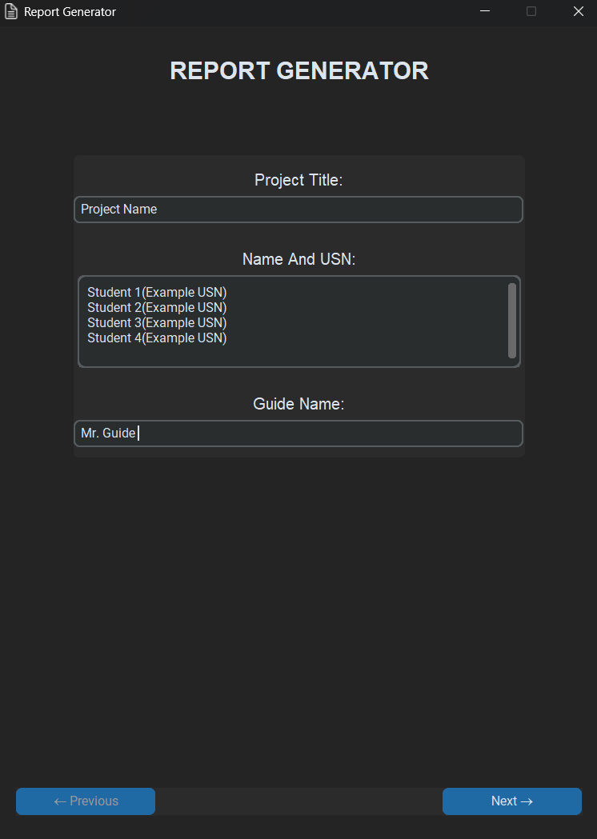
Fig 1.2

Fig 1.3

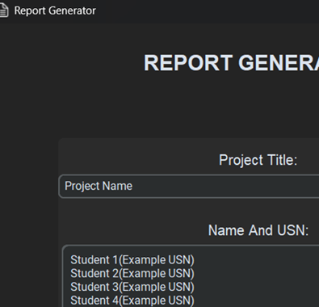
Fig 1.4

Fig 1.5

Chapter 2
Auto-Text for Chapter2Title

Auto-Text for Chapter2Title
Line 1 of Chapter 2.
Line 2 of Chapter 2.
Fig 2.1
Fig 2.2

Fig 2.3

Fig 2.4

Fig 2.5

Chapter 3
Auto-Text for Chapter3Title

Auto-Text for Chapter3Title
Line 1 of Chapter 3.
Line 2.
Line 3.
Line 4.
Line 5.
Line 6.
Line 7.
Line 8 of Chapter 3.

Fig 3.1

Fig 3.2

Fig 3.3

Fig 3.4

Fig 3.5

Chapter 4
Auto-Text for Chapter4Title

Auto-Text for Chapter4Title
Auto-Content for Chapter4Content. Auto-Content for Chapter4Content. Auto-Content for Chapter4Content. Auto-Content for Chapter4Content. Auto-Content for Chapter4Content. Auto-Content for Chapter4Content. Auto-Content for Chapter4Content. Auto-Content for Chapter4Content. Auto-Content for Chapter4Content. Auto-Content for Chapter4Content. Auto-Content for Chapter4Content. Auto-Content for Chapter4Content. Auto-Content for Chapter4Content. Auto-Content for Chapter4Content. Auto-Content for Chapter4Content. Auto-Content for Chapter4Content. Auto-Content for Chapter4Content. Auto-Content for Chapter4Content. Auto-Content for Chapter4Content. Auto-Content for Chapter4Content. Auto-Content for Chapter4Content. Auto-Content for Chapter4Content. Auto-Content for Chapter4Content. Auto-Content for Chapter4Content. Auto-Content for Chapter4Content. Auto-Content for Chapter4Content. Auto-Content for Chapter4Content. Auto-Content for Chapter4Content. Auto-Content for Chapter4Content. Auto-Content for Chapter4Content. Auto-Content for Chapter4Content. Auto-Content for Chapter4Content. Auto-Content for Chapter4Content. Auto-Content for Chapter4Content. Auto-Content for Chapter4Content. Auto-Content for Chapter4Content. Auto-Content for Chapter4Content. Auto-Content for Chapter4Content. Auto-Content for Chapter4Content. Auto-Content for Chapter4Content. Auto-Content for Chapter4Content. Auto-Content for Chapter4Content. Auto-Content for Chapter4Content. Auto-Content for Chapter4Content. Auto-Content for Chapter4Content. Auto-Content for Chapter4Content. Auto-Content for Chapter4Content. Auto-Content for Chapter4Content. Auto-Content for Chapter4Content. Auto-Content for Chapter4Content.
Fig 4.1

Fig 4.2
Fig 4.3

Fig 4.4

Fig 4.5

Chapter 5
Auto-Text for Chapter5Title

Auto-Text for Chapter5Title
Auto-Content for Chapter5Content. Auto-Content for Chapter5Content. Auto-Content for Chapter5Content. Auto-Content for Chapter5Content. Auto-Content for Chapter5Content. Auto-Content for Chapter5Content. Auto-Content for Chapter5Content. Auto-Content for Chapter5Content. Auto-Content for Chapter5Content. Auto-Content for Chapter5Content. Auto-Content for Chapter5Content. Auto-Content for Chapter5Content. Auto-Content for Chapter5Content. Auto-Content for Chapter5Content. Auto-Content for Chapter5Content. Auto-Content for Chapter5Content. Auto-Content for Chapter5Content. Auto-Content for Chapter5Content. Auto-Content for Chapter5Content. Auto-Content for Chapter5Content. Auto-Content for Chapter5Content. Auto-Content for Chapter5Content. Auto-Content for Chapter5Content. Auto-Content for Chapter5Content. Auto-Content for Chapter5Content. Auto-Content for Chapter5Content. Auto-Content for Chapter5Content. Auto-Content for Chapter5Content. Auto-Content for Chapter5Content. Auto-Content for Chapter5Content. Auto-Content for Chapter5Content. Auto-Content for Chapter5Content. Auto-Content for Chapter5Content. Auto-Content for Chapter5Content. Auto-Content for Chapter5Content. Auto-Content for Chapter5Content. Auto-Content for Chapter5Content. Auto-Content for Chapter5Content. Auto-Content for Chapter5Content. Auto-Content for Chapter5Content. Auto-Content for Chapter5Content. Auto-Content for Chapter5Content. Auto-Content for Chapter5Content. Auto-Content for Chapter5Content. Auto-Content for Chapter5Content. Auto-Content for Chapter5Content. Auto-Content for Chapter5Content. Auto-Content for Chapter5Content. Auto-Content for Chapter5Content. Auto-Content for Chapter5Content.

REFERENCES
[1] Auto-Ref 1
[2] Auto-Ref 2
[3] Auto-Ref 3

