[YOUR THESIS TITLE HERE]
A thesis submitted in partial fulfillment of the requirements
for the award of the degree of

[BACHELOR OF TECHNOLOGY]

By: | Enrollment No.
[Student 1 full name]  [student 2 full name]  [student 3 full name] | [IIT2021001]  [IIT2021002]  [IIT2021003]

Under the Supervision of
[DR. SUPERVISOR FULL NAME]
to the
[DEPARTMENT OF INFORMATION TECHNOLOGY]

INDIAN INSTITUTE OF INFORMATION TECHNOLOGY, ALLAHABAD
[MONTH YEAR]

CERTIFICATE
It is certified that the work contained in the thesis titled '[THESIS TITLE]' by [STUDENT NAMES] has been carried out under my supervision and that this work has not been submitted elsewhere for a degree.

________________________________________
[DR. SUPERVISOR NAME]
[DEPARTMENT NAME]
IIIT Allahabad


CANDIDATE DECLARATION
I/We, [STUDENT NAME (ROLL NO.)], hereby certify that the thesis titled '[THESIS TITLE]' has been submitted by me/us in partial fulfillment of the requirements for the Degree of [DEGREE NAME] in the [DEPARTMENT NAME] at the Indian Institute of Information Technology, Allahabad.
We acknowledge that plagiarism includes:
- Reproducing another person's work (fully or partially) or ideas and presenting them as our own.
- Copying or paraphrasing another person's work without appropriate attribution.
- Engaging in literary theft by reproducing a unique literary construct without crediting its source.
We affirm that due credit has been given to all original authors and sources through proper citations for words, ideas, diagrams, graphics, computer programs, experiments, results, and websites that are not our own contributions. Direct quotations have been appropriately marked, and sources have been properly referenced. Furthermore, we declare that no portion of our work is plagiarized. In the event of a plagiarism claim, we accept full responsibility for the contents of this thesis. We acknowledge that our supervisor may not be able to verify the originality of every aspect of our work.
Place: _________________ Date: _________________
[STUDENT 1 NAME (ROLL NO.)]
[STUDENT 2 NAME (ROLL NO.)]
[STUDENT 3 NAME (ROLL NO.)]
INDIAN INSTITUTE OF INFORMATION TECHNOLOGY, ALLAHABAD
ABSTRACT
WORD LIMITS: B.Tech: 300 words (1 page) | M.Tech: 500 words (1-2 pages) | PhD: 1000 words (4 pages)
[WRITE YOUR ABSTRACT HERE]
This thesis presents a comprehensive study on [topic]. The primary objective is to [objective]. We propose a novel approach [method description]. The experimental results demonstrate that [key findings]. This work contributes to [contribution].
(Replace the sample text above with your actual abstract. Delete this instruction.)

ACKNOWLEDGEMENTS
[WRITE YOUR ACKNOWLEDGEMENTS HERE]
I would like to express my sincere gratitude to my supervisor, [Supervisor Name], for continuous support, guidance, and encouragement throughout this research. His/Her insightful comments and suggestions have been invaluable in shaping this work.
I am also grateful to the faculty members of the [Department Name] for their support during my studies. Special thanks to my colleagues and friends who provided a stimulating environment for learning.
Finally, I would like to thank my family for their unconditional love, support, and patience throughout my academic journey.
(Replace the sample text above with your actual acknowledgements. Delete this instruction.)

TABLE OF CONTENTS
Chapter 1 1
INTRODUCTION 1
1.1. Background 1
1.1.1 Historical Context 1
1.2 Motivation 1
1.3 Research Objectives 2
1.4 Organization of Thesis 2
Chapter 2 3
LITERATURE REVIEW 3
2.1. Early Approaches 3
2.2 Recent Developments 3
Chapter 3 4
METHODOLOGY 4
3.1. System Architecture 4
3.2 Algorithm Description 4
REFERENCES 6
APPENDIX A 7
ADDITIONAL MATERIALS 7

(This will auto-generate from your chapter headings. Right-click and select 'Update Field' in Word.)

LIST OF FIGURES
INSERT > Table of Figures in Word to auto-generate this list from your figure captions.
Figure 1.1: System Architecture Diagram . . . . . . . . . . . . . . . . 5
Figure 2.1: Literature Timeline . . . . . . . . . . . . . . . . . . . . . . 12
Figure 3.1: Methodology Flowchart . . . . . . . . . . . . . . . . . . . 18
(Sample entries above - replace with auto-generated list)

LIST OF TABLES
INSERT > Table of Tables in Word to auto-generate this list from your table captions.
Table 2.1: Comparison of Existing Approaches . . . . . . . . . . . 14
Table 3.1: Dataset Description . . . . . . . . . . . . . . . . . . . . . . 20
Table 4.1: Performance Results . . . . . . . . . . . . . . . . . . . . . 28
(Sample entries above - replace with auto-generated list)

LIST OF ABBREVIATIONS
Replace the sample abbreviations below with your actual abbreviations used in the thesis.
AI | Artificial Intelligence
ML | Machine Learning
CNN | Convolutional Neural Network
IoT | Internet of Things
(Add/remove rows as needed)

Chapter 1

INTRODUCTION
[This chapter provides an introduction to the research problem, motivation, objectives, and organization of the thesis. The rapid advancement of technology has created new opportunities and challenges in [your domain].

1.1. Background
The background section introduces the fundamental concepts and provides context for the research. Recent developments in [field] have shown promising results [1-3].

1.1.1 Historical Context
This subsection provides historical context. The evolution of [topic] can be traced back to [year] when [event].
Table 1.1: Summary of methods
Reference | Method | Accuracy | Limitations
Smith et al. [1] | Traditional ML | 85.2% | High complexity
Kumar et al. [2] | Deep Learning | 92.1% | Large dataset required
Proposed | Hybrid Approach | 94.5% | —

1.2 Motivation
The motivation for this research stems from [specific problem or gap]. Despite significant progress, existing approaches face several limitations:
- Limited scalability in real-world applications
- High computational complexity
- Lack of robust evaluation frameworks
These limitations motivate the need for novel approaches addressed in this thesis.

1.3 Research Objectives
The primary objectives of this research are:
- To develop [objective 1]
- To evaluate [objective 2]
- To demonstrate [objective 3]

1.4 Organization of Thesis
The remainder of this thesis is organized as follows:
Chapter 2 reviews related work and existing approaches in the literature.
Chapter 3 describes the proposed methodology and system architecture.
Chapter 4 presents experimental results and performance evaluation.
Chapter 5 concludes the thesis and discusses future work.

Chapter 2

LITERATURE REVIEW
[WRITE YOUR LITERATURE REVIEW HERE]
This chapter presents a comprehensive review of existing literature related to [topic]. We analyze various approaches, identify gaps, and position our work within the current research landscape.

2.1. Early Approaches
Early work in [field] focused primarily on [approach]. Smith et al. [1] proposed [method], which achieved [results]. However, this approach suffered from [limitations].

2.2 Recent Developments
Recent advances have introduced [new techniques]. Table 2.1 summarizes key approaches from the literature.
Table 2.1: Comparison of Existing Approaches
Reference | Method | Accuracy | Limitations
Smith et al. [1] | Traditional ML | 85.2% | High complexity
Kumar et al. [2] | Deep Learning | 92.1% | Large dataset required
Proposed | Hybrid Approach | 94.5% | —
(Replace sample table with your actual comparison. Use INSERT > Table in Word.)

Chapter 3

METHODOLOGY
[WRITE YOUR METHODOLOGY HERE]
This chapter describes the proposed methodology, system architecture, and implementation details.

3.1. System Architecture
Figure 3.1 illustrates the overall system architecture. The system consists of three main components: [Component 1], [Component 2], and [Component 3].
[INSERT YOUR ARCHITECTURE DIAGRAM HERE]
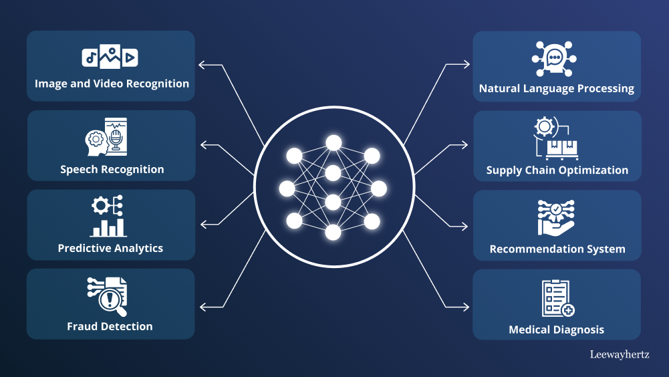
Figure 3.1:System Architecture
(Use INSERT > Pictures in Word to add your figure, then add caption)

3.2 Algorithm Description
The proposed algorithm operates in the following steps:
- Initialize parameters and load dataset
- Preprocess data using normalization
- Train model using [training method]
- Evaluate performance on test set
- Optimize hyperparameters

REFERENCES
IEEE CITATION FORMAT: List references in the order they appear in text. Use [1], [2], [3] for citations.
[1] J. Smith and A. Doe, "Deep learning for network security," IEEE Trans. Network Security, vol. 15, no. 3, pp. 234-251, 2020.
[2] R. Kumar and P. Patel, "Machine learning approaches for intrusion detection," in Proc. Int. Conf. Network Security, 2019, pp. 45-52.
[3] I. Goodfellow, Y. Bengio, and A. Courville, Deep Learning. Cambridge, MA: MIT Press, 2016.
(Replace sample references with your actual references)

APPENDIX A

ADDITIONAL MATERIALS
[WRITE YOUR APPENDIX CONTENT HERE]
Appendices contain supplementary material such as:
- Detailed algorithm pseudocode
- Additional experimental results
- Source code listings
- Questionnaires or survey forms
(Add your appendix content here. Create additional appendices as APPENDIX B, APPENDIX C, etc.)

