Week3:

Manichean Dichotomy: The dualistic effects.

“The general function of any racial stereo type is to establish and, preserve order between different elements of society, maintain the continuity and growth of Western civilization, and enforce white supremacy with a minimum of effort, attention, and expense” (Chan and Chin, 66.)

Model of behavior

The subject minority eventually becomes the stereotype (I.e in agreement with the stereotype.)

Vehicle of the stereotype, the medium of its perpetuation, and the subject race to be controlled.

The state of euphemized self-contempt.

Asian patriarchy is so much more malevolent than the benevolent western patriarchy.

Immigrant hero is one who’s converted to the Western culture, accepting the stereotypes given to him by the Westerners, and conform and support the Westerner’s cause.

Hegemonic masculinity based on homophobia.

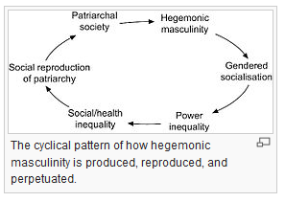

Masculinity is an ideology and social construct (Chan, 16.)

