## 1 For each of the following pairs, which represents a class and which represents an object of that class?

|  |  |  |
| --- | --- | --- |
|  | **Class** | **Object** |
| Superhero, Superman | Superhero | Superman |
| Justin, Person | Person | Justin |
| Rover, Pet | Pet | Rover |
| Magazine, Time | Magazine | Time |
| Christmas, Holiday | Holiday | Christmas |
|  |  |  |

## 2  Write a method called multiConcat that takes a String and an integer as parameters. Return a String that consists of the string parameter concatenated with itself count times, where count is the integer parameter. For example, if the parameter values are "hi" and 4, the return value is "hihihihi". Return the original string if the integer parameter is less than 2.

//*********************************************************

//Author: Hieu Pham

//ID: 0953-827

//Section: 28317

//Date: 01/30/2015

//

//Write a method called multiConcat that takes a String and an

//integer as parameters. Return a String that consists of the

//string parameter concatenated with itself count times, where

//count is the integer parameter. For example, if the parameter

//values are "hi" and 4, the return value is "hihihihi". Return

//the original string if the integer parameter is

//less than 2.

//

//

//**********************************************************

**public** **class** TestString //The .java to submit to javac

{

**public** **static** **void** main(String[] args) //The main method

{

String text = *multiConcat*("hi",4); //Declare a variable

//and assign it to the call

System.***out***.printf("%s\n",text); //Print out the result

}//End of main entrance

**public** **static** String multiConcat(String s, **int** width) //multiConcat //method

{

String NewString=""; //Use NewString because s is immutable

**if**(width < 2) //if cont is less than 2

{

**return**(s); //return the original string

}//End if

**else** //Otherwise

{

**for**(**int** i = 0; i < width; i++) //Set up the loop from 0 to //count - 1

{

NewString = NewString + s; //add the same string (i-//1) times

}

**return**(NewString);//give it back to caller

}//End else

}//End multiConcat

}//End .java class to submit to javac

## 3 Overload the multiConcat method from Exercise 5.25 such that if the integer parameter is not provided, the method returns the string concatenated with itself. For example, if the parameter is "test", the return value is "testtest".

//*********************************************************

//Author: Hieu Pham

//ID: 0953-827

//Section: 28317

//Date: 01/30/2015

//

//Overload the multiConcat method from Exercise 5.25 such that

//if the integer parameter is not provided, the method returns

//the string concatenated with itself. For example, if the

//parameter is "test", the return value is "testtest".

//

//

//**********************************************************

**public** **class** TestString //The .java to submit to javac

{

**public** **static** **void** main(String[] args) //The main method

{

String text = *multiConcat*("hi",4);//Declare a variable

//and assign it to the call

String text2 = *multiConcat*("test"); //Declare a variable

//and assign it to the call

//test2 tests out the overloading feature of java compiler

System.***out***.printf("%s\n",text); //Print out the result

System.***out***.printf("%s\n",text2); //Print out the result

}//End of main entrance

**public** **static** String multiConcat(String s, **int** width) //multiConcat //method

{

String NewString=""; //Use NewString because s is immutable

**if**(width < 2) //if cont is less than 2

{

**return**(s); //return the original string

}//End if

**else** //Otherwise

{

**for**(**int** i = 0; i < width; i++) //Set up the loop from 0 to //count - 1

{

NewString = NewString + s; //add the same string (i-//1) times

}

**return**(NewString);//give it back to caller

}//End else

}//End multiConcat

**public** **static** String multiConcat(String s) //multiConcat overloaded

{

String NewString=""; //Use NewString because s is immutable

**for**(**int** i = 0; i < 2; i++) //Set up the loop from 0 to count - 1

{

NewString = NewString + s; //add the same string (i-//1) times

}

**return**(NewString);//give it back to caller

}//End multiConcat

}//End .java class to submit to javac

## 4 Explain why a static method cannot refer to an instance variable

*Static methods cannot reference instance variables because instance variables don't exist until an object exists.*

## 4.3  Draw a UML class diagram for the Transactions program.

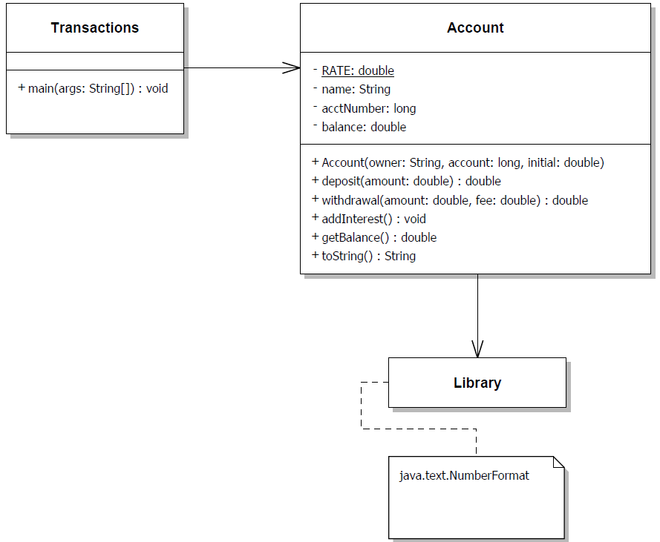

## 5 Which of the following are valid declarations? Which instantiate an array object? Explain your answers.

int primes = {2, 3, 4, 5, 7, 11};

*Not valid. Square brackets are needed. Additionally, a list has multiple elements that must be declared as an array. Therefore, the declaration above is invalid.*

float elapsedTimes[] = {11.47, 12.04, 11.72, 13.88};

*This declaration is valid. One may also declare it as float[] elapsedTimes = {11.47, 12.04, 11.72, 13.88};*

*An array object of type float is created as a result.*

int[] scores = int[30];

*This declaration is invalid and therefore no object will be created. To make it valid, add the keyword new before int[30] or an initializer list but not both. For example, int scores[] = new int[30]; or int[] scores = {2, 3, 4, 5, 6,..,17};*

int[] primes = new {2, 3, 5, 7, 11};

*This declaration is invalid because it has the new keyword and the initializer list. To make it valid, remove the keyword new, such as follows: int[] primes = {2, 3, 5, 7, 11};*

int[] scores = new int[30];

*This declaration is valid and it will create an array object of type int as a result.*

char grades[] = {'a', 'b', 'c', 'd', 'f'};

*This declaration is valid and will create an array object of type char. The declaration is also valid as follows: char[] grades = {‘a’, ‘b’, ‘c’, ‘d’, ‘f’};*

char[] grades = new char[];

*This declaration is invalid because the size of the array is missing. To make it work, try as follows: char[] grades = new char[5];*

## 6 Describe what problem occurs in the following code. What modifications should be made to it to eliminate the problem?

int[] numbers = {3, 2, 3, 6, 9, 10, 12, 32, 3, 12, 6};

for (int count = 1; count <= numbers.length; count++)

System.out.println (numbers[count]);

*The out threw an array out of bound exception error at run time. As shown below:*

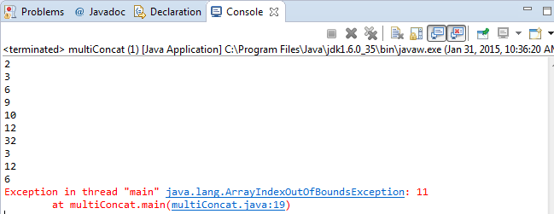

*The compiler managed to compile the code without any issue, but the problem was that the loop went to index 12, adding one more element to the array, which was outside of the 0-11 range. For loop is 0th base indexing. To fix this problem, use the for each loop, as shown below:*

**int**[] numbers = {3, 2, 3, 6, 9, 10, 12, 32, 3, 12, 6};

**for** (**int** count : numbers)

System.***out***.println (count);

*Which yielded a correct result, as shown below:*

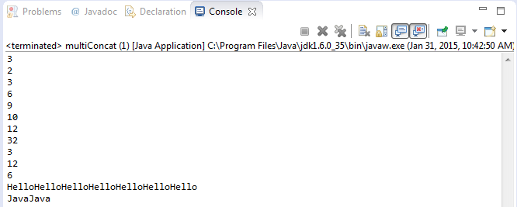

## 7 Write an array declaration and any necessary supporting classes to represent the following statements:

1. students’ names for a class of 25 students

*String[] students = new String[25];*

1. students’ test grades for a class of 40 students

*char[] grades = new char[40];*

1. credit-card transactions that contain a transaction number, a merchant name, and a charge

*final int MAXIMUM = 10;*

*transactions[] charges = new transactions(172015,”Hieu Pham”, 1.85); //Creates and initialies*

*public class transactions*

*{*

*private int transactionNumber;*

*private String merchantName;*

*private double charge;*

*//Constructor*

*public transaction(int tn, String mn, double chrg)*

*{*

*transactionNumber = tn;*

*merchantName = mn;*

*charge = chrg;*

*}*

*//may be a mutator here…*

*//may be an accessor here…*

*}*

1. students’ names for a class and homework grades for each student

*final int MAXIMUM = 100;*

*student[] CST200 = new student[MAXIMUM]; //Create 100 students*

*public class student*

*{*

*private String name;*

*private String postID;*

*private char[] scores;*

*//Constructor*

*public student(String Name, String pID, char[] Scores)*

*{*

*name = Name;*

*postID = pID;*

*scores = Scores;*

*}*

*//may be a mutator here…*

*//may be an accessor here…*

*}*

1. for each employee of the L&L International Corporation: the employee number, hire date, and the amount of the last five raises

**double** raises[] = {0.75, 1.15, 0.85, 1.12, 2.05};

employees MyEmployees = **new** employees(000,"02/27/2012", raises);

**public** **static** **class** employees

{

**private** **int** EmployeeID;

**private** String StartDate;

**private** **double** PerfRaise[] = **new** **double**[5];

**public** employees(**int** EID, String DOH, **double** Raise[])

{

**int** iterator = 0;

EmployeeID = EID;

StartDate = DOH;

**for**(**double** aNumber : Raise)

{

PerfRaise[iterator] = aNumber;

iterator++;

}

}//Close constructor

**public** String toString()

{

**return**(EmployeeID + "\n"

+ StartDate + "\n"

+ PerfRaise[0] + "\n"

+ PerfRaise[1] + "\n"

+ PerfRaise[2] + "\n"

+ PerfRaise[3] + "\n"

+ PerfRaise[4] + "\n");

}//Close the string

}//Close class employees

## 8 Revise the Coin class such that its state is represented internally using a boolean variable. Test the new versions of the class as part of the CountFlips and FlipRace programs.

*The revised Coin class*

/*********************************************************

//Author: Hieu Pham

//ID: 0953-827

//Section: 28317

//Date: 01/31/2015

//

//Revise the Coin class such that its state is represented

//internally using a boolean variable. Test the new versions

//of the class as part of the CountFlips and FlipRace

//programs.

//

//**********************************************************

**public** **class** Coin

{

//private final int HEADS = 0; // tails is 1

// HEADS is not used at after the mod,

//so I commented it out.

**private** **boolean** face; //Revised right here, HQP 01/31/2015

//Changed from int to boolean type.

//-----------------------------------------------------------------

// Sets up this coin by flipping it initially.

//-----------------------------------------------------------------

**public** Coin()

{

flip();

}

//-----------------------------------------------------------------

// Flips this coin by randomly choosing a face value.

//-----------------------------------------------------------------

**public** **void** flip ()

{

face = ((**int**)(Math.*random*() * 2) != 0);

//Forced/type-casting into a boolean evaluation here.

//HQP, 01/31/2015

}

//-----------------------------------------------------------------

// Returns true if the current face of this coin is heads.

//-----------------------------------------------------------------

**public** **boolean** isHeads()

{

**return**(face); //Changed this to return the state

//the boolean value of face, HQP 01/31/2015

}

//-----------------------------------------------------------------

// Returns the current face of this coin as a string.

//-----------------------------------------------------------------

**public** String toString()

{

**return** (face != **true**) ? "Heads" : "Tails";

//Changed to judge face based on its boolean state

//HEADS = 0, and 0 is not true

//HQP, 01/21/2015

}

}

*The revised CountFlips program*

//-----------------------------------------------------------------

// Used Lewis' CountFlips program with minimal modification

//-----------------------------------------------------------------

**public** **class** CountFlips

{

**public** **static** **void** main (String[] args)

{

**final** **int** FLIPS = 1000;

**int** heads = 0, tails = 0;

Coin myCoin = **new** Coin();

**for** (**int** count=1; count <= FLIPS; count++)

{

myCoin.flip();

**if** (myCoin.isHeads())

heads++;

**else**

tails++;

}

System.***out***.println ("Number of flips: " + FLIPS);

System.***out***.println ("Number of heads: " + heads);

System.***out***.println ("Number of tails: " + tails);

//Added println() below to print out myCoin object

//and its boolean state, HQP, 01/31/2015

System.***out***.println (myCoin);

}

}

Output of CountFlips:

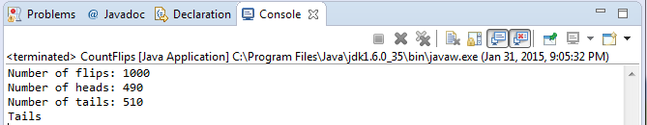

*The FlipRace program*

//-----------------------------------------------------------------

// Used Lewis' FlipRace program with minimal modification

//-----------------------------------------------------------------

**public** **class** FlipRace

{

**public** **static** **void** main (String[] args)

{

**final** **int** GOAL = 3;

**int** count1 = 0, count2 = 0;

Coin coin1 = **new** Coin(), coin2 = **new** Coin();

**while** (count1 < GOAL && count2 < GOAL)

{

coin1.flip();

coin2.flip();

System.***out***.println ("Coin 1: " + coin1 + "\tCoin 2: " + coin2);

//Increment or reset the counters

count1 = (coin1.isHeads()) ? count1+1 : 0;

count2 = (coin2.isHeads()) ? count2+1 : 0;

}

**if** (count1 < GOAL)

{

System.***out***.println ("Coin 2 Wins!");

}

**else**

{

**if** (count2 < GOAL)

System.***out***.println ("Coin 1 Wins!");

**else**

System.***out***.println ("It's a TIE!");

}

//Revised to group the if/else block logically

//so I can do the println() lines below

System.***out***.println(coin1);

System.***out***.println(coin2);

}

}

Output of FlipRace:

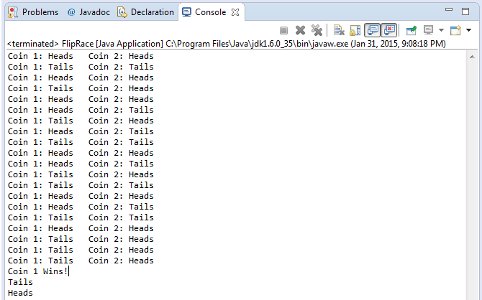

## 9 Repeat programming project in item 8 above, representing the state of the coin using an enumerated type.

*The revised Coin class*

//*********************************************************

//Author: Hieu Pham

//ID: 0953-827

//Section: 28317

//Date: 01/31/2015

//

//Revise the Coin class such that its state is represented

//internally using an enum variable. Test the new versions

//of the class as part of the CountFlips and FlipRace

//programs.

//

//**********************************************************

**enum** coinstate{***head***, ***tail***} //Must have

**public** **class** Coin

{

//private final int HEADS = 0; // tails is 1

// HEADS is not used at after the mod,

//so I commented it out.

**private** **boolean** flips;

**private** coinstate face;

//Revised right here, HQP 01/31/2015

//Changed from int to boolean type.

//-----------------------------------------------------------------

// Sets up this coin by flipping it initially.

//-----------------------------------------------------------------

**public** Coin()

{

flip();

}

//-----------------------------------------------------------------

// Flips this coin by randomly choosing a face value.

//-----------------------------------------------------------------

**public** **void** flip ()

{

flips = ((**int**)(Math.*random*() * 2) != 0);

//Forced/type-casting into a boolean evaluation here.

//HQP, 01/31/2015

}

//-----------------------------------------------------------------

// Returns head if the current face of this coin is heads.

//-----------------------------------------------------------------

**public** coinstate isHeads()

{

**if**(flips == **true**)

{

face = coinstate.***tail***;

}

**else**

{

face = coinstate.***head***;

}

**return**(face); //Changed this to return the state

//the boolean value of face, HQP 01/31/2015

}

//-----------------------------------------------------------------

// Returns the current face of this coin as a string.

//-----------------------------------------------------------------

**public** String toString()

{

**return** (face == coinstate.***head***) ? "Heads" : "Tails";

//Changed to judge face based on its boolean state

//HEADS = 0, and 0 is not true

//HQP, 01/21/2015

}

}

## The revised CountFlips program

//-----------------------------------------------------------------

// Used Lewis' CountFlips program with minimal modification

//-----------------------------------------------------------------

**public** **class** CountFlips

{

**public** **static** **void** main (String[] args)

{

**final** **int** FLIPS = 1000;

**int** heads = 0, tails = 0;

Coin myCoin = **new** Coin();

**for** (**int** count=1; count <= FLIPS; count++)

{

myCoin.flip();

**if** (myCoin.isHeads() == coinstate.***head***)

heads++;

**else**

tails++;

}

System.***out***.println ("Number of flips: " + FLIPS);

System.***out***.println ("Number of heads: " + heads);

System.***out***.println ("Number of tails: " + tails);

//Added println() below to print out myCoin object

//and its boolean state, HQP, 01/31/2015

System.***out***.println (myCoin);

}

}

Output of CountFlips:

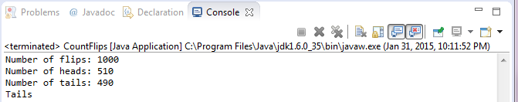

## The revised FlipRace program

//-----------------------------------------------------------------

// Used Lewis' FlipRace program with minimal modification

//-----------------------------------------------------------------

**public** **class** FlipRace

{

**public** **static** **void** main (String[] args)

{

**final** **int** GOAL = 3;

**int** count1 = 0, count2 = 0;

Coin coin1 = **new** Coin(), coin2 = **new** Coin();

**while** (count1 < GOAL && count2 < GOAL)

{

coin1.flip();

coin2.flip();

System.***out***.println ("Coin 1: " + coin1 + "\tCoin 2: " + coin2);

//Increment or reset the counters

count1 = (coin1.isHeads() == coinstate.***head***) ? count1+1 : 0;

count2 = (coin2.isHeads() == coinstate.***head***) ? count2+1 : 0;

}

**if** (count1 < GOAL)

{

System.***out***.println ("Coin 2 Wins!");

}

**else**

{

**if** (count2 < GOAL)

System.***out***.println ("Coin 1 Wins!");

**else**

System.***out***.println ("It's a TIE!");

}

//Revised to group the if/else block logically

//so I can do the println() lines below

System.***out***.println(coin1);

System.***out***.println(coin2);

}

}

Output of FlipRace:

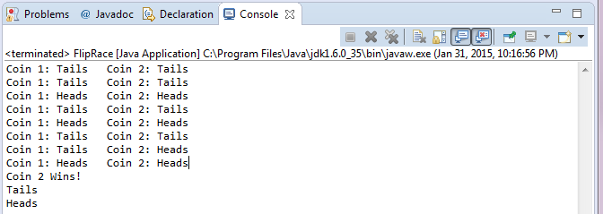

## 10 Design and implement a class called Sphere that contains instance data that represents the sphere’s diameter. Define the Sphere constructor to accept and initialize the diameter, and include getter and setter methods for the diameter. Include methods that calculate and return the volume and surface area of the sphere (see programming project 3.5 for the formulas). Include a toString method that returns a oneline description of the sphere. Create a driver class called MultiSphere, whose main method instantiates and updates several Sphere objects.

*The Sphere class*

//*********************************************************

//Author: Hieu Pham

//ID: 0953-827

//Section: 28317

//Date: 02/01/2015

//

//Design and implement a class called Sphere that contains

//instance data that represents the sphere’s diameter.

//Define the Sphere constructor to accept and initialize

//the diameter, and include getter and setter methods for

//the diameter. Include methods that calculate and return

//the volume and surface area of the sphere

//(see programming project 3.5 for the formulas).

//Include a toString method that returns a oneline

//description of the sphere.

//

//**********************************************************

**import** java.text.DecimalFormat;

**public** **class** Sphere

{

**private** **double** radius;

**private** **double** area;

**private** **double** volume;

**public** Sphere(**double** rad)

{

radius = rad;

}

**public** **void** setArea(**double** rad)

{

radius = rad; //Always update current values

area = (4.0 * Math.***PI*** * Math.*pow*(radius, 2.0));

}

**public** **double** getArea()

{

**return**(area);

}

**public** **void** setVolume(**double** rad)

{

radius = rad; //Always update current values

volume = ((4.0 / 3.0) * Math.***PI*** * Math.*pow*(radius, 3.0));

}

**public** **double** getVolume()

{

**return**(volume);

}

**public** **void** Spherify()

{

area = (4.0 * Math.***PI*** * Math.*pow*(radius, 2.0));

volume = ((4.0 / 3.0) * Math.***PI*** * Math.*pow*(radius, 3.0));

}

**public** String toString()

{

DecimalFormat fmt = **new** DecimalFormat("0.###");

**return**("Radius = " + fmt.format(radius) + ", "

+ "Area = " + fmt.format(area) + ", "

+ "Volume = " + fmt.format(volume) + "\n");

}

}

*The MultiSphere driver class*

//*********************************************************

//Author: Hieu Pham

//ID: 0953-827

//Section: 28317

//Date: 02/01/2015

//

//Create a driver class called MultiSphere,

//whose main method instantiates and updates

//several Sphere objects.

//

//**********************************************************

**import** java.text.DecimalFormat;

**public** **class** MultiSphere

{

**public** **static** **void** main(String[] args)

{

Sphere sphere1 = **new** Sphere(2.5), sphere2 = **new** Sphere(4.7);

Sphere sphere3 = **new** Sphere(7.93), sphere4 = **new** Sphere(11.56);

DecimalFormat fmt = **new** DecimalFormat("0.###");

sphere1.setArea(1.19);

sphere2.setArea(4.16);

sphere3.setArea(2.29);

sphere4.setArea(3.77);

System.***out***.println();

System.***out***.println("Area of sphere #1 " + fmt.format(sphere1.getArea()));

System.***out***.println("Area of sphere #2 " + fmt.format(sphere2.getArea()));

System.***out***.println("Area of sphere #3 " + fmt.format(sphere3.getArea()));

System.***out***.println("Area of sphere #4 " + fmt.format(sphere4.getArea()));

System.***out***.println();

sphere1.setVolume(1.19);

sphere2.setVolume(4.16);

sphere3.setVolume(2.29);

sphere4.setVolume(3.77);

System.***out***.println("Volume of sphere #1 " + fmt.format(sphere1.getVolume()));

System.***out***.println("Volume of sphere #2 " + fmt.format(sphere2.getVolume()));

System.***out***.println("Volume of sphere #3 " + fmt.format(sphere3.getVolume()));

System.***out***.println("Volume of sphere #4 " + fmt.format(sphere4.getVolume()));

System.***out***.println();

System.***out***.println();

sphere1.Spherify();

sphere2.Spherify();

sphere3.Spherify();

sphere4.Spherify();

System.***out***.println("Sphere1: " + sphere1);

System.***out***.println("Sphere2: " + sphere2);

System.***out***.println("Sphere3: " + sphere3);

System.***out***.println("Sphere4: " + sphere4);

}

}

Output:

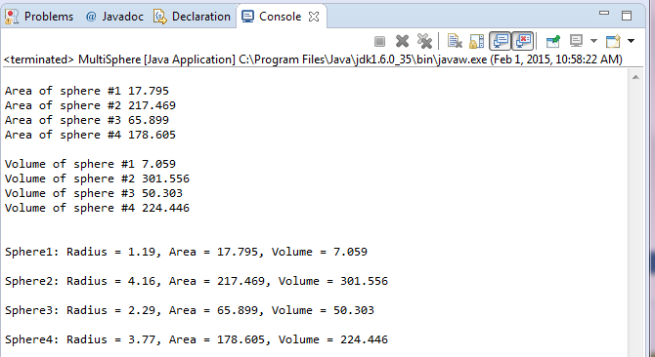

## 11 Design and implement a class called Box that contains instance data that represents the height, width, and depth of the box. Also include a boolean variable called full as instance data that represents if the box is full or not. Define the Box constructor to accept and initialize the height, width, and depth of the box. Each newly created Box is empty (the constructor should initialize full to false). Include getter and setter methods for all instance data. Include a toString method that returns a one-line description of the box. Create a driver class called BoxTest, whose main method instantiates and updates several Box objects.

*The Box class*

//****************************************************************

//Author: Hieu Pham

//ID: 0953-827

//Section: 28317

//Date: 02/01/2015

//

//Design and implement a class called Box that contains

//instance data that represents the height, width, and

//depth of the box. Also include a boolean variable called

//full as instance data that represents if the box is full

//or not. Define the Box constructor to accept and initialize

//the height, width, and depth of the box. Each newly created

//Box is empty (the constructor should initialize full to false).

//Include getter and setter methods for all instance data.

//Include a toString method that returns a one-line

//description of the box.

//

//****************************************************************

**import** java.text.DecimalFormat;

**public** **class** Box

{

**private** **double** height;

**private** **double** width;

**private** **double** depth;

**private** **double** area;

**private** **double** volume;

**private** **boolean** full;

**public** Box(**double** h, **double** w, **double** d)

{

full = **false**;

height = h;

width = w;

depth = d;

**this**.Boxify();

}

**public** **void** setArea(**double** w, **double** d)

{

width = w; //Always update current values

depth = d; //Always update current values

area = (width * depth);

}

**public** **double** getArea()

{

**return**(area);

}

**public** **void** setVolume(**double** h, **double** w, **double** d)

{

height = h; //Always update current values

width = w; //Always update current values

depth = d; //Always update current values

volume = (width * depth * height);

}

**public** **double** getVolume()

{

**return**(volume);

}

**public** **void** setFilledState(**boolean** f)

{

full = f;

}

**public** String getFilledState()

{

**return**((full & **true**) ? "Full" : "Empty");

}

**public** **void** Boxify()

{

area = (width * depth);

volume = (width * depth * height);

full = (full & **true**);

}

**public** String toString()

{

DecimalFormat fmt = **new** DecimalFormat("0.###");

**return**("Height = " + fmt.format(**this**.height) + ", "

+ "Width = " + fmt.format(**this**.width) + ", "

+ "Depth = " + fmt.format(**this**.depth) + ", "

+ "Area = " + fmt.format(**this**.area) + ","

+ "Volume = " + fmt.format(**this**.volume) + ", "

+ **this**.getFilledState());

}

}

*The BoxTest driver class*

//*********************************************************

//Author: Hieu Pham

//ID: 0953-827

//Section: 28317

//Date: 02/01/2015

//

//Create a driver class called BoxTest, whose main method

//instantiates and updates several Box objects.

//

//**********************************************************

**import** java.text.DecimalFormat;

**public** **class** BoxTest

{

**public** **static** **void** main(String[] args)

{

Box box1 = **new** Box(3.35,2.25,1.15), box2 = **new** Box(4.7,3.27,4.17);

Box box3 = **new** Box(7.93,5.63,8.23), box4 = **new** Box(11.56,10.15,12.25);

System.***out***.println();

System.***out***.println("****** Initialized the boxes ******");

System.***out***.println("Box1: " + box1);

System.***out***.println("Box2: " + box2);

System.***out***.println("Box3: " + box3);

System.***out***.println("Box4: " + box4);

DecimalFormat fmt = **new** DecimalFormat("0.###");

box1.setArea(1.19, 0.89);

box2.setArea(2.34, 1.19);

box3.setArea(6.59, 4.89);

box4.setArea(11.29, 9.59);

System.***out***.println();

System.***out***.println("Area of box #1 " + fmt.format(box1.getArea()));

System.***out***.println("Area of box #2 " + fmt.format(box2.getArea()));

System.***out***.println("Area of box #3 " + fmt.format(box3.getArea()));

System.***out***.println("Area of box #4 " + fmt.format(box4.getArea()));

System.***out***.println();

box1.setVolume(2.25,1.19, 0.89);

box2.setVolume(3.15,2.34, 1.19);

box3.setVolume(4.35,6.59, 4.89);

box4.setVolume(6.65,11.29, 9.59);

System.***out***.println("Volume of box #1 " + fmt.format(box1.getVolume()));

System.***out***.println("Volume of box #2 " + fmt.format(box2.getVolume()));

System.***out***.println("Volume of box #3 " + fmt.format(box3.getVolume()));

System.***out***.println("Volume of box #4 " + fmt.format(box4.getVolume()));

System.***out***.println();

box1.setFilledState(((**int**)(Math.*random*() * 2) != 0));

box2.setFilledState(((**int**)(Math.*random*() * 2) != 0));

box3.setFilledState(((**int**)(Math.*random*() * 2) != 0));

box4.setFilledState(((**int**)(Math.*random*() * 2) != 0));

System.***out***.println("Capacity of box #1 " + box1.getFilledState());

System.***out***.println("Capacity of box #2 " + box2.getFilledState());

System.***out***.println("Capacity of box #3 " + box3.getFilledState());

System.***out***.println("Capacity of box #4 " + box4.getFilledState());

System.***out***.println();

System.***out***.println();

box1.Boxify();

box2.Boxify();

box3.Boxify();

box4.Boxify();

System.***out***.println("Box1: " + box1);

System.***out***.println("Box2: " + box2);

System.***out***.println("Box3: " + box3);

System.***out***.println("Box4: " + box4);

}

}

Output:

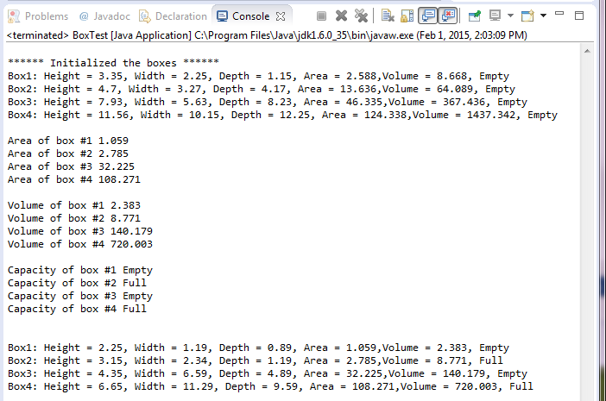

## 12 Using the Die class defined in this chapter, design and implement a class called PairOfDice, composed of two Die objects. Include methods to set and get the individual die values, a method to roll the dice, and a method that returns the current sum of the two die values. Rewrite the SnakeEyes program using a PairOfDice object.

*The PairOfDice Class*

//****************************************************************

//Author: Hieu Pham

//ID: 0953-827

//Section: 28317

//Date: 02/01/2015

//

//Using the Die class defined in this chapter, design and implement a

//class called PairOfDice, composed of two Die objects. Include methods

//to set and get the individual die values, a method to roll the dice,

//and a method that returns the current sum of the two die values.

//

//****************************************************************

**public** **class** PairOfDice

{

**private** **final** **int** MAX = 6; // maximum face value

**private** **int**[] Diefacevalue = **new** **int**[2];

// current value showing on the die

//-----------------------------------------------------------------

// Constructor: Sets the initial face value of this die.

//-----------------------------------------------------------------

**public** PairOfDice()

{

Diefacevalue[0] = 6;

Diefacevalue[1] = 6;

}

//-----------------------------------------------------------------

// Computes a new face value for this pair and returns the result.

//-----------------------------------------------------------------

**public** **int**[] roll()

{

Diefacevalue[0] = (**int**)(Math.*random*() * MAX) + 1;

Diefacevalue[1] = (**int**)(Math.*random*() * MAX) + 1;

**return**(Diefacevalue);

}

//-----------------------------------------------------------------

// Face value mutator. The face value is not modified if the

// specified value is not valid.

//-----------------------------------------------------------------

**public** **void** setFaceValues(**int** value1, **int** value2)

{

**if**(value1 > 0 && value1 <= MAX)

{

Diefacevalue[0] = value1;

}

**if**(value2 > 0 && value2 <= MAX)

{

Diefacevalue[1] = value2;

}

}

//-----------------------------------------------------------------

// Face value accessor.

//-----------------------------------------------------------------

**public** **int**[] getFaceValue()

{

**return** Diefacevalue;

}

//-----------------------------------------------------------------

//Return the sum of the dice

//-----------------------------------------------------------------

**public** **int** getSumOfDice()

{

**return**(Diefacevalue[0] + Diefacevalue[1]);

}

//-----------------------------------------------------------------

// Returns a string representation of this pair die.

//-----------------------------------------------------------------

**public** String toString()

{

String result = ("Die 1 = " + Integer.*toString*(Diefacevalue[0])

+ ", " + "Die 2 = " + Integer.*toString*(Diefacevalue[1])

+ ", Their sum = " + Integer.*toString*(Diefacevalue[1] + Diefacevalue[0]));

**return**(result);

}

}

*The modified SnakeEyes driver class*

//****************************************************************

//Author: Hieu Pham

//ID: 0953-827

//Section: 28317

//Date: 02/01/2015

//

//Rewrite the SnakeEyes program using a PairOfDice object.

//

//****************************************************************

**public** **class** SnakeEyes

{

//-----------------------------------------------------------------

// Creates two Die objects and rolls them several times, counting

// the number of snake eyes that occur.

//-----------------------------------------------------------------

**public** **static** **void** main(String[] args)

{

**final** **int** ROLLS = 500;

**int**[] numx = **new** **int**[2];

**int**[] fv = **new** **int**[2];

**int** count = 0, sums = 0;

PairOfDice PoD1 = **new** PairOfDice(); //Each die will be 6

System.***out***.println();

System.***out***.println(PoD1);

System.***out***.println();

//Set the face values

PoD1.setFaceValues(3, 3);

System.***out***.println();

System.***out***.println(PoD1);

System.***out***.println();

//Get the face values

fv = PoD1.getFaceValue();

System.***out***.println();

System.***out***.println("Die 1: " + Integer.*toString*(fv[0]));

System.***out***.println("Die 2: " + Integer.*toString*(fv[1]));

System.***out***.println();

//Get the sum

sums = PoD1.getSumOfDice();

System.***out***.println();

System.***out***.println("Their sum is: " + Integer.*toString*(sums));

System.***out***.println();

**for** (**int** roll=1; roll <= ROLLS; roll++)

{

numx = PoD1.roll();

**if** (numx[0] == 1 && numx[1] == 1) // check for snake eyes

count++;

}

System.***out***.println("Number of rolls: " + ROLLS);

System.***out***.println("Number of snake eyes: " + count);

System.***out***.println("Ratio: " + (**float**)count / ROLLS);

}

}

Output:

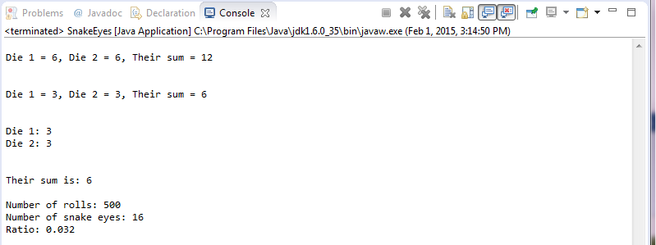

## 13 Using the PairOfDice class from programming project 5.10, design and implement a class to play a game called Pig. In this game, the user competes against the computer. On each turn, the current player rolls a pair of dice and accumulates points. The goal is to reach 100 points before your opponent does. If, on any turn, the player rolls a 1, all points accumulated for that round are forfeited and control of the dice moves to the other player. If the player rolls two 1’s in one turn, the player loses all points accumulated thus far in the game and loses control of the dice. The player may voluntarily turn over the dice after each roll. Therefore the player must decide to either roll again (be a pig) and risk losing points or relinquish control of the dice, possibly allowing the other player to win. Implement the computer player such that it always relinquishes the dice after accumulating 20 or more points in any given round.

*The PigGame driver class will be submitted as PigGame.java*

Output:

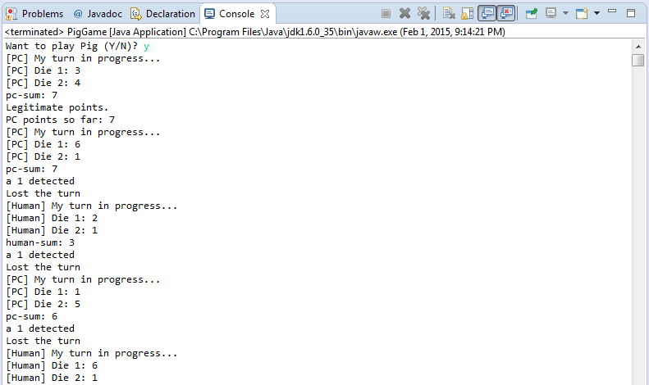

## 14 Design and implement an application that creates a histogram that allows you to visually inspect the frequency distribution of a set of values. The program should read in an arbitrary number of integers that are in the range 1 to 100 inclusive; then produce a chart similar to the one below that indicates how many input values fell in the range 1 to 10, 11 to 20, and so on. Print one asterisk for each value entered.

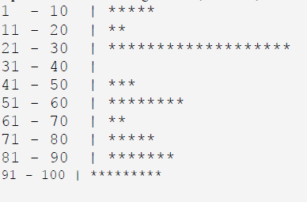

*The Histogram class*

//****************************************************************

//Author: Hieu Pham

//ID: 0953-827

//Section: 28317

//Date: 02/01/2015

//

//Design and implement an application that creates a histogram that

//allows you to visually inspect the frequency distribution of a set

//of values. The program should read in an arbitrary number of integers

//that are in the range 1 to 100 inclusive; then produce a chart similar

//to the one below that indicates how many input values fell in the range

//1 to 10, 11 to 20, and so on. Print one asterisk for each value entered.

//

//****************************************************************

**import** java.util.Scanner;

**public** **class** Histogram

{

**public** **static** **void** main(String[] args)

{

Scanner stdin = **new** Scanner(System.***in***);

//Should have the same effect using the Scanner class

**final** **int** MAXIMUM = 10;

**final** **int** MINIMUM = 1;

**final** **int** GAP = 10;

**int**[] dataset = **new** **int**[MAXIMUM];//Create an array of 10 ints

**for**(**int** b=0; b < dataset.length; b++)

{

dataset[b] = 0;// Initialize the array to zero

}

//Prompt user for integer data entry

System.***out***.println("Please enter a set of integers between 1 and 100.");

System.***out***.println("Enter an integer outside this range to stop.");

System.***out***.print("Enter Integer: ");

**int** value = stdin.nextInt();

**while**(value >= MINIMUM && value <= (MAXIMUM*GAP))

{

//Divide by gap to increment accordingly

dataset[(value-1)/GAP] = dataset[(value-1)/GAP] + 1;

//Next integer

System.***out***.print("Enter an integer: ");

value = stdin.nextInt();//Keep entering them integers

}

//Print out the histogram

System.***out***.println("\nThe histogram is:");

**for**(**int** c=0; c < dataset.length; c++)

{

//Arranging the fancy output of numbers, dashes, and asterisks

System.***out***.print(" " + (c * GAP + 1) + " - " + (c + 1) * GAP

+ "\t| ");

// Print asterisks based on the tally in dataset[i]

**for**(**int** a=0 ; a < dataset[c] ; a++)

{

System.***out***.print("*");//Here is the asterisk

}

System.***out***.println(); //New line

}

}

}

The Histogram Output:

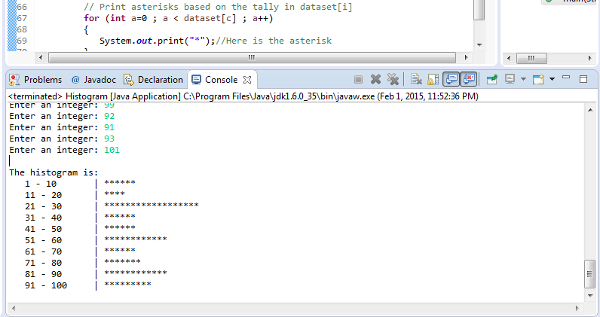

## 15 Define a class called Quiz that manages a set of up to 25 Question objects. Define the add method of the Quiz class to add a question to a quiz. Define the giveQuiz method of the Quiz class to present each question in turn to the user, accept an answer for each one, and keep track of the results. Define a class called QuizTime with a main method that populates a quiz, presents it, and prints the final results.

*I am sorry, but I do not understand this multiple part question. What does the Question class look like to store the “Question” objects? I am totally lost in this question.*