## 1 EX 10.2 Describe the output for the ProductCodes program if a finally clause were added to the try statement that printed the string "Got here!".

//********************************************************************

// ProductCodes.java Author: Lewis/Loftus

//

// Demonstrates the use of a try-catch block.

//********************************************************************

**import** java.util.Scanner;

**public** **class** Generic

{

//-----------------------------------------------------------------

// Counts the number of product codes that are entered with a

// zone of R and and district greater than 2000.

//-----------------------------------------------------------------

**public** **static** **void** main (String[] args)

{

String code;

**char** zone;

**int** district, valid = 0, banned = 0;

Scanner scan = **new** Scanner (System.***in***);

System.***out***.print ("Enter product code (STOP to quit): ");

code = scan.nextLine();

**while** (!code.equals ("STOP"))

{

**try**

{

zone = code.charAt(9);

district = Integer.*parseInt*(code.substring(3, 7));

valid++;

**if** (zone == 'R' && district > 2000)

banned++;

}

**catch** (StringIndexOutOfBoundsException exception)

{

System.***out***.println ("Improper code length: " + code);

}

**catch** (NumberFormatException exception)

{

System.***out***.println ("District is not numeric: " + code);

}

**finally**

{

System.***out***.println ("Got here!");

}

System.***out***.print ("Enter product code (STOP to quit): ");

code = scan.nextLine();

}

System.***out***.println ("# of valid codes entered: " + valid);

System.***out***.println ("# of banned codes entered: " + banned);

}

}

Output:

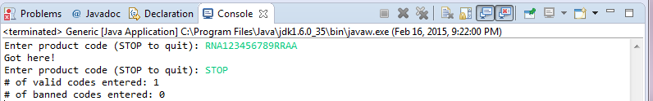

The finally clause did not serve any purpose here other than causing the CPU to be more busy for no reason.

## 2  EX 10.6 Look up the following exception classes in the online Java API documentation and describe their purpose:

a. ArithmeticException

b. NullPointerException

c. NumberFormatException

d. PatternSyntaxException

|  |  |  |  |
| --- | --- | --- | --- |
| **Exception** | **Purpose** |  |  |
| ArithmeticException | Thrown when an exceptional arithmetic condition has occurred. For example, an integer "divide by zero" throws an instance of this class. ArithmeticException objects may be constructed by the virtual machine as if suppression were disabled and/or the stack trace was not writable. |  |  |
| NullPointerException | Thrown when an application attempts to use null in a case where an object is required. These include:   * Calling the instance method of a null object. * Accessing or modifying the field of a null object. * Taking the length of null as if it were an array. * Accessing or modifying the slots of null as if it were an array. * Throwing null as if it were a Throwable value.   Applications should throw instances of this class to indicate other illegal uses of the null object. NullPointerException objects may be constructed by the virtual machine as if suppression were disabled and/or the stack trace was not writable. |  |  |
| NumberFormatException | Thrown to indicate that the application has attempted to convert a string to one of the numeric types, but that the string does not have the appropriate format. |  |  |
| PatternSyntaxException | Unchecked exception thrown to indicate a syntax error in a regular-expression pattern. |  |  |

## 3 PP 10.1 Design and implement a program that reads a series of 10 integers from the user and prints their average. Read each input value as a string, and then attempt to convert it to an integer using the Integer.parseInt method. If this process throws a NumberFormatException (meaning that the input is not a valid number), print an appropriate error message and prompt for the number again. Continue reading values until 10 valid integers have been entered.

//****************************************************************

//Author: Hieu Pham

//ID: 0953-827

//Section: 28317

//Date: 02/16/2015

//

//PP 10.1 Design and implement a program that reads a series of 10

//integers from the user and prints their average. Read each input

//value as a string, and then attempt to convert it to an integer

//using the Integer.parseInt method. If this process throws a

//NumberFormatException (meaning that the input is not a valid number),

//print an appropriate error message and prompt for the number again.

//Continue reading values until 10 valid integers have been entered.

//

//****************************************************************

**import** java.util.Scanner;

**public** **class** ReadTen

{

**public** **static** **void** main (String [] args)

{

//int a,b;

**int**[] numbers = **new** **int** [10];//In case of need for an int array

**int** count = 0; **int** a = 0; //Variables used in program

String aString =""; //String buffer

**int** sum = 0; //Used for summing at the end

Scanner ReadNumbs = **new** Scanner(System.***in***); //Read from keyboard

**do**

{

System.***out***.println("This is index " + count + " of the 10 element array");

**try**

{

System.***out***.print("Enter an integer: ");

aString = ReadNumbs.nextLine();

a = Integer.*parseInt*(aString);

count += 1; //If everything is good, move on, increment count

}

**catch**(NumberFormatException e)

{

System.***out***.println("An exception has been thrown. " + aString +

" is not a valid number");

count -= 1; //Otherwise, decrement count

}

**finally**

{

sum = sum + a; //No matter what, update the sum

}

}**while**(count < 10); //Get out when 10 numbers reached

System.***out***.println("Array length is: " + numbers.length + " sum is: " + sum);

System.***out***.println("Average is: " + ((**float**) (sum / numbers.length)));

}

}

Output (Good):

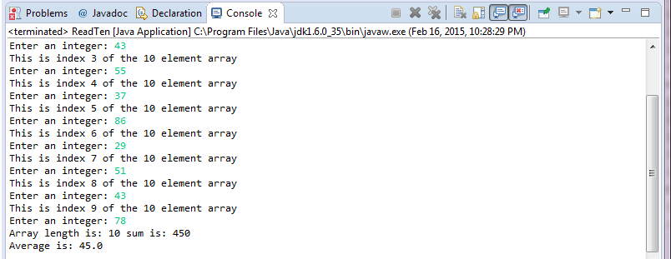

Output (Bad):

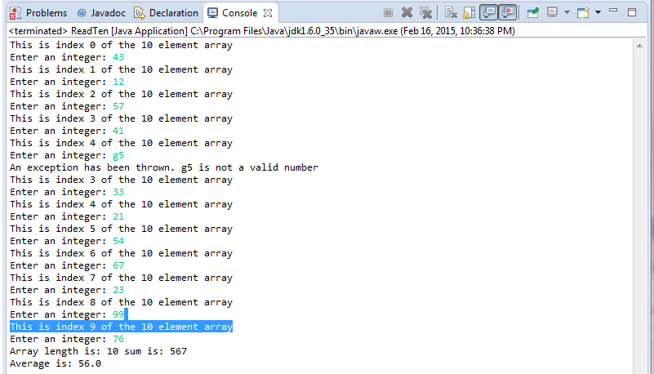

## 4 PP 10.6 Write a program that reads strings from the user and writes them to an output file called userStrings.dat. Terminate processing when the user enters the string "DONE". Do not write the sentinel string to the output file.

//********************************************************************

// TestData.java Author: Lewis/Loftus

//

// Demonstrates I/O exceptions and the use of a character file

// output stream.

//********************************************************************

//****************************************************************

//Author: Hieu Pham

//ID: 0953-827

//Section: 28317

//Date: 02/16/2015

//

//PP 10.6 Write a program that reads strings from the user and writes them

//to an output file called userStrings.dat. Terminate pro- cessing when the

//user enters the string "DONE". Do not write the sentinel string to the

//output file.

//Most of the work was based on Lewis example.

//****************************************************************

**import** java.util.Scanner;

**import** java.io.*;

**public** **class** UserString

{

//-----------------------------------------------------------------

// Creates a file of test data that consists of ten lines each

// containing ten integer values in the range 10 to 99.

//-----------------------------------------------------------------

**public** **static** **void** main (String[] args) **throws** IOException

{

String file = "userStrings.dat";

String code;

Scanner scan = **new** Scanner (System.***in***);

FileWriter fw = **new** FileWriter(file);//Inherited from the author.

BufferedWriter bw = **new** BufferedWriter(fw);//Inherited from the author.

PrintWriter outFile = **new** PrintWriter(bw);//Inherited from the author.

//Basically bw contains fw, and outFile contains bw, hence buffering.

System.***out***.print ("Enter product code (DONE to quit): ");

code = scan.nextLine();

**while** (!code.equals ("DONE"))

{

**if**(!code.equals ("DONE"))//Don't write the sentinel

{

outFile.print(code); //Store the user string

outFile.println();//Adds a new line

}

System.***out***.print ("Enter product code (DONE to quit): ");

code = scan.nextLine(); //Continue

}

outFile.close();//Close the output file

System.***out***.println ("Output file has been created: " + file);

}

}

Output:

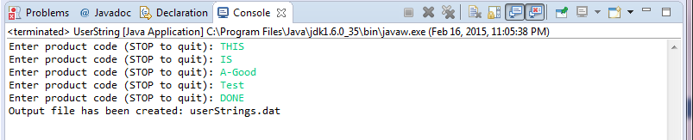

## 4.3  EX 11.1 What is the order of the following growth functions?

a. 10n2 + 100n + 1000

b. 10n3 - 7

c. 2n + 100n3

d. n2 log n

|  |  |  |  |
| --- | --- | --- | --- |
| **Growth Function** |  | **Order** |  |
| 10n2 + 100n + 1000 |  | O(n2) |  |
| 10n3 - 7 |  | O(n3) |  |
| 2n + 100n3 |  | O(n) |  |
| n2 log n |  | O(n2 log n) |  |

## 5 EX 11.2 Arrange the growth functions of the previous exercise in ascending order of efficiency for n=10 and again for n = 1,000,000.

|  |  |  |  |
| --- | --- | --- | --- |
| **Growth Function** | **Order** | **n = 10** | **n = 1000000** |
| 10n2 + 100n + 1000 | O(n2) | n2 log n | n2 log n |
| 10n3 - 7 | O(n3) | 10n2 + 100n + 1000 | 10n2 + 100n + 1000 |
| 2n + 100n3 | O(n3) | 10n3 - 7 | 10n3 - 7 |
| n2 log n | O(n2 log n) | 10n3 - 7 | 10n3 - 7 |