## EX 18.4 consider the following list:

|  |  |  |  |  |  |  |  |  |
| --- | --- | --- | --- | --- | --- | --- | --- | --- |
| 90 | 8 | 7 | 56 | 123 | 235 | 9 | 1 | 653 |

## Show a trace execution for:

1. Selection Sort
2. Insertion Sort
3. Bubble Sort
4. Quick Sort
5. Merge Sort

**Selection Sort:**

**Algorithm: Sort a list of values by repetitively putting a particular value into its final, sorted position.**

|  |  |  |  |  |  |  |  |  |
| --- | --- | --- | --- | --- | --- | --- | --- | --- |
| 90 | 8 | 7 | 56 | 123 | 235 | 9 | 1 | 653 |
| 1 | 8 | 7 | 56 | 123 | 235 | 9 | 90 | 653 |
| 1 | 7 | 8 | 56 | 123 | 235 | 9 | 90 | 653 |
| 1 | 7 | 8 | 9 | 123 | 235 | 56 | 90 | 653 |
| 1 | 7 | 8 | 9 | 56 | 235 | 123 | 90 | 653 |
| 1 | 7 | 8 | 9 | 56 | 90 | 123 | 235 | 653 |

**Insertion Sort:**

**Algorithm: Sort a list of values by repetitively inserting a particular value into a subset of the list that has already been sorted.**

|  |  |  |  |  |  |  |  |  |  |
| --- | --- | --- | --- | --- | --- | --- | --- | --- | --- |
| 90 | 8 | 7 | 56 | 123 | 235 | 9 | 1 | 653 | **Shifted** |
| 8 | 90 | 7 | 56 | 123 | 235 | 9 | 1 | 653 | 1 |
| 7 | 8 | 90 | 56 | 123 | 235 | 9 | 1 | 653 | 2 |
| 7 | 8 | 9 | 90 | 56 | 123 | 235 | 1 | 653 | 4 |
| 1 | 7 | 8 | 9 | 90 | 56 | 123 | 235 | 653 | 7 |
| 1 | 7 | 8 | 9 | 56 | 90 | 123 | 235 | 653 | 1 |

**Bubble Sort:**

**Algorithm: Sort a list by repeatedly comparing neighboring elements and swapping them if necessary.**

|  |  |  |  |  |  |  |  |  |
| --- | --- | --- | --- | --- | --- | --- | --- | --- |
| 90 | 8 | 7 | 56 | 123 | 235 | 9 | 1 | 653 |
| 8 | 90 | 7 | 56 | 123 | 235 | 9 | 1 | 653 |
| 8 | 7 | 90 | 56 | 123 | 235 | 1 | 9 | 653 |
| 8 | 7 | 56 | 90 | 123 | 1 | 235 | 9 | 653 |
| 8 | 7 | 56 | 90 | 1 | 123 | 235 | 9 | 653 |
| 8 | 7 | 56 | 1 | 90 | 123 | 235 | 9 | 653 |
| 8 | 7 | 1 | 56 | 90 | 123 | 235 | 9 | 653 |
| 8 | 1 | 7 | 56 | 90 | 123 | 235 | 9 | 653 |
| 1 | 8 | 7 | 56 | 90 | 123 | 235 | 9 | 653 |
| Second Pass | | | | | | | | |
| 1 | 8 | 7 | 56 | 90 | 123 | 235 | 9 | 653 |
| 1 | 8 | 7 | 56 | 90 | 123 | 235 | 9 | 653 |
| 1 | 8 | 7 | 56 | 90 | 123 | 9 | 235 | 653 |
| 1 | 8 | 7 | 56 | 90 | 9 | 123 | 235 | 653 |
| 1 | 8 | 7 | 56 | 9 | 90 | 123 | 235 | 653 |
| 1 | 8 | 7 | 9 | 56 | 90 | 123 | 235 | 653 |
| 1 | 8 | 7 | 9 | 56 | 90 | 123 | 235 | 653 |
| 1 | 7 | 8 | 9 | 56 | 90 | 123 | 235 | 653 |

**Quick Sort:**

**Algorithm: Sort a list by partitioning the list and then recursively sorting the two partitions.**

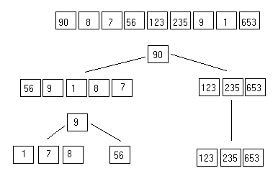

**Merge Sort:**

**Algorithm: Sort a list by recursively dividing the list in half until each sublist has one element and then merging these sublists into the sorted order.**

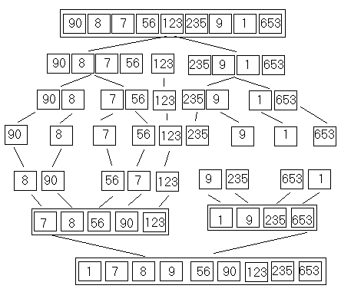

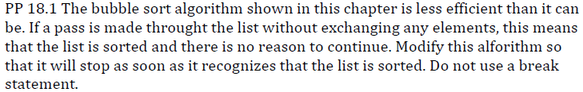

One possible solution:

/**

* Sorts the specified array of objects using a bubble sort

* algorithm.

*

* @param data the array to be sorted

*/

public static <T extends Comparable<T>>

void bubbleSort(T[] data)

{

int scan; //This variable serves as a traverser

int current = 0; //This variable sets the dynamic starting position

boolean sorted = false; //This variable keeps the sorting going

T temp; //Not used

while((current < (data.length))&&(sorted==false))

{

//Each iteration is one pass

scan = (data.length - 1); //Sets traverser index to last index

sorted = true; //Sets sorted to true to keep the outer

//loop going

while(scan > current) //While traverser index > current position

{

//If last index data is smaller the data before last

if (data[scan].compareTo(data[scan-1]) < 0)

{

sorted = false;//Set sorted to false

swap(data, scan, (scan - 1));//Exchange the 2 data

}

scan--; //Keep traversing

}

current++; //Keep the loop going if sorted is false

}

}

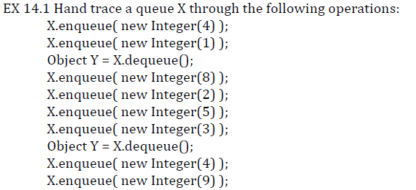

One possible solution:

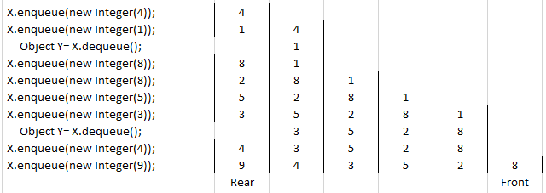

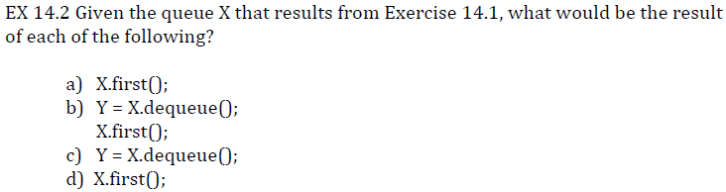

One possible solution:

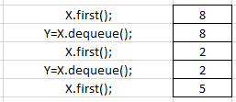



One possible solution:

*Because stack is a data structure in which the first element in is the last element out, or first-in-last-out operation. Due to this, the push and pop operations only care about current position, or one end, of the element in the stack while the other end, index 0, is the last location of the operation before the stack becomes empty. In contrast, non-circular array of implementation of a queue requires elements to be shifted to index 0 of the stack because the queue is a data structure in which the first element enters is the first element exits. The enqueuer operation pushes the element from the rear index while the dequeue operation pops the element from index 0 only. If no shifting of elements is performed, then the dequeuer operation can only be done once and the subsequent dequeuer will yield no value due to the empty content at index 0.*

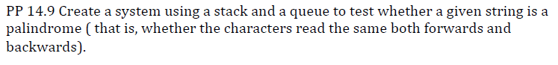

One possible approach:

**import** java.util.*;

**import** java.io.*;

/**

* Palindrome demonstrates the use of queue and stack to

* determine whether a given string of characters is a palindrome.

* CST200, Spring 2015

* **@author** Hieu Pham

* **@version** 4.0

*/

**public** **class** Palindrome

{

@SuppressWarnings("unchecked")

**public** **static** **void** main(String[] args)

{

Scanner iCh = **new** Scanner(System.***in***);//Keyboard input

String ICH = "";

**char** TestChar; //Use this to equate input string

//char TC=0; //Use this to equate input string

Scanner again = **new** Scanner(System.***in***);//Need this for messages and prompting

String Prompting=""; //Need this for messages and prompting

**boolean** confirmed = **false**; //Need to confirm palindrome

**boolean** longstring = **false**;

**int** a=0,b=0,c=0; //Need for computing in various places

@SuppressWarnings("rawtypes")

Stack CharStack = **new** Stack();

@SuppressWarnings("rawtypes")

Queue CharQueue = **new** LinkedList();

//Declaring the stack and the queue here will force

//them to be empty each pass through

System.***out***.print("Please enter a string of characters: ");

ICH=iCh.nextLine();//User enters a \n terminated string here

b = ICH.length(); //Determine the length of user's string

**if**(b>16)

{

System.***out***.println("string too long");

longstring = **true**;

}

**while**(c < b) //Read the input string one character at a time.

{

TestChar=ICH.charAt(c); //Process one char at a time

CharStack.push(TestChar); //Load the stack

CharQueue.add(TestChar); //Load the queue

//A copy of ICH goes at the top of the stack and at the rear end

//of the queue.

c++;

}// end while

confirmed = **true**;

a = 1;

//Some attempt to guard the stack to avoid

//the emptystack situation while in processing

**try**

{

//Repetitively compare the top element of the stack

//and the front element of the queue

**if**(CharStack.peek() == CharQueue.peek())

{

CharStack.pop();

CharQueue.remove();

a++;

}

**else**

{

//Change confirmed flag to false when

//the comparison failed

confirmed = **false**;

}

}

**catch**(EmptyStackException e)

{

System.***out***.println("empty structure");

}

//Processing the result...

**if**((confirmed == **true**)&&(!longstring))

{

System.***out***.println("The string is a palindrome.");

}

**else**

{

System.***out***.println("The string is a Not palindrome.");

**if**(!longstring)

{

System.***out***.println("The string is too long.");

}

}

}

}

Output:

confirmed is true

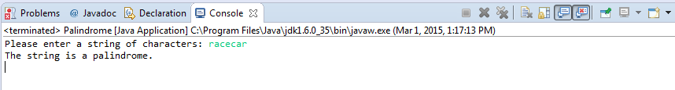

confirmed is false

