**Hieu Pham** CST216 Spring B 2016 Arizona State University **Assignment2**

Assignment 2 Code Review

# 1. Specification / Design

The functionality described in the specification is fully implemented by the code.

There is no excess functionality in the code.

# 2. Initialization and Declarations

All local and global variables initialized before use.

Variables and class members are of the correct type and mode.

A constructor was called and used as a single instance during program execution.

All needed import statements were included.

# 3. Method Calls

All parameters presented in correct order.

Methods were called with proper parameters (and types).

Correct methods were called.

Methods returned values (and threw exceptions) properly.

# 4. Arrays

Not Applicable. Used with only one special array type - the String class.

# 5. Object Comparison

No comparison. Only charAt[index] used to process single character in the string.

# 6. Output Format

There was an incorrect label “Lab4” which I changed to Assignment 2.

This is a java.swing GUI-base application and all spaces were provided as best as my eyes allowed.

# 7. Computation, Comparisons, and Assignments

Order of computation / evaluation, operator precedence and parentheses were checked with correct arrangements.

There was no division involved.

No truncation/rounding found.

Proper relational and logical operators were used.

Error conditions were legitimate in all cases.

No implicit type conversion.

# 8. Exceptions

All relevant exceptions were caught.

# 9. Flow of Control

No switch statement used.

No dangling else clauses.

Loops were formed with proper initial and final conditions, including base-case.

Open/Close parentheses paired up OK.

# 10. Files

Not Applicable.

# Appendix A

## Test Cases

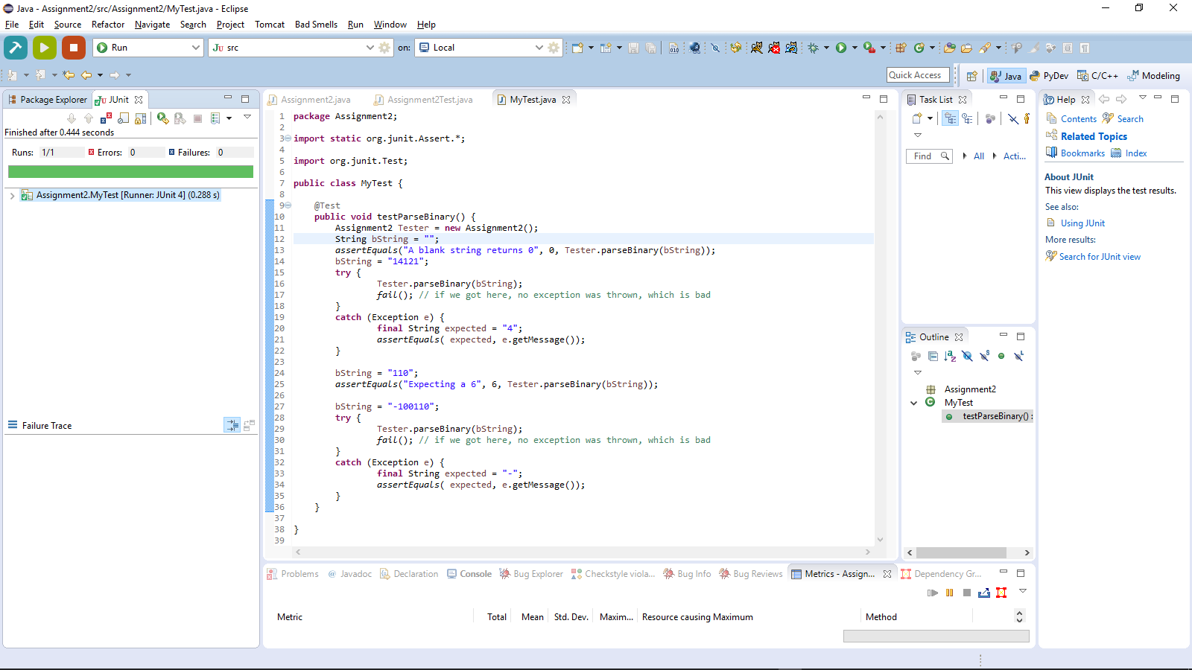The 4 test cases used as follows:

- Blank string, expected 0 returned.

- “14121”, expected an exception thrown due to bad format.

- “110”, expected a 6 returned.

- “-100110”, expected an exception thrown due to bad format.