Build-and-Fix: The “defacto” process

Waterfall and “V” models: Distinct phases of specification, development and test

Iterative and Incremental: Iterate over phases, build the system incrementally

Spiral Model: Risk management as a key phase in the process

Rational Unified Process: Use-case driven, architecture-centric

Agile Extreme Programming (XP): Embrace change, empower people, code

# M1

Why a process?

* ▪Repeatable: everything went right -how do we do it again?
* Permits Analysis: something went wrong, need to find the root of an issue.
* Informs Estimation: can better predict time or budget when adhering to a process.

1. We will leverage the iterative, selective and refining nature of a design process
2. Prototype solutions in the face of incomplete & inconsistent info
3. The prototype is the vehicle of communication –about your assumptions and understanding, not just UI specific
4. What about Software Design?
5. We will address software design in 2 parts:
   1. User Experience Design –Interaction Design and UI Design
   2. Software System Design –Modeling object structures & communication with UML
6. Modeling and Prototyping will be a key activity for both!
7. On the UX side, we will model end users and prototype UIs make tangible our designs and get feedback
8. On the System side, we will model in UML and prototype to explore technology feasibility of a solution path

# M2

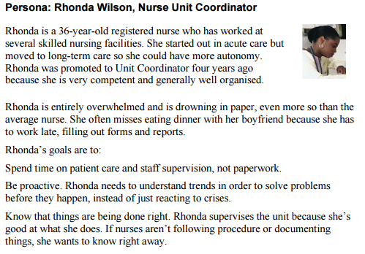

*Example of Persona*

The main contribution of using personas in interaction design is that the process will be focused

on the user’s goals instead of tasks. The design process also regards personal objectives as

important, which often is neglected in design methods and in theoretical models of users. The risk

with personas is that the designers may easily be carried away and more or less make up personas

without careful analyzing real users.

Cooper has a commercial interest to promote goal-directed design as a straightforward and effective design process. So it’s important to remember that personas are not a complete and accurate tool for user modeling. Another weakness is that the relevance of his ideas isn’t confirmed in scientific studies.

The role of the user in Cooper’s approach is blurred with the roles as a consumer and a marketing

target. The issue of usability and interaction design becomes a matter of satisfying the needs of

the consumers, not to improve human work and life.

Personas/goal-directed design emphasis that interaction is driven by users’ motives and goals. But

goal-directed design has a rather narrow view on users and activities, but this also makes it more

easy to use as a tool to direct design. This, naturally, is the main aim of the approach.

The techniques in this presentation are not exhaustive, they are representative

* That is, just like your lab on various “techniques”, using personas, use case actors, and observation are not necessary nor sufficient to capture your users
* You also need to engage in a number of other activities • Interviews, research, consult standards, texts, and user guides and so on
* You want to be able to write down Users, Goals, and Tasks
* Understanding who your users are, and giving them a name or identity, defines scope and accountability in your approach
* Goals are forms of requirements; it tells you what your users want to accomplish
* Humans interact with software products
* They could receive information (we will discuss information modeling later)
* Usually they interact with the system (do something) to achieve a Goal

# M3

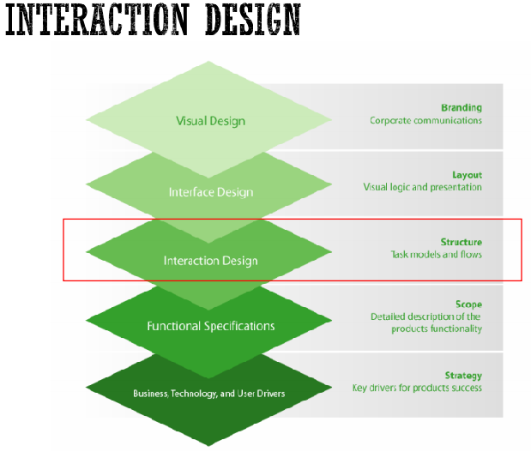

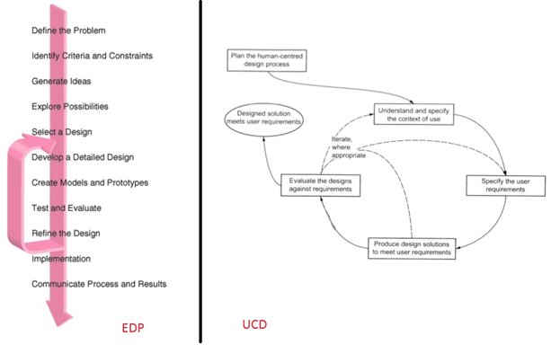

USER INTERACTION DESIGN KEY POINTS

* User interface principles covering:
  + user familiarity
  + Consistency
  + Minimal surprise
  + Recoverability
  + user guidance
  + user diversity

help guide the design of user interfaces.

* Styles of interaction with a software system include direct manipulation, menu systems, form fill-in, command languages and natural language.
* Graphical information display should be used when it is intended to present trends and approximate vales. Digital display should only be used when precision is required.
* Colour should be used sparingly and consistently in user interfaces. Designers should take account of the fact that a significant number of people are colour-blind.
* The user interface design process includes sub-processes concerned with user analysis, interface prototyping and interface evaluation. The aim of user analysis is to sensitise designers to the ways in which users actually work. You should use different techniques—task analysis, interviewing and observation—during user analysis.
* User interface prototype development should be a staged process with early prototypes based on paper versions of the interface that, after initial evaluation and feedback, are used as a basis for automated prototypes.
* The goals of user interface evaluation are to obtain feedback on how a UI design can be improved and to assess whether or not an interface meets its usability requirements.

# M4

There are four basic considerations:

* Limited short-term memory
* People can instantaneously remember about 7 items of information. If you present more than this, they are more liable to make mistakes.
* People make mistakes
* When people make mistakes and systems go wrong, inappropriate alarms and messages can increase stress and hence the likelihood of more mistakes.
* People are different
* People have a wide range of physical capabilities. Designers should not just design for their own capabilities.
* People have different interaction preferences
* Some like pictures, some like text.

# The Information-Seeking Mantra

A first step to designing information-centric UIs is to consider the following pattern:

“Overview first, zoom and filter, then details-on-demand. “

# Visual Design Summary

A collection of best practices

• Spatial layout

• Clutter

• Visual Noise (high cognitive load)

Information Presentation

• The concept of moving from an informational model stored within a system to a presentation best suited for

1) human understanding

2) contextualization – the task at hand

• Foreshadowing: when we talk about the “system design” on the backend, it has to support a flexible rendering pipeline with a clean separation of concerns

• Visual cues and error messages set user back on track w/out “blame”

There are other visual elements we have not discussed

• Color schemes (skins) • Branding.